Sea surface debris, particularly around the coastal waters of Malta, presents numerous ecological and environmental challenges that negatively affect both marine ecosystems and human activities. A possible issue stems from the absence of an effective system that can predict the movement of sea surface debris, making it more challenging to mitigate this issue effectively.

The objective of this project was to create a framework capable of forecasting future dispersion patterns of sea surface debris around Malta's coastal waters. This pipeline leverages historical sea surface currents data to predict future conditions while also having the ability to visualise the movement of surface marine debris. This system aims to enhance our understanding of debris movement patterns, thereby aiding us to make more informed decisions towards conservation and reducing the adverse impacts of sea surface debris.

To achieve this, a comprehensive pipeline that integrates machine learning with a physical-based model was implemented. The pipeline starts by selecting a specific area of interest within the Maltese coastal waters as seen in *Figure 1*. The next step is to preprocess the historical sea surface currents data. For each point within this selected area, neural network models were trained to be able to predict the next 24 hours of sea surface currents. These predictions were then used to simulate and visualise the movement of surface debris. Throughout the project, several discoveries and challenges emerged, notably the preprocessing of data and the complexity of accurately predicting future sea surface currents.

The project utilized both LSTM and GRU neural networks, comparing their performance to determine the most effective model. These predictions were then fed into a Lagrangian model, which simulates and visualises the movement of sea surface debris. The visualisation outcome, showcasing the initial and final locations of surface debris after 24 hours, is illustrated in *Figure 2*.

Figure 1 - Area Boundaries for the Simulation

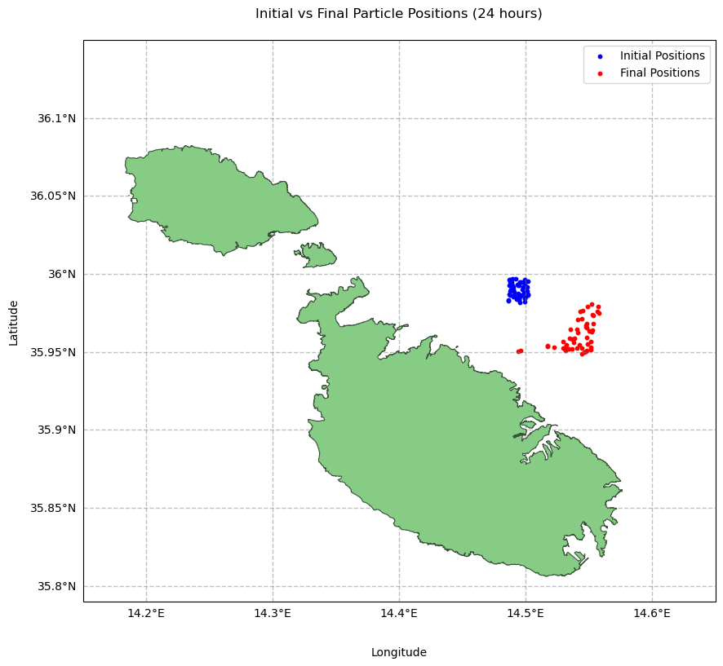

Figure 2 - Debris Locations Before and After 24 hr Simulation