Sea surface debris, particularly around the coastal waters of Malta, presents numerous ecological and environmental challenges that negatively affect both marine ecosystems and human activities. This is exacerbated by the absence of an effective system that can predict their movement, making it more challenging to address and mitigate this issue effectively.

The primary objective of this project was to create a forecasting system that can predict dispersion patterns of sea surface debris around Maltese coastal waters. Our pipeline uses historical sea surface current data to predict future conditions while also having the ability to visualise the movement of debris. This allows us to enhance our understanding of such patterns, helping us make more informed decisions about our environment and our effect on it.

To achieve this, we developed a comprehensive machine learning and physics-based pipeline. This pipeline starts by selecting a specific area of interest within the Maltese coastal waters as seen in *Figure 1*. The next step is to preprocess the historical sea surface currents data; for each point within this selected area, both LSTM and GRU models were trained to predict the next 24 hours of sea surface currents. We compared both models to determine the most effective one.

These predictions were fed into a Lagrangian model to simulate and visualise the movement of surface debris. An example visualisation, showing the initial and final locations of surface debris after 24 hours, can be seen in *Figure 2*.

While several observations and challenges were encountered (most notably concerning data preprocessing and sea surface currents predictions), our current results are showing immense promise. We also propose several improvements to make our system more robust and effective.

Figure 1 - Area boundaries for the simulation.

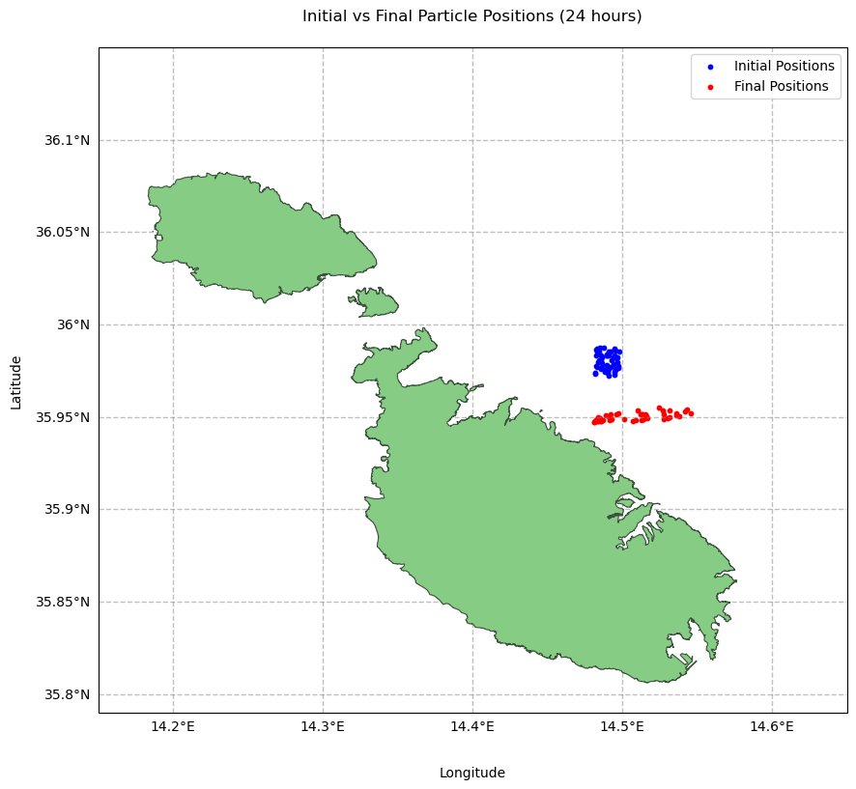

Figure 2 - Debris locations before and after 24 hours.