A Smart Insect Pest Detection Technique With

Qualified Underground Wireless Sensor Nodes for Precision Agriculture

Muhammed Enes Bayrakdar

***Abstract*—Wireless underground sensor networks are the new area of research. It is widely used in many engineering applications, from smart irrigation to security and precision agriculture. Some of the application areas of wireless underground sensor networks are underground with space, such as tunnel, cave, and so on, while some consist of no spaced underground solid areas as well. In this context, wireless underground sensor networks have recently become very important for precision agriculture purposes. In this paper, a smart insect pest detection technique with qualified underground wireless sensor nodes for precision agriculture has been investigated with a mathematical simulation model. In a simulated smart technique, insect pest detection is assumed to be carried out with a qualified acoustic sensor. In order to evaluate the performance of the underground network structure, the received signal strength and path loss parameters are examined. As the depth distance increases, the increase in path loss of communication has been revealed. The obtained performance evaluation result reveals the need for signal transmission with different transmitter power for depth-based communication in wireless underground sensor networks.**

***Index Terms*—Depth, sensor network, underground.**

I. INTRODUCTION IRELESS underground sensor networks are one of the types of wireless sensor networks with embedded sensor nodes [1]. The underground sensor nodes communicate wirelessly with each other in the soil environment or with the collector stations located above the ground [2]. A wide range of applications is available, including underground infrastructure monitoring, earthquakes, and landslide estimation, monitoring of moisture in the soil, landscape management, border patrols and security-based sensor nodes [3]. When we consider terrestrial wireless networks, sensor nodes communicate mainly by using electromagnetic waves in the air environment [4]. In underground sensor networks, communication difficulties arise as the spreading environment generally has environments such as soil, rock, and water where the channel model may not work well [5].

**W**

There is a tremendous amount of research in the literature on the performance of wireless sensor networks [6]. Network connectivity quality is one of the most important criteria used to assess the reliability of these networks [7]. The connection level between the wireless sensor nodes basically depends

|  |
| --- |
| Manuscript received May 13, 2019; revised July 1, 2019; accepted July 25, 2019. Date of publication July 29, 2019; date of current version October 17, 2019. The associate editor coordinating the review of this paper and approving it for publication was Prof. Nitaigour P. Mahalik. The author is with the Computer Engineering Department, Düzce University, 81620 Düzce, Turkey (e-mail: muhammedbayrakdar@duzce.edu.tr).  Digital Object Identifier 10.1109/JSEN.2019.2931816 |

on spatial density, sending-receiving characteristics, and the characteristics of the wireless channel [8].

Nowadays, it is essential to investigate the usability and reliability of these networks due to the rapidly increasing demands on the application of underground sensor networks as a solution to real-life problems [9]. At the beginning of the research, besides the investigation of the propagation characteristics of electromagnetic waves in the soil; other factors such as multiple paths, soil composition, soil moisture and burial depth [10]. There are three basic communication directions in underground sensor networks: (i) underground – underground (ii) underground - collector station (iii) aboveground – underground [11].

Main contributions of our work are as follows: (i) insect pest detection with acoustic sensor is taken into consideration, (ii) energy consumption is decreased with the help of qualified underground sensor nodes, (iii) design of acoustic sensor nodes and network environment is simulated, (iv) path loss performance and received signal strength are evaluated, (v) underground sensor nodes are utilized in sleep-awake mode in order to decrease energy consumption, (vi) simulation results obtained from Riverbed software are validated with analytical results, (vi) this smart technique is designed and simulated in Riverbed software for precision agriculture purposes in underground wireless sensor networks for the first time in the literature.

# II. RELATED WORKS

|  |
| --- |
| 1558-1748 © 2019 IEEE. Personal use is permitted, but republication/redistribution requires IEEE permission. See http://www.ieee.org/publications_standards/publications/rights/index.html for more information. |

In the literature, there are a lot of research papers related to underground sensor networks and precision agriculture. Vuran et al. presented sensing technology and communication mechanisms for the internet of underground things and reviewed state-of-the-art communication architectures [12]. Hu et al. developed a specific wireless sensor and actor network application for precision agriculture with the ability of intelligent irrigation and emphasized that the functions of the platform can be extended to other applications of precision agriculture [13]. Xiao and Guo introduced the theory of the monitoring system and discussed the aspect of hardware and software design of the composed modules, network topology, network communication protocol and the present challenges [14]. Sahota et al. designed medium access control and network layers for a wireless sensor network deployed for a precision agriculture application which requires the periodic collection of sensor readings from fixed locations in a field [15]. Kamarudin et al. investigated the impact of the propagation model on the wireless sensor networks system under the OMNeT++ simulation environment [16].

Zhang introduced the structure and its key technology of one kind of node system of wireless sensor networks including the communication protocol between the nodes in a wireless sensor network and the method of application for a sensor network in digital agriculture [17]. Li et al. presented the design of a wireless sensor network for precision agriculture monitor system and discussed the research and engineering challenges in implementation and deployments [2]. Tagarakis et al. were conducted a study to calibrate and install the watermark sensors in a commercial vineyard according to the precision agriculture practices [18]. Patil et al. presented an automatic irrigation controller for precision agriculture [10]. Xia et al. designed and deployed an environment monitoring system for precise agriculture based on wireless sensor networks in a red bayberry greenhouse located on a hillside with the aim of solving the problems occurring in the traditional precision agriculture such as poor real-time data acquisition, small monitoring coverage area, excessive manpower requirement etc. [19].

Ma et al. reported on the design of the sensor network when connecting agriculture to the internet of things [20]. Mampentzidou et al. provided basic guidelines for deploying wireless sensor networks in agriculture, and more specifically in applications requiring crop monitoring [21]. Mafuta et al. demonstrated how an irrigation management system can practically be implemented by successfully deploying a wireless sensor network [4]. Liao et al. presented a wireless agricultural and environmental sensing system for crop monitoring based on investigation and applications in precision agriculture [3]. Shouyi et al. designed a precision agriculture sensing system with the aim of satisfying the needs of modern precision agriculture, which is based on wireless multimedia sensor networks [22]. Besides, they designed a battery-array switching system to power the sensor node in order to elongate the lifetime.

Jao et al. presented a proof-of-concept wireless sensor network in order to collect soil moisture content, which is one of the most fundamental data required for precision agriculture [1]. Nandurkar et al. studied on a project aiming to give cheap, reliable, cost-efficient and easy to use technology which would help in the conservation of resources such as water and also in automatizing farms [7]. Mohd Kassim et al. presented a wireless sensor network as the best way to solve the agricultural problems related to farming resources optimization, decision making support, and land monitoring [23]. Yitong et al. designed a multi-parameter wireless monitoring system based on the STM32F107 chip [24]. Dinh Le and Tan described the design, implementation, and deployment of a wireless sensor network for precision agriculture [25].

Imam et al. investigated various requirements of humidity sensors characteristics in the context of WSN application for precision agriculture [26]. Deepika and Rajapirian presented a survey paper explaining the existing methods and new methods and the development of wireless sensor networks [27]. Nguyen and Kodagoda addressed the problem of predicting soil organic matter content in an agriculture field using information collected by a low-cost network of mobile, wireless and noisy sensors that can take discrete measurements in the environment [6]. Sahitya et al. designed a wireless sensor network for smart agriculture to make it smart, simple and give correct input to the crop [28]. Hamouda and Elhabil designed and developed a greenhouse smart management system using wireless sensor networks in order to automatically control, manage and monitor the agricultural parameters and activities inside the greenhouses [29].

Raghunandan et al. have discussed the sensor network and compared various techniques used in precision agriculture [30]. Mondal et al. have designed new sensor nodes with the help of the Arduino platform and raspberry pi module to minimize the cost of the entire product [5]. Durga et al. proposed a unique solution for multiple cropping scenarios, in a system design perspective [31]. Gajjar et al. developed an agriculture support system using wireless sensor and actuator networks and information technology for the management of large scale and commercial agriculture [32]. Pujari and Bogiri designed an on-field wireless sensor network that captures real-time temperature, relative humidity, soil moisture and rainfall [11]. Panda and Saha wrote a paper that is based on wireless sensor networks for indoor agricultural applications [9]. Ponde and Lomte proposed an adaptive sleep scheduling algorithm that schedules the nodes into sleep and active state by comparing their energy with threshold [33]. Ojha et al. reviewed the potential wireless sensor network applications and the specific issues and challenges associated with deploying wireless sensor networks for improved farming [8].

As it is clearly seen, none of the above-mentioned research publications focus on insect pest detection problem in precision agriculture. Vegetables are grown under the ground such as potatoes, onions, carrots, etc. are always at risk by insect pests or other harmful underground living beings. The proposed insect pest detection technique simulated with the help of qualified underground sensor nodes is very useful for precision agriculture.

# III. UNDERGROUND SENSOR NETWORKS

The subject of sensor networks is a very active research area today [22]. The richness of existing practices from commercial agriculture to security and geology; it exposed the need to monitor various underground conditions [19]. In this context; underground sensor nodes are commonly used to monitor agricultural soil conditions such as water and mineral content [14]. Sensor nodes are also successfully used to monitor the integrity of infrastructures such as plumbing [24]. In addition, extraordinary situations such as landslide and earthquake monitoring are also performed using various sensor nodes [17].

## A. Usage Areas

In addition to monitoring the underground soil conditions such as water and mineral content, sensor nodes are frequently used in agriculture to provide data for appropriate irrigation and fertilization [12], [34]. However, a wireless underground sensor network system is seen as an important alternative to existing approaches for more efficient soil maintenance [18]. For example; since the installation of wireless underground sensor networks is easier than existing wired solutions, the sensor nodes can be positioned more densely to provide detailed data [28]. With a wide range of sensor node data, fountains connected to the sensor nodes can be activated instead of watering an entire area [30]. Considering a greenhouse environment, sensor nodes can be placed in nearby of each plant [11].

In today’s infrastructure systems; there are large amounts of underground installations, such as pipes, electrical cables and liquid storage tanks [33]. Wireless underground sensor networks can be used to monitor all such infrastructure systems [10]. For example; in the case of fuel stations that store fuel in underground tanks, it is necessary to ensure that no leakage is present and the amount of fuel in the tank must be monitored carefully and accurately [9].

Fixed underground sensor nodes that are aware of their position can be used as a signal for location-based services [8], [35]. By way of example, sensor nodes placed under the surface may be provided to communicate with any car as it passes through a road [6]. A possible service in this environment can be considered to warn the driver of an approaching stop signal or a traffic signal [5]. In such a scenario, the vehicle will receive information about the approaching signal by means of sensor nodes and transmit it to the driver of the respective vehicle [23].

Wireless underground sensor networks can also be used to monitor the presence and movement of people or objects on the ground [21]. Sensor nodes placed for locating should be fixed and aware of their position [4], [36]. However, in contrast to locating, in cases where objects report their existence through direct communication with the embedded device, asset tracking requires the use of sensor nodes with pressure, acoustic or magnetic properties to determine the presence of an individual or object [20]. This can be used for home and workplace safety where sensor nodes are located around a building to detect intruders [3]. In such a system, it is very unlikely that the intruder will be aware of the presence of the sensor nodes [2].

## B. Types of Communication

The sensor nodes used for underground communication consist of all sensing devices other than the collector station, which can be placed underground or aboveground [16]. As in terrestrial wireless sensor networks, in the wireless underground sensor networks, the collector station is the last point of all data [1]. In underground communication, all sensors can be of the same or different depth [26]. For both communication types, the sensor device hardware is specifically designed to enable the data to be routed efficiently to a collector station [13].

The depth at which devices are placed varies depending on the purpose of the network structure [29]. For example; the pressure sensors are placed close to the surface, while the water sensors in the soil are placed closer to the roots of the plants [32]. In this way, the maximum privacy of the network is ensured by minimizing underground equipment [31]. Shallow depth devices are subject to lower path losses [25].

The technology in which underground and ground sensor nodes co-exist in the same communication environment is called a hybrid [27]. Wireless signals; as the air can be emitted from the soil with less loss, the aboveground sensor devices consume less power [26]. In hybrid technology, it is ensured that the data are guided by less hopping from the underground [2].

In addition, terrestrial devices are more accessible than underground devices when the power supply needs to be replaced or recharged [4]. Therefore; when a choice is required in terms of power consumption, operations requiring more power consumption are made by surface devices [23]. The disadvantage of hybrid topology is that the sensor network cannot be completely hidden as in a solid underground technology [5].

IV. MATHEMATICAL MODEL AND SIMULATION MODEL

The technique is considered for vegetables such as potatoes, onions, and carrots. Because these vegetables are cultivated in rural areas and grow underground, they are vulnerable to insect pests and other harmful living beings. In order to detect these harmful living beings, the sensor node should be capable of communicating from depth in the ground with electromagnetic waves. Acoustic underground sensor nodes are indispensable for healthy precision agriculture in terms of detecting underground insect pests. With the help of qualified acoustic underground sensor nodes, information of detected insect pests is transmitted to the collector station directly or via other nodes in an ad-hoc manner. Sensor nodes get into sleep mode while there is no action in the underground environment in order to save energy.

An acoustic sensor is an insect pest detection sensor that works by observing the noise level of the insect pests. Wireless sensor nodes connected to a collector station are placed in the underground. When the noise level of the insect pest exceeds a certain threshold, a sensor transmits that information to the collector station. Accordingly, the required measures are taken in order to get rid of insect pests.

## A. Mathematical Model

In this study, the network structure of the sensor nodes between underground - underground communication and collector stations - underground communication are discussed. The nodes transmit their data to the collector station which is primarily close to it. If this is not possible by direct communication, data is transmitted in an ad-hoc manner to the collector station via other nodes. Since underground sensor nodes are located at different depths, depth is taken into account when calculating the received signal strength and path loss parameters. The expression of the distance from the depth of the sensor node to the collecting station is as follows:

*d* = *(x* − *x*1*)* + *(x*1 − *x*2*)* + *(y* + *x*2*)* (1)

In Equation (1); the total distance d is calculated where x represents the depth of the underground nodes and y represents

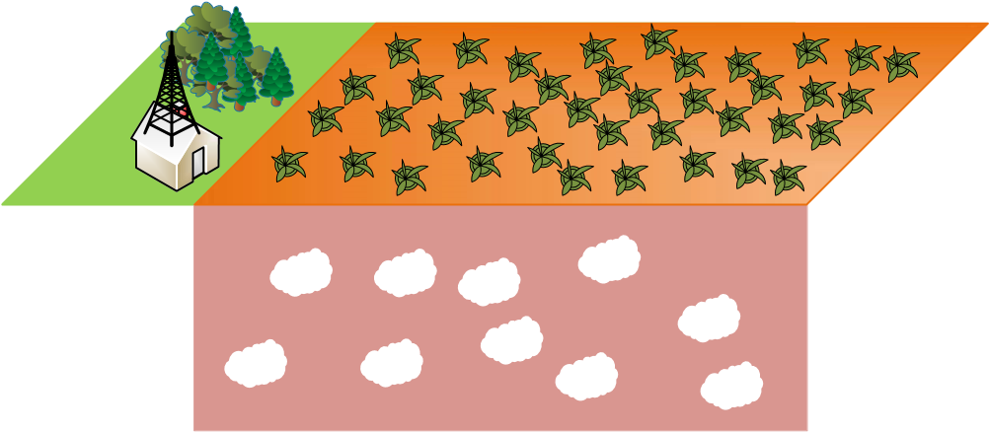

Fig. 1. Underground sensor network structure.

the height of the collector station from the ground. x1 and x2 are other nodes in which the corresponding node communicates in an ad-hoc manner to transmit data to the collector station. If the depth of the corresponding node in relation to the collector station is shallow, it transmits its data directly as (x + y). The path loss is obtained as in (2) by taking into account d.

*pl* = 20*log*10*(d)* + 20*log*10*( f )* (2)

In Equation (2), pl refers to path loss and f refers to frequency. The path loss is mainly dependent on depth distance and frequency. The received signal strength is written as (3) using pl.

*rss* = *tss* + *tg*−*pl* − *sa* (3)

In Equation (3); rss indicates the received signal strength, tss indicates transmitted signal strength, tg indicates the total gain of the transmitter-receiver antennas, and sa indicates signal attenuation resulting from soil or aqueous soil absorption. The signal attenuation is calculated as in (4).

*sa* = *msa(1* − *exp(*−*xip/msa))* (4)

In Equation (4); signal attenuation is formulated where msa is maximum signal attenuation and xip is the depth of insect pest.

*sptp* = *(plr*^ *(j* − *1))(1* − *plr)* (5)

In Equation (5); successful packet transmission probability for detection of insect pest is expressed where plr is packet loss ratio and j is the iteration parameter for jth sensor node.

## B. Simulation Model

Fig. 1 shows the nodes and collector station in the underground sensor network. It is assumed that the sensor nodes in the underground are at different depths. The nodes can transfer data directly to the collector stations or via other nodes in an ad-hoc manner. Underground sensor nodes can transmit data to one of the collector stations near them. The nodes communicate wirelessly between each other and with the collector station.

For power management, underground sensor nodes wait in sleep mode when they are idle in order to ensure that the nodes provide the lowest possible energy consumption.

Table 1 shows the simulation parameters and values of the underground sensor network. The frequency value is chosen as 315 MHz because of communication with electromagnetic waves in underground sensor networks and it is suitable for

# TABLE I

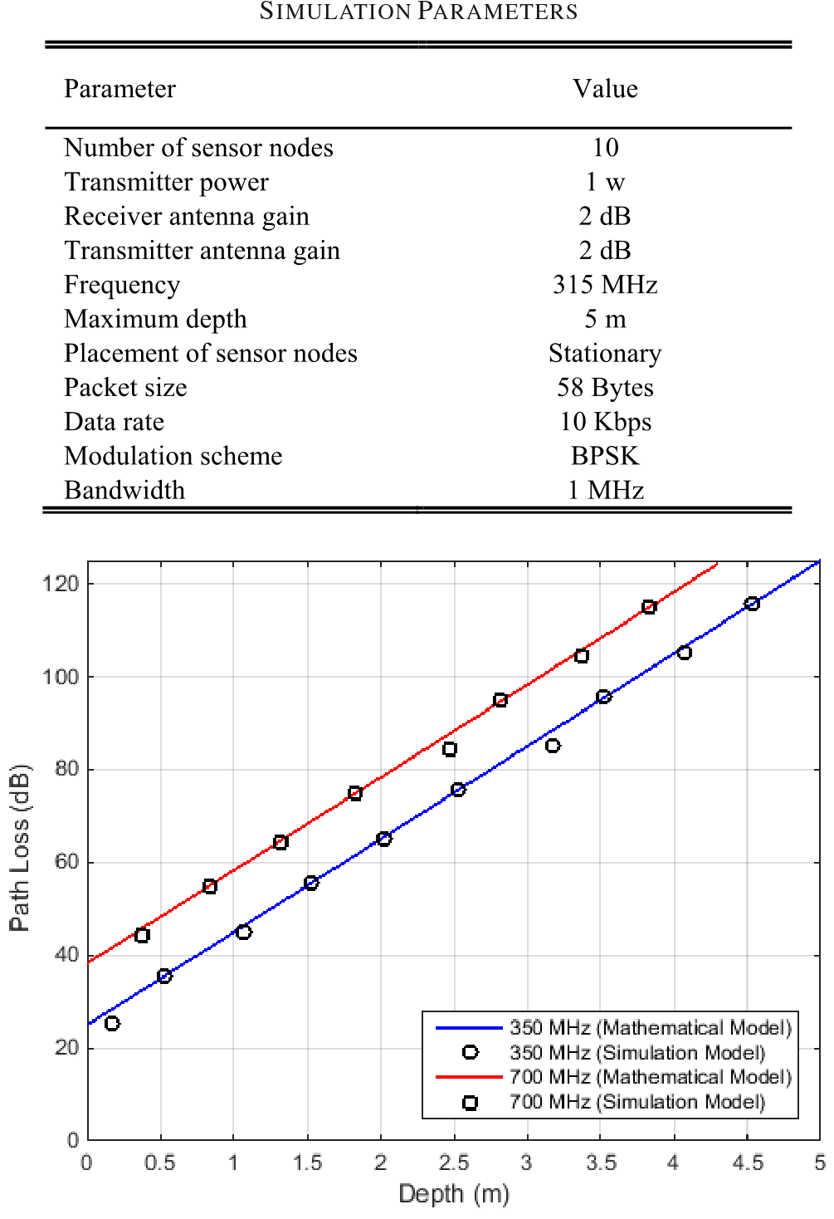

Fig. 2. Path loss according to depth for different frequencies.

use in commercial terrestrial sensor networks. After a certain depth level, the weakening effect and path loss values caused by the soil disrupt the signal. Therefore, a maximum depth of 5 meters is considered.

The Riverbed Modeler simulation software composes of various tools such as simulation, designing, and data collection [37]. Moreover, Riverbed Modeler simulation software presents a widespread development environment covering the modeling of underground sensor networks. The simulation model of the underground sensor network was carried out utilizing Riverbed modeler software. Each underground sensor node and collector station was designed in the simulation environment. Besides, simulation parameters were set for sensor nodes and collector station. The depth factor is taken into account for underground sensor nodes and their parameters were set accordingly. The working principle of sensor nodes is written with proto-c programming language in Riverbed modeler software.

# V. PERFORMANCE EVALUATION

To evaluate the performance of the wireless sensor network structure; depth, path loss, and received signal strength parameters are investigated.

Fig. 2 shows the results of the path loss parameter for depth for different frequencies. While the depth ranges from 0 to 5 meters, the path loss varies from 0 to 120 in dB.

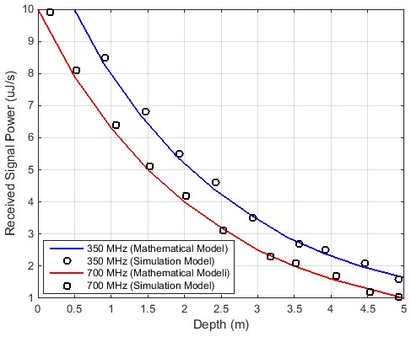

Fig. 3. Received signal power according to depth for different frequencies.

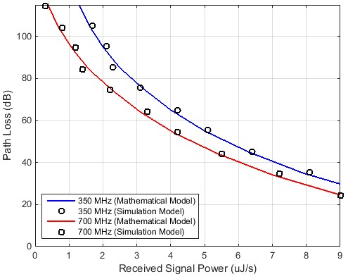

Fig. 4. Path loss according to received signal power for different frequencies.

Increasing the frequency from 350 MHz to 700 MHz leads to an increase in path loss.

Fig. 3 shows the results of the signal strength parameter for the different frequencies according to the depth. The unit of the received signal power is taken as *µ*J/s. Increasing the frequency from 350 MHz to 700 MHz causes the received signal power to decrease.

When Fig. 2 and Fig. 3 are analyzed in detail, it is clearly seen that 350 MHz frequency is ideal for underground sensor node communication. In addition, it can be concluded from the graphical results that insect pest detection technique for the depth of five meters is possible with the proposed underground sensor network.

In Fig. 4, path loss according to received signal power for different frequencies is illustrated. The average values both for path loss and received signal power are acquired when path loss is about 60 dB and received signal power is about 5 *µ*J/s, respectively. It is clearly seen that the frequency of 350 MHz gives a better performance than 700 MHz.

In Fig. 5, the number of successfully received data packets according to depth for different frequencies is demonstrated.

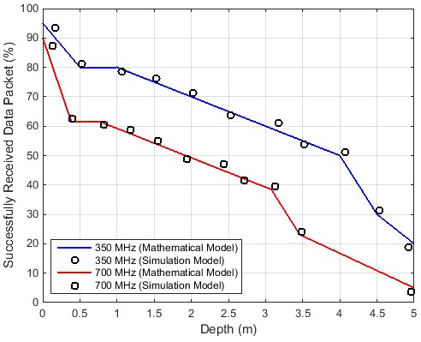

Fig. 5. Received data packets according to depth for different frequencies.

When depth is 1 meter, the successfully received data packet is about 80% for the frequency of 350 MHz and 60% for the frequency of 700 MHz.

It is clearly concluded that the more the depth is the lower the successfully received data packets. When depth is 5 meters, the successfully received data packet is about 20% for the frequency of 350 MHz and 5% for the frequency of 700 MHz. When path loss is above 110 dB which is also called a threshold, successful packet transmission is not possible. Similarly; when received signal power is under 1 *µ*J/s which is named as threshold, successful packet transmission is not possible.

# VI. CONCLUSION

Within the scope of this paper, a smart insect pest detection technique with qualified underground wireless sensor nodes for precision agriculture has been investigated with a mathematical simulation model. In a simulated smart technique, insect pest detection is assumed to be carried out with a qualified acoustic sensor. In order to evaluate the performance of the underground network structure, the received signal strength and path loss parameters are examined. As the depth distance increases, the increase in path loss of communication has been revealed. The obtained performance evaluation result reveals the need for signal transmission with different transmitter power for depth-based communication in wireless underground sensor networks.

In future studies, the studies on the energy consumption problem in the underground sensor networks may contribute to the current precision agriculture techniques.

# ACKNOWLEDGMENT

The author would like to thank his precious wife Sumeyye and his sweet daughter Asel for their valuable support.

# REFERENCES

1. J. Jao, B. Sun, and K. Wu, “A prototype wireless sensor network for precision agriculture,” in *Proc. IEEE 33rd Int. Conf. Distrib. Comput.*

*Syst. Workshops*, Philadelphia, PA, USA, Jul. 2013, pp. 280–285.

1. S. Li, J. Cui, and Z. Li, “Wireless sensor network for precise agriculture monitoring,” in *Proc. 4th Int. Conf. Intell. Comput. Technol. Automat.*, Shenzhen, China, Mar. 2011, pp. 307–310.
2. Z. Liao, S. Dai, and C. Shen, “Precision agriculture monitoring system based on wireless sensor networks,” in *Proc. IET Int. Conf. Wireless Commun. Appl. (ICWCA)*, Kuala Lumpur, Malaysia, 2012, pp. 1–5.
3. M. Mafuta, M. Zennaro, A. Bagula, G. Ault, H. Gombachika, and T. Chadza, “Successful deployment of a wireless sensor network for precision agriculture in Malawi,” in *Proc. IEEE 3rd Int. Conf. Netw. Embedded Syst. Every Appl. (NESEA)*, Liverpool, U.K. Dec. 2012, pp. 1–7.
4. A. Mondal, I. S. Misra, and S. Bose, “Building a low cost solution using wireless sensor network for agriculture application,” in *Proc. Int. Conf. Innov. Electron. Signal Process. Commun. (IESC)*, Shillong, India, Apr. 2017, pp. 61–65.
5. L. Nguyen and S. Kodagoda, “Soil organic matter estimation in precision agriculture using wireless sensor networks,” in *Proc. 14th Int. Conf. Control Automat. Robot. Vis. (ICARCV)*, Phuket, Thailand, Nov. 2016, pp. 1–6.
6. S. R. Nandurkar, V. R. Thool, and R. C. Thool, “Design and development of precision agriculture system using wireless sensor network,” in *Proc. 1st Int. Conf. Automat. Control Energy Syst. (ACES)*, Hooghy, India, Feb. 2014, pp. 1–6.
7. T. Ojha, S. Misra, and N. S. Raghuwanshi, “Wireless sensor networks for agriculture: The state-of-the-art in practice and future challenges,” *Comput. Electron. Agricult.*, vol. 118, pp. 66–84, Oct. 2015.
8. G. Panda and T. Saha, “Building of low cost reliable wireless sensor network for smart indoor agriculture products,” in *Proc. 2nd Int. Conf. Electron. Mater. Eng. Nano-Technol. (IEMENTech)*, Kolkata, India, May 2018, pp. 1–5.
9. P. Patil, H. Vidya, S. Patil, and U. Kulkarni, “Wireless sensor network for precision agriculture,” in *Proc. Int. Conf. Comput. Intell. Commun. Netw.*, Gwalior, India, Oct. 2011, pp. 763–766.
10. S. Pujari and N. Bogiri, “Precision agriculture for banana using wireless sensor network,” in *Proc. Int. Conf. Comput. Commun. Control Automat. (ICCUBEA)*, Pune, India, Aug. 2017, pp. 1–6.
11. M. C. Vuran, A. Salam, R. Wong, and S. Irmak, “Internet of underground things: Sensing and communications on the field for precision agriculture,” in *Proc. IEEE 4th World Forum Internet of Things (WF-IoT)*, Singapore, Feb. 2018, pp. 586–591.
12. J. Hu, L. Shen, Y. Yang, and R. Lv, “Design and implementation of wireless sensor and actor network for precision agriculture,” in *Proc. IEEE Int. Conf. Wireless Commun. Netw. Inf. Secur.*, Beijing, China, Jun. 2010, pp. 571–575.
13. L. Xiao and L. Guo, “The realization of precision agriculture monitoring system based on wireless sensor network,” in *Proc. Int. Conf. Comput. Commun. Technol. Agricult. Eng.*, Chengdu, China, Jun. 2010, pp. 89–92.
14. H. Sahota, R. Kumar, A. Kamal, and J. Huang, “An energy-efficient wireless sensor network for precision agriculture,” in *Proc. IEEE Symp. Comput. Commun.*, Riccione, Italy, Jun. 2010, pp. 347–350.
15. L. M. Kamarudin, R. B. Ahmad, B. L. Ong, A. Zakaria, and D. Ndzi, “Modeling and simulation of near-earth wireless sensor networks for agriculture based application using OMNeT++,” in *Proc. Int. Conf. Comput. Appl. Ind. Electron.*, Kuala Lumpur, Malaysia, Dec. 2010, pp. 131–136.
16. Y. Zhang, “Design of the node system of wireless sensor network and its application in digital agriculture,” in *Proc. Int. Conf. Comput. Distrib. Control Intell. Environ. Monit.*, Changsha, China, Feb. 2011, pp. 29–35.
17. A. Tagarakis, V. Liakos, L. Perlepes, S. Fountas, and T. Gemtos, “Wireless sensor network for precision agriculture,” in *Proc. 15th Panhellenic Conf. Inform.*, Kastonia, Greece, Sep./Oct. 2011, pp. 397–402.
18. J. Xia, Z. Tang, X. Shi, L. Fan, and H. Li, “An environment monitoring system for precise agriculture based on wireless sensor networks,” in *Proc. 7th Int. Conf. Mobile Ad-Hoc Sens. Netw.*, Beijing, China, Dec. 2011, pp. 28–35.
19. J. Ma, X. Zhou, S. Li, and Z. Li, “Connecting agriculture to the Internet of Things through sensor networks,” in *Proc. Int. Conf. Internet Things 4th Int. Conf. Cyber, Phys. Social Comput.*, Dalian, China, Oct. 2011, pp. 184–187.
20. I. Mampentzidou, E. Karapistoli, and A. A. Economides, “Basic guidelines for deploying wireless sensor networks in agriculture,” in *Proc. 4th Int. Congr. Ultra Mod. Telecommun. Control Syst.*, St. Petersburg, Russia, Oct. 2012, pp. 864–869.
21. Y. Shouyi, L. Leibo, Z. Renyan, S. Zhongfu, and W. Shaojun, “Design of wireless multi-media sensor network for precision agriculture,” *Commun., China*, vol. 10, no. 2, pp. 71–88, Feb. 2013.
22. M. R. M. Kassim, I. Mat, and A. N. Harun, “Wireless sensor network in precision agriculture application,” in *Proc. Int. Conf. Comput. Inf. Telecommun. Syst. (CITS)*, Jeju, South Korea, Jul. 2014, pp. 1–5.
23. W. Yitong, S. Yunbo, and Y. Xiaoyu, “Design of multi-parameter wireless sensor network monitoring system in precision agriculture,” in *Proc. 4th Int. Conf. Instrum. Meas. Comput. Commun. Control*, Harbin, China, Sep. 2014, pp. 721–725.
24. T. D. Le and D. H. Tan, “Design and deploy a wireless sensor network for precision agriculture,” in *Proc. 2nd Nat. Found. Sci. Technol. Develop. Conf. Inf. Comput. Sci. (NICS)*, Ho Chi Minh City, Vietnam, Sep. 2015, pp. 294–299.
25. S. A. Imam, A. Choudhary, and V. K. Sachan, “Design issues for wireless sensor networks and smart humidity sensors for precision agriculture: A review,” in *Proc. Int. Conf. Soft Comput. Techn. Implementations (ICSCTI)*, Faridabad, India, Oct. 2015, pp. 181–187.
26. G. Deepika and P. Rajapirian, “Wireless sensor network in precision agriculture: A survey,” in *Proc. Int. Conf. Emerg. Trends Eng. Technol. Sci. (ICETETS)*, Pudukkottai, TN, India, Feb. 2016, pp. 1–4.
27. G. Sahitya, N. Balaji, and C. D. Naidu, “Wireless sensor network for smart agriculture,” in *Proc. 2nd Int. Conf. Appl. Theor. Comput. Commun. Technol. (iCATccT)*, Bangalore, India, Jul. 2016, pp. 488–493.
28. Y. E. M. Hamouda and B. H. Y. Elhabil, “Precision agriculture for greenhouses using a wireless sensor network,” in *Proc. Palestinian Int. Conf. Inf. Commun. Technol. (PICICT)*, May 2017, pp. 78–83.
29. G. H. Raghunandan, S. Y. Namratha, S. Y. Nanditha, and G. Swathi, “Comparative analysis of different precision agriculture techniques using wireless sensor networks,” in *Proc. 4th Int. Conf. Electron. Commun. Syst. (ICECS)*, Coimbatore, India, Feb. 2017, pp. 129–133.
30. P. Durga, G. Narayanan, B. Gayathri, M. V. Ramesh, and P. Divya, “Modelling a smart agriculture system for multiple cropping using wireless sensor networks,” in *Proc. IEEE Global Humanitarian Technol. Conf. (GHTC)*, San Jose, CA, USA, Oct. 2017, pp. 1–7.
31. S. Gajjar, D. Kothari, M. Upadhyay, and V. Dhingra, “FARMNET: Agriculture support system using wireless sensor and actuator network,” in *Proc. Int. Conf. Wireless Commun. Signal Process. Netw. (WiSPNET)*, Chennai, India, Mar. 2017, pp. 291–296.
32. S. S. Ponde and S. S. Lomte, “Adaptive sleep scheduling for cluster based wireless sensor networks for precision agriculture,” in *Proc. Int. Conf. Adv. Commun. Comput. Technol. (ICACCT)*, Sangamner, India, Feb. 2018, pp. 353–356.
33. O. Mahdavipour *et al.*, “Opto-dielectrometric sensor for measuring total incombustible content in underground coal mines,” *IEEE Sensors J.*, vol. 17, no. 19, pp. 6443–6450, Oct. 2017.
34. Z. Chen and J. Wang, “Underground odor source localization based on a variation of lower organism search behavior,” *IEEE Sensors J.*, vol. 17, no. 18, pp. 5963–5970, Sep. 2017.
35. K. Zhu, W. Han, W. K. Lee, and P. W. T. Pong, “On-site noninvasive current monitoring of multi-core underground power cables with a magnetic-field sensing platform at a substation,” *IEEE Sensors J.*, vol. 17, no. 6, pp. 1837–1848, Mar. 2017.
36. Riverbed Modeler, San Francisco, CA, USA. *Simulation Software*. Accessed: Apr. 30, 2019. [Online]. Available: https://www. riverbed.com/gb/

**MuhammedEnes Bayrakdar** received the B.S. and M.S. degrees in electronics and computer education from Kocaeli University in 2010 and 2013, respectively, and the Ph.D. degree in electrical-electronics and computer engineering from Düzce University in 2017.

From 2010 to 2017, he was a Research Assistant with Kocaeli University and Düzce University. He has been Assistant Professor with Düzce University since 2017. His research interests include cognitive radio, sensor networks, and medium-access control protocols.

Prof. Bayrakdar received the Publons 2018 Peer Reviewer Award in the category of top 1% reviewer in computer science. He is also an Associate Editor of the *IET Communications*.