**4 VM connection issues**

# 4.1 USRP in VirtualBox

**Tested on:**

* Windows 10 machine with VirtualBox 6.1
* Linux Ubuntu 20.04.1 LTS image
* Ettus USRP B200/B210 SDR

**Note that you need to have the USRP connected to a USB 3.0 port preferably.**

Execute the following steps:

* Install VirtualBox: [6]
* Install a Linux VM: [7]
* Install the VirtualBox Extension Pack
* Install GRC as stated in section 1

When connecting the USRP to the Windows machine it will not be recognized. However when going into Device Manager, you see a device called Cypress Westbridge (i.e. the USB host controller chip of the USRP).

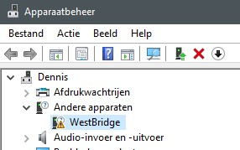

Also when you connect this device in VirtualBox, the same name shows. Note that you will not get this device working frome here in your VM.

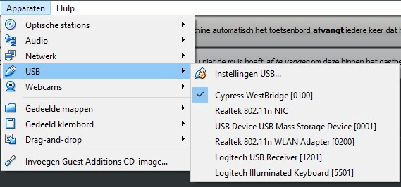

To get it working in VirtualBox, you need to install the USRP driver on Windows (in this case the host machine). Go to the following source to download the Windows driver:

[http://files.ettus.com/binaries/misc/erllc](http://files.ettus.com/binaries/misc/erllc_uhd_winusb_driver.zip) [uhd](http://files.ettus.com/binaries/misc/erllc_uhd_winusb_driver.zip) [winusb](http://files.ettus.com/binaries/misc/erllc_uhd_winusb_driver.zip) [driver.zip](http://files.ettus.com/binaries/misc/erllc_uhd_winusb_driver.zip)

General page: [https://files.ettus.com/manual/page](https://files.ettus.com/manual/page_install.html) [install.html](https://files.ettus.com/manual/page_install.html)

Go to **Device Manager** (q+X) in Windows and manually select the driver that you have downloaded.

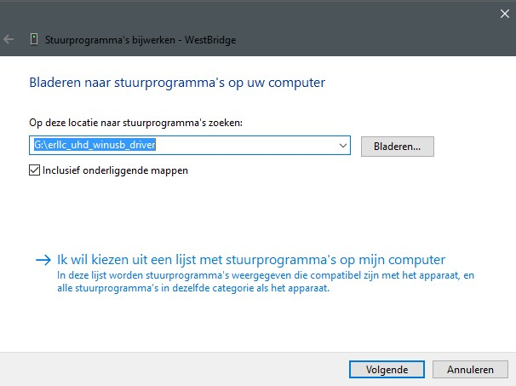

Windows might tell you that there is a problem. This is not the case. Just unplug and replug the USRP and/or reboot your PC. Afterwards it will show up in **Device Manager**.

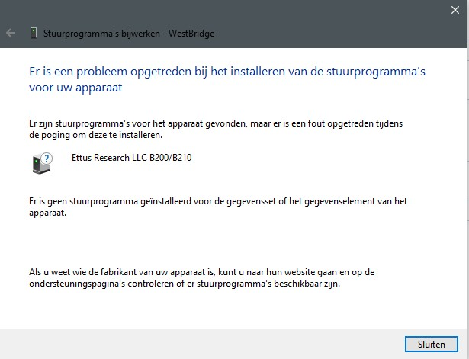

When opening the **Device Manager**, the USRP should be visible now.

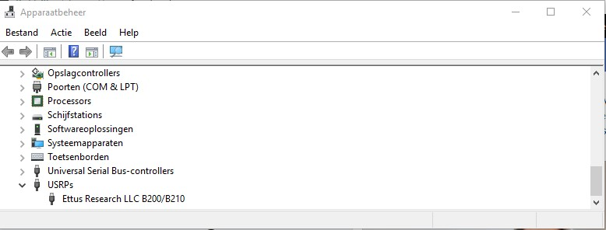

Open VirtualBox. Add the device by creating a filter and make sure to select the USB 3.0 Controller. It could be that the Ettus Research LLC USRP B200 option is not available, shutdown and reboot the VM to fix this.

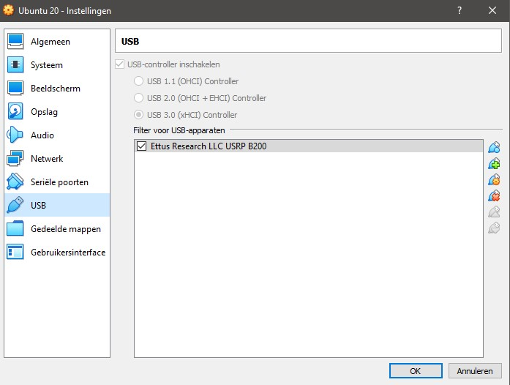

When the VM is booted go to **Devices** and select **USB**. The Cypress Westbridge name should be changed.

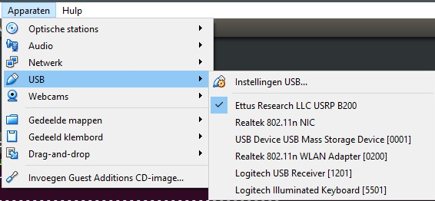

Open a terminal in the VM and execute the following command. This should properly state the device.

Create a GRC flowgraph with a USRP source and a GUI sink. Change the **Device Address** to the corresponding address of the USRP:

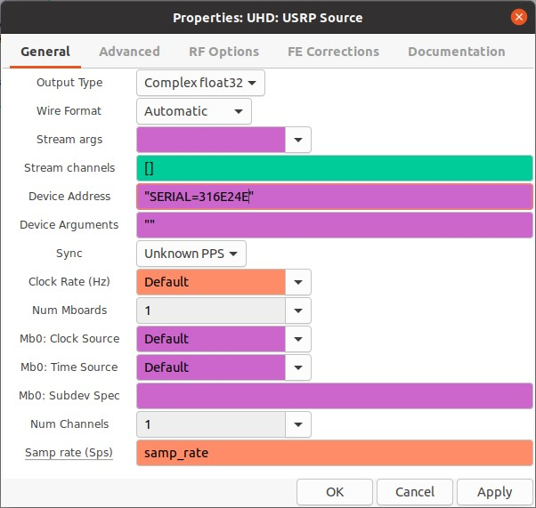

Now you can run the flowgraph:

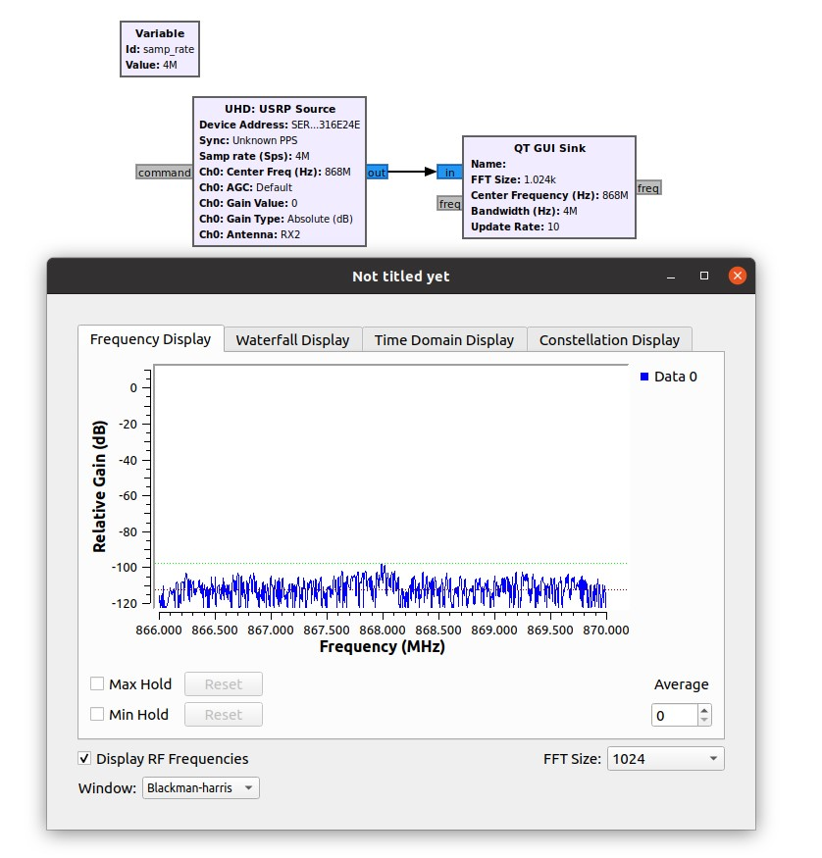

**References**

1. Gnuradio. *GNU Radio - The Free & Open Source Radio Ecosystem* · *GNU Radio*. url: [https://www.gnuradio.org.](https://www.gnuradio.org/)
2. Gnuradio. *gnuradio*. url: [https://github.com/gnuradio/gnuradio/releases.](https://github.com/gnuradio/gnuradio/releases)
3. Gnuradio. *install from source*. url: [https://wiki.gnuradio.org/index.](https://wiki.gnuradio.org/index.php?title=InstallingGR)

[php?title=InstallingGR.](https://wiki.gnuradio.org/index.php?title=InstallingGR)

1. Gnuradio. *install with pybombs*. url: [https://github.com/gnuradio/pybombs/ blob/master/README.md.](https://github.com/gnuradio/pybombs/blob/master/README.md)
2. Gnuradio. *gnuradio*. url: [https://github.com/gnuradio/gnuradio.](https://github.com/gnuradio/gnuradio)
3. *Download Oracle VM VirtualBox* | *Oracle*. url: [https://www.virtualbox. org.](https://www.virtualbox.org/)
4. *Download Ubuntu Desktop* | *Ubuntu*.
5. *Download VMware Workstation Player* | *VMware*. url: [https://www.vmware. com/products/workstation-player/workstation-player-evaluation. html.](https://www.vmware.com/products/workstation-player/workstation-player-evaluation.html)