**Installation guide:**

**GNU Radio Companion & USRP Hardware Driver**

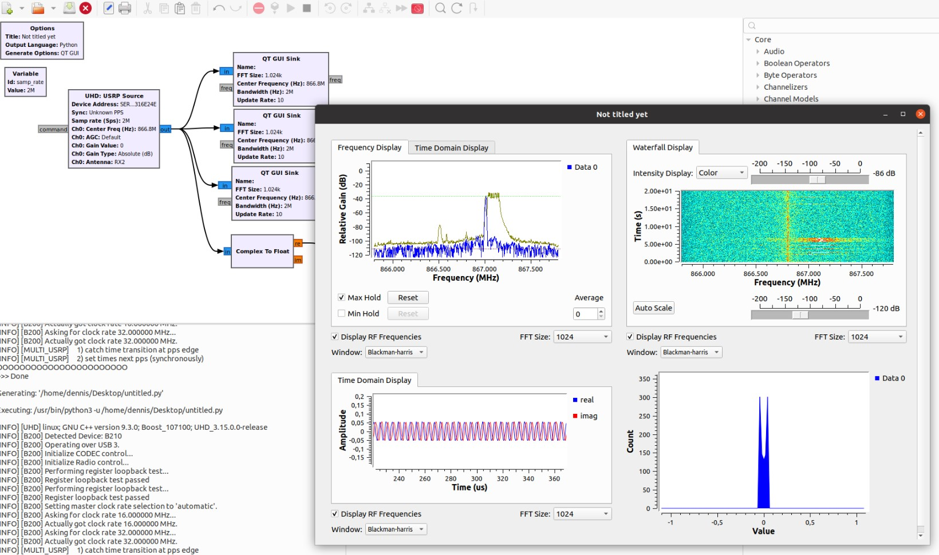

**II-Communication Systems - Laboratory sessions**

**Author:**

**Dennis Joosens dennis.joosens@uantwerpen.be**

**Academic year: 2021-2022**

**Contents**

**1 Installing GNU Radio Companion** **3**

1.1 Getting started 3

**2 Installation of the USRP Hardware Driver** **4**

2.1 Installing the driver 4

2.2 UHD version check 4

2.3 FPGA images 5

**3 Hello SDR, are you there?** **6**

3.1 Check the SDR 6

3.2 Notes 7

3.3 Troubleshooting 8

**4 VM connection issues** **9**

4.1 USRP in VirtualBox 9

4.2 USRP in VMware 14

1

**Preface**

This guide will help you with installing the software that is needed for the lab sessions which are part of the master course [II-Communication-systems.](https://www.uantwerpen.be/en/study/programmes/all-programmes/master-electronics-and-ict-technology/about-the-programme/study-programme/) This document involves installing GNU Radio Companion and the USRP Hardware Driver as well as some troubleshooting will be touched upon.

Do not hesitate to reach out via mail when you get stuck or run into other problems which are not described in this document.

# Installing GNU Radio Companion

**Prerequisites:**

• Native Linux machine or Linux VM (**preferably latest Ubuntu/Debian LTS version**)

## Getting started

There are a few ways to install GNU Radio Companion. We highly advise to use a native Linux machine preferably Ubuntu. When using Ubuntu, open up a terminal and type:

user@PC

:

∼

$

sudo apt update

user@PC

:

∼

$

sudo apt install gnuradio

This installs the latest stable version of GNU Radio. Version **3.9** or **3.10** is ok to use.

The latest release can be checked at [1] or at [2].

This default installation should suffice for the lab sessions.

If for some reason your installation did not work, other ways to install the software are:

* Install an older version
* Install from source [3]
* Install with PyBOMBS[4]

For more information on how to do this go to GitHub repo of GNU Radio [5].

To run GRC, open up a terminal:

user@PC

:

∼

$

gnuradio-companion

# Installation of the USRP Hardware Driver

The Universal Software Radio Peripheral [(USRP B200/B210)](https://www.ettus.com/product-categories/usrp-bus-series/) is a medium/high end Software Defined Radio developed by Ettus Research which is a National Instruments company that focuses on the development of highly versatile SDR’s. [(more info).](https://www.ettus.com/products/) We will be using the [USRP B200/B210](https://www.ettus.com/wp-content/uploads/2019/01/b200-b210_spec_sheet.pdf) for the lab sessions.

The USRP needs the UHD (USRP Hardware Driver) to properly work with GRC.

## Installing the driver

Make sure to **close GRC**. Open up a terminal on the Linux machine and execute the following commands:

user@PC

:

∼

$

sudo add-apt-repository ppa:ettusresearch/uhd

user@PC

:

∼

$

sudo apt-get update

user@PC

:

∼

$

sudo apt-get install libuhd-dev

user@PC

:

∼

$

sudo apt-get install libuhd3.15.0 uhd-host

Connect a USRP to your PC and run the **uhd find devices** command in a terminal.

## UHD version check

To check if the driver is installed correctly:

user@PC

:

∼

$

apt search "libuhd"

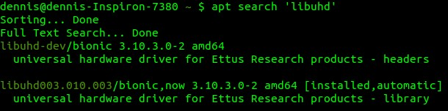

Figure 1: Checking the current UHD version

## FPGA images

If the UHD (source/sink) block in GNU Radio can not find the FPGA images, make sure to check if the directory **/usr/share/uhd/images/** exists and if it is empty or not. Check that the binaries **usrp b200 fpga.bin** and **usrp b210 fpga.bin** are present in this folder. One of these files is uploaded to the FPGA on the USRP when running a GRC flowgraph containing a USRP source and/or sink.

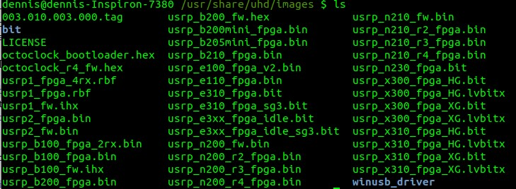

Figure 2: Directory of the FPGA images

If this directory does not exist or is empty, execute:

user@PC

:

∼

$

sudo uhd_images_downloader

or another way:

user@PC

:

∼

$

cd /usr/lib/uhd/utils/

user@PC

:

∼

$

cd python3 uhd_images_downloader.py

Make sure that the FPGA images are in the **/usr/share/uhd/images** directory.

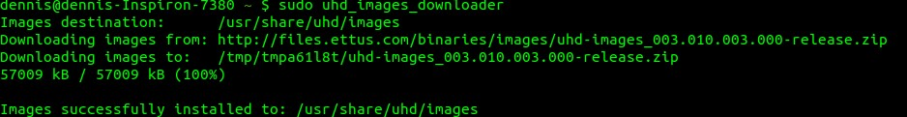

Figure 3: Downloading the FPGA images

# Hello SDR, are you there?

## Check the SDR

To get any SDR working in GRC we need to make sure we can ”talk” to the device. Most SDR’s are equipped with a software tool to check if the communication with the hardware is working. For the USRP device this can be checked in a terminal:

user@PC

:

∼

$

uhd_find_devices

or

user@PC

:

∼

$

uhd_usrp_probe

**uhd usrp probe** provides more information regarding the connected USRP and RF front end. This includes more information about gain, bandwidth, channels, firmware version, unit names, revision numbers,...

GRC needs the serial number of the USRP device to identify which devices it is using. Open a terminal and type:

user@PC

:

∼

$

uhd_find_devices | grep serial:

## Notes

**Note that you need to connect the USRP to a USB 3.0/3.1 port preferably.** A USB 2.0 port should also work but will be much slower when uploading the image to the FPGA and samples will get lost when capturing data.

**When one device is connected to your PC you do not have to worry about the serial number.** The only available device is initialized by default. However, it is good practice to always fill it in. When attaching a second device this serial number becomes really important.



Figure 4: USRP device not found

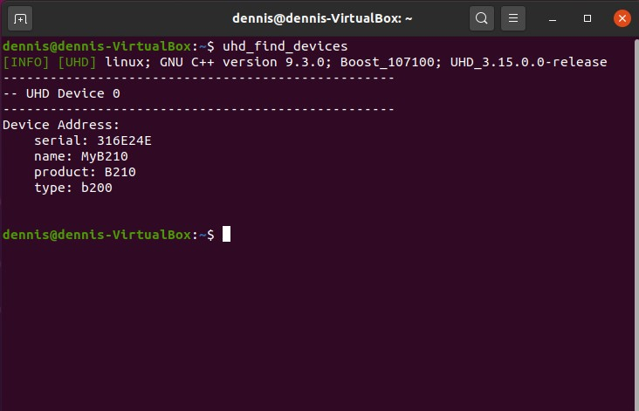

Figure 5: USRP device found

It could be that you have to replug the device to get it visible on your computer. The first attempt sometimes fails.

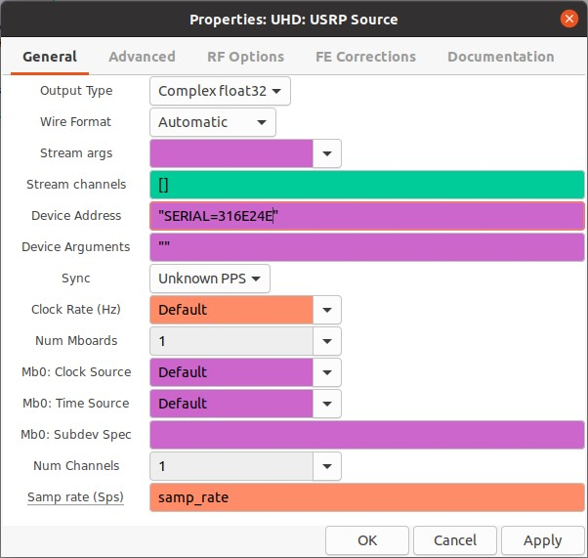

Figure 6: USRP source block in GNU Radio

## Troubleshooting

If for any reason the installation of the UHD driver fails, you can always install the driver manually. Browse to [(UHD images)](https://files.ettus.com/binaries/images/uhd-images_003.010.003.000-release.zip) and extract the downloaded zip file.

user@PC

:

∼

$

cd uhd-images_003.010.003.000-release/share/uhd/

user@PC

:

∼

$

cd cp -r images/ /usr/share/uhd

Open up GRC. Connecting to the USRP should work fine now.

# VM connection issues

## USRP in VirtualBox

**Tested on:**

* Windows 10 machine with VirtualBox 6.1
* Linux Ubuntu 20.04.1 LTS image
* Ettus USRP B200/B210 SDR

**Note that you need to have the USRP connected to a USB 3.0 port preferably.**

Execute the following steps:

* Install VirtualBox: [6]
* Install a Linux VM: [7]
* Install the VirtualBox Extension Pack
* Install GRC as stated in section 1

When connecting the USRP to the Windows machine it will not be recognized. However when going into Device Manager, you see a device called Cypress Westbridge (i.e. the USB host controller chip of the USRP).

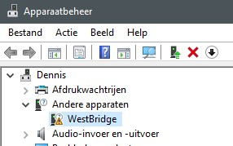

Also when you connect this device in VirtualBox, the same name shows. Note that you will not get this device working frome here in your VM.

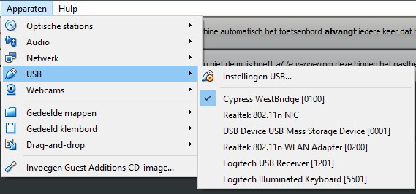

To get it working in VirtualBox, you need to install the USRP driver on Windows (in this case the host machine). Go to the following source to download the Windows driver:

[http://files.ettus.com/binaries/misc/erllc](http://files.ettus.com/binaries/misc/erllc_uhd_winusb_driver.zip) [uhd](http://files.ettus.com/binaries/misc/erllc_uhd_winusb_driver.zip) [winusb](http://files.ettus.com/binaries/misc/erllc_uhd_winusb_driver.zip) [driver.zip](http://files.ettus.com/binaries/misc/erllc_uhd_winusb_driver.zip)

General page: [https://files.ettus.com/manual/page](https://files.ettus.com/manual/page_install.html) [install.html](https://files.ettus.com/manual/page_install.html)

Go to **Device Manager** (q+X) in Windows and manually select the driver that you have downloaded.

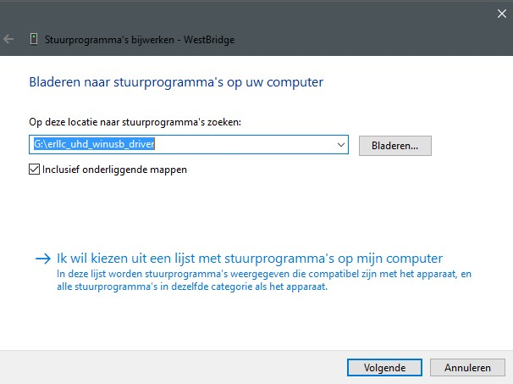

Windows might tell you that there is a problem. This is not the case. Just unplug and replug the USRP and/or reboot your PC. Afterwards it will show up in **Device Manager**.

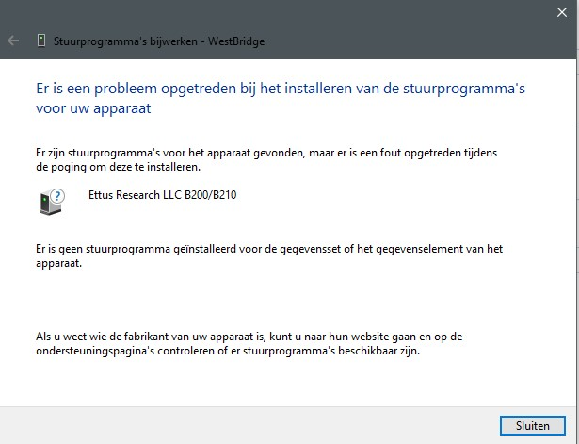

When opening the **Device Manager**, the USRP should be visible now.

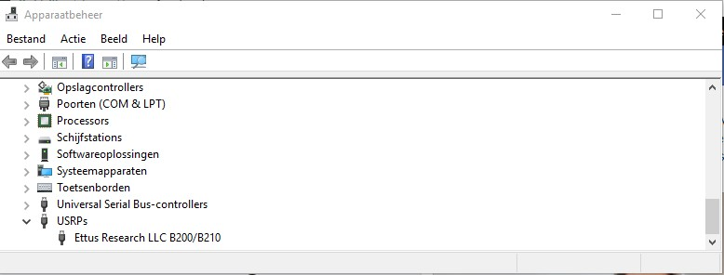

Open VirtualBox. Add the device by creating a filter and make sure to select the USB 3.0 Controller. It could be that the Ettus Research LLC USRP B200 option is not available, shutdown and reboot the VM to fix this.

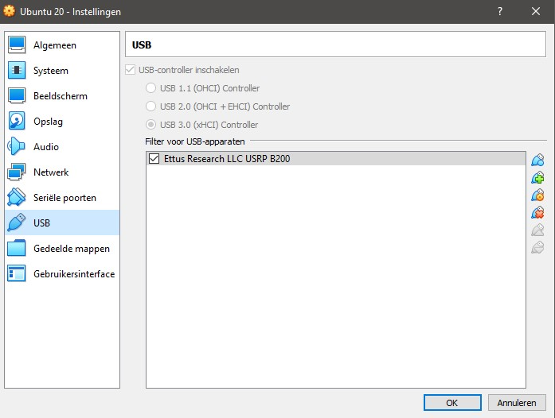

When the VM is booted go to **Devices** and select **USB**. The Cypress Westbridge name should be changed.

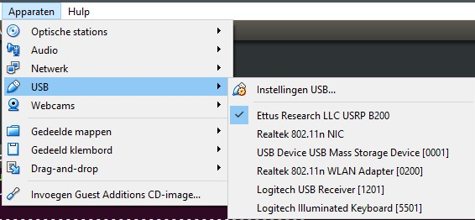

Open a terminal in the VM and execute the following command. This should properly state the device.



Create a GRC flowgraph with a USRP source and a GUI sink. Change the **Device Address** to the corresponding address of the USRP:



Now you can run the flowgraph:

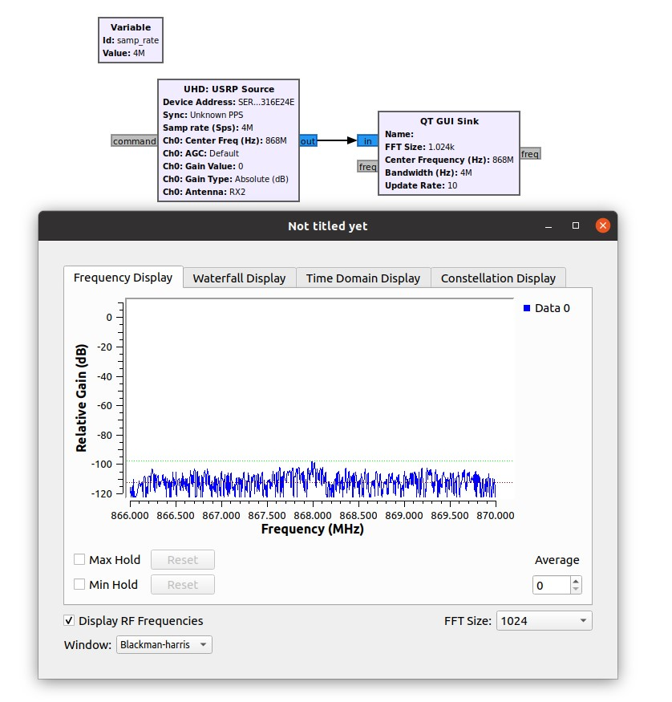

## USRP in VMware

**Tested on:**

* Windows 10 machine with VMWare Player or Workstation [8]
* Linux Ubuntu LTS version
* Ettus Research USRP B200/B210 SDR

Install Ubuntu in VMware.

Install GNU Radio Companion.

The same issues seem to appear in VMware (Workstation Pro/Player). This is resolved the same way as in section 4.1. The approach could deviate slightly due to the fact that VMWare works a bit different than VirtualBox.

**References**

1. Gnuradio. *GNU Radio - The Free & Open Source Radio Ecosystem* · *GNU Radio*. url: [https://www.gnuradio.org.](https://www.gnuradio.org/)
2. Gnuradio. *gnuradio*. url: [https://github.com/gnuradio/gnuradio/releases.](https://github.com/gnuradio/gnuradio/releases)
3. Gnuradio. *install from source*. url: [https://wiki.gnuradio.org/index.](https://wiki.gnuradio.org/index.php?title=InstallingGR)

[php?title=InstallingGR.](https://wiki.gnuradio.org/index.php?title=InstallingGR)

1. Gnuradio. *install with pybombs*. url: [https://github.com/gnuradio/pybombs/ blob/master/README.md.](https://github.com/gnuradio/pybombs/blob/master/README.md)
2. Gnuradio. *gnuradio*. url: [https://github.com/gnuradio/gnuradio.](https://github.com/gnuradio/gnuradio)
3. *Download Oracle VM VirtualBox* | *Oracle*. url: [https://www.virtualbox. org.](https://www.virtualbox.org/)
4. *Download Ubuntu Desktop* | *Ubuntu*.
5. *Download VMware Workstation Player* | *VMware*. url: [https://www.vmware. com/products/workstation-player/workstation-player-evaluation. html.](https://www.vmware.com/products/workstation-player/workstation-player-evaluation.html)