MoMoTag
A Privacy-Preserving Alias System for Mobile Money Transactions
Stopping the silent harvesting of real names through fake mobile money transfers
A Conceptual Proposal
Version 1.0

Mark Drah
Backend Engineer & Innovator | Cybersecurity Educator
Author & Proposer
Email: neutral520@gmail.com | LinkedIn: linkedin.com/in/markdrah
August 1, 2026

Executive Summary
Most mobile money (MoMo) systems display a recipient's full registered legal name whenever a transfer is initiated to their phone number — including transfers that are never completed. This proposal identifies that behaviour as an overlooked privacy vulnerability: it allows anyone with a phone number to retrieve a stranger's real, government-verified name at zero cost, with no rate limit, and without leaving a usable trace of intent.
MoMoTag proposes replacing the full name shown during transaction confirmation with a persistent, user-linked alias. The recipient's legal identity remains fully intact for KYC, compliance, and law-enforcement purposes — only what is displayed to an unrelated sender changes. The result is a system that closes a passive data-harvesting channel without weakening regulatory or anti-fraud infrastructure.
In short
The problem: full names leak through fake or cancelled transfer attempts.
The fix: show a persistent alias instead of the legal name at the display layer only.
What stays the same: KYC records, compliance access, and law-enforcement access are untouched.

The Problem
Digital fraud is expanding as fast as digital finance itself, and attackers continually look for the smallest, least-monitored openings. One such opening in mobile money systems has gone almost unnoticed: the transaction-confirmation screen quietly discloses a recipient's full legal name to anyone who simply types in their phone number — whether or not a transfer is ever completed.

A Walkthrough Example
Consider how easily this can be exploited, using a fictional pair of users:
- Step 1 — Probe: A stranger, knowing only your phone number, opens a mobile money app and starts a transfer to you. No money needs to be sent.
- Step 2 — Disclose: Before confirming, the app displays your full registered name for the sender to verify — this is standard “confirm recipient” behaviour in most MoMo systems.
- Step 3 — Capture: The stranger notes or screenshots your name, then cancels the transfer. Nothing was sent, nothing was logged as suspicious, and you were never notified.
- Step 4 — Exploit: Your real name — now confirmed and tied to your phone number — can be used to impersonate you, fabricate claims or debts in your name, run targeted scams on people who know you, or be combined with a single photo to build a convincing false identity.
Why this matters
The harvesting step costs the attacker nothing, requires no special access, and leaves no record of malicious intent — a cancelled transaction looks identical to a genuine mistake.
It can be automated: sequential phone numbers can be probed to build a database of real names at scale.
Awareness is extremely low; this proposal estimates roughly 1 in 100 users has ever considered this as an attack surface.

The Proposed Solution: MoMoTag
MoMoTag introduces a persistent, non-identifying alias that stands in for a user's full legal name at the transaction-confirmation layer. Instead of seeing “Mark Drah,” a sender initiating a transfer would see an alias such as “MD-4471.” The legal name is never removed from the system — it remains fully intact in KYC records — it is simply no longer the thing displayed to an unrelated sender.
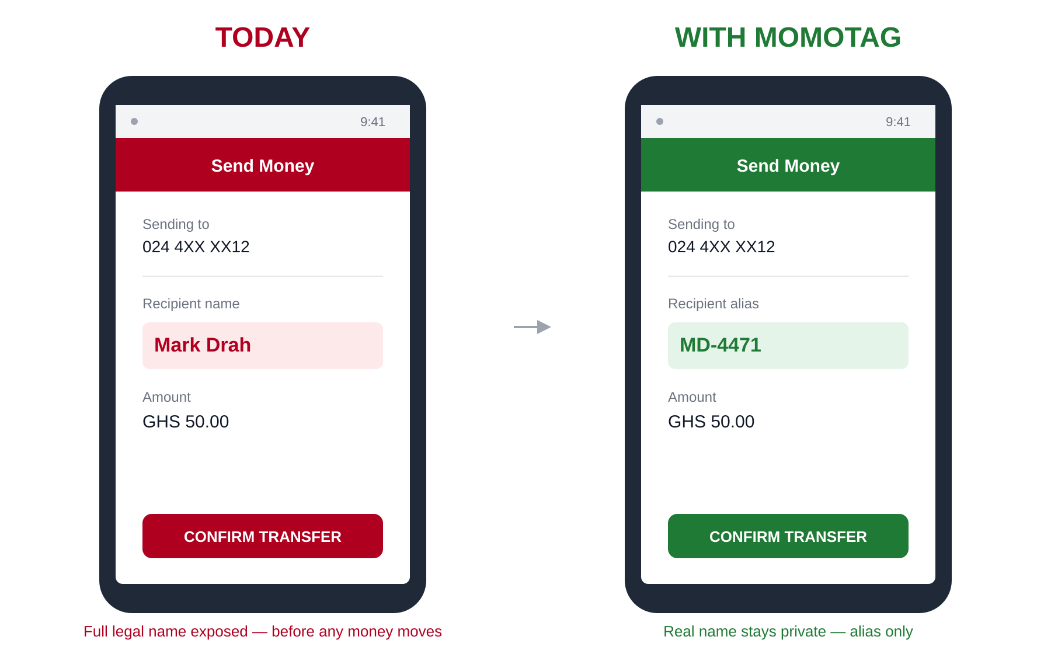
Figure 1 — Today's confirmation screen vs. the proposed MoMoTag confirmation screen.
Today | With MoMoTag
“Confirm transfer of GHS 50 to Mark Drah?” | “Confirm transfer of GHS 50 to MD-4471?”

Two Tiers of Alias Assignment
To balance privacy with usability, MoMoTag proposes two tiers:
- Tier 1 — Default (automatic): Every user is assigned a system-generated alias at registration, requiring no action. This guarantees baseline privacy for every user, not just the privacy-conscious.
- Tier 2 — Optional (customizable): Users may personalize the readable portion of their alias (e.g. “MARKD”) for recognisability — particularly useful for merchants and small businesses. The telecom-assigned numeric suffix remains mandatory to guarantee uniqueness and prevent guessable aliases.
To prevent abuse, customized aliases (Tier 2) are subject to a change-frequency limit — for example, no more than one change every 30 days — preventing rapid alias-cycling as a way to evade being identified after a dispute or scam.

How It Works
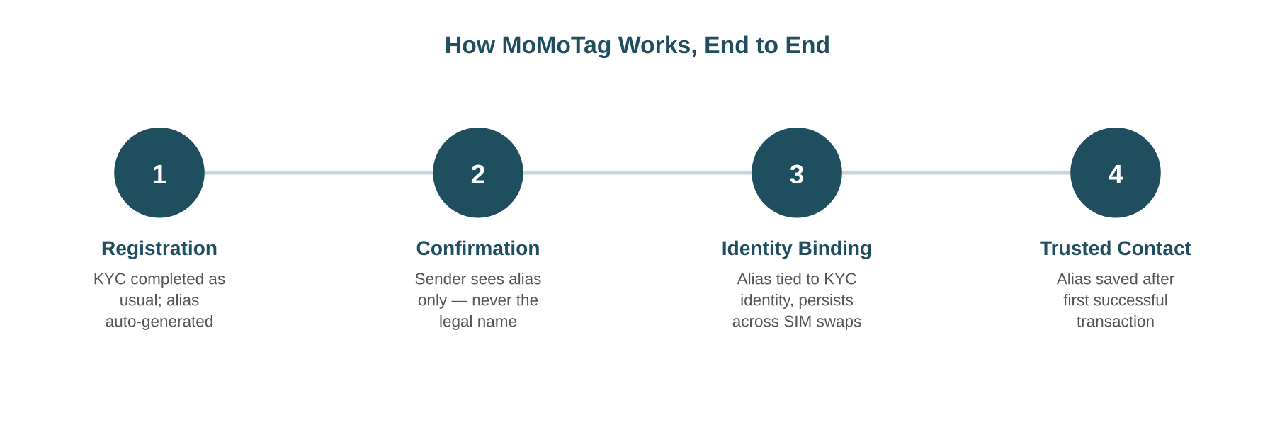
Figure 2 — The MoMoTag lifecycle, from registration through trusted-contact verification.

1. Registration
- User completes standard SIM/KYC registration with full legal documentation — this step is unchanged.
- The system automatically generates a unique alias, bound to the user's verified KYC identity rather than to the phone number itself.
- The user may optionally personalise the readable portion of the alias (Tier 2), subject to uniqueness rules and a change-frequency limit.

2. Transaction Confirmation
- A sender enters the recipient's phone number to initiate a transfer, exactly as today.
- The confirmation screen displays the recipient's alias (e.g. “MD-4471”) instead of their full legal name.
- The sender confirms the transfer based on the alias — the legal name is never exposed to a sender who is not already an authorised party.

3. Identity Binding
- The alias is tied to the user's verified identity, not to their current SIM — it persists across SIM swaps and number changes.
- If a user's phone number changes, their existing alias continues to route correctly, and previously saved contacts are not broken.

4. Trusted-Contact Verification
MoMoTag deliberately does not attempt to solve first-contact identity verification — a broader problem that isn't fully solved by today's full-name display either. Instead, it targets passive, automated, no-consent name harvesting specifically.
- On a successful transaction, the recipient's alias is saved to the sender's contact list, alongside any private label the sender chooses to give them.
- Repeat transactions with saved contacts are inherently verified by transaction history, not by the alias alone.
- First-time transfers remain the sender's judgment call — consistent with today's baseline, since names can also be manipulated or misrepresented under current systems.

What Doesn't Change
MoMoTag is a display-layer change, not a data-layer change. It does not weaken any existing regulatory, compliance, or investigative capability:
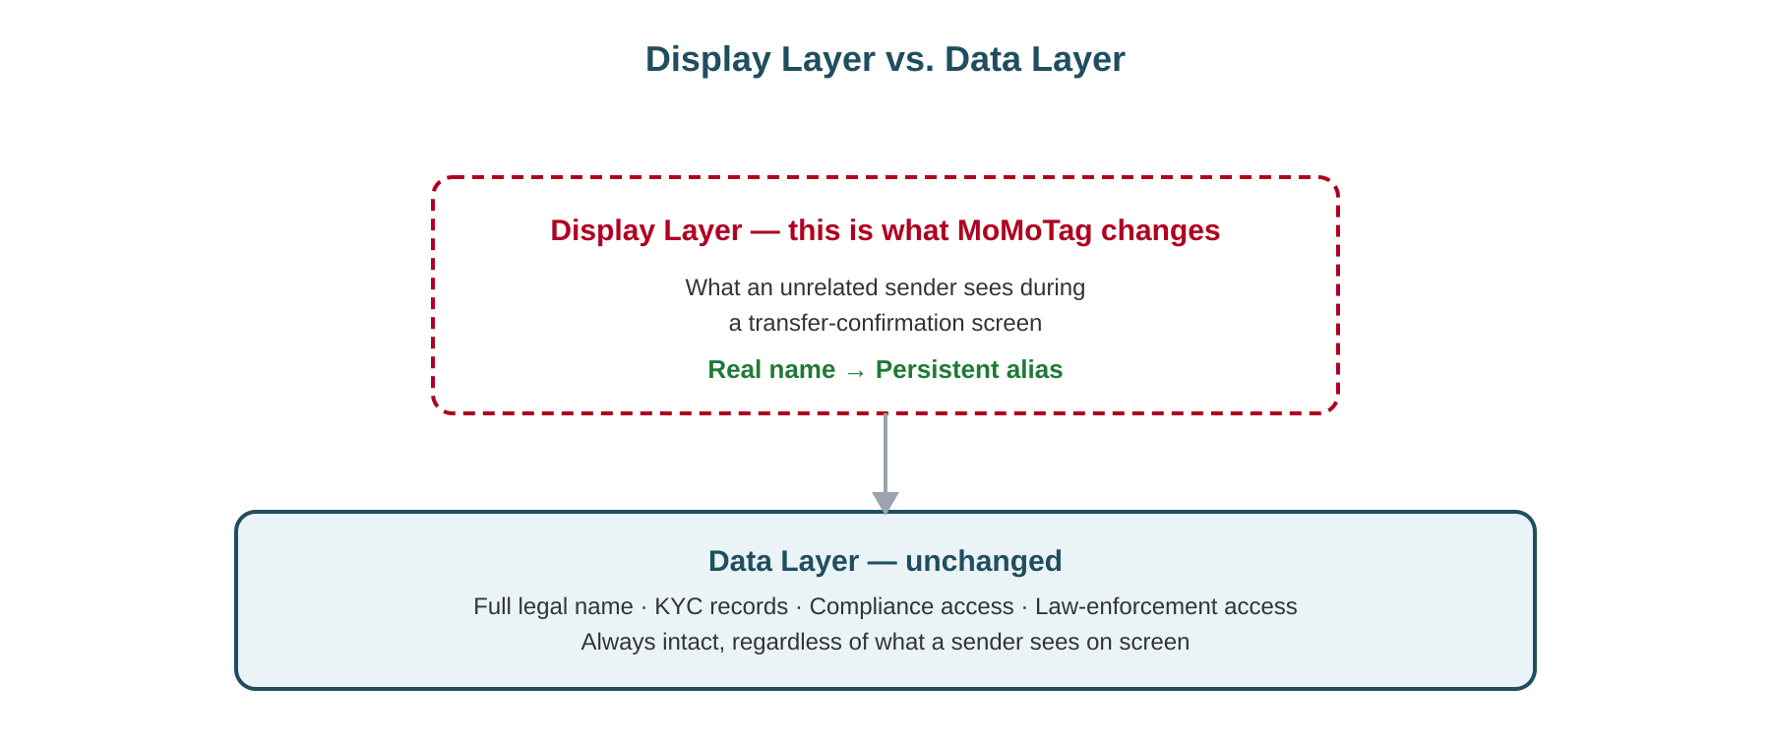
Figure 3 — MoMoTag operates entirely at the display layer; the data layer underneath is untouched.
- Full legal names remain stored and tied to verified KYC records, exactly as required by telecom and financial regulation today.
- Account holders can always view their own real name and alias pairing.
- Telecom compliance and fraud-detection systems retain full access to real identity data.
- Law enforcement retains access to real identity data through proper legal process.
Key distinction
MoMoTag changes what an anonymous sender sees on a confirmation screen.
It does not change what is stored, what regulators can access, or what law enforcement can investigate.

Scope and Honest Limitations
This proposal is deliberately scoped to solve one specific problem well, rather than overreaching into a broader claim it cannot support.
What MoMoTag solves
Passive, automated, no-consent harvesting of real names via fake or cancelled transfer attempts.
What MoMoTag does not claim to solve
First-contact identity verification — confirming with certainty that an alias belongs to the specific person a sender intends to pay before any transaction history exists.
This limitation already exists in current full-name systems, since registered names can also be inaccurate, changed, or misrepresented.

Advantages
- Privacy by default: every user gains protection automatically, without needing to opt in or understand the underlying risk.
- Reduced automated harvesting: removes the ability to cheaply script large-scale collection of real names tied to phone numbers.
- Regulatory compatibility: requires no change to KYC, AML, or law-enforcement access — an easier path to real-world adoption.
- Persistent, portable identity: alias binding to KYC identity (not SIM) means privacy protection survives SIM swaps and number changes.
- Branding opportunity for merchants: Tier 2 customization lets businesses use a recognisable, trustworthy alias instead of a random code.

Proposal at a Glance
Element | Description
Problem | Full legal names are disclosed to anyone who initiates (even a cancelled) mobile money transfer.
Solution | Replace the displayed name with a persistent alias (“MoMoTag”) at the confirmation screen.
Default behaviour | System-generated alias, automatic, no user action required (Tier 1).
Optional behaviour | User-customized alias with enforced unique suffix and change-frequency limit (Tier 2).
Identity binding | Alias tied to verified KYC identity, persists across SIM swaps.
Verification model | Trusted-contact based; targets passive harvesting, not first-contact verification.
Unchanged | KYC records, telecom compliance access, and law-enforcement access.

Closing Note
MoMoTag is an early-stage conceptual proposal, shared to invite scrutiny, refinement, and discussion. Feedback from telecom operators, security researchers, regulators, and everyday mobile money users is welcome — the goal is a safer default for millions of people who have never had reason to think about this risk until now.

Mark Drah
Backend Engineer & Innovator | Cybersecurity Educator
Author & Proposer — August 1, 2026
Email: neutral520@gmail.com | LinkedIn: linkedin.com/in/markdrah

