**Game School Simulator 2015**

**Neko Means Cat**

Game Design Document

GAM150S14-D

Spring 2014

Adam Rezich - Technical Director

Tai Der Hui - Producer

Eduardo Gorinstein - Lead Designer

Samuel Valdez - Production Manager

**High Concept**

Game School Simulator 2015 is a 2D simulation game where the player manages the construction and day-to-day affairs of a Game School.

**Summary**

In Game School Simulator 2015, the player starts off a large sum of money loaned from the bank. The player must use this money to begin construction of a game school on the land granted to them. The building starts off small, with a main lobby and one empty classroom. The player can then expand the building or upgrade the classroom into other more useful rooms (such as a computer lab or lecture hall). The player can earn money to upgrade or expand through various methods. At the start of each new semester, the player will be able to adjust different variables (such as tuition fees, or acceptance rate) to determine how many new students will come in next semester. By attracting more students, the player will receive more money from tuition, and can thus improve the school further. The school will also have a reputation, which will affect acceptance rate. As a stretch goal, the player will also be able to purchase new courses that have various bonuses that affect the students’ abilities. The goal of the game is to create a successful game school and pay off the loan from the bank. There will also be various achievements for the player to unlock that go past just paying off the loan.

**Story**

The player’s character is an experienced game developer who has decided to leave the video game industry and create an institution to train future game developers. To do this, the player has taken up a loan. The player then has to use the money from the loan to construct and run a game school, using the revenue generated from the institution to pay off the loan within ten years.

**Game Flow**

The game begins with an empty lot. As the game progresses, the player will gradually have a larger school to manage. The player will spend most of his time managing the school’s budget, by changing variables such as tuition, number of students, teachers’ salaries, and other expenses.

As a stretch goal, the player will occasionally be presented with random events throughout the course of the game. These random events are meant to keep the game fresh and throw the player curveballs.

The time in game will be measured in months, where six months equals a semester and each month takes 10 seconds in real time. This means that each semester takes one minute to pass, giving the player time to decide on what to set the tuition and minimum GPA to. Once a semester starts the player will have little options to influence the current semester. Instead, the player will mainly be concentrated on preparing the school for the upcoming semester. The construction of buildings will take time, so the player must plan accordingly if they wish to use that room in the upcoming semester.

Main Menu

Starting Lot

Construction ←----|

Management |

New Semester -----|

**Game Mechanics**

Construction:

The player is able to construct new rooms which expand the size of the school and its capabilities. Rooms that can be constructed include classrooms (regular and lecture halls), labs, cafeterias, and libraries. These rooms can be upgraded to increase their production and capacity. Adding classrooms to the school increases the total number of students the player is able to accept. As a stretch goal, the player will be able to spread students out as having small classes will give them a better education and produce better students. Constructing new rooms costs an initial price and adds additional maintenance to the monthly expenses. Construction begins on the ground level and the player can choose to add elevators/stairs to add a second floor. The player can add up to three floors.

Management:

The player will spend the most time managing the schools budget and resources. The variables which can be modified include tuition rates, minimum required GPA, teacher salary, and which courses are offered. These variables all affect the school’s overall reputation and the amount of incoming students. All changes made will go into effect at the start of the upcoming semester, meaning the player has six months’ time (1 minute) to configure these variables.

Reputation:

Reputation is used to determine the quality of students the school is producing. A higher reputation will mean a larger number of applicants and more recognition from the outside world. Students will also be more willing to pay a larger tuition if the school has a good reputation. This, along with generating money, is the player’s largest goal.

**Game Characters**

The player takes control of an unseen character who acts as the curator of the new game school. In order to repay his loan, he sets out on creating a game school where aspiring students can attend in hopes of making it into the game industry. He is in charge of building rooms, managing what classes take place in them, and keeping track of incoming students and the grades of current students. He is also in charge of managing funds and changing key values, such as tuition fees. This unseen character is the sole power behind the game school and all its key decisions.

Brad Bromair acts as the player’s guide and advisor during the early parts of the game, and helps relay key information to the player through dialogue. At the start of a new game, Bromair assists the player in constructing the first buildings, setting their classes, and managing the first batch of students while trying to assure their success.

A vast majority of the game’s population, however, is in the randomly generated students that enrol at the new game school. Each semester, new students begin attending the player’s school, with adequate students surviving all four semesters and making it to graduation while underperforming students drop out. Each student is made up of three randomly generated parts (head, torso, legs), as well as a randomly generated name.

Only a small portion of students will be visible on the screen, walking around rooms and attending classes. Ideally, these students will rotate in and out, allowing the player to eventually see all students within the campus. A total list of students will be made available, where the player can see key statistics for each individual student.

**Game Resources**

The game’s major resource is money; the player will have to monitor their income and expenses through each semester and eventually pay back the loan. The player will be able to spend money on upgrading pre-existing classes, building additional rooms, or upgrading pre-existing rooms. As a stretch goal, the player will also be able to purchase more classes for the curriculum. Monthly expenses consist of room and property upkeep and maintenance. Income consists of the number of students attending the college, with the player being able to alter the cost of tuition between tuition.

At the same time, the player also has to prioritize the education of his students and make sure they are gaining the necessary stats in order to graduate after four semesters. Students have four keys stats: Art Skill, Tech Skill, Design Skill, and Motivation. If a student runs out of motivation or doesn’t have enough of a certain skill by a specific point in their career at DigiPen, they will drop out. The player will be able to see the stats of all of the students as well as have access to graphs and statistics to see their progress based on the current parameters that the player has defined.

Finally, reputation influences how many students apply to the game school overall, with a high reputation correlating to more student applicants. As more students that graduate from the school successfully and as the level of education is improved, the school’s reputation rises gradually.

**Game Environment**

The entirety of the game will take place at the site that the player builds his school at. The whole school will be visible from the outside, with the player being able to zoom in and out if the building gets too big. At the same time, the inside of each room will be visible, and students can be seen randomly walking around inside of them. All in all, this full view of the school acts mostly as a visual aide, with the player being able to see how many rooms of each type he has.

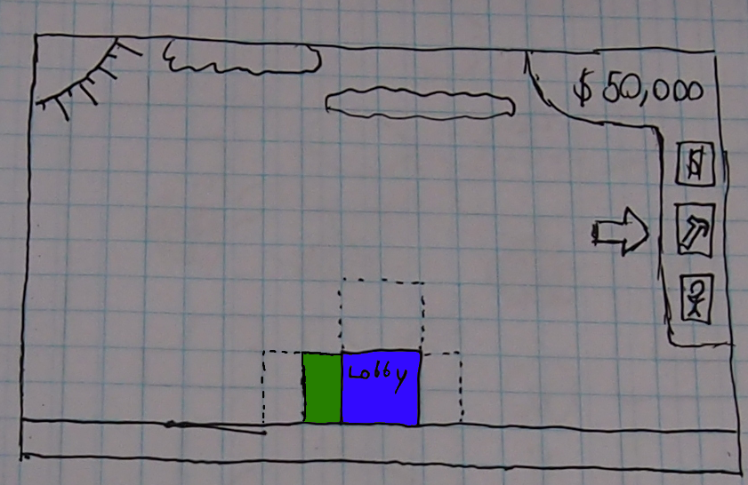

When the player wishes to add structures, he’ll be able to access a build screen from the HUD and select where to build in relation to his school’s current state. Different rooms will vary in price, school lot size, student capacity, and give bonuses to learning certain skills. There will also be special rooms available, such as Academic Support Centers, Lecture Halls, and Pottery Rooms. All rooms will take at least a single semester to finish constructing, but assigning classes or modifying a room is instantaneous and takes effect at the beginning of the next semester.

**Game Controls**

The mouse will be used to perform most actions the player needs during gameplay. The “Esc” button will be used to bring up the pause menu. The player can also enter characters with the keyboard.

**Visual Design**

The game will be a full 2D game and will use simple pixel art. Generally, the game will incorporate bright and vibrant colors. The game should look and feel lively and energetic because the player will be looking at the same screen throughout the entire game. We will have different art for all the different rooms, as well as randomly generated torsos and heads to represent the different students. On the whole, we want the style of the game to be very simple but representative, similar to that of *Tiny Tower*.

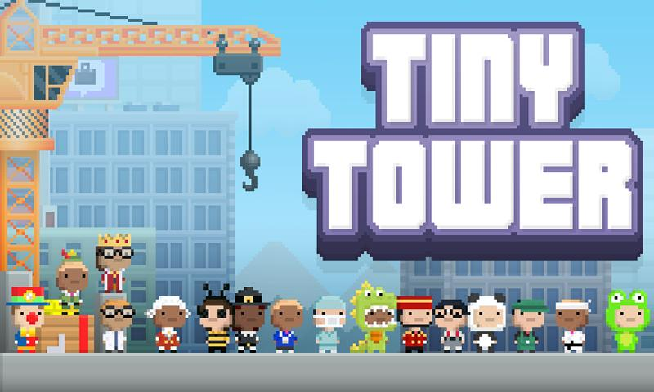

**Audio Design**

Both the music and the sound effects in the game will be made from simple, 8-bit sounds to suit the visual style of the game. We will need background music for the menu, as well as for gameplay. The music will be upbeat and energetic so that the player will feel enthusiastic about managing their game school. We will also include short sound effects like electronic beeps that play when the player interacts with buttons. There will also be sound effects like flipping papers or students talking in class to make the school feel like a school. As a stretch goal, we will include short voice samples for the students.

**Behavior Design**

In the game, there will mainly only be students and teachers moving around the building based on which rooms are occupied. These characters do not have to interact with each other as their behavior is purely aesthetic. However, students need to be able to move into a classroom and move to their desks and sit down. Lecturers also need to be able to move to the front of the classroom and teach a class.

**Physics Design**

The game will not incorporate any complex physics or collisions. The main collision that will have to be handled is taking into account mouse position and what the mouse is colliding with so that the player is able to click on buttons in the game. Students and teachers might also need to have some simple collision resolution so they do not overlap.

**Multiplayer Design**

There will be no multiplayer built into the game. Players, however, will be able to earn many achievements throughout the course of the game, and compare the achievements they've gotten.

**References**

*Image of Tiny Tower taken from:*

<https://play.google.com/store/apps/details?id=com.mobage.ww.a560.tinytower_android>