CarKeeper
Vehicle Maintenance & Shareable Service History
SOFTWARE ENGINEERING CAPSTONE PROJECT
Mark Enriquez | Institute of Data | October 2026
PROJECT DOCUMENTATION

1. Introduction

Project overview
CarKeeper is a full-stack web application that helps vehicle owners organise vehicle information, record maintenance history and monitor upcoming maintenance needs. It also lets an owner generate a read-only public link to share a vehicle’s service history without giving the recipient an account or editing rights.

Problem and opportunity
Vehicle maintenance information is often scattered across paper receipts, workshop invoices, notes and personal memory. Owners may struggle to reconstruct work completed on a vehicle, identify upcoming WOF or registration deadlines, or present a coherent service history when selling a vehicle.

Why this matters
A consolidated history supports better maintenance decisions and reduces the effort of locating old records. A shareable history can also make communication with prospective buyers or other interested parties more straightforward. CarKeeper does not independently verify workshop entries; information is supplied by the vehicle owner.

Current state and desired state
Current state: maintenance details are fragmented and can be difficult to retrieve. Desired state: an authenticated owner can manage vehicles and service entries from one dashboard, see maintenance-related information, and selectively share read-only history through a revocable link.

Comparable solutions
Existing applications such as CARFAX Car Care, AUTOsist and Drivvo offer vehicle maintenance tracking, service history management and reminders. However, these platforms often include broader features such as fleet management, fuel tracking and expense reporting.
CarKeeper focuses on a simpler experience for everyday vehicle owners, combining maintenance tracking, New Zealand-specific WOF and registration expiry information, and shareable read-only service histories. A practical distinction is its owner-controlled, revocable public link, which lets recipients view a service history without creating an account. Similar applications offer forms of record sharing, so this is a focused design choice rather than an entirely new concept.

2. Industry / Domain

Domain overview
CarKeeper sits in the automotive ownership and maintenance-management domain. It supports record keeping across servicing, WOF and vehicle registration, including information that may be useful when sharing a vehicle's history with a prospective buyer. The application is not a workshop booking, insurance or vehicle marketplace platform.

Current industry landscape
Vehicle maintenance records are often spread across paper receipts, workshop invoices and digital platforms, making them difficult to organise and access. CarKeeper focuses on a straightforward approach to managing vehicle records, upcoming maintenance and shareable service histories.

Domain participants
The primary participant is the vehicle owner. Secondary participants include buyers or other recipients who may view a shared service history. Mechanics and inspection providers may supply information to owners but do not have dedicated accounts in the current MVP.

Key domain concepts
- Vehicle profile: make, model, year, registration, transmission and mileage.
- Maintenance event: service type, date, mileage, cost, workshop and notes.
- Due information: WOF expiry, registration expiry and next service mileage.
- Service history sharing: owner-enabled, token-based, read-only access.

Relevance to other industries
CarKeeper's approach to maintenance tracking and digital record management could also apply to fleet management, machinery and equipment maintenance. These industries similarly benefit from centralised service histories, scheduled maintenance and accessible records.

3. Stakeholders
Stakeholder | Interest / expectation
Vehicle owners | Securely manage vehicle details, service records and due information.
Public-link recipients | View shared vehicle history without logging in or editing records.
Developer / maintainer | Clear project structure, repeatable tests and manageable future changes.
Assessors / reviewers | Review requirements, design decisions, implementation and testing evidence.

4. Product Description / Design
The solution uses a React/Vite single-page frontend, a Node.js/Express REST API and MongoDB Atlas. Authenticated endpoints use JWT-based access checks. Vehicle images are stored in the backend file system and served by Express; the database stores their paths. Public sharing uses a token-specific read-only endpoint without requiring the recipient to log in.
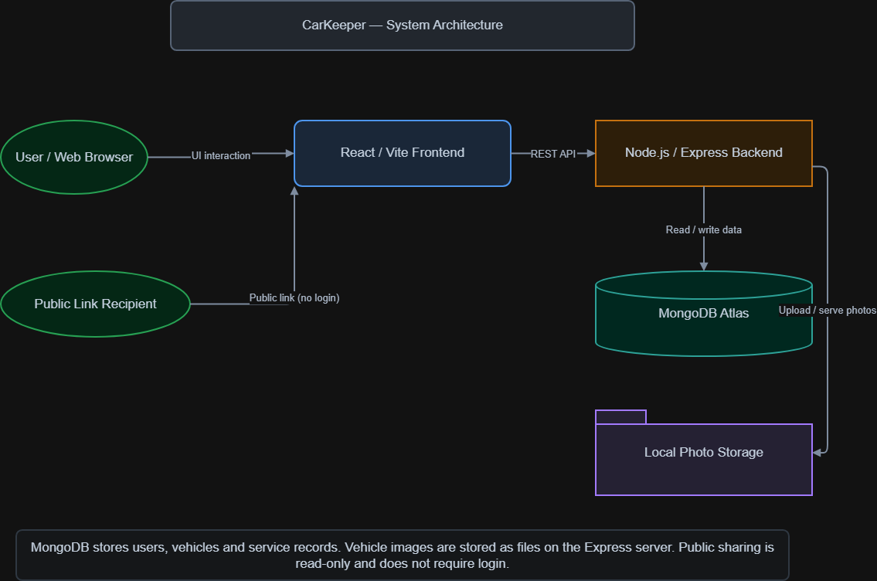
Figure 1. High-level system architecture of the CarKeeper MVP.

Main application capabilities
- Register, log in and access protected application pages.
- Create, view, edit and delete vehicle profiles, including an optional photo.
- Create, view, edit and delete service records.
- Review dashboard summaries, upcoming maintenance and recent records.
- Enable or disable a public read-only service-history link.

5. User Stories for MVP 1
ID | User Story Title | User Story Description
UM1 | Account Registration | As a vehicle owner, I want to create an account so that I can securely manage my vehicle records.
UM2 | Secure Login | As a vehicle owner, I want to log in so that only I can edit my vehicle information.
VM1 | Add Vehicle | As a vehicle owner, I want to add a vehicle so that I can track its details and maintenance.
VM2 | Edit or Delete Vehicle | As a vehicle owner, I want to edit or delete a vehicle so that my garage records remain accurate.
VM3 | Upload Vehicle Photo | As a vehicle owner, I want to upload a photo so that I can identify my vehicle visually.
SR1 | Add Service Record | As a vehicle owner, I want to record servicing and repairs so that I can maintain a service history.
SR2 | Edit or Delete Service Record | As a vehicle owner, I want to correct or remove service entries so that my maintenance history stays accurate.
DB1 | Dashboard Overview | As a vehicle owner, I want to see vehicle summaries and upcoming maintenance so that I know what needs attention.
SH1 | Share Service History | As a vehicle owner, I want to share a read-only service history link so that others can view maintenance records.
SH2 | Disable Public Sharing | As a vehicle owner, I want to disable a shared link so that I can revoke public access.
SH3 | View Shared Service History | As a recipient, I want to view a shared service history without registering so that I can review the vehicle records.

6. User Flow
The user journey is divided into five linked diagrams rather than one crowded flow. Authentication leads to Dashboard; navigation links to vehicle management; vehicle details lead to service history; sharing leads to a public read-only view.

01 Login & Registration
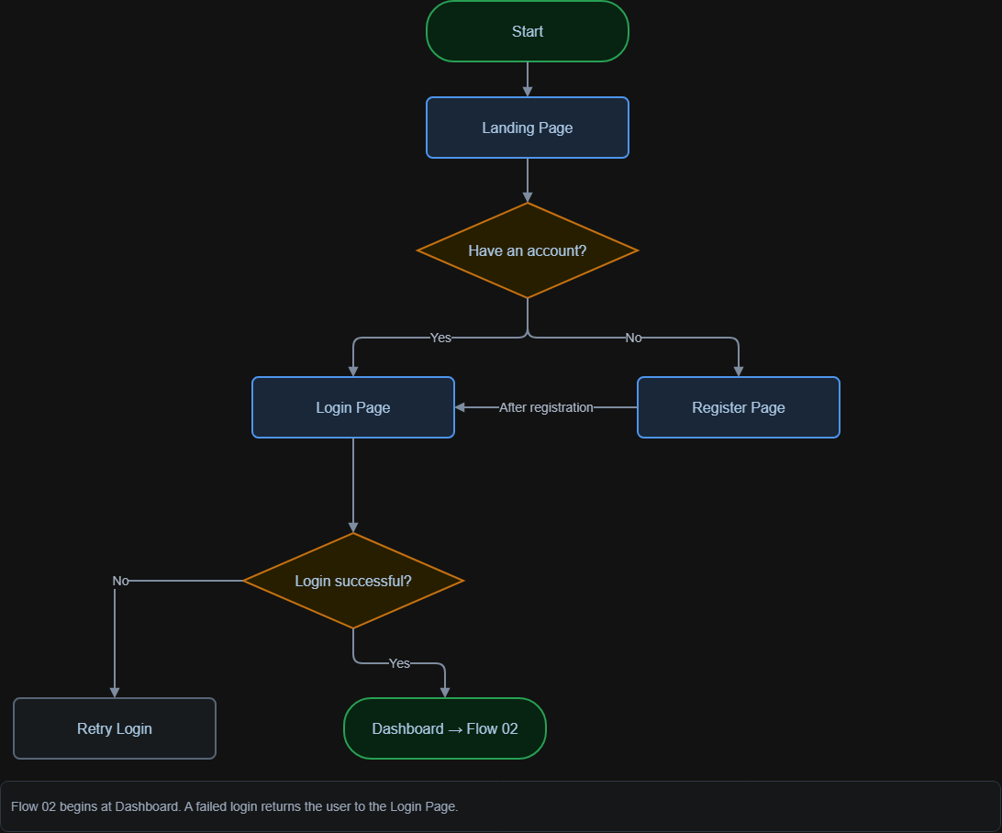
Figure 2. User flow — 01 Login & Registration

02 Main Navigation
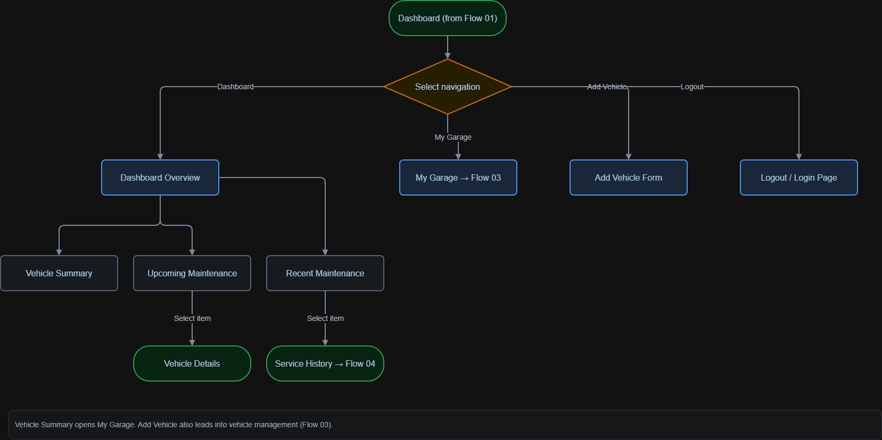
Figure 3. User flow — 02 Main Navigation

03 Vehicle Management
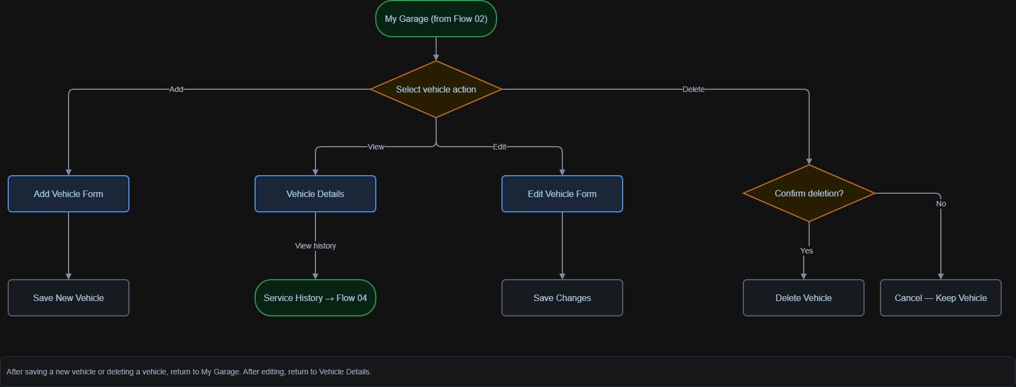
Figure 4. User flow — 03 Vehicle Management

04 Service History
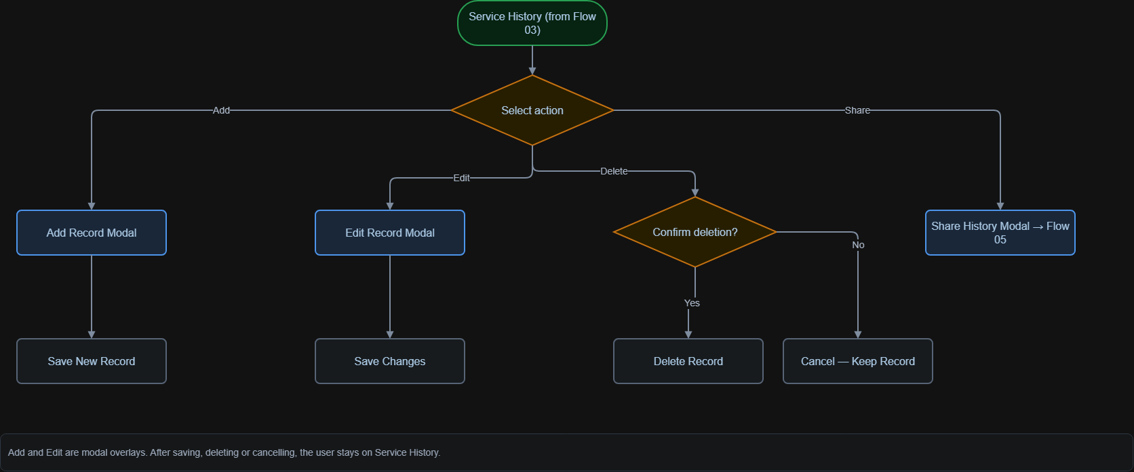
Figure 5. User flow — 04 Service History

05 Public Sharing
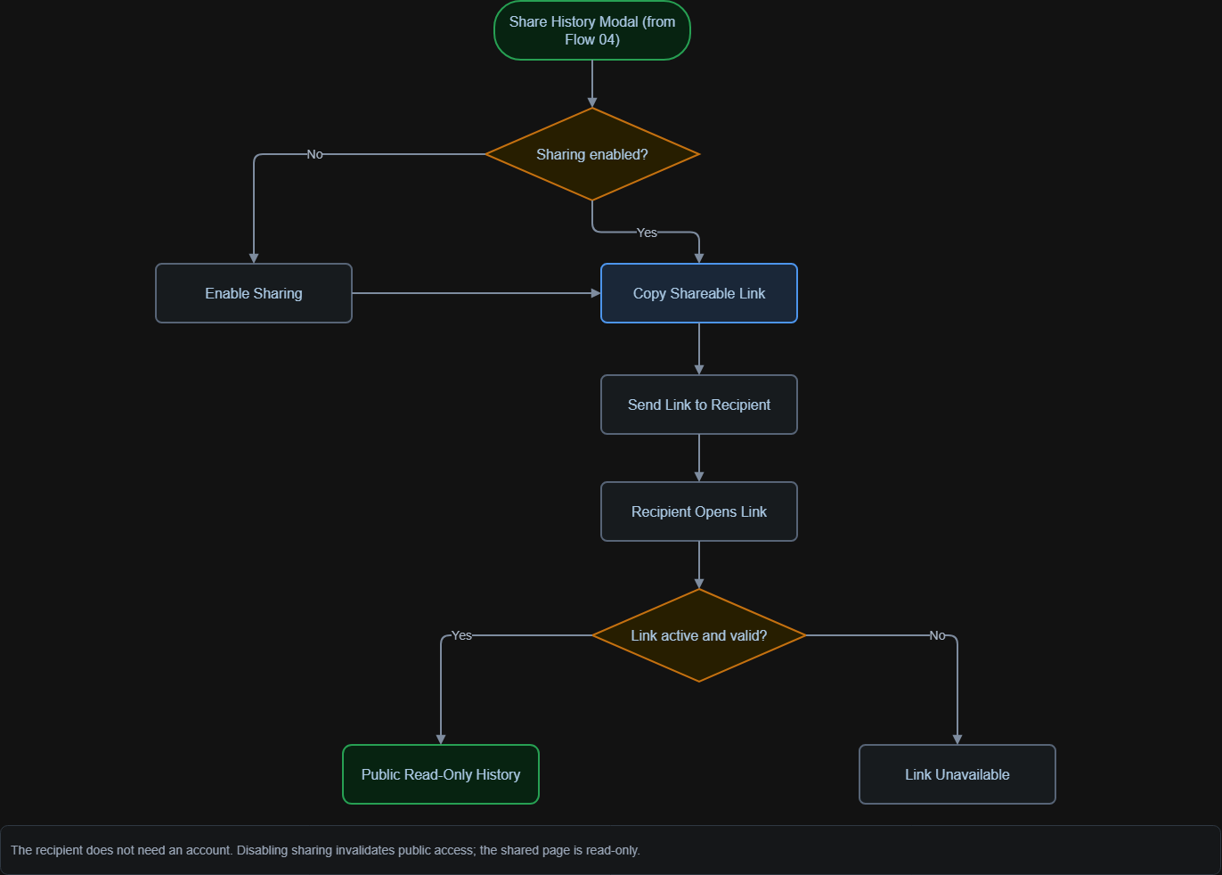
Figure 6. User flow — 05 Public Sharing

7. Wireframes & Design
The interface was planned in Figma using page-level wireframes for landing, registration, login, dashboard, garage, vehicle details, vehicle forms, service history and the public shared view. Add/Edit Service Record and Share History are modal overlays rather than standalone pages. The landing and authentication pages omit the logged-in navigation bar.

Brand colour palette
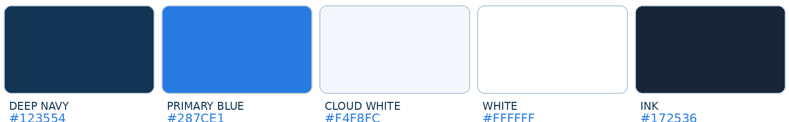
Figure 7. CarKeeper five-colour brand palette.

The palette uses restrained navy and blue accents, light surfaces and dark text to prioritise legibility. Additional status colours and borders may appear in the application but are not treated as primary brand colours.

Wireframe evidence
CarKeeper's screen layouts were planned before implementation and refined in Figma. The layout reference below and application screenshots illustrate the intended design and implemented interface. Figma project: https://www.figma.com/design/n9UrRMXAyJO0N67UxRGjOY/CarKeeper?node-id=0-1
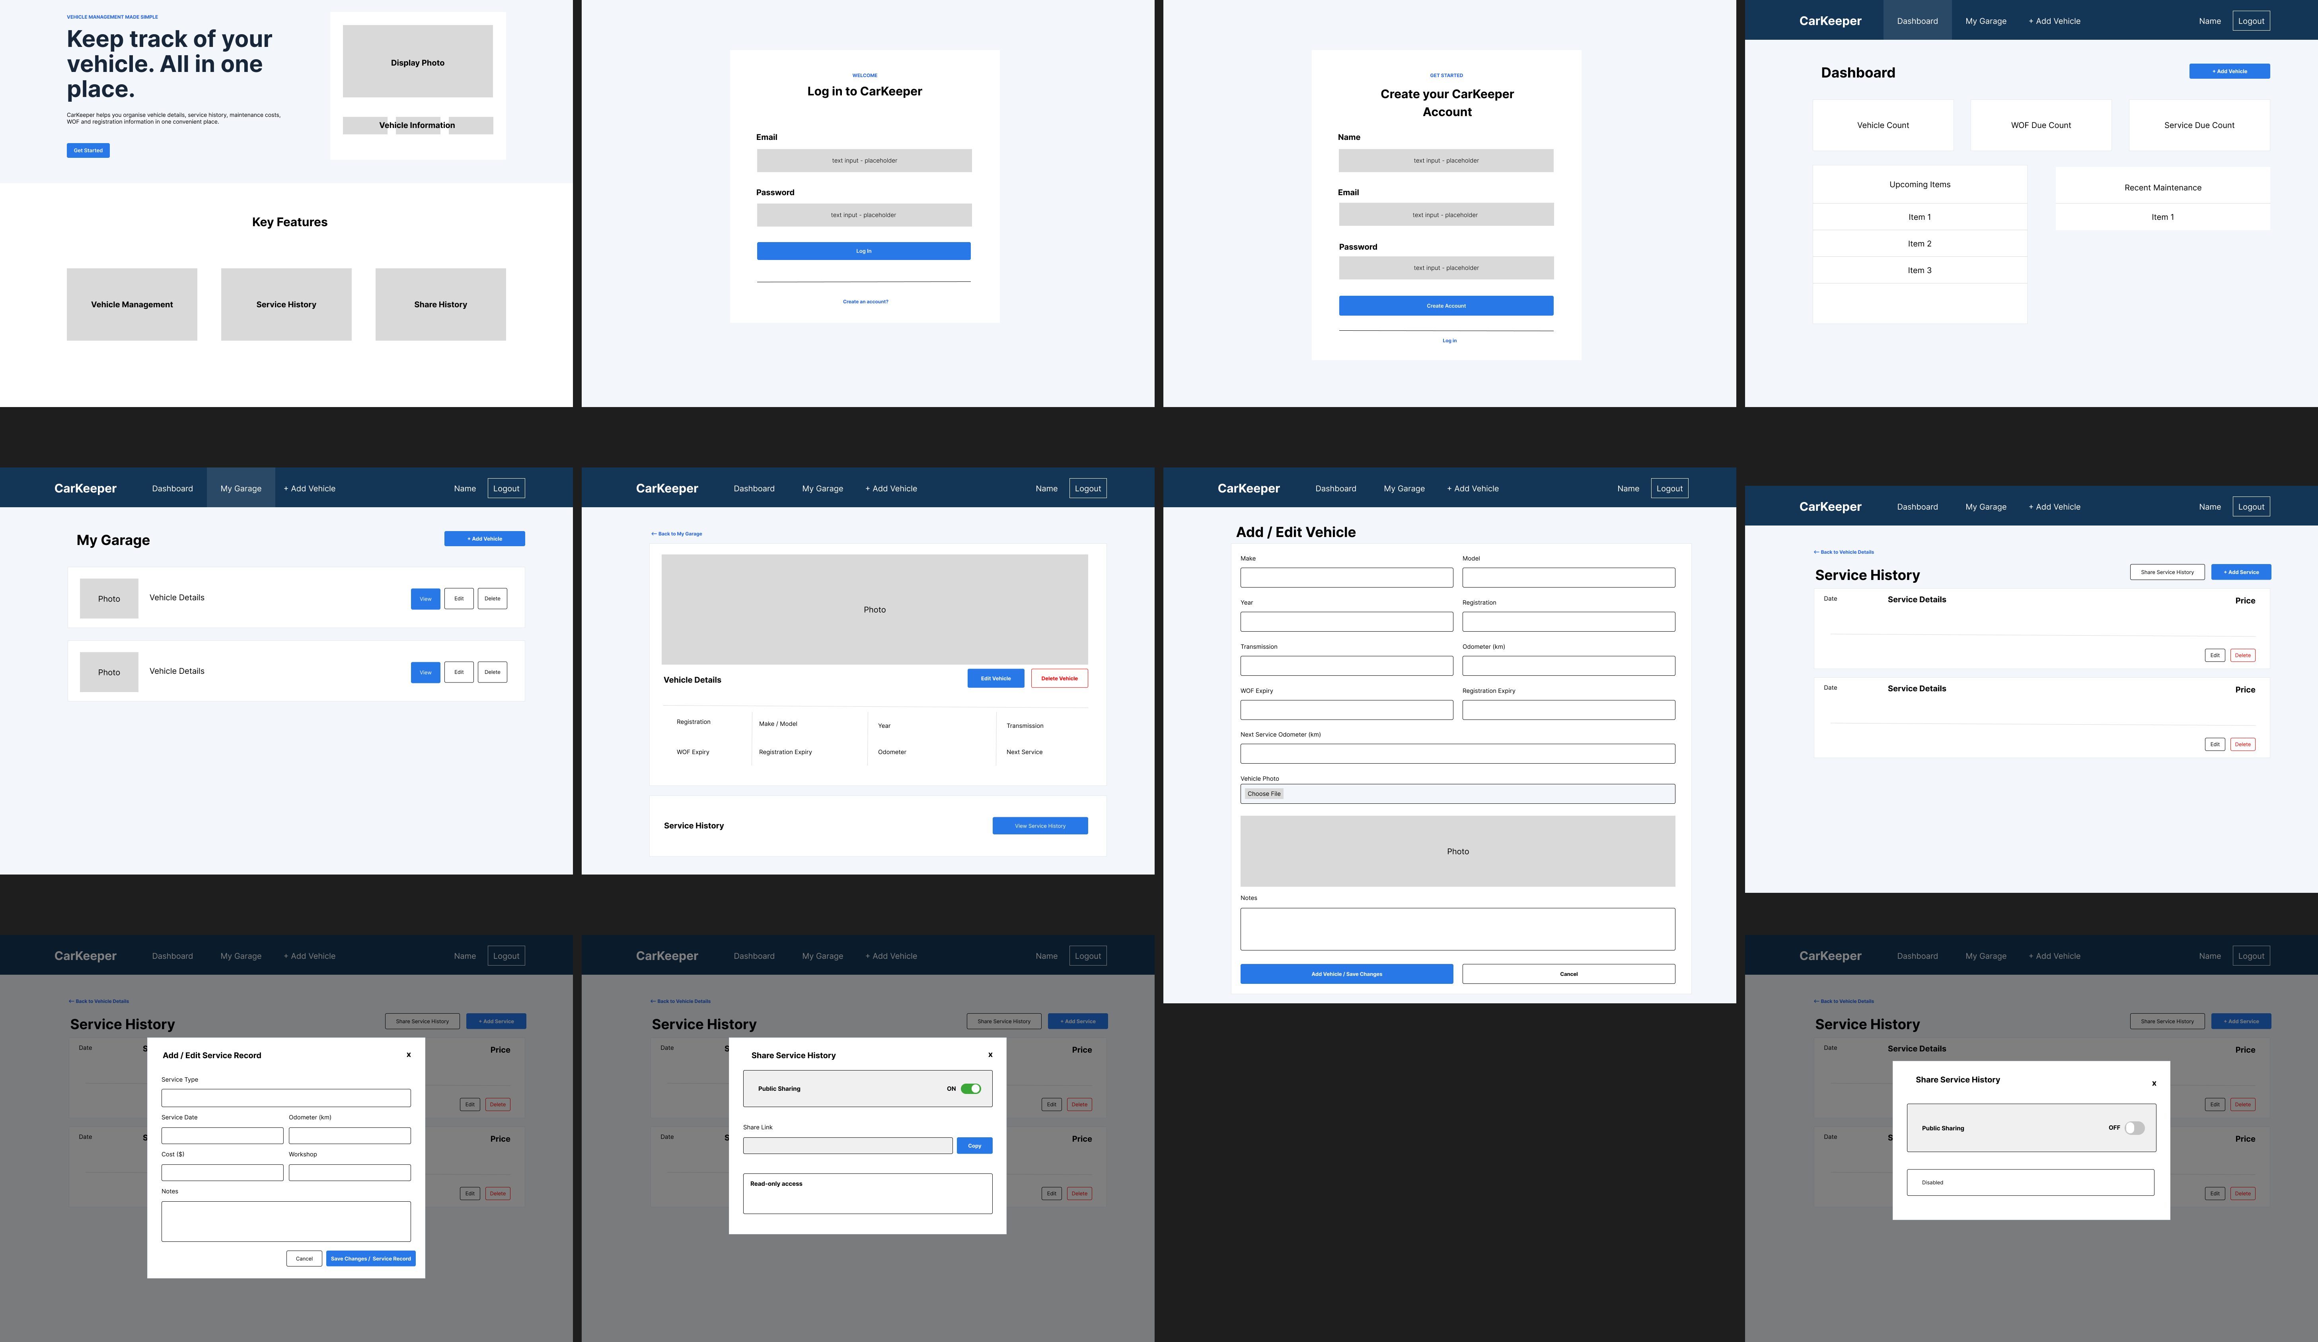
Figure 8. Initial CarKeeper layout reference showing the intended application screens (design reference).

8. Database Design — Logical & Physical
MongoDB Atlas holds three main collections. Each User can own multiple Vehicles; each Vehicle can contain multiple ServiceRecords. The owner and vehicle fields use Mongoose ObjectId references. The Vehicles collection also holds a photo path and an optional, sparse unique shareToken.
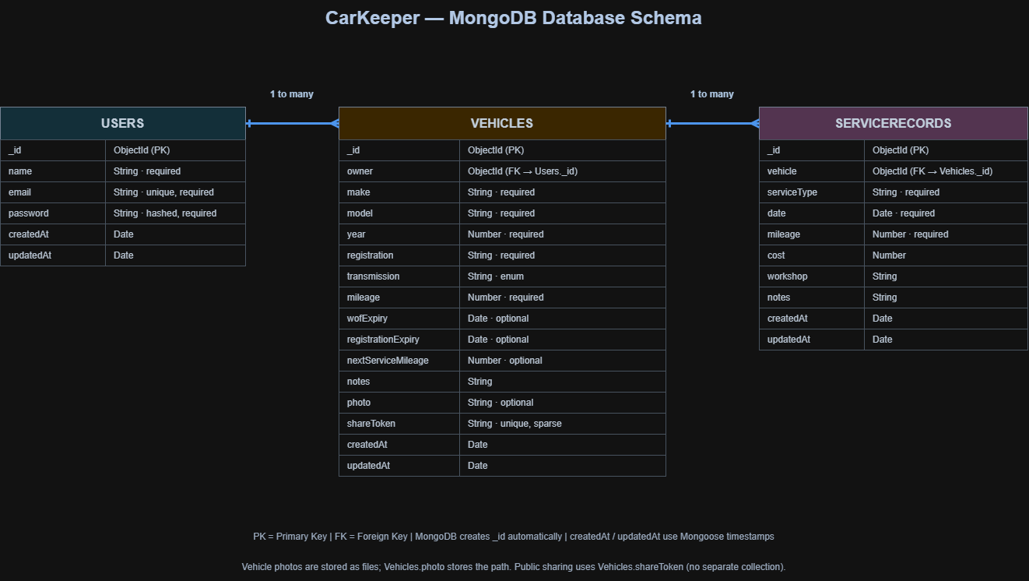
Figure 9. CarKeeper MongoDB schema showing Users, Vehicles and ServiceRecords, with one-to-many relationships and field types.
Collection | Core fields
Users | _id, name, email (unique), password (hashed), createdAt, updatedAt
Vehicles | _id, owner (FK), make, model, year, registration, transmission, mileage, wofExpiry, registrationExpiry, nextServiceMileage, notes, photo, shareToken, timestamps
ServiceRecords | _id, vehicle (FK), serviceType, date, mileage, cost, workshop, notes, timestamps

Photo files are stored under server/uploads/vehicles, rather than as MongoDB binary objects. Sharing is implemented with Vehicles.shareToken, not a separate collection.

9. Open Questions / Out of Scope
- Workshop and mechanic user accounts or verified workshop-submitted records.
- Automated reminders via email, SMS or push notification.
- Vehicle marketplace listings, buyer accounts and online payments.
- Fuel economy analytics, telematics or manufacturer integrations.
- Receipt/document attachments and a multi-image vehicle gallery.
- Cloud object storage for uploaded photos; AWS S3 is a future option.
- Production hosting on AWS Elastic Beanstalk remains pending account verification.

10. Non-functional Requirements
Area | Requirement / implementation approach
Security | Use bcrypt, JWT and record-ownership checks; keep secrets out of Git.
Privacy | Public links reveal read-only history only while sharing is enabled.
Usability | Clear navigation, familiar forms, feedback and modal actions.
Data integrity | Mongoose checks required fields and types; ObjectId references link collections.
Maintainability | Separate routes, controllers, models, middleware and reusable React components.
Performance | Keep API responses and dashboard interactions practical for a small MVP; no benchmark claim is made.
Portability | Document environment variables and run frontend/backend independently.

11. Project Planning
Project activities were organised on a Trello board covering requirements, design, development, testing, documentation and deployment. The board records completed work and outstanding finalisation tasks. Deployment is separately marked blocked while AWS account verification is pending.
The screenshot below captures the board status at the time of documentation.
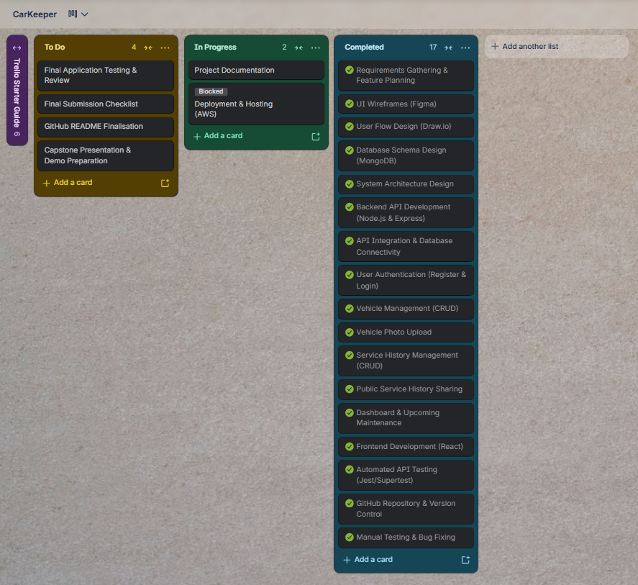
Figure 10. CarKeeper Trello planning board

12. Testing Strategy

Testing approach
CarKeeper was tested incrementally as frontend and backend features were built. API integration tests provide repeatable checks of core routes, while browser-based development checks assess navigation, forms, modals, vehicle photos and the public sharing experience.
The automated tests run against a separate MongoDB test database (carkeeper_test), so test operations do not modify normal application records. Automated and manual evidence is reported separately below.

Incremental development and frontend checks
After implementing a backend route, its request and response behaviour was exercised through the integration test suite. Once a React page or component was connected to the API, its workflow was checked in the browser, including routing, data display, form submissions and feedback after saving or deleting records.
The browser checks included the protected Dashboard and My Garage pages, vehicle and service-record forms, service-record modals, image handling, and read-only history opened using a public link. These development checks were not maintained as a separate signed manual test log.

Automated backend testing — Jest and Supertest
Jest runs the integration tests, and Supertest sends HTTP requests to the Express app without requiring a separate production server process. The recorded run contains one passing suite and 19 passing tests. The cases below follow the test names shown in the captured terminal output.
ID / test | Test steps and expected result | Result | Notes
A01 API health check | Send GET /; confirm the API running message. | Pass | Basic endpoint
A02 Register new user | POST /api/auth/register with new user details; confirm registration. | Pass | Authentication
A03 Reject duplicate email | Repeat registration using an existing email; confirm rejection. | Pass | Validation
A04 Log in successfully | POST /api/auth/login with valid credentials; confirm successful login. | Pass | Authentication
A05 Reject wrong password | POST /api/auth/login with an incorrect password; confirm rejection. | Pass | Authentication
A06 Reject missing JWT | GET /api/vehicles without an access token; confirm refusal. | Pass | Protected route
A07 Create vehicle | POST /api/vehicles as an authenticated user; confirm a new vehicle. | Pass | Vehicle CRUD
A08 List owned vehicles | GET /api/vehicles; confirm the owner's vehicles are returned. | Pass | Vehicle CRUD
A09 Get vehicle details | GET /api/vehicles/:id; confirm the requested vehicle is returned. | Pass | Vehicle CRUD
A10 Update vehicle | PUT /api/vehicles/:id with changed details; confirm update. | Pass | Vehicle CRUD
A11 Add service record | POST /api/vehicles/:vehicleId/services; confirm record creation. | Pass | Service CRUD
A12 List service records | GET /api/vehicles/:vehicleId/services; confirm records are returned. | Pass | Service CRUD
A13 Update service record | PUT /api/services/:id; confirm changed service information is saved. | Pass | Service CRUD
A14 Delete service record | DELETE /api/services/:id; confirm record removal. | Pass | Service CRUD
A15 Enable sharing | POST /api/vehicles/:id/share; confirm public sharing is enabled. | Pass | Sharing
A16 Public read-only retrieval | GET /api/public/vehicles/:shareToken without a JWT; confirm shared history. | Pass | Public access
A17 Disable sharing | DELETE /api/vehicles/:id/share; confirm sharing is disabled. | Pass | Revocation
A18 Reject revoked link | GET /api/public/vehicles/:shareToken using the old token; confirm rejection. | Pass | Revocation
A19 Vehicle cleanup | DELETE /api/vehicles/:id; confirm the test vehicle is deleted. | Pass | Cleanup / CRUD

Automated test evidence
The screenshot below is the recorded Jest/Supertest run. It verifies 19 passed, 0 failed and one passing test suite; it does not prove that every possible validation or browser scenario has been tested.
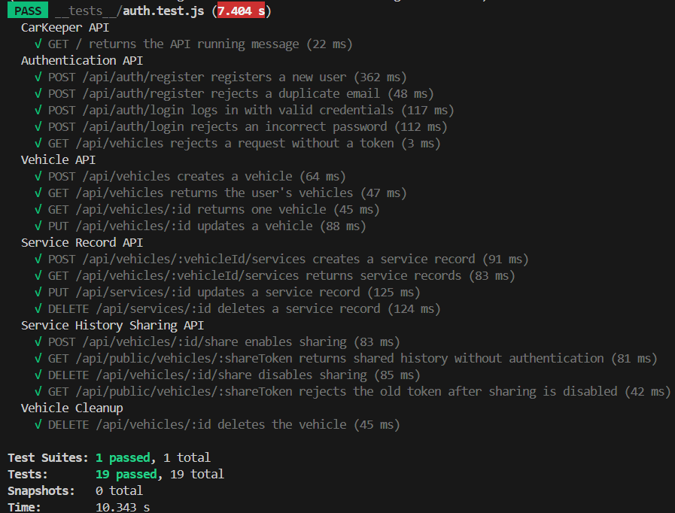
Figure 11. Jest/Supertest automated API test results: 19 passed, 0 failed.

Manual acceptance tests
The scripts below document the user journeys exercised or considered during development. “Development check” reflects the existing project record that these workflows were manually exercised; separate dated pass/fail evidence was not provided. “Final recheck” identifies a scenario to confirm before submission. These labels are deliberately distinct from the verified automated passes above.
Test scenario | Steps / acceptance criteria | Outcome | Notes
M01 Register and log in | - Open Register;  - Enter user details and submit.  - Log in and confirm navigation to Dashboard. | Development check | Auth flow
M02 Dashboard information | - Open Dashboard with vehicles recorded;  - Inspect vehicle summary, due information and recent maintenance. | Final recheck | UI display
M03 Add vehicle | - Open Add Vehicle;  - Enter required details and save.  - Confirm the new entry appears in My Garage. | Development check | Vehicle CRUD
M04 Edit vehicle | - Open existing vehicle;  - Change details and save.  - Reopen details and verify the changes. | Development check | Vehicle CRUD
M05 Delete vehicle | - Select a vehicle;  - Initiate deletion and confirm.  - Check that it is removed from the garage. | Development check | Vehicle CRUD
M06 Upload vehicle photo | - Attach a supported photo when adding a vehicle;  - Save and confirm it displays on the vehicle card/details. | Development check | Image upload
M07 Remove photo before saving | - Open Add Vehicle and select an image;  - Remove the selected photo before submitting;  - Save and confirm the vehicle uses the no-photo fallback. | Final recheck | Add form
M08 Add service record | - Open vehicle Service History;  - Use Add Record modal;  - Submit valid details;  - Confirm record appears. | Development check | Service CRUD
M09 Edit service record | - Choose an existing record;  - Edit it in the modal;  - Save and confirm the updated values. | Development check | Service CRUD
M10 Delete service record | - Choose a service record;  - Delete and confirm it no longer appears in the list. | Development check | Service CRUD
M11 Enable public sharing | - Enable sharing in Share History modal;  - Copy the URL;  - Open it without logging in and confirm read-only history. | Development check | Public link
M12 Disable public sharing | - Disable sharing and attempt the previous public URL again;  - Confirm history is unavailable. | Development check | Revoked link
M13 Protected page access | - Open a protected route after removing authentication;  - Confirm the route is inaccessible. | Final recheck | JWT API pass

Edge cases and test boundaries
The automated suite explicitly covers duplicate account registration, incorrect passwords, missing authentication for a protected vehicle route, and attempts to reuse a revoked share token. Browser validation, unauthorised cross-owner access, unusual image files, mobile layouts and accessibility would benefit from additional, separately recorded test cases before production use.

Known limitations
The 19 automated passes demonstrate the tested API behaviours, not full production readiness. The current evidence does not establish load performance, cross-browser compatibility, accessibility conformance, comprehensive security testing, or deployment validation. AWS hosting was not completed because account verification was pending.

13. Implementation

Frontend
React and Vite provide a single-page application. React Router separates public routes from protected owner pages. AuthContext and ProtectedRoute coordinate authentication state; Axios handles REST requests and attaches the JWT for protected endpoints. Components are organised around vehicles, service records, dashboard and layout.

Backend
Node.js and Express expose authentication, vehicle, service-record and sharing routes. Controllers implement application logic, Mongoose models define validation and persistence, and middleware handles authentication, authorisation and vehicle-photo uploads. The architecture is one modular Express backend, not a microservices system.

Database and storage
MongoDB Atlas stores users, vehicles and service records. The owner/vehicle references support one-to-many relationships. Uploaded photos are saved locally and served as static files by Express; MongoDB stores the corresponding path.

Source control and hosting
The codebase is tracked in Git and pushed to GitHub. Secrets, dependencies and uploaded files are excluded from version control where appropriate. AWS Elastic Beanstalk was considered for deployment, but account verification prevented completion at the time of this document. No production deployment is claimed.

14. End-to-End Solution
An owner registers or logs in, arrives at the dashboard and navigates to My Garage to manage vehicles. Selecting a vehicle opens its details and service history. Service entries can be added or edited in modals. An owner can enable sharing, copy the generated URL and provide it to a recipient, who sees a read-only history without an account. Disabling sharing invalidates public access.

MVP feature summary
- JWT-based registration and login with protected owner views.
- Vehicle and service-record CRUD backed by MongoDB Atlas.
- Vehicle photo upload and display.
- Dashboard with vehicle summary, upcoming items and recent maintenance.
- Public token-based read-only sharing with enable/disable control.

15. Lessons Learned
- Separating frontend components and backend routes/controllers makes features easier to change and troubleshoot.
- Mongoose schema design and ownership checks are important for keeping each owner’s data isolated.
- Building user flows and wireframes clarifies navigation before final presentation.
- Automated API tests complement manual browser testing and provide repeatable evidence.
- File uploads require coordination between browser forms, Express middleware, file storage and URL handling.
- Deployment introduces account and infrastructure dependencies beyond application code; recording blockers transparently is part of project delivery.

16. References
- Project repository: CarKeeper source code on GitHub (https://github.com/markenrqz/CarKeeper/tree/main).
- Figma: CarKeeper wireframes and interface planning (https://www.figma.com/design/n9UrRMXAyJO0N67UxRGjOY/CarKeeper?node-id=0-1).
- diagrams.net (draw.io): used to create the user flows, system architecture and database schema.
- Trello: CarKeeper planning board; screenshot included in Section 11.
- Technology documentation: React, Vite, React Router, Node.js, Express, MongoDB/Mongoose, Axios, bcrypt, JWT, Multer, Jest and Supertest.

