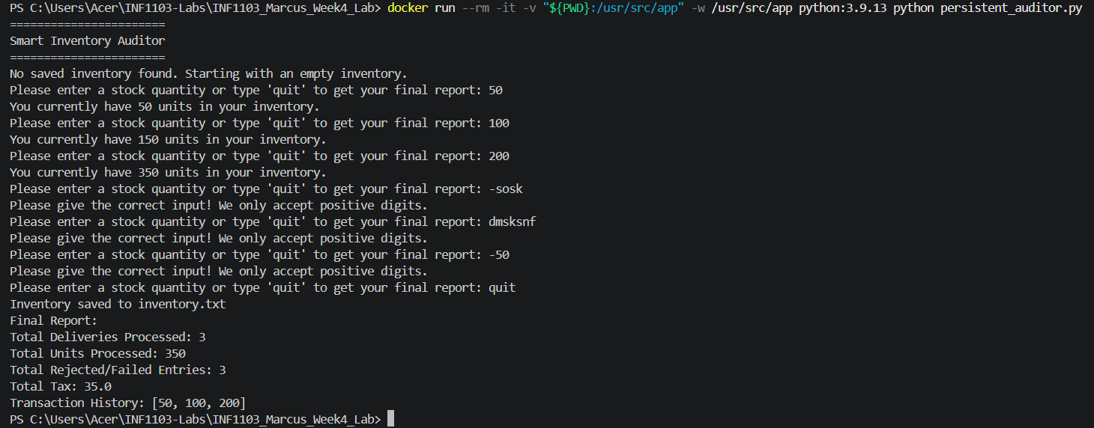
Docker Run
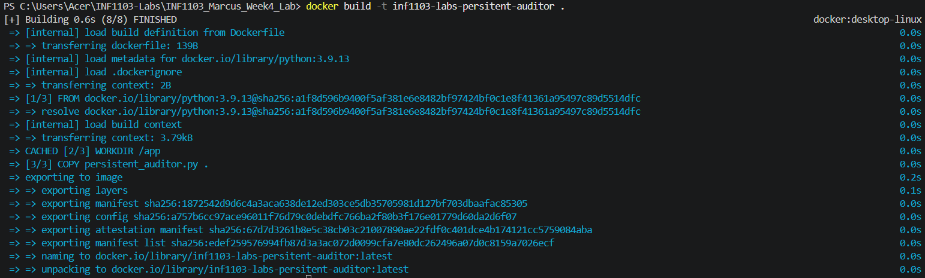
Docker Build
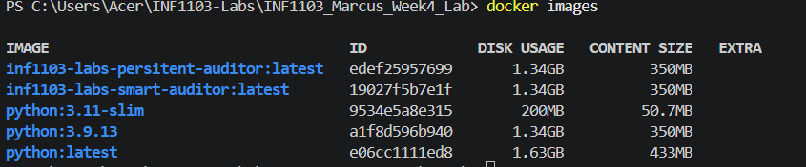
Docker images

