Assignment 5

Mark Sherriff : N01299223

CPAN155B Operating Systems

1. The sh command is used for documents stored with some sort of linux code. The -n option is a redirection operator, which is used for debugging code without running it. The -v option is also a redirection operator, which displays and executes a command simultaneously.
2. Calculator.sh

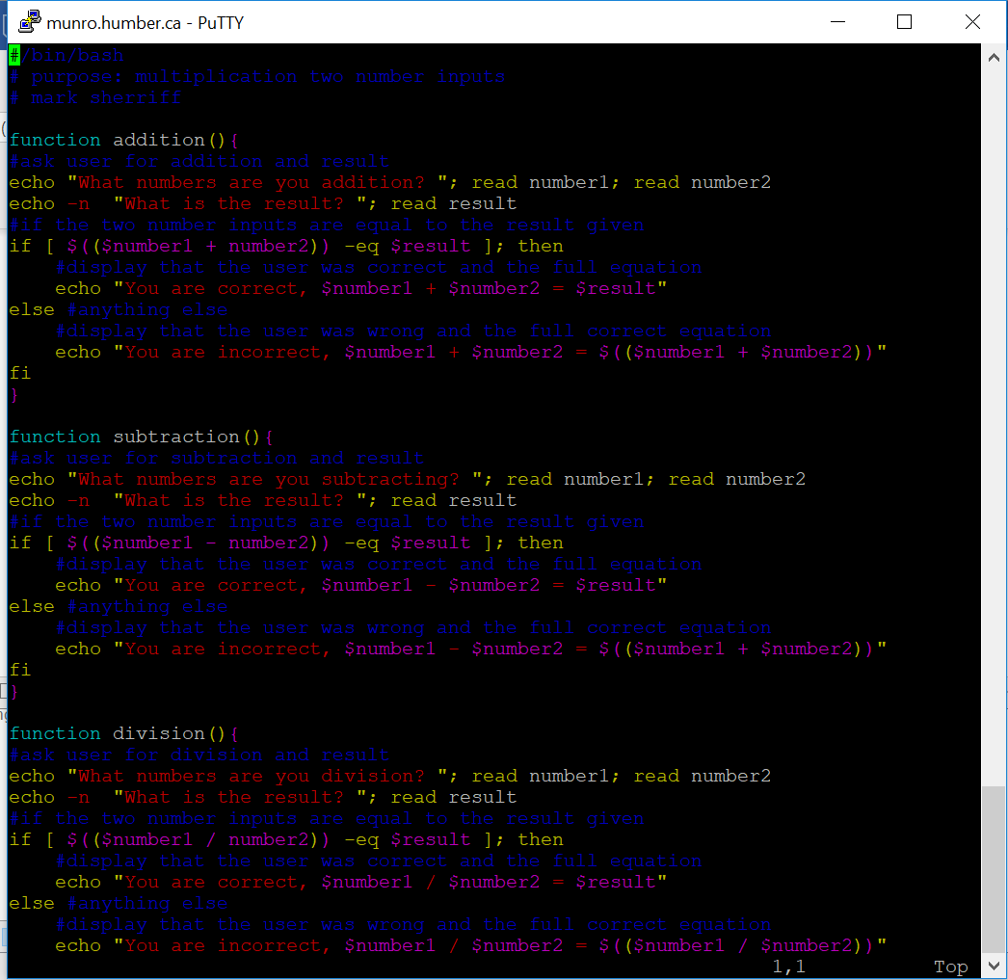

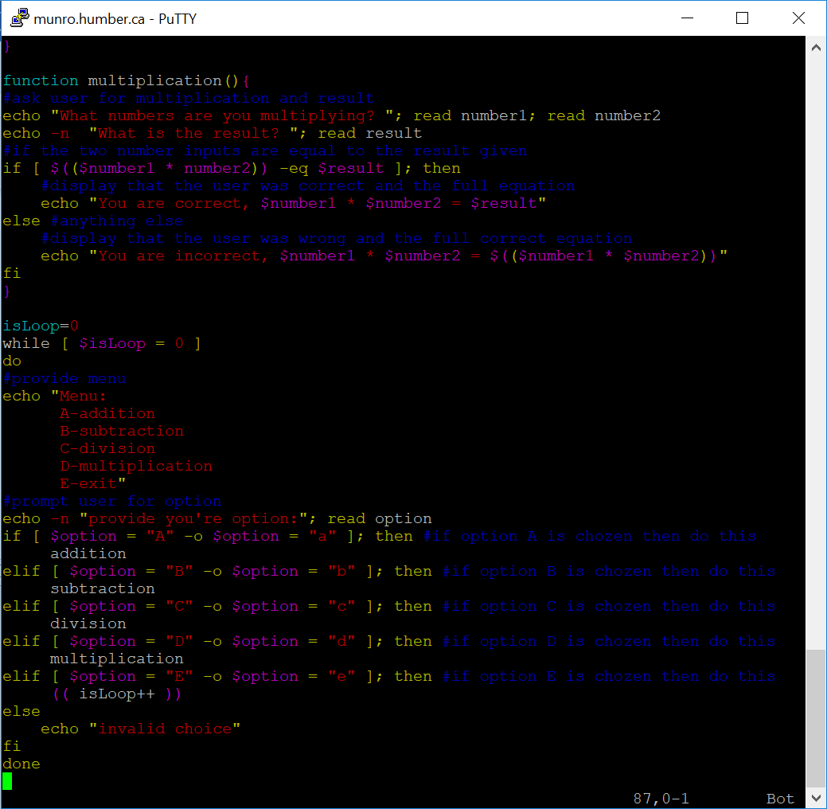

1. createFile.sh

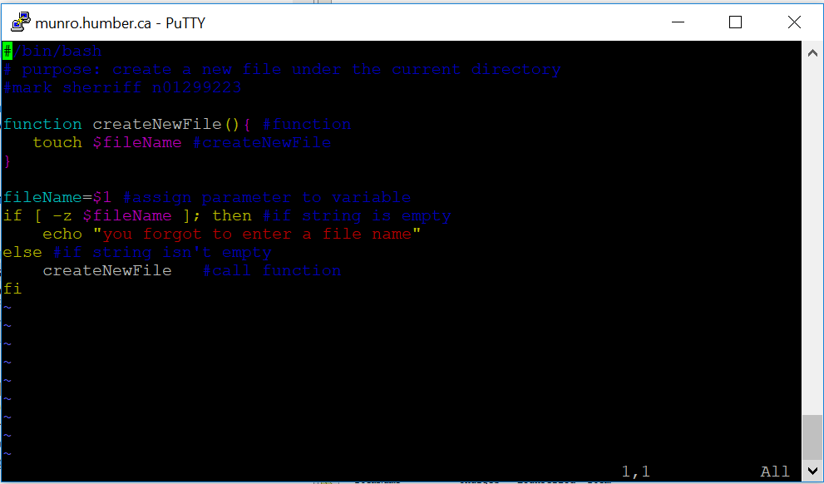

1. 