Sources of information in the marketing communication industry:

1. Australian Marketing Institute

2. Australian Association of National Advertisers

3. Australian Direct Marketing Association

4. Marketing Mag

5. Media Federation of Australia

Marketing communications industry structure:

| **Participants** | **Description** |
| --- | --- |
| 1. Australian Communications and Media Authority | ACM regulates some areas overseen by the Department of Communication. It provides to the client guidance, compliance standards, receives and adjudicates complaints and enforcement for matters relating to regulation of all forms of electronic communication, including internet content, internet security, content and advertising, telecommunications, radio content and spectrums, broadcasting and anstispam. |
| 1. Australian Competition and Consumer Commission | It works to benefit consumers, businesses and the community overall. In order to do that, ACCC promotes competition and fair trade in markets with responsibilities such as to ensure that individuals and businesses comply with Australian laws regarding competition, fair trading, and consumer protection, that are applied under the Competition and Consumer Act 2010. The ACCC is concerned with false or misleading claims, managing online reviews, shopping online, internet banking, online auctions and group buying, social media advertising, pricing displays and unfair prices. |
| 1. Office of the Australian Information Commissioner (OAIS) | It is responsible for laws and privacy function related to privacy obligations, such as complying with the Anti Money Laundering and Telecommunications laws. It also works with matters related to obligations with respect to disclosure of personal information of an individual by organizations (client). The primary legislation used as the base for the OAIS is the Privacy Act 1988, which sets guidelines dealing with collection, holding, use and disclosure of personal information that belongs to an individual. |
| 1. Australian Marketing Institute | AMI represents professional marketers throughout Australia, from all functions and industries. It has strong links with the businesses, academia and government to build a recognised voice for the institute and its members. It provides networks opportunities, courses, training, work metrics, CPM, national awards and mentoring. |
| 1. IP Australia | IP Australia is an Australian governmental agency of the department of industry, innovation and science. It administers intellectual property rights and legislation relating to patents, trade markets, registered designs and plant breeders rights in Australia. It relates to marketers in the ground of intellectual property used for marketing practices, being it either your own property or someone else’s, in order to protect each individual and organisation. |

**Fusion Marketing organizational structure**

The current marketing department’s structure consists on a CMO, a traditional marketing director and a digital marketing director. The traditional marketing director coordinates public relations, offline advertising and event management departments. The digital marketing director coordinates analytics, digital production and online advertising departments. It currently follows the structure presented below:

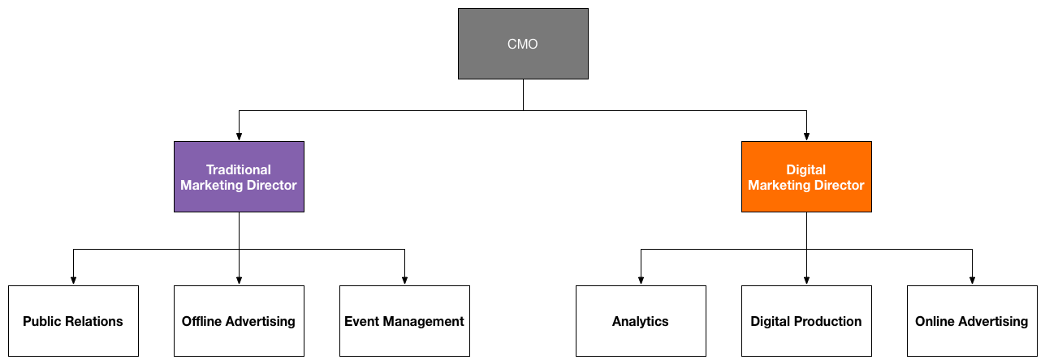

This current structure presents some issues:

First, traditional and digital marketing should not be separated. They should be integrated to have one unified approach, so that traditional and digital strategies can communicate and work with strategies that are aligned to each other.

The structure of the marketing department should not be divided into digital and traditional, since digital solutions are just one more technology for the strategies of the organisation. The structure should be divided into the areas in which the organisation works, and digital and traditional solutions should permeate all those areas.

The structure does not align to the organisational services, splitting those areas into different categories that do not communicate, and those services should be coordinated by only one head of department.

The following structure should be considered:

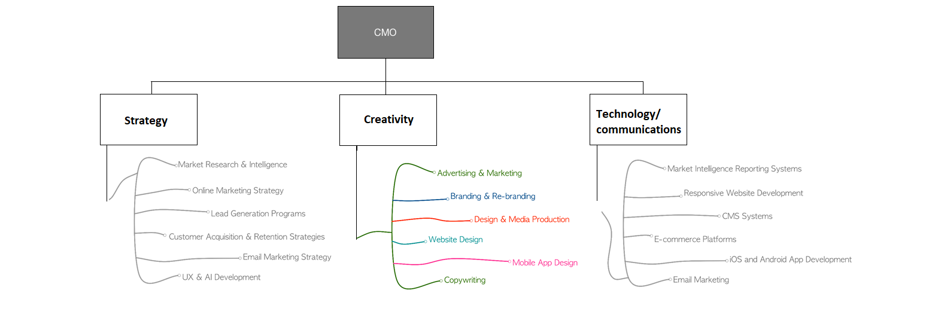

This structure represents better the organisation’s services and complies with the organisational plan. It does not divide traditional and digital channels, instead, they are used as communication channels through all areas to execute marketing functions. Also, this structure allow the strategy group to outline a plan of execution, which the creative group will use to develop the content for all the channels, which is then publicized by the technology and communications. Furthermore, one person coordinates all the actions: the CMO, who can review everything to make sure it is integrated and efficient. This organisation enhances communication across all the processes that happen at the same stage.

**Marketing communication plan**

The core elements of an integrated marketing communication plan are:

1. Advertising
2. Direct marketing
3. Digital marketing
4. Sales promotion
5. Publicity/public relations

The positioning of the product and service, the price and place are determined by the activities undertaken by the organization, and this needs to relate to the marketing plan. The channels chosen and the messages delivered need to be aligned with the target market and the image the organization want to create.

Also, the IMC plan needs to meet the organization’s visions and values. The marketing activities need to comply with the business goals, the identity and history of the brand, and the strategic goals and activities outlined in the business plan. To create an integrated marketing, the message and the activities delivered by the IMC need to be working towards those values, visions and goals.

In addition, IMC activities need to comply with the financial strategy and budget. The budget set for the marketing activities need to be enough to put them into practice, but still allowing other business activities outlined in the business plan to happen at their best.

From this, we can see that the IMC Plan relates to the organisation’s business plan and marketing plan in its objectives and strategies, helping to understand how the different marketing communications will be best used to achieve business goals.

**Marketing communication industry sectors**

1. Customer service

2. Market research

3. Product pricing

4. Media planning

5. Public Relations

**Marketing communication industry associations and networks**

1. Australian Association of National Advertisers

2. Australian Direct Marketing Association (ADMA)

3. Australian Graphic Design Association

4. Australian Interactive Media Industry Association

5. Australian Professional Services Marketing Association (APSMA)

6. International Association of Business Communicators (IABC)

7. Marketing Association of Australia and New Zealand

8. The Australian Subscription Television and Radio Association (ASTRA)

9. Public Relations Institute of Australia (PRIA)

10. Media Federation of Australia

**Societal role of the marketing communication industry**

1. Information Marketing is an information source for society. It spreads information and educates consumers, even though it is persuasive, it explains how products and services work and meet consumers’ needs. It can also include a variety of other general information and information on how to make purchase or other actions involved in the process of buying a service or product. Information delivered by marketers must follow regulations and follow ethics not to be misleading and to respect competition.

2. Economical responsibility Marketing drives a consumer economy, promoting goods and services and targeting consumers most likely to become buyers. Higher sales for a business that employs successful marketing strategies translate into expansion, job creation, higher tax revenue for governments and, eventually, overall economic growth.

3. Modeling behavior Marketers work to understand consumer behaviour and produce advertising that is most likely to influence it. This provides a place for behavioural researchers and economic analysts to model consumer behaviour. By examining marketing data and its correlation to consumer behaviour, analysts can learn about how and why people make the decisions they do.

**Key Stakeholders of Fusion Marketing**

**1**. Government

2. Marketers

3. Consumers

4. Associations

5. Corporations