Website Notes:
- Please change from “Hear More of What Matters” to “Hear More of Who Matters”
- Expert hearing tests, hearing aid fittings and after care with our main office in Tanay, Rizal and branches in Cebu City, Dasmariñas City, Cavite and Rosario, La Union.
- Comprehensive Hearing Evaluation
  - From, “Accurate hearing assessments for adults and children, using the latest audiometric tools to measure hearing capacity precisely.” to “We provide accurate hearing assessments for adults and children using the latest audiometric tools.”
  - Please change the word “licensed audiologist” to “qualified audiologist” because we still don’t have licensing exam for audiologists here in the Philippines.
  - Hearing evaluations are available across all four Linaw Dinig branches in Tanay, Rizal, Cebu City, Cebu, Dasmariñas City, Cavite, and Rosario, La Union.
  - For the Adult Hearing Tests, please combine Speech audiometry with Pure Tone Audiometry. So it should be Pure Tone Audiometry & Speech Audiometry.
  - From “to map the type and degree..” to “to map the degree and type…” Sa proper reporting po kasi nauuna ang degree of hearing loss followed by type.
  - For tympanometry description please use this caption, “It is a quick, non-invasive test that evaluates how well the eardrum and middle ear are functioning. This test checks the movement of the eardrum and helps identify middle ear conditions such as ear infections.
  - For Pediatric Hearing Tests, please use the following captions:
    - Newborn Hearing Screening: A safe, quick, and painless hearing test that may be performed shortly after birth to check a baby's hearing. Early detection of hearing loss allows timely intervention and support, which are essential for normal speech, language, and cognitive development.
    - Play Audiometry: A hearing test designed for young children, typically ages 2 to 5 years, that uses games or playful activities to measure hearing ability. This fun and engaging approach helps audiologists accurately assess a child's hearing levels in a comfortable and child-friendly manner.
    - ABR / BAER & ASSR: These are objective hearing tests that measure how the hearing nerve and brain respond to sound which are commonly used for newborns, younger children, and individuals who cannot participate in conventional hearing tests. ABR / BAER helps assess the integrity of the hearing pathway, while ASSR provides frequency-specific information that can estimate the degree of hearing loss and assist in hearing aid fitting.

- Hearing aid Fitting & Customization
  - Kindly change to “Hearing Aid Counseling & Fitting”
  - Description: A great hearing aid is only as good as its fitting. At Linaw Dinig, fitting is a guided, unhurried process. We start by understanding how and where you struggle to hear, recommend the right technology for your needs and budget, then fit and fine-tune every device so each sound reaches you exactly as it should.
From the first counseling session to long-term adjustments, our qualified audiologist makes sure your hearing aids feel natural, comfortable and genuinely helpful in everyday life may it be at home, at work, or in noisy places.
- Hearing Aid Repair & Maintenance
  - Instead of, “Fast and reliable repair and maintenance for various hearing aid brands — even if you didn't buy them from us.” Replace with, “Reliable repair and maintenance for your hearing devices.”
  - From, “Many repairs and routine maintenance can be done in-clinic the same day. For more complex issues, we send to the manufacturer and keep you updated every step of the way.” To “Routine maintenance and minor cleaning can be done in-clinic the same day. For more complex issues, we send to the manufacturer and keep you updated every step of the way.”
  - Who it’s for: For clients using hearing aid brands we offer.
  - Turnaround: Often same-day for cleaning and minor fixes. 2 weeks to 1 month for manufacturer repairs.
- Follow-up Care & Counseling: No changes needed.
- Assistive Listening Devices and Accessories: No changes needed.
- From “Hearing Aids from All Major Brands” to simply “Hearing Aids”
- Description: We are independent, private practice and we recommend the right aid for you- not necessarily the most expensive one.
- Please only put Unitron, Bernafon, and Beltone as brands offered.
- If kaya pa, kindly add a section for “Other Hearing Devices”:
  - Cochlear Implants
  - Bone-anchored Hearing Aids (BAHA)
  - CROS / Bi-CROS Aids
- How it works,
  - Kindly remove the word “free” sa Free Hearing Test. Much as I want to offer it to entice more walk-ins, may sites kasi ako na need na may payment ang bawat pasok ng client as per agreement with the facility owner. Kindly remove the “No cost, no obligation” line narin po.
- What our Patients Say. Here are the links to our google reviews,
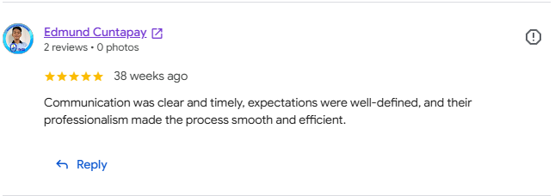
  - Tanay: https://tinyurl.com/Tanay-Reviews

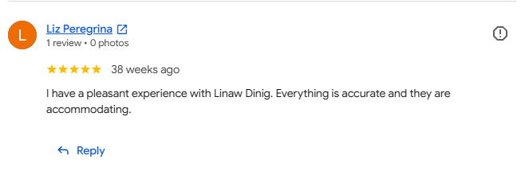

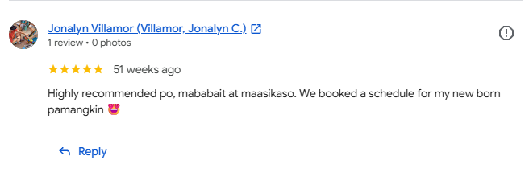

Cebu: https://tinyurl.com/Cebu-Review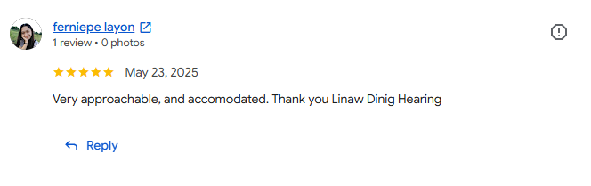
Dasma: https://tinyurl.com/DasmaGoogleReview
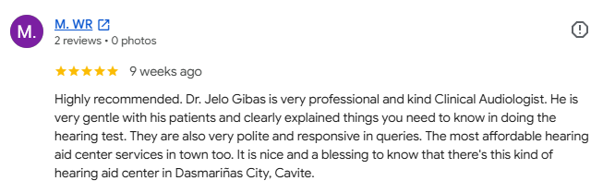

- Meet the Team, I’ve created a folder in the drive for each staff’s pictures po. Pa-zoom in na lang ang mga mukha and do not include the whole body. Here are our profiles:
  - Jelo Gibas
    - Lead Audiologist
    - Registered Nurse
    - Certified Newborn Hearing Screening Personnel
    - Graduate of Master in Clinical Audiology from University of Santo Tomas, Manila
    - Holder of Diploma in Pediatric Audiology from School of Advanced Education, Research and Accreditation, Spain
    - Graduate of Bachelors of Science in Nursing from Far Eastern University, Manila
    - Fun fact: Unflappable

  - Rica Roxas
    - Audiometrist (Tanay)
    - Certified Newborn Hearing Screening Personnel
    - With special training in Practical Home Behavior Management for Children with Special Needs and Identifying Red Flags of Developmental Delay
    - Certificate in Medical Office Administration
    - Certificate in Occupational First Aid Training and BLS CPR w/AED
    - Fun fact: Animal Lover
  - Hannah Pason
    - Audiometrist (Cebu)
    - With special training in Practical Home Behavior Management for Children with Special Needs and Identifying Red Flags of Developmental Delay
    - Certificate in Medical Office Administration
    - Certificate in Occupational First Aid Training and BLS CPR w/AED
    - Fun Fact: Jokester
  - Jah Estoque
    - Audiometrist (La Union)
    - Registered Midwife
    - With special training in Practical Home Behavior Management for Children with Special Needs
    - Certificate in Medical Office Administration
    - Fun fact: Comical
- Quick Hearing Self-Check: 5/5 stars for including this portion. Maybe we can bump it up sa bandang unahan Sir para clients can do a quick check pag enter pa lang ng site. Can we also add pictures per question para mas mapansin? I’ll create another folder of pictures for this sa drive po.
- FAQs
  - Hearing test cost: Hearing tests price can range from 550 pesos up to 8000 pesos depending on the required hearing test procedure. Message us to know the exact test price.
  - Hearing aid cost & payment options: Hearing aid price varies depending on the following factors- degree of hearing loss, technology level, visibility when wearing the devices, and connectivity. Send us a copy of your latest hearing test result so we can quote you accordingly.
Several flexible payment options are available such as cash, GCash, bank transfer or deposit, debit card, and credit card. We accept major cards such as Mastercard and Visa.
  - What Happens during a test: We start with a friendly chat about your hearing concerns, take a look in your ears, then run a series of comfortable hearing tests. Your audiologist explains the results in plain language and discusses your options.
  - How long does fitting take: As is. No change needed.
  - Best hearing aid brand: There is no single 'best' brand. The right device depends on the degree of your hearing, lifestyle, and budget. As an independent clinic we recommend what truly suits you.
  - Hearing aid trial: Yes. We offer a no-pressure, in-clinic trial session so you can experience the difference in your everyday life before committing.
  - Hearing aid repair: Yes, we service same brands that we offer — even if you didn't buy them from us.
  - How long hearing aid lasts: Most modern hearing aids last 3 – 5 years with proper care. We provide minor cleaning, servicing, and re-programming for the life of your device. All hearing aid purchases comes with 1 year warranty against manufacturing defects.
  - Do you test children’s hearing: As is. No change needed.
  - Do I need referral: As is. No change needed.
- For the facebook icons at the bottom of the page, can we add its respective location po para clients will know which icon to click?
- For the linaw dinig logo at the bottom of the page, can we retain its original color? I know hindi magiging uniform sa white texts but yung gold swirl sa letter D po kasi ang isa sa mga naka trademark register.
- For the Get in Touch portion: Can we itemize each contact details per branch? Para direct na ang inquiry ng clients and di na sila maligaw ng booking sa ibang branch? Nangyari na kasi before na sa Tanay sila nagpalista only to find out sa Cavite pala sila.
- For patients section:
  - New Patient Info:
    - What to bring: Doctor’s referral for hearing test (if available), Senior or PWD ID. Also, helpful if you tag along a family member or friend.
    - Time to allow: As is.
    - Parking & Access:
      - Tanay: Ample parking space and wheelchair accessible.
      - Cebu: Limited parking space. Not accessible by wheelchair.
      - Dasma: Limited parking space. Accessible by wheelchair.
      - La Union: Limited parking space. Limited mobility for wheelchair users.
- Fees & rebates: Please remove the word “rebates”. For the description, “Each hearing assessment has its corresponding rate. Please call us to know the exact amount.”
  - What to Expect:
    - 1. As is.
    - 2. Using an otoscope to check for wax, ear infection, or anything unusual in your external ears.
    - 3. As is.
    - 4. Jargon-free explanation of results.
    - 5. As is.
- About Us: Please remove the date 14 on established date. June 2021 will do I think. I have uploaded a picture in the drive to replace the existing one.
  - Why choose us:
    - Qualified professionals instead of licensed
  - Our clinics & Branches: Pls. put “Our Clinics” instead and remove the word branches. Please also remove the lounge picture as it is not our facility. I will upload a pic in the folder as replacement po. Front desk ng aming Tanay branch.
  - Pa remove na lang din po ang part na ito,
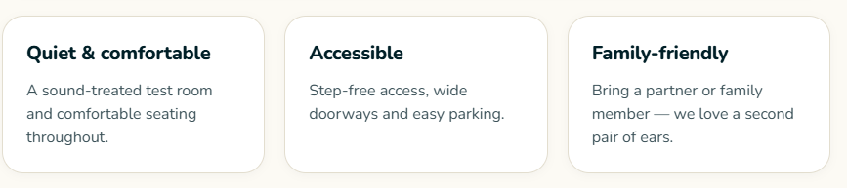
  - Find branch near you: As is.
- Book Your Appointment:
  - Please remove the line “Your first hearing test is completely free with no obligation to purchase.”
  - For appointment type:
    - Please remove free hearing consultation
    - Hearing aid counseling & fitting
    - “Follow-up care” only
    - Preferred time: Morning or Afternoon only
    - How did you hear about us:
      - Please add “Facebook, Tiktok” in parenthesis right after social media option.
      - Instead of GP, use the word Doctor
  - Can we add other branch numbers or maybe a link to contact us section on the “Prefer to Talk” section?
- Lastly, on the bottom-most part. Kindly remove the word “licensed”.

