Oracle Cluster File System (OCFS2) User’s Guide

1. Introduction

A Cluster File System allows all nodes in a cluster to concurrently access a device via the standard file system interface. This allows for easy management of applications that need to run across a cluster.

OCFS (Release 1) was released in December 2002 to enable Oracle Real Application Cluster (RAC) users to run the clustered database without having to deal with RAW devices. The file system was designed to store database related files, such as data files, control files, redo logs, archive logs, etc.

OCFS2 is the next generation of the Oracle Cluster File System. It has been designed to be a general-purpose cluster file system. With it, one can store not only database related files on a shared disk, but also store Oracle binaries and configuration files (shared Oracle home) making management of RAC even easier.

2. Installation

The OCFS2 distributions comprises of two sets of packages. Namely, the kernel module and the tools.

The kernel module is available for download from http://oss.oracle.com/projects/ocfs2/files/ and the tools from http://oss.oracle.com/projects/ocfs2-tools/files/.

Download the appropriate packages. For the kernel module, download the one that matches the distribution, platform, kernel version and the kernel flavor (smp, hugemem, psmp, etc). For tools, simply match the platform and distribution.

The tools packages are split into two. ocfs2-tools includes the command line tools, whereas, ocfs2console includes the GUI front-end for the tools. One does not have to install the console, though it is recommended for ease-of-use.

Install the packages using the rpm --install or rpm --upgrade command on each node that will be part of an OCFS2 cluster.

3. Configuration

OCFS2 has one configuration file, namely, /etc/ocfs2/cluster.conf. In it, one needs to specify all the nodes in the cluster. This file should be the same on all the nodes in the cluster. Whereas one can add new nodes to the cluster dynamically, any other change, like name, ip address, requires the cluster to be restarted for the changes to take effect.

Users are strongly recommended to use ocfs2console to setup and propagate the cluster.conf to all the nodes in the cluster. This needs to be done only on one of the nodes in the cluster. After this step, users will see the same /etc/ocfs2/cluster.conf on all nodes in the cluster. Please note that differing cluster.conf(s) will lead to unpredictable behavior.

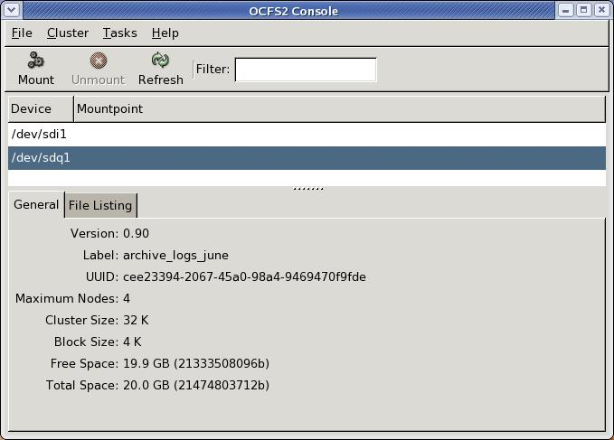

Start ocfs2console and click on menu item Cluster followed by Configure Nodes. If the cluster is offline, the console will start it and display a message to that effect. If cluster.conf is not present, the console will create one with a default cluster name ocfs2.

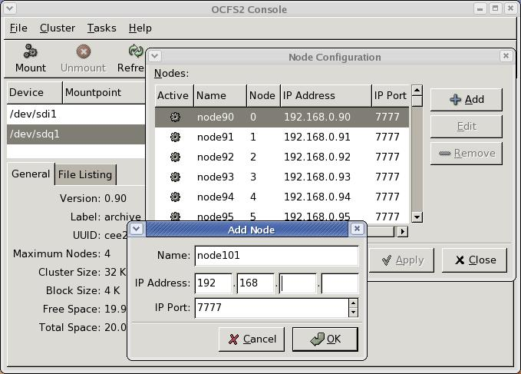

Click on Add to add nodes to the cluster. One needs to enter the node name (same as the hostname), the IP Address and Port. The console assigns node numbers sequentially from 0 to 254.

Once all the nodes are added, one can propagate the configuration to all the nodes by clicking on menu item Cluster followed by Propagate Configuration.The console uses ssh to propagate the configuration file. If the nodes have not been setup for automatic ssh login authentication (refer ssh manpage), the console will prompt the user for the root password of the node it is propagating to.

Please refer to the appendix A for a sample cluster.conf and the description of the layout.

4. O2CB Cluster Service

OCFS2 comes bundled with its own cluster stack, O2CB. The stack includes:

- NM: Node Manager that keep track of all the nodes in the cluster.conf
- HB: Heart beat service that issues up/down notifications when nodes join or leave the cluster
- TCP: Handles communication between the nodes
- DLM: Distributed lock manager that keeps track of all locks, its owners and status
- CONFIGFS: User space driven configuration file system mounted at /config
- DLMFS: User space interface to the kernel space DLM

All the cluster services have been packaged in the o2cb system service.

OCFS2 operations, such as format, mount, etc., require the O2CB cluster service to be at least started in the node that the operation will be performed.

To check the status of the cluster, do:

# /etc/init.d/o2cb status
Module "configfs": Not loaded
Filesystem "configfs": Not mounted
Module "ocfs2_nodemanager": Not loaded
Module "ocfs2_dlm": Not loaded
Module "ocfs2_dlmfs": Not loaded
Filesystem "ocfs2_dlmfs": Not mounted

To load the modules, do:

# /etc/init.d/o2cb load
Loading module "configfs": OK
Mounting configfs filesystem at /config: OK
Loading module "ocfs2_nodemanager": OK
Loading module "ocfs2_dlm": OK
Loading module "ocfs2_dlmfs": OK
Mounting ocfs2_dlmfs filesystem at /dlm: OK

To online cluster ocfs2, do:

# /etc/init.d/o2cb online ocfs2
Starting cluster ocfs2: OK

The O2CB cluster should be now started, ready for OCFS2 operations such as format (which is described in the next section).

Other O2CB operations are described below.

To offline cluster ocfs2, do:

# /etc/init.d/o2cb offline ocfs2
Cleaning heartbeat on ocfs2: OK
Stopping cluster ocfs2: OK

To unload the modules, do:

# /etc/init.d/o2cb unload
Unmounting ocfs2_dlmfs filesystem: OK
Unloading module "ocfs2_dlmfs": OK
Unmounting configfs filesystem: OK
Unloading module "configfs": OK

To configure O2CB to start on boot, do:

# /etc/init.d/o2cb configure
Configuring the O2CB driver.

This will configure the on-boot properties of the O2CB driver.
The following questions will determine whether the driver is loaded on
boot. The current values will be shown in brackets ('[]'). Hitting
<ENTER> without typing an answer will keep that current value. Ctrl-C
will abort.

Load O2CB driver on boot (y/n) [n]: y
Cluster to start on boot (Enter "none" to clear) []: ocfs2
Writing O2CB configuration: OK
#

If the cluster is setup to load on boot, one could start and stop cluster ocfs2, as follows:

# /etc/init.d/o2cb start
Loading module "configfs": OK
Mounting configfs filesystem at /config: OK
Loading module "ocfs2_nodemanager": OK
Loading module "ocfs2_dlm": OK
Loading module "ocfs2_dlmfs": OK
Mounting ocfs2_dlmfs filesystem at /dlm: OK
Starting cluster ocfs2: OK

# /etc/init.d/o2cb stop
Cleaning heartbeat on ocfs2: OK
Stopping cluster ocfs2: OK
Unmounting ocfs2_dlmfs filesystem: OK
Unloading module "ocfs2_dlmfs": OK
Unmounting configfs filesystem: OK
Unloading module "configfs": OK

5. Format

If the O2CB cluster is offline, start it. The format operation needs the cluster to be online, as it needs to ensure that the volume is not mounted on some node in the cluster.

One can format a volume either using the console or using the command line tool, mkfs.ocfs2. This needs to be done from one node in the cluster and does not need to be repeated for the same volume from other nodes.

To format using the console, start ocfs2console, and click on menu item Tasks followed by Format.

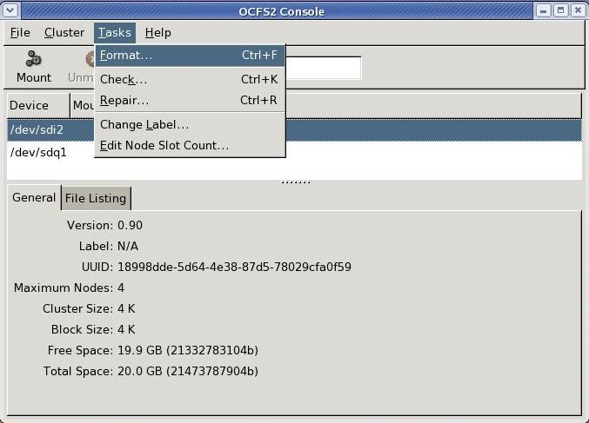

Select a device to format in the drop down list Available devices. Wherever possible, the console will list the existing file system type.

Enter a label. It is recommended one label the device for ease of management. The label is changeable after the format.

Select a cluster size. The sizes supported range from 4K to 1M. For a data files volume, large files, a cluster size of 128K or larger is appropriate.

Select a block size. The sizes supported range from 512 bytes to 4K. As OCFS2 does not allocate a static inode area on format, a 4K block-size is most recommended for most disk sizes. On the other hand, even though it supports 512 bytes, that small a block size is never recommended.

Both the cluster and blocks sizes are not changeable after the format.

Enter the number of node slots. This number determines the number of nodes that can concurrently mount the volume. This number can be increased, but not decreased, at a later date.

Click on OK to format the volume.
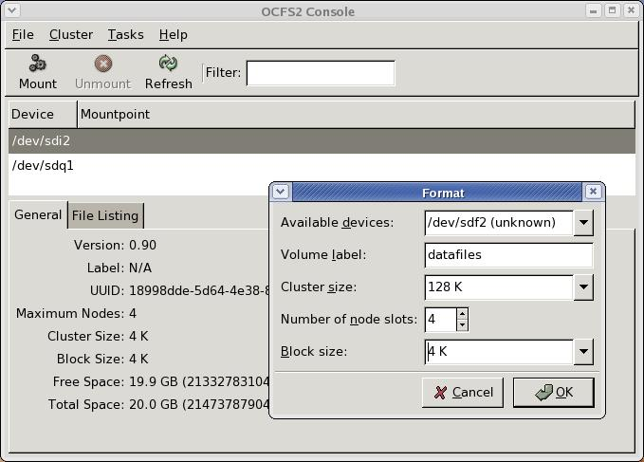

To format a volume with a 4K block-size, 32K cluster-size and 4 node slots using the command line tool, mkfs.ocfs2, do:

# mkfs.ocfs2 -b 4K -C 32K -N 4 -L oracle_home /dev/sdf2
mkfs.ocfs2 1.2.0
Overwriting existing ocfs2 partition.
Proceed (y/N): y
Filesystem label=oracle_home
Block size=4096 (bits=12)
Cluster size=32768 (bits=15)
Volume size=21474820096 (655359 clusters) (5242872 blocks)
21 cluster groups (tail covers 10239 clusters, rest cover 32256 clusters)
Journal size=33554432
Initial number of node slots: 4
Creating bitmaps: done
Initializing superblock: done
Writing system files: done
Writing superblock: done
Writing lost+found: done
mkfs.ocfs2 successful

For the complete help on mkfs.ocfs2, refer to its man page.

6. Mount

If the O2CB cluster service is offline, start it. The mount operation requires the cluster to be online.

One can mount a volume using the console or the command line tool, mount. This operation should be performed on each node that the volume needs to be mounted.

To mount from the console, start ocfs2console, select the device and click on Mount. In the dialog, enter the directory mount point and, optionally, mount options. Click on OK. On a successful mount, the device list will show the mount point along with the device.

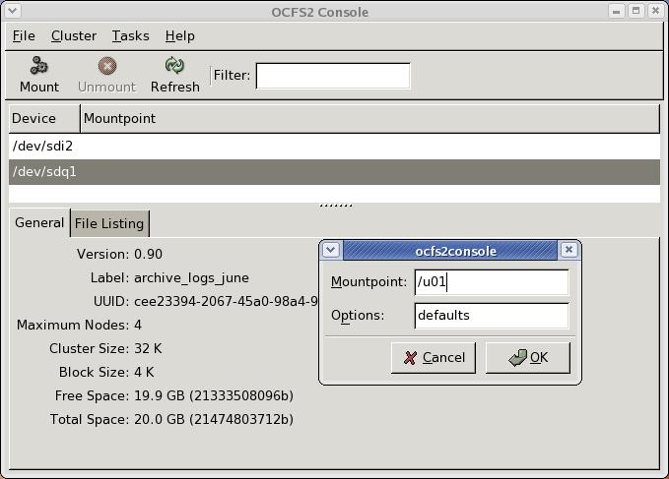

To mount from the command line, do:

# mount -t ocfs2 /dev/sdf2 /u01

To unmount a volume, one can select the desired volume in the console and click Unmount or do:

# umount /u01

Oracle database users must mount the volumes containing the Voting Disk file (CRS), Cluster Registry (OCR), Data files, Redo logs, Archive logs and Control files with the datavolume,nointr mount options. The datavolume mount option ensures that the Oracle processes open the files with the o_direct flag. The nointr mount option ensures that the reads and writes on that device are not interrupted by signals. All other volumes, including Oracle home, should be mounted without these mount options.

To mount volume containing Oracle data files, Voting disk, etc., do:

# mount -t ocfs2 -o datavolume,nointr /dev/sdf2 /u01
# mount
/dev/sdf2 on /u01 type ocfs2 (rw,datavolume,nointr)

To mount OCFS2 volumes on boot, one needs to enable both the o2cb and ocfs2 services using chkconfig, configure o2cb to load on boot, and add the mount entries into /etc/fstab as follows:

# cat /etc/fstab
...
/dev/sdf2 /u01 ocfs2 _netdev,datavolume,nointr 0 0
/dev/sdg2 /orahome ocfs2 _netdev 0 0
...

The _netdev mount option is a must for OCFS2 volumes. This mount option indicates that the volume is to be mounted after the network is started and dismounted before the network is shutdown. (The datavolume and nointr mount options are only required for Oracle data files, etc.)

The ocfs2 service can be used to mount and umount OCFS2 volumes. It should always be enabled to ensure that the OCFS2 volumes are umounted before the network is stopped during shutdown.

# chkconfig --add ocfs2
ocfs2 0:off 1:off 2:on 3:on 4:off 5:on 6:off
# chkconfig --add o2cb
o2cb 0:off 1:off 2:on 3:on 4:off 5:on 6:off
#
#
# /etc/init.d/o2cb configure
...
Load O2CB driver on boot (y/n) [n]: y
Cluster to start on boot (Enter "none" to clear) []: ocfs2
Writing O2CB configuration: OK

To mount by label, do:

# mount -L datafiles /u01

7. Tune

The tuning operation allows one to increase the number of node slots (to increase the number of nodes that can concurrently mount the volume), change the volume label and increase the size of the journal file.

tunefs.ocfs2 is the command-line tool that performs the tuning. One can also access this tool via the console.

If the O2CB cluster service is offline, start it. The tune operation requires the cluster service to be online.

To increase the number of node slots in the volume using the console, click on the menu-item Tasks followed by Edit Node Slot count. Enter the new number and click on OK.

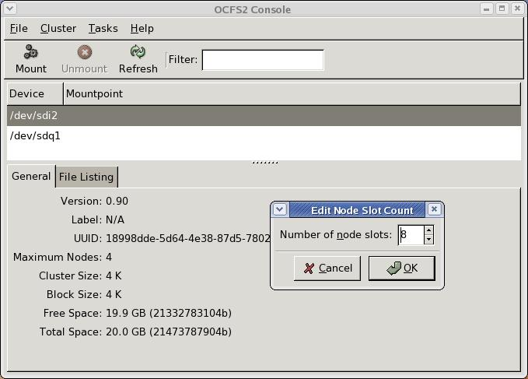

To increase the number of node slots using the command-line tool, tunefs.ocfs, do:

# tunefs.ocfs2 -N 8 /dev/sdf2
tunefs.ocfs2 1.2.0
Changing number of node slots from 4 to 8
Proceed (y/N): y
Added node slots
Wrote Superblock

To change the volume label in the volume using the console, click on the menu item Tasks followed by Change Label. Enter the new label and click on OK.

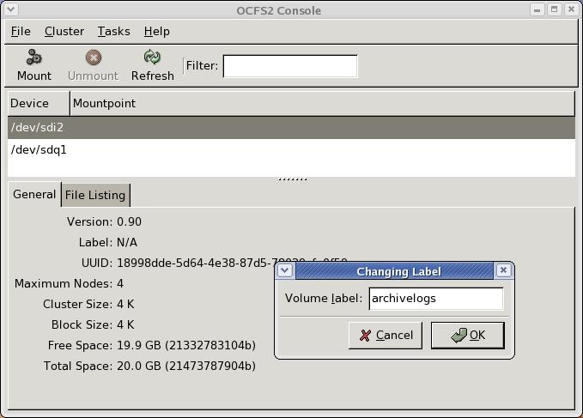
To change the volume label using the command-line tool, tunefs.ocfs, do:

# tunefs.ocfs2 -L "old datafiles" /dev/sdf2
tunefs.ocfs2 1.2.0
Changing volume label from datafiles to old datafiles
Proceed (y/N): y
Changed volume label
Wrote Superblock

For the complete help on tunefs.ocfs2, refer to its man page.

8. File System Check

File system check operation checks the health of the file system. It is recommended one run this utility regularly in order to detect and fix any irregularities in the volume.

fsck.ocfs2 is the command-line tool that performs the check. One can also access this tool via the console.

Start ocfs2console, and click on menu-item Task followed by Check. This performs the read-only check operation, and could be performed with the file system mounted on the cluster. The equivalent on the command-line would be,

# fsck.ocfs2 -n /dev/sdf2
Checking OCFS2 filesystem in /dev/sdf2:
label: oracle_home
uuid: dc a2 90 1b 24 1f 40 6e 80 e9 85 dd 6b 45 2d 1a
number of blocks: 5242872
bytes per block: 4096
number of clusters: 655359
bytes per cluster: 32768
max slots: 4

/dev/sdf2 is clean. It will be checked after 20 additional mounts.

To do the repair, click on the menu-item Task followed by Repair. This operation requires the O2CB cluster service to be online to ensure that the volume is not mounted on any node in the cluster. The equivalent for the command-line would be,

# fsck.ocfs2 -y /dev/sdf2
Checking OCFS2 filesystem in /dev/sdf2:
label: oracle_home
uuid: dc a2 90 1b 24 1f 40 6e 80 e9 85 dd 6b 45 2d 1a
number of blocks: 5242872
bytes per block: 4096
number of clusters: 655359
bytes per cluster: 32768
max slots: 4

/dev/sdf2 is clean. It will be checked after 20 additional mounts.

For the complete help on fsck.ocfs2, refer to its man page.

9. Context Dependent Symbolic Links (CDSL)

In a shared-disk clustered environment, there are instances when one needs to share just the file or the directory name across the cluster but not the contents. For example, in a shared Oracle home setup, network/admin/listener.ora is common to all the nodes but its contents differ from node to node. Similarly, in a shared root setup, one needs /etc/ to be different for each node in the cluster.

In both these instances, the actual contents of the file or directory depend on the hostname. In other instances, one may require that the contents are dependent on the architecture (x86, x86-64 or IA64), or perhaps, the node number.

To handle this issue, OCFS2 implements Context Dependent Symbolic Links (CDSL). In short, it uses soft links to match a file or a directory name to its contents. (Please note that this feature is not enabled on the volumes mounted with the datavolume mount option.)

ocfs2cdsl is the command-line tool used to create these links.

To create a hostname dependent CDSL file, do,

root@node32:admin/# ocfs2cdsl listener.ora
root@node32:admin/# ls –l listener.ora
lrwxrwxrwx 1 root root 50 Aug 8 11:41 listener.ora ->
../.cluster/hostname/{hostname}/10g/network/admin/listener.ora

Edit this file and save the new content. To access the file from some other node in the cluster, create the CDSL on that node before editing. (As hostname is the default, one does not need to specify –t hostname in the command.)

root@node31:admin/# ocfs2cdsl listener.ora

To convert an existing file into a CDSL file, do,

root@node32:admin/# ocfs2cdsl –c sqlnet.ora

Once again, to access from some other node in the cluster, create the CDSL on that node before accessing the file.

root@node31:admin/# ocfs2cdsl sqlnet.ora

In this case, you will notice that the file has the same content as it did when the file was converted to a CDSL. Any new changes to the file on both nodes will not be visible to the other node.

To edit a CDSL file or directory belonging to another host or architecture, change directory to
.cluster in the root (mount directory) of the OCFS2 volume and traverse to the directory holding the required copy. For example, to edit node32’s copy of listener.ora on node31, do,

root@node31:/# ls -l /ohome/.cluster/hostname/node32/10g/network/admin/l*
-rw-r--r-- 1 root root 3867 Aug 8 11:54 listener.ora

To delete a CDSL file, just unlink it, as,

root@node31:admin/# rm listener.ora

For the complete help on ocfs2cdsl, refer to its man page.

10. Other Tools

mounted.ocfs2

mounted.ocfs2 is a command-line tool used to list all the OCFS2 volumes on a node. This tool scans all the partitions listed in /proc/partitions as part of its detection process. If run in the full detect mode, it lists all the nodes that have mounted that volume.

To list all the OCFS2 volumes on a system, do,

# mounted.ocfs2 -d
Device FS UUID Label
/dev/sdb1 ocfs2 e70c75a0-a08c-480a-bf50-ebda4191da30 mm_v2_dbf1
/dev/sdb2 ocfs2 f49163e8-6288-43c4-a792-e9401fde45fa mm_v2_ctrl
/dev/sdb3 ocfs2 2d441be2-adb6-4c52-9e19-9a7c2c485dc4 mm_v2_dbf2
/dev/sdb5 ocfs2 8607eae9-8e4f-4495-84e8-8db0bc9da60c mm_v2_log1
/dev/sdb6 ocfs2 acfb7b7d-a277-4741-9791-620ea9b82670 mm_v2_log2
/dev/sdf1 ocfs2 84749537-df45-4a97-aa28-fad63760b674 9ihome
/dev/sdq1 ocfs2 dca2901b-241f-406e-80e9-85dd6b452d1a oracle_home
/dev/sdcf1 ocfs2 663764bd-1eed-4b3c-aa48-a98f0be0e574 10ghome
/dev/sdcf2 ocfs2 8e2d9c21-ef47-4fea-8ac5-2306cc60455e mm_v2_log3

To list all the nodes that have mounted the OCFS2 volumes on a system, do,

# mounted.ocfs2 -f
Device FS Nodes
/dev/sdb1 ocfs2 node31, node32, node33, node34
/dev/sdb2 ocfs2 node31, node32, node33, node34
/dev/sdb3 ocfs2 node31, node32, node33, node34
/dev/sdb5 ocfs2 node31, node32, node33, node34
/dev/sdb6 ocfs2 node91, node90
/dev/sdf1 ocfs2 Not mounted
/dev/sdq1 ocfs2 node34, node35
/dev/sdcf1 ocfs2 Not mounted
/dev/sdcf2 ocfs2 Not mounted

Note: The node names are only listed if the O2CB cluster service is online. If not, it lists the global node numbers instead.

For the complete help on mounted.ocfs2, refer to its man page.
APPENDIX A

The configuration file is in a stanza format with two types of stanzas, namely, cluster and node. As OCFS2 does not support multiple clusters, a typical cluster.conf will have one cluster stanza and multiple node stanzas. (Please note that the cluster.conf parser currently expects the stanza line to start from the first column (no whitespace) and end with a colon and expects the parameter line to start with a tab followed by the name of the parameter and value separated by a equal to sign.)

Sample /etc/ocfs2/cluster.conf

cluster:
node_count = 2
name = racdb

node:
ip_port = 7777
ip_address = 192.168.0.107
number = 7
name = node7
cluster = racdb

node:
ip_port = 7777
ip_address = 192.168.0.106
number = 6
name = node6
cluster = racdb

The Cluster stanza has two parameters:

- node_count - Total number of nodes in the cluster
- name - Name of the cluster

The Node stanza has five parameters:

- ip_port - IP Port
- ip_address - IP Address
- number - Unique node number from 0-254
- name - Hostname
- cluster - Name of the cluster should match that in the Cluster stanza

