

Image credit: http://www.clker.com/clipart-344791.html

Director
(c) Mark Final, 2016-2017
v0.0.17

Cg animation made easy for everyone

User Guide
Last update: 09-February-2017

Designed and written by Mark Final
markfinal@hotmail.com

Table of Contents
Requirements 4
Optional 4
Version numbers 4
Installation 5
Windows 5
Linux 5
OSX 5
First run : licensing 5
Subsequent runs 6
Software Updates 6
Tips 6
What is Director? 7
A brief tour of the Director UI 7
Drag-n-drop 8
Asset files 8
Geometry 9
Images 10
Actors 10
Transformations 11
Motion paths 12
Shaders and shader instances 13
Dope sheet 15
Easing 18
Lights 19
Viewport 20
Orbit camera 20
Animatable camera 20
View options 20
Normals 20
Bones 21
Flip between GPU and RSL single-frame renders 21
Onion skinning 22
Shadows 23
Props 24
Motion path visualisation 24
Additional visualisations 25
Beauty renders 27
Projects 28
Source control and project collaboration 28
Git plugin 28
Configuring remotes 29
Letting others use your TimeLine 29
Project Collaboration 30
Using github 30
Installing git 30
Windows 30
Linux 30
OSX 30
Settings 31
Theme 31
User authentication 31
Bugs and feature requests 31
In-application feedback 31
Log file 31
Third party licenses 32
Documentation feedback 32

Requirements
- 64-bit desktop operating system:
  - Windows 7+
  - Linux Ubuntu 14+/CentOS7+
  - OSX 10.9+
- Internet connection (proxy settings available)
- Beauty renders using REYES renders require:
  - A fairly modern CPU (or multiple CPUs)
  - Sufficient memory
  - Sufficient disk space (mostly taken up by per frame images)
- A valid email address that you have access to.

Optional
- Each of the following requires a preference to be set in Director:
  - To render with PRMan 19+ (non-commercial available from https://renderman.pixar.com/view/non-commercial-renderman)
  - To load .blend files, Blender v2.76+ must be installed. Available to download from https://www.blender.org/
  - To create movies, ffmpeg v3.0.7+ (static build) must be installed, available from https://www.ffmpeg.org/
  - If you want to use an external movie player, its path and any command line arguments can be configured. This can be useful if your computer does not have all the necessary codecs provided in the system.
- A modern GPU with drivers supporting OpenGL2 will generally enhance the 3D viewport experience.

Version numbers
The version of the software is split into several parts

major.minor.patch.yymmdd.phase

major.minor.patch are the standard version numbers:
A change in patch means a bug fix. Compatibility with older major.minor versions will be maintained where possible.
A change in minor generally means bug fixes with wider implications, and additional features. Compatibility with older major versions will be maintained.
A change in major is a wide scale change. There is likely to be incompatible changes with older versions.

yymmdd is the date tagged when the build was made; two digits for year, two for month, and two for day.

phase is one of:
- a – alpha build; do not rely on the stability of this, as it may not be feature complete, and there may be breaking changes forthcoming
- b – beta build; should be feature complete, and subsequent betas should only contain bug fixes
- c – candidate build; zero or only a few minor bugs should remain to be fixed for the feature set (this is for final testing)
- d – delivery build; all known bugs of the feature set have been fixed.

Installation

Windows
Run the installer .exe. Choose a directory to install. There is currently no requirement for Director to be located in a privileged location. No data is written into the registry. No shortcut is created on the start menu/start page. Also, no uninstaller is created. To uninstall, simply delete the Director directory containing the main executable.
Run the Director.exe executable.

Linux
Extract the .tgz to a location of your choice. The files within the archive are within a directory named after the release, so the current directory will not be polluted.
Run the Director executable.

OSX
Open the .dmg disk image. Either run Director.app from within the dmg, or drag Director.app to a location of your choosing (it does not have to be in Applications).

If your security settings do not allow double-click opening a file downloaded from the internet, right click over the .dmg and choose Open, and there should be an option to allow it.

First run : licensing
A dialog showing the EULA (End User Licensing Agreement) is displayed for you to read and agree with. In order to use the software, you must agree with the terms in the EULA.

Once agreed, the Director UI will open, and first time users will be asked to register for licensing. Licensing is cloud based, and thus requires an active internet connection in order to contact servers. If external access is blocked at your site, proxy settings will be offered if the servers cannot be contacted.

License registration consists of several interactive steps:
- register an email address for your user account. You must have access to this email account in order to complete the licensing process. A file is saved in your home directory in order to identify your account: .patchworks.privatekey. Do not delete this file under any circumstances as it unique to your account and cannot be recreated. Do not share this file with anyone else, as it is equivalent to sharing a password. If you want to use your registered email address to license this software on another machine, this file must be copied to your home directory on the other machine.
  - Because this is such an important step, you must specify the email twice; both entries must be identical to enable the registration button.
  - You will also be prompted to confirm that what you have written is correct and you want to continue registering.
- register the machine on which you are running Director. You are entitled to run Director on up to three different machines (identified by MAC address) for your email address. Each new machine will require registration and authorisation.
- authorise the machine for use with your user account (each user of the same machine must individually authorise its use for their account). This will involve reading an email sent to the address you previously registered.
- acquire a license. If you have not previously acquired a license for the software, a 30 day trial license is granted. Trial licenses are fully featured. While your license remains valid, Director will continue to run.

Note that clicking on the close button on the licensing dialog at any stage will cancel licensing and close Director.

Subsequent runs
Only when a new version of Director is detected will the EULA agreement be shown again. The EULA may change with new versions of Director.
As long as your license remains valid, licensing should no longer require any input from the user, unless a previously unknown machine is used, or an error occurs.

Software Updates
A check for an update is run automatically when Director starts. A manual check can also be run from the option in the Help menu. The automatic check can be disabled from the preferences.
Updates are optional, but will contain bug fixes and feature improvements. There may also be changes to project data formats, but all endeavours will be made to upgrade existing projects. Projects using newer features will not open in older versions of the software.

Tips
A dialog showing tips to use Director is shown at startup. You may cycle through all the tips. There is a checkbox on the dialog to disable showing this at startup. This may also be set in the preferences.

What is Director?
Director is a Cg animation authoring desktop application, designed with a straight-forward to use interface, and an aim of being able to animate almost everything in a scene. Its primary target audience is the animation amateur/enthusiast/student, but it is hoped that professionals will also enjoy using it.
Director allows the user to add geometric actors into a scene that can be animated at user-defined keyframes along a timeline. A single frame of the timeline can be previewed on the computer, using GPU acceleration if available, for an approximation to the final look. Alternatively and additionally, the entire timeline can be rendered using a REYES renderer for a beauty render, and a movie file generated subsequently. The same data is used in both approaches.
Actors can be created from geometry files (.obj, .3ds, .ply, .stl for rigid bodies, .blend for rigid and/or rigged bodies). Geometry data is not modifiable, nor generated (except for normals), within Director.
Shaders are defined through a node graph in Director using (a subset of) the Open Shading Language (OSL) specification. These shaders are translated by Director to a GPU shader or an RSL shader.
Texture images can be used in shaders (.tiff, .png, .exr, .jpeg files currently supported). Image data is not modifiable within Director.
There is no audio support.

A brief tour of the Director UI
The UI centres around the 3D viewport, surrounded by several dockable panes and toolbars. All windows in the dockable panes can be moved around or undocked.
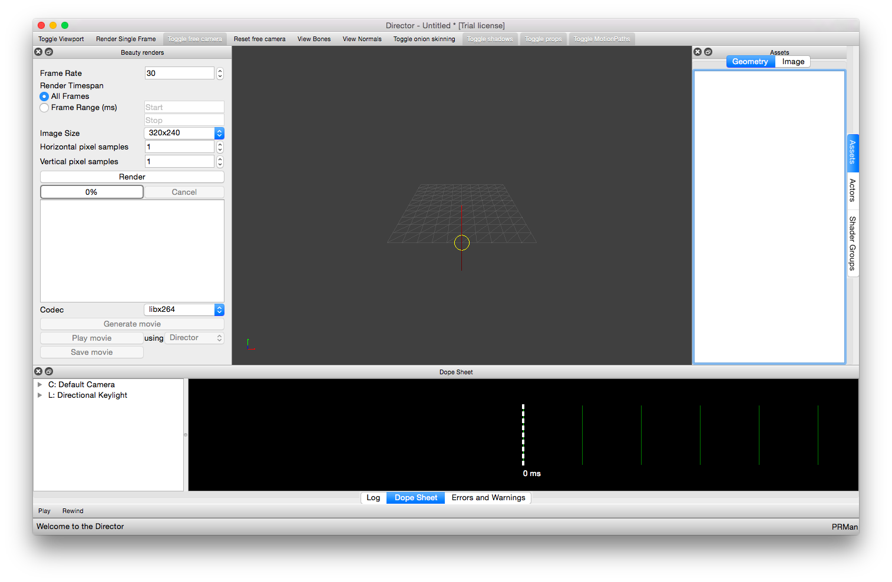
Above the 3D viewport, there is a toolbar that mirrors the options on the View menu. These toolbar buttons affect what is rendered in the viewport.
On the bottom dockable area, there is the application log (see Log file), an errors and warnings pane for Director to report issues to you, and the Dope Sheet displaying all animatable parameters in the timeline. Below this dockable area is a toolbar with two buttons, Play and Rewind, that can be used to preview the animation in the 3D viewport. Below the toolbar is a status bar. Messages and progress bars will occasionally appear here. Also the far right of the status bar indicates which REYES renderer is selected, and the total number of pending background tasks will be noted here as well.
To the right, there are windows detailing the assets loaded (tabbed for each type of asset), the actors defined and their non-animatable parameter values, and the shaders available.
To the left, is the beauty render pane, providing the settings to configure the REYES renderer, as well as movie generation, and playback.

Drag-n-drop
The UI is drag-n-drop enabled. Files can be dragged from your filesystem into Director to be loaded, if they are of supported types.
Other items can also be dragged around the UI. These will be explained in context below.

Asset files
Director is aware of several types of asset file:
- Wavefront .obj geometry files
- 3DS max files
- Stanford .ply geometry files
- Stereolithography .stl files
- Blender .blend mixed type files (although mostly geometry, embedded images are also detected)
- .tiff image files
- .png image files
- .exr OpenEXR image files
- .jpeg image files
These files can be dragged from your filesystem into the Director UI and will appear in the Assets pane. Any filetype not recognized will disallow being dragged in (the cursor will change to reflect this).
In order to use .blend files, Blender must be installed on your computer, and its location set in Director's preferences.
In addition to drag-n-dropping a file onto the UI, the Assets pane also has a context menu that allows loading one or more files.

Geometry
Director uses a left-handed coordinate system. Positive x is to the right; positive y is up; positive z is into the screen.
Currently, only polygonal meshes are supported. Normals and one set of UV coordinates are supported. If normals are not present in the data, they will be generated upon load.
For geometry files only supporting rigid body meshes, mesh animations in Director are therefore limited to transforming those meshes in the scene (see Dope sheet). Director will identify the different meshes defined in the geometry file (e.g. 'groups' in an .obj file), and display these in the UI in the Assets pane (Geometry tab) as children of that file.
Rigid body vertex data appears in Director as-is from the source file. The one exception to this is when using the Assimp loader, which will generate smooth normals if missing, and will change to a left-handed coordinate system.
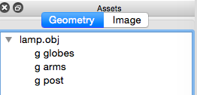
Blender .blend files support rigid body meshes and rigged meshes (through Blender Armatures and a hierarchy of bones). Director will identify all meshes, and group those parented to a rig, in the Assets pane (Geometry tab). In addition to transforming meshes in the scene, rigged meshes expose transformations on each of the bones in the rig, also available on the Dope sheet.
Blender uses a right handed coordinate system; positive x is to the right, positive z is up, positive y is into the screen. Rigid bodies are converted to Directors left handed coordinate system upon export. Rigged geometries have a conversion embedded into the skinning matrices.
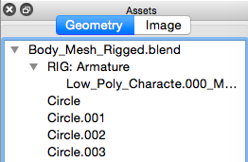

Images
Image files dragged into the Director UI appear under the Assets pane (Image tab). Since image files can consist of multiple images, each are exposed in the UI in a similar way to individual meshes in geometry files.
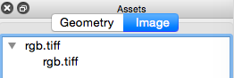
Each image then becomes available for selection in drop-down selections for shader instances.
A default checkerboard image is defined automatically by Director, and initially selected for image inputs in shader instances.

Actors
Dragging one or more of the meshes from the Assets window into the viewport creates an Actor in Director, and will become visible in the viewport at the world origin. This allows a single asset file to contain the geometry source to potentially many Actors.
Note that an actor can only contain meshes from the same asset file. It is not possible to use meshes from different asset files.
Each mesh in the actor has an associated instance of a shader, allowing per-mesh configuration of shader parameter values. The default shader is used initially.
Actors appear in the UI in two locations. On the right Actor window
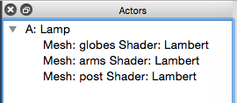
which offers selection of non-animatable parameter values:
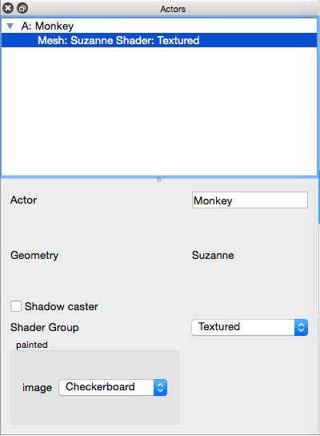
Also, in the Dope sheet, with an associated value for each animatable parameter at each keyframe.
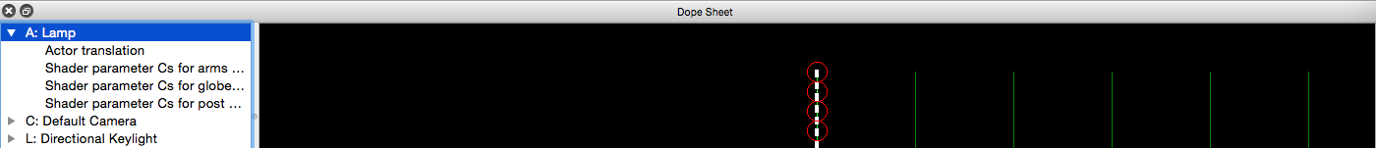
By default, an actor will be assigned the following animated properties in the DopeSheet:
- translation transformation at a keyframe at time zero (to place it in the scene), defaulting to the origin, and
- any animatable parameters for the default shader.

Transformations
Director defines three types of transformation:
- Translation
- Scale
- Rotate
Actors can have any combination of these transformations applied to them, each transformation animating independently.
Bones in rigged Actors can only currently have rotations applied to them.
Lights currently have a direction only (a translation).
Cameras have a
- position (a translation),
- a lookat position (a translation),
- focal distance (a float, distance from camera),
- focal length (a float),
- field of view (fov) (a float),
- fstop (a float).
Since the underlying mathematics of applying transformations requires that order matters (matrix multiplication is non-commutative), the order in which transformations are applied to Actors is important in Director. For example, a rotation followed by a translation will be different to a translation followed by a rotation. Hence, in the DopeSheet, Actor transformations can be reordered by dragging them up or down. The evaluation order is top-down.
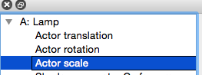
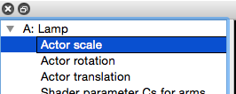
Each transformation type works directly by specifying values along the XYZ axes, but the visible effect of modifying a transformation depends on how those axes have been transformed by those transformations that have been applied before it.
Note that rotations are currently stored as Euler angles. (* Haven't yet seen an interpolation issue, such a gimbal lock, that would require changing to Quaternions.)

Motion paths
The default interpolation between all animatables in Director is linear. Modifying the easing between two keyframes allows the speed of the interpolation to be varied. However, if a curved path is required, then this is not easily achieved, unless you have the patience to create a piecemeal set of linear translations.
If 'Toggle MotionPaths' is enabled on the View menu/toolbar, a blue line is rendered following the trajectory of the currently selected Actor or Camera. Initially, this will be linear paths between keyframes.
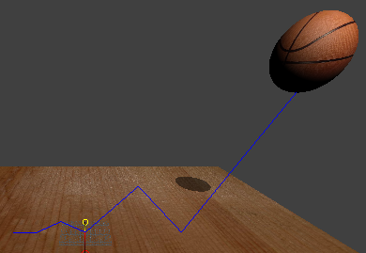
Director supports the concept of motion paths between two translation keyframes. Those two keyframes define the end points of a curve, and the motion path specifies the position of two control points, defining a cubic bezier curve in 3D.
The control points are defined relative to the position in the first keyframe, so will move if that translation is edited.
If a keyframe is added between two that have a MotionPath, the MotionPath will re-associate with the initial keyframe, and the just added one. There is no support for splitting an existing MotionPath. So note that the curve will change as the end point has moved.
To modify a MotionPath, right click over the start keyframe in the dope sheet, and choose 'Edit MotionPath...'. In the 3D viewport, the control points will appear (blue circles) and translation widgets (arrows) will appear in each of the 3 major axes. Click and drag the arrows to move the control points, constraining to the axis selected.
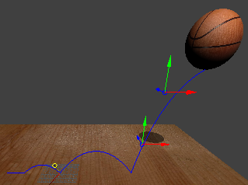
Clicking on another keyframe will disable the MotionPath edit.

Shaders and shader instances
The available shaders in the timeline can be viewed in the ShaderGroups pane on the right dockable area.
By default a Lambert shader is defined (but can be modified). Each mesh created for an actor is initially defined an instance of this default shader, but a different shader may be assigned in the Actor pane.
Shaders in Director use (a part of) the Open Shading Language (OSL) specification. As such, they are defined by a sequence of layers (the DAG) of reusable component shaders, and layer inputs/outputs are connected together. Not all inputs can be connected to outputs; they need to be of compatible types. Some layers output colours while some layers output closures, and these are considered different types by OSL. Please refer to the OSL specifications for more details on this.
To view the DAG, right click over a shader in the ShaderGroups pane and choose Edit. A graphical representation of the DAG will then be displayed.
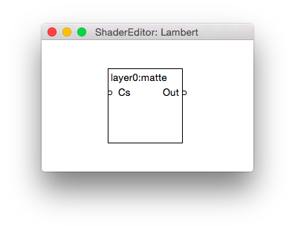
Each large rectangle represents one of the layers. The top of the rectangle shows the layer name and name of the component shader. The circles down the left of the layer are input parameters. The circles down the right of the layer are output parameters. Connections between inputs and outputs are represented by lines, and can be created by dragging from an output to an unconnected input. Right clicking over a connection line opens a context menu allowing the connection to be deleted.
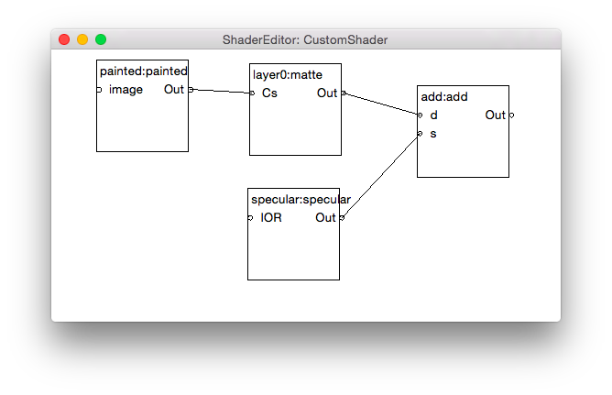
Unconnected input parameters are of interest in the Director UI. If they are animatable, e.g. the parameter type is a colour, then this is exposed on the DopeSheet for each instance of the shader used in the scene. If they are not animatable, e.g. the parameter type is an image, then this is exposed in the Actor window for each shader instance.
Every instance of a shader uses the same definition of the DAG, but stores independent values for each of its parameters.
Shaders are translated into GPU shaders for the Director viewport, and RSL shaders for beauty renders.
Right click over a layer to open a context menu to delete that layer. At least one layer must exist in the shader, so the last layer cannot be deleted. All connections are deleted to/from that layer when it is deleted.
The DAG is recompiled every time any change is made to it. This is reflected in the 3D viewport, so while editing a shader, you may see unexpected results until the edits are finished.

Dope sheet
The Dope sheet is where keyframe animatables of any animatable property can be defined. The Dope sheet is split into three areas:
- A tree hierarchy of actors and their animatable properties
- A graphical representation of the timeline and the keyframes of each animatable property
- An editable panel for the currently selected keyframe
Without any actors defined in the timeline, two animatable entities exist in the Dopesheet: the default camera and a directional key-light.
The tree hierarchy on the left has prefixes before each top-level item:
- A for actor
- L for light
- C for camera
For each animatable property visible in the hierarchy, a horizontal line between its first and last keyframes are visible in the graph. Each keyframe along that line is represented by a circle at the time of that keyframe.
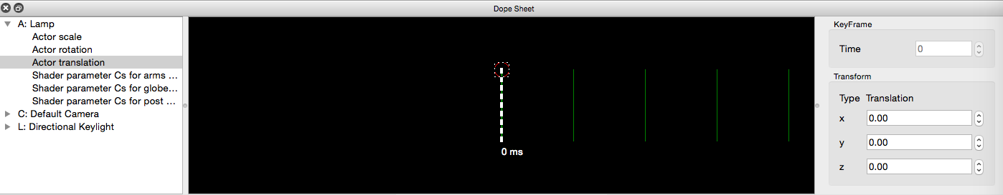
The number and frequency of keyframes for each property is independent.
The total length of the animation is the time at the right most keyframe when all animated properties are considered.
Keyframe times are in integer milliseconds, e.g. Keyframe at time 1000 is 1 second into the animation.
For times greater the last keyframe time for a property, that property remains at the value set for the last keyframe.
Left clicking on a keyframe opens the editable panel to the right, containing the keyframe time and the current value of the underlying property. The panel changes its UI given the type of the property, e.g. it can distinguish between a colour and a rotation.
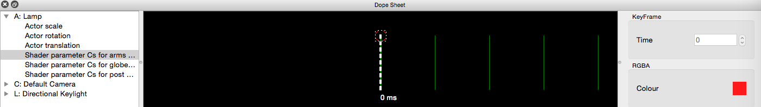
Additional keyframes for a property can be added by cloning an existing keyframe, by right clicking over that keyframe and choosing Clone. The value of the property of the source of the clone is also copied. By default, 1000ms is added to the time. If a keyframe is already ahead of the source of the clone, then the new keyframe is placed half way between the two.
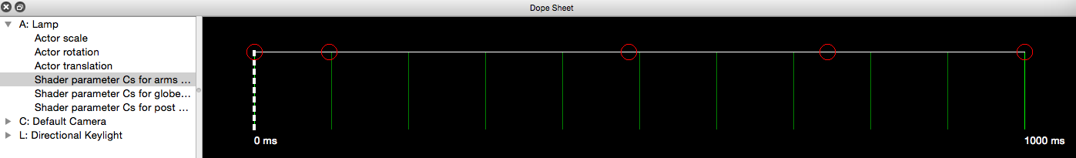
Dragging a keyframe circle left or right along the timeline modifies the time at which it is defined. This is possible for any keyframe except those at time zero, which are invariant.
Right clicking over a transformation keyframe, and choosing Edit, allows modifications to the transformation to be applied in the 3D viewport. The mesh in question will change to a wireframe view, and widgets corresponding to each axis become visible, and may be dragged. If using the free camera, the scene can be manipulated while the transformation is edited. To abort the current modification in the viewport, press the Escape key, and transformation will be reset to the last known value. To confirm the current modification, press the Enter key. In either case, the viewport will return to a solid render.
To modify a translation in viewport, drag the cone on the axis of motion. The origin of the widgets is always the origin of the actor.
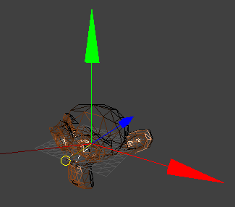
To modify a rotation in viewport, drag the octahedrons on the axis of motion, following the great circles. The origin of a rotation depends on the order of previous transformations. If the rotation is first, then it is about the origin of the Actor:
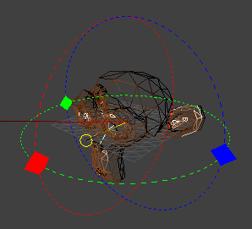
If, say, a translation is applied before the rotation, then the origin of rotation is about the world origin:
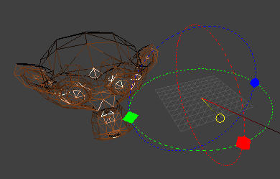
To modify a scale in viewport, drag the cubes on the axis of motion. Note that this will generate non-uniform scaling factors. The origin of a scale depends on the order of previous transformations. If the scale is first, then it is about the origin of the Actor:
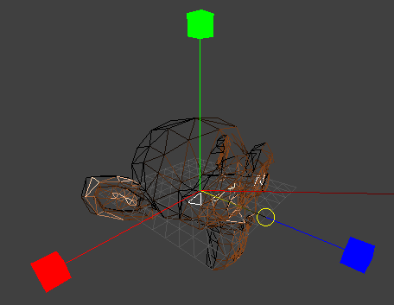
If, say, a translation is applied before the scale, then the origin of the scale is the world origin:
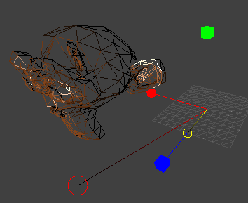
Note that for a scaling transformation, pressing Shift while dragging the scaling widgets will cause a uniform scale in all axes.
The current time in the Dope sheet is represented by the dashed white vertical line. Dragging this left or right changes the current time, and will interpolate property values which will be visible in the 3D viewport.

Easing
Given an animatable property, and two consecutive keyframes, the value of the property at each keyframe is, by default, linearly interpolated when the animation is run.
Right clicking over a keyframe, and choosing Modify Easing, opens a graph editor. This is a bezier curve, with two control points (the red circles), and represents how the interpolation is executed over time.
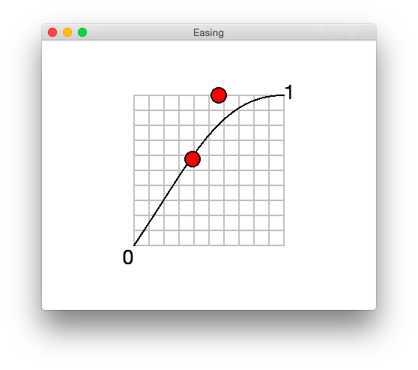
The control points can be dragged around, which modifies the curve. For example, moving the left most control point to the upper left corner causes the interpolation to run slowly at first, but then finish quickly.
Right clicking over the graph offers a menu of preset easing configurations.
The easing configuration is saved for each individual keyframe.

Lights
Currently a single directional key light is defined by default. Initially, its direction is into the scene (0,0,1), but is animatable. Its colour is fixed and white.
Currently, no additional lights can be defined.

Viewport
This is a 3D perspective projection of the scene, using the GPU to render the scene. The GPU shaders are generally an approximation to what is produced by the beauty renders, so some variation between the viewport and a beauty render should be expected.
Director defines a left handed coordinate system (x = right, y = up, z = into screen).
A grid is visible about the origin of the scene.
A gnomon is visible at the bottom left of the viewport, indicating the orientation of the world axes. Standard colours are used: red for x-axis (right), green for y-axis (up), blue for z-axis (in).

Orbit camera
There is a free 'orbit' style free camera, allowing rotation around two axes (azimuthal and polar) and panning along the radius. This is enabled by default, but can be toggled on the View menu or viewport toolbar.
The mouse or trackpad can be used to navigate the scene using this camera.
Rotations: mouse = drag left/right/up/down, trackpad = one button click, and drag finger
Radial pan: mouse = mouse wheel, trackpad = two button pinch
Pan: mouse = 3rd button drag (no equivalent on the trackpad currently)
Resetting the default camera position is available on the View menu.

Animatable camera
The Timeline contains a default animatable Camera, which is used for full beauty (multi-frame) renders, and toggled in the viewport. See the Dope sheet for all of the camera properties that can be animated.
Some rendering features are only available in the animatable camera:
- depth of field
Some visualisations intended to help create scenes are disabled in the animatable camera, since it is intended as a preview of the final render:
- grid
- props
- visualisation helpers (e.g. frustums, shadow caster bounding boxes)

View options

Normals
Viewings normals (on the View menu or viewport toolbar) renders the per-vertex normals as blue lines.

Bones
Viewing bones (on the View menu or viewport toolbar) renders them as cuboids with a red head and a green tail.

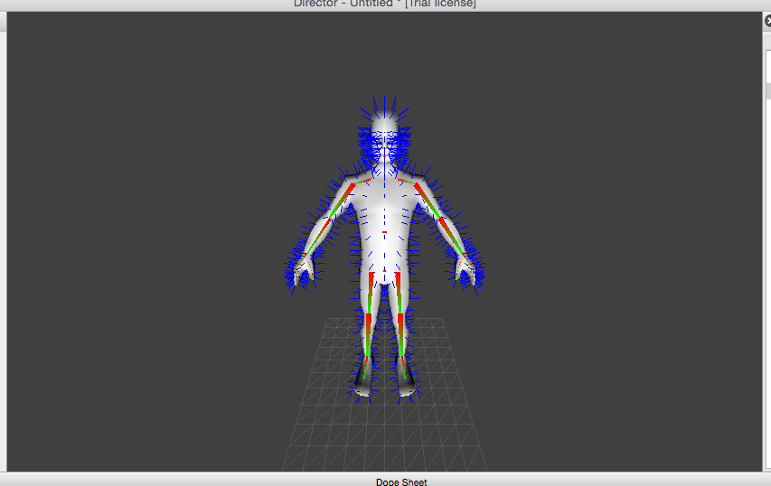
Flip between GPU and RSL single-frame renders
By default, the viewport shows the GPU render of the scene interpolated to the current time in the Dope sheet. A single frame beauty render is also available. Press F1 to flip the viewport between GPU render and the single frame (also available on the View menu or viewport toolbar).
Also available on the View menu or viewport toolbar, or by pressing F5:
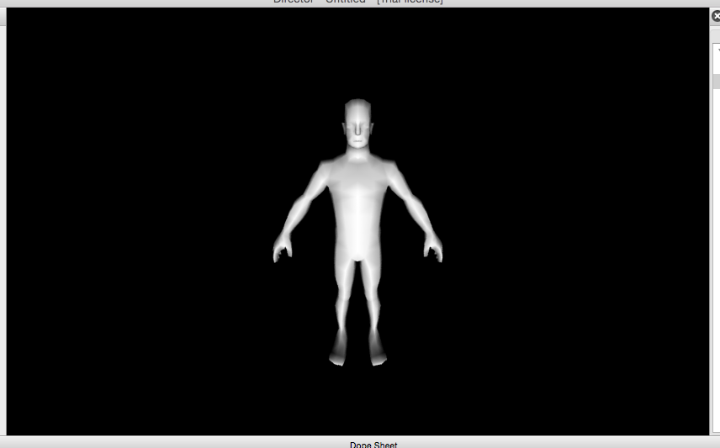
Note that the beauty render is just a single image, so is not interactive. Flip back to the GPU render for interactivity, or to compare the GPU vs REYES render.
Note that the single frame beauty render honours whether the free camera is enabled.

Onion skinning
For actors with more than one keyframe defining an animation, a number of subsequent frames can be rendered translucently in the 3D viewport to indicate the path of motion, for example. This is called onion skinning.
There is an option on the View menu/View toolbar, to enable onion skinning. To display it for a specific Actor, select that actor in the Dope Sheet. The actor will be displayed as the shader intended at the current playback time, but subsequently more translucent for up to a second into the future.
Modifying the transform of the currently selected Actor will dynamically update the onion skinning, giving a sense of change.
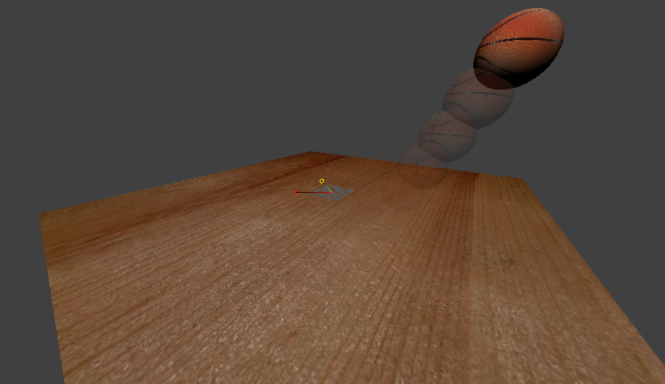

Shadows
If enabled on the View menu or viewport toolbar, real-time shadows are rendered in the viewport for each light. Shadows make use the shadowmap technique for both the viewport and beauty renders.
Shadows are only rendered for those actor meshes marked as shadow casters. There is a checkbox in the Actor pane to select shadow casters.
All meshes in the scene are considered to be shadow receivers. Thus, self shadowing is automatically available.
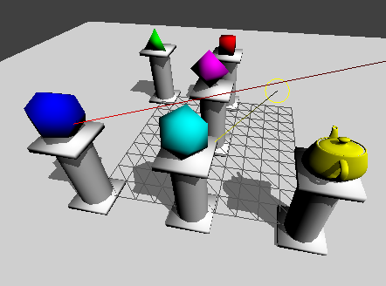
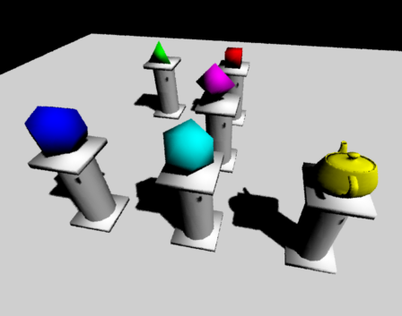
For directional lights, an orthographic frustum for the light is calculated that should encompass all shadow casters and project far enough into the scene so that the shadow will be received on all other meshes.
Note that there is no requirement in the Shader node graph to add shadow specific code. This is automatically generated for the 3D viewport and beauty renders.

Props
Props are lights and cameras in the scene. It is useful to be able to visualise their settings in the 3D viewport. They can be toggled on and off via the View menu or viewport toolbar.
Lights are displayed by a camera-facing yellow circle at the 'position' of the light, and a line pointing from the circle in the direction of the light. Directional lights do not have a position, so the circle is located at the inverse direction.
Animated cameras are displayed by a camera-facing red circle at the position of the camera, and a line to the 'lookat' position.

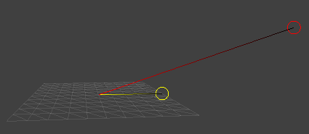
Motion path visualisation
Enabling the motion path visualisation draws a blue curve between translation keyframes. If there is no edited path, a straight line is draw between consecutive keyframes, otherwise a cubic Bezier curve is drawn, using the positions of the two control points in the path.
If the path is being edited, widgets appear at the positions of the two control points, allowing those control points to be moved in space. The path visualisation will update dynamically as those control points are moved.

Additional visualisations
As an aid to setting up scenes, additional visualisations are available. These are available from the View menu only:
- Light frustums – see the frustums used for lighting shadow casters
- Shadow caster bounding box – a bounding box around the shadow casting meshes, which is used to calculate the light frustums.
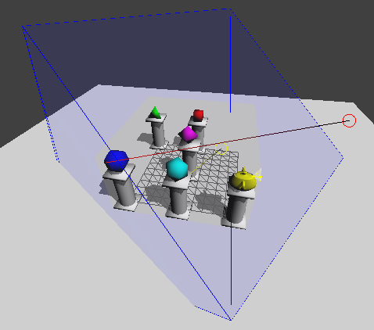
- Camera frustums – see the frustums used for the animated cameras. These are visible only when the free orbit camera is in use.
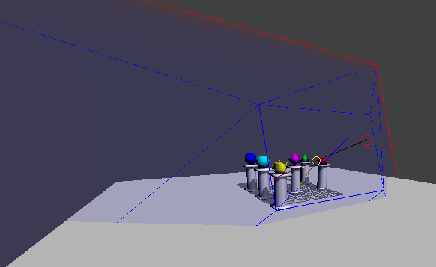

Beauty renders
Beauty renders refers to renders of the scene using a REYES renderer. Director is packaged with an open source REYES renderer, Pixie. Director is also compatible with PRMan (version 19 and above), which is available to download and license separately.
Director will translate the geometric, image and shader data in a timeline into RIB, RSL and texture data suitable for a REYES renderer. If an animation is being rendered, a RIB per frame is generated, using interpolated data as time progresses. There is a choice of whether all frames are rendered, or just a range, specified as a start/stop time in milliseconds.
If the host machine has multiple CPU cores, all will be made use of to generate the RIB files.
Once all RIB files are generated, they are passed to the renderer and associated tools to generate frame image files. Note that this can be a CPU/memory/disk intensive operation.
For an animated sequence, these frame image files can then be combined using ffmpeg (an external tool to download) into a movie file, using an appropriate codec.
Director supports viewing the generated movie with its own viewer (assuming a suitable codec can be found on your computer) an external video player (if configured in the preferences) or saving the generated movie for playing in an external application or sharing with others.
The movie generation UI is kept separate from the beauty render UI, because you can change the movie options (e.g. a different codec) and regenerate the movie on the same frame image files.
The viewport also supports rendering the current frame as a beauty render, and toggling between the live GPU render and this generated still image. This can be useful for visually comparing the result of the two different renders, since most of the editing time in Director will be spent with the GPU render.
Using the Preferences, the following can be set:
- the path to PRMan. If valid, then the Preferences also allows a choice between Pixie and PRMan to render with.
- the path to ffmpeg, required to generate movie files following a render
- the path to an external video player, as well as the command line used to launch it, as an alternative to the built-in player.
Beauty renders are, by default, set to use the lowest (and hence fastest) quality settings. On the Beauty Render pane, the horizontal and vertical pixel samples can be adjusted. This affects both single frame, and animation renders. The default is 1 for both. Frames containing blurs will often exhibit an amount of noise at the lowest pixel samples settings. Increase these values and re-render, to improve the quality, at the cost of render time. The value will be used across all frames rendered.
For the single frame beauty render visible in the viewport, a user choice of how the renderer displays its buckets of pixels is available as a Preference, under Bucket Order. This is a PRMan only setting, since Pixie only supports a single bucket order. The default bucket order is horizontal, where buckets are supplied top to bottom, left to right. It is down to personal preference as to which bucket order you choose. 'random' or 'spiral' tends to be more appealing, in the authors opinion. Note that multi-frame beauty renders do not use this preference.

Projects
Director saves its project files to a directory, consisting of a project file with the extension .tml (Timeline), and optionally subdirectories containing copies of asset files. The .tml file contains references to all of the asset files, actors, and all animation data. It is human readable, but should not be edited by hand.
Director's File menu has options to save a project, and also start a new, or load an existing. There is also a short list of recently opened projects.
TimeLine projects are loaded by finding the .tml file of interest.
Saving projects requires an empty directory to write into (or an existing project directory, which will prompt for overwrite).

Source control and project collaboration
By default, a project is saved with references to files relative to your computer (both local and networked files can be used). Whenever the project is saved, the last set of changes are overwritten, and cannot be recovered without having to rewind your last steps.
However, Director contains plugins that allows a project to be saved into source control.
Currently, a plugin supporting the git source control system is provided.
Although source control is generally thought of for software developers, any type of file can be stored. One of the strengths of source control is to contain a full history of changes. As such, when a project is saved into source control, all referenced asset files are collated into the project directory, so that the directory becomes a self contained package of data.
Director uses the strengths of source control, and choices of data files, to enable collaborative workflows in projects.
By using source control, you are required to provide a description of the changes each time you save. Thus, you, and others, can view the evolution of your project over time.

Git plugin
Git is a distributed source control system, meaning you have a local copy of the repository, but there can also be a remote 'copy' as well, which others can see and use. If your local repository has been configured to see a remote, Director will try to push your local changes up to the remote copy whenever you save.
Before you can save a project with git, you need to set three options in the Preferences:
- your email address to commit against,
- your name to commit against,
- the user for the remote hosting site (if you use one)
- the password for the remote hosting site (if you use one)
These are required by git.
The remote user and password is only in use when you have configured a remote 'copy' as described below.
There is no requirement that the commit name/email has to match the remote user, although it helps if the remote hosting site is aware of the commit email. (Usually they will match if you configured the hosting, but if you are sharing, then they might not.)
Director only supports the https protocol for remote git repositories. (ssh is not supported.)
In git terminology, one Timeline project is equivalent to one git repository.

Configuring remotes
Some command line use with git is required to enable a remote 'copy'.
Setting up the remote 'copy' itself, involves creating something called a bare git repository. The instructions for doing so depends on where you host it. There are some instructions below for github.
However, regardless of the hosting option, it is important to name the git repository identically to the TimeLine project folder.
Once a project has been saved, with git enabled, to link it a remote 'copy', open a terminal and cd to the Timeline project directory. Type
git remote add origin <path to remote 'copy'>
For example, in one of the examples on github, this was the command used:
git remote add origin https://director-examples@github.com/director-examples/monkey-turntable.git
The use of 'origin' here is convention in git, as a reference to the remote 'copy'.
You can check that this has worked, by typing
git remote -v
which will output something like this:
origin https://director-examples@github.com/director-examples/monkey-turntable.git (fetch)
origin https://director-examples@github.com/director-examples/monkey-turntable.git (push)
Then you must push these changes to the remote copy, and link branches:
git push -u origin master
which will output something like:
Counting objects: 5, done. Delta compression using up to 4 threads. Compressing objects: 100% (4/4), done. Writing objects: 100% (5/5), 20.01 KiB | 0 bytes/s, done. Total 5 (delta 0), reused 0 (delta 0) To https://director-examples@github.com/director-examples/monkey-turntable .git * [new branch] master -> master Branch master set up to track remote branch master from origin.
Once this initial push to the remote 'copy' has succeeded, subsequent saves in Director, assuming that the remote user and password are configured in the Preferences and are correct, will push your saves up to the remote 'copy', to be visible to everyone.

Letting others use your TimeLine
Once a remote 'copy' has been set up and configured, others can then sync your TimeLine and view/edit it in Director. Editing relies on you allowing them access. Viewing is generally available to everyone. This very much depends on where you host your remote.
To get a copy of the example above, cd to where you want the TimeLine directory to appear, and type
git clone https://github.com/director-examples/monkey-turntable.git
This will create a monkey-turntable TimeLine folder, and you can load it from Director.
Director will detect when there have been changes in the remote copy, and will inform you at load time that it wants to update to the most recent changes.

Project Collaboration
Using this project sharing with source control allows multiple users to work on the same project. There are currently some limitations:
- If user A has submitted changes to the remote 'copy' while user B is editing the project, then user B will not be able to save. There is currently no support to merge changes, or replay edits, on top of a sync'd project. (* merging would be an ideal solution in the future)
If users take it in turns to load, edit, save, then the collaborative workflow should work.

Using github
Github is just one example of a hosting site for remote 'copies'.
Here are some useful articles:
- https://help.github.com/articles/set-up-git/
- https://help.github.com/articles/create-a-repo/ - do not add a README file in the case of a shared TimeLine project, as the push command above will not work.

Installing git
You will need a command line installation of git to get the data from github.

Windows
Download from https://git-scm.com/download/win

Linux
Depending on your distro, you may have to do
- sudo apt get install git
or
- sudo yum install git

OSX
- Open Terminal
- Type 'git'
- Either it is already installed, or a dialog will open asking to download Xcode command line tools. Agree to this.

Settings
Director uses .ini files to store its preferences. These can be found in the following locations:
- OSX ~/.config/uk.co.tfc/Director.ini
- Windows %APPDATA%/tfc/Director.ini
- Linux ~/.config/tfc/Director.ini
where ~ represents your home directory.
It is preferable to let Director manage this file, but it is human readable. If you modify it, and Director no longer works, delete the file, and Director will create a new one. However, your settings will be lost.
Use the Preferences menu option to configure your settings instead.

Theme
Director is distributed with a number of themes to style the user interface. These can be selected from the Preferences dialog. These themes can be written by users as well, by providing additional .qss files into the themes subdirectory next to the executable. For reference, the format of this file uses the definitions described in the Qt stylesheet reference guide.

User authentication
The cloud based licensing solution requires a file to be stored in your home directory. This is called
~/.patchworks.privatekey
where ~ represents your home directory.
This file generated when you first submit your email address to acquire a license to run Director, and is needed for all communications to the cloud.
It is equivalent to a secret password, and should never be shared with anyone.
You can, however, copy it to another machine to use your email account to license that machine, up to a maximum of three machines.

Bugs and feature requests
A public bug tracker has been set up for Director. If you encounter a bug, please log an issue, so the author can be made aware of it.
https://bitbucket.org/markfinal/patchwork/issues
The author is also keen to hear ideas for improvements, which can also be logged in this tracker.

In-application feedback
As an alternative method of providing feedback, Director's Help menu has an option to send feedback back to the author.

Log file
In addition to the visible log in the Director UI, the contents are also serialized to disk, and rotated upon each run of Director (the creation date of the file is added to the filename to make it unique). These log files may contain useful information to the author in the case of exceptional behaviour from Director. Please attach it when you log issues in the bug database.
Locations
- Windows %TEMP%
- Linux /tmp
- OSX Use 'open $TMPDIR' from Terminal to locate the folder.

Third party licenses
All third party software used in Director is open source and non-GPL. The exact licenses are included in the 'About Director' dialog, available from the Help menu.

Documentation feedback
Please provide feedback by emailing markfinal@hotmail.com.

Pixie is a fast, but not-guaranteed accurate, Reyes renderer. Glitches have been reported seen using Pixie to make beauty renders. It is recommended to use PRMan for best quality.

