

Image credit: http://www.clker.com/clipart-344791.html

Director
(c) Mark Final, 2016
v0.0.11

Cg animation made easy for everyone

Examples
Last update: 19-December-2016

Written by Mark Final
markfinal@hotmail.com

Table of Contents
Requirements 3
Shared TimeLine projects 3
Compatibility 3
github 3
Installing git 3
Windows 3
Linux 3
OSX 3
Getting the examples 4
Cloning 4

Requirements
- 64-bit desktop operating system:
  - Windows 7+
  - Linux Ubuntu 14+/CentOS7+
  - macOS 10.9+
- Internet connection (proxy settings available)
- A valid email address that you have access to.
- An installation of Director

Shared TimeLine projects
Director supports sharing TimeLine projects via source control. Currently this requires the git source control system.
A number of examples have been added to a hosting site (github) so that users can see some basic illustrations of what is achievable in Director.

Compatibility
The examples provided are for use with the latest version of Director. As such, older versions of Director will not support loading them.
The minimum version of Director to use the examples is currently v0.0.11.

github
The github account used for the examples is
https://github.com/director-examples

Installing git
You will need a command line installation of git to get the data from github.

Windows
Download from https://git-scm.com/download/win

Linux
Depending on your distro, you may have to do
- sudo apt get install git
or
- sudo yum install git

OSX
- Open Terminal
- Type 'git'
- Either it is already installed, or a dialog will open asking to download Xcode command line tools. Agree to this.

Getting the examples
Each example Timeline project is a git repository. To see the repositories available, goto https://github.com/director-examples?tab=repositories in a browser.

Cloning
Git's operation to get a local copy of a repository is referred to as making a clone.
Click on the repository you're interested in from the link above, and you should see a Clone or Download green button to the right. Here is one of the examples available:
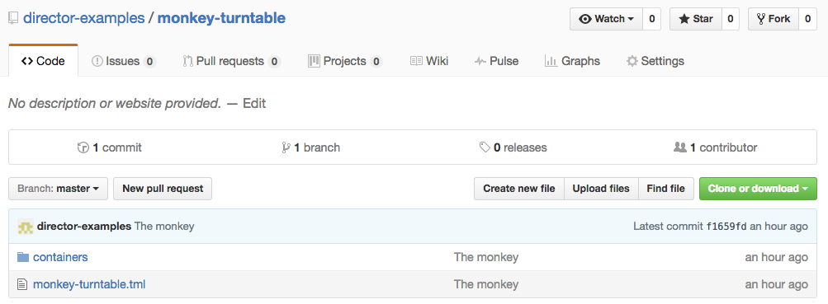
Click on this button to get a copy on the clipboard of the URL for the repository:
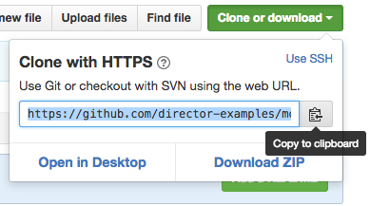
On your computer, open a terminal/console, and cd to a directory in which you want your cloned TimeLine project to appear, and type
git clone <URL from the clipboard>
There will be output similar to this:
git clone https://github.com/director-examples/monkey-turntable.git
Cloning into 'monkey-turntable'...
remote: Counting objects: 5, done.
remote: Compressing objects: 100% (4/4), done.
remote: Total 5 (delta 0), reused 5 (delta 0), pack-reused 0
Unpacking objects: 100% (5/5), done.
Checking connectivity... done.
Once finished, you can now browse to the monkey-turntable directory from Director's Load dialog, and select the .tml file to load this project.

