Real-Image Stress Test Document
This document tests Posey with REAL photographic images (JPEGs with EXIF metadata, fine detail, gradients) rather than synthetic uniform-color PNGs. Each section probes a different real-world scenario.

Section 1: Real photo, default size
A 1200x800 landscape photo with real image data — fine detail, gradients, possibly EXIF rotation tags. Verifies JPEG decoding works.
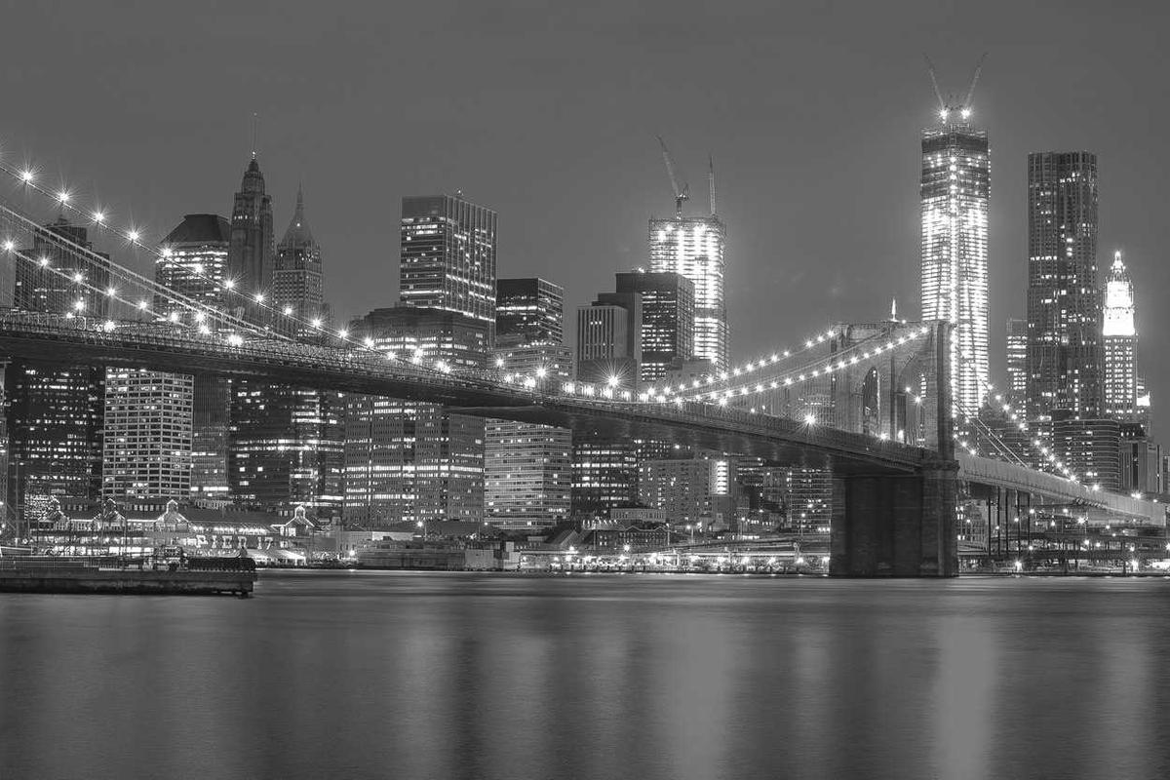
After the photo. The decoder should handle the EXIF, render the actual pixel data, and not crash on the larger file size.

Section 2: Portrait orientation
A 600x900 portrait JPEG. Tests that vertical aspect ratios render correctly without distortion.
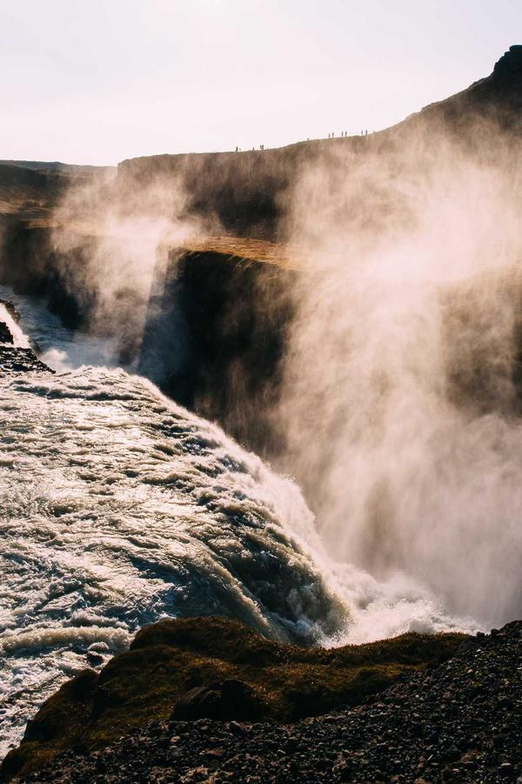
Portrait images often have EXIF orientation flags that some renderers ignore. Posey should respect orientation.

Section 3: Tiny image
A 300x300 square photo (8KB) — close to thumbnail size with real photographic content.
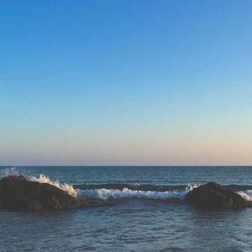
Should render without upscaling artifacts.

Section 4: Large image (memory pressure)
A 2000x1200 high-detail JPEG (~350KB). Memory-pressure test: the importer should handle larger images without choking.
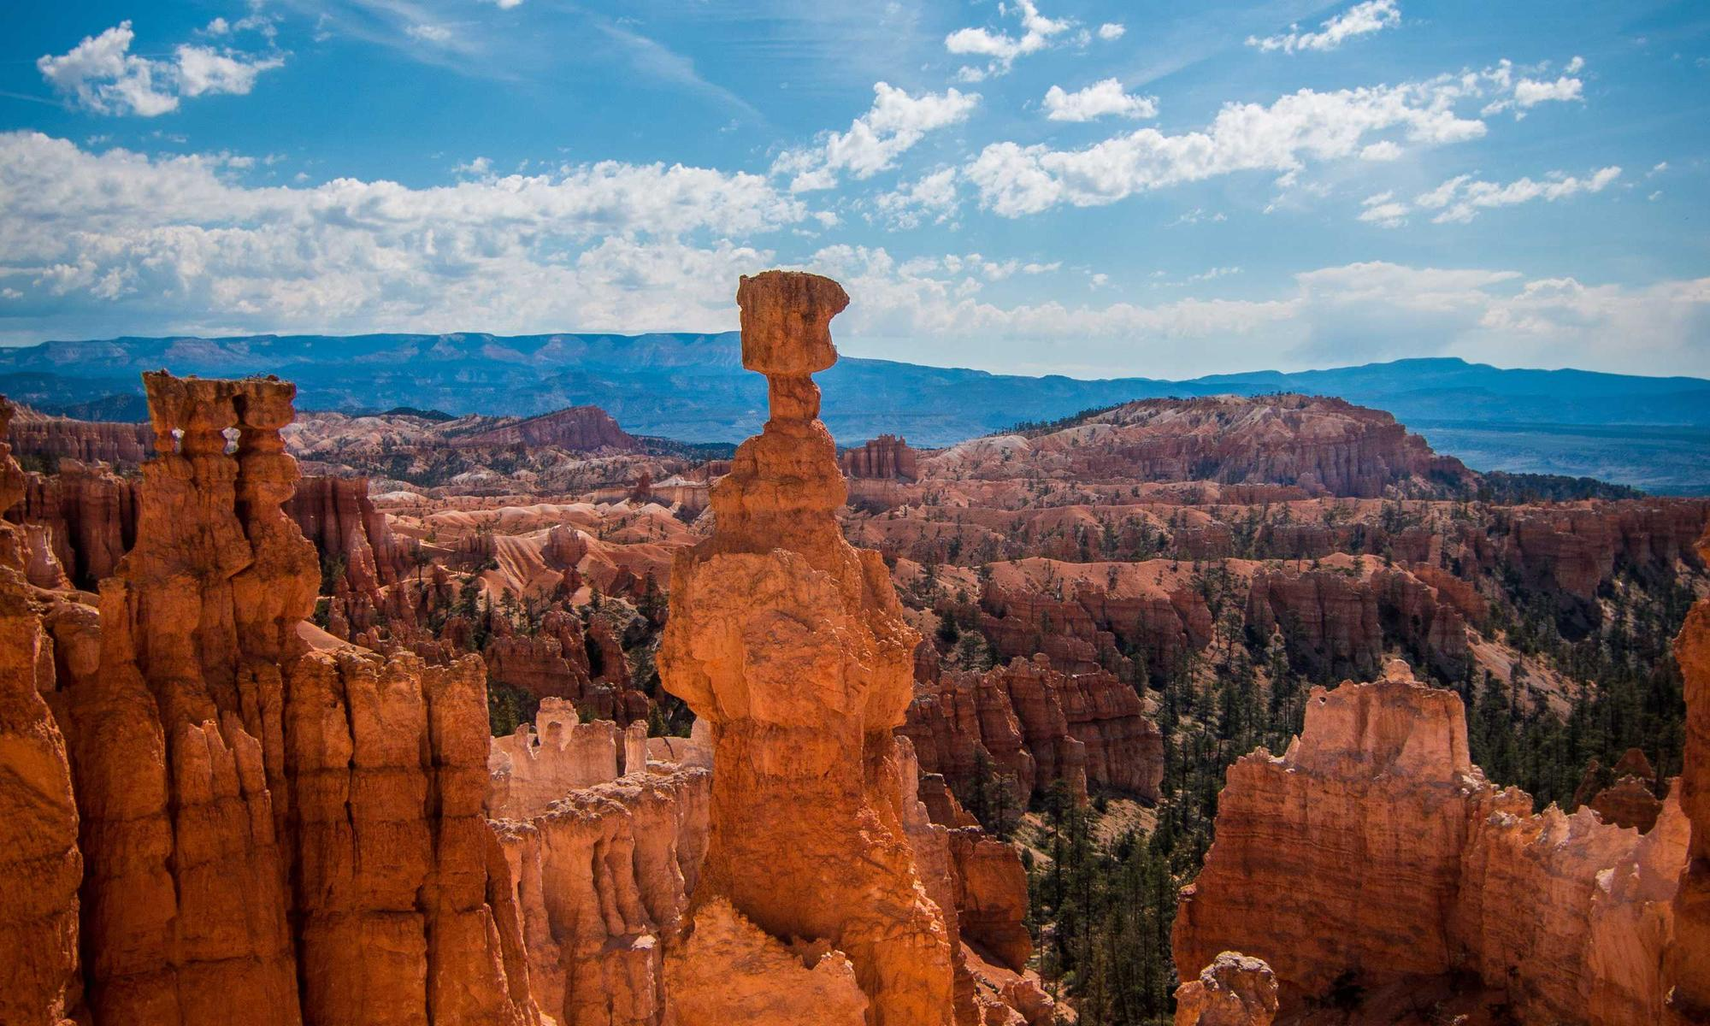
After the large image.

Section 5: Tiny wide banner
A 200x100 wide aspect ratio photo (8KB).
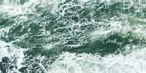
Wide banners should preserve aspect.

Section 6: Mixed format — PNG with transparency would go here
In real-world use, documents mix JPEG photos and PNG/icon graphics. Posey should handle both. The lack of a PNG with transparency in this test is a deliberate gap — Wikipedia rate-limited my download. The synthetic-PNG tests in image-stress.docx covered the alpha-channel codepath.
Closing paragraph confirming text continues normally after the image-rich content above.

