***********PROJECT DOCUMENTATION***

CAT DUMPLING PRODUCTIONS

***SUBMISSION CHECKER***

**(VISUAL BASIC)**

***DATE:* September 25, 2022**

***BY:* Mark Francis P. De Guzman**

**CONTENTS**

* INTRODUCTION TO CDP SUBMISSION CHECKER
* LOGICAL ERRORS / FUTURE IMPROVEMENTS
* CUSTOMIZATION OF THE APPLICATION FOR INTERESTED PEOPLE (FOR PERSONAL USE)
* FUNCTIONS AND FEATURES

**INTRODUCTION**

The CDP Submission Checker is an application where you can use it to check all of your submissions, deadlines, and more. It contains what usually a student would really need in situations like, always forgetting the deadline or when to submit the requirements needed for school.

This introduction will also contain the other issues of the software for further context and information. It has a submission checker, schedule updater, and google meet links.

FOR FURTHER INFORMATION, I will be leaving some contact information if you are willing to test the software and to be customized to your liking.

**LOGICAL ERRORS / FUTURE IMPROVEMENTS**

The software still contains its flaws and logical errors. The language used for this is Visual Basic, so we need to keep in mind that it uses an old programming language and can be further improve in the future. It still can be a good software; we can actually implement a login info for users to be connected to their own database of information. But for now, it will only be a customized software for people.

This was created for personal use and needed to be customized for the user to be comfortable with.

**CUSTOMIZATION OF THE SOFTWARE**

As it being said that the software is still incomplete, this is still completely customizable. For students, I will be needing a copy of your subjects and schedule, so that I can input it in the software. Please be noted that all of the information given to me will remain private for the safety of our users.

Contact me for further information and we can start customizing your software.

For immediate response:

Facebook: [www.facebook.com/siopao.mark](http://www.facebook.com/siopao.mark)

For comments and suggestions, please visit my website here:

Website: <https://markgg33.github.io/cdportfolio/>

**FUNCTIONS AND FEATURES**

This section contains some of the functions and features of the software so that our users could understand how the software works.

Submission Checker – This section contains the highlight of the software, which is checking all of your deadlines on a specific subject.

Schedule – This section is self-explanatory. It contains your current schedule and can be updated freely to your liking.

Google meet links – This section contains buttons redirecting you to your specific subject meetings. It is RECOMMENDED to contact me if you want this section to be customized to your specific meetings.

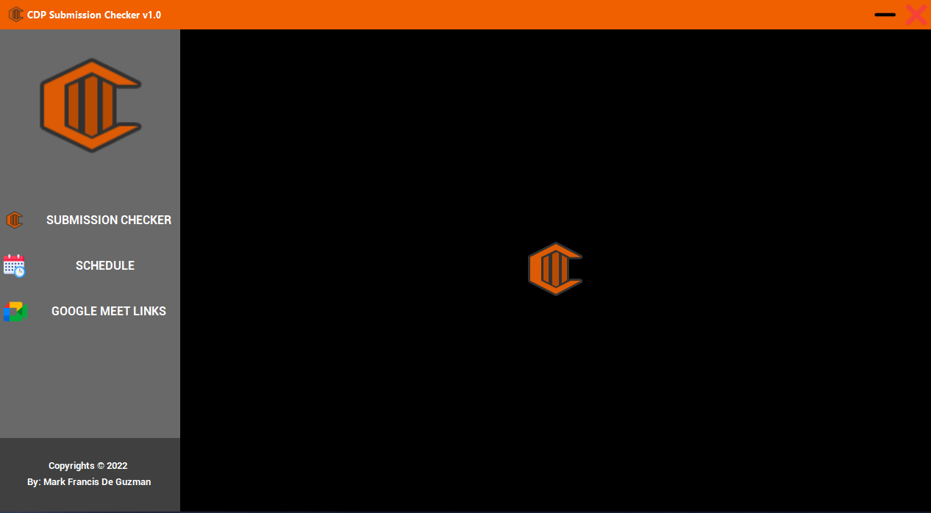

**SEARCH SECTION**



* Search: This drop-down box contains a list of subjects in which was customized. It is also disabled by default to avoid conflict.
* Search Button: This button is programmed to search what you’ve input in the search box.
* Search Switch: These buttons are switches that are programmed to change the behavior of the search box to enable if you are going to search for a specific subject.

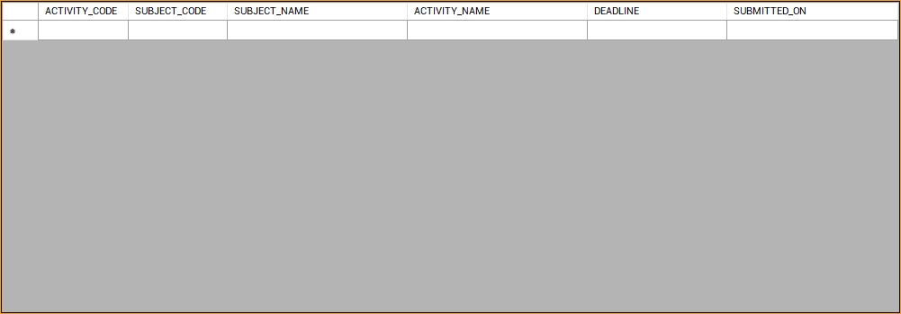**DATAGRID VIEW (SUBJECT DATABASE)**

DATAGRID VIEW: This DataGrid view contains all of your specified subjects with the ACTIVITY CODE, SUBJECT CODE, SUBJECT NAME, ACTIVITY NAME, DEADLINE AND SUBMITTED ON.

Example:

NSTP1 ACTIVITY 1 / NSTP1 / NATIONAL SERVICE TRAINING PROGRAM 1/ WRITTEN / VIDEO / SEPT 16, 2022 / SEPT 13, 2022

**DATA INPUT W/ SWITCH**

DATAVIEW SWITCH: These switches functions to change the behavior of the next and previous buttons that will be shown later in the documentation.

ACTIVITY CODE: A textbox in where you can input the number of activities with their respective subject code.

Example: (SUBJECT CODE) NSTP1 (ACTIVITY NUMBER) ACT#1

SUBJECT CODE: A drop down box that comes with a list of subjects.

SUBJECT NAME: This textbox automatically inputs the name of your subject after you picked a subject code.

ACTIVITY NAME: A textbox in where you can input the name of your activities.

**UPDATE TOGGLE SWITCH**

UPDATE BUTTON: The update button functions as a toggle to enable the Save button, Activity name and the Submitted-on section.

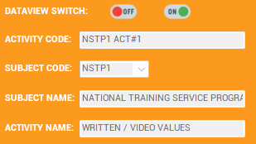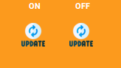

**DEADLINE AND SUBMISSION CALENDARS**

**AND REFRESH BUTTON**

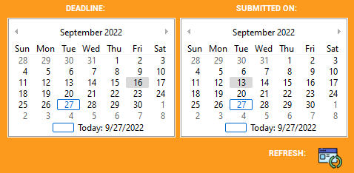

**‘**

DEADLINE CALENDAR: This calendar indicates your deadline of your specific activity or assignment. This will be filled by the user, so make sure that the date being inputted is FINAL.

SUBMITTED-ON CALENDAR: This calendar indicates your submissions for your specific activities and assignments. This section can be edited by the user since the calendar is filled automatically with the present date.

REFRESH BUTTON: This button functions as a refresh after search in the data view table.

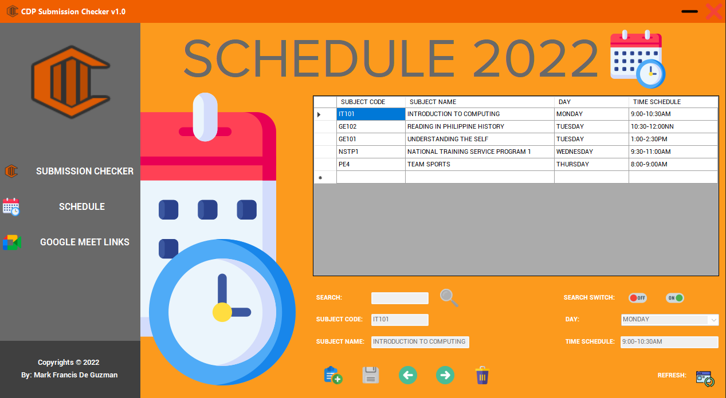 **SCHEDULE SECTION (FUNCTIONS)**

All of the buttons from the previous section that has the same photos will remain the same in terms of functionality.

SUBJECT CODE: The function of this textbox is to input your desired subject in a form of code. Example: NSTP1 which is National Service Training Program. 

SUBJECT NAME: This textbox will display the name of your subject based on the input of your subject code box. ***STRICTLY FOR CUSTOMIZATION*** Please refer to the content table with this title: “CUSTOMIZATION OF THE SOFTWARE”.

**GOOGLE MEET LINK SECTION**

ALL of the buttons that are displaying in these pages are all programmed to be directed to their respectful google meet room. If you want to be part of testing out the software, please refer to the content of “CUSTOMIZING OF THE SOFTWARE” section above the content table.

Thank you for reading the documentation. Feel free to contact me for personalization of your copy.

