CISCO PACKET TRACER PROJECT
Design and Configure a Secure Office Network Using VLANs
VLANs, 802.1Q Trunking and Router-on-a-Stick Inter-VLAN Routing
Student | Mark Gichuhi Gichohi
Institution | Multimedia University
Program | Computer Science
Subject | Computer Networking
Software | Cisco Packet Tracer
Submission date | 20 October 2026
Packet Tracer file | Mark_Gichuhi_Gichohi_VLAN_Routing_Project.pkt
Student ID | CIT-223-039/2024

1. Executive Summary
This report documents the design, configuration, verification and analysis of a small office network for a company with three departments: HR (VLAN 10), IT (VLAN 20) and Finance (VLAN 30). Each department has its own VLAN and IP subnet. Two Cisco 2960 switches carry all three VLANs over an 802.1Q trunk, and a Cisco 2911 router connected to Switch1 provides inter-VLAN routing using Router-on-a-Stick.
Every department has one PC on each switch, so each VLAN spans both switches. Testing showed that PCs in the same VLAN communicate by Layer 2 switching (TTL=128) and that PCs in different VLANs communicate through the router (TTL=127). When the router link was shut down, inter-VLAN traffic stopped completely, which confirms that the VLANs are isolated from each other at Layer 2 and that the router is the single controlled point between departments.

2. Network Topology and Architecture
The network uses one Cisco 2911 router (Router1), two Cisco 2960-24TT switches (Switch1 and Switch2) and six PCs, two for each department. Router1 connects to Switch1, and Switch1 connects to Switch2. The departments are distributed across the switches: each switch has one HR PC, one IT PC and one Finance PC. The optional server was not included.
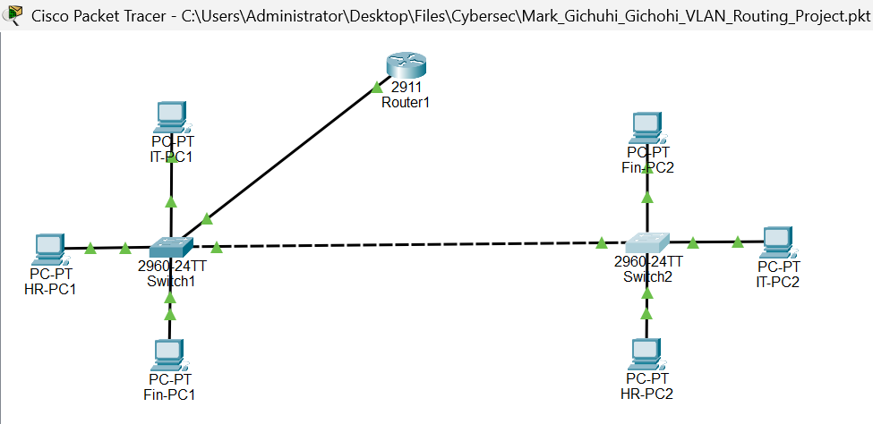
Figure 1: Complete network topology (Packet Tracer logical view)

2.1 Physical connections
Link | End A | End B | Port mode
Router to Switch1 | Router1 Gi0/0 | Switch1 Fa0/1 | 802.1Q trunk
Switch1 to Switch2 | Switch1 Fa0/24 | Switch2 Fa0/24 | 802.1Q trunk
HR-PC1 | Switch1 Fa0/2 | HR-PC1 | Access, VLAN 10
Fin-PC1 | Switch1 Fa0/3 | Fin-PC1 | Access, VLAN 30
IT-PC1 | Switch1 Fa0/4 | IT-PC1 | Access, VLAN 20
IT-PC2 | Switch2 Fa0/2 | IT-PC2 | Access, VLAN 20
HR-PC2 | Switch2 Fa0/3 | HR-PC2 | Access, VLAN 10
Fin-PC2 | Switch2 Fa0/4 | Fin-PC2 | Access, VLAN 30

3. IP Addressing Plan
Each PC has a static address in its department subnet. The default gateway of each PC is the router sub interface for its VLAN.
Device | Switch / port | VLAN | IP address | Subnet mask | Default gateway
HR-PC1 | SW1 Fa0/2 | 10 | 192.168.10.11 | 255.255.255.0 | 192.168.10.1
HR-PC2 | SW2 Fa0/3 | 10 | 192.168.10.12 | 255.255.255.0 | 192.168.10.1
IT-PC1 | SW1 Fa0/4 | 20 | 192.168.20.11 | 255.255.255.0 | 192.168.20.1
IT-PC2 | SW2 Fa0/2 | 20 | 192.168.20.12 | 255.255.255.0 | 192.168.20.1
FIN-PC1 | SW1 Fa0/3 | 30 | 192.168.30.11 | 255.255.255.0 | 192.168.30.1
FIN-PC2 | SW2 Fa0/4 | 30 | 192.168.30.12 | 255.255.255.0 | 192.168.30.1

4. VLAN and Switch Configuration
VLANs 10, 20 and 30 were created on both switches. Each PC port was set as an access port in its department VLAN, and the switch-to-switch and router-to-switch links were configured as 802.1Q trunks that carry all three VLANs.
VLAN | Name | Network | Access ports
10 | HR | 192.168.10.0/24 | Switch1: Fa0/2; Switch2: Fa0/3
20 | IT | 192.168.20.0/24 | Switch1: Fa0/4; Switch2: Fa0/2
30 | FINANCE | 192.168.30.0/24 | Switch1: Fa0/3; Switch2: Fa0/4

Equivalent configuration for the port types used (shown for Switch1):
Switch1(config)# vlan 10
Switch1(config-vlan)# name HR
Switch1(config)# vlan 20
Switch1(config-vlan)# name IT
Switch1(config)# vlan 30
Switch1(config-vlan)# name FINANCE

Switch1(config)# interface FastEthernet0/2
Switch1(config-if)# switchport mode access
Switch1(config-if)# switchport access vlan 10

Switch1(config)# interface FastEthernet0/1
Switch1(config-if)# switchport mode trunk

4.1 VLAN assignment and trunk verification
show vlan brief lists the VLANs and their access ports. Trunk ports do not appear in this list. show interfaces trunk confirms the trunks: Switch1 trunks on Fa0/1 (to the router) and Fa0/24 (to Switch2), and Switch2 trunks on Fa0/24. Every trunk uses 802.1Q, is in the trunking state, uses native VLAN 1, and carries VLANs 1, 10, 20 and 30.
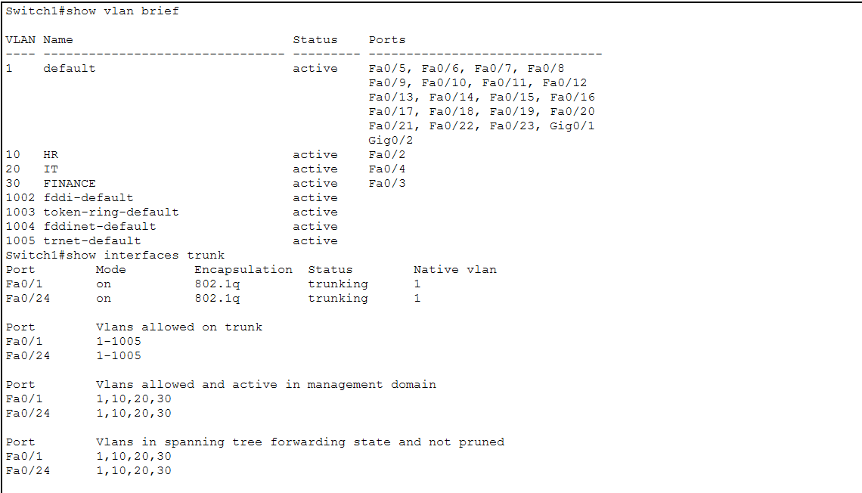
Figure 2: Switch1: show vlan brief and show interfaces trunk
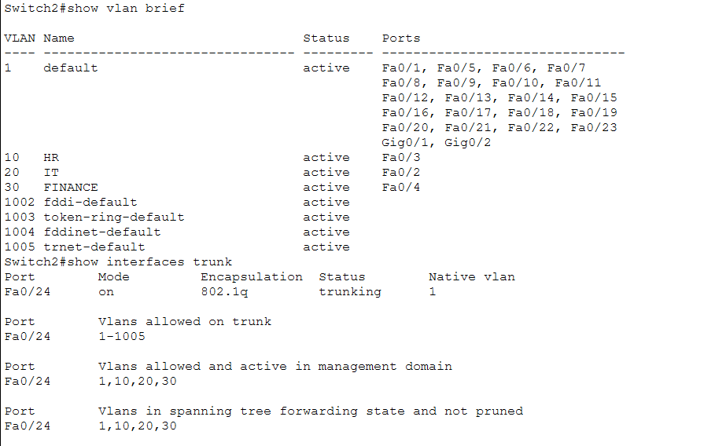
Figure 3: Switch2: show vlan brief and show interfaces trunk

4.2 Port status
show interfaces status shows each port as connected or not connected, with its VLAN, duplex and speed. Switch1 Fa0/1 shows as a trunk (router link) and Switch2 Fa0/24 shows as a trunk (inter-switch link). The PC ports show connected in VLANs 10, 20 and 30 as planned. Switch1 Fa0/24 (the inter-switch trunk) is listed further down the output, beyond the part captured in Figure 4, and is confirmed by Figure 2.
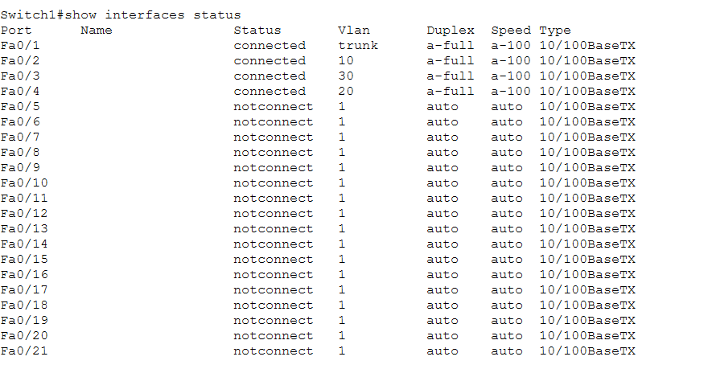
Figure 4: Switch1: show interfaces status (first screen)
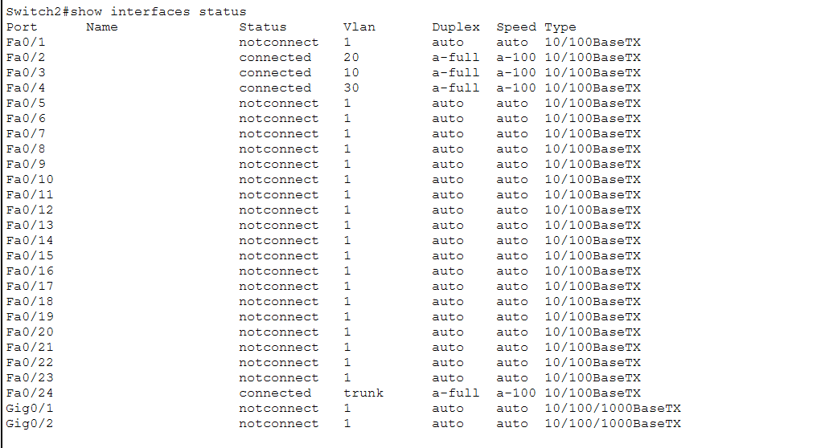
Figure 5: Switch2: show interfaces status

4.3 MAC address tables
show mac address-table shows where each MAC address was learned. On Switch1, the router MAC address 0004.9aa3.1e01 is learned on Fa0/1 in every VLAN, so all frames for the gateway leave through the router trunk. Hosts attached to Switch2 appear on Switch1 Fa0/24, and hosts on Switch1 appear on Switch2 Fa0/24, as expected when the VLANs span the inter-switch trunk.
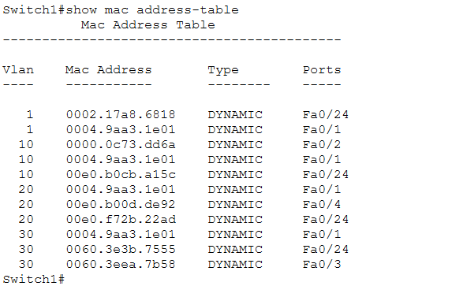
Figure 6: Switch1: show mac address-table
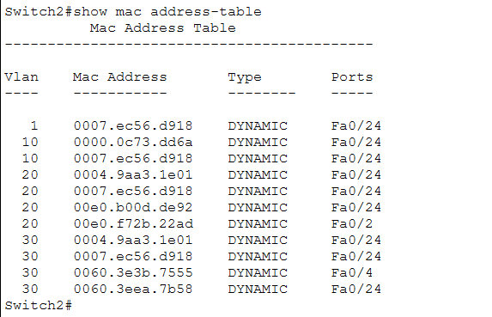
Figure 7: Switch2: show mac address-table

4.4 Running configuration
show running-config displays the active configuration. The access ports for each switch are visible in the captured output.
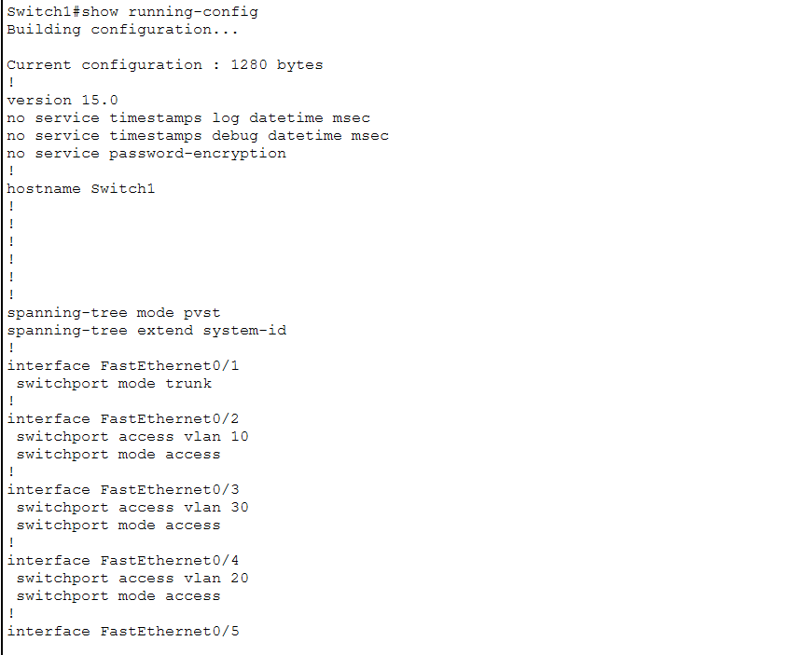
Figure 8: Switch1: show running-config (first screen)
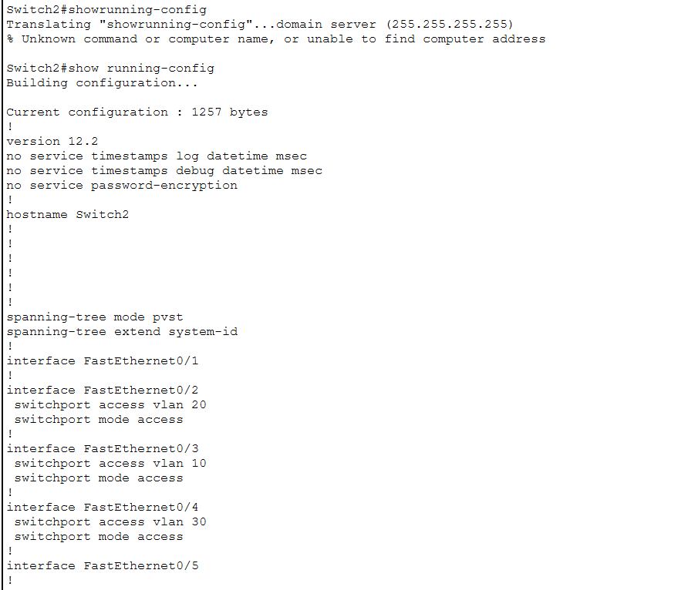
Figure 9: Switch2: show running-config (first screen)

5. Router-on-a-Stick Configuration
Inter-VLAN routing uses one physical interface, GigabitEthernet0/0, divided into three logical sub interfaces. Each sub interface is tagged with one VLAN through 802.1Q encapsulation and holds the default gateway address for that VLAN.
Sub interface | VLAN | IP address | Role
GigabitEthernet0/0.10 | 10 | 192.168.10.1/24 | HR gateway
GigabitEthernet0/0.20 | 20 | 192.168.20.1/24 | IT gateway
GigabitEthernet0/0.30 | 30 | 192.168.30.1/24 | Finance gateway

Equivalent configuration:
Router(config)# interface GigabitEthernet0/0
Router(config-if)# no shutdown

Router(config)# interface GigabitEthernet0/0.10
Router(config-subif)# encapsulation dot1Q 10
Router(config-subif)# ip address 192.168.10.1 255.255.255.0

Router(config)# interface GigabitEthernet0/0.20
Router(config-subif)# encapsulation dot1Q 20
Router(config-subif)# ip address 192.168.20.1 255.255.255.0

Router(config)# interface GigabitEthernet0/0.30
Router(config-subif)# encapsulation dot1Q 30
Router(config-subif)# ip address 192.168.30.1 255.255.255.0

5.1 Router verification
In show ip interface brief, GigabitEthernet0/0 and the three sub interfaces are up/up with the correct addresses, while the unused interfaces (Gi0/1, Gi0/2 and Vlan1) remain administratively down. In show ip route, each VLAN network appears as a connected route (C) with a matching local route (L) for the sub interface, so the router can forward between all three networks without any static or dynamic routing.
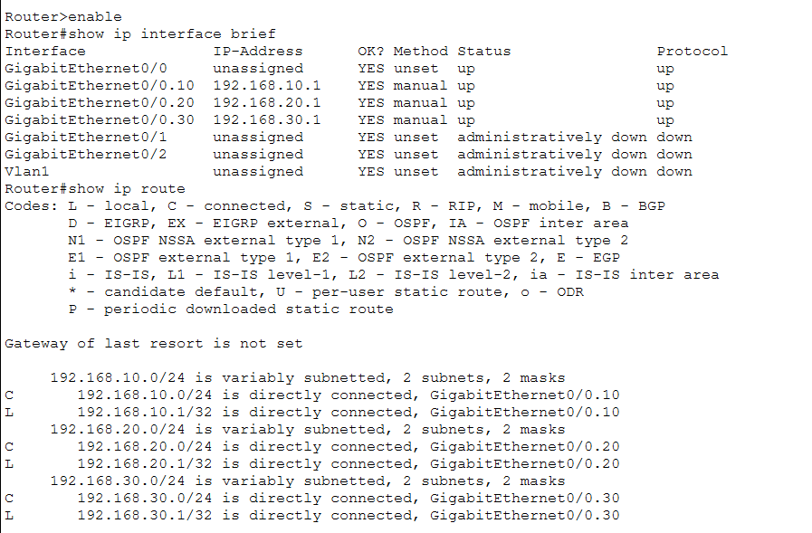
Figure 10: Router1: show ip interface brief and show ip route
show interfaces shows that Gi0/0 is up/up at 100 Mbps full duplex, and that the sub interfaces use 802.1Q encapsulation with their VLAN IDs and addresses (VLAN 10 and VLAN 20 are visible in this screen; VLAN 30 is confirmed in Figure 10). All sub interfaces share the physical MAC address 0004.9aa3.1e01, which is the address used in ARP replies for the gateways.
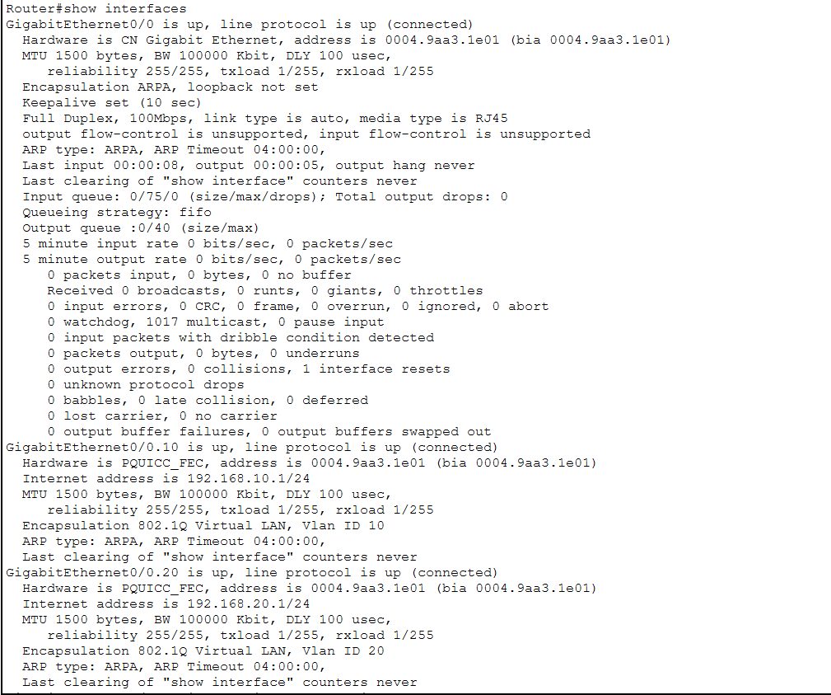
Figure 11: Router1: show interfaces
show running-config on the router displays the global configuration of Router1.
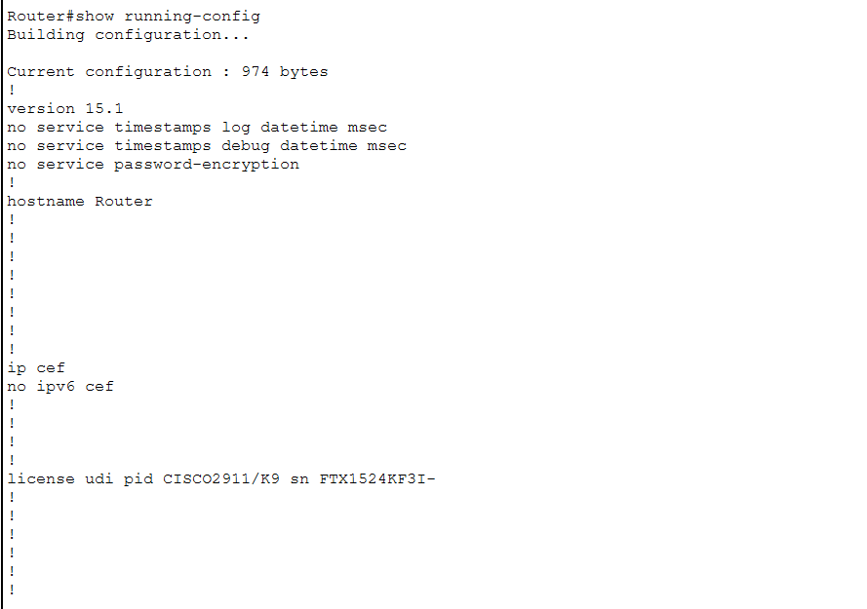
Figure 12: Router1: show running-config (first screen)

6. Testing and Verification

Test A: Same-VLAN communication
Each department's two PCs were tested. All three tests succeeded with 0% loss and TTL=128. A TTL of 128 is the default starting value for these PCs, so the packets were not routed. They were switched at Layer 2, across the Switch1 to Switch2 trunk. The HR test also shows a typing mistake (see Troubleshooting, Fault 4).
Test | Source | Destination | Result
HR VLAN 10 | HR-PC1 | HR-PC2 (192.168.10.12) | 4/4 replies, TTL=128
IT VLAN 20 | IT-PC1 | IT-PC2 (192.168.20.12) | 4/4 replies, TTL=128
Finance VLAN 30 | Fin-PC1 | Fin-PC2 (192.168.30.12) | 4/4 replies, TTL=128

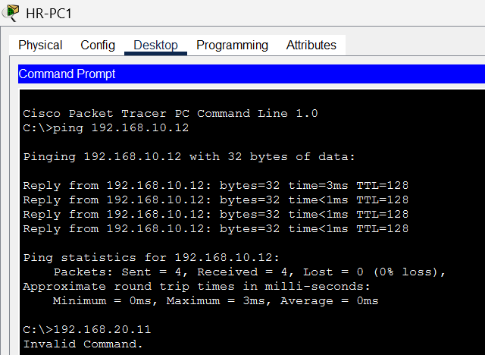
Figure 13: Test A: HR-PC1 pings HR-PC2 (192.168.10.12)
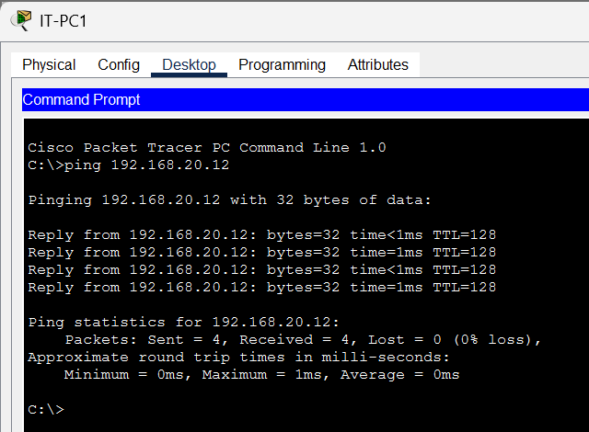
Figure 14: Test A: IT-PC1 pings IT-PC2 (192.168.20.12)

Test B: Inter-VLAN communication
HR-PC1 pinged IT-PC1 (192.168.20.11) and Fin-PC1 (192.168.30.11), and Fin-PC1 pinged HR-PC1 (192.168.10.11). All tests succeeded. The replies show TTL=127, one lower than in Test A, which proves that each packet crossed exactly one router hop (Router1) and had its TTL decremented.
Test | Source | Destination | Result
HR to IT | HR-PC1 | IT-PC1 (192.168.20.11) | 4/4 replies, TTL=127
HR to Finance | HR-PC1 | Fin-PC1 (192.168.30.11) | 4/4 replies, TTL=127
Finance to HR | Fin-PC1 | HR-PC1 (192.168.10.11) | 4/4 replies, TTL=127

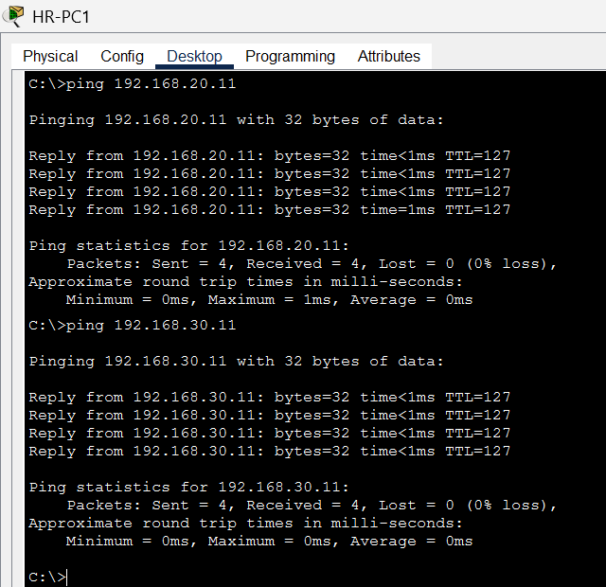
Figure 15: Test B: HR-PC1 pings IT-PC1 and Fin-PC1 (extracts of the same session)
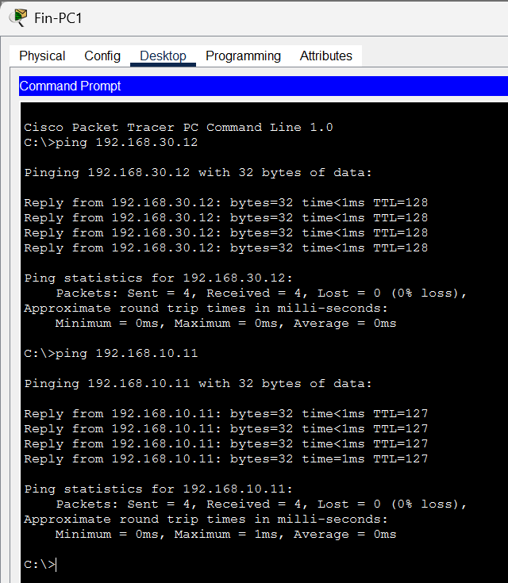
Figure 16: Test A and Test B: Fin-PC1 pings Fin-PC2 (TTL=128) and HR-PC1 (TTL=127)

Test C: VLAN isolation (router link shut down)
The router-to-switch connection was shut down and HR-PC1 pinged IT-PC1 in another VLAN. All four requests timed out (100% loss). After the link was restored, the first pings recovered and the result returned to 0% loss (see Troubleshooting, Fault 5).
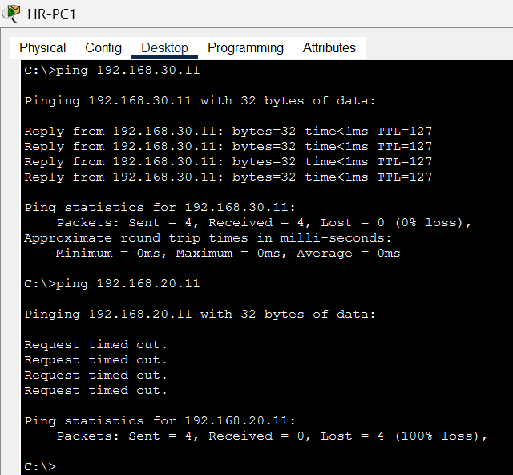
Figure 17: Test C: ping from HR-PC1 to VLAN 20 fails with 100% loss while the router link is down
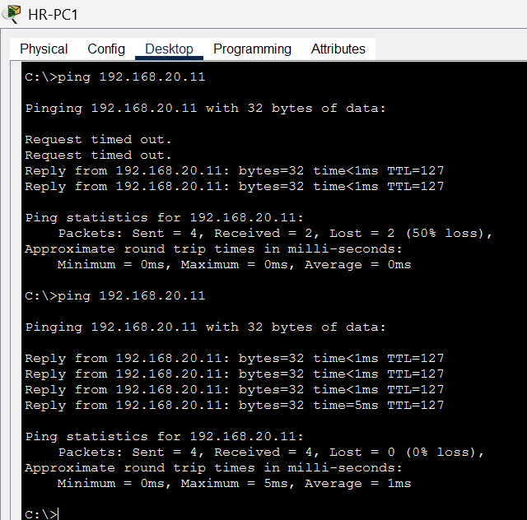
Figure 18: Test C: after the router link was restored, pings recover (50% loss, then 0% loss)
- Can two PCs in the same VLAN still communicate? Yes. Same-VLAN traffic is switched at Layer 2 using MAC addresses, either inside one switch or across the Switch1 to Switch2 trunk (Fa0/24). Neither path uses the router.
- Can a PC in VLAN 10 communicate with a PC in VLAN 20? No. The two VLANs are different broadcast domains and different IP subnets. The only path between them is through the router sub interfaces, so with the router link down there is no path and the pings fail (Figure 17).
- Why does the router affect inter-VLAN traffic but not intra-VLAN traffic? A host sends traffic for its own subnet directly to the destination MAC address, and the switches forward it without any Layer 3 device. Traffic for another subnet must be sent to the default gateway, and only a Layer 3 device can route between subnets. The router is therefore required for inter-VLAN traffic and not needed for intra-VLAN traffic.
The router connection was restored after the test.

Test D: Simulation Mode analysis
Packet Tracer was switched to Simulation Mode and a ping was sent from HR-PC1 (192.168.10.11) to Fin-PC1 (192.168.30.11). The event list shows the packet moving HR-PC1, Switch1, Router1, Switch1 and then arriving at Fin-PC1. Fin-PC1 is on Switch1 (Fa0/3), so the packet leaves Switch1 on the trunk to the router and returns on the same trunk.
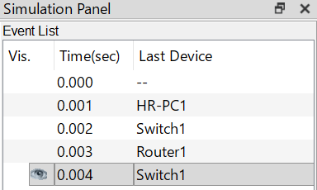
Figure 19: Simulation Mode event list: HR-PC1, Switch1, Router1, Switch1
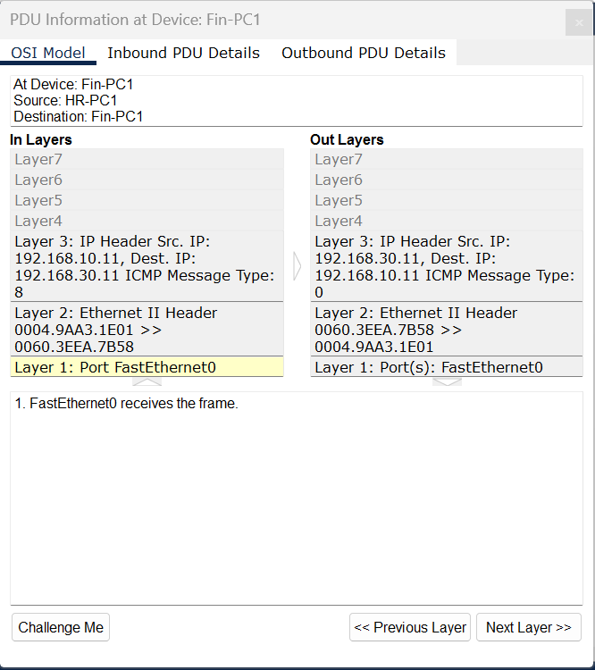
Figure 20: PDU information at Fin-PC1: the frame delivered after routing
- How the source PC finds its default gateway MAC address. Fin-PC1 is on a different subnet, so HR-PC1 sends the packet to its default gateway, 192.168.10.1. If the gateway MAC address is not in its ARP cache, HR-PC1 broadcasts an ARP request asking who has 192.168.10.1. The request floods VLAN 10 and reaches sub interface Gi0/0.10, which replies with its MAC address, 0004.9aa3.1e01.
- How the frame travels from the access switch to the router. The frame enters Switch1 untagged on access port Fa0/2 (VLAN 10). Its destination MAC address is the router, which Switch1 has learned on Fa0/1 (Figure 6). Switch1 therefore forwards it out the trunk port Fa0/1, adding an 802.1Q tag with VLAN ID 10.
- How the router identifies the correct outgoing interface. The 802.1Q tag (VLAN 10) places the incoming frame on sub interface Gi0/0.10. The router removes the Ethernet header, reads the destination IP address 192.168.30.11 and looks it up in its routing table. The connected route 192.168.30.0/24 points to Gi0/0.30, so that is the outgoing interface. The router then uses ARP, if needed, to find the MAC address of Fin-PC1.
- What happens to the source and destination MAC addresses? They are rewritten by the router. Into the router, the source MAC is HR-PC1 (0000.0c73.dd6a) and the destination MAC is the router (0004.9aa3.1e01). Out of the router, a new frame is built: the source MAC is the router (0004.9aa3.1e01, sub interface Gi0/0.30) and the destination MAC is Fin-PC1 (0060.3eea.7b58). Figure 20 shows this second frame arriving at Fin-PC1. It leaves the router tagged with VLAN 30, and Switch1 removes the tag and delivers it on access port Fa0/3.
- Do the source and destination IP addresses change? No. Without NAT, the source IP (192.168.10.11) and destination IP (192.168.30.11) stay the same from end to end, as shown in the PDU in Figure 20. Routing changes only the Layer 2 header (MAC addresses and VLAN tag) and reduces the TTL by one, which matches the TTL=127 seen in the inter-VLAN ping results.

7. Command Reference
The table lists each required verification command, the information it provides, and what it showed in this project.
Device | Command | Information provided | Result in this project
Switch | show vlan brief | VLANs, names, status and the access ports in each. Trunk ports are not listed. | VLANs 10, 20, 30 active with the ports in Section 4 (Figures 2, 3).
Switch | show interfaces trunk | Trunk ports, mode, encapsulation, status, native VLAN, allowed and forwarding VLANs. | 802.1q trunking on SW1 Fa0/1 and Fa0/24, SW2 Fa0/24; VLANs 1, 10, 20, 30 forwarding.
Switch | show interfaces status | One line per port: connected state, VLAN or trunk, duplex, speed, type. | PC ports connected in the correct VLAN; trunk ports shown as trunk (Figures 4, 5).
Switch | show mac address-table | Learned MAC addresses with VLAN and port. | Router MAC on SW1 Fa0/1; remote hosts learned over Fa0/24 (Figures 6, 7).
Switch | show running-config | Active configuration: VLAN, access and trunk port settings. | Access and trunk port settings (Figures 8, 9).
Router | show ip interface brief | Each interface and sub interface with IP address and status. | Gi0/0 and .10, .20, .30 up/up with correct addresses (Figure 10).
Router | show ip route | Routing table and how each route was learned. | Three connected (C) and three local (L) routes (Figure 10).
Router | show running-config | Active router configuration. | Global configuration of Router1 (Figure 12).
Router | show interfaces | Detailed interface data: status, MAC, encapsulation, counters. | Gi0/0 up/up; sub interfaces with 802.1Q VLAN IDs; MAC 0004.9aa3.1e01 (Figure 11).

8. Troubleshooting Report

Fault 1: Router link down
Symptom | The link between Router1 and Switch1 showed red in Packet Tracer and there was no inter-VLAN traffic.
Cause | The router physical interface GigabitEthernet0/0 was administratively down. Router interfaces are shut down by default.
Solution | Ran no shutdown on GigabitEthernet0/0. The link came up and the sub interfaces changed to up/up (Figure 10).

Fault 2: Inter-VLAN pings failing while same-VLAN pings worked
Symptom | PCs in the same VLAN could ping each other but pings between VLANs timed out.
Cause | Router-on-a-Stick needs the router-facing switch port to be a trunk and each sub interface to have its 802.1Q encapsulation set (encapsulation dot1Q <VLAN ID>) before the IP address is applied.
Solution | Set Switch1 Fa0/1 to switchport mode trunk and configured encapsulation dot1Q and the gateway address on each sub interface. Inter-VLAN pings then succeeded with TTL=127 (Figures 2 and 10).

Fault 3: First ping packet lost
Symptom | The first ping to a new destination showed "Request timed out", followed by three replies (25% loss).
Cause | ARP had not yet resolved the gateway and destination MAC addresses, so the first packet was dropped while ARP completed.
Solution | No fix needed. Pinging again gave 0% loss. This is normal behaviour and not a configuration fault.

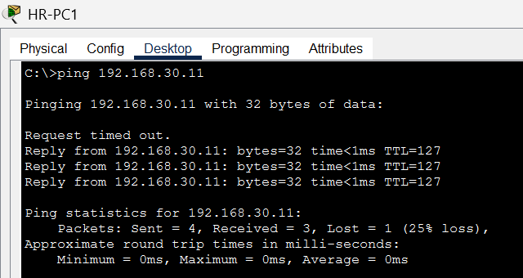
Figure 21: Fault 3: first ping to 192.168.30.11 loses one packet (25% loss)

Fault 4: Command entry errors
Symptom | On Switch2, showrunning-config returned "Translating... domain server" and "Unknown command or computer name". On HR-PC1, typing only 192.168.20.11 returned "Invalid Command".
Cause | A missing space in the first command made the switch treat it as a hostname to look up. In the second, the ping keyword was left out.
Solution | Re-entered the commands correctly as show running-config and ping 192.168.20.11. Both then worked (Figures 9 and 13).

Fault 5: Temporary packet loss after restoring the router link
Symptom | After the router link was restored at the end of Test C, the first ping to VLAN 20 lost 2 of 4 packets (50% loss).
Cause | The restored trunk port needs a few seconds to return to the forwarding state, and ARP entries may need to be learned again.
Solution | Waited a few seconds and pinged again. The next ping showed 0% loss (Figure 18).

9. Conclusion
VLANs let one physical network be divided into separate logical networks. Placing HR, IT and Finance in their own VLANs keeps each department's broadcast traffic inside its own broadcast domain, which reduces unnecessary traffic and improves network management. Users in the same department stay together logically even when they are connected to different switches, because the trunk carries all VLANs between the switches.
VLANs also improve isolation and security. Hosts in one VLAN cannot reach another VLAN directly at Layer 2, and all traffic between departments must pass through the router. This gives one central point where access rules, such as access control lists, can be applied if the company needs stricter policy. Testing confirmed that VLANs, trunks and Router-on-a-Stick work together: same-VLAN traffic stays switched (TTL=128), inter-VLAN traffic is routed (TTL=127), and shutting down the router link stops inter-VLAN traffic while same-VLAN traffic is unaffected.

Submission Checklist
No. | Requirement | Where it is covered
1 | Completed Packet Tracer .pkt file | Mark_Gichuhi_Gichohi_VLAN_Routing_Project.pkt (submitted separately)
2 | Screenshot of the complete topology | Section 2, Figure 1
3 | VLAN configuration on both switches | Section 4.1, Figures 2 and 3
4 | Trunk configuration | Section 4.1, Figures 2 and 3
5 | Router sub interfaces | Section 5.1, Figures 10 and 11
6 | Same-VLAN and inter-VLAN ping results | Section 6, Tests A and B
7 | Simulation Mode answers | Section 6, Test D
8 | Troubleshooting report | Section 8
9 | Conclusion | Section 9

