1. Provide a screenshot to show that you were able to open the Final_Assignment_Module_12 folder in VS Code. A screenshot of a computer

   Description automatically generated
2. 1. Provide a screenshot to show that you successfully ran the command to initialize the *driver* for Part 2 in VS Code. A screen shot of a computer

      Description automatically generated
   2. Provide two screenshots. The first screenshot should show the code demonstrating which data you defined, including the required three entries. The second screenshot should show that you successfully ran the `create.py` file. A screenshot of a computer program

      Description automatically generated
   3. Provide a screenshot of your Terminal window to show that your data is visualized correctly, that you ran the correct commands, and that the correct entry is displayed. A screen shot of a computer

      Description automatically generated
   4. Provide a screenshot to show that you successfully created the *container* named ‘final_assignment’ in Docker using port 3300. A screenshot of a computer

      Description automatically generated
3. 1. Provide a screenshot to show that you successfully ran the command to initialize the *driver* for Part 3 in VS Code. A screenshot of a computer

      Description automatically generated
   2. Provide two screenshots: The first screenshot should show that you successfully ran the command to create the “final_assignment_part3” *container* in your Terminal window. The second screenshot should show that the *container* you just created is active on Docker. A screenshot of a computer

      Description automatically generated
   3. Provide a screenshot to show that you successfully used the Redis *method*, mset, to create a *dictionary*, r, with *keys* equal to “Milk” and “Bread” and corresponding values equal to “Lactose” and “Gluten”. A black screen with a white text

      Description automatically generated
   4. Provide a screenshot of your Terminal window running the write.py file to show that your syntax does not contain any errors. 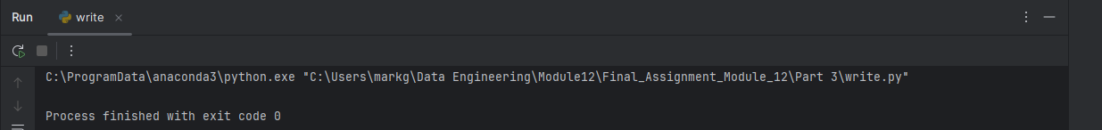
   5. Provide a screenshot of the read.py file to show your updated code after you used the Redis *method*, get, to read all values in r. A screen shot of a computer program

      Description automatically generated
   6. Provide a screenshot of your Terminal window to show that your code prints the *dictionary* values correctly in the read.py file. A screen shot of a computer

      Description automatically generated
4. 1. Provide a screenshot to show that you successfully ran the command to open the starter file for Part 4. A screenshot of a computer program

      Description automatically generated
   2. Provide a screenshot to show that you created a new project called “Assignment-Module12” in Firebase. A screenshot of a computer

      Description automatically generated
   3. Provide two screenshots: One screenshot should show that you navigated to the correct page in Firebase to obtain the private *key*, and one screenshot should show that you copied the private *key* file correctly into the serviceAccountKey.json file. Feel free to blur your private *key* in the screenshots. A screenshot of a computer

      Description automatically generatedA screenshot of a computer program

      Description automatically generated
   4. Provide a screenshot to show that you created an empty Realtime database for your project in Firebase. A screenshot of a computer

      Description automatically generated
   5. Provide a screenshot to show that you updated the databaseURL field in the fire.py file in VS Code with the URL that you copied. A screen shot of a computer program

      Description automatically generated
   6. Provide a screenshot to show that you updated two entries in your database in the fire.py file. A screenshot of a computer program

      Description automatically generated
   7. Provide a screenshot of your Terminal window to show that you ran the correct command to write to your database in Firebase. A black screen with a black background

      Description automatically generated with medium confidence
   8. Provide a screenshot from Firebase to show that your database has been written as expected.

