1. Provide a screenshot from VS Code to show that you created a time_loop.py file within the “Activity 13.2” folder.

1. Provide a screenshot to show that you successfully imported the necessary libraries to run a time *loop* inside the time_loop.py file.

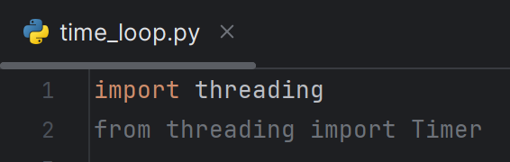

1. Provide a screenshot to show that you successfully created the five *lists*with the correct elements in each *list*. A screenshot of a computer program

   Description automatically generated
2. Provide a screenshot (or screenshots, if needed) to show that you successfully completed the following:
   1. Defined the build_book_dict() *function* with the five *lists* in the correct order.
   2. Used the Python zip() *function* to create a variable called inputs.
   3. Created an empty *dictionary*, d, inside the build_book_dict() *function*.
   4. Used a for*loop* to iterate over all the entries ininputs and update the entries of the *dictionary*,d, so that d becomes a nested *dictionary* with the structure defined in Step 4.
   5. Added a line of code to delay the execution of your *function* by three seconds.

1. Provide a screenshot of your Terminal window to show that you ran a print *statement* to call your *function* to ensure that your code works as expected. A screen shot of a computer

   Description automatically generated
2. Provide a screenshot to show that you successfully added a *timer* in your code that delays the execution of your code by five seconds. A computer screen with text

   Description automatically generated
3. Provide a screenshot of your Terminal window to show that you used the correct *function* to stop the *timer*, that you used a print *statement* to *print* the *string* “Timer Cancelled”, and that your code ran successfully.

