1. Provide a screenshot to show that you have successfully created the MBTANetwork network.

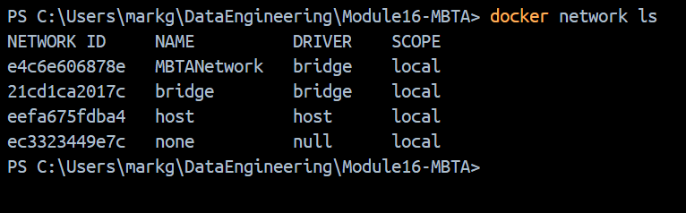

1. Provide a screenshot to show that you have successfully opened the mysqlDocker folder.

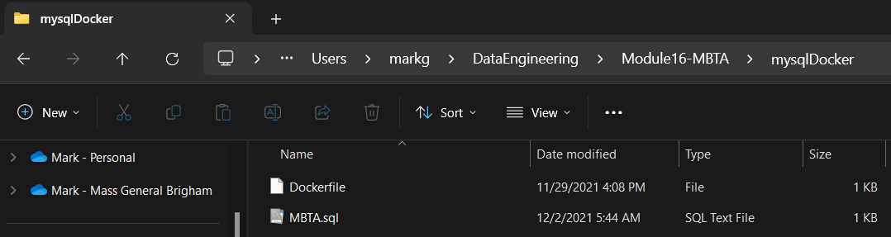

* 1. Provide a screenshot to show that you have successfully opened the MBTA.sql file.

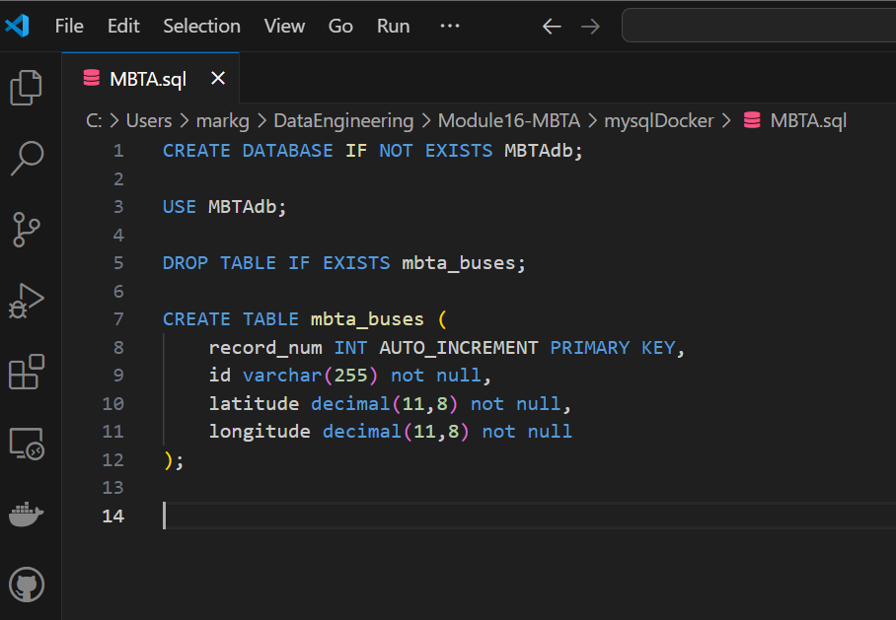

* 1. For this step, you will provide two screenshots. The first screenshot should show that you have successfully run the provided code in a Jupyter Notebook. The second screenshot should show that you have successfully added at least five additional fields to the mbta_buses table.

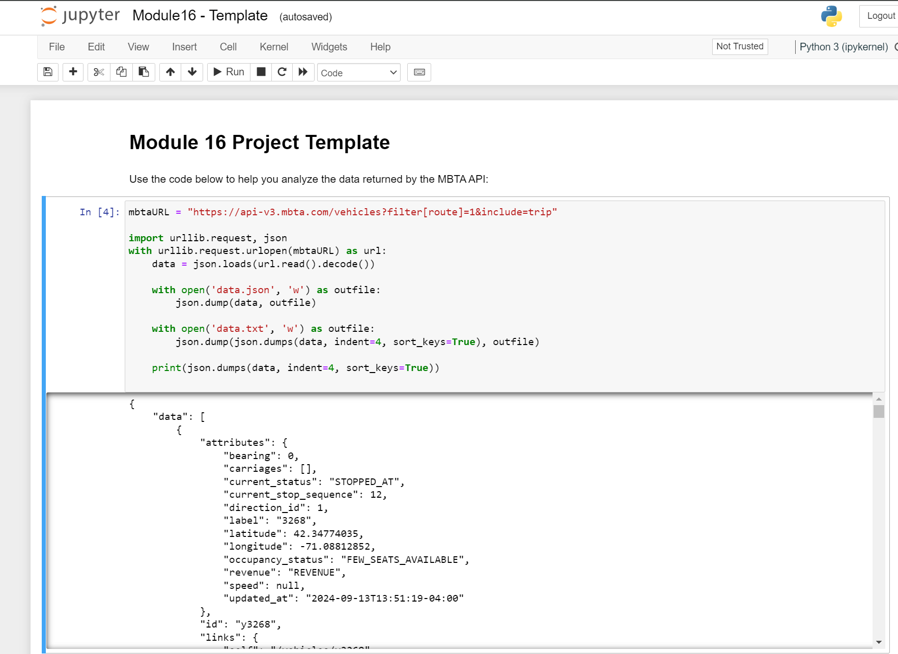

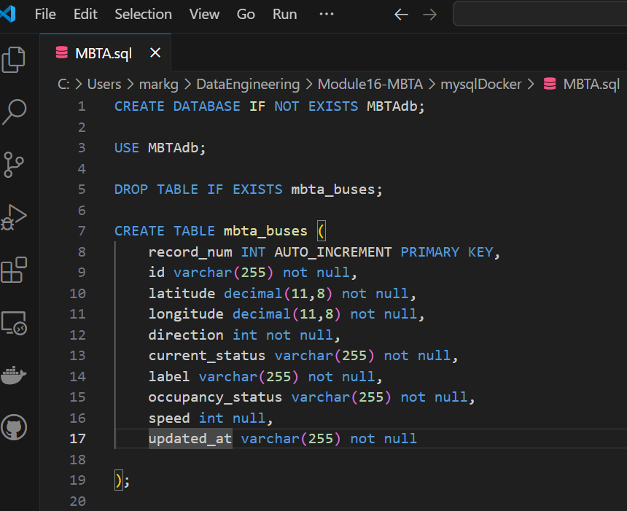

* 1. Provide a screenshot to show that you have successfully created the mysqlmbtamasterimg Docker *image*.

* 1. Provide a screenshot to show that you have successfully created the mysqlserver Docker *container*.

1. Provide a screenshot to show that you have successfully created the some-mongo Docker *container*.

1. 1. Provide a screenshot to show that you have successfully opened the Module16ProjectFlask.zip folder in VS Code.

* 1. Provide a screenshot to show that you have successfully modified the mysqldb.py file.

* 1. Provide a screenshot to show that you have successfully modified the MBTAApiClient.py file.

* 1. Provide a screenshot to show that you have successfully added your Mapbox access *token*in the index.html file.
  2. Provide a screenshot to show that you have successfully initialized the buses *list*in the server.py file.
  3. Provide a screenshot to show that you have successfully run the server.py file in VS Code.
  4. Provide a screenshot to show that you have successfully navigated to localhost:3000.

1. 1. Provide a screenshot to show that you have successfully opened the DebeziumCDC.zip folder in VS Code.
   2. Provide a screenshot to show that you have successfully created the debeziummodule16 Docker *image*.
   3. Provide a screenshot to show that you have successfully created the Docker *container* and associated it with the MBTANetwork network.
   4. Provide a screenshot to show that you have successfully installed the nano text editor in your shell.
   5. Provide a screenshot to show that you have successfully modified the MongoDB.java *class*.
   6. Provide a screenshot to show that you have successfully modified the handleChangeEvent *method*.
   7. Provide a screenshot to show that you have successfully run the Maven SpringBoot application.
2. 1. Provide a screenshot of your Docker desktop to show the javamaven *container* running.
   2. Provide a screenshot to show that you successfully navigated to the *directory* and listed the files.
   3. Provide a screenshot to show that you successfully created the ReadCDC.java file and copied the code.
   4. Provide a screenshot to show the results of the bash command to execute the ReadCDC.java *class*.

Your second submission will be the [Project 16.1 Jupyter Notebook template](https://classroom.emeritus.org/courses/9296/files/2494064/download) with your answers to the following three questions included:

1. Answer the following questions in your Jupyter Notebook submission:
   1. What is the average time it takes for a bus to complete Route 1?
   2. Include a *plot*-type visualization based on the data. The type of *plot*you choose to include is up to you.
   3. Give an estimate of the speed of the bus from current_stop_sequence = 1 to the last current_stop_sequence. **Note**: You can use the [haversine Links to an external site.](https://pypi.org/project/haversine/)Python *library*to calculate the distance between two points given two longitude and latitude coordinates.