**Part 1: Writing Data to an Excel File**

1. Provide a screenshot to show that you successfully created the two folders: input and output.

1. Provide a screenshot to show that you successfully copied the movies.xlsx file in the input folder.

1. Provide a screenshot to show that you successfully created the Assignment17 process group.

1. Provide a screenshot to show that you correctly configured the *properties* for the GetFile *processor*.

1. Provide a screenshot to show that you correctly configured the *properties* for the ConvertExcelToCSVProcessor *processor*.

1. Provide a screenshot to show that you correctly configured the *properties* for the PutFile *processor*.

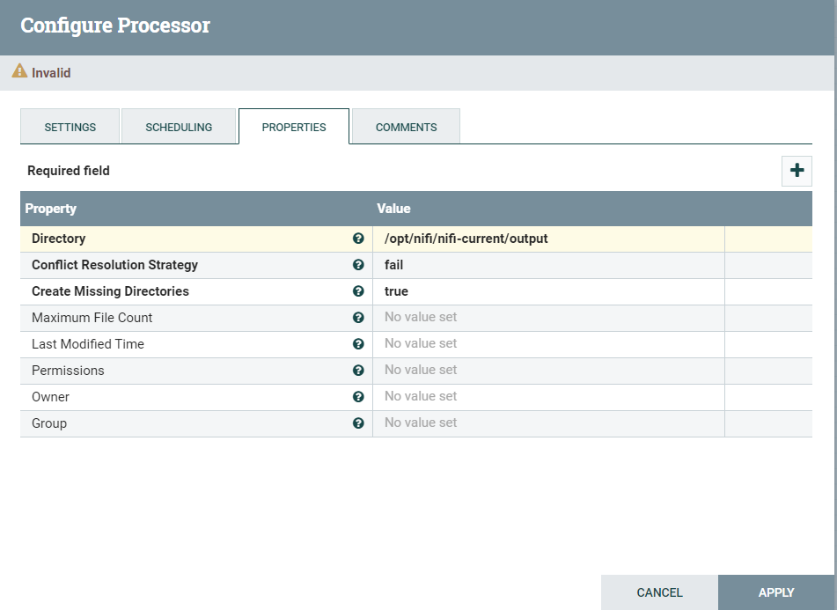

1. Provide a screenshot to show that you successfully connected all the *processors* with the correct relationships.

1. Provide a screenshot to show that all the *processors* are running (as indicated by a green arrow).

1. Provide a screenshot to show that the movies_Assignment.csv file has been created.

**Part 2: Writing Data to an SQL Database**

1. Provide a screenshot of your MySQL Workbench to show that you have successfully initialized an empty movies table in the movielens database.

1. Provide a screenshot to show that the movies.csv file is now on the NiFi *server*.

1. Provide a screenshot to show that you successfully opened the NiFi UI.

1. Provide a screenshot to show that you successfully created and enabled the MySQL *controller* service.

1. Provide a screenshot of the *controller*screen to show that the three *controller* services (*reader*, *writer*, and MySQL) are enabled.

1. Provide a screenshot of your complete data pipeline, including all five *processors*: GetFile, SplitText, ConvertRecord, ConvertJSONToSQL, and PutSQL.

1. Provide a screenshot of all five *processors* to show that the correct *connectors* have been added between the *processors*.

1. Provide a screenshot of your NiFi browser screen to show all five*processors* connected and running. A screenshot of a computer

   Description automatically generated
2. Provide a screenshot of the result of this *query*to show that the movies table in the movieslens database is now saturated with data.

