1. Provide a screenshot to show that you successfully reviewed the list of Docker *containers* running on your machine using the docker ps command.

1. Provide a screenshot to show that you successfully cloned the Big Data Europe Project GitHub repository.

1. Provide a screenshot to show that you are able to find the docker-compose.yml file using the command line interface.

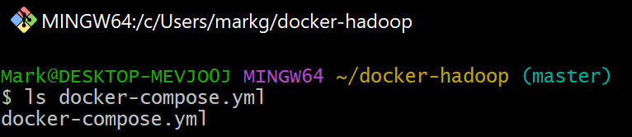

1. Provide a screenshot to show that you successfully ran the Docker command to create the *containers*.

1. Provide a screenshot to show that you have all of the Hadoop *containers* running in the (healthy) STATUS.

1. Provide a screenshot to show that you are able to open a Hadoop web browser link by navigating to http://localhost:9870.

