1. Provide a screenshot to show that you successfully installed DASK.

1. Provide a screenshot to show that you opened the file correctly.

1. Provide a screenshot to show that you created the pandas_df *dataframe* correctly.

1. Provide a screenshot to show that you set the npartitions *argument* equal to 2.

1. Provide a screenshot to show that you ran the code without any errors.

1. Provide a screenshot to show that the 0.part and 1.part files are present inside of the activity22.1 folder.

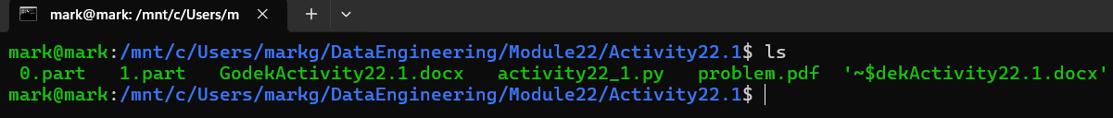

1. Provide a screenshot showing the contents of the 0.part and 1.part file.

