1. Provide a screenshot to show that you successfully installed DASK.

DASK was installed in previous activities. I can’t install it twice. You can see it is installed and running in Step 2.

1. Provide a screenshot to show that you successfully ran the dask-scheduler.

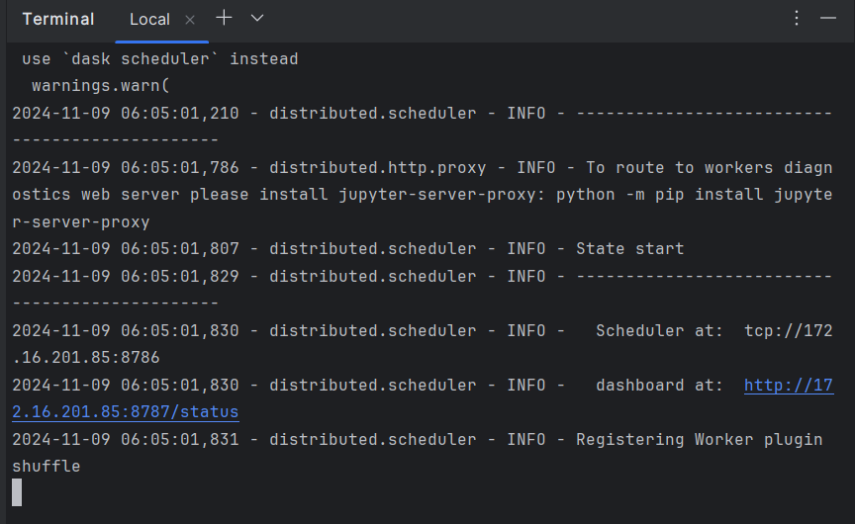

1. Provide two screenshots to show that you successfully started both of the dask-worker processes by passing the correct address to the dask-scheduler.

1. Provide a screenshot to show that you created a Jupyter Notebook and successfully imported the DASK *libraries*.

1. Provide a screenshot to show that you successfully executed the command to create a matrix, compute the mean, and assign the value to the y variable.

1. Provide a screenshot to show that you successfully computed your calculations using DASK using the compute*function*.
2. A screenshot of a computer program

   Description automatically generated