Three lots of capacitors were submitted Gideon Labs for chloride and zinc contamination analysis on the terminal leads of the electrolytic capacitors.
The analysis was performed using a SEM-EDS system giving elemental analysis in relation to intensity of the element at a specific wavelength or energy level (Kev). Since Kev (energy levels) for specific elements do not change, these are used to identify the elements in the sample.
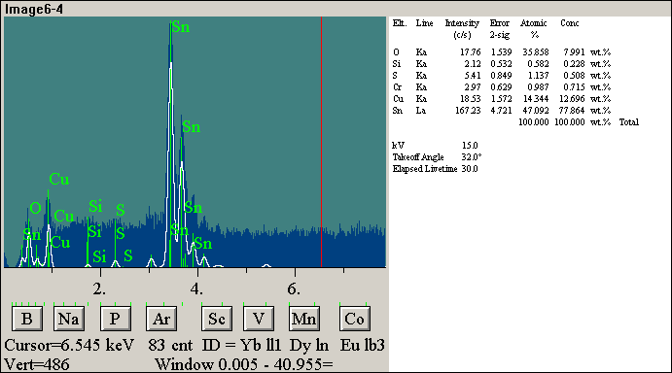

This is an EDS of the contamination. The analysis proved the leads had silver, tin and silicone. The silicone contaminate on the lead prevents solderability and thus, weak solder joints will form, if they form at all.
Gideon Labs can save your company money by identifying the contamination and the contamination source. If your product has unidentified foreign material, send it to Gideon labs between our 30 years’ experience and analysis we can identify the majoring of contaminates and source at a reasonable cost.

