Building catkin_ws with realsense-ros
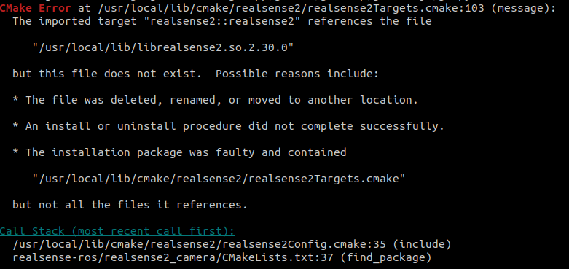
When building catkin_ws with realsense-ros :https://github.com/IntelRealSense/realsense-ros#step-3-install-intel-realsense-ros-from-sources
Getting error like shown above. Went to usrlocal/lib/cmake/realsense2 and checked the files. Some files still contained version 2.30.0. Changed this to 2.29.0 via terminal made it work.

Made use of Realsense SDK version 2.29.0 (build from source)

Cpp files error realsense SDK
After getting ROS fixed with realsense, original Cpp code started giving errors like shown above. Try to build the code again. It should fix the issue.

