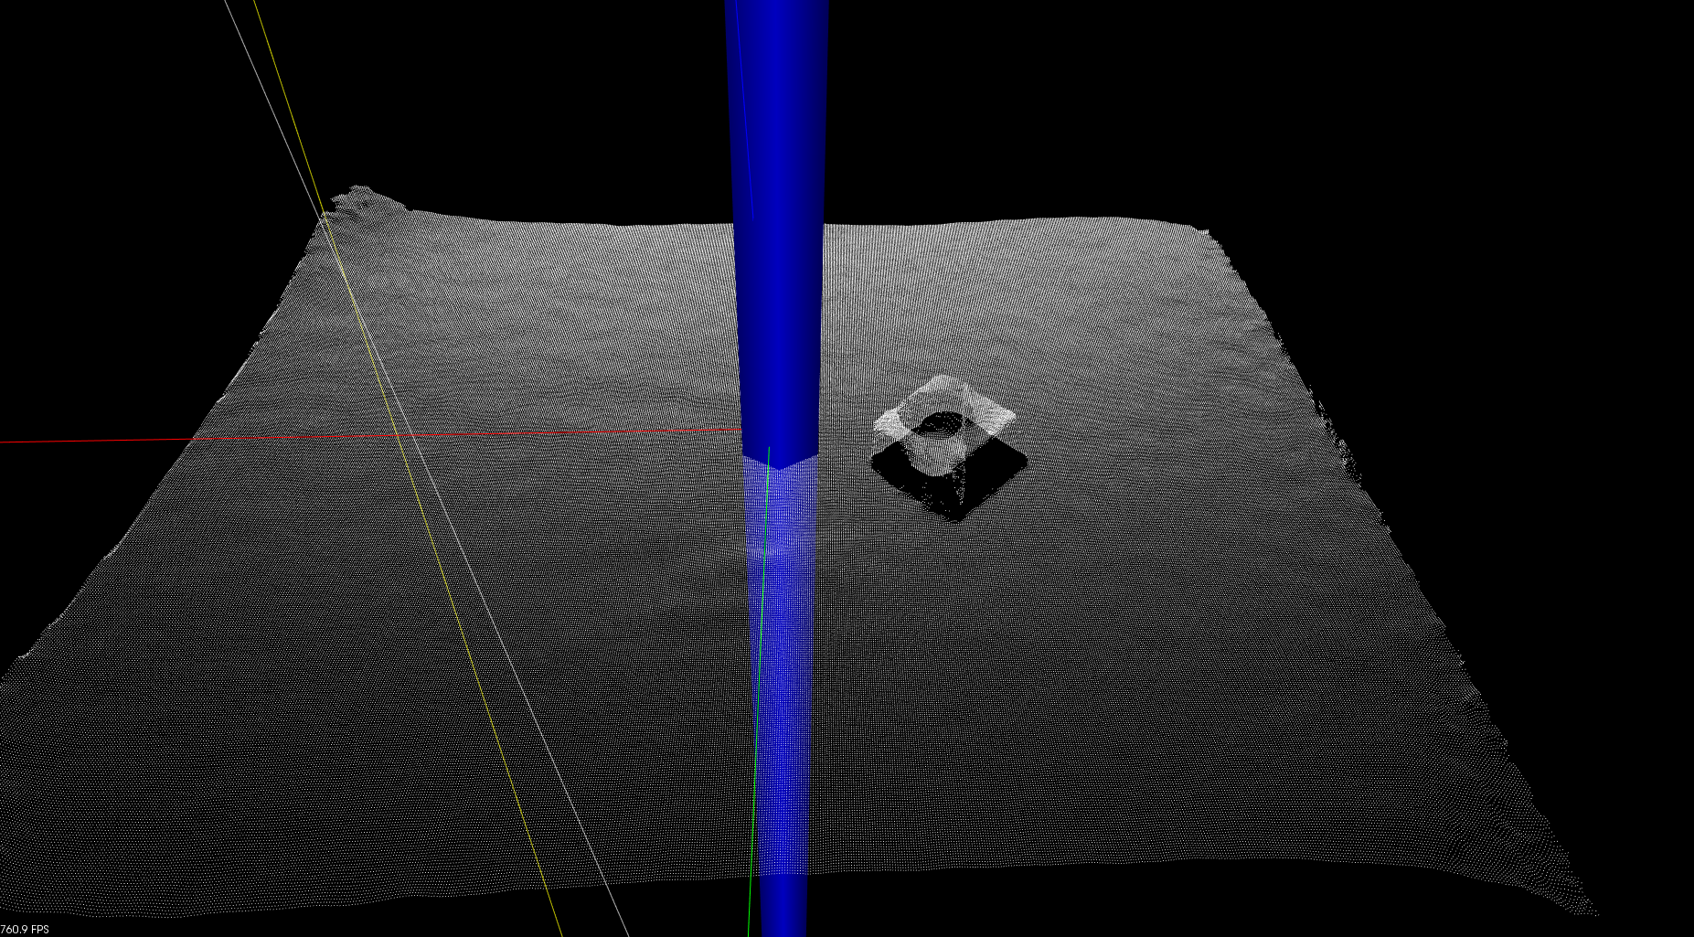
Bearing box before pass through filter

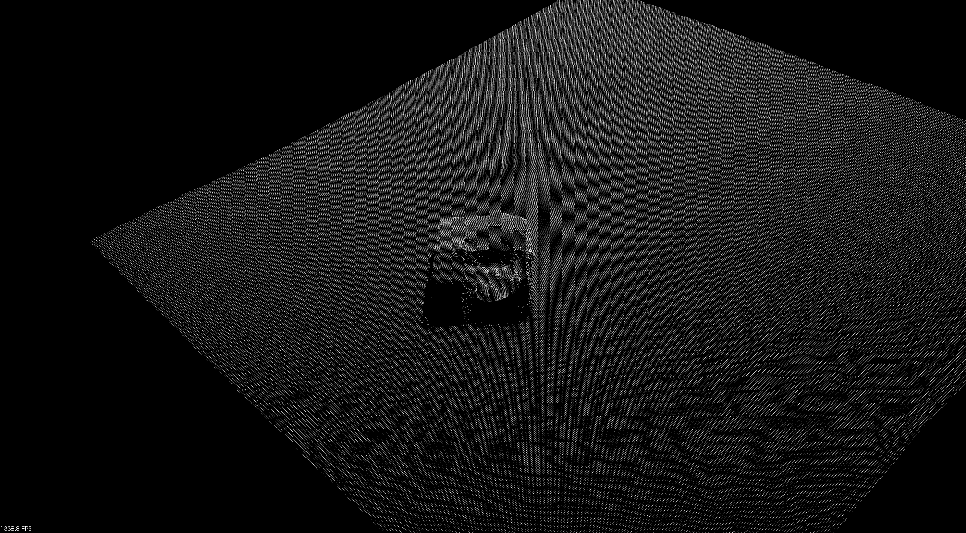
Bearing box after pass through filter

With this filter you can define min and max dimensions of x,y,z. In this particular example we use it to remove the curved edges so the segmentation will get easier and more accurate.

Note that the generated PCD file contains a lot of 0 0 0 points. This can give miscalculations when calculating the TF. We saw this happening and this will be fixed.

After removing the 0 0 0 points. The Z height of the TF is level with the table.

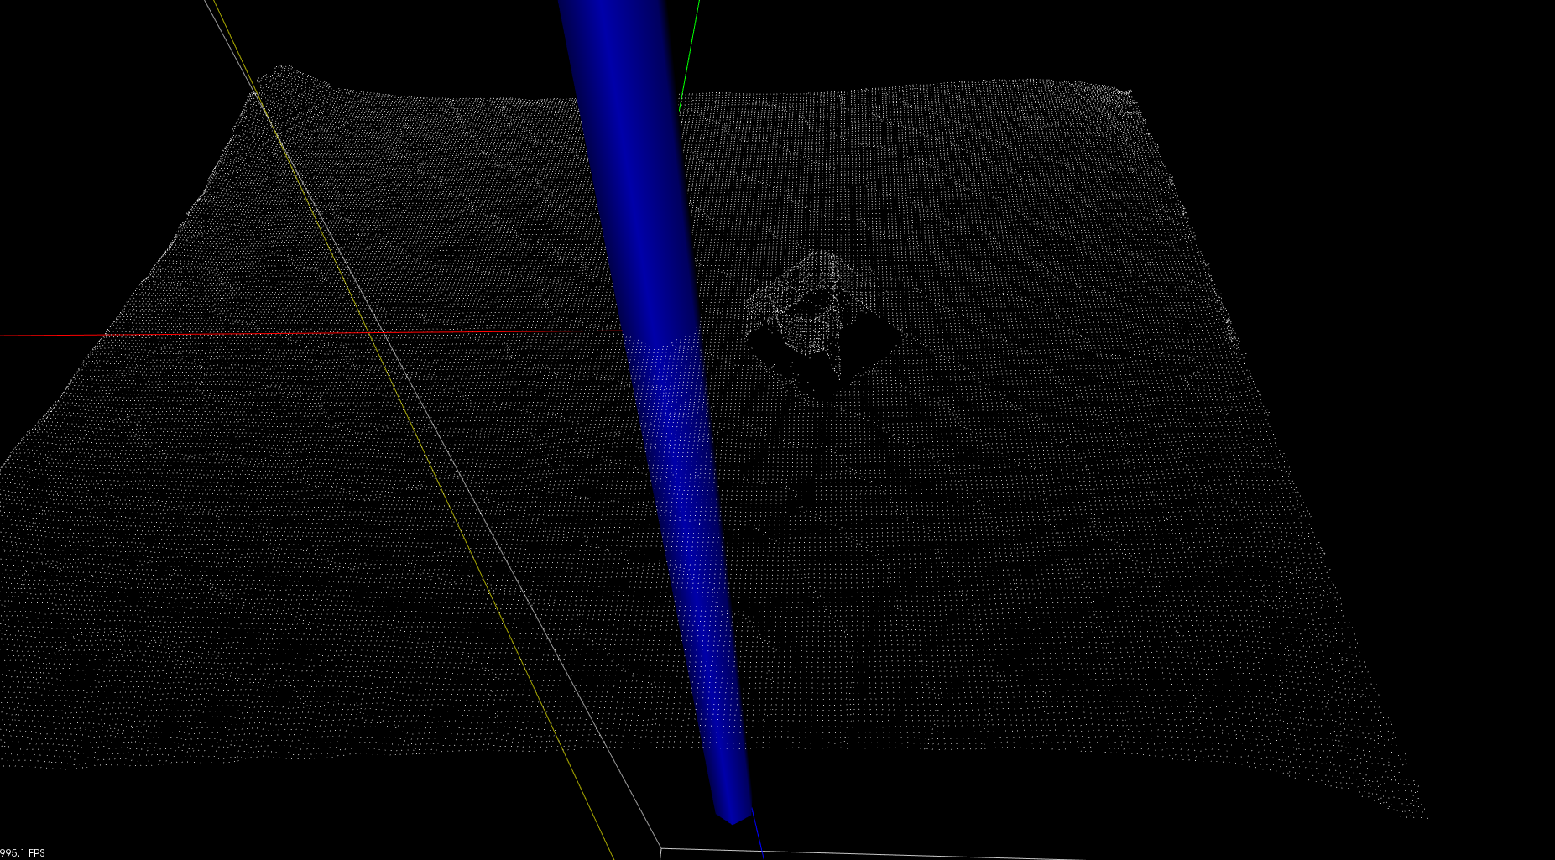
Bearing box before Voxel Grid filter

Bearing box after Voxel Grid filter

The Voxel Grid filter is used to reduce the number of points. This decreases computing time.
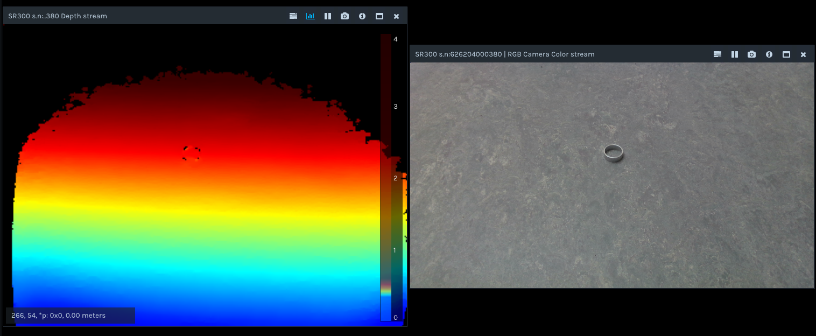
Little test if watching with an angle to the distance tube makes it more visible. We decided to stick with current setup and make this work before we change things like this.
ROS research
http://wiki.ros.org/ROS/Tutorials

Packages contain:
- Own folder
- CmakeLists.txt which uses catkin
- Catkin compliant package.yml

Create package with:
# catkin_create_pkg <package_name> [depend1] [depend2] [depend3]
Dependencies are stored in package.yml

Building catkin:
Whole src folder:
# In a catkin workspace
$ catkin_make
$ catkin_make install # (optionally)
from source:
# In a catkin workspace
$ catkin_make --source my_src
$ catkin_make install --source my_src # (optionally)
Start Roscore:
$ roscore

ROS Nodes:
- Executable that uses ROS to communicate with other nodes
- Can publish or subribe to a topic
- Can provide or use a service

List of running nodes:
$ rosnode list

Run a node from given package:
$ rosrun [package_name] [node_name]

ROS Topics:
Communication is done over a ROS Topic

get information about rostopic with:
$ rostopic

show published data with:
$ rostopic echo [topic]

List of all topics to pusblish and subribe to and their type:
$ rostopic list -v

ROS Message:
- Messages are used to communicate between nodes. For the publisher and subscriber to communicate they must send and receive the same type of messages. The topic type is defined by the message type published on it.

Find type of a topic:
$ rostopic type [topic]

ROS Services:
Nodes can communicate with each other via services. Services allow nodes to send a request and receive a response.

Find type of a ROS Service:
$ rosservice type [service]

Call a ROS Service:
$ rosservice call [service] [args]

MSG and SRV:
- msg files are simple text files that describe the fields of a ROS message. They are used to generate source code for messages in different languages
- srv files describe services. It is composed of two parts: a request and a response
- msg files are stored in msg dir and srv files are stored in srv dir

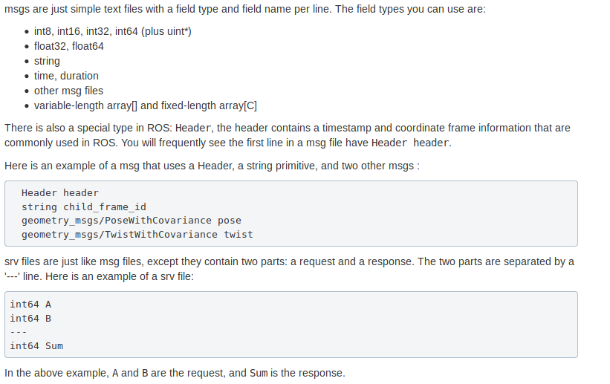

X
Y
Angle
Angle
Angle
Angle

angle

PI - angle

2*PI - angle

PI + angle

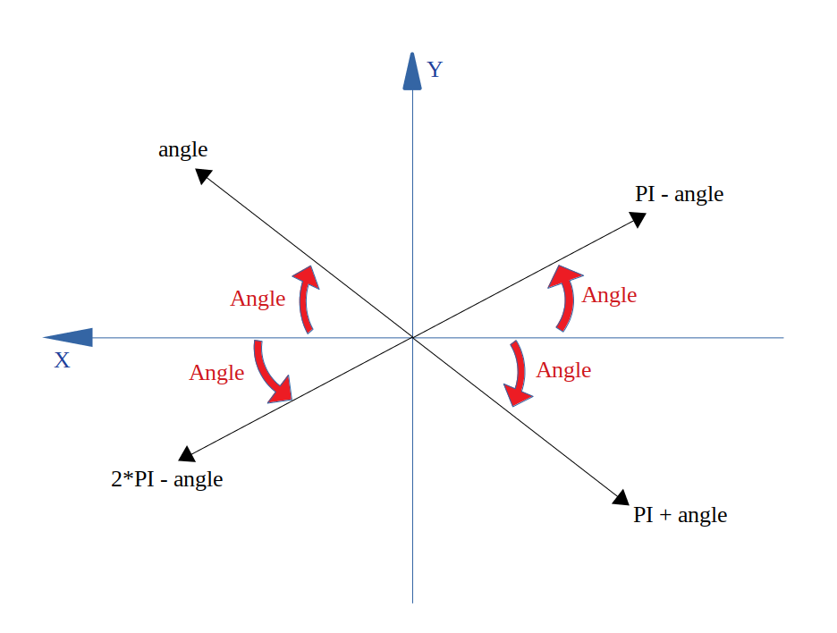

The angle relative to the positive x-axis is calculated as shown in the picture above. In our code we add use (PI + angle and 2*PI + angle) because the calculated angles are negative.

