Research progress:

To do:
- update draw.io
- add making list with vector
- add build_viewer
- TF transformator

1
Installing ubuntu 18, c++ compilers, ros1, opencv & PCL library
https://pydeeplearning.com/opencv/install-opencv-with-c-on-ubuntu-18-04/
http://www.pointclouds.org/downloads/linux.html
PCL:
- sudo apt-get update
- sudo apt-get install libpcl*
http://wiki.ros.org/ROS/Installation

librealsens:
Sudo apt-get update
sudo apt install librealsense2-dkms librealsense2-utils librealsense2-dev
pip3 install pyrealsense2
https://github.com/IntelRealSense/librealsense/blob/master/doc/distribution_linux.md

2
Research for most optimal 3D library. PCL is chosen due to it’s very wide range of different classes to receive and process a 3D image/ point cloud and it very clear documentation! PCL is written in c++. There are several bindings to use PCL with python but not for all classes. We chose to learn c++ for full use of the PCL.

Step to take and to research:

Filtering | Type of tree | Segmentation | TF determination | visualization
Depends on segmentation choice | Depends on segmentation choice | Plane Model segmentation | Moment of inertia | Depend on TF and segmentation choice
 |  | Cilinder model segmentation | GASD
 |  | Euclidean cluster extraction
 |  | Region growing segmentation
 |  | Color-based region growing segmentation
 |  | Min-cut based segmentation
 |  | Conditional Euclidean clustering
 |  | Difference of Normals Based Segmentation

3
Learning c++ from online tutorials and setting up CMakeLists

4
Starting to use and integrate PCL llibrary and opencv.

5
Setting up datastream from BlasterX Senz3D and receive colored, IR and depth images.
Files: cam_test2 & cam_test3
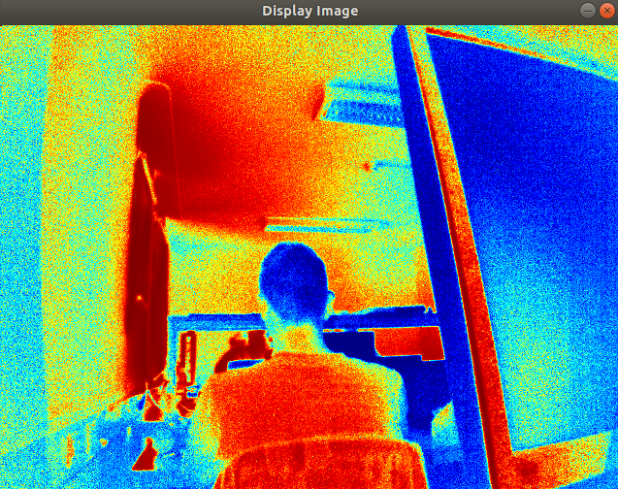

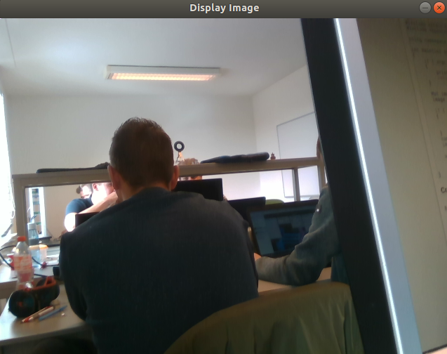

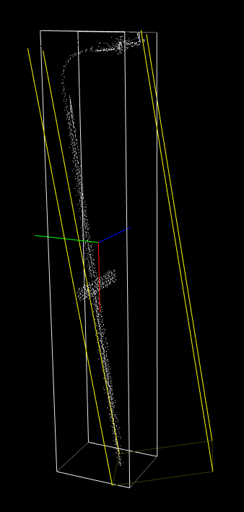
6
Getting TF from .pcd file. We chose to use Moment of Inertia to get TF. This is chosen because the GASD method was more complex due to the fact that it also uses object recognition. We first want to start with determing the TF’s of one single object point cloud and if we succeed in time, upgrade to include object recognition if possible. Next step is to do this with an own create pcd file or directly from the data stream
Files: pcl_v1.1_TF_Enertia.

7
Grab point cloud from DepthSense cameras
http://www.pointclouds.org/documentation/tutorials/depth_sense_grabber.php#depth-sense-grabber

8
Segmentation. Our approach for segmentation will be as followed. First we want to make a point cloud of a table, scanned form 30 cm height, with the position of the camera parallel to the table, with only one object on it. After that we want to segment the table an the object. After that we want to remove the table data so you only keep the object data. This data will be used to determine the TF of the object.

The segmentation options:

Options | Pros | Cons | Extra
Plane Model segmentation | Detect planes in pc, meaning it can detect the table and filter it out
Cilinder model segmentation |  | Detects cylindrical models, we also have not cylindrical objects
Euclidean cluster extraction | This will cluster all different objects and create different pcd per object/cluster |  | -Uses plane model segmentation  - uses kd tree
Region growing segmentation |  | It will cluster surfaces, meaning it will cluster a cube in more clusters/ surfaces
Color-based region growing segmentation |  | It will cluster objects based on color, meaning we are again color and light depended.
Min-cut based segmentation |  | It will binary segment a given pc and makes a set of foreground and background points. BUT IT NEEDS ALREADY THE CENTER OF THE OBJECT.
Conditional Euclidean clustering | It will cluster have a simular approach as euclidion cluster, region growing and color-base segmentation but it can be manually be fine tuned for user specific results | It is much more advanced to use and integrate in comparison with the other named approach in the pros row.
Difference of Normals Based Segmentation |  | It will find normals in an pc depending on user defined parameters. It will not output clusters of objects or the table.

To test our concepts we first start with working out the Plane Model Segmentation and the Euclidean Cluster extraction. This is chosen because with the plane model we remove the background and only keep our required object and is good enough mandatory test to determine one object at a time. We also can measure the distance between the table and the camera with Plane model segmentation. The Euclidean Cluster is chosen because this is more sufficient when we have more than one object on the table. This is important to achieve when the software will be integrated in a robotic system. The conditional Euclidean clustering is maybe an option when we have a working concept and want to improve it.

Succes with both concepts:
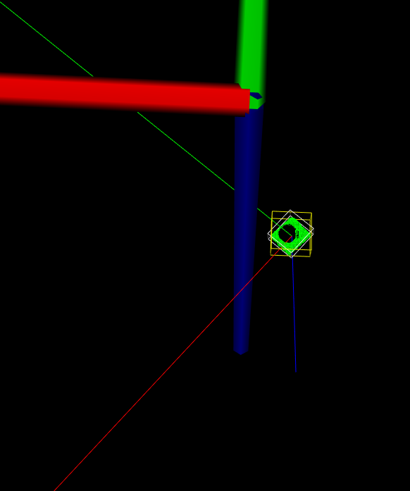
Euclidean:
detected object bearing box

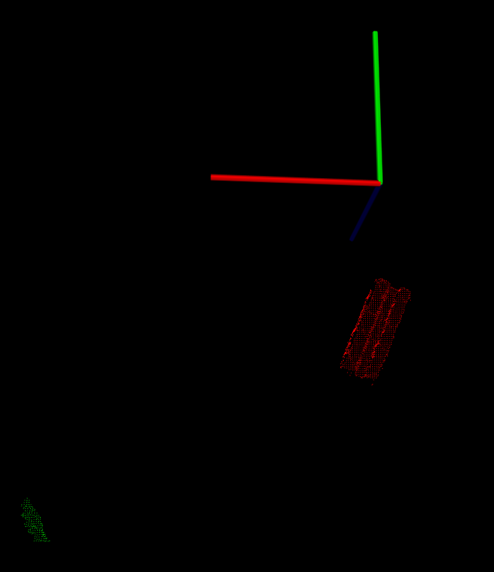
Still need to filter pcd in left down corner.

Plane model:
Detected the table with plane model:
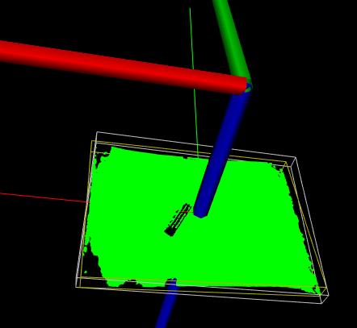

Problem cameras:
BlasterX Senz3d
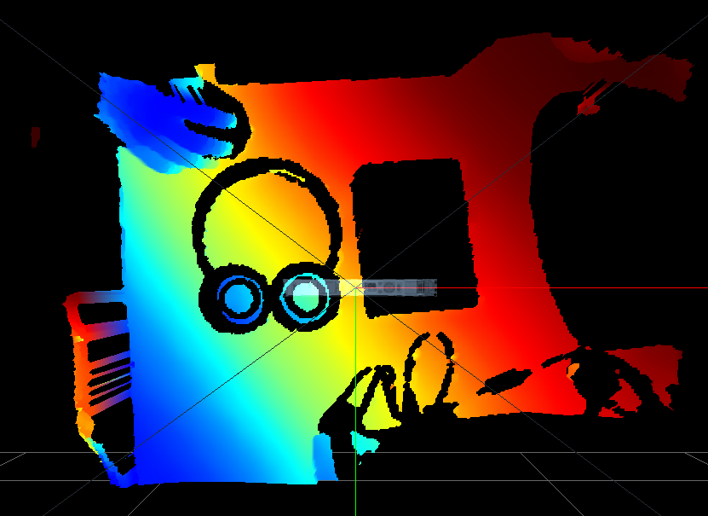
d400
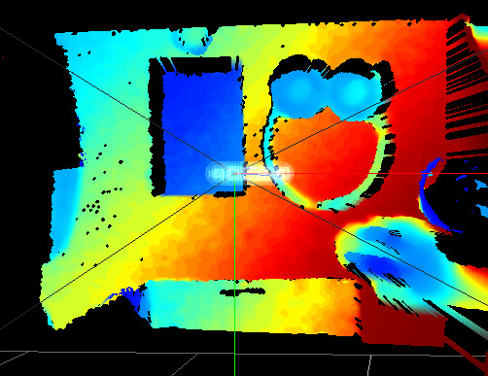
Result camera problem:
We discussed the problem with the client. The client was aware that due to the fact that black objects absorb IR light, they wont be detectable. We need to put this in the disclaimer. If there is time, we can try using 2d object detecting for detecting the black objects, and use the measurement of the distance from camera to table to create a tf. This isn’t mandatory.
C++ design:
https://www.jannovergara.me/posts/solid-design-principles-for-the-modern-c++/
https://cppcodetips.wordpress.com/2013/12/23/uml-class-diagram-explained-with-c-samples/

Main c++:
Currently we can’t fix an option to return pcl datatypes in a flexible way when there are more than one PCD. Currently we assume that we only generate one solution with Euclidean segmentation because we only give one PCD containing one object due to object recognition.

After combining al the separate codes we succeded getting the TF of the table, the object an the camera. We also visualized everything:
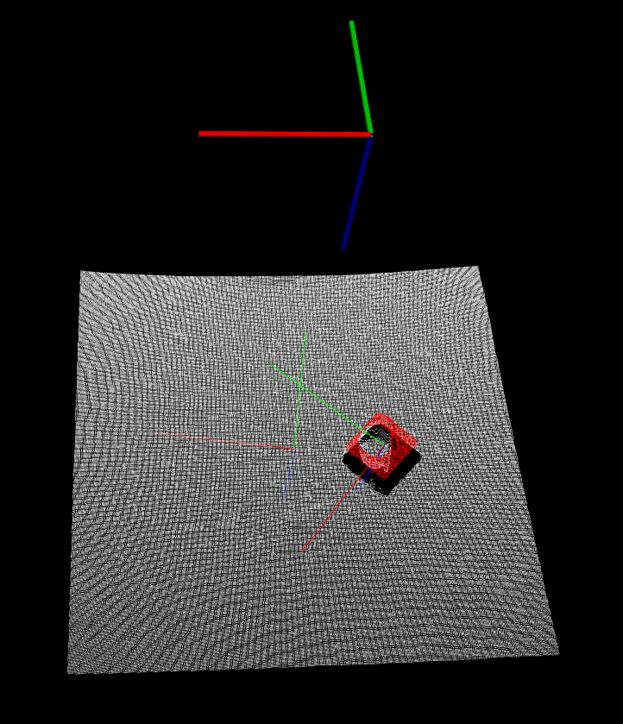
We notice that at some objects the disturbance is bigger than other and can result to rotated TF’s.
Disturbance:
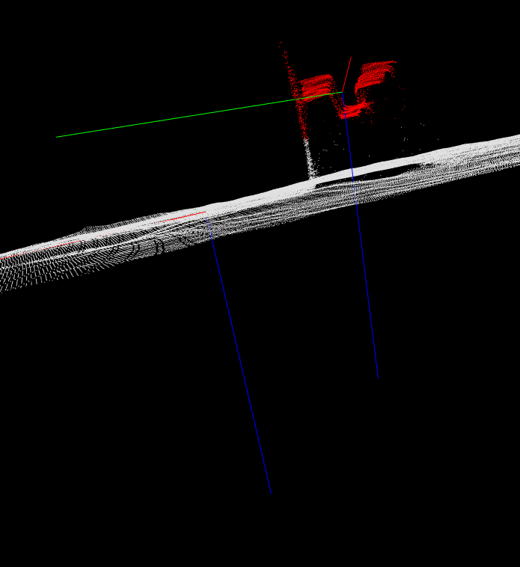
/suii_vision_3d/src_test_folders/main
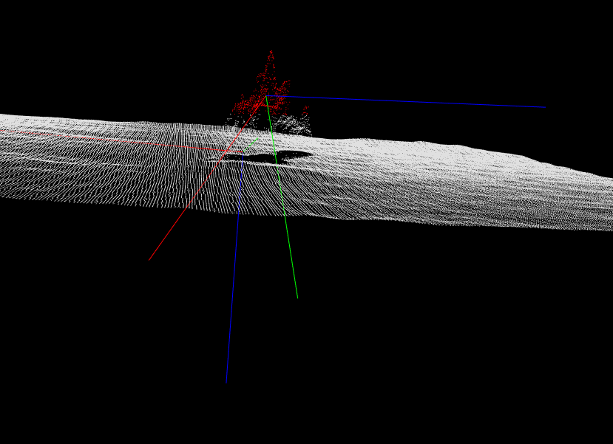
Main GetTf time:

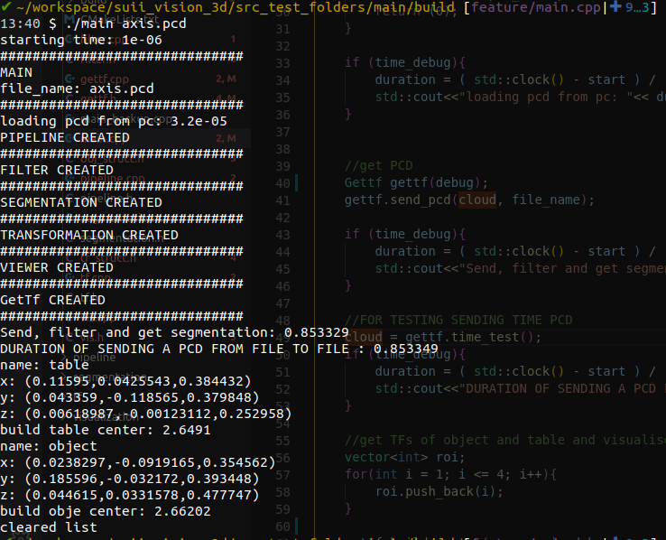
At this speed test we were teste the time it takes to send a pcd from a file to another file, this because we wanted to test if we needed to change sending the pcd or only a pointer. We want in a later stadium try to optimize this and use pointers. Due to time and other priorityes (FIXING THE PRECISION OF THE GETTF RESULTS) we will leave this for later.

The time it took to send and receive a pcd is (0.853349-0.853329)*1000 = 0.02 ms

Next we tested what took the most time. The most time was determined by creating the TF of big data sets.

For the planar data (the table):
- points: 156919 data points
- time: 2.46531-0.815891 = 1.649404 [s]
For the segmented data (the object):
- points: 1825 data points
- time 2.49286-2.46531 = 0.02755 [s]

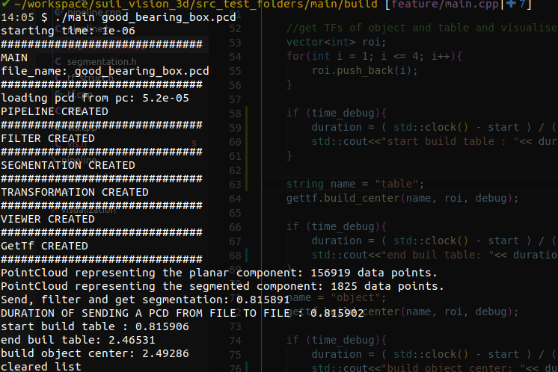

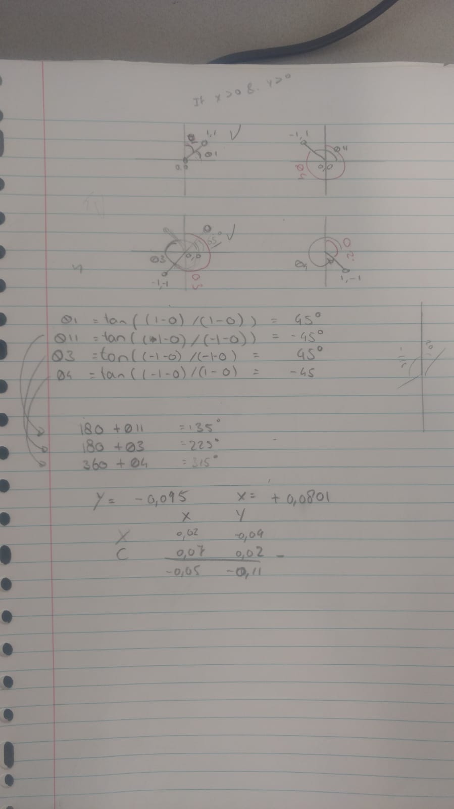
TF publisher:

we needed to caculate the TF output of PCL to the required TF input for ROS. PCL gave 4 XYZ points to create a tf. Center point, X_axis, Y_axis and Z_axis.

Ros need a XYZ position and a XYZW rotattion (quaternion).

After calculating the ange in euler.
double pitch = 0.0;
double roll = 0.0;
double cy = cos(yaw * 0.5);
double sy = sin(yaw * 0.5);
double cp = cos(pitch * 0.5);
double sp = sin(pitch * 0.5);
double cr = cos(roll * 0.5);
double sr = sin(roll * 0.5);
tf_br.quat_x = 0.0;
tf_br.quat_y = 0.0;
tf_br.quat_z = sy * cp * cr - cy * sp * sr;
tf_br.quat_w = cy * cp * cr + sy * sp * sr;

http://wiki.ros.org/tf/Tutorials

