Mark van Zalk
Professor Monshi
CMSC 204-21921
12/03/2026
Graph Lab
1
Oregon
Texas
Hawaii
New York
Alaska
Vermont
California

2a) no
2b) yes
2c) Texas

3.
0 | 0 | 0 | 0 | 1 | 0 | 0
0 | 0 | 0 | 0 | 0 | 0 | 0
1 | 1 | 0 | 1 | 0 | 1 | 0
0 | 0 | 0 | 0 | 0 | 0 | 0
0 | 0 | 0 | 0 | 0 | 0 | 0
0 | 0 | 1 | 0 | 0 | 0 | 1
1 | 1 | 0 | 0 | 0 | 0 | 0
States
Alaska: V[0]
California: V[1]
Hawaii: V[2]
New York V[3]
Oregon V[4]
Texas V[5]
Vermont V[6]

Alaska: V[0]
California: V[1]
Hawaii: V[2]
New York V[3]
Oregon V[4]
Texas V[5]
Vermont V[6]

[0]
[1]
[2]
[3]
[4]
[5]
[6]
null
Oregon
null
Texas
New York
California
Alaska
null

null
null
null
Vermont
Hawaii
null
California
Alaska

4a) C
4b) A

5.
(Atlanta-Washington: 600),(Atlanta-Houston:800), (Atlanta-Washington-Dallas:1900),
(Atlanta-Washington-Dallas-Austin: 2100),(Atlanta-Washington-Dallas-Denver: 2680),
(Atlanta-Washington-Dallas-Chicago: 2800)

6.
Step 1
V: {0}
E:{Null}
N: {1,2,3,4,5}
Step 2
V:{0,2}
E: {(0,2)}
N:{1,3,4,5}
Step 3
V: {0,2,5}
E:{(0,2),(2,5)}
N: {1,3,4}
Step 4
V:{0,1,2,5}
E:{(0,2),(2,5),(5,1)}
N: {3,4}

Step 5
V:{0,1,2,4,5}
E:{(0,2),(2,5),(5,1)(5,4)}
N: {3}
Step 6
V:{0,1,2,3,4,5}
E:{(0,2),(2,5),(5,1),(5,4),(1,3)}
N: {Null}

7.
(2,5): 1 | (2,5): 1 | (2,5): 1 | (2,5): 1 | (2,5): 1 | (2,5): 1
(1,5):2 | (1,5):2 | (1,5):2 | (1,5):2 | (1,5):2 | (1,5):2
(0,2):3 | (0,2):3 | (0,2):3 | (0,2):3 | (0,2):3 | (0,2):3
(4,5):3 | (4,5):3 | (4,5):3 | (4,5):3 | (4,5):3 | (4,5):3
(1,3):5 | (1,3):5 | (1,3):5 | (1,3):5 | (1,3):5 | (1,3):5
(3,4):6 | (3,4):6 | (3,4):6 | (3,4):6 | (3,4):6 | (3,4):6
(0,1):7 | (0,1):7 | (0,1):7 | (0,1):7 | (0,1):7 | (0,1):7
(2,4):8 | (2,4):8 | (2,4):8 | (2,4):8 | (2,4):8 | (2,4):8

V:{2,5} V:{1,2,5} V:{0,1,2,5} V:{0,1,2,4,5} V:{0,1,2,3,4,5}

8. Using Prim’s:
E:{(Minnesota, Des Moines) ,(Minnesota, Madison),(Madison, Milwaukee),(Milwaukee, Chicago),(Chicago, St. Louis),(Chicago, Detroit)}
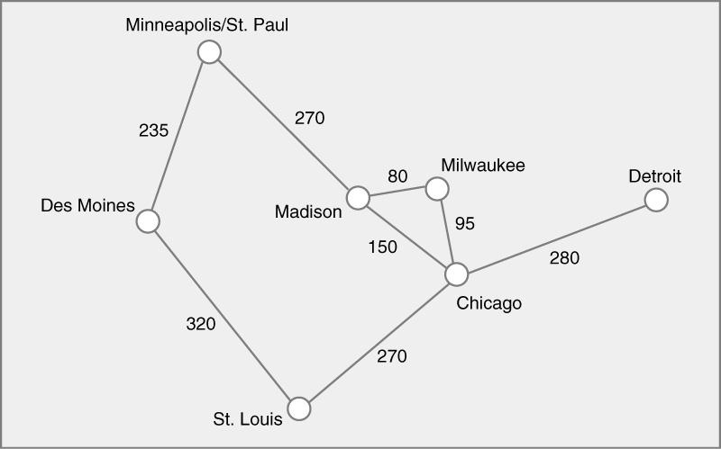

9.
[0] [1] [2] [3] [4] [5] [6] [7] [8] [9]
Pred count
Top order
Queue
Pred count
Top order
Queue
Pred count
Top Order
Queue
Pred Count
Top Order
Queue
Pred Count

0 | 1 | 1 | 3 | 3 | 2 | 2 | 0 | 2 | 2
0 | 7
0 | 0 | 1 | 3 | 3 | 1 | 2 | 0 | 2 | 2
0
7 | 1
0 | 0 | 1 | 3 | 2 | 1 | 1 | 0 | 2 | 1
0 | 7
1
0 | 0 | 0 | 2 | 1 | 0 | 0 | 0 | 2 | 1
0 | 7 | 1
2 | 5 | 6
0 | 0 | 0 | 1 | 0 | 0 | 0 | 0 | 2 | 1
0 | 7 | 1 | 2
5 | 6 | 4
0 | 0 | 0 | 2 | 0 | 0 | 0 | 0 | 1 | 1
0 | 7 | 1 | 2 | 5
6 | 4
0 | 0 | 0 | 1 | 0 | 0 | 0 | 0 | 0 | 1
0 | 7 | 1 | 2 | 5 | 6
4 | 8
0 | 0 | 0 | 0 | 0 | 0 | 0 | 0 | 0 | 1
0 | 7 | 1 | 2 | 5 | 6 | 4
8 | 3
0 | 0 | 0 | 0 | 0 | 0 | 0 | 0 | 0 | 0
0 | 7 | 1 | 2 | 5 | 6 | 4 | 8
3 | 9
0 | 0 | 0 | 0 | 0 | 0 | 0 | 0 | 0 | 0
0 | 7 | 1 | 2 | 5 | 6 | 4 | 8 | 3
9
0 | 7 | 1 | 2 | 5 | 6 | 4 | 8 | 3 | 9
Top order
Queue
Pred count
Top order
Queue
Pred count
Top Order
Queue
Pred Count
Top Order
Queue
Pred Count
Top order
Queue
Pred count
Top order
Queue
Top order
Queue

10. Start, Discrete math, Programming 1, Computer Organization, Programming 2, Operating Systems, High-level Languages, Algorithms, Compliers, Theory of Computation, Senior seminar, End

