**1. Introduction**

**CROPLOOK: BARANGAY KAPATAGAN AGRICULTURAL TRADING PORTAL WITH REALTIME SMS NOTIFICATION FOR CROP-GROWTH MONITORING AND DATA STATISTICS TO EXHIBIT THE MOST AND LEAST PROFITABLE CROPS**

Amilissa O. Araneta Dhominic T. Arendain Jean Nikolai P. Roxas

BSIT BSIT BSIT

UM Digos College UM Digos College UM Digos College

San Jose Digos City Bangkal Matanao Davao del sur Zone 3 Digos City

araamilissa@gmail.com dhominicarendain604@yahoo.com jnproxas@gmail.com

Cyvil Dave T. Dasargo

Adviser

UM Digos College

cyvildavedasargo@gmail.com

**1.1 Project Context**

In an organization, information plays an important role, because information allows us to make our future decisions. When making decisions and in resolving problems, information has, therefore, a significant significance, since the organization offers the correct information and gives the proper decision and verdict on the progress of the organization [11].

An information system must be set up to collect, process, store and recover data in every organization, big or small. Such activities have been carried out in the past generation in manual methods like pen and paper which take a great deal of time. Companies and companies are now using modern technology to simplify their processes and services. Information systems play an important role in the data processing and decision-making of an organization, and if done correctly, the quality of service, efficiency, excellence and performance of an enterprise will inevitably be impacted. [10].

In Digos City, in the province of Davao del Sur, Barangay Kapatagan is a barangay. Elevation of 1,296.0 meters or 4,25.9 feet above the mean sea level is measured for those coordinates. Besides, Barangay shares the same boundary with Bansalan Sibayan, Davao City Sibulan and Makilala Buena Vida.

Most of the lives of the people in Barangay Kapatagan are agricultural products, dining and tourist spots in the local regions. [9].In Kapatagan there is a large range of yield and productivity in six crops and by mutual agreement, long-term relationships, they sell products there and the way they buy their crops individually, which reduces the possibility of meeting potential customers outside the group.

It is important for a company to be online, whether this is a website, an e-commerce portal, a social network page or a combination of all three, to have a major benefit from running an online business.

One is to expand the customer base and get input from the consumer because some potential customers are looking for a particular product or business through the Internet for purchase.[1]

More than that, the online marketing business is growing increasingly over the last five years and it is more likely that goods will be bought and sold on the Internet, but that products will be used digitally.[12]

Due to their economic growth and the use of their rich agriculture climate, Kapatagan is a developing society.

The proponents have put forward a system to make substantial stocks, purchases and sales of their crops for farmers and customers. This program is a trading platform for online selling which would improve the efficiency of online communication and transaction both for buyers and sellers.

The proposed system also provides customers with crop reservations and customers with SMS updates when their crop reservation is ready to be picked and harvested.

Online selling of goods and products gain many customers and can also be viewed and accessed by anyone interested to buy it rather than the traditional way of selling it that would require a great deal of time, effort and money.

**1.2 Purpose and Description**

The main purpose of this project is to allow farmers, customers, and potential customers to buy and sell online as they can connect easily with each other, to promote the goods of farmers to expand their customer base and to create faster transactions and easier communications between the two parties. Likewise, this project can be a big help in the trading of crops in the community over the internet, for faster reservation and selling of crops.

Anyone can access the site but only the members of KUFA (Kapatagan Upland Farmers Association) can only sign up on the system as farmer or seller. However, anyone can sign up as a buyer as long as there is an assurance that you are a legit buyer as you agree on the terms and conditions upon signing up as a buyer to access and use the features to reserve crops online.

In addition, the project also benefits clients as the client does not need to spend time and energy to see the farmers individually just to reserve the crops. Additionally, with the proposed system, reservation of desired crops is a lot faster whenever customers maybe so as long as they are connected to the internet.

**1.3 Objective of the Study**

**1.3.1 General Objectives**

The general target of this project is to serve as an auxiliary for the improvement of crop trading using an online platform by providing a web application and data analyzation that has a useful information and supporting decision making for our farmers of Barangay Kapatagan.

**1.3.2 Specific Objectives**

The following are the unique goals to achieve the main aim:

* To create an online platform to reserve, buy and sell crops in Brgy. Kapatagan.
* To implement SMS notification, to notify customers about their reservation of crops.
* To exhibit the most and the least profitable crops to provide support for farmers' decisions by using a statistical chart.
* To enable farmers and customers to communicate using the in-app chatbox.
* To show currently available and unavailable crops - from seed to fully grown crops that are currently planted in a community.

**1.4 Scope and Limitations of the Project**

The CropLook runs in desktop and laptop through web browsers and also in mobile phones requiring an internet connection. The project focuses on reserving, buying and selling of crops in Barangay Kapatagan through online website and also view top charts of the available crops from seed to fully grown crops in the community through the mobile application. The farmers' agricultural areas are exclusive only in Barangay Kapatagan and only the farmers in Barangay.

The people who are a member of KUFA (Kapatagan Upland Farmers Association) that also owned agricultural lands in Barangay Kapatagan can only sign up as farmers on the system. Customers can be anyone interested in buying crops from Brgy. Kapatagan and anyone can sign up as customers and they need to fill up some form for agreements that are usually concerned for future transactions. Crops' details should be updated by the farmers/sellers when actual payment and negotiation of payments happen between both farmers and customers, and this phenomenon is excluded on the system scope, thus the system is only a virtual site for buyers and sellers.

The system limits only the main purpose of the project thus, problems about the crops' quality are not concerned. Technically, the proposed project focuses only on the process and transactions of the site, physical aspects of the crops are excluded.

**2. Review of Related Literature**

This section discusses the related literature that served as the overview and basis for the study to give more reason and understanding of the project to develop clarity and comprehension in any study, it is necessary to review the various concept, research methodologies and analytical tool used by researchers earlier in their studies. This would help the researchers grasp the implications of the research issue more precisely and would also encourage researchers to update and developing the existing study system in the right direction. The findings of the earlier studies will direct the researchers in the identification and comparison of hypotheses and objectives.

This chapter discusses briefly the principles, research methods, analytical tools and findings of past studies that apply to this review.

**2.2 Related Literature**

Countries have depended for centuries on trade in agricultural and food commodities to complement and supplement their domestic production. The uneven distribution of land resources and the impact of climatic zones on the ability to cultivate plants and animals have led to trade between and within continents. Historical patterns of settlements and colonization have led to the concept of trade patterns and the construction of infrastructure to support such trade.

More recently, transnational corporations with integrated production and distribution networks have taken over post-colonial trading structures as a model for world agricultural trade organizations. Changes in consumer preferences have facilitated the rise of global markets and added to the value of trade. Without a significant drop in national income, few countries could survive without a significant reduction in consumer choices and welfare.

In return, the developing country shall continue to import large amounts of other agricultural products, particularly tropical beverages, rubber, and fiber, into the developing country. Agricultural food needs will increase. The developing countries, however, are not a regular trading bloc. While its net exports of tropical products will increase and import more and more temperate zone goods, significant net exporting of temperate zone goods will remain within the community.

The global trade prospects in this chapter are focused, like all projections, on several assumptions regarding likely developments in policy which affect trade flows, as well as basic income, population and productivity trends.

The continuity of existing policies on support and protection of agriculture is the main premise of quantitative projections, including policy changes that will be implemented in the future, for example, the EU's Everything but Arms Initiative (EBA) that foresees a liberal import regime for rice and sugar from the least developed countries (LDCs) in the future. When policies vary considerably in the future, the results will vary. For example, if a fundamental sectoral change is achieved under the reform process that began with Uruguay Round Agreement on Agriculture and if significant reductions were made in subsidies to increase production and security in industrial countries, this may affect expected patterns of trade. And if policy reforms spread beyond developed countries and culminated in the elimination in the various developing countries ' policy of the remainder of agricultural partitions, this could mobilize capital to boost productivity and stimulate rural economic growth.

As a result, much of the conceptual discussion in the chapter aims to demonstrate how policies will evolve in the next three decades.[13]

(Porka, 2017) Food imports in countries with high population growth pressures are used internationally to address local limitations. Although food imports increase in recent decades in the parts of the world with huge resources such as Finland ([Sandström et al., 2017](https://www.frontiersin.org/articles/10.3389/fsufs.2018.00067/full#B72)). Food production relocation is predominantly from a cropland-efficient standpoint and is capable of satisfying consumer demands with local production studies for some countries and regions have been analyzed (see e.g., for the UK: [Cowell and Parkinson, 2003](https://www.frontiersin.org/articles/10.3389/fsufs.2018.00067/full#B8); Sweden: [Röös et al., 2016](https://www.frontiersin.org/articles/10.3389/fsufs.2018.00067/full#B70); Portugal: [Cardoso et al., 2017](https://www.frontiersin.org/articles/10.3389/fsufs.2018.00067/full#B4); USA: [Zumkehr and Campbell, 2015](https://www.frontiersin.org/articles/10.3389/fsufs.2018.00067/full#B83)) [2].

Agricultural marketing efforts have tended to focus on several areas, in particular infrastructure development; knowledge provision; training of farmers in marketing and post-harvest matters; and support for the development of a proper political environment. The development of agricultural marketing efforts is particularly important in developing countries. Efforts have been made previously to establish marketing bodies run by the government, but these have become less popular over the years.[3]

To support this notation we need to work hard with a good calculation method, to start this trading platform in Indian farming: State Andhra Pradesh is called rice bowl in India.

Through Sunrise Andhra Pradesh's vision 2029, Andhra Pradesh is at the forefront of technology-driven agricultural transformation. The AP AgTech Summit 2017 will build on this momentum.[4]

In one of Mindanao's most fertile land, the tomato farmers in Kapatagan, Digos, Davao del Sur, are doing additional agricultural work just to hold their production and fill their pockets for a living.[1]

**2.3 Review of Related System Matrix**

This section discusses the systems and applications that are related to the application which helped the proponents to have an idea about algorithms and methods that were used for the study and development of the proposed system.

**2.3.1 Mandi Trades Farm to Shop Trading Platform: India**

Mandi Trades takes up the opportunity to revolutionize life for farmers through a mobile app, substantially designed for farmers residing in rural areas of India. It's a one-step platform for Farmers where information about weather updates, crop prices, shop agricultural-based products, selling their produce, agricultural news are all presented in one mobile application.

This forum brings farmers and customers together in the agricultural value chain, promotes market data management and communication. [5]

**2.3.2 CropSwap**

Crop swap is a mobile application that you can buy, sell or trade harvested fruits and veggies as well as seeds and plant starts, simply upload vegetables you are growing and they will appear on the feed for everyone to see. [6]

**2.3.3 AgriTrade: India**

This device enables farmers to sell their agricultural products straight to traders from all over India. AgriTrade is an Agriculture Marketplace android app that links farmers and traders across the whole world.

In this marketplace app, farmers can list their farm products, and traders can search by the name, commodity, and position of essential agricultural products. [7]

**2.3.4 Farmers e-Market**

A website and a mobile app entirely dedicated to displaying and selling farmers' goods. It's a reality, not a dream. The Thodupuzha Farmers ' Club has managed to develop a mobile farmers app. The breadth is more than one can imagine and its service to the public is enormous and commendable.

It may be used by a farmer or public to buy or sell their agricultural products, livestock, poultry, fish, dairy and other agricultural products, nurseries and gardening goods, etc. It's a good place to sell and buy used cars, farm machinery, agricultural innovations, plants, bulbs, and homemade [8].

**2.3.5 Related System Matrix**

*2.3.6 Matrix of Related Systems*

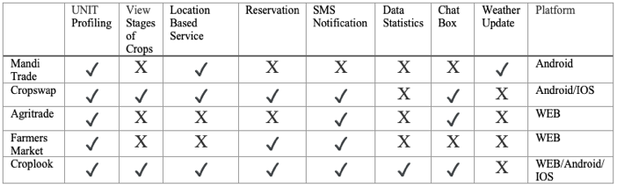

*Figure 1. Related System Matrix*

Differences and similarities of Croplook related to existing systems are shown in Table 1. It shows in the table that most of the related systems have User Profiling where they can see the information of users like name, address, and contact number.

The second most common feature is the SMS Notification. SMS Notification is a short message that the system sends to people about news and updates within a short period.

The least common features are stages of crops and Weather updates. In Data Statistics, Crop Analyzing philosophy is based on various kinds of data collected from different sources like Statistical data.

Stages of Crops indicates the stages of crops from seed to fully grown and ready to harvest crops Stages of Crops indicates the stages of crops from seed to fully grown and ready to harvest crops. In the Weather forecast, In the developing fields of precision agriculture, weather information plays an increasingly important role, a farming activity that emphasizes accurate production and control.

Apart from all the common features of the existing systems, “Croplook" has features that enable the user to use Location-Based Service (LBS) and Reservation. Location-Based Service helps the buyer to locate on what specific location are crops located. Reservation plays an important role in this system for the convenience of buyers and sellers based on the availability and condition of crops.

**3. Technical Background**

The chapter describes the ways of technicality used by the researcher in creating and finalizing the function of technical processes.

**3.1 Software Design**

*3.1.1 Conceptual Framework*

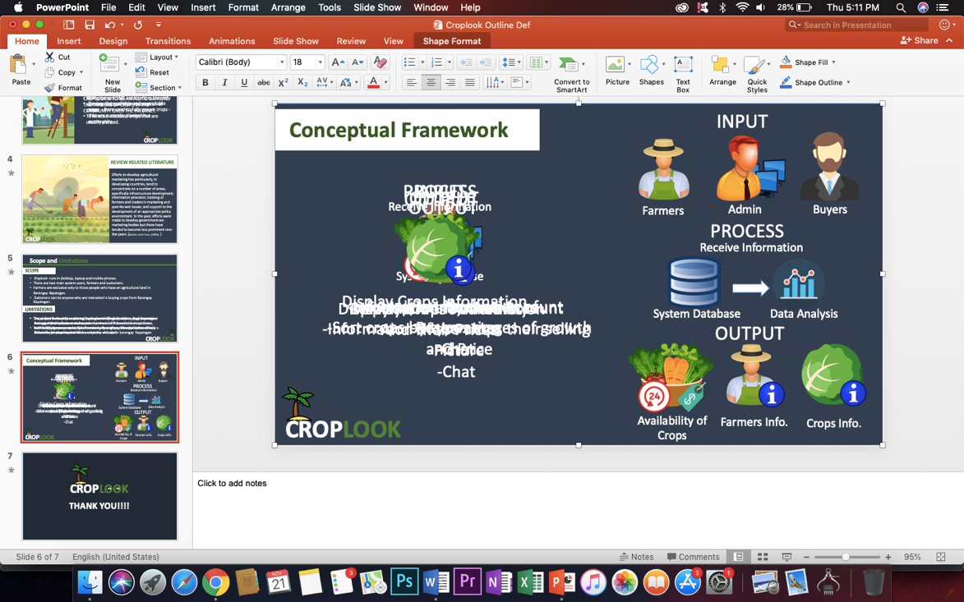

*Figure 2. Conceptual Framework*

Figure 2 shows the input-process and output of the study. The input is the data from the admin and the users, specifically the farmer and the buyer's information including their attributes and unique identification.

Also, on the inputs are details and pictures of the farmer’s crops, and as for the buyers, they can reserve for the crops that they want to buy, and both users can communicate with each other using chat. On the process, all the data that has been inputted by the users, admin, and buyers will automatically store on a database and by using these statistical data a Predictive Analytics can be performed to forecast the availability of crops for the upcoming years. Outputs are processed information that is the result of the product from the analysis and operation on the previous transaction. These outcomes will be the basis for the accomplishment of the study and as part of completing the system goals and objectives.

*3.1.2 Architectural Framework*

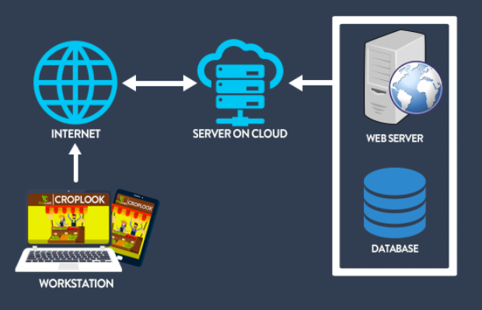

*Figure 3. Infrastructure*

Figure 3 displays the network Infrastructure. The workstation, also named as the end-users are responsible for all transaction input and output data.

The Internet Service Provider (ISP) provides us with the internet because this program can not operate without the internet, which is also part of this system. The server on the cloud, on the other side, consists of a web server, program, and databases.

The cloud allows users to access the same files and software from almost every computer, as the processing and storage take place centrally on servers in a data center rather than on the system. Web server is the one that handles requests from the workstation but is not connected to the database, so it only serves the user/workstation application.

The application is connected to the database and submits queries to it to obtain the data of interest and show the result in a manner suitable for the application. The database is accessible from the Cloud and delivered to users on-demand via the internet, cloud storage is safer and larger data history space.

**3.2 Discussion of the Computing Concepts**

**3.2.1 Project Technology**

**HTML5 –** The researchers used this tool to create interactive web pages, arranging graphics, aligning media context like resizing images and videos added or linked to the page, formatting texts like changing font including weight, size, and font-family, modifying it to either normal, bold or italic, headings and also to link other web pages within the system by clicking on special text called hyperlinkswhich bring you to the next page, you can go to any place on the Internet whenever you want by clicking on the links.

In simple words, HTML will be used to change the look and style of the page more importantly on the content.

**MySQL –** The researchers used MySQL for data storing in an open-source database executable for all platforms that will keep all the data that will be stored by the system. This tool will be used as the system's primary data storage where all data that has been inputted is kept.

**PhpMyAdmin –** The researchers used PhpMyAdmin to administer MySQL the will be used as data storage with a web browser including:

* Install databases, charts, fields of views and indexes.
* Creating, copying, removing, renaming and modifying folder, tables and indexes.
* Each SQL statement executes, edit, bookmark, even batch-quests.
* Import CSV and SQL data and export data into different formats. XML, PDF and CVS SQL.

**PHP –** The researchers used this scripting language as the server-side language to collect form data, generate dynamic page content that is generated from information accessed from a MySQL database used as data storage, send and receive cookies, create modules that include:

* Validating inputs before being inserted into the database storage to prevent SQL injection, application attack, cross-site scripting, and unfiltered data.
* Retrieve, delete and update stored information from data storage.

**4. Methodology**

Within this chapter, the initial section discusses the following program architecture specifications.

**4.1 Data Gathering**

The Proponents conducted a formal investigation about the process of selling of crops at the Barangay Kapatagan. The respondents are the farmers who are a member of KUFA (Kapatagan Upland Farmers Association) in which we conducted a written survey, yet we found out the common problem that they have are financial support, failures and unstable buyers. The association of KUFA is helping the farmers for their financial needs by giving them financial support and weekly training and workshop that focuses the improvement of their farming, on the other hand giving the proponents an opportunity to be part of this association by helping the farmers to improve selling their crops.

**4.2 Development Approach**

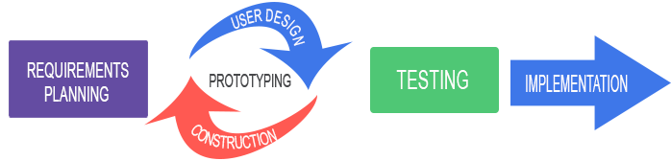

*Figure 4. Rapid Application Development Model*

The mechanism for enhancing the strategy generated to produce prompt device performance is shown in Figure 4. The researchers used this strategy because it is designed to enable much faster advancement and structures of higher quality than the traditional life cycle. In addition to producing a more reliable product in less time, rapid application creation often ensures greater customer service that suits perfectly with the researcher's needs [15].

This model was used to describe a software development method that places great emphasis on rapid prototyping and iterative delivery. The phase will require less long term planning.

**4.3 Planning**

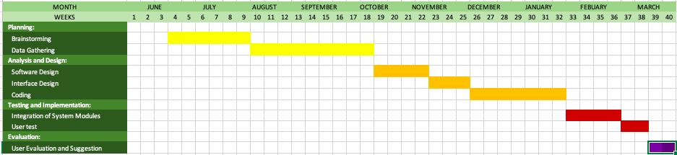

*Figure 5. Gantt Chart*

**4.4 Software Requirement Specification**

The type of requirement refers to the system's specific process and purpose. In a separate module that has a framework, such processes and functionalities are presented.

**4.5 Functional Requirements**

These demands are the key things the users expect from the program. It also contains the basic modules you need to bring into your system, as to what the users want.

**4.5.1 Main Page Module**

This module shows the list of available crops that are posted by our farmers in which the buyers can also view and find their interest crops.

**4.5.2 Farmers Profile Module**

This module shows the Farmers Information which they can also view the list of uploaded crops and previous transactions. The farmers can also view a graph in which they can compare some of the crops that are posted from other farmers.

**4.5.3 Visualization Module**

This module is intended to graph the total percentage of every crop and transactions from farmers to buyers. This graph can also help our farmers to view most and the least profitable crops to provide support for farmers' decisions. Generate graphs automatically interpret after the transactions. It also calculates the total percentage of crop availability, Crop Fixed Quantity and Total percentage of crop sales by Kilogram.

**4.5.4 User/Activity Logs Module**

In this module, the activities of the farmers and buyers will be traced by the Administrator.

**4.6 Non-Functional Requirements**

These are the provision that was not needed but are in the program to ensure the system's quality of service.

**4.6.1 Security Requirement**

This module enables the user to protect his / her data. The program has a feature where in order to maintain anonymity.

**4.7 Usability & Compatibility**

The system is a Web-based application that will run on PC or Mobile Phone as long as it is connected to internet connections. We also assured that the system can easily understand by the users.

In relation to that, during the implementation, we will conduct basic training for the farmers to understand the process of using the system. The development of this system redounds the benefit of farmers whose members of KUFA (Kapatagan upland Farmers Association) from Barangay Kapatagan, Digos City Davao del Sur and the buyers from different locations.

**4.7.1 Recovery**

The system can be efficiently restored and recovered through MySQL. The user who has experience with the proposed program will modify the program and has a way to restore it.

**4.7.2 Availability**

The system can be accessed when the PC or Mobile Phone is connected to Internet Connection. There are some features that are only visible to different users.

The farmers can both view menu and farmers' page in which they can post their available crops. The buyers can only view the home page in which they can do the reservations.

**4.8 Hardware & Software Requirements**

To run the system in the computer it requires a computer device or mobile phone that has at least 1 gigahertz (GHz) processor to run a search engine properly, minimum RAM would be 1GBto make some tasks easier, the system will run in any operating system and it should have an internet connection, any search engines are compatible with this web-based system.

**4.9 Analysis**

It has become an imperative part of developing an information system. It is where the various diagram structure and work as to the whole system where the data is stored and records and is important in the creation of information systems as it helps understand procedures, programs, and structures and provides a systematic flow of events and procedures of activities.

The process flow of Web-Based Management System for Croplook Agricultural Trading Portal is where the admin can view, manage and trace activity, reports, and assessment on every transaction from farmers to buyers and buyers to farmers. Also, to help our farmers’ decisions, the exhibition of graphs that show the most the least profitable crops. Furthermore, the data are being collected, it is where analysis is being processed.

This requires a number of operations, to resolve the technical analysis issues and the requirement specification. This is where analysis becomes more iterative because of the data being processed is continuously collected and analyzed simultaneously.

**4.9.1 Context Flow Diagram**

A broad overview of the whole system is given in the background diagram. It determines which data is to be stored or where it goes.

In the current process flow, the manual process is addressed and the discrepancy between the proposed system flow is defined.

*4.9.1 Context Level Diagram*

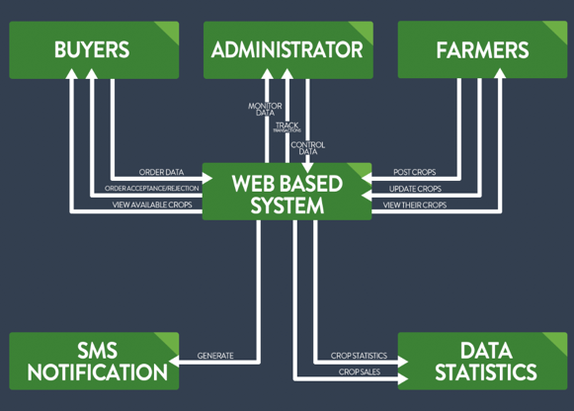

*Figure 6. Context Flow Diagram*

Figure 5 displays the system project context flow diagram. The administrator can monitor, control and track system operation and the user who is Croplook's farmers and buyers can register and do the transactions in the system application.

The proponents also add functionality to the system that can send an SMS notification notifying buyers of the condition of their reserved crops based on the state of the crops that our farmers are updated and Data Statistics to exhibit the most and the least profitable crops to provide support for farmers' decisions.

**4.9.2 Data Flow Diagram**

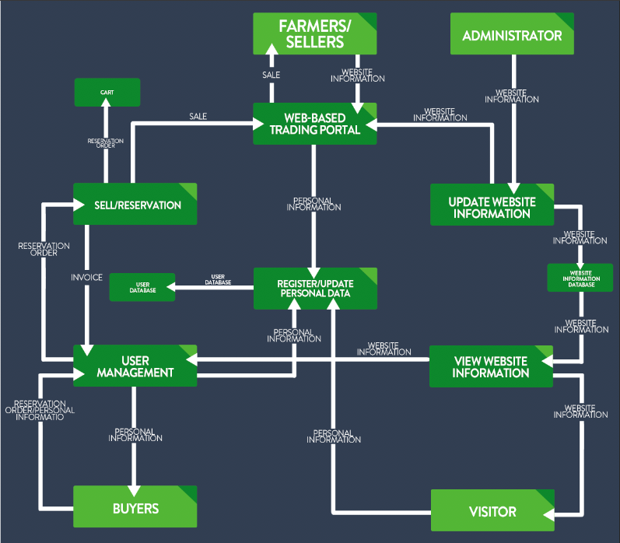

*Figure 7. Level 0 Diagram*

Figure 7 shows a data flow diagram is a way to depict a flow of a processor device data. This will help the developer to easily track the flow of every data in the system Also, the DFD contains knowledge about each entity's outputs and inputs, and the process itself.

**4.9.3 Existing Process Diagram**

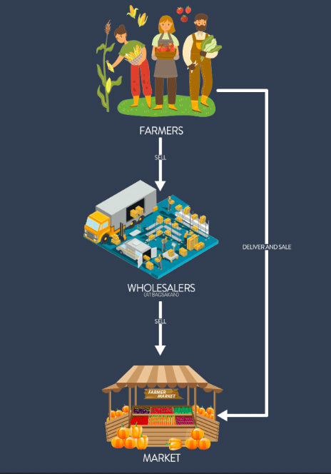

*Figure 8. Manual Process of Selling*

Figure 8 shows the current flow with a manual method in conducting a survey and initial interview at the Barangay Kapatagan Bagsakan ng Gulay Center, which leads to the purchasing of their crops at a lower price and no guarantee as to who will purchase their available crops and, due to the exposure of their crops to any environmental factor after harvesting, the quality of the crops will decrease. This program does not disrupt the conventional market process, rather it does help strengthen and hasten the Barangay Kapatagan Agricultural System's manual trading operation.

**4.9.4 Proposed Process Flow**

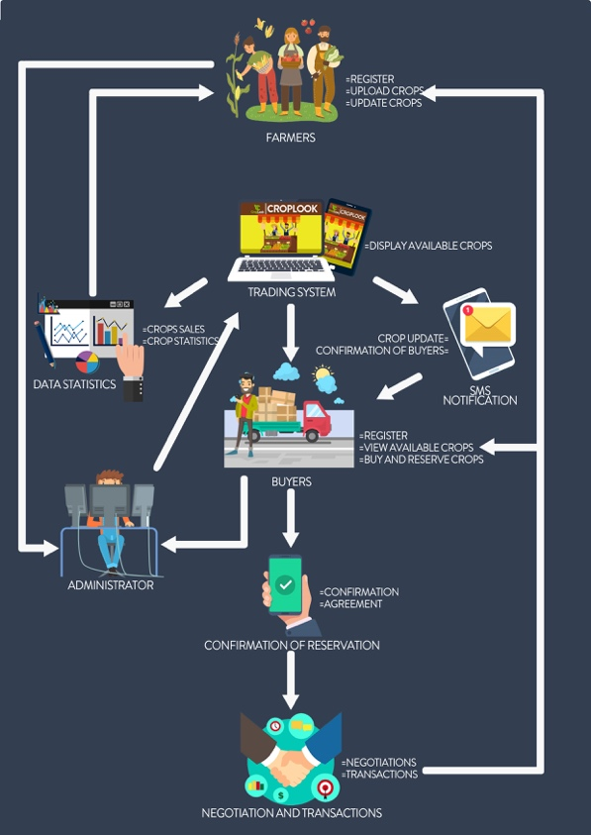

*Figure 9. Proposed Process Flow*

Figure 9 shows the proposed process flow of the system. It contains Farmers and buyers, each user performs a different action and has a different process. The administrator or the staff of KUFA (Kapatagan Upland Farmers Association) who has access to the data or information of the existing farmers and buyers, they can also monitor the transactions of users and has the authority to accept or reject the registrations of farmers and buyers. Administrative Panel has the privilege to manage and view the happenings as well as the activity logs inside the system.

Farmers are one of the key users of this system as they are the ones who will post the system's available crops, but before that, they need to register to access and use the features of the system that only farmers can access along with the administrators. These are one of the conditions that are required to ensure the system's quality of service.

Buyers are also one of the most important users for this system as they are the ones who will buy or reserve the available crops that are posted by our farmers. And to ensure security and safety purposes for our users, the proponents added a feature that requires the farmers and buyers to agree on the conditions and agreements during the registration and transactions.

In connection with that, the proponents also added a chat box that helps to connect the farmers and buyers for them to have the negotiation and transactions.

Data Statistics helps our farmers to review or compare the data from different crops from the previous transactions of farmers and buyers. Short Message Service or SMS notification sends updates on buyers about the condition of their reserved crops, this also notifies the farmers if there are buyers who are interested to buy or have a reservation on their posted crops.

**4.9.5 System Flowchart**

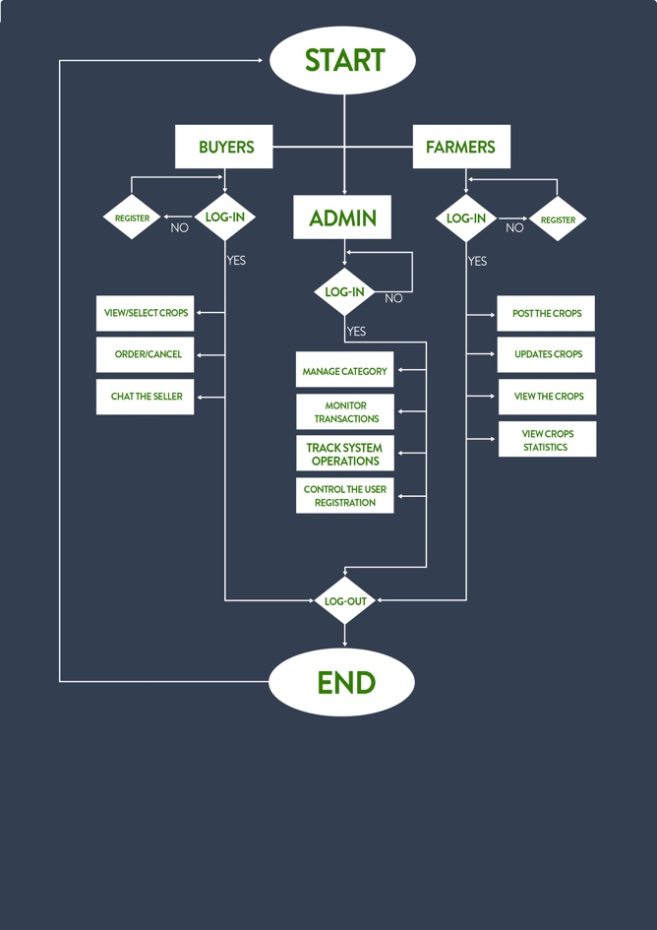

*Figure 10. System Flowchart*

**4.10 Designing**

This defines the features of the system. By combining the idea of the proponents and the suggestion of KUFA Administrators. The proponents created three interfaces which are the farmer's panel, buyers panel.

The farmer's panel consists of the registration form and a page in which they can post their available crops and the buyer's panels which also have the registration form and only they can view the available crops and do the reservations for their interest crops. The administrative panel consists of data and information from the existing farmers and buyers, also the activity logs and transactions.

**4.10.1 System Design**

The researcher presented their system design including the Use Case Diagram, Entity-Relationship Diagram and the interface where the process is being defined. The figure below is the process of the project.

**4.11 Entity-Relationship Diagram**

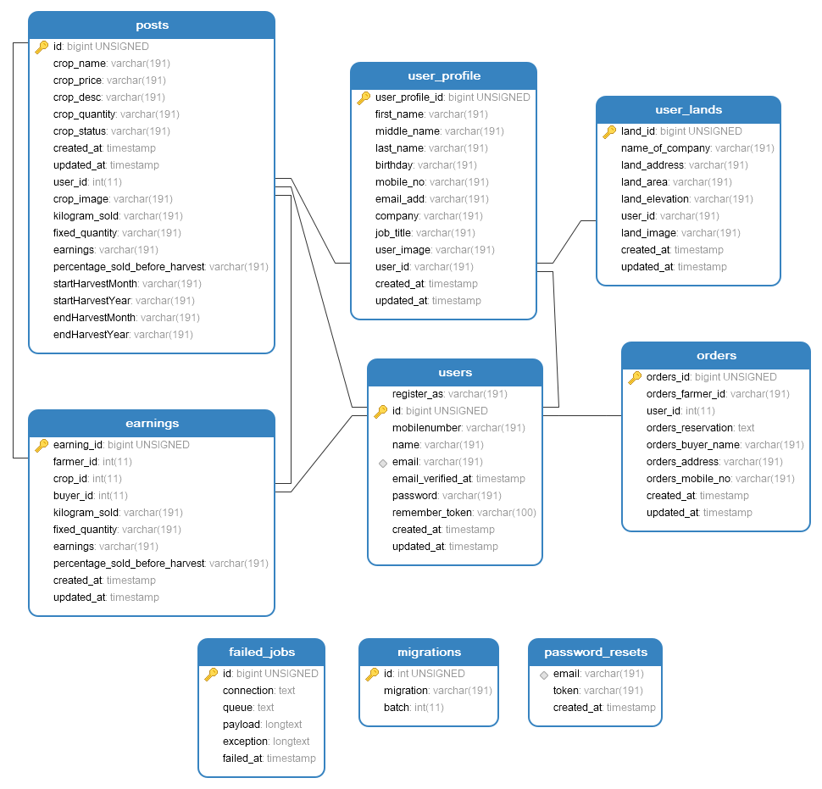

*Figure 11. Entity-Relationship Diagram*

**4.12 Use Case Diagram**

The use case diagram shows the connection between the different users of the system and shows the interaction between them. The system itself is only intended for the Farmers who are members of KUFA or Kapatagan Upland Farmers Association which means other farmers who are not a member of the said association are not allowed to upload their products nor register on the system but they can view the homepage and available feature that only visible for buyers. The admin has full access to the system in order to manage the user as well as the testing services.

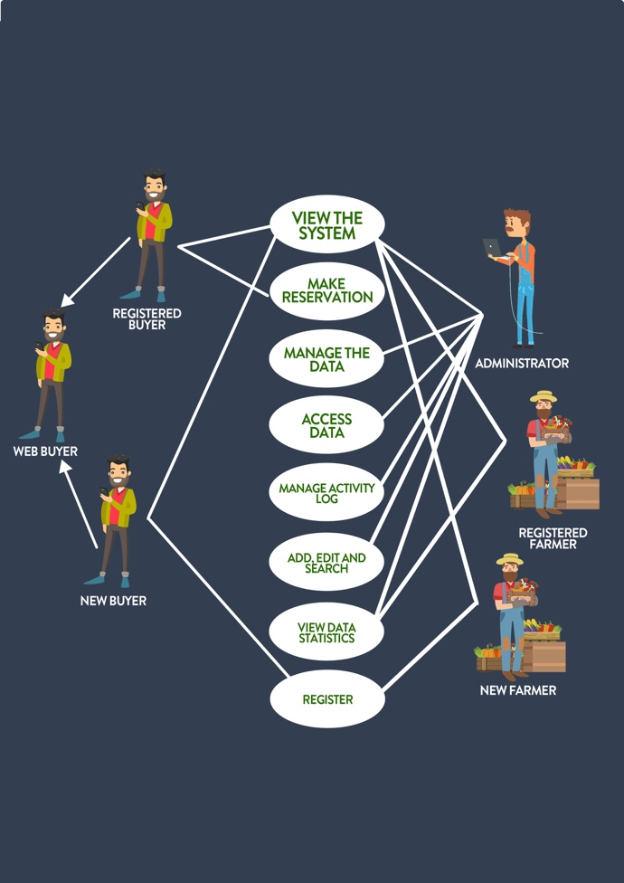

*Figure 12. Use Case Diagram*

**4.13 Coding**

The essential for implementation is system development. And the developer used some programming tools to make the program a success, the supporters used Visual Studio Code as a code-writing software editor. The proponents used HTML, CSS, JavaScript Languages with support from Bootstrap platform and Sass, a CSS extension, for the front-end development in which it produces the system's user interface. The proponents have used, PHP Language for the development of backend programming to construct the application with Laravel Framework support. It also allows procedures such as reading and writing into the database, editing and upgrading data and showing data on the system's interface. As a graphical tool, MySQL for the database and Chart.js is used to better distribute charts and Adobe Photoshop as a graphics editor for layout icons used in the device interface.

**4.14 Implementation**

The researchers require that their program be implemented as soon as the program is complete. This process must be carried out after the detailed test series, the following are the tests: The Alpha Review, in which the consultant checked it to verify if it is eligible for beta testing.

The Beta test is after the alpha test which allows the real users to check the program. Next is the User Acceptance Testing and System Evaluation, these test cases performed by the researchers ensure maximum usability and reliability of the program. during the implementation at Barangay Kapatagan, we will conduct basic training for the farmers to understand the process of using the system in Partnership of KUFA (Kapatagan Upland Farmers Association). The implementation contains how the information system will be deployed and installed.

**4.15 Testing**

A procedure that should be worked out during the production process takes place in the testing phase. Testing was one of the software's most critical phases because it can assess the system's consistency as well as identify bugs and errors. The KUFA (Kapatagan Upland Farmers Association) was the selected association of the proponents to conduct a test with regards to understanding the risks of software implementation. The proponents conducted testing which is the unit testing and user acceptance testing. The proponents also conducted the alpha test and beta testing to the association (KUFA). These tests are the process of evaluating a system if the software meets the user requirements.

**4.15.1 Unit Testing**

This was performed by the development team. Unit evaluations include testing of individual components or systems. It is usually written and run by advocates to ensure code fulfills its purpose and performs as intended.

**Table 1.** User Activity/Logs Module

|  |  |
| --- | --- |
| TEST STEPS | STATUS |
| Track the user logs |  |
| Track the user activities |  |

**Table 2.** WEB Based Set UP

|  |  |
| --- | --- |
| TEST STEPS | STATUS |
| Multiple users (farmers, Buyers, and Administrator) access the software application |  |
| Admin can access the system |  |
| SMS Notification |  |

**Table 3.** Farmers Log-in

|  |  |
| --- | --- |
| STEPS | STATUS |
| Enter username |  |
| Enter password |  |
| Login as Farmer |  |
| Recover account |  |

**Table 4.** Farmers

|  |  |
| --- | --- |
| TEST STEPS | STATUS |
| View Dashboard |  |
| View Data Statistics |  |
| Upload Crops including Photos |  |
| Update Crops |  |
| Delete Crops |  |
| View their Information |  |
| Send a request to the admin |  |
| Update personal information |  |
| Edit personal information |  |
| Register as Farmer |  |

**Table 5.** Buyers Log-in

|  |  |
| --- | --- |
| STEPS | STATUS |
| Enter username |  |
| Enter password |  |
| Login as buyer |  |
| Recover account |  |

**Table 6.** Buyers

|  |  |
| --- | --- |
| TEST STEPS | STATUS |
| View Dashboard |  |
| View Available Crops |  |
| Reserve Available Crops |  |
| Send a message through Chat Box to Farmers |  |
| View farmers basic  information |  |
| View their Information |  |
| Send a request to the admin |  |
| Update personal information |  |
| Edit personal information |  |
| Register as Buyer |  |

**Table 7.** Administrator (Log in)

|  |  |
| --- | --- |
| TEST STEPS | STATUS |
| Enter username |  |
| Enter password |  |
| Login as Administrator |  |
| Recover account |  |

**Table 8.** Administrator

|  |  |
| --- | --- |
| TEST STEPS | STATUS |
| View Dashboard |  |
| View Profiling |  |
| View List of Existing Accounts |  |
| View Data Statistics |  |
| View Transactions |  |
| Trace user activity/logs |  |
| Edit personal information |  |
| Update personal information |  |

**4.15.2 User Acceptance Test**

Proponents conducted the final testing which allows the users allows to test and perform the system in relation to the requirement agreed upon. After the development process, the researcher administered alpha and beta testing. Alpha Testing is a type of acceptance testing: performed to identify all possible issues and bugs before releasing the system to the KUF Association. After this, the proponents step on the Beta Testing is performed by a real user of the software application to a real environment. The reliability and usability of the system were demonstrated by the proponents and tested by the Staff of the KUF Association.

**4.16 Maintenance**

In the maintenance phase, the system would give assurance that it is effective to use in the KUF Association. In this stage, it seeks to review the stages of diagnosis and technical maintenance indicators. But for now, the proponents do not conduct maintenance yet in the said institution because it is not yet deployed. But if the system will be deployed in the institution, the proponents should provide support to meet the unwavering needs of users. The proponents shall give a regular visit to make sure that the problem will be fixed in case trouble should happen by modifying to keep it up to date with its environment to adapt new/upgraded environment by providing new functionality to address requirements that crop up due to changes in the environment (software, interfaces, operating system, middleware) or new regulations that impact client operations. In addition to this, the enhancement of the system is the other process where the Staff of KUFA might suggest that they wanted to improve and with that, the proponents can surely accept it in order to have a better educational system to be implemented.

**REFERENCES**

[1]Sustaining the yield amid drought **-** [ACE JUNE RELL S. PEREZ](https://www.sunstar.com.ph/author/4282/1/Ace-June-Rell-S.-Perez) – Sun Star Philippines (2016) <https://www.sunstar.com.ph/article/69312?fbclid=IwAR0tqI3saFM0njHnR22SG7awUDsoux_px0vPuucQwYTvKoBF34Tbl2LUx0s>

[2] Replacing domestic production of imported crops-based products in Finland: the ability to reduce imports of virtual water-front. Sustain. Food Syst., 17 October 2018  <https://doi.org/10.3389/fsufs.2018.00067>

[3] Food and Agriculture United Nations (1986). Abbott, John Cave. Developing global marketing improvement: what happens and what we know. Food & Farming Org. Pages 3–.ISBN 978-92-5-10131-1.

[4] Summit AP AgTech 2017: Smart Farming, 15–17Nov2017, Radical farmer.Vizag,www.apagtechsummit2017.in/.

[5] APP FACE - mandi trades farm to shop trading flatform <http://www.manditrades.com/>

[6] Crop swap Buy, Sell and Trade homegrown produce from your phone <https://www.cropswapapp.com/>

[7] AgriTrade Agriculture Marketplace Mobile App <https://www.pgsoftwares.com/agriculture-marketplace-mobile-app/>

[8] First Floor Mangalam Commercial Building, V-code Infotech India Pvt Ltd., Opposite KSRTC Thodupuzha, Kerala, India, 685584

[9]PhilAtlas-Mindanao 2015; Kapatagan Digos City, <https://www.philatlas.com/mindanao/r11/davao-del-sur/digos/kapatagan.html?fbclid=IwAR0nU9WbX8GTCZ0xCU8VxOcO7H8XAalrZnBu4w8k8Afl4N9CJcbcCQUpItM>

[10] Michelle Seidel, B.Sc., LL.B., MBA; Revisions; Michelle Seidel, B.Sc.:<https://smallbusiness.chron.com/importance-information-systems-organization-69529.html?fbclid=IwAR0zvclwm9hlKKKtu32_7_ZMbVOBSnHu0DfSeNsJ5Z6SrLzpHvizAhz3QIQ>

[11] Address in full detail the role of knowledge in an organization. Before taking action, an organization needs knowledge about itself, its client and supplier (where applicable) and the environment." *eNotes Editorial*, 8 Aug. 2019, https://www.enotes.com/homework-help/discuss-the-role-of-information-within-an-184715. Accessed 18 Sep. 2019.[https://www.enotes.com/homework-help/discuss-the-role-of-information-within-an 184715?fbclid=IwAR0dDJ6VhNwqKvmMaRssn8dtj zNBaqMN6vqTJxjzaRhBaOSl478SvjgHug](https://www.enotes.com/homework-help/discuss-the-role-of-information-within-an%20184715?fbclid=IwAR0dDJ6VhNwqKvmMaRssn8dtj%20zNBaqMN6vqTJxjzaRhBaOSl478SvjgHug)

[12] E-commerce 2016 Kenneth C. Laudon and Carol Guercio Traver Business Software Society Twelfth Edition

[13] Trade-in agriculture, trade and the global food network <http://www.fao.org/3/y4252e/y4252e09.pdf>

[14] Rapid Application Development Model <https://airbrake.io/blog/sdlc/rapid-application-development>

|  |  |  |  |  |  |  |  |  |  |
| --- | --- | --- | --- | --- | --- | --- | --- | --- | --- |
|  | UNIT Profiling | View Stages of Crops | Location  Based  Service | Reservation | SMS  Notification | Data  Statistics | Chat  Box | Weather  Update | Platform |
| Mandi Trade | **✓** | X | ✓ | X | X | X | X | ✓ | Android |
| Crop swap | ✓ | ✓ | ✓ | ✓ | ✓ | X | ✓ | X | Android/IOS |
| Agritrade | ✓ | X | X | X | ✓ | X | ✓ | X | WEB |
| Farmers  Market | ✓ | X | X | ✓ | ✓ | X | X | X | WEB |
| Croplook | ✓ | ✓ | ✓ | ✓ | ✓ | ✓ | ✓ | X | WEB/Android/  IOS |