OpenRepGrid.ic: A software for Interpretive Clustering

28 November 2020

# Introduction

The [OpenRepGrid.ic R package](https://cran.r-project.org/web/packages/OpenRepGrid.ic/index.html) is a browser-based software package to perform *Interpretive Clustering* (IC) for [repertory grid](https://en.wikipedia.org/wiki/Repertory_grid) data. The software accompanies our recent publication which describes the IC method in detail [(Burr, King, and Heckmann 2020)](https://doi.org/10.1080/14780887.2020.1794088). While IC can also be conducted by hand, using software support massively speeds up the process. The package presented here is part of the [OpenRepgrid project](http://openrepgrid.org/), which contains several software packages for the analysis of repertory grid data. In the following, we will give a brief example of how a repertory grid (often abbreviated as *grid* or *repgrid*) dataset can be analyzed using the [OpenRepGrid.ic](https://cran.r-project.org/web/packages/OpenRepGrid.ic/index.html) software.

# Repertory Grid Technique

The repertory grid technique (RGT) is a method which originated from *Personal Construct Theory (PCT)* (Kelly 1955). It was originally designed as an instrument for clinical psychology but quickly spread to other disciplines like marketing, political, organization, and educational research in the decades after its inauguration (Fransella, Bell, and Bannister 2004). The RGT is a person-centered method which focuses on understanding how an individual sees, or in constructivist terms *construes*, the world. The data collected by the RGT is both, *qualitative* and *quantitative*. The qualitative part of the data consists of a list of elicited bipolar attributes (e.g. *light-hearted vs. depressed*). These are called *constructs* in PCT terminology and constitute the templates a person uses to construe a set of objects under consideration (e.g. persons like *my father*, *my mother*; so called *elements* in PCT terminology). In a additional step, quantitative data is generated by assigning a score (e.g. 1 to 6) for each element on each self-generated bipolar attribute (construct). Originally, only binary ratings (0/1) were applied, where each element was assigned to one of the construct poles. Nowadays, scales with more grades (e.g. 1 to 6) are also very common. The IC method currently works with binary ratings only. In the grid data set in Figure 1, the element *my father* received a score of 1 on the *isolated = 0 vs. sociable = 1* construct, indicating that the father is seen as sociable. The results of the RGT are usually displayed as a constructs *x* elements matrix as shown below. A more comprehensive introduction to the RGT can be found in Fransella, Bell, and Bannister (2004).

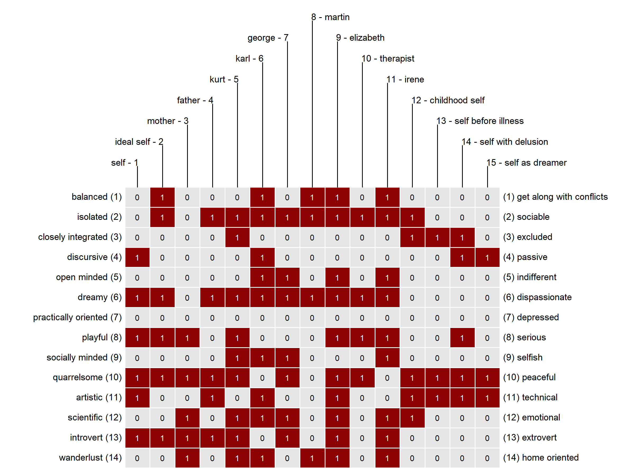

**Figure 1.** Example of a binary repertory grid dataset. The data is a binarized version of a grid from Böker (1996)

# Interpretive Clustering

IC is an idiographic method of interpretation which makes use of the qualitative and quantitative grid data. In contrast to thematic analysis on content analysis, which could be used to identify themes in person’s elicited constructs (see Braun and Clarke 2006), IC identifies the relation between the constructs via quantitative assessment. By assessing the construct relations, implications which constructs hold for each other are identified. IC essentially identifies clusters of constructs which hold implications for each other. These clusters (or cliques) of constructs form the basis for a subsequent qualitative interpretation. We will provide a brief interpretation example below. The example builds on the analysis results the software generates as shown next. However, for a more thorough introduction to the IC method and comprehensive illustrations of interpretations, the reader is referred to our publication [(Burr, King, and Heckmann 2020)](https://doi.org/10.1080/14780887.2020.1794088).

# Running the software

The package can be downloaded from the CRAN repository via the R command install.packages("OpenRepGrid.ic"). The software is then started as follows.

library(OpenRepGrid.ic)  
ic()

Alternatively, there is a web version available under <https://ic.openprepgrid.org>. Also, a docker image is provided under <https://hub.docker.com/repository/docker/markheckmann/openrepgrid.ic>. Below a screenshot of the user interface is displayed. The image shows a grid dataset from an interview with *Sylvia* which is also contained in the package.

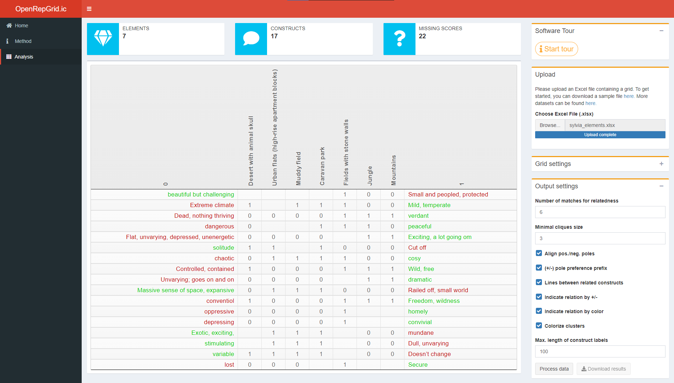

**Figure 2.** Screenshot of the software.

The results of the IC analysis are not displayed interactively but are included in an MS Excel file that can be downloaded. Also the results of the intermediate IC steps as described in [Burr, King, and Heckmann (2020)](https://doi.org/10.1080/14780887.2020.1794088) are contained. The main purpose of the software is to automate the cluster identification step of the IC procedure, which is a cumbersome and error-prone task if performed manually. In Figure 3, an extract of the analysis results for Sylvia’s grid and corresponding analysis settings as shown in Figure 2 are displayed and subsequently discussed.

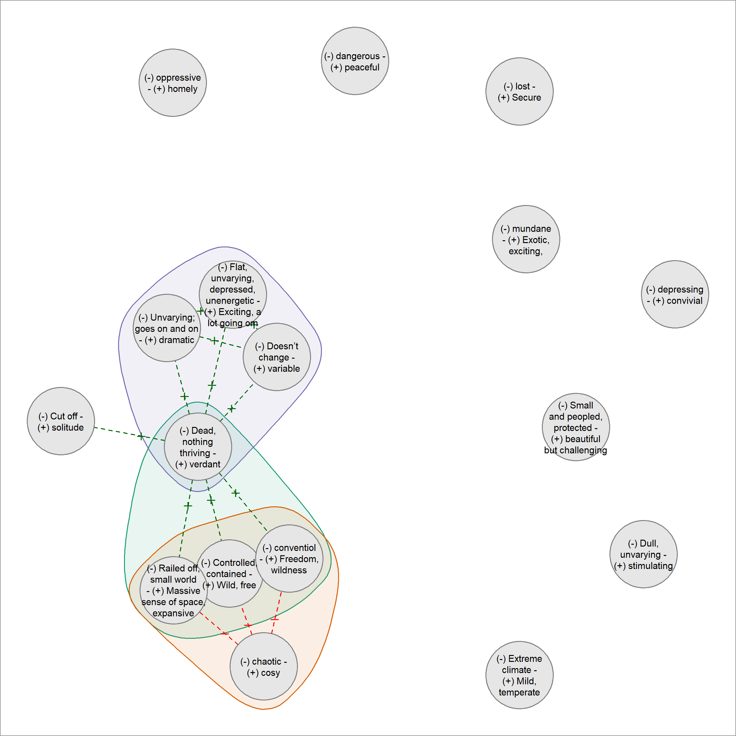

**Figure 3.** Results of IC method for Sylvia.

# Interpretation

Psychologically relevant information can be obtained from the interpretation of the network graphs. What follows is a shortened example. More comprehensive examples are outlined in our publication.

In the resulting diagram for Sylvia’s grid in Figure 3, a construct is indicated by a circle, with (-) denoting the preferred and (-) the non-preferred pole. The diagram shows three clusters (also called cliques), indicated by the colored hulls around several constructs. In Sylvia’s case, the three clusters are highly overlapping. Two of these are of particular interest, sharing a ‘core’ of three constructs – ‘(+) Wild, free *vs* (-) controlled, contained,’ ‘(+) Massive sense of space, expansive *vs* (-) railed-off, small world’ and ‘(+) Freedom, wildness *vs* (-) conventional,’ with (+) indicating the preferred and (-) the non-preferred pole. In one cluster, these three constructs are strongly associated with ‘(+) Verdant *vs* (-) dead, nothing thriving’; the association between her preferred poles suggests that she is drawn to places that are thriving and green, wild and expansive, as opposed to those which lack life, are small-scale, controlled and conventional. However, these three constructs share another cluster with the construct ‘(+) Cosy *vs* (-) Chaotic,’ where ‘cosy’ is her preferred pole. In this cluster, however, her desires for the wild, free and expansive appear to be in tension with her desire for the ‘cosy,’ as they are aligned with her non-preferred pole ‘chaotic‘. The attraction of wild, free spaces for Sylvia is therefore not straightforward.

The third cluster includes the ‘(+) Verdant *vs* (-) dead, nothing thriving’ construct, which is here associated with ‘(+) Exciting, a lot going on *vs* (-) flat, unvarying, depressed, unenergetic,’ ‘(+) Dramatic *vs* (-) unvarying, goes on and on’ and ‘(+) Variable *vs* (-) doesn’t change.’ This suggests that to Sylvia ‘verdant’ spaces are also full of excitement, drama and variability- they are full of life in these ways. However, the fact that these three constructs do not cluster with the wild/expansive/freedom constructs indicates that they constitute a somewhat separate idea for her. A ‘wild’ space for her need not be ‘exciting,’ for example, although a ‘verdant’ space is likely to be both exciting and wild. Interpretive clustering therefore gives us insight into some of the complexity of Sylvia’s construing.

# Contributing

In order to maximize the package’s usefulness for the research community, we welcome participation in the package’s development. Experienced R programmers are asked to make pull requests to the [OpenRepGrid.ic github repository](https://github.com/markheckmann/OpenRepGrid.ic), [report issues](https://github.com/markheckmann/OpenRepGrid.ic/issues), or commit code snippets. Non-technical oriented researchers are invited to send us feature requests or suggestions for improvement.

# References

Böker, Hein. 1996. “The Reconstruction of the Self in the Psychotherapy of Chronic Schizophrenia: A Case Study with the Repertory Grid Technique.” In *Empirical Constructivism in Europe: The Personal Construct Approach*, edited by Jörn W. Scheer and Ana Catina, 160–67. Giessen: Psychosozial-Verlag.

Braun, Virginia, and Victoria Clarke. 2006. “Using Thematic Analysis in Psychology.” *Qualitative Research in Psychology* 3 (2): 77–101. <https://doi.org/10.1191/1478088706qp063oa>.

Burr, Viv, Nigel King, and Mark Heckmann. 2020. “The Qualitative Analysis of Repertory Grid Data: Interpretive Clustering.” *Qualitative Research in Psychology* 0 (0): 1–25. <https://doi.org/10.1080/14780887.2020.1794088>.

Fransella, Fay, Richard C. Bell, and Donald Bannister. 2004. *A Manual for Repertory Grid Technique*. 2nd ed. Chichester: John Wiley & Sons.

Kelly, George Alexander. 1955. *The Psychology of Personal Constructs*. New York: Norton.