13
Differentiate real images from deepfakes

This chapter covers
- ResNet-50 and how it works
- Create a model to distinguish real images from deepfakes based on ResNet-50
- Prepare a large-scale dataset of real and fake images for fine-tuning
- Teste the fine-tuned model on unseen images
We currently live in a world where digital content is rapidly generated and shared. The ability to distinguish between real images and deepfakes (AI-generated images that convincingly mimic real people or objects) has become crucial. Deepfakes are increasingly prevalent, raising concerns about misinformation, privacy, and security. As these deepfakes grow more sophisticated, traditional methods of image verification struggle to keep up. This challenge demands innovative solutions grounded in deep learning and computer vision techniques.
This chapter aims to provide a robust approach for differentiating real images from deep fakes using a fine-tuned ResNet architecture. ResNet, known for its depth and efficiency in image classification tasks, serves as an ideal candidate for this purpose. By taking advantage of the power of transfer learning, we will modify and fine-tune a pretrained ResNet model to check image authenticity. Compared to training a model from scratch, fine-tuning ResNet significantly reduces the time and resources required for our task.
Specifically, we’ll choose a pretrained ResNet-50 model as our starting point. We'll modify the last layer in the model so there are two outputs instead of 1000 outputs from the model: the two outputs represent the probabilities of an image being real and being fake, respectively. We'll use training data to train the weights in the last layer, while keeping the weights in all other layers unchanged.
During the fine-tuning process, we'll evaluate model performance on a separate validation set. This step ensures the model is learning to generalize beyond the training data, offering insights into potential overfitting and underfitting issues. Further, we'll use the validation set to determine when to stop fine-tuning. Proper fine-tuning requires understanding when the model has reached its optimal state. We will explore how to use early stopping based on validation performance, avoiding overfitting and improving the model’s efficiency. If the model stops improving after three consecutive epochs, we'll stop the fine-tuning loop.
Finally, the chapter demonstrates how to deploy the fine-tuned ResNet model to classify new images, providing a practical and effective tool for real-world applications. We apply the fine-tuned model to an unseen, out-of-sample, test subset. We'll display ten images from the test set and compare the predicted label (real or fake) with the ground truth. We'll also calculate the prediction accuracy in the entire test subset, which consists of 10000 real images and 10000 fake images. The fine-tuned model achieved an accuracy of 93.73%.
By the end of this chapter, you will have a clear understanding of how to use deep learning techniques, specifically ResNet, to tackle the problem of distinguishing real images from deepfakes, equipping you with the skills needed to build and fine-tune a powerful image classification system.

  - A blueprint to fine-tune ResNet-50
To accurately distinguish real images from deepfakes, we need a deep learning model that’s both powerful and efficient. ResNet-50, with its deep architecture and proven success in image classification, is an ideal candidate for this task, especially when paired with transfer learning.
Instead of training a new model from scratch, we’ll fine-tune a ResNet-50 model that’s already learned general visual features from a large dataset. By replacing and retraining only the final layers, we can quickly adapt ResNet-50 to classify images as real or fake, saving time and resources.
In this section, we’ll introduce the key features and strengths of ResNet-50 and explain the advantages of fine-tuning over training from scratch. We’ll also outline the steps to modify and prepare ResNet-50 for our deepfake detection task.
    - The history and architecture of ResNet-50
ResNet-50 is a landmark architecture in deep learning, introduced in 2015 by Kaiming He and colleagues at Microsoft Research. Its key innovation, the residual connection, transformed how deep neural networks are built and trained, allowing them to go much deeper than before without suffering from the vanishing gradient problem.
Traditional deep networks struggled as layers increased, often failing to learn meaningful features. ResNet (short for Residual Network) tackled this by adding shortcut, or “skip,” connections that allow the input of a layer to bypass one or more layers and be added directly to the output. This simple yet powerful idea helps preserve information and enables the effective training of much deeper models. In fact, the “residual connection” concept has become foundational, now appearing in everything from vision models to transformers for natural language processing.
ResNet-50 is one of the most popular variants, featuring 50 layers organized into modular blocks. Its architecture enables the network to learn hierarchical and abstract representations of images, which is why it has performed exceptionally well on large-scale datasets like ImageNet (over a million images, 1,000 object classes). The availability of high-quality pretrained weights makes ResNet-50 a go-to choice for transfer learning in many real-world applications.
Figure 13.1 illustrates the main building blocks of ResNet-50.
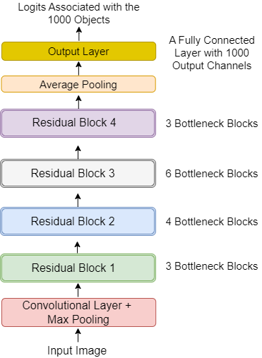
Figure 13.1 The architecture of ResNet-50. ResNet-50 is structured as follows:
(1) An initial convolutional layer followed by max pooling to reduce spatial dimensions;
(2) Four sequential “residual blocks” composed of bottleneck units with residual connections;
(3) An average pooling layer;
(4) A fully connected output layer.
The model takes an image as input and outputs logits for 1,000 object classes, which can be converted into predicted probabilities using the softmax activation function.
The input to ResNet-50 is an input image, which will first go through a convolutional layer and a max pooling layer to extract low-level features and reduce the image size. The heart of the network consists of four residual blocks, each made up of several bottleneck sub-blocks. Each bottleneck uses three convolutional layers with a residual connection, which allows gradients and information to flow more easily through the network as it learns.
After passing through all the residual blocks, the features are aggregated by an average pooling layer, and the network ends with a fully connected output layer. Originally, this layer outputs 1,000 values (called logits), one for each possible ImageNet class (such as bee, ant, zebra). After applying the softmax activation function on these logits, we can obtain the predicted probability distribution over the 1000 classes.
The modular and extensible design of ResNet-50 makes it ideal for fine-tuning. By swapping out or modifying the output head, you can quickly adapt the model to new tasks, such as distinguishing real images from deepfakes.
    - A plan to fine-tune ResNet-50 for classification
Fine-tuning is one of the most effective strategies in modern deep learning, especially when you want to adapt a powerful model like ResNet-50 to a new, specialized task, such as distinguishing real images from deepfakes. Instead of starting from scratch, we take advantge of the knowledge that ResNet-50 has already acquired from massive datasets like ImageNet, and repurpose it for our classification problem.
To understand why this approach is so powerful, let’s first contrast training from scratch with fine-tuning a pretrained model. When you train a deep neural network from scratch, you begin with randomly initialized parameters. The model must “learn everything” from scratch, which requires vast amounts of data and computational resources. This process is time-consuming and often impractical for most real-world projects.
In contrast, fine-tuning starts with a model that already knows how to perform general tasks (extracting useful visual features from images in the case of ResNet-50). By updating only the last few layers, typically the output head, you can quickly adapt the model to new tasks with far less data and time. Figure 13.2 illustrates the difference between training from scratch and fine-tuning.
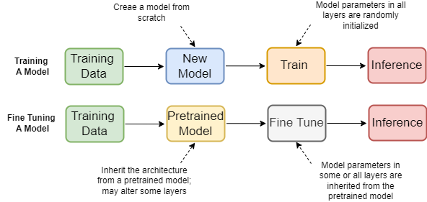
Figure 13.2. Training from scratch vs. fine-tuning an existing model. Training from scratch (top row in the diagram) involves building a model with randomly initialized parameters, requiring the network to learn all features from raw data. In contrast, fine-tuning uses the architecture and pretrained weights of an existing model, modifying (often only) the output layer for a new downstream task. The bulk of the network retains the learned parameters, while only the final layers are updated for the new objective.
This fine-tuning approach is the secret to achieving state-of-the-art performance with limited resources. For our task, it means we can use a ResNet-50 model pretrained on ImageNet, and tailor it to distinguish real from fake images simply by retraining the output head. Specifically, the original ResNet-50 outputs 1,000 logits, one for each object class in ImageNet. For deepfake detection, we only need to classify images into two categories: real or fake.
Our plan involves replacing the final fully connected layer (the output head) of ResNet-50 with a new one that has just two output channels. All other layers of the network are left unchanged, preserving their pretrained parameters. Only the parameters in the new output layer will be randomly initialized and updated during fine-tuning. Figure 13.3 is the architecture of the modified model we’ll use in this chapter.
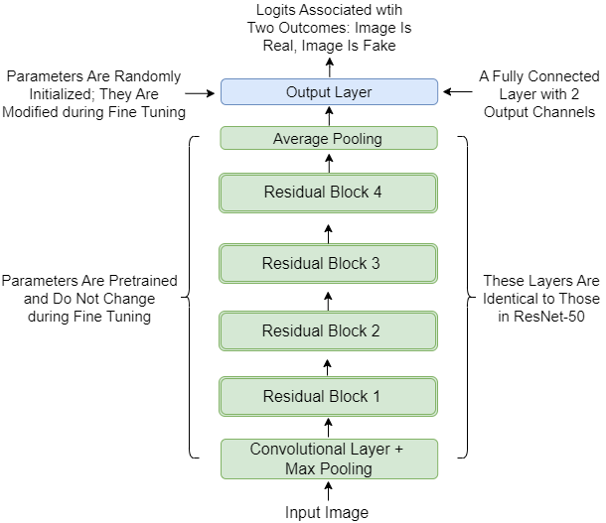
Figure 13.3: Modified ResNet-50 architecture for deepfake detection. All original layers of ResNet-50 are retained, except for the last fully connected output layer. The original output head (with 1,000 output channels) is replaced with a new head (with 2 output channels), producing logits for the “real” and “fake” classes. Parameters in the new output layer are initialized randomly and trained on our dataset. All other parameters are inherited from the pretrained model and kept frozen during fine-tuning.
By making this simple yet powerful adjustment, we harness the deep feature extraction capabilities of ResNet-50 while customizing it for our classification goal.
In summary, our fine-tuning strategy consists of the following steps:
- Load a ResNet-50 model pretrained on ImageNet.
- Replace its final output layer with a new layer for two-class output.
- Freeze the weights of all other layers to retain their learned features.
- Train only the new output head on our dataset of real and fake images.
This approach dramatically reduces training time and data requirements, and consistently delivers high performance for tasks where labeled data is limited. In the next sections, we’ll implement each of these steps in code, fine-tuning ResNet-50 to become a highly effective deepfake detector.
  - Use ResNet-50 to classify images
Before we fine-tune ResNet-50 for detecting deepfakes, it’s valuable to see how this model works “out of the box.” In this section, we’ll explore how to use a pretrained ResNet-50 to classify some example images, demonstrating its powerful feature extraction abilities and familiarizing ourselves with its workflow.
We’ll start by loading the ResNet-50 model and its pretrained weights using the torchvision library. You’ll see how the model processes an input image, outputs a prediction, and translates this prediction into a human-readable class label from the 1,000 categories in ImageNet. By working through hands-on examples, you’ll gain insight into both the capabilities and the inner workings of ResNet-50.
The Python program in this chapter is adapted from two wonderful GitHub repositories: https://github.com/khanaabidabdal/Ai-Image-Classifier-Real-Vs-Fake-Faces and https://github.com/cyb0rg14/fake-image-detector. Before you start, run the following code cell in Jupyter Notebook to install the kagglehub library for this chapter:
!pip install kagglehub
    - Load the pretrained ResNet-50
One of the major advantages of using the torchvision library is the ease with which you can access state-of-the-art, pretrained models like ResNet-50. Directly accessing the pretrained weights, learned from millions of images in the ImageNet dataset, lets us instantly benefit from powerful feature extraction without having to start from scratch.
Let’s walk through the process of loading a ResNet-50 model with pretrained weights, setting it up for inference, and examining its architecture. These steps provide a crucial foundation for both experimentation and later customization.
First, we’ll import the relevant module and load the pretrained ResNet-50 model:
import torchvision.models as models

weights = models.ResNet50_Weights.DEFAULT
model = models.resnet50(weights=weights) #A
model.eval() #B
print(model) #C
#A Initiate ResNet-50 with pretrained weights
#B Set the model to evaluation mode for inference
#C Print out the model structure
We create an instance of the ResNet-50 model, specifying that it should load the default pretrained weights. Setting the model to evaluation mode is essential before using it for inference. This ensures that layers like dropout and batch normalization behave appropriately, producing deterministic and reliable results. Printing the model structure allows you to inspect all the layers and modules that make up ResNet-50. The output is as follows:
ResNet(
(conv1): Conv2d(3, 64, kernel_size=(7, 7), stride=(2, 2), padding=(3, 3), bias=False)
(bn1): BatchNorm2d(64, eps=1e-05, momentum=0.1, affine=True, track_running_stats=True)
(relu): ReLU(inplace=True)
(maxpool): MaxPool2d(kernel_size=3, stride=2, padding=1, dilation=1, ceil_mode=False)
(layer1): Sequential(
(0): Bottleneck(
(conv1): Conv2d(64, 64, kernel_size=(1, 1), stride=(1, 1), bias=False)
(bn1): BatchNorm2d(64, eps=1e-05, momentum=0.1, affine=True, track_running_stats=True)
(conv2): Conv2d(64, 64, kernel_size=(3, 3), stride=(1, 1), padding=(1, 1), bias=False)
(bn2): BatchNorm2d(64, eps=1e-05, momentum=0.1, affine=True, track_running_stats=True)
(conv3): Conv2d(64, 256, kernel_size=(1, 1), stride=(1, 1), bias=False)
(bn3): BatchNorm2d(256, eps=1e-05, momentum=0.1, affine=True, track_running_stats=True)
(relu): ReLU(inplace=True)
(downsample): Sequential(
(0): Conv2d(64, 256, kernel_size=(1, 1), stride=(1, 1), bias=False)
(1): BatchNorm2d(256, eps=1e-05, momentum=0.1, affine=True, track_running_stats=True)
)
)
(1): Bottleneck(
…
)
)
(avgpool): AdaptiveAvgPool2d(output_size=(1, 1))
(fc): Linear(in_features=2048, out_features=1000, bias=True)
)
For brevity, we omitted most of the output, which is a detailed summary of the ResNet-50 architecture. The output starts with the initial convolutional and pooling layers, followed by the four main residual blocks, and ending with the average pooling and fully connected output layer.
NOTE The Python programs for this chapter can be accessed from the Google Colab notebook https://colab.research.google.com/drive/15p4RIPTgM-7bUGc8ITYQd0tsHcavmTpH?usp=sharing and the GitHub repository https://github.com/markhliu/txt2img.
Go to the book’s GitHub repository, download the image fish.png. Place it in the /files/ folder on your computer (or simply clone the repository to your computer). We’ll use the fish image as our sample picture to show how ResNet-50 works.
The ResNet-50 can only accept images of size 3x224x224, we therefore load the fish image first and define a transform method to convert the image to the desired shape:
Listing 13.1 Loading and processing the sample image
from PIL import Image
import torch

img = Image.open('files/fish.png').convert('RGB') #A
preprocess = models.ResNet50_Weights.DEFAULT.transforms()
input_tensor = preprocess(img) #B
input_batch = input_tensor.unsqueeze(0) #C
print(f"the shape of the input image is {input_batch.shape}")
device="cuda" if torch.cuda.is_available() else "cpu"
input_batch = input_batch.to(device)
model.to(device) #D
#A Read the sample image
#B Transform the image into a PyTorch tensor with the desired size
#C Create a mini-batch as expected by ResNet-50
#D Move the input and model to GPU if available

The output from the above code cell is:
the shape of the input image is torch.Size([1, 3, 224, 224])
The shape of the input image is (1, 3, 224, 224), meaning there is one image in the batch, and the size of the image is 3x224x224.
Exercise 13.1
Go to the book’s GitHub repository, download the image deer.png. Place it in the /files/ folder on your computer. Load the image and transform it into a format that ResNet-50 can accept as input. Call the input tensor input_batch2.

    - Make predictions on images
With our pretrained ResNet-50 model loaded and ready, we can now see it in action by making predictions on real-world images. This section guides you through the process of classifying images using the model and interpreting the results, offering practical insights into both the mechanics and the strengths of deep convolutional networks.
Let’s start with the fish image that you have preprocessed and formatted to the required size. We can now run this image through the model and observe how it produces predictions.
from torch.nn.functional import softmax

with torch.no_grad():
output = model(input_batch) #A
probabilities = softmax(output[0],
dim=0) #B
predicted_class_idx = torch.argmax(probabilities).item() #C
highest_prob = torch.max(probabilities).item() #D
print("the predicted class is", predicted_class_idx)
print("the highest probability is", highest_prob)
#A Make a prediction on the sample image
#B Convert logits to probabilities
#C Obtain the class index with the highest probability
#D Obtain the highest probability
The model processes the input image and produces raw outputs (logits), one for each possible class. We use the softmax function to convert these logits into a probability distribution over the 1,000 ImageNet classes. The argmax() function identifies the index of the class with the highest predicted probability. We also print out the probability value for the top prediction using the max() function.
The output from the above code block is:
the predicted class is 1
the highest probability is 0.1901196837425232
The predicted class index is 1, which means the model believes the image most likely belongs to class 1 (out of 1,000), with an associated probability of 19%. But what does this class index represent in human terms?
To answer that, we can map class indices to actual category names, like so:
labels = models.ResNet50_Weights.DEFAULT.meta['categories']
print(labels) #A
print("object name is:", labels[predicted_class_idx]) #B
#A Print out the 1000 object names
#B Print out the name of the object with index 1
This prints out all 1,000 object categories from ImageNet. Using the class index, we retrieve and print the name of the predicted class. The output is:
['tench', 'goldfish', 'great white shark', 'tiger shark', 'hammerhead', 'electric ray', 'stingray',
…,
'gyromitra', 'stinkhorn', 'earthstar', 'hen-of-the-woods', 'bolete', 'ear', 'toilet tissue']
object name is: goldfish
For brevity, we omitted most of the output. We can see that the first of the 1,000 objects is tench, the second object is goldfish, and the last object is toilet tissue. Since Python uses zero-based indexing, the class index 1 corresponds to the second object, goldfish.
Exercise 13.2
Feed the input tensor input_batch2 that you generated in exercise 13.1 to ResNet-50 and print out the predicted class index as well as the name of the predicted object.

To better understand the model’s behavior, let’s try running it on a variety of images. For this, we’ll use four images, those of a bird, a dog, a bunny, and a fish, preprocessed in the same way. We’ll collect both the predicted labels and their associated probabilities for each image. Go to the book’s GitHub repository, download the three images bird.png, dog.png, and bunny.png. Place them in the /files/ folder on your computer. Or clone the repository to your computer.
We use ResNet-50 to make predictions on these images and store the predicted probabilities and the outcomes.
Listing 13.2 Using ResNet-50 to make predictions
probs=[]
indexes=[]
images=["bird","dog","bunny","fish"]
for img in images:
img = Image.open(f"files/{img}.png").convert('RGB')
input_tensor = preprocess(img)
input_batch = input_tensor.unsqueeze(0).to('cuda')
with torch.no_grad():
output = model(input_batch) #A
probabilities = softmax(output[0],dim=0)
idx=torch.argmax(probabilities).item() #B
indexes.append(idx)
prob=torch.max(probabilities).item() #C
probs.append(prob)
#A Make predictions on the four images
#B Obtain the class indexes
#C Obtain the highest probabilities
We iterate through the four images. For each image, we use ResNet-50 to make a prediction and obtain the index with the highest probability and the associated probability. We store the four probabilities in the list probs and the four indexes in the list indexes.
Now, we can visualize the results by displaying the images alongside their predicted class names and confidence scores.
Listing 13.3 Plotting predictions and the associated probabilities
from torchvision import transforms
import matplotlib.pyplot as plt

plt.figure(figsize=(8,5),dpi=100)
for i in range(4):
plt.subplot(1,4,i+1)
img=Image.open(f"files/{images[i]}.png")
img=transforms.ToTensor()(img)
plt.imshow(img.permute(1,2,0)) #A
pred=labels[indexes[i]]
msg=f"{pred}\nprob: {probs[i]:.2f}"
plt.title(msg,fontsize=15) #B
plt.axis('off')
plt.tight_layout()
plt.show()
#A Display the four images
#B Display the predictions and the associated probabilities
Each subplot displays one of the four images. The title above each image shows the predicted class name and the model’s confidence. The output is shown in figure 13.4.

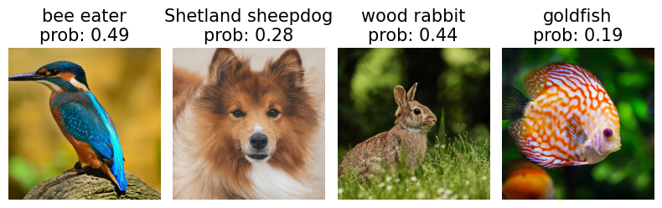
Figure 13.4 Using ResNet-50 to make predictions on images. Each image is shown with its top predicted class and the corresponding probability as determined by ResNet-50. The results highlight both the strengths and quirks of large-scale classification models: for example, the model may predict “bee eater” for a bird image that looks like a kingfisher, since “kingfisher” isn’t among the 1,000 ImageNet classes. Such observations show that the model’s predictions depend not only on the input image, but also on the set of categories it was trained to recognize.
This hands-on exploration demonstrates the predictive power and limitations of ResNet-50 in its default setting. Understanding these behaviors is essential before we move on to fine-tuning the model for our custom classification task, detecting real images and deepfakes.
  - Prepare a dataset for fine-tuning
Having seen how ResNet-50 performs on general image classification tasks, we now turn to the challenge of adapting it for deepfake detection. The first step in this process is to prepare a dataset that enables the model to learn the subtle differences between real and AI-generated (fake) images.
Fine-tuning a neural network requires high-quality, well-labeled data that closely matches your task. For our task at hand, this means gathering and organizing a large number of images, clearly labeled as either “real” or “fake.” The more representative and diverse the dataset, the better the model will be at generalizing to new, unseen images.
    - Download and visualize real and fake face images
In this subsection, we’ll walk through downloading a popular dataset and inspecting its contents to gain intuition for the task ahead.
We’ll use the 140k Real and Fake Faces dataset from Kaggle, which provides a rich source of both genuine and AI-generated images. This collection contains a total of 140,000 images, 70,000 real faces sourced from real-world photographs and 70,000 fake faces generated by an AI model. The dataset is organized into clearly labeled folders for “real” and “fake” images, and is split into training, validation, and test subsets for evaluation and testing.
Let’s start by downloading the dataset and setting up the file paths:
Listing 13.4 Downloading the 140k Real and Fake Faces dataset
import kagglehub

path = kagglehub.dataset_download(
"xhlulu/140k-real-and-fake-faces") #A

print("Path to dataset files:", path) #B

train_dir=rf"{path}/real_vs_fake/real-vs-fake/train"
val_dir=rf"{path}/real_vs_fake/real-vs-fake/valid"
test_dir=rf"{path}/real_vs_fake/real-vs-fake/test" #C
#A Download the dataset from Kaggle
#B Print out the local path to dataset files
#C Define the paths to the train, validation, and test subsets
We first use the dataset_download() method in the kagglehub library to download the dataset. We then print out the path to the dataset files. Depending on your operating system, the path may differ. I am using Windows 11, and the output on my computer is as follows:
Path to dataset files: C:\Users\hlliu2\.cache\kagglehub\datasets\xhlulu\140k-real-and-fake-faces\versions\2
If you are using Google Colab, the output is:
Path to dataset files:
/kaggle/input/140k-real-and-fake-faces
We then define the paths to the train, validation, and test subsets as train_dir, val_dir, and test_dir, respectively.
Below, we count the number of images in the three subsets:
Listing 13.5 Counting and displaying real and fake face images
import os
import glob
import matplotlib.pyplot as plt
import PIL
def count_images(folder):
for path, name, files in os.walk(folder):
if len(files)>0:
print(f"There are {len(files)} images in {path}.")
count_images(train_dir)
count_images(val_dir)
count_images(test_dir) #A

imgs=glob.glob(f'{train_dir}/real/*.jpg')[66:66+5]+\
glob.glob(f'{train_dir}/fake/*.jpg')[88:88+5] #B

plt.figure(figsize=(10,4),dpi=100)
for i in range(10): #C
ax = plt.subplot(2,5, i + 1)
img=PIL.Image.open(imgs[i])
plt.imshow(img)
plt.xticks([])
plt.yticks([])
if i<5:
plt.title("real image")
else:
plt.title("fake image")
plt.tight_layout()
plt.show()
#A Count the number of images in train, validation, and test subsets
#B Select five real images and five fake images
#C Display the ten images in a 2x5 grid
The output from the code listing is:
There are 50000 images in C:\Users\hlliu2\.cache\kagglehub\datasets\xhlulu\140k-real-and-fake-faces\versions\2/real_vs_fake/real-vs-fake/train\fake.
There are 50000 images in C:\Users\hlliu2\.cache\kagglehub\datasets\xhlulu\140k-real-and-fake-faces\versions\2/real_vs_fake/real-vs-fake/train\real.
There are 10000 images in C:\Users\hlliu2\.cache\kagglehub\datasets\xhlulu\140k-real-and-fake-faces\versions\2/real_vs_fake/real-vs-fake/valid\fake.
There are 10000 images in C:\Users\hlliu2\.cache\kagglehub\datasets\xhlulu\140k-real-and-fake-faces\versions\2/real_vs_fake/real-vs-fake/valid\real.
There are 10000 images in C:\Users\hlliu2\.cache\kagglehub\datasets\xhlulu\140k-real-and-fake-faces\versions\2/real_vs_fake/real-vs-fake/test\fake.
There are 10000 images in C:\Users\hlliu2\.cache\kagglehub\datasets\xhlulu\140k-real-and-fake-faces\versions\2/real_vs_fake/real-vs-fake/test\real.
Here, we select five real and five fake images from the training subset, and arrange them in a 2x5 grid for easy comparison. After running the code cell, you’ll see an image similar to figure 13.5.
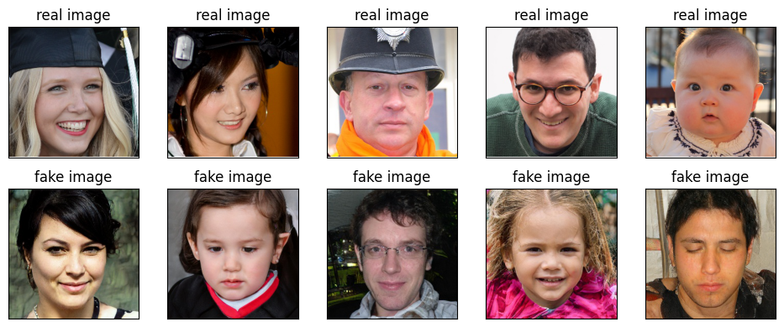
Figure 13.5 Sample real and fake images from the 140k Real and Fake Faces dataset. The top row displays five real face images, while the bottom row shows five face images generated by AI. At a glance, both sets look convincingly realistic. This side-by-side comparison highlights the subtlety of the deepfake detection challenge: to the naked eye, even AI-generated images can appear authentic. Such visualizations emphasize the need for advanced machine learning methods to distinguish between real and fake images.
The fake images look very real. It's hard to tell real images and fake images apart by just looking. We'll train a deep learning model for this purpose.
Exercise 13.3
Display the first five real images and the last five fake images in the validation subset in a 2x5 grid.

    - Process the dataset for fine-tuning
Once the dataset of real and fake faces has been downloaded and inspected, the next step is to prepare it for training our deepfake detector. Deep learning models like ResNet-50 expect inputs to be preprocessed in specific ways, especially regarding image size, normalization, and batching, so it’s important to handle these details carefully to ensure effective training.
ResNet-50, as trained on ImageNet, expects input images to be in the shape (3, 224, 224) (three color channels, height and width of 224 pixels), and normalized using the same statistics as the original dataset. We must ensure that all images in our dataset are transformed accordingly before feeding them into the model.
Listing 13.6 Converting images to the desired size
from torchvision import datasets, models
import torch

torch.manual_seed(42)
preprocess = models.ResNet50_Weights.DEFAULT.transforms()

train_data = datasets.ImageFolder(
root=train_dir,
transform=preprocess,
target_transform=None) #A
val_data = datasets.ImageFolder(
root=val_dir,
transform=preprocess,
target_transform=None) #B
test_data = datasets.ImageFolder(
root=test_dir,
transform=preprocess) #C
#A Process images in the train subset
#B Process images in the validation subset
#C Process images in the test subset
We define preprocess as a transformation pipeline automatically provided for ResNet-50, ensuring each image is resized, cropped, converted to a tensor, and normalized in a way that matches the expectations of the pretrained model.
The datasets.ImageFolder utility loads images from disk, applying the transformation pipeline to every image in the respective folder. This structure allows us to organize our dataset conveniently; each subfolder name (“real”, “fake”) is treated as a label.
After transformation, we batch the data. Training in batches is a standard practice in deep learning. It allows for efficient computation and more stable gradient updates.
from torch.utils.data import DataLoader
train_dataloader = DataLoader(dataset=train_data,
batch_size=32,
shuffle=True) #A
val_dataloader = DataLoader(dataset=test_data,
batch_size=32,
shuffle=False)
test_dataloader = DataLoader(dataset=test_data,
batch_size=32,
shuffle=True) #B
#A Put training data into batches of 32 observations
#B Do the same for validation and test subsets
The result of this data pipeline is that, whenever we iterate over these DataLoader objects, we receive a batch of images (as tensors, ready for input to ResNet-50) along with their corresponding labels (“real” or “fake”, encoded as 0 or 1).
  - Fine-tune ResNet-50 to detect fake images
With our dataset fully prepared and preprocessed, we’re ready to tackle the heart of this chapter: transforming a powerful pretrained ResNet-50 into a specialized detector that can distinguish between real and AI-generated (deepfake) faces. This is where the strengths of transfer learning truly shine.
In this section, you’ll learn how to:
- Freeze the weights of the early layers of ResNet-50 to preserve their generic image understanding;
- Replace the output “head” of the network to support real vs. fake classification;
- Train just the new output layers using your custom dataset, while monitoring validation performance;
- Implement techniques like early stopping to avoid overfitting and ensure the model generalizes well to unseen images.
By the end of this section, you’ll have all the practical tools and knowledge required to adapt a cutting-edge image classification model to a deepfake detection task.
    - Fine-tune ResNet-50
The key to fine-tuning is deciding which parts of the network to retrain and which to keep fixed. In most transfer learning workflows, we “freeze” the weights of all layers except the final output head. This preserves the network’s general visual feature extraction ability, while letting the last layer learn how to map those features to our specific labels, “real” or “fake.”
The following code demonstrates this process:
Listing 13.7 Replacing the output head in ResNet-50
for param in model.parameters():
param.requires_grad = False #A

model.fc= torch.nn.Sequential(
torch.nn.Linear(2048,1000),
torch.nn.ReLU(),
torch.nn.Linear(1000,500),
torch.nn.Dropout(),
torch.nn.Linear(in_features=500,
out_features=2,
bias=True)).to(device) #B

num_trainable=sum([p.numel() for p in model.parameters()
if p.requires_grad])
print(f"Number of trainable parameters: {num_trainable}")
non_trainable=sum([p.numel() for p in model.parameters()
if not p.requires_grad])
print(f"Number of untrainable parameters: {non_trainable}") #C
#A Freeze parameters in ResNet-50
#B Replace the output head so that there are two output channels
#C Count the number of parameters
We first set requires_grad=False for every parameter, ensuring that none of the existing ResNet-50 weights will be updated during training. We replace the final fully connected (fc) layer with a new “head” tailored for our task. Here, we stack several linear layers, activation functions, and dropout for added flexibility and regularization. The final output layer produces two values, logits for “real” and “fake.” The output from the above code listing is:
Number of trainable parameters: 2550502
Number of untrainable parameters: 23508032
There are more than 23 million untrainable parameters and there are only about 2.5 million trainable parameters (which are the parameters in the new output layer).
To determine when to stop training, we'll look at the performance of the model in the validation set. We'll stop training if the model doesn't improve for three consecutive epochs.
We define a train_epoch() function to train the model for one epoch:
Listing 13.8 Defining the train_epoch() function
from tqdm import tqdm

def train_epoch(model,dataloader,loss_fn,optimizer): #A
model.train()
train_loss = 0
for batch, (X, y) in enumerate(tqdm(dataloader)): #B
X, y = X.to(device), y.to(device)
y_pred = model(X) #C
loss = loss_fn(y_pred, y) #D
train_loss += loss.item()
optimizer.zero_grad()
loss.backward()
optimizer.step() #E
return train_loss/len(dataloader)
#A Define the train_epoch() function
#B Iterate through all batches in the training dataset
#C Make predictions using the model
#D Calculate the loss by comparing predictions with the ground truth
#E Backpropagate to minimize the loss
The train_epoch() function trains the model for one epoch and calculates the training loss.
We define a val_epoch() function to evaluate the model using the validation data:
def val_epoch(model,dataloader,loss_fn): #A
model.eval()
val_loss=0
with torch.inference_mode():
for batch, (X, y) in enumerate(dataloader): #B
X, y = X.to(device), y.to(device)
pred_logits = model(X)
loss = loss_fn(pred_logits, y)
val_loss += loss.item()
return val_loss/len(dataloader) #C
#A Define the val_epoch() function
#B Iterate through all batches in the validation dataset
#C Return the average loss in the epoch
The val_epoch() function evaluates the performance of the model using validation data. The function returns the average loss in each batch in the validation dataset. This helps us gauge generalization and watch for overfitting.
We set up the loss function and the optimizer as follows:
loss_fn = torch.nn.CrossEntropyLoss()
optimizer = torch.optim.Adam(params=model.parameters(),
lr=0.001)
To prevent overfitting and wasted computation, we implement early stopping. The training loop stops if the model’s performance on the validation set does not improve for three consecutive epochs, and we retain the best weights seen during training:
class EarlyStop:
def __init__(self, patience=3):
self.patience = patience
self.steps = 0
self.min_loss = float('inf')
def stop(self, val_loss):
if val_loss < self.min_loss: #A
self.min_loss = val_loss
self.steps = 0
elif val_loss >= self.min_loss: #B
self.steps += 1
if self.steps >= self.patience: #C
return True
else:
return False
stopper=EarlyStop() #D
#A If the validation loss is smaller than the previously achieved minimum, keep training
#B If the loss in the validation set is larger than the minimum, add 1 to the counter
#C If the performance doesn’t improve in three consecutive epochs, stop training
#D Instantiate the EarlyStop() class
With this in place, we start the training process::
for i in range(100): #A
trainloss=train_epoch(model,train_dataloader,
loss_fn,optimizer) #B
valloss=val_epoch(model,val_dataloader,loss_fn) #C
print(f'epoch {i},trainloss={trainloss},valloss={valloss}')
if stopper.stop(valloss)==True: #D
break
#A Fine-tune the model for a maximum of 100 epochs
#B Calculate the training loss using the train_epoch() function
#C Calculate the validation loss using the val_epoch() function
#D Stop training if the performance stops improving in the validation set
The training takes about an hour. The training stops after six epochs. The best model is saved after three epochs. If you don't have GPU training, you can go to https://github.com/khanaabidabdal/Ai-Image-Classifier-Real-Vs-Fake-Faces to download the fine-tuned model parameters.
    - Detect deep fakes using the fine-tuned ResNet-50
With training complete and our fine-tuned model ready, it’s time for the most exciting step, seeing how well our ResNet-50 distinguishes between real and AI-generated faces on never-before-seen data. This subsection demonstrates how to load the best-performing weights, generate predictions on the test set, visualize results, and evaluate the model’s overall performance.
If you trained the model yourself, you can directly use your saved weights. Alternatively, you can download a set of pretrained weights, fine-tuned for this task, from the open-source community. This ensures you can test the model’s abilities even without a GPU.
Listing 13.9 Loading fine-tuned weights
import requests, os

url=("https://github.com/khanaabidabdal/"
"Ai-Image-Classifier-Real-Vs-Fake-Faces/"
"raw/main/RealityCheck.pth") #A

file="files/RealityCheck.pth" #B

if not os.path.exists(file): #C
print("downloading fine-tuned weights")
fb=requests.get(url)
with open(file,"wb") as f:
f.write(fb.content)
else:
print("weights have already been downloaded")
model.load_state_dict(torch.load(file, #D
map_location=device))
#A URL to download the fine-tuned weights
#B Where to save the weights locally
#C Download the fine-tuned weights, if not already
#D Load the fine-tuned weights to the model
Now let’s put our fine-tuned model to work on a batch of test images. We’ll randomly sample a batch and generate predictions for each image.
torch.manual_seed(42)
imgs, ys = next(iter(test_dataloader))
The tensor imgs has 32 images in it. The tensor ys has 32 values and each value is either 0 or 1: 0 means the image is fake and 1 means the image is real.
Now we use the fine-tuned model to make predictions on the 32 images:
with torch.inference_mode():
X, y = imgs.to(device), ys.to(device)
logits = model(X)
preds = logits.argmax(dim=1)
We print out the values of ys, which are ground truth, and preds, which are predictions, and see if each prediciton is correct:
print(ys)
print(preds)
print(ys==preds.cpu())
The output is:
tensor([0, 0, 1, 0, 1, 0, 0, 1, 0, 1, 1, 1, 0, 0, 1, 1, 1, 1, 1, 1, 1, 0, 1, 1, 0, 1, 1, 0, 0, 1, 1, 0])
tensor([0, 0, 1, 0, 1, 0, 0, 1, 0, 1, 1, 1, 0, 0, 1, 1, 1, 1, 1, 1, 1, 0, 1, 1, 0, 1, 1, 0, 0, 1, 1, 0], device='cuda:0')
tensor([True, True, True, True, True, True, True, True, True, True, True, True, True, True, True, True, True, True, True, True, True, True, True, True, True, True, True, True, True, True, True, True])
Results show that the model made 32 correct predictions and no wrong prediction.
Exercise 13.4
Change the random seed to 0 and obtain a batch of 32 images from the test subset. Make predictions on them using the fine-tuned model and see how many predictions are correct.

A powerful way to assess your model’s real-world performance is to visualize a sample of predictions, including both successes and errors. Let’s plot the first ten images from the test batch, clearly labeling each one with both its ground-truth and predicted class.
import torchvision.transforms as T

T1=T.Compose([
T.Normalize([0, 0, 0],
[1/0.229, 1/0.224, 1/0.225])])

T2=T.Compose([
T.Normalize([-0.485, -0.456, -0.406],
[1,1,1])])

plt.figure(figsize=(10,4),dpi=100)
for i in range(10):
ax = plt.subplot(2,5, i + 1)
plt.imshow(T2(T1(imgs[i])).permute(1,2,0))
plt.xticks([])
plt.yticks([])
if preds[i]==0 and ys[i]==0:
plt.title("fake image\nprediction: fake",color="green")
elif preds[i]==1 and ys[i]==0:
plt.title("fake image\nprediction: real",color="red")
elif preds[i]==0 and ys[i]==1:
plt.title("real image\nprediction: fake",color="red")
elif preds[i]==1 and ys[i]==1:
plt.title("real image\nprediction: real",color="green")
plt.tight_layout()
plt.show()
You’ll see the output in figure 13.6. Each subplot shows one test image with its true class and model prediction, letting you visually inspect where the model makes the correct prediction or not.
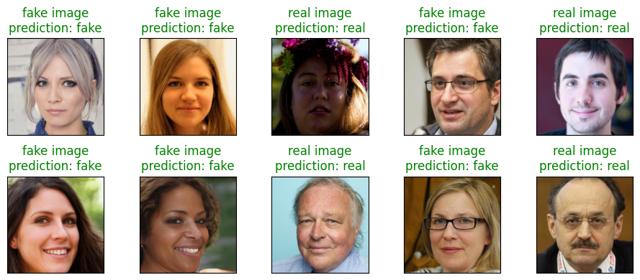
Figure 13.6 Using the fine-tuned model to differentiate real images from deepfakes. Each image is labeled with both its ground-truth class (real or fake) and the model’s prediction. This side-by-side visualization provides immediate feedback on the model’s predictions. Notice how convincingly realistic some “fake” images appear, underscoring the importance of robust deep learning solutions.
For a quantitative summary, let’s calculate the model’s overall prediction accuracy across the entire test set, comprising 10,000 real and 10,000 fake images. Since the classes are balanced, accuracy is a reliable metric.
model.eval()
test_acc = 0
with torch.inference_mode():
for batch, (X, y) in enumerate(test_dataloader):
X, y = X.to(device), y.to(device)
test_pred_logits = model(X)
test_pred_labels = test_pred_logits.argmax(dim=1)
test_acc += ((test_pred_labels == y).sum(
).item()/len(test_pred_labels))
test_acc = test_acc / len(test_dataloader)
print(f"the prediction accuracy is {test_acc:.4f}")
This script computes and averages accuracy over all batches in the test set. The output is:
the prediction accuracy is 0.9373
This means the fine-tuned ResNet-50 correctly classified 93.73% of all test images, a testament to the effectiveness of transfer learning for deepfake detection.
In the next chapter, we’ll conclude the book with new developments and challenges in state-of-the art text-to-image models.

Summary
- Traditional deep networks struggled as layers increased, often failing to learn meaningful features. ResNet (short for Residual Network) tackled this by adding shortcut, or “skip,” connections that allow the input of a layer to bypass one or more layers and be added directly to the output. This simple yet powerful idea helps preserve information and enables the effective training of much deeper models. The “residual connection” concept has become foundational, now appearing in everything from vision models to transformers for natural language processing.
- ResNet-50 is a landmark architecture in deep learning. Its key innovation, the residual connection, transformed how deep neural networks are built and trained, allowing them to go much deeper than before without suffering from the vanishing gradient problem Its architecture enables the network to learn hierarchical and abstract representations of images, which is why it has performed exceptionally well on large-scale datasets like ImageNet (over a million images, 1,000 object classes). The availability of high-quality pretrained weights makes ResNet-50 a go-to choice for transfer learning in many real-world applications.
- Training from scratch involves building a model with randomly initialized parameters, requiring the network to learn all features from raw data. In contrast, fine-tuning uses the architecture and pretrained weights of an existing model, modifying (often only) the output layer for a downstream task. The bulk of the network retains the learned parameters, while only the final layers are updated for the new objective.
- Fine-tuning a neural network requires high-quality, well-labeled data that closely matches your target task. For our deepfake detection problem, this means gathering and organizing a large number of images, clearly labeled as either “real” or “fake.” The more representative and diverse the dataset, the better the model will be at generalizing to new, unseen images.
- The fine-tuned ResNet-50 model performs well on unseen, out-of-sample images, achieving an accuracy of 93.73% among a test dataset.

Kaiming He, Xiangyu Zhang, Shaoqing Ren, and Jian Sun, 2015, Deep Residual Learning for Image Recognition, https://arxiv.org/abs/1512.03385.

