LAB Logbook

Lab 1
1. DataFrame
A DataFrame is a two-dimensional labelled data structure in Pandas that stores​ data in rows and columns similar to a spreadsheet or database table
2. Series
It is a one-dimensional labelled array in Pandas​ that can hold data of any type and represents a single column of data.
3. Index
An Index​ is an​ immutable​ array used by Pandas to label and​ identify data rows or columns for efficient data alignment.
4. Timestamp
A Timestamp represents a single point in time in Pandas and is commonly used for time-series data analysis.
5‌. Categorical
Used to represent data with a fixed set of values, helping reduce memory usage and improve performance.
Lab 2
WannaCry Ransomware attack (2017)
Resources-
- https://www.cloudflare.com/learning/security/ransomware/wannacryransomware/
Lab 3
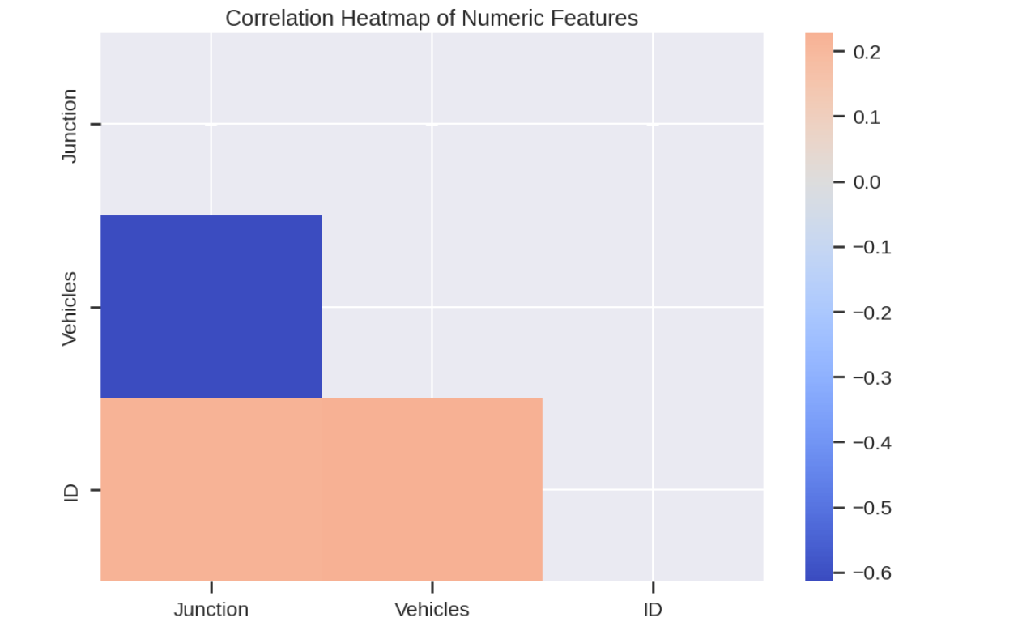
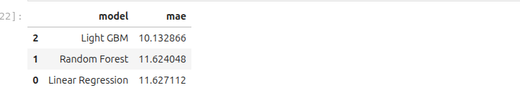
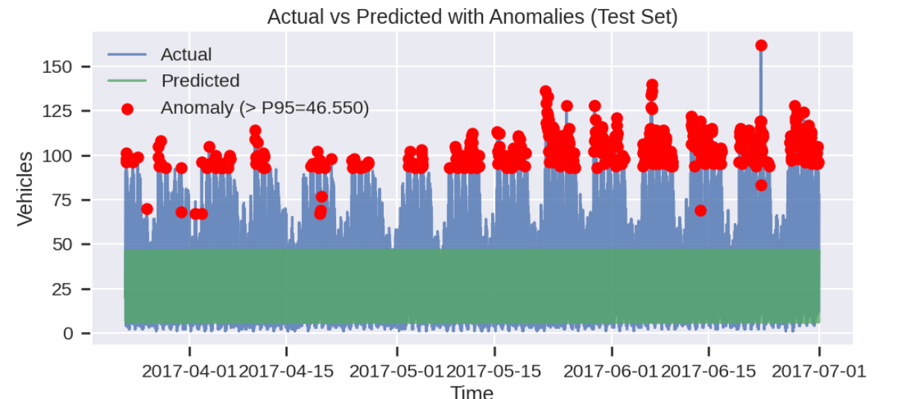

Lab 4
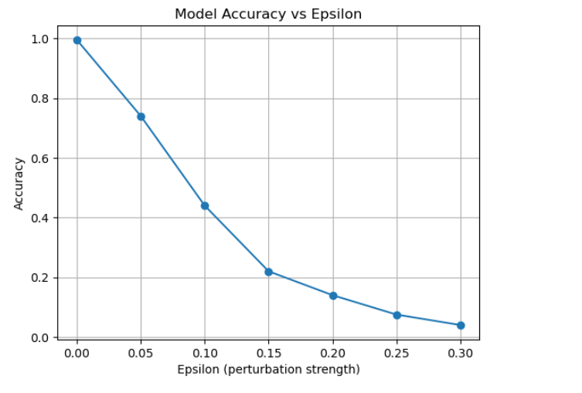


Lab 5
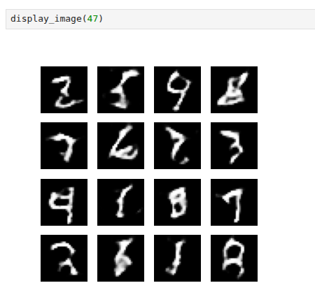
Lab 6
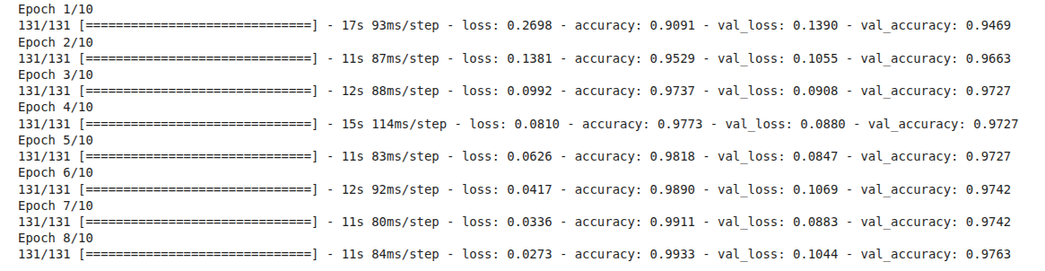
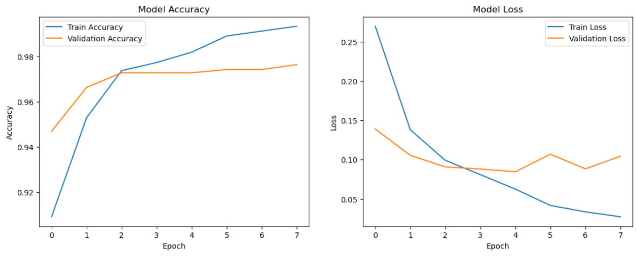
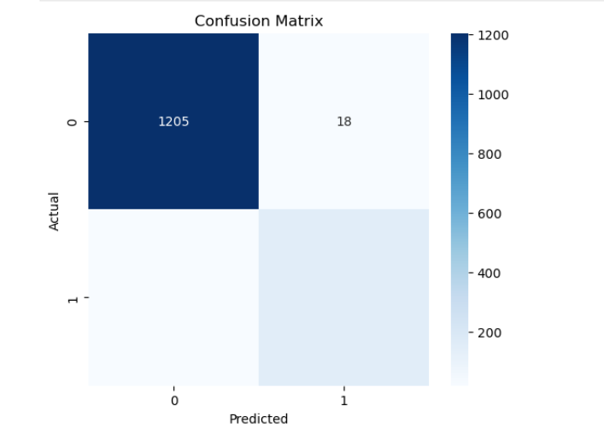
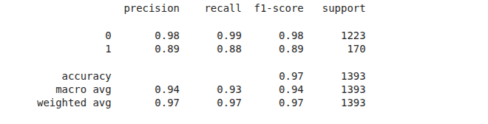

Lab 7

Lab 8
Name: Erick Rotich
p = 23
g = 5
s = 18

Private key = 9

Lab 9
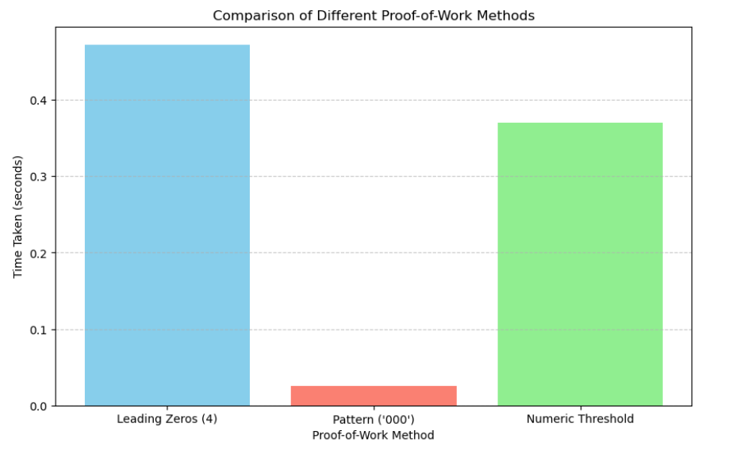
Lab 10

Lab 11

Lab 12

