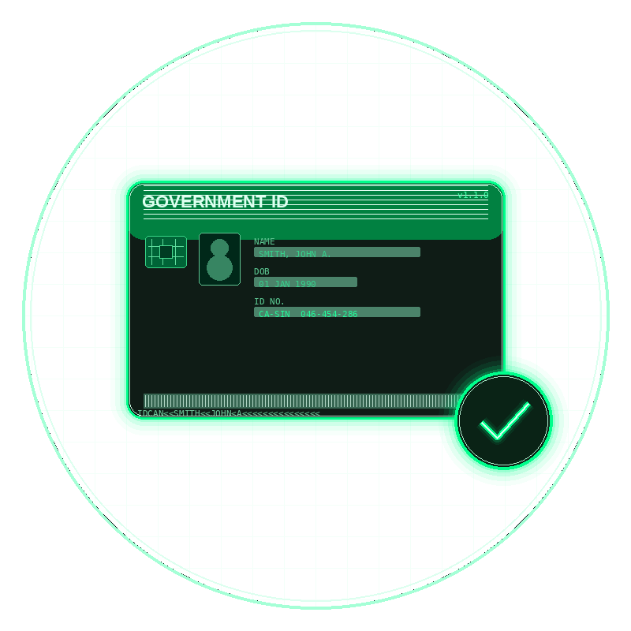
gov-id-validator
Government ID Format Validation Library
Canada & United States · 95 ID Types · Format Validation Reference

Version 1.1.0 | Spring Boot Library | Author: Markisio | Internal Use Only

1. Purpose & Scope
This document describes the gov-id-validator Spring Boot library — a lightweight, dependency-free Java component that checks whether a government-issued ID number matches the correct format for its type and issuing jurisdiction.

Important: This library validates format only. It confirms that an ID number looks structurally correct — it does not verify that the ID was actually issued, that it belongs to a specific person, or that it is currently active. For identity verification, a separate KYC layer is required.

The library is intended for use at the point of data entry in banker-facing and customer-facing applications where format errors (wrong length, wrong character types, transposed digits) should be caught immediately, before the record is saved or sent downstream.

2. How It Works
Each supported ID type has a registered format rule. When an ID number is submitted for validation, the library applies a two-step check:

- Pattern check — the value is tested against a regular expression that encodes the exact structure required (length, character types, ordering of letters and digits).
- Checksum check (select types only) — for the Canadian SIN, a Luhn mod-10 algorithm is also applied. This catches common data-entry errors such as transposed digits that would otherwise pass the pattern check.

The library normalises input automatically: leading and trailing spaces are trimmed, and letters are uppercased before matching. This means "ab123456" and "AB123456 " are both treated as "AB123456".

2.1 What the library returns
Every call to the validate() method returns a ValidationResult object containing:

- valid — true or false
- idType — the ID type that was validated (e.g. CA_SIN)
- value — the normalised input that was tested
- formatDescription — a plain-English description of the expected format
- failureReason — if invalid, explains why (e.g. "Fails Luhn checksum" or "Does not match expected format: 2 letters followed by 6 digits")

3. Format Notation Key
The following symbols are used in the format columns throughout this document:

Symbol | Meaning
# | Any single digit (0–9)
A | Any single uppercase letter (A–Z)
L | Letter (shorthand used in plain-English descriptions)
d | Digit (shorthand used in plain-English descriptions)
(n–m) | Length range — between n and m characters
+ | One or more of the preceding character type

4. Canada — Supported ID Types
The library supports 38 Canadian ID types across three categories: federal government IDs, provincial/territorial driver licences, and provincial health cards.

4.1 Federal IDs
Constant | ID Name | Format | Example | Plain-English Rule
CA_SIN | Social Insurance Number (SIN) | ###-###-### | 046-454-286 | 9 digits, first digit must be 1–9. Optional dashes. Also runs a Luhn checksum to catch typos.
CA_PASSPORT | Passport | AA###### | AB123456 | 2 uppercase letters followed by exactly 6 digits.
CA_PR_CARD | Permanent Resident Card | AAAA####### | ABCD1234567 | 4 uppercase letters followed by exactly 7 digits.
CA_CITIZENSHIP_CERT | Citizenship Certificate | AA###### | AB123456 | Same format as a Canadian passport: 2 letters + 6 digits.
CA_MILITARY_ID | Military ID (CAF Service Number) | A######## | A12345678 | 1 uppercase letter followed by exactly 8 digits. Issued by the Canadian Armed Forces on the NDI 20 identity card.
CA_NEXUS | NEXUS Card (PASS ID) | PP####### | 102345678 | 9 digits beginning with a known CBP/CBSA-assigned prefix (10, 13, 14, 15, 16, 50, 70, 80, 95, 98, or 99).
CA_PAL | Possession & Acquisition Licence | ########(.####) | 12345678.0001 | 7–8 core digits, optionally followed by a decimal point and 4-digit issuance sequence. Best-effort format — RCMP does not publish the full specification.

The Canadian SIN is the only ID type in this library that applies a checksum. The Luhn (mod-10) algorithm is standard across financial and government systems and can catch around 90% of single-digit data-entry errors.

4.2 Driver Licences — by Province / Territory
Each Canadian province and territory issues driver licences with a distinct format. All 13 jurisdictions are supported.

Constant | Province / Territory | Format | Example | Plain-English Rule
CA_DL_AB | Alberta | #####-### or #####(5–9) | 123456-789 | 5–9 digits, or 6 digits followed by a dash and 3 more digits.
CA_DL_BC | British Columbia | ####### | 1234567 | Exactly 7 digits, nothing else.
CA_DL_MB | Manitoba | AA-AA-AA-A###AA | HH-HH-HH-H123HH | A structured mix of letter groups separated by optional dashes, ending with 3 digits and 2 letters.
CA_DL_NB | New Brunswick | #####(5–7) | 1234567 | 5 to 7 digits.
CA_DL_NL | Newfoundland & Lab. | A######### | A123456789 | 1 letter followed by exactly 9 digits.
CA_DL_NS | Nova Scotia | AAAAA + encoded date | SMITH-010199#### | 5 letters (often derived from surname) followed by a date-encoded segment and 6 digits.
CA_DL_ON | Ontario | A####-#####XXXX | A1234-5678 9012 | 1 letter + 4 digits + 5 digits + 4 digits that encode date of birth.
CA_DL_PE | Prince Edward Island | ##### or ###### | 123456 | 5 or 6 digits.
CA_DL_QC | Quebec | A############ | A123456789012 | 1 letter followed by exactly 12 digits.
CA_DL_SK | Saskatchewan | ######## | 12345678 | Exactly 8 digits.
CA_DL_NT | Northwest Territories | ###### | 123456 | Exactly 6 digits.
CA_DL_NU | Nunavut | ##### or ###### | 12345 | 5 or 6 digits.
CA_DL_YT | Yukon | #(1–6) | 12345 | 1 to 6 digits.

4.3 Provincial Health Cards
Six provincial health card formats are supported. Note that several provinces use the same 9-digit numeric format, but each is registered as a separate ID type to allow jurisdiction-specific handling in the future.

Constant | Province | Format | Example | Plain-English Rule
CA_HEALTH_ON | Ontario (OHIP) | AAAA######AA | ABCD123456XY | 4 letters + 6 digits + 2 letters. Total 12 characters.
CA_HEALTH_BC | British Columbia | ########## | 1234567890 | Exactly 10 digits.
CA_HEALTH_AB | Alberta | ######### | 123456789 | Exactly 9 digits.
CA_HEALTH_QC | Quebec (RAMQ) | AAAA########AA | SMIT12345678AB | 4 letters + 8 digits + 2 letters. Total 14 characters.
CA_HEALTH_SK | Saskatchewan | ######### | 123456789 | Exactly 9 digits.
CA_HEALTH_MB | Manitoba (PHIN) | ######### | 123456789 | Exactly 9 digits (Personal Health Identification Number).

Legal note: Ontario's Personal Health Information Protection Act (PHIPA) and similar provincial laws restrict the collection and use of health card numbers to health care purposes. Consult your legal team before storing health card numbers in any non-clinical application.

5. United States — Supported ID Types
The library supports 57 US ID types: 6 federal IDs and driver licences for all 50 states plus Washington D.C.

5.1 Federal IDs
Constant | ID Name | Format | Example | Plain-English Rule
US_SSN | Social Security Number (SSN) | ###-##-#### | 123-45-6789 | 9 digits with optional dashes. Area code cannot be 000, 666, or 900–999. Group cannot be 00. Serial cannot be 0000.
US_PASSPORT | Passport | ######### | 123456789 | Exactly 9 digits.
US_PASSPORT_CARD | Passport Card | C######## | C12345678 | Letter C followed by exactly 8 alphanumeric characters.
US_ITIN | Individual Taxpayer ID (ITIN) | 9##-##-#### | 912-70-1234 | Like an SSN but the area code always starts with 9, and the group is in the range 70–99.
US_EAD | Employment Authorization (EAD) | AAA########## | ABC1234567890 | 3 letters followed by exactly 10 digits.
US_GREEN_CARD | Permanent Resident Card | AAA######### | ABC123456789 | 3 letters followed by exactly 9 digits.
US_MILITARY_ID | Military ID (CAC / DoD EDIPI) | ########## | 1234567890 | Exactly 10 digits. The DoD Electronic Data Interchange Personal Identifier (EDIPI) printed on the Common Access Card (CAC). Issued to military personnel, DoD civilians, and eligible contractors.

The US SSN validator rejects known-invalid area codes (000, 666, and the 900–999 range), group 00, and serial 0000 — all of which the Social Security Administration has confirmed are never assigned.

5.2 Driver Licences — by State
All 50 US states plus Washington D.C. are supported. Format notation: L = letter, d = digit.

State | Constant | Format | Example
Alabama | US_DL_AL | 1–7 digits | 1234567
Alaska | US_DL_AK | 1–7 digits | 1234567
Arizona | US_DL_AZ | 1L+8d or 9 digits | A12345678
Arkansas | US_DL_AR | 4–9 digits | 123456789
California | US_DL_CA | 1L+7d | A1234567
Colorado | US_DL_CO | 9d or 1–2L+3–6d | 123456789
Connecticut | US_DL_CT | 9 digits | 123456789
Delaware | US_DL_DE | 1–7 digits | 1234567
Florida | US_DL_FL | 1L+12d | A123456789012
Georgia | US_DL_GA | 7–9 digits | 12345678
Hawaii | US_DL_HI | H+8d or 9d | H12345678
Idaho | US_DL_ID | 2L+6d+1L | AB123456C
Illinois | US_DL_IL | 1L+11–12d | A12345678901
Indiana | US_DL_IN | 10d or 1L+9d | 1234567890
Iowa | US_DL_IA | 9d or 9d+2L | 123456789
Kansas | US_DL_KS | 1L+8d or 9d | A12345678
Kentucky | US_DL_KY | 1L+8–9d | A12345678
Louisiana | US_DL_LA | 1–9 digits | 123456789
Maine | US_DL_ME | 7d or 7d+1L | 1234567
Maryland | US_DL_MD | 1L+12d | A123456789012
Massachusetts | US_DL_MA | S+8d or 9d | S12345678
Michigan | US_DL_MI | 1L+12d | A123456789012
Minnesota | US_DL_MN | 1L+12d | A123456789012
Mississippi | US_DL_MS | 9 digits | 123456789
Missouri | US_DL_MO | 1L+5–9d or 9d | A12345678
Montana | US_DL_MT | 13d or 1L+8d | 1234567890123
Nebraska | US_DL_NE | 1L+6–8d | A1234567
Nevada | US_DL_NV | 9–10d, 12d, or X+8d | 1234567890
New Hampshire | US_DL_NH | 2d+3L+5d | 12ABC12345
New Jersey | US_DL_NJ | 1L+14d | A12345678901234
New Mexico | US_DL_NM | 8–9 digits | 12345678
New York | US_DL_NY | 1L+7–18d or 8–9d | A1234567
North Carolina | US_DL_NC | 1–12 digits | 12345678
North Dakota | US_DL_ND | 3L+6d or 9d | ABC123456
Ohio | US_DL_OH | 2L+6d or 1L+8d | AB123456
Oklahoma | US_DL_OK | 1L+9d or 9d | A123456789
Oregon | US_DL_OR | 1–9 digits | 1234567
Pennsylvania | US_DL_PA | 8 digits | 12345678
Rhode Island | US_DL_RI | 7d or V+6d | 1234567
South Carolina | US_DL_SC | 5–11 digits | 12345678
South Dakota | US_DL_SD | 6–10 digits | 12345678
Tennessee | US_DL_TN | 7–9 digits | 12345678
Texas | US_DL_TX | 7–8 digits | 12345678
Utah | US_DL_UT | 4–10 digits | 12345678
Vermont | US_DL_VT | 8d or 7d+1L | 12345678
Virginia | US_DL_VA | 1L+8–11d or 9d | A123456789
Washington | US_DL_WA | 1–7L+5 alphanum | SMITHJ123AB
West Virginia | US_DL_WV | 1–2L+5–6d | A12345
Wisconsin | US_DL_WI | 1L+13d | A1234567890123
Wyoming | US_DL_WY | 9–10 digits | 1234567890
Washington D.C. | US_DL_DC | 7 digits | 1234567

6. Coverage Summary

Category | Canada | USA | Total
Federal IDs | 7 | 7 | 14
Driver Licences | 13 | 51 | 64
Health / Benefits Cards | 6 | — | 6
Total | 26 | 58 | 84

7. What Is Out of Scope
The following are explicitly not covered by this library in its current version:

- Existence verification — confirming that an ID number was actually issued by a government authority.
- Identity matching — confirming that an ID number belongs to a specific named individual.
- Expiry / status checking — confirming that an ID is still valid and not expired or revoked.
- Quebec or Ontario non-driver provincial ID cards — distinct from driver licences.
- US Real ID compliance — the library validates format only, not REAL ID act status.
- Tribal IDs, military IDs, and other non-standard government credentials.

Existence and status verification requires integration with government data sources or a third-party KYC provider (such as Plaid, Jumio, or Veriff) and is outside the scope of format validation.

