SOLUTION DESIGN DOCUMENT
gov-id-validator
Government ID Format Validation Library

Version 1.1.0

Technology: Java 17 · Spring Boot 3.2 · Zero external dependencies
Coverage: Canada (41 ID types) · United States (58 ID types)
Classification: Internal · Author: Markisio · Audience: Senior Developers / Architects

1. Document Purpose & Scope
This Solution Design Document (SDD) describes the architecture, design decisions, API contract, integration patterns, and operational characteristics of the gov-id-validator Spring Boot library (v1.1.0).

The intended audience is developers and senior technical reviewers who will integrate, extend, or maintain this library. For a business-facing summary of supported ID types in plain English, refer to the companion document: gov-id-validator-reference.docx.

1.1 Problem Statement
Customer-facing and banker-facing applications need to validate that a government-issued ID number is structurally correct at the point of data entry — before records are persisted or forwarded to downstream systems. Without format validation, bad data (wrong length, wrong character types, transposed digits) propagates into core banking records and causes failures in downstream KYC, AML, and onboarding pipelines.

1.2 Solution Summary
A lightweight, stateless, dependency-free Spring Boot library that exposes a single service bean. Given an ID type and a string value, it returns a structured result indicating whether the value matches the expected format — with a human-readable description of the expected format and a specific failure reason if invalid.

Format validation ≠ Identity verification. This library confirms structural correctness only. It does not call any external API, does not query a database, and does not confirm that an ID has been issued to a real person. KYC/identity verification is a separate concern.

1.3 Out of Scope
- ID existence verification (government database lookups)
- Identity matching (does this ID belong to this person?)
- Expiry and revocation status
- OCR / image-based ID scanning
- Encryption or masking of ID values
- Audit logging — the library performs no I/O

2. Architecture Overview
The library is designed as a standard Spring Boot auto-configured service bean. It contains no web layer, no persistence layer, and no external dependencies beyond the Spring Boot starter. It compiles to a standard .jar that any Spring Boot application can declare as a Maven or Gradle dependency.

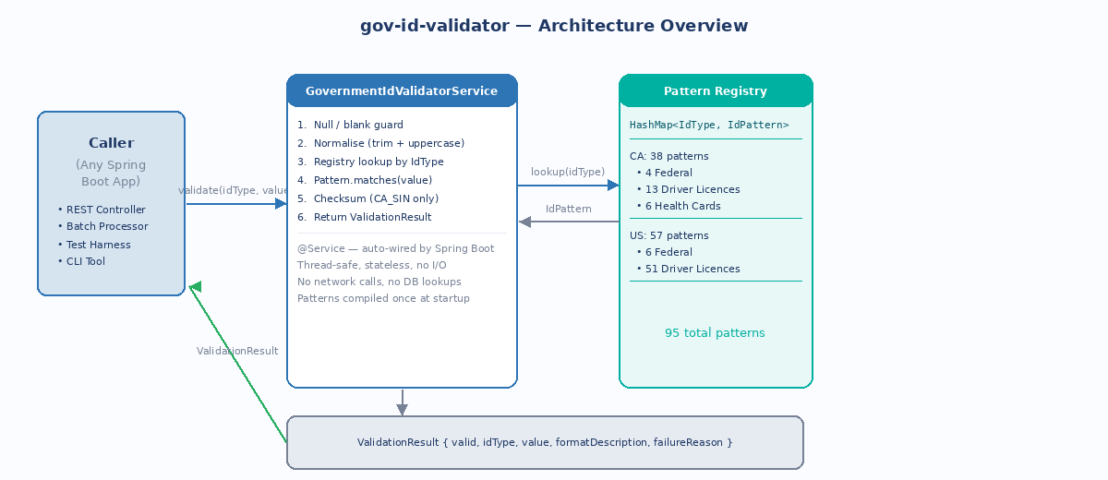
Figure 1 — Architecture overview: caller, service, pattern registry

2.1 Key Design Decisions
Decision | Choice | Rationale
Pattern storage | HashMap<IdType, IdPattern> populated once at construction | O(1) lookup per validation; patterns compiled once, reused across all calls
Thread safety | Stateless — all state is immutable after construction | Safe for shared singleton use; no synchronisation needed
Normalisation | Trim whitespace + uppercase before matching | Tolerates common entry variations without burdening the caller
Checksum layer | Applied only where publicly specified (CA SIN = Luhn mod-10) | Keeps the library honest without over-engineering
Spring integration | AutoConfiguration via META-INF imports file | Zero-config for Spring Boot consumers; @ConditionalOnMissingBean allows override
No external I/O | Pure in-memory regex + arithmetic | No network latency, no dependency on third-party availability, no data exfiltration risk

3. Component Design

3.1 Class Diagram
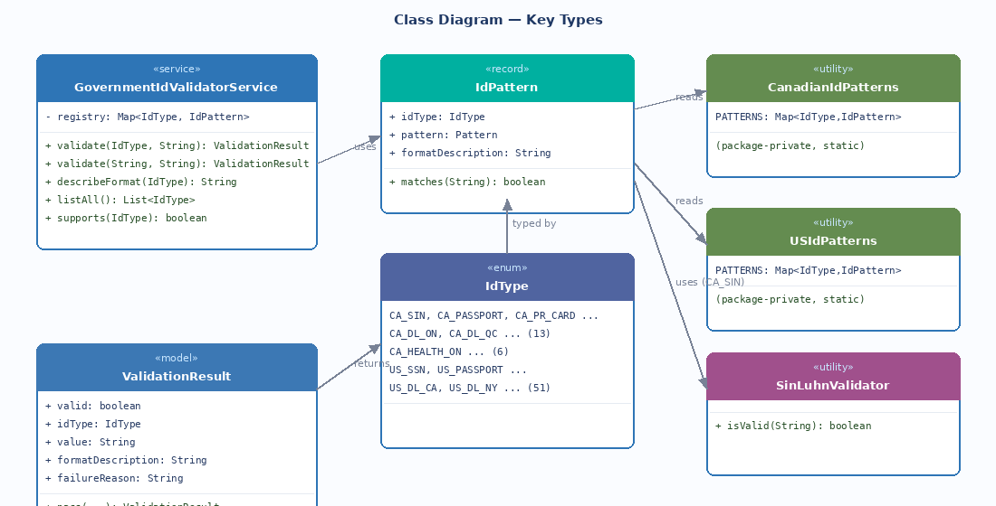
Figure 2 — Key types and their relationships

3.2 Component Descriptions

GovernmentIdValidatorService
The single public-facing component. Annotated with @Service and registered by auto-configuration. Owns the unified pattern registry built by merging CanadianIdPatterns.PATTERNS and USIdPatterns.PATTERNS at construction time.

Java
@Service
public class GovernmentIdValidatorService {

// Immutable after construction — thread-safe
private final Map<IdType, IdPattern> registry;

public ValidationResult validate(IdType idType, String rawValue) { ... }
public ValidationResult validate(String idTypeName, String rawValue) { ... }
public String describeFormat(IdType idType) { ... }
public List<IdType> listAll() { ... }
public boolean supports(IdType idType) { ... }
}

IdType (enum)
Enumerates all 99 supported ID types (v1.1.0). Naming convention: {COUNTRY}_{CATEGORY}_{JURISDICTION}. Examples: CA_SIN, CA_MILITARY_ID, CA_NEXUS, CA_PAL, US_MILITARY_ID, CA_DL_ON, US_SSN, US_DL_CA.

IdPattern (record)
Immutable value object binding an IdType to its compiled regex Pattern and a human-readable format description string. The matches() method delegates to Pattern.matcher().matches().

ValidationResult (model)
Returned by every validate() call. Contains five fields:

Field | Type | Always present? | Description
valid | boolean | Yes | true if format is valid
idType | IdType | Yes | The enum constant that was validated
value | String | Yes | Normalised input value that was tested
formatDescription | String | Yes | Human-readable expected format
failureReason | String | Only if invalid | Specific reason the value failed

CanadianIdPatterns / USIdPatterns
Package-private utility classes. Each exposes a single static Map<IdType, IdPattern> field populated via Map.ofEntries(). All regex patterns are compiled with Pattern.CASE_INSENSITIVE. Neither class is intended to be used directly — access is exclusively through GovernmentIdValidatorService.

SinLuhnValidator
Package-private utility class with a single static method isValid(String digitsOnly). Implements the Luhn mod-10 algorithm. Called only when the idType is CA_SIN and the regex check has already passed.

Java
// Luhn algorithm: double every 2nd digit, subtract 9 if > 9, sum all, check mod 10 == 0
static boolean isValid(String digitsOnly) {
int sum = 0;
for (int i = 0; i < 9; i++) {
int digit = Character.getNumericValue(digitsOnly.charAt(i));
if (i % 2 == 1) { digit *= 2; if (digit > 9) digit -= 9; }
sum += digit;
}
return sum % 10 == 0;
}

4. Validation Flow
The following diagram shows the complete decision logic executed on every call to validate().

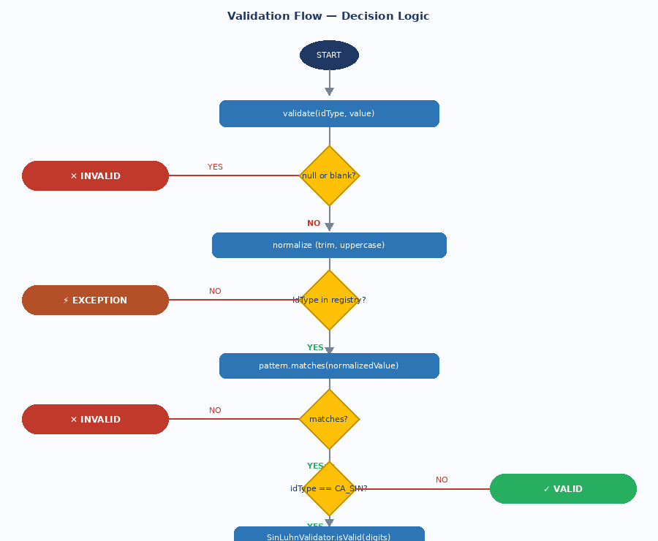
Figure 3 — Validation decision flow

4.1 Step-by-Step Logic
Step | Check | On Fail | On Pass
1 | idType is not null | Throw InvalidIdTypeException | Continue
2 | idType has a registered pattern | Throw InvalidIdTypeException | Retrieve IdPattern
3 | rawValue is not null / not blank | Return ValidationResult(valid=false) | Continue
4 | Normalise: trim + uppercase | — | Continue with normalized value
5 | pattern.matches(normalizedValue) | Return ValidationResult(valid=false, failureReason=...) | Continue
6 | If CA_SIN: Luhn checksum passes | Return ValidationResult(valid=false, failureReason="Fails Luhn checksum") | Return ValidationResult(valid=true)
7 | All other ID types | — | Return ValidationResult(valid=true)

4.2 Sequence Diagram — Happy & Sad Paths
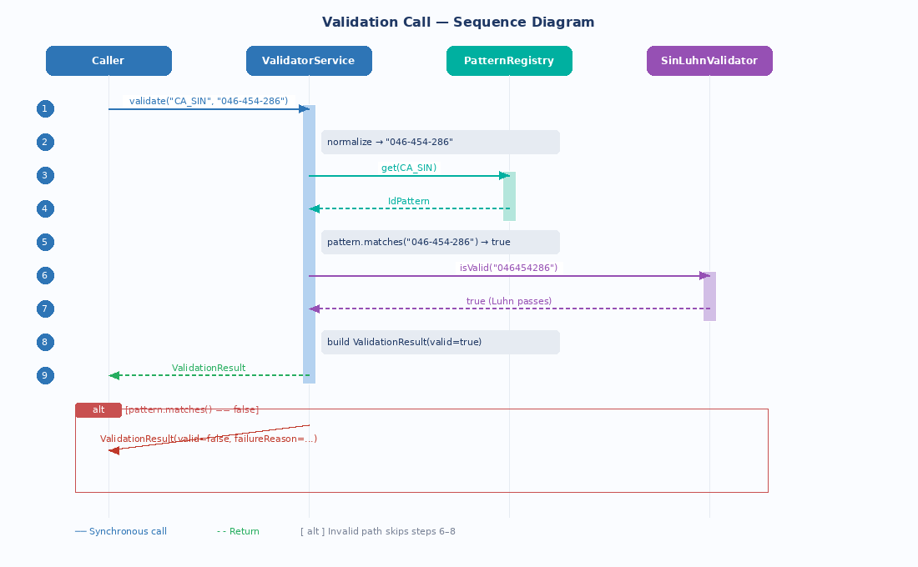
Figure 4 — Sequence diagram for a valid CA_SIN and an invalid US_SSN

5. API Contract

5.1 Java API (direct library usage)
Consumers inject GovernmentIdValidatorService and call validate() directly. This is the primary intended integration mode.

Java
@Autowired
private GovernmentIdValidatorService idValidator;

// Validate by enum constant
ValidationResult r = idValidator.validate(IdType.CA_SIN, "046-454-286");

if (r.isValid()) {
// proceed — format is correct
} else {
log.warn("Invalid ID: {} — {}", r.getValue(), r.getFailureReason());
}

// Validate by string name (e.g. from a form field or REST request param)
ValidationResult r2 = idValidator.validate("US_DL_FL", "A123456789012");

// Get expected format without validating (e.g. for UI hint)
String hint = idValidator.describeFormat(IdType.CA_PASSPORT);
// → "2 letters followed by 6 digits (AB123456)"

5.2 BFF REST API (when exposed via the test app)
The accompanying id-validator-bff Spring Boot application wraps the library as a REST API for testing and UI integration. The diagrams below show exact request and response payloads.

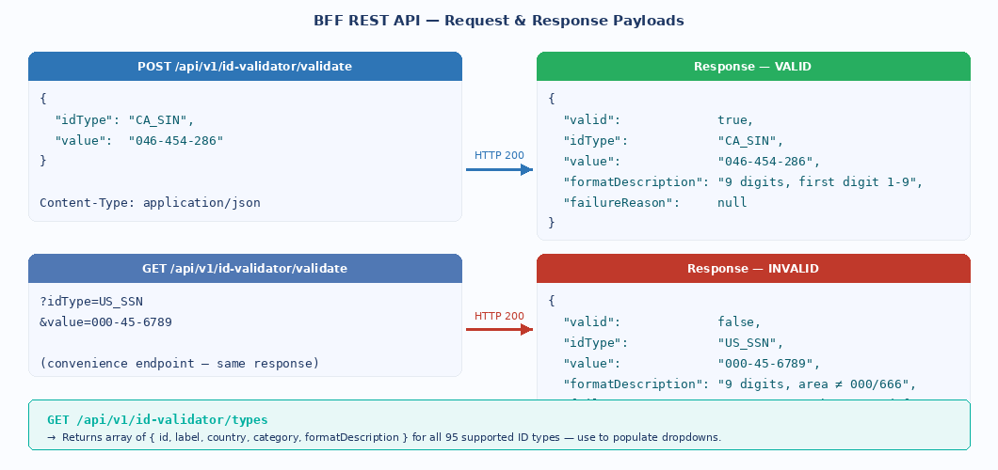
Figure 5 — BFF REST request and response payloads

5.3 REST Endpoints Reference
Method | Path | Description | Response codes
GET | /api/v1/id-validator/health | Health check — confirms the service is up | HTTP 200
GET | /api/v1/id-validator/types | Returns all 95 ID type descriptors (id, label, country, category, formatDescription). Use to populate UI dropdowns. | HTTP 200
POST | /api/v1/id-validator/validate | Validate a single ID. Body: { idType, value }. Returns ValidationResponse. | HTTP 200 (always — check valid field)
GET | /api/v1/id-validator/validate?idType=X&value=Y | Convenience GET for quick testing or curl usage. | HTTP 200

5.4 Error Handling
The service never returns HTTP 4xx/5xx for a failed validation — an invalid format is a valid response (valid=false). HTTP 400 is returned only when the idType string does not correspond to any known IdType enum constant.

JSON — Error response
// HTTP 400 — unknown idType
{
"valid": false,
"idType": "XX_BOGUS",
"value": "123",
"formatDescription": null,
"failureReason": "Unknown IdType: XX_BOGUS"
}

InvalidIdTypeException is thrown by the service layer when an unrecognised IdType is passed. In the BFF this is caught and converted to an HTTP 400 response. In direct library use, callers should handle this exception.

6. Integration Guide

6.1 Adding the Library Dependency
After building the library locally (mvn clean install), add it to any Spring Boot project:

pom.xml (Maven)
<dependency>
<groupId>com.validation</groupId>
<artifactId>gov-id-validator</artifactId>
<version>1.0.0</version>
</dependency>

build.gradle (Gradle)
implementation "com.validation:gov-id-validator:1.0.0"

6.2 Auto-Configuration
The library uses Spring Boot auto-configuration. The GovernmentIdValidatorService bean is registered automatically when the library is on the classpath — no @ComponentScan or @Import annotation is needed in the consuming application.

Auto-config registration
# META-INF/spring/org.springframework.boot.autoconfigure.AutoConfiguration.imports
com.validation.govid.config.GovIdValidatorAutoConfiguration

The auto-configuration uses @ConditionalOnMissingBean, which means applications can override the default service bean by declaring their own GovernmentIdValidatorService bean if customisation is needed.

6.3 Recommended Integration Pattern — REST Controller
Java — Example controller
@RestController
@RequestMapping("/api/customer")
public class CustomerOnboardingController {

@Autowired
private GovernmentIdValidatorService idValidator;

@PostMapping("/validate-id")
public ResponseEntity<IdValidationResponse> validateId(
@RequestParam String idType,
@RequestParam String idValue) {

ValidationResult result = idValidator.validate(idType, idValue);

if (!result.isValid()) {
return ResponseEntity.badRequest()
.body(new IdValidationResponse(false, result.getFailureReason()));
}
return ResponseEntity.ok(new IdValidationResponse(true, null));
}
}

6.4 Building the Library
Shell
# Clone / unzip the library project
cd gov-id-validator

# Build and install to local Maven repository
mvn clean install

# Run tests only
mvn test

# Package as jar without installing
mvn clean package
# Output: target/gov-id-validator-1.0.0.jar

7. Performance & Operational Characteristics
Characteristic | Value / Detail
Startup time impact | Negligible — one HashMap population (~99 entries) at bean construction
Per-call latency | Sub-microsecond — single regex match + optional 9-iteration loop
Memory footprint | ~210 KB — compiled Pattern objects + string constants (99 patterns)
Thread safety | Fully thread-safe — stateless after construction, no shared mutable state
Network I/O | None — zero external calls
Database I/O | None
Dependencies | Spring Boot starter only (spring-boot-autoconfigure, spring-boot-starter)
JDK requirement | Java 17+ (uses records, Map.ofEntries, pattern matching)
Spring Boot version | 3.2.x (Spring Framework 6.x)
Test coverage | 40+ unit tests covering valid, invalid, edge cases, and Luhn checksum

The library is intentionally stateless and produces no side effects. It is safe to use as a singleton shared across threads, and imposes no performance overhead on the consuming application beyond a single method call per validation.

8. Security Considerations

8.1 Data Handling
The library accepts ID values as plain strings and performs in-memory processing only. No ID value is persisted, logged, transmitted, or stored by the library itself. Responsibility for secure handling (masking in logs, encryption at rest, access control) belongs to the consuming application.

8.2 Regex Safety
All regex patterns are pre-compiled at startup and anchored (^ ... $) to prevent partial matches. None of the patterns use unbounded quantifiers (.*) or nested repetition, eliminating the risk of ReDoS (Regular Expression Denial of Service) attacks. The longest pattern is Ontario's driver licence at approximately 20 characters, with a deterministic matching time.

8.3 Input Sanitisation
The library normalises input (trim + uppercase) but does not sanitise for injection, XSS, or other attack vectors — it is not a web-layer component. Input sanitisation for web-facing surfaces should be handled by the consuming application's input validation layer before the ID validator is called.

Health card numbers: Ontario PHIPA and similar provincial privacy laws restrict collection of health card numbers to health care purposes. The CA_HEALTH_* ID types are provided for format validation completeness but should not be used to collect or store health card numbers in non-clinical applications without legal review.

9. Extending the Library

9.1 Adding a New ID Type
Three files need to be updated to add a new ID type:

- Add the new constant to IdType.java
- Add the corresponding IdPattern entry to CanadianIdPatterns.java or USIdPatterns.java
- Add at least one valid and one invalid test case to GovernmentIdValidatorServiceTest.java

Java — Adding a new ID type
// Step 1 — IdType.java
CA_HEALTH_NS, // Nova Scotia Health Card

// Step 2 — CanadianIdPatterns.java
e(IdType.CA_HEALTH_NS,
"^\\d{10}$",
"Exactly 10 digits"),

// Step 3 — GovernmentIdValidatorServiceTest.java
@Test void ns_health_valid() { assertValid(IdType.CA_HEALTH_NS, "1234567890"); }
@Test void ns_health_invalid() { assertInvalid(IdType.CA_HEALTH_NS, "12345"); }

9.2 Overriding the Service Bean
If a consuming application needs custom behaviour (e.g. additional business rules on top of format validation), it can declare its own bean:

Java — Bean override
@Configuration
public class IdValidatorConfig {

@Bean // @ConditionalOnMissingBean in auto-config means this takes precedence
public GovernmentIdValidatorService governmentIdValidatorService() {
return new CustomGovernmentIdValidatorService();
}
}

10. New ID Types — v1.1.0 Additions
Version 1.1.0 adds four new government ID types: three Canadian and one American. The table below summarises each addition including the format rationale and any caveats.

Constant | ID Name | Issuing Authority | Format | Caveat
CA_MILITARY_ID | CAF Service Number | Dept. of National Defence | 1 letter + 8 digits (A########) | None — format is publicly documented on the NDI 20 card specification
CA_NEXUS | NEXUS Card (PASS ID) | CBSA / CBP (joint) | 9 digits with known prefix (e.g. 10, 13, 50, 95) | Prefix list based on CBP documentation — new prefixes may be issued in future
CA_PAL | Possession & Acquisition Licence | RCMP Canadian Firearms Program | 7–8 digits, optional .NNNN suffix | BEST-EFFORT — RCMP does not publish authoritative format; based on observed card samples
US_MILITARY_ID | DoD CAC / EDIPI | US Dept. of Defense | Exactly 10 digits | None — DoD EDIPI is a well-documented 10-digit identifier

10.1 PAL — Best-Effort Caveat Detail
The Possession and Acquisition Licence (CA_PAL) format is flagged as best-effort because the RCMP Canadian Firearms Program does not publish the authoritative digit count for the core licence number. The pattern (7–8 digits with an optional .NNNN issuance sequence suffix) is derived from observed licence card samples and community documentation. If the RCMP formally publishes a specification, this pattern should be reviewed and tightened.

Recommendation: When validating PAL numbers in a production system, supplement format validation with a secondary check against the RCMP Canadian Firearms Registry where legally permissible.

10.2 NEXUS Prefix Maintenance
The NEXUS / PASS ID pattern encodes a list of known CBP-assigned prefixes (10, 13, 14, 15, 16, 50, 70, 80, 95, 98, 99). If CBP or CBSA introduces new prefix ranges for future card issuance, the regex in CA_NEXUS within CanadianIdPatterns.java must be updated. This is a low-risk, one-line change.

11. Appendix — Package Structure
Package layout
com.validation.govid
├── IdValidatorApplication.java ← Entry point (BFF only, not in library)
├── config/
│ └── GovIdValidatorAutoConfiguration ← Spring Boot auto-config
├── controller/
│ ├── IdValidatorController ← REST endpoints (BFF only)
│ └── Dtos ← Request/response records (BFF only)
├── exception/
│ └── InvalidIdTypeException ← Thrown for unknown IdType
├── model/
│ ├── IdType ← Enum of all 95 ID types
│ ├── IdPattern ← Record: idType + regex + description
│ └── ValidationResult ← Returned by every validate() call
├── service/
│ └── GovernmentIdValidatorService ← Public API — the one class to inject
└── validator/
├── CanadianIdPatterns ← 38 CA patterns (package-private)
├── USIdPatterns ← 57 US patterns (package-private)
└── SinLuhnValidator ← Luhn mod-10 (package-private)

Revision History
Version | Date | Author | Change
1.0.0 | March 2026 | Markisio | Initial release — 95 ID types, CA + US coverage
1.1.0 | March 2026 | Markisio | Added CA_MILITARY_ID, CA_NEXUS, CA_PAL, US_MILITARY_ID — total 99 ID types

