Running head: Final Project

Final Project
Mark E. Harris Jr.
IT/125
Tim Held
University Of Phoenix

List of Currencies used:
    - American USD
    - Mexican Peso
    - French Franc
    - Japanese Yen
    - English Pound (Sterling)

Application-Level Requirements:
    - Display program title
    - Display program description
    - Display program menu
    - Currency conversions
    - Unit tests

Input-Process-Output:
Input | Process | Output
Currency | Convert | Real (The currency result)
Menu Selection | Display | String (The selected menu entry)
Get currency values | Validate | Real (The validated currency values)
Display Results | Output | String (The results of the calculation)

Hierarchy Chart (in roman numeral format):
    - Menu Selection
      - Get currency values
      - Convert Currencies
      - Output results

FlowChart:
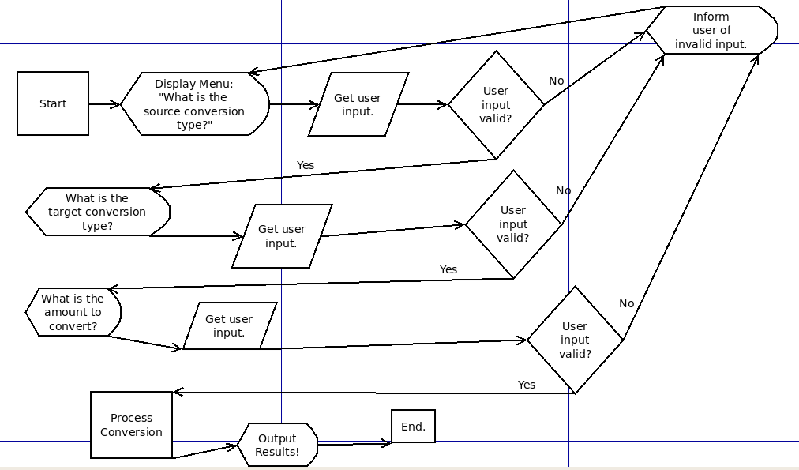
Psudocode:
Please see .\FinalProject\Currency.vb, .\FinalProject\FinalProject.vb and .\FinalProject\FinalProject.Designer.vb.

Test Cases:
Please see .\FinalProject\ConvertTest.vb

