=$= Title PICUP Exercise Template J72335918

=$= Author

=$= Description Description or abstract.

=$= LearningObjectives Learning Objectives

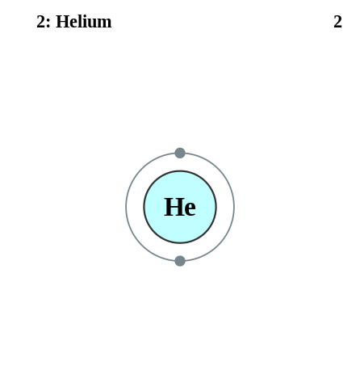

Helium Electron Shells

=$= InstructorGuide Instructor’s Guide Section

=$= Theory Theory Section

=$= Exercises 1. Exercise 1 2. Exercise 2 3. Exercise 3 4. Exercise 4

=$= Pseudocode Pseudocode 1.

Pseudocode 2.

=$= Solutions 1. Solution 1 2. Solution 2 3. Solution 3 4. Solution 4

=$= TextbookConnections Physics Textbooks Sections