**Module 11**

**The system can generate the following reports:**

1. New Clients Report

2. Asset Overview for a Specific Client

3. Transaction Report for a Specific Client

**New Clients Report**

- Objective: To provide a breakdown of new clients added in the current year.

- Data: Client details, number of assets, and total asset value.

- Functionality: The report lists each new client with their ID, name, date added, number of assets, and total asset value.

**Asset Overview**

- Objective: To provide a detailed overview of a specific client's assets.

- Data: Asset type, ID, and value.

- Functionality: The report lists all assets for a given client, including the total and average value of these assets.

**Transaction Report**

- Objective: To detail the transactions of a specific client.

- Data: Transaction date, number, and amount.

- Functionality: The report lists all transactions for a given client, including the total value and count of transactions.

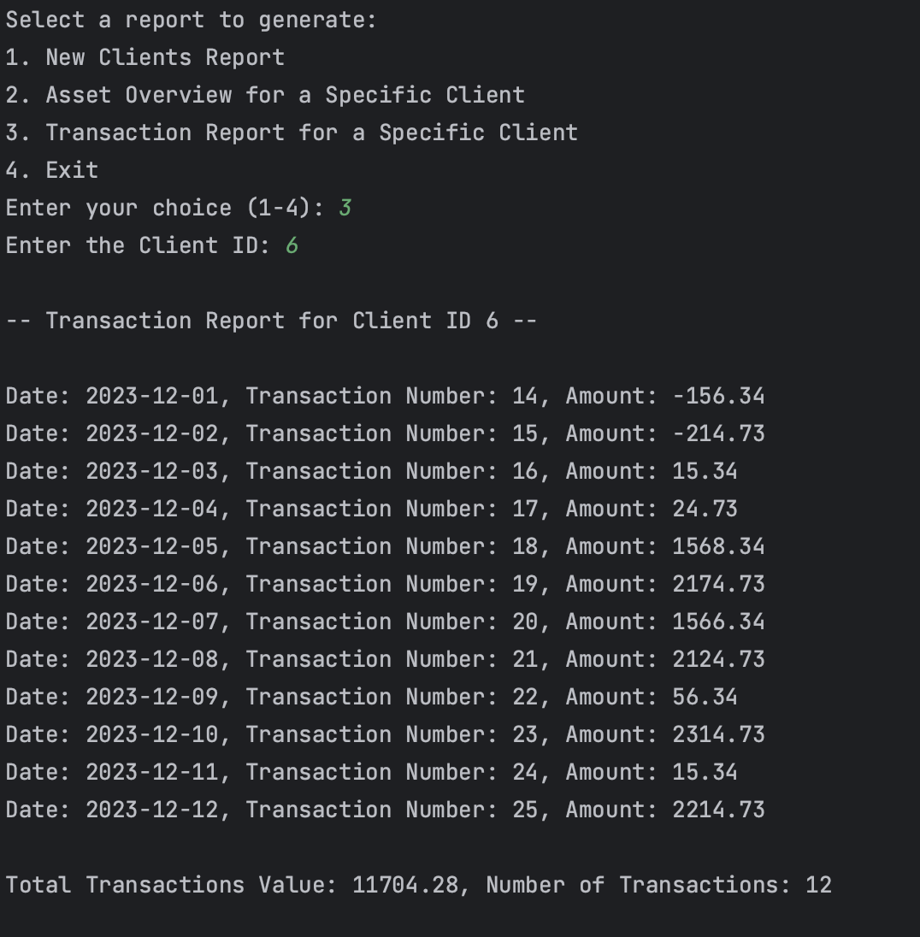

**User Interaction**

Users can interact with the system through a menu-driven interface, allowing them to select the type of report they wish to generate.