CS 2062 - Lab 1

Jan 13th, 2022

Mark O’Connor

3371604

**Deliverable 1:**

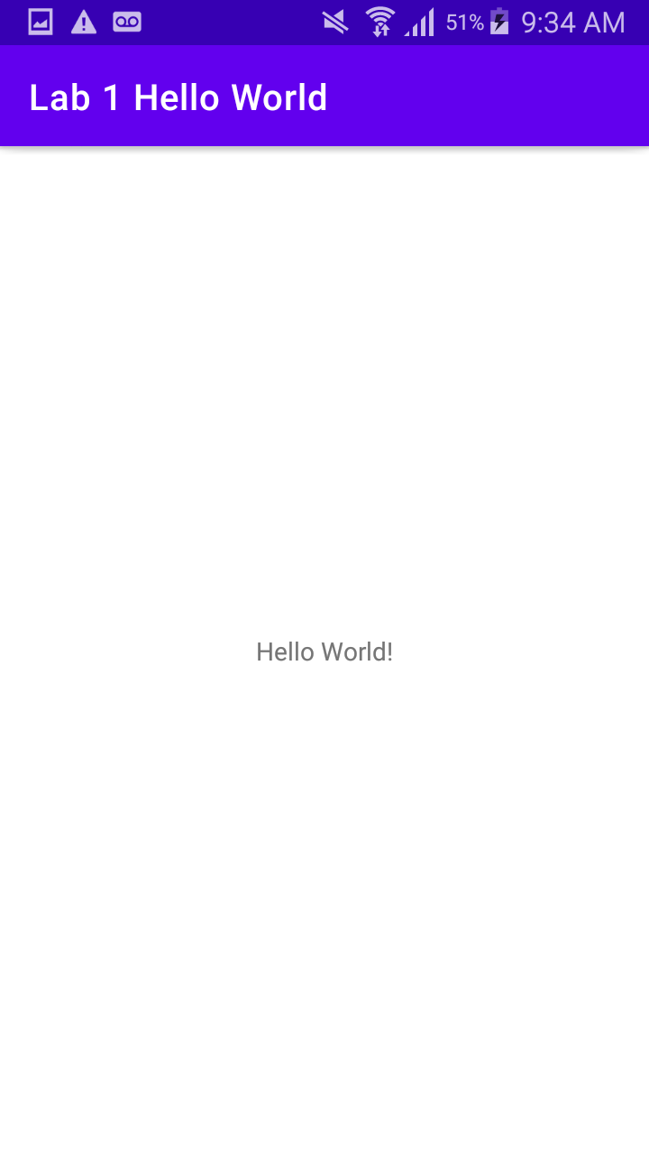

**Deliverable 2:**

android:theme="@style/Theme.Lab1HelloWorld"

**Deliverable 3:**

setContentView is a function that set the app to a particular "view" or screen. For our Hello World Application, this shows the user the screen with "Hello World!" on it as defined in activity_main.xml.

**Deliverable 4:**

The 3 most common types of layouts are:

- Linear Layout

- Relative Layout

- Constraint Layout

Having a unique id is important when using the relative layout, as views reference their layouts based on "sibling" views, which are defined by their id. Without the id you could not reference it.

**Deliverable 5:**

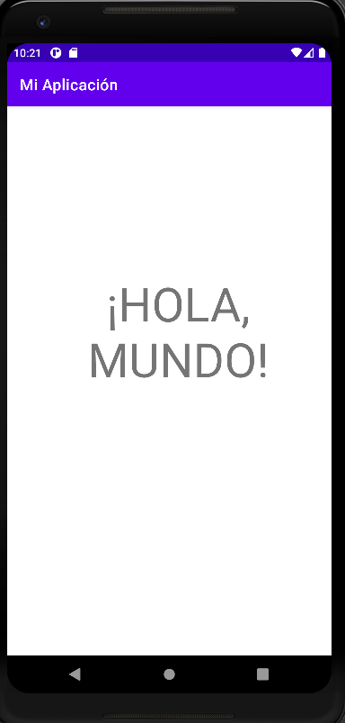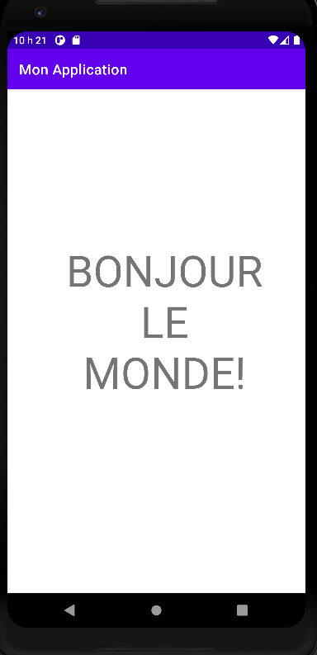

**Deliverable 6:**

