PORTFOLIO CASE STUDY
Bitcoin vs. Bitcoin Proxy Stocks
An AI-Augmented Investment Analytics System
A June 2025 analysis rebuilt with a ChatGPT-centered five-stage decision process
Central question: Should an investor own Bitcoin directly, or can a publicly traded Bitcoin proxy create greater value per diluted common share during a major Bitcoin bull market?

Scope
Six public companies | Three Bitcoin scenarios | 24-month horizon | Source data through August 2026
Prepared as an employer-facing demonstration of decision framing, source normalization, financial modeling, validation, and executive interpretation.

Technical summary
Decision: A proxy opportunity exists. MSTR is the best overall choice when the goal is the highest credible probability of beating Bitcoin; ABTC has the greatest modeled upside; Metaplanet offers the strongest middle ground.

The analysis evaluates six Bitcoin-linked public companies against the benchmark of simply owning BTC. The primary KPI is modeled stock return minus Bitcoin return under identical price scenarios. The model is per-share and capital-structure aware: total BTC holdings alone are not accepted as evidence of shareholder value creation.
Three companies beat Bitcoin in all three modeled scenarios: MSTR, Metaplanet, and American Bitcoin. Twenty One Capital, CleanSpark, and MARA produce positive stock returns in some cases, but fail the actual benchmark because they underperform BTC after dilution, senior claims, capex, mining difficulty, and execution requirements are incorporated.
Rank | Proxy | Role | BTC +100% stock return | Excess vs BTC | Scenarios beating BTC
1 | MSTR | Best overall | 128.4% | +28.4 pts | 3 / 3
2 | Metaplanet | Best risk-adjusted alternative | 124.9% | +24.9 pts | 3 / 3
3 | ABTC | Maximum convexity | 246.5% | +146.5 pts | 3 / 3
4 | XXI | Discount special situation | 93.9% | -6.1 pts | 0 / 3
5 | CLSK | Diversified miner | 32.9% | -67.1 pts | 0 / 3
6 | MARA | High-beta trading vehicle | 56.8% | -43.2 pts | 0 / 3

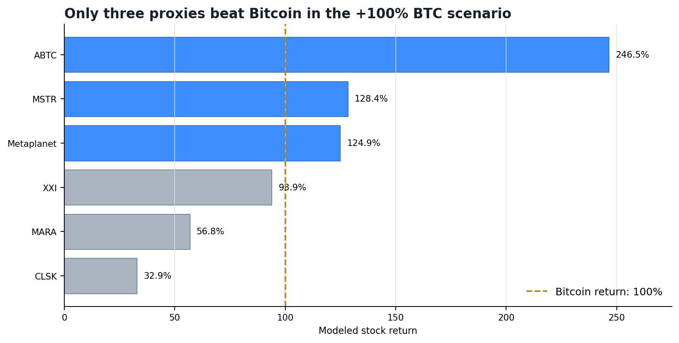
Figure 1. Modeled stock returns when Bitcoin rises 100%.
Source: Stage 4 rebuilt model; valuation anchor BTC $78,511.23; 24-month horizon.

Why this project was rebuilt with AI
The project originated as a more code-heavy analysis completed around June 2025. This version deliberately tests whether the same investment question can be handled through a ChatGPT-centered workflow without abandoning analytical discipline. The AI does not replace the investment decision. It accelerates the structure, research synthesis, normalization, modeling, validation, and communication surrounding that decision.
Earlier project | AI-augmented redevelopment
Code-led exploration | Decision-led five-stage workflow
Company screening and historical analysis | Explicit benchmark, hypotheses, KPI definitions, and source hierarchy
Manual analytical assembly | ChatGPT-assisted source normalization and auditable scenario model
Results emphasized | Results, assumptions, model checks, caveats, and decision implications preserved together
Static project output | Workbook, notebook, detailed report, and presentation as linked portfolio artifacts

Employer takeaway: The project demonstrates how AI can extend an analyst's judgment and execution capacity while keeping assumptions visible, calculations reproducible, and recommendations bounded by evidence.

The five-stage analytical system
Stage | Purpose | Output
1. Start | Identify the real decision alternatives | Own BTC; own a proxy; reject the proxy opportunity
2. Framing | Convert the alternatives into one decision question | Can a proxy create more value per diluted share than BTC itself?
3. Design | Define evidence before collecting it | Hypotheses, KPIs, segments, confounders, and required metrics
4. Execution | Build the source-backed model | Normalized inputs, 18 scenario rows, checks, and reproducible notebook
5. Finish | Interpret the evidence and recommend | Ranking, decision, uncertainty, and monitoring rules

Stage 1 - Start: define the decision before analyzing companies
The business problem is not 'which company owns the most Bitcoin?' It is which exposure best expresses a bullish Bitcoin thesis after accounting for company-specific risks.

Decision A - Own Bitcoin directly
Receive essentially pure BTC exposure without dilution, management, operating, financing, or capital-allocation risk. This is the controlling benchmark, not a passive comparison point.

Decision B - Own a publicly traded Bitcoin proxy
Accept additional risk in exchange for potential outperformance created by operating leverage, fixed senior claims, BTC-per-share accretion, NAV discount closure, or accretive financing.

Decision C - Reject the proxy opportunity
Conclude that no stock offers enough expected excess return to compensate for dilution, debt, operating costs, capex, execution risk, or governance risk.
Stage 1 decision: Should the investor own Bitcoin directly, or is there a public proxy with a sufficiently attractive and defensible economic mechanism to justify choosing its common stock instead?

Stage 2 - Framing: force every proxy to beat the benchmark
The unit of analysis is the economic outcome for one diluted common share. Total BTC, Bitcoin-related revenue, historical beta, or headline treasury growth can all rise while value per share deteriorates.
Primary analytical question: Among publicly traded businesses materially exposed to Bitcoin, are there companies whose economics can outperform BTC during a major bull market after accounting for dilution, liabilities, operating costs, capital requirements, and execution risk?

Every candidate must answer one question: Why should an investor accept this company's additional risks instead of simply buying Bitcoin?

Stage 3 - Design: determine what evidence would change the decision

Hypotheses
- H1: At least one proxy has an economically defensible mechanism capable of creating greater value per diluted share than direct BTC ownership.
- H0: After dilution, senior claims, capex, mining difficulty, financing needs, and execution risk, proxies do not offer a sufficiently reliable advantage.
- Treasury hypothesis: net BTC per diluted share matters more than total BTC growth.
- Mining hypothesis: efficient miners outperform only when price-driven margin expansion exceeds difficulty, energy, capex, and dilution growth.
- NAV hypothesis: discount closure can create convexity, but it is less reliable than demonstrated per-share value creation.
- Capital-allocation hypothesis: high BTC correlation can coexist with poor shareholder economics.

Primary and secondary decision metrics
Metric | Definition | Decision use
Modeled excess return vs BTC | Proxy stock return minus BTC return under the same scenario | Directly tests whether company risk is rewarded
Probability of beating BTC | Judgment band based on dilution, execution, capital structure, operations, and valuation | Separates maximum upside from likelihood of realization
BTC per diluted share | BTC holdings divided by diluted common shares | Tests whether treasury growth reaches each shareholder
Net BTC per diluted share | BTC and liquid assets less senior claims, divided by diluted shares | Captures capital-structure burden

Evidence architecture and source normalization
The evidence layer combines market data, company filings, investor-relations disclosures, Bitcoin network data, and explicit model assumptions. Source-backed inputs remain distinct from forecast assumptions, and missing fields are carried as model risks rather than silently set to zero.
Source family | Evidence captured | Role in the model | Main limitation
Token Terminal | BTC price, market context, fee mix | Benchmark anchor and miner revenue context | Not a source for company capital structures
Mempool / network research | Difficulty, hashrate, revenue mix | Mining competition assumptions | Snapshot rather than full forecast
Company IR and SEC filings | BTC, shares, debt, preferreds, ATM, mining and HPC | Company-specific model inputs | Disclosure timing differs by issuer
Uploaded prior analysis | Earlier targets, risk hypotheses, probability judgments | Context and challenge set | Contained denominator conflicts and subjective ranges
Rebuilt workbook + notebook | Normalized metrics, formulas, checks, scenarios | Controlling analytical source | Forecasts remain assumption-driven

The source-refresh workbook records the evidence class, as-of date, URL, limitation, and workbook use for each input family. Two denominator conflicts identified in the earlier analysis were corrected before Stage 4 was completed.

Stage 4 - Execution: rebuild the model around company-specific economics
The execution layer produces 18 company-scenario observations: six companies multiplied by three BTC outcomes. It deliberately avoids a single generic valuation formula.
Component | Treasury companies | Bitcoin miners
Core value | Terminal BTC assets plus liquid assets | Terminal treasury value plus mining enterprise value
Claims | Debt, preferreds, convertibles, and fixed charges | Debt, leases, equipment obligations, and financing
Dilution | Equity issuance and price-dependent conversion | ATM utilization and stock compensation
Operating value | Normally separated from BTC reserve value | Production, difficulty, cash cost, capex, and EBITDA
Optionality | NAV discount or premium behavior | HPC value kept separate and probability-weighted
Per-share output | Common equity value divided by ending diluted shares | Treasury + mining + HPC less net claims, divided by ending shares

Scenario assumptions
Scenario | Terminal BTC | BTC return | Difficulty increase | Horizon
BTC +50% | $117,766.85 | +50% | +25% | 24 months
BTC +100% | $157,022.46 | +100% | +45% | 24 months
BTC +200% | $235,533.69 | +200% | +80% | 24 months

Conservative design choice: Miner profitability does not scale one-for-one with Bitcoin. Rising price attracts hashrate and capital, so difficulty, cash cost, capex, and dilution are increased alongside BTC.

Model validation and execution gate
The workbook contains a visible Checks sheet and a separate calculation notebook. All twelve execution assertions pass: company count, scenario count, model-row count, populated targets, positive common equity, positive ending shares, representative return ties, sats/share ties, equity bridges, notebook calculations, and the Stage 4 completion gate.
Validation item | Result
Model observations | 18 of 18 rebuilt
Missing target prices | 0
Formula errors | 0 detected
Independent notebook checks | 6 of 6 passed
Execution status | STAGE 4 COMPLETE

Stage 4 results: only half the proxy universe beats Bitcoin
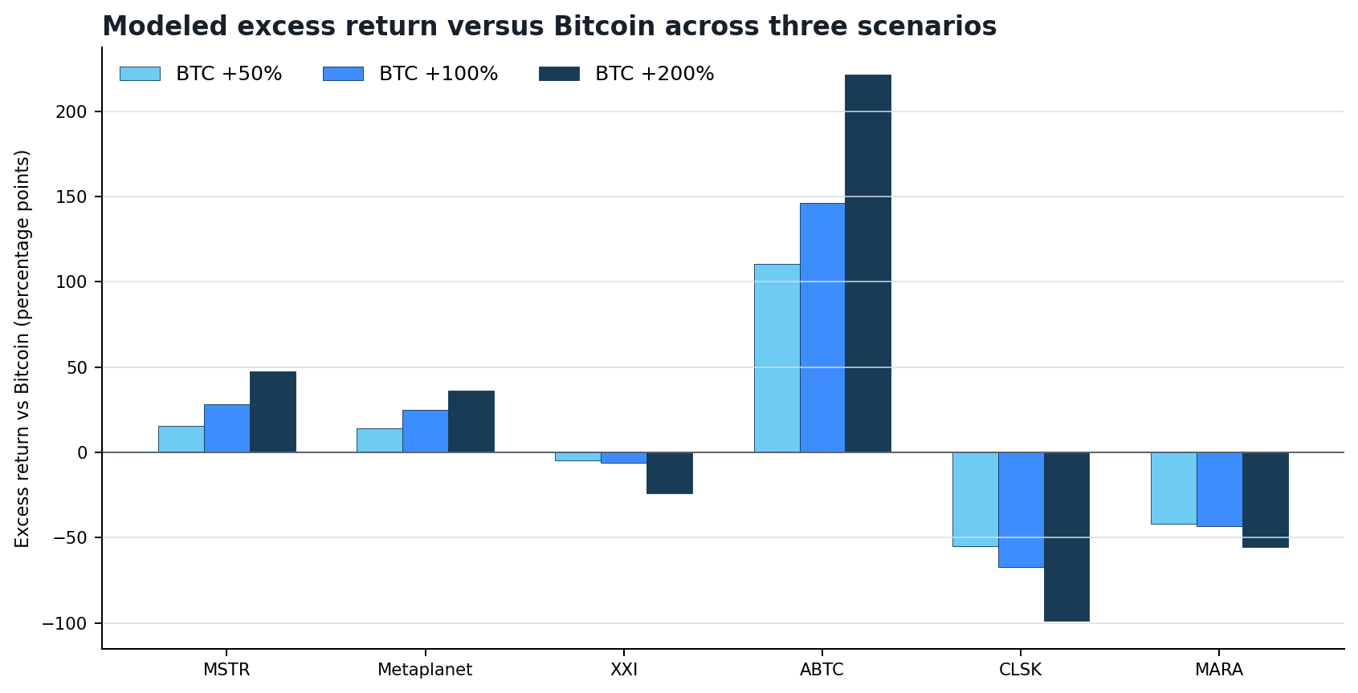
Figure 2. Modeled stock return minus Bitcoin return across all three BTC scenarios.
Source: Stage 4 rebuilt scenario model. Positive values indicate that accepting company risk is rewarded in the modeled case.
Company | Target +50% | Excess +50% | Target +100% | Excess +100% | Target +200% | Excess +200%
MSTR | $209.72 | +15.4 pts | $289.65 | +28.4 pts | $440.69 | +47.5 pts
Metaplanet* | $3.40 | +14.2 pts | $4.66 | +24.9 pts | $6.97 | +36.4 pts
XXI | $9.47 | -4.5 pts | $12.63 | -6.1 pts | $17.96 | -24.1 pts
ABTC | $24.09 | +110.7 pts | $32.02 | +146.5 pts | $48.20 | +221.6 pts
CLSK | $12.09 | -54.9 pts | $16.89 | -67.1 pts | $25.54 | -99.0 pts
MARA | $12.81 | -41.7 pts | $18.55 | -43.2 pts | $28.90 | -55.7 pts

*Metaplanet targets are shown in USD equivalent using the model's same-date FX conversion. Local-market presentation should use the corresponding JPY values after refreshing FX.

Per-share exposure explains why headline BTC growth is insufficient
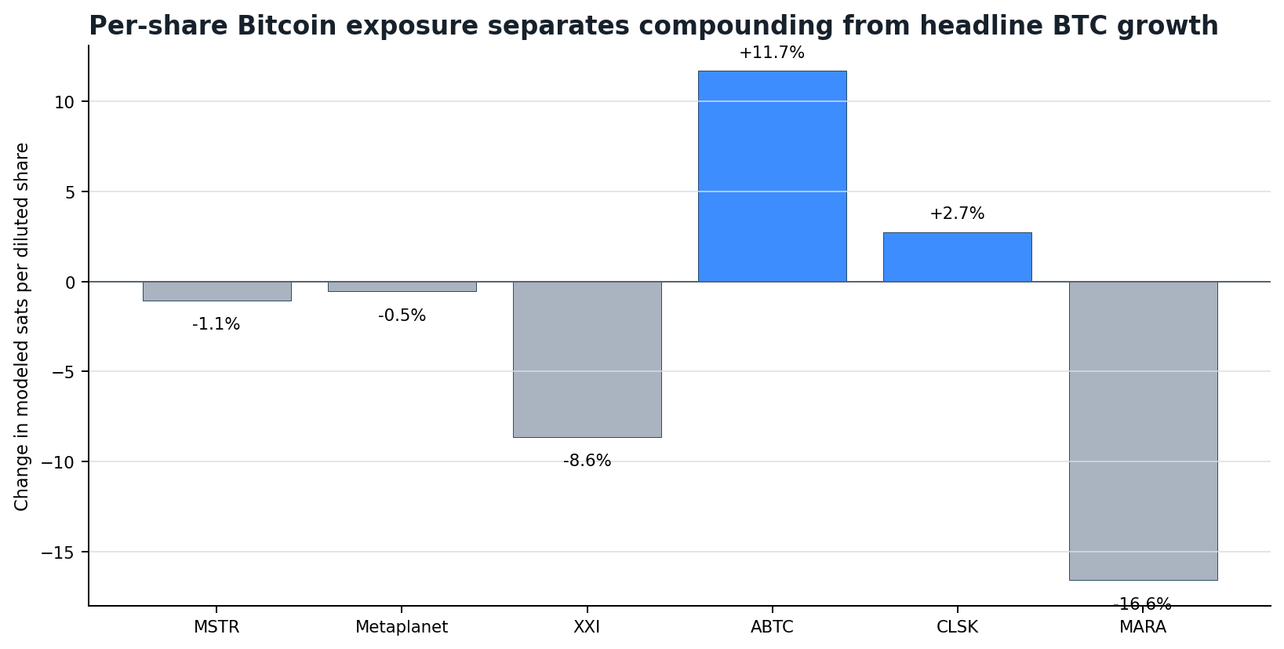
Figure 3. Change in modeled sats per diluted share in the BTC +100% scenario.
Source: Stage 4 rebuilt model and normalized starting denominators.
ABTC is the only candidate combining large modeled stock outperformance with substantial growth in BTC per diluted share. MSTR and Metaplanet still outperform because fixed-claim leverage and financing mechanics offset modest dilution. CLSK produces slight sats/share growth but fails to translate it into superior equity returns after capital intensity. MARA's falling BTC-per-share profile is the weakest transmission mechanism in the group.

Company interpretation

1. MSTR - highest-confidence leveraged Bitcoin
MSTR beats Bitcoin in all three scenarios. Its excess return rises from 15.4 points in the +50% case to 47.5 points in the +200% case. The mechanism is straightforward: a large BTC asset base appreciates while debt, preferred claims, and other fixed obligations do not rise proportionally. Strategy also has the most proven capital-markets execution platform in the group.
What could break the thesis: Continued issuance that reduces BTC per share, expensive preferred financing, cash held rather than deployed, or a lower NAV multiple.

2. Metaplanet - strongest valuation and quality asymmetry
Metaplanet also beats Bitcoin in all three modeled cases, with slightly lower excess return than MSTR. The attraction is the combination of BTC exposure, fixed-claim leverage, and a more favorable starting valuation. It becomes the leading risk-adjusted alternative if BTC-per-share growth continues and its full capital stack confirms the implied NAV bridge.
What could break the thesis: An incomplete cash/liability bridge, warrant or preferred dilution, derivative losses, FX changes, or persistent NAV discount.

3. American Bitcoin - maximum fundamental convexity
ABTC is the numerical winner. In the +100% BTC scenario the stock rises 246.5%, beating Bitcoin by 146.5 percentage points. It combines treasury appreciation, mining-margin expansion, and a relatively small starting equity denominator. Modeled sats per share rise 11.7% in that scenario.
What could break the thesis: The $2.1 billion ATM program, higher difficulty, equipment and lease obligations, pledged BTC, fleet obsolescence, or costs above model assumptions.

4. Twenty One Capital - discounted Bitcoin without proven compounding
XXI remains a potentially attractive NAV-discount special situation, but the rebuilt model reverses the earlier outperformance thesis. Once conversion and share-count mechanics are incorporated, it underperforms Bitcoin in all three scenarios. Discount closure is a market rerating assumption, not demonstrated operating value creation.

5. CleanSpark - a stronger company than Bitcoin proxy
CLSK may be the strongest diversified operator among the miners, but that is not the same as being the strongest BTC proxy. Difficulty, capex, debt, dilution, and HPC funding absorb too much of the modeled BTC upside. HPC can add independent value, while simultaneously reducing the purity of the Bitcoin exposure.

6. MARA - high beta with the weakest per-share transmission
MARA can remain a powerful trading vehicle, but the fundamental model does not show reliable BTC outperformance. BTC sales, debt, ATM issuance, infrastructure spending, and a 16.6% modeled decline in sats per share in the +100% scenario weaken the link between Bitcoin's success and common-share value.

Stage 5 - Finish: interpret the evidence and make the decision
Final decision: Choose Decision B selectively. Use MSTR as the primary proxy when the goal is the highest credible probability of outperforming Bitcoin. Use ABTC only when maximum upside is more important than dilution and execution risk. Metaplanet is the strongest middle ground.

Rank | Company | Investment role | Estimated probability of beating BTC* | Decision
1 | MSTR | Highest-confidence leveraged BTC | 60-70% | Primary proxy
2 | Metaplanet | Best valuation/quality asymmetry | 55-65% | Risk-adjusted alternative
3 | ABTC | Maximum convexity | 50-60% | Aggressive allocation only
4 | XXI | Discount special situation | 35-45% | Watchlist
5 | CLSK | Diversified mining/HPC | 30-40% | Good company, weak benchmark fit
6 | MARA | High-beta BTC trade | 25-35% | Reject for fundamental proxy thesis

*Probability bands are structured forward-looking judgments, not statistical estimates. Historical adjusted-price data were insufficient for a defensible empirical probability model.

What would change the ranking
- Move Metaplanet ahead of MSTR if its capital stack is fully reconciled and BTC per diluted share continues growing while MSTR's declines.
- Move ABTC toward the top if it uses the ATM selectively, sustains BTC-per-share accretion, and outgrows network difficulty without cost deterioration.
- Upgrade XXI only after a price-dependent diluted cap table is confirmed and management demonstrates sustained BTC-per-share growth.
- Upgrade miners only when hashrate growth, efficiency, power economics, and financing jointly support free-cash-flow accretion per share.
- Default back to direct BTC if proxy valuation, capital allocation, or disclosure quality makes the excess-return mechanism too dependent on unverified assumptions.

Limitations, uncertainty, and robustness
The analysis is ready to share with caveats. The calculations reconcile, but the forecasts are not company guidance and do not establish a statistical probability distribution. The conclusions are conditional on the explicit 24-month BTC, difficulty, financing, dilution, cost, and valuation assumptions.
Issue | Status | Decision impact
Metaplanet full cash and liability bridge | Partial | Could change NAV and ranking
Miner 24-month operating guidance | Modeled assumptions | Could materially change production, cost, and EBITDA
Historical return distributions | Partial | Probability bands remain subjective
HPC contract timing and funding | Modeled separately | Could change CLSK/MARA value but not proxy purity
Taxes and jurisdiction | Not fully modeled | May affect after-tax comparability
Rapidly changing prices and capital structures | Refresh required | Targets and ranking can move materially

Portfolio capabilities demonstrated
Capability | Demonstrated work
Decision framing | Converted a vague 'best Bitcoin proxy' request into three alternatives and one benchmarked analytical question
Metric design | Defined excess return vs BTC as the primary KPI and per-share capital economics as the controlling unit
Research synthesis | Combined market, network, filings, IR, capital structure, mining, and HPC evidence
Data normalization | Corrected denominator conflicts and distinguished basic, diluted, and economic share counts
Financial modeling | Built company-specific treasury, mining, conversion, dilution, and sum-of-parts mechanics
Reproducibility | Delivered a formula-driven workbook and executed calculation notebook with explicit checks
Validation | Ran formula, bridge, denominator, target-price, and notebook tie-outs before interpretation
Executive communication | Separated highest upside from highest probability and translated evidence into a clear decision
AI augmentation | Used ChatGPT to orchestrate the five-stage process while preserving human judgment and auditability

Reproducibility and project artifacts
The project is designed as a connected portfolio package rather than a single presentation. Each artifact has a distinct analytical role:
- Bitcoin_Proxy_Stage5_Input.xlsx - normalized evidence, model assumptions, 18 scenario rows, summary outputs, gaps, sources, and checks.
- Stage4_Model_Rebuild.ipynb - reproducible companion calculations and independent validation checks.
- AI_Augmented_Bitcoin_Proxy_Analysis_Report.pdf - detailed employer-facing case study.
- AI_Augmented_Bitcoin_Proxy_Analysis_Presentation.pptx - concise interview and LinkedIn/GitHub presentation.
Recommended repository structure: README overview -> report and deck -> workbook and notebook -> data/source notes. The AI-augmented redevelopment should appear in the README and both deliverables, not only in a comment.

Source and audit trail
Bitcoin market metrics (2026-08-25) - Token Terminal: https://tokenterminal.com/terminal/projects/bitcoin/metrics
Bitcoin network data (2026-08-14 to 2026-08-21) - Mempool: https://mempool.space/
Strategy filings and investor materials (2026-08-23) - Strategy IR: https://www.strategy.com/investor-relations
Metaplanet filings and shareholder materials (2026 Q2/H1) - Metaplanet IR: https://metaplanet.jp/en/shareholders
American Bitcoin filings (2026 Q2) - American Bitcoin IR: https://ir.americanbitcoin.com/financials/sec-filings
Twenty One Capital filings (2026 Q1/latest) - SEC EDGAR: https://www.sec.gov/edgar/search/#/q=Twenty%2520One%2520Capital
CleanSpark filings (2026 Q2/July) - CleanSpark IR: https://investors.cleanspark.com/financials/sec-filings/default.aspx
MARA filings (2026 Q2) - MARA IR: https://ir.mara.com/financial-information/sec-filings
Model output source: Bitcoin_Proxy_Stage5_Input.xlsx and Stage4_Model_Rebuild.ipynb. Prior contextual analysis: Pasted markdown(20260827-031908).md. Company disclosures change quickly; exact filing accession and page references should be refreshed before publication as investment research.

Conclusion
The project demonstrates that AI-augmented analytics is not merely faster reporting. Used correctly, it is a disciplined decision workflow: define alternatives, frame the benchmark, design the evidence, execute an auditable model, and interpret the result without confusing theoretical upside with probability of realization.
Final answer: The proxy opportunity should not be rejected. MSTR is the best overall expression of the thesis, Metaplanet is the strongest risk-adjusted alternative, and ABTC offers the greatest upside if its dilution and operating risks remain controlled.

