PET ADOPT HUB: A WEB PLATFORM FOR ANIMAL SHELTERS TO MANAGE AND PROMOTE PET ADOPTION

Undergraduate Capstone Project
Submitted to the Faculty of the
Department of Information Technology
Cavite State University – Tanza Campus
Tanza, Cavite

In partial fulfillment
of the requirements for the degree of
Bachelor of Science in Information Technology

GERALD COLON
EUGINE A. CLORES
GINA S. CONCENSINO
MARCUS A. JARAMIL
JACKELYN P. SARMIENTO
September 2025


Republic of the Philippines
CAVITE STATE UNIVERSITY
Tanza Campus
Ph. 2, Bahay Katuparan, Bagtas, Tanza, Cavite
www.cvsu.edu.ph

Department of Information Technology (DIT)

TITLE APPROVAL SHEET

Name of Researcher(s) | COLON, GERALD
 | CLORES, EUGINE A.
 | CONCENSINO, GINA S.
 | JARAMIL, MARCUS A.
 | SARMIENTO, JACKELYN P.
Final Title of the Study | PET ADOPT HUB: A WEB PLATFORM FOR ANIMAL
 | SHELTERS TO MANAGE AND PROMOTE
 | PET ADOPTION
Degree/Course | BACHELOR OF SCIENCE IN INFORMATION
 | TECHNOLOGY

Endorsed by:

MUHAIMIN MACAPUNDAG
Signature over Printed Name/Date
Instructor

Recommending Approval: Approved:

JOYCE ERIKA S. SENARIS RITCH M. BANATE, PhD
Signature over Printed Name/Date Signature over Printed Name/Date
Chair Research Coordinator

TABLE OF CONTENTS

LIST OF TABLES iv
LIST OF FIGURES iv
LIST OF APPENDIX FIGURES………………………………………………………… v
LIST OF APPENDICES …………………………………………………………………...vi
INTRODUCTION 1
Project Context 2
Objectives of the Study 2
Purpose and Description 3
Time and Place of the Study 4
Scope and Limitations of the Study 4
Conceptual Framework 5
Definition of Terms 6
REVIEW OF RELATED LITERATURE 7
Related Studies 7
System Technical Background 10
Synthesis 11
METHODOLOGY 12
Design of Software, Systems, Product and/or Processes 12
System Development 22
System Testing 25
System Evaluation 25
Implementation Plan 27
REFERENCES 29
APPENDICES ……………………………………………………………………………..30

LIST OF TABLES

Table
- Comparison Table of related studies 12
- Estimated cost of the project 20
- Likert Sale Enterpretation 26
- Decriptive Enterpretation of the mean 26
- Implementation Plan 27

LIST OF FIGURES

Figures Page
1 . Conceptual framework of the study 5
2 . HIPO diagram of PetAdoptHub: A Web Platform for Animal Shelters to Manage and Promote Pet Adoption 14
3. . Use case diagram of PetAdoptHub 15
4. Graphical User Interface Design of The Login Page 16
5. Graphical User Interface Design of the Registration Page 16
6. Fishbone Diagram 19
7. Gantt Chart 22
8.Agile Model 23

LIST OF APPENDIX FIGURES

Appendix
Tables Page
1. Top-level diagram of the Petadopthub web-based 41
2. Function of process 1.1 42
3. Function of process 1.2 42
4. Function of process 1.3 43
5. Function of process 1.4 43
6. Function of process 1.5 43
7. Function of process 1.1.1.1 44
8. Function of process 1.1.1.2 44
9. Function of process 1.1.1.3 45
10. Function of process 1.1.1.4 45
11. Function of process 1.1.1.5 45
12. Function of process 1.1.1.2 46
13. Function of process 1.1.1.2.1 46
14. Function of process 1.1.1.2.2 47
15. Function of process 1.1.1.2.2.1 47
16. Function of process 1.1.1.2.2.3 48
17. Function of process 1.1.1.2.2.4 48
18. Function of process 1.1.1.2.3.2 49
19. Function of process 1.1.1.2.3.3 49
20. Function of process 1.1.1.2.3.4 50
21. Function of process 1.1.1.2.4.3 50
22. Function of process 1.1.1.2.4 51
23. Function of process 1.1.1.2.4.3 51
24. Function of process 1.1.1.2.4.4 52
25. Function of process 1.1.1.2.5 52
26. Function of process 1.1.1.2.6 52
27. Home Page 53
28. User Profile Page 53
29. Adoption and Rescheduling 54
30. Favorite Section 54
31. User Chat 55
32. Adoption Application Form 55
33. AI Chatbot 56
34. Donation Information 56
35. Contact and Location 57
36. Admin Dashboard 57
37. Manage Pets 58
38. Archive 58
39. Adoption Application Management 59
40. Admin Chat 59

LIST OF APPENDICES

Appendix | Page
1 | Evaluation instrument for testing ……………………………35
2 | Data flow diagram ……………………………………………41
3 | Screen layouts ………………………………………………..53
4 | Request for adviser and technical critic …………………….60
5 | Title approval defense …………………………………………
6 | Budgetary requirements ………………………………………
7 | Request for proposal defense ……………………………….. 63
8 | Proposal defense evaluation ………………………………….64

PET ADOPT HUB: A WEB PLATFORM FOR ANIMAL SHELTERS TO MANAGE AND PROMOTE PET ADOPTION

GERALD COLON
EUGINE A. CLORES
GINA S. CONCENSINO
MARCUS A. JARAMIL
JACKELYN P. SARMIENTO

An undergraduate capstone project manuscript submitted to the faculty of Department of Information Technology, Cavite State University, Tanza Campus, Tanza, Cavite in partial fulfillment of the requirements for the degree of Bachelor of Science in Information Technology. Contribution No._________. Prepared under the supervision of Mr. Janos P. Rapanut.

INTRODUCTION

In recent years, the number of stray and abandoned animals has continued to rise, creating a serious concern for communities and animal welfare organizations. Many animal shelters face challenges in managing their operations efficiently and finding suitable adopters for the pets under their care. Traditional adoption processes, which often rely on in-person visits and paper-based records, can be time-consuming and limit the shelters’ ability to reach a wider audience.
The Pet Adopt Hub aims to address these issues by providing a web-based platform that helps animal shelters manage their data, promote adoptable pets online, and connect with potential adopters more effectively. Through this platform, shelters can maintain accurate records of animals, upload profiles and images, and update adoption statuses in real time. Likewise, users can browse available pets, learn about their characteristics, and submit adoption requests conveniently from their devices.
This system promotes efficiency, transparency, and accessibility in the pet adoption process. By integrating technology into animal welfare efforts, Pet Adopt Hub not only simplifies management tasks for shelters but also increases the chances of finding loving homes for rescued animals. Ultimately, the platform seeks to foster a more compassionate community that values responsible pet ownership and animal care.

Project Context
Animal shelters play a vital role in rescuing, rehabilitating, and rehoming stray and abandoned animals. However, many shelters continue to struggle with outdated and manual systems for managing pet information, adoption records, and communication with potential adopters. These traditional methods, which often rely on handwritten logs or basic spreadsheets, make it difficult to organize data efficiently and to promote animals to a wider audience. As a result, many adoptable pets remain unnoticed, prolonging their stay in shelters and increasing operational costs.
In addition, the lack of an online platform limits public awareness of available pets and discourages potential adopters who prefer convenient, digital access to adoption information. Without a centralized system, shelters may also experience challenges in tracking adoption histories, vaccination records, and overall shelter operations. This inefficiency can lead to missed opportunities for successful adoptions and can affect the well-being of the animals under their care.
To address these challenges, the researchers developed Pet Adopt Hub, a web-based system designed to modernize and streamline the pet adoption process. This platform provides animal shelters with a convenient digital tool to manage records, update pet profiles, and interact with adopters in real time. By promoting transparency, accessibility, and efficiency, the project aims to support animal shelters in fulfilling their mission of providing safe and loving homes for rescued animals while encouraging responsible pet ownership in the community.

Objectives of the Study
The general objective of this study is to develop Pet Adopt Hub, a web-based platform designed to assist animal shelters in efficiently managing pet records and promoting pet adoption through a centralized and accessible online system.
Specifically, this study aims to:
- Design the system, outlining its main functions and features such as pet profiling, adoption request management, user registration, shelter dashboard, and real-time status updates.
- Develop the system using appropriate hardware and software requirements, including:
- Hardware: personal computers, mobile devices, and stable internet connectivity
- Software: HTML, CSS, JavaScript, PHP, MySQL database, and a web server environment such as XAMPP or WAMP
- Test the system to ensure functionality, usability, responsiveness, accuracy of data processing, and overall system reliability.
- Evaluate the system using feedback from target users such as shelter staff and potential adopters based on criteria including efficiency, ease of use, accessibility, and effectiveness in improving adoption process.
- Prepare an implementation plan that outlines the steps for deploying the system in actual animal shelter operations, including user training, maintenance procedures, and future system enhancements

Purpose and Description
The purpose of developing Pet Adopt Hub is to provide animal shelters with a modern and efficient digital platform that simplifies the management of pet information and enhances the visibility of adoptable animals. This study was undertaken to address the persistent challenges faced by shelters that rely on manual or outdated systems, which often result in disorganized records, slow adoption processes, and limited public access to information about animals in need of homes. By introducing a web-based solution, the project aims to improve shelter operations and increase the chances of successful pet adoption.
The study is important because it offers several key benefits. First, it provides shelters with a centralized and accessible system that allows staff to manage pet profiles, update adoption statuses, and handle inquiries more efficiently. Second, it helps potential adopters by giving them convenient online access to detailed pet information, enabling them to make informed decisions. Third, the study contributes to the existing body of knowledge by demonstrating how digital tools can support animal welfare initiatives and streamline community-based services. The system has strong practical application, as it can be used directly by animal shelters, rescue groups, and adoption centers to improve their workflows and outreach.
The Pet Adopt Hub features essential functions such as user registration, pet listing management, adoption request processing, and real-time updates. Its capabilities promote greater transparency, faster transactions, and more effective communication between shelters and adopters. By integrating these features into a user-friendly web environment, the project becomes both innovative and relevant—offering a unique digital approach to addressing the increasing number of stray and abandoned animals. Ultimately, the system seeks to strengthen the pet adoption process and support the mission of providing safe and loving homes for rescued animals.

Time and Place of the Study
The study will be conducted from November 2025 to July 2026 at PARA Haven Shelter, Pulo 4, Isla, Barangay Adlas, Dasmariñas, Cavite

Scope and Limitations of the Study
The Pet Adopt Hub is a web-based application to assist shelters with managing pet adoptions. The study discusses the Pet Adopt Hub through its analysis, design, development, testing and evaluation phases. The study's authors also included the user registration process, pet profile creation, adoption request submission process, and shelter dashboard in this document. The study measured usability and functionality using feedback from shelter staff members and those adopted through the Pet Adopt Hub. Limitations to the study consisted of only addressing web functionality, Internet connectivity issues, and excluding some advanced features such as payment systems and tracking tools. Limitations of the study included a limited number of participants and external influences such as shelter policies, which need to be addressed in future development of the Pet Adopt Hub.

Conceptual Framework
The conceptual framework of the study used the Input-Process-Output model for the Pet Adopt Hub: A Web Platform for Animal Shelters to Manage and Promote Pet Adoption. This model illustrates the essential elements required (input), the phases followed in developing the system (process), and the expected results (output).

INPUT
Knowledge Requirement

- Web Development Technology
- Database Management
- System Analysis and Design
- User Interface and User Experience Design
- Programming Languages and Development Tools
- ISO 25010 Software Quality Mode

Software Requirement

- HTML, CSS, JS
- PHP
- MySQL
- XAMP
- VS code

Hardware Requirement

- 1 Computer Set
- Internet Connectivity

PROCESS
Requirement Analysis

- Define the Objectives of the system
- Animal shelters willing to use digital system
- Users have basic knowledge of using web application
Requirement Documentation

Software Design

- Making Prototypes
- Designing the User interface
- Designing the Database

Development and Testing

- Security implementation
- Usability test
- Functionality test
- Efficiency test
- Test the system with the client
OUTPUT

PETADOPTHUB: A WEB PLATFORM FOR ANIMAL SHELTER TO MANAGE AND PROMOTE PET ADOPTION

EVALUATION

Figure 1. Conceptual framework of the study

Definition of Terms

Adoption Request – This refers to the online form that a user fills out in the system when they want to adopt a pet.
Admin – The shelter staff who manages the system by adding pet profiles, updating records, and checking adoption requests.
Animal Shelter – The place or organization that takes care of stray or abandoned animals. In this study, it is the main user of the Pet Adopt Hub.
Dashboard – The main page used by the admin where they can view and manage all the system’s features.
Database – The storage area of the system where all information, such as pet details and user accounts, is saved.
Pet Profile – The information page of a specific pet in the system that includes its name, age, breed, description, and photo.
Pet Adopt Hub – The web platform created in this study to help animal shelters manage their records and promote pet adoption online.
System Evaluation – The part of the study where users test the system and give feedback on how easy and effective it is to use.
System Testing – The process of checking the system for errors and making sure that all functions work properly before using it for real.
User – Anyone who uses the system, such as shelter staff (admins) or people who want to adopt a pet.
Web-Based System – A system that can be opened through a web browser and needs internet connection to work

REVIEW OF RELATED LITERATURE

This chapter discusses a comprehensive review of literature and studies, system technical background, and synthesis relevant to the development of the Pet Adopt Hub: A Web Platform for Animal Shelters to Manage and Promote Pet Adoption. This literature and study review aided the researchers in gaining familiarity with and understanding of the topic.

Related Studies
Several academic capstone projects have explored the development of digital solutions for pet adoption in the Philippine context. Garcia and Molina (2024) developed PetFaves, a web-based system designed for Humane Paws Animal Shelter in Cavite, Philippines. Their study aimed to create a user-friendly platform that connects animal shelters with potential adopters, featuring pet browsing, matchmaking based on user preferences, donation systems, and real-time chat functionality. The system was developed using PHP, Firebase, and Vue.js, and was evaluated using the ISO 25010 quality model with 42 respondents, achieving an “Excellent” overall rating with a mean of 4.79. The researchers noted that the system effectively streamlined the adoption process and improved administrative efficiency, though they recommended future enhancements such as e-commerce integration for fundraising and mobile application development (Garcia & Molina, 2024).
Similarly, Butlig, Segun, and Torres (2024) developed the Shelter of Hope Web-Based Pet Adoption System to address the challenges of manual operations at a shelter in Bacoor, Cavite. Prior to the system’s implementation, the shelter relied entirely on paper-based forms and manual record-keeping, which caused significant organizational problems. The system was developed using PHP and MySQL following the Agile methodology. Evaluation using the ISO 25010 model with 50 respondents, including adopters, donors, IT professionals, and volunteers, yielded a mean rating of 4.10, equivalent to “Very Good.” The researchers recommended adding additional payment channels for donations and online visitation appointment features to further enhance the system (Butlig et al., 2024).
Ladrera, Poblacion, Pajaganas, Gundaya, and Abad (2025) developed AdopTails, a web-based feedback system designed specifically for Biyaya Animal Sanctuary. The study focused on integrating real-time feedback mechanisms to improve communication between adopters and shelters, support informed decision-making, and increase adoption success rates. The researchers identified challenges in the pet adoption process including limited feedback mechanisms, inefficient communication, and lack of structured post-adoption monitoring. The ongoing study aims to demonstrate that enhanced communication and improved documentation of adoption experiences can support continuous improvement of the adoption process (Ladrera et al., 2025).
Macario and Pastor (2025) conducted a study titled “Bridging Paws and People: Analyzing High School Students’ Engagement in Pet Shelter Website for Adoption and Awareness” at the University of the Philippines Rural High School. The study created a WordPress-based website for a local animal shelter and evaluated user engagement toward adoption, donations, and volunteering. The researchers assessed website characteristics including surface credibility, aesthetics, usability, navigation, interactivity, content organization, and content credibility. Results showed positive correlations between all website characteristics and user engagement, motivation, and awareness. Notably, content credibility and website interactivity emerged as particularly important factors, focusing on the website’s trustworthiness and communication features respectively. The study recommended that future research should track actual adoption, donation, and volunteer rates to better measure engagement success (Macario & Pastor, 2025).
Cuya Camara (2025) conducted a systematic review examining barriers and strategies to improve dog adoption in shelters through digital technologies. Using the PICO model, the review identified obstacles such as stress in dogs, low effectiveness of adoption advertisements, and unrealistic expectations of adopters. The analysis included 15 articles selected from the Scopus information repository. The review evaluated the effectiveness of strategies including human interaction, training programs, and advertisement optimization, demonstrating that these can increase adoption rates. Furthermore, when comparing traditional adoption methods with mobile applications, the review highlighted that a centralized digital platform could improve the management of adoptions, donations, and volunteering, while also reducing stress in dogs and optimizing both adoption rates and post-adoption experiences. The author concluded that a well-designed mobile application has the potential to transform adoption processes in shelters and strengthen the connection between adopters and shelters (Cuya Camara, 2025).
Unleash PH represents a commercial digital ecosystem tailored for Filipino pet owners, launched in 2025 as a full-service platform offering a curated marketplace, emergency support, pet transport, and partnerships with major airlines. The platform includes a social media feature called REAP (Reads) specifically designed to promote pet adoption and raise awareness about animal welfare. According to Jaafar, the platform’s operations director, the goal is to provide a holistic environment for pet lovers where everything related to pet parenting is accessible in one place. The platform also features mobile grooming, telemedicine, pet sitting, training, and a pet-friendly café. With an ambitious target of 10 million downloads, Unleash PH demonstrates the growing market demand for integrated digital solutions in the Philippine pet care sector (Del Rosario, 2025).
The Unified Theory of Acceptance and Use of Technology (UTAUT) provides a foundational framework for understanding user adoption of digital platforms. Chen and Lin (2024) applied the UTAUT model to study the adoption of IoT-based smart pet appliances, integrating brand trust, perceived value, and perceived enjoyment into their research framework. Their findings revealed that effort expectancy has a direct impact on performance expectancy, while performance expectancy, effort expectancy, and facilitating conditions all positively influence usage intention. Although social influence did not directly affect usage intention, it indirectly influenced intention through perceived value and perceived enjoyment. The study also identified demographic factors as significant moderators, noting that users under 30 years old showed no significant impact of effort expectancy on usage intention, while users over 30 demonstrated different patterns in brand trust influence. These findings provide valuable insights for understanding how potential adopters may respond to PET ADOPT HUB, particularly regarding the importance of perceived ease of use and facilitating conditions (Chen & Lin, 2024).
Shrinidhi, Swathi, Tejesh, and Vachana (2024) conducted a comprehensive review on promoting animal welfare through online platforms encompassing a wide range of stakeholders. The study examined the significant increase in research activity in animal sheltering across academic institutions, commercial businesses, and the governmental sector. The research outlined a conceptual framework structured around several domains: animal behavior, adoptions and special needs populations, medical issues and disease transmission, community wellness (One Health), operations, and collaboration between public, private, academic, and corporate sectors. The review highlighted successful cases from previous decades and advocated for further technology integration in both practical applications and research. The authors emphasized that while animal shelters exist, some remain inadequate for stray animals, reinforcing the need for digital platforms that can improve shelter operations and adoption outcomes (Shrinidhi et al., 2024).

System Technical Background
Pet Adopt Hub is designed as a web-based, database-driven adoption and shelter management system. A web-based system allows users to access services through a web browser without installing specialized software. This architecture follows a client-server model, where the client (user’s browser) sends requests to the server, and the server processes those requests and retrieves data from the database.
The system uses a structured database to store pet profiles, adopter information, and adoption records. A Database Management System (DBMS) ensures organized storage, retrieval, and updating of data through CRUD operations (Create, Read, Update, Delete). These operations enable administrators to add new pets, update records, review adoption applications, and manage shelter information efficiently. User authentication mechanisms are integrated to restrict administrative access and protect sensitive records. By implementing these technical components, the system ensures data accuracy, accessibility, and security. Understanding these technical foundations helps explain how Pet Adopt Hub aligns with modern digital adoption platforms and management systems discussed in previous studies.

Synthesis
The review of existing literature reveals a growing body of research on web-based pet adoption platforms in the Philippines. Studies by Garcia and Molina (2024), Butlig et al. (2024), and Ladrera et al. (2025) demonstrate the viability and benefits of digitizing shelter operations and adoption processes. Macario and Pastor (2025) provide insights into the website characteristics that drive user engagement, while Cuya Camara (2025) offers a systematic overview of digital strategies that can improve adoption outcomes.
The theoretical framework provided by Chen and Lin (2024) based on UTAUT offers guidance for understanding user acceptance factors that influence adoption of digital platforms. However, a gap exists in the development of a comprehensive web platform that integrates multiple shelter management functions—including animal profiles, adoption processing, adopter tracking, feedback mechanisms, and donation management—into a single system tailored to the specific needs of Philippine animal shelters. Additionally, there is limited research on platforms that combine shelter management features with community engagement tools and post-adoption monitoring capabilities. PET ADOPT HUB aims to address this gap by creating an accessible, user-friendly platform that serves both shelters and potential adopters while incorporating the website characteristics and technology acceptance factors identified in the literature.

Table 1. Comparison table of related studies
 | Petfinder Online Adoption Platform | ASPCA Shelter Data System | Shelter Soul Web-Based Adoption System | Pet Adoption Management System (Research Prototype) | Pet Adopt Hub  (Proposed Project)
Pet Listing | ✔ | ✔ | ✖ | ✖ | ✔
User Registration | ✖ | ✖ | ✖ | ✔ | ✔
Adoption Request | ✔ | ✔ | ✔ | ✖ | ✔
Shelter Dashboard | ✔ | ✔ | ✔ | ✖ | ✔
Record Management | ✔ | ✔ | ✔ | ✔ | ✔
Real-Time Updates | ✖ | ✔ | ✖ | ✖ | ✔

METHOLOGY

This chapter includes the design of software, systems, products, or processes, system development, system testing and evaluation, data analysis, and implementation plan of the study.

Design of Software, Systems, Product and/or Processes
Pet Adopt Hub is a website-based platform developed to support animal shelters with pet record management, promote adoptable animals, and connect to potential adopters. The platform allows the shelter to keep an accurate pet profile, upload images of the pets, as well as update the status of the pet being adopted in real-time, while facilitating the users search for pets and view their profiles and request to adopt from any device with internet access. The primary users are animal shelter staff, also known as Admins, and potential adopters of pets that were available. The site is designed for efficiency, transparency, and accessibility in the process of pet adoption. The features and functionality possibilities of the web site include; user registration, pet profile with image upload, dynamic adoption requests, shelter management dashboard, and real time option status, all packaged within an intuitive user interface.
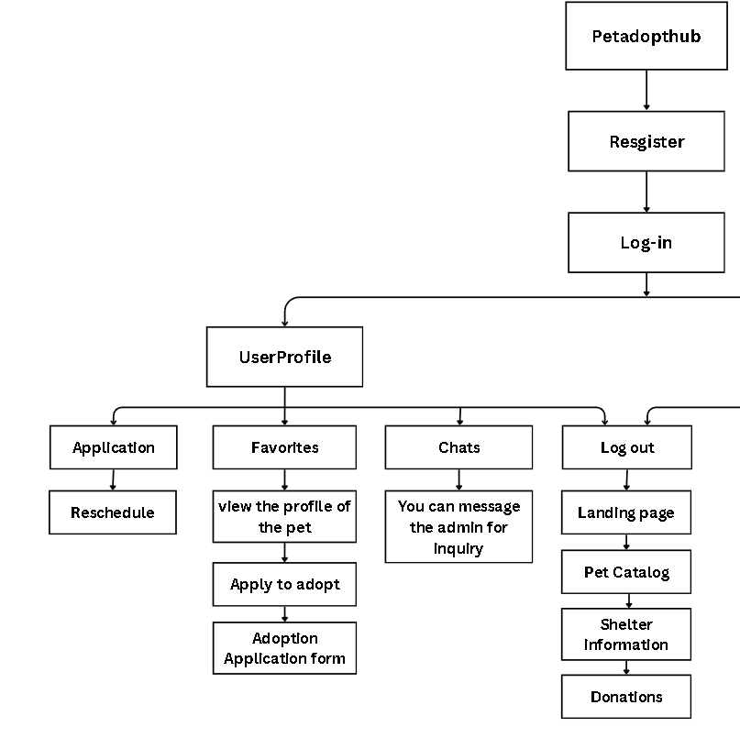
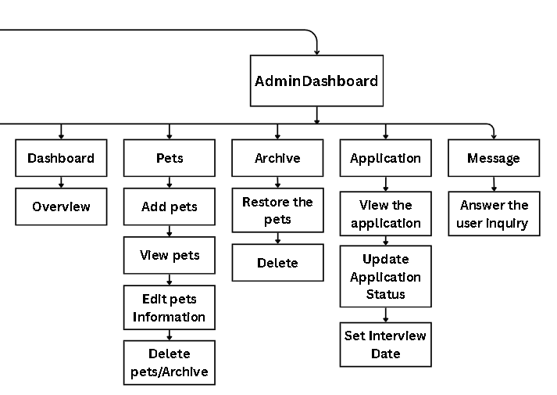

Figure 2. HIPO diagram of PetAdoptHub: A Web Platform for Animal Shelters to Manage and Promote Pet Adoption

In Figure 2, the hierarchical input-process-output (HIPO) diagram provides an overview of the Pet Adopt Hub system. The diagram shows that the platform has an overarching module which branches out into four broad components: User Registration which submits a request to register an account, and a suite of main functionalities, including Pet Browsing and Adoption Requests, through which users review pet data; supplemented by two subsystems, including Pet Profiling and Image Uploads; with a parallel disposition for the Shelter Dashboard, which encapsulates the administrative abilities of updating pet status or editing the user's personal information; and a Settings module which allows an end-user to easily configure account parameters. Overall, this hierarchical layout supports a clear flow of user inputs through the user registration stage, the browsing process and ultimately into measurable outputs as an outcome of the adoption process and the administrative management of shelter data.

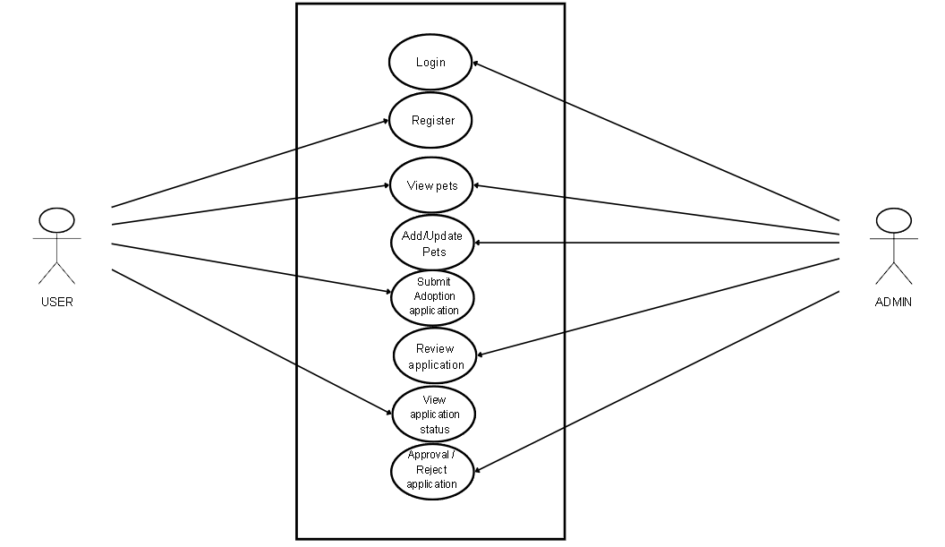

Figure 3. Use case diagram of PetAdoptHub

The Use Case Diagram of PetAdoptHub illustrates the interactions between the users and the system. There are two main actors: User and Admin/Staff. The User can register, log in, view available pets, submit adoption applications, and track application status. Meanwhile, the Admin/Staff is responsible for managing user accounts, adding and updating pet information, reviewing adoption applications, and approving or rejecting requests. This diagram presents the functional requirements of the system.
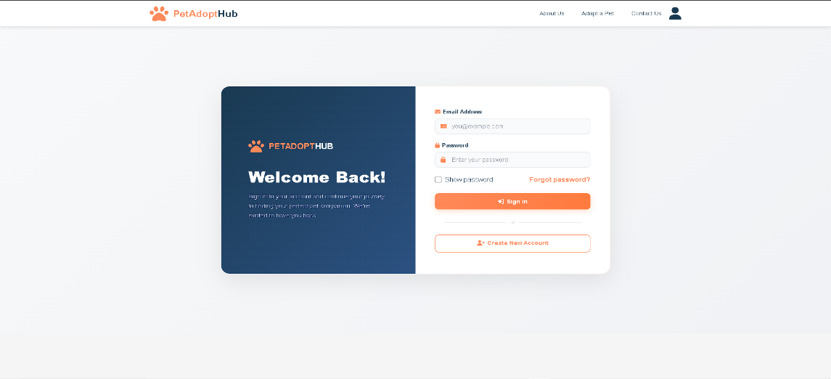

Figure 4. Graphical User Interface Design of The Login Page

Figure 4 shows the graphical user interface design of the PetAdoptHub: A Web Platform for Animal Shelters to Manage and Promote Pet Adoption. The Login Page Interface allows registered users to securely access their accounts by entering their valid email address or username and password. This feature ensures that only authorized users can access the system and perform transactions such as submitting adoption application and sending inquiries.

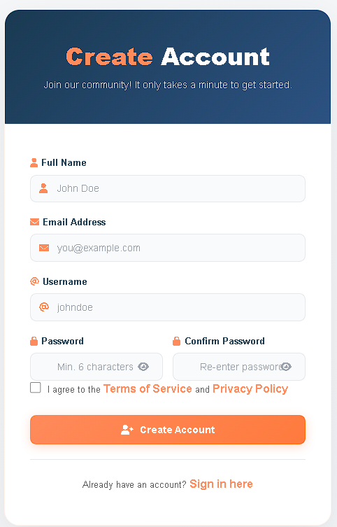

Figure 5. Registration Page

Figure 5 shows the graphical user interface design of the Registration Page Interface.It enables new users to create an account in the system. Users are required to provide essential personal information such as full name, email address, username, and password. This information is stored in the database and will be used for identification and communication purposes.

Requirements Analysis
For a successful development of PetAdoptHub, a comprehensive requirements analysis was performed to identify the needs of animal shelters,
volunteers, and potential adopters. The project undertook interviews with animal shelter employees, and conducted surveys and prototype testing, to uncover
experiences related to operations and the required specifications needed for a complete, efficient adoption platform.
Many shelters rely on spreadsheets or social media posts or in need of a formal process to track their pets and processes for adoption inquiries. These methods often create situations of misleading or contradictory information, lost inquiries, slow responses to adoption inquiries, and consistent and timely display of animals looking for homes. In addition, adopters may not have access to updated information or online applications and documents for a specific animal which will limit the success of adoption.
PetAdoptHub was developed to meet these needs by housing all relevant pet information, digitizing all adoption processes and providing a platform useful by volunteers and adopters alike across devices. The system's main requirements include reported capabilities of the system ensuring there are features for managing pet profiles, applications and processing, managing user accounts and messaging, and responsive design. Since many shelters are also run on limited budgets, there will be an emphasis on a low-cost web hosting and low device requirements.
The development stack utilized by PetAdoptHub of HTML, CSS, PHP and SQL for database .
Figure 6 presents the fishbone diagram illustrating the different factors that contribute to the inefficiencies in the traditional pet adoption process. The diagram identifies five major categories that affect the current system, namely Machine, Method, Material, Environment, and Manpower. Under the Machine category, the problems include the use of outdated technology and slow communication systems. Many shelters still rely on traditional tools instead of digital platforms, which results in delays in responding to adoption inquiries and managing pet information. The Method category highlights issues such as manual paperwork and the absence of a standardized system. The adoption process often depends on manual documentation, which makes the process time-consuming and prone to errors. In terms of Material, the use of paper forms can lead to problems such as misplaced or lost documents. These issues may affect the proper recording of adoption details and applicant information. The Environment factor shows limitations such as physical visits being the only way for potential adopters to view pets and limited shelter space. These restrictions reduce the visibility of adoptable animals and make the adoption process less accessible to the public. Lastly, the Manpower category includes poor coordination among shelter staff and the lack of incentives for volunteers. These factors may reduce operational efficiency and slow down the adoption process.

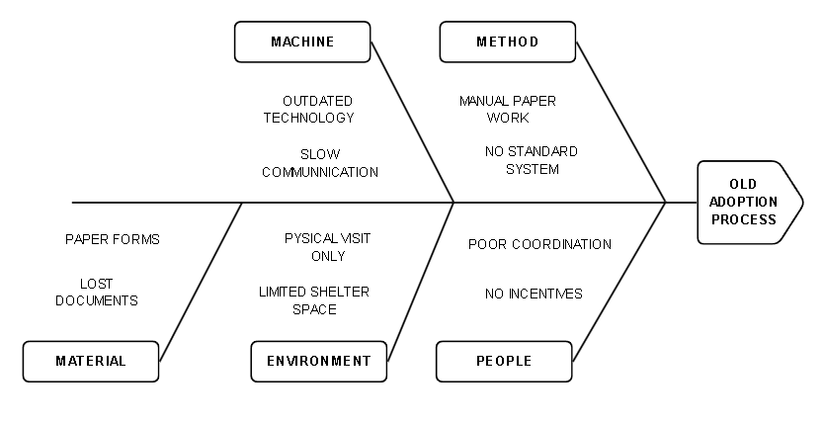

Figure 6. Fishbone Diagram

Technical Feasibility. The technical feasibility of Pet Adopt Hub: A Web Platform for Animal Shelters to Manage and Promote Pet Adoption evaluates the availability and suitability of existing digital tools, platforms, and resources necessary for the system’s development, deployment, and maintenance.
Below are the key factors:

Web Development Framework: Standard web technologies like HTML, CSS, and JavaScript for the front end and PHP or Node.js for the back end will be used in the platform's development. These technologies are popular, dependable, and appropriate for creating user-friendly and responsive online applications.
Database Management: Data including pet profiles, user accounts, and adoption records will be stored and managed by the system using MySQL as its database management system. It guarantees scalability, security, and effective data management.
Hardware Requirements: Existing desktops or laptops with simple requirements can support development and deployment. It is sufficient to have a reliable internet connection for system deployment, testing, and access.
Deployment and Hosting: A domain name and reasonably priced web hosting services will be used to launch the platform. This enables users and shelters to use the system online at any time and from any location.
System Accessibility: Pet Adopt Hub is a web-based platform that ensures convenience and scalability by requiring less network infrastructure and being available through common web browsers on various devices.
Technical Skills and Support: The developers have sufficient expertise in database administration, system design, and web development. When more assistance is required, it can be found through developer communities and online documentation.
Economic Feasibility. Table 3 presents the estimated costs for developing and implementing PET ADOPT HUB, totaling ₱5,000. The costs are itemized as follows: web hosting (₱1,000) to ensure the platform is accessible online; domain registration (₱500) for securing a unique website address; database and storage (₱2,500) to manage and store pet adoption data efficiently; and printing (₱1,000) for any required documentation or reports. This budget allocation demonstrates a clear and practical approach to covering essential expenses necessary for the system’s functionality and initial deployment.
PARTICULARS | AMOUNT (P)
Web Hosting | 1,000.00
Domain Registration | 500.00
Database & Storage | 2,500.00
Printing | 1,000.00
Total | 5,000.00
Table 3. Estimated cost of the system development

Schedule Feasibility. Figure 7 presents the Gantt chart illustrating the planned schedule for the development and implementation of PET ADOPT HUB. The timeline spans from November 2025 to July 2026, covering all key project activities, including proposal drafting and defense, system design, development, testing, evaluation, implementation, manuscript preparation, and final oral defense. The sequential arrangement of activities ensures that each phase is completed systematically, allowing sufficient time for development, testing, revisions, and final documentation, thereby demonstrating that the project is feasible within the proposed timeframe.

ACTIVITY | 2025 |  | 2026
 | Nov | Dec | Jan | Feb | Mar | Apr | May | Jun | Jul
Proposal drafting
Proposal defense
System design
System Development
System testing
System
evaluation
System implementation
Manuscript
preparation
Final oral
defense
Manuscript
review

Figure 7. Gantt Chart

Requirements Documentation.This project centres around the development of a web-based solution to facilitate the adoption management for animal shelters. PetAdoptHub initiates the improvement of animal welfare through the increased visibility of adoptable animals and streamlining of shelter processes.
The system comprises three modules, including Pet Management, Adoption Workflow, Pet Catalog, User Accounts, Messaging and Dashboard Analytics. These features will allow for the civic creation, tracking, and promotion of adoptable animals. The state-based platform will be able to work inside without a viable connection for most actions, such as pdf drafting and reading cached pet details.
In addition to each module, adoption engagement will be managed through various interactive features, including push notifications, dynamic form validation, and regenerative status updates to keep the adoptive families informed and engaged with the platform and adoption journey. Most importantly, the platform and modules must consist of heavy graphics or other content such that they will not be "heavy", meaning the user experience must be dimensionally accessible reminders. Please provide some notes about this if possible.

System Development
PetAdoptHub was conceived using an iterative method composed of six ongoing and repetitive phases—Planning, Requirements Analysis, Design, Building, Testing, and Re-planning. Each cycle added new features to the system on that phase, such as filtering companion animals in the pet catalog, uploading pet photos, processing forms for a shelter, and administering the platform

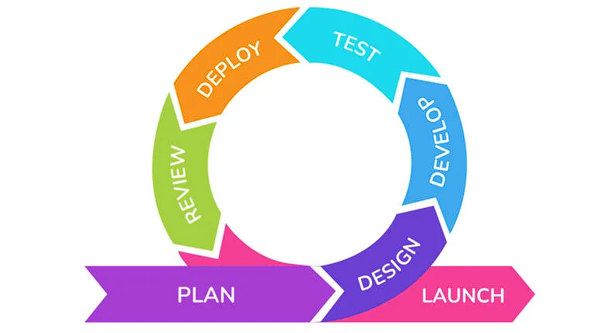

Figure 8. Agile model

Plan
Each development cycle began with a planning phase to define the objectives for the upcoming iteration. The project's initial scope was established to address the core problems of inefficient shelter management and limited public visibility for adoptable pets. During this phase, the team defined the technical architecture, selecting appropriate technologies such as HTML, CSS, JavaScript, PHP, and MySQL. A project timeline and the division of responsibilities among the researchers (Colon, Clores, Concensino, Jaramil, Sarmiento) were also outlined to ensure a systematic workflow.

Design
Following the planning phase, the team translated the defined requirements into tangible design elements. This involved creating wireframes and user interface (UI) layouts to visualize user interaction with the system. The design prioritized simplicity and clarity, focusing on features such as large pet photos, intuitive search filters, and streamlined forms for adoption requests. Simultaneously, the backend architecture was designed, including the database schema for storing pet profiles, user accounts, and adoption records, as well as the logic for shelter dashboard functionalities.
Develop
The development phase was where the actual coding and implementation took place. Using tools like Visual Studio Code (VSCode), the team built the core features of the platform, such as user registration, pet profile management, and the adoption request system. The development was done incrementally, focusing on completing one set of features per cycle before moving on to the next. This approach ensured that a functional version of the system was always available for internal review and testing.
Test
Throughout each cycle, rigorous testing was conducted to ensure the system's functionality, usability, and reliability. This included unit testing of individual components (e.g., form validation), integration testing of modules (e.g., connecting pet profiles to adoption requests), and system testing to verify the overall flow of processes. Usability testing was also conducted with potential users to observe the clarity of the interface and ease of navigation, aligning with the study’s objective to ensure a user-friendly platform.
Review
After testing, the team convened for a review phase to assess the completed work. Feedback was gathered from internal team members, technical critics, and, when possible, from shelter staff and potential adopters. This review was critical for identifying areas for improvement, uncovering any bugs, and validating that the developed features met the objectives outlined in the planning phase. This phase directly supported the system evaluation objective by incorporating feedback early and often.
Launch
The final phase of each cycle was the launch of a new, stable version of the system. This could be a new feature, such as the admin dashboard, or an enhanced version of an existing one. By "launching" after each cycle, the team ensured that the system was continuously improving and that no single phase became a bottleneck. The final launch at the end of the project lifecycle represented the complete, fully-functional Pet Adopt Hub platform, ready for implementation in an actual animal shelter environment.
System Testing
The system was tested through unit testing for each of the different features, including pet profile, pet adoption application, and progress tracking, to ensure the system functionality was accurate and the system was stable. Usability testing of the application was conducted for shelter staff and potential adopters, to observe clarity of the interface and ease of navigation. Performance tests verified usability of the platform on devices with a range of specifications, and testing confirmed that the platform displayed correctly across different browsers and screen sizes. Offline functionality was also tested, to confirm that the application accessed without a network connection.
System Evaluation
Evaluation of the system used modified ISO 25010 software quality measures to verify the PetAdoptHub fulfilled both technical and operational requirements. Shelter staff and user participants participated in functionality evaluation on key measures—usability, performance efficiency, reliability, and portability.
Data Assessment Plan
As presented in Table 2, descriptive interpretations of the mean examined the assessment findings based on the data collected by the researchers. The responses received from users including shelter managers, volunteers, and adopters were evaluated using a Likert scale to indicate the performance of the system usability, functionality, and overall user satisfaction. The mean scores calculated from the survey were interpreted with the following scale:

Table 1. Likert Scale Interpretation
Numerical Scale | Scale Interpretation
5 | Excellent
4 | Very Good
3 | Good
2 | Fair
1 | Poor

Table 2. Descriptive Interpretation of the mean
Numerical Scale | Interpretation
4.51 – 5.00 | Excellent
3.51 – 4.50 | Very Good
2.51 – 3.50 | Good
1.51 – 2.50 | Fair
1.50 – below | Poor

Implementation Plan
As shown in Table 3, the implementation plan for PetAdoptHub. It summarizes the interventions, activities, persons and time available for each intervention, as a methodical approach by the researchers in launching the web platform within local animal shelters.

Strategies | Activities | Persons Involved | Duration
Permission &  Consent | Seek approval from shelter directors for the conduct of testing and implementation | Researchers, Shelter Directors | 1 week
Orientation | Introduce the platform to shelter staff and volunteers; explain objectives and features | Researchers, Shelter Staff | 1 week
Installation | Deploy the web application on shelter computers and mobile devices for operational use | Researchers | 1 week
Training | Conduct hands-on training for staff on using the platform for pet management and adoption promotion | Researchers, Shelter Staff | 1–2 weeks
Pilot Testing | Allow staff and volunteers to manage pet listings and process adoption applications during daily operations | Shelter Staff, Volunteers, Researchers | 1 month
Feedback Collection | Gather feedback from staff and volunteers regarding usability, engagement, and adoption outcomes | Shelter Staff, Volunteers, Researchers | 1 week
Refinement | Apply improvements based on feedback (user interface, content, features) | Development Team | 1 month
Full Implementation | Integrate the platform into shelter workflows as a tool for managing and promoting pet adoptions | Shelter Staff, Volunteers | Ongoing

REFERENCES

Butlig, J. N., Segun, K. M. Q., & Torres, A. J. C. (2024, January). Shelter of Hope web-based pet adoption system (Undergraduate capstone project). Cavite State University – Bacoor Campus, Bacoor, Cavite, Philippines. https://www.cvsu- bacoor.edu.ph/research/capstones/2024/ShelterOfHope_PetAdoption.pdf
Chen, C.-C., & Lin, C.-P. (2024). What drives IoT-based smart pet appliances usage intention? The perspective of the unified theory of acceptance and use of technology model. International Journal of Interactive Multimedia & Artificial Intelligence, 8(7), 5–14. https://doi.org/10.9781/ijimai.2024.03.001
Cuya Camara, J. L. (2025). Digital strategies in dog adoption: A systematic review on the impact of mobile applications. In Proceedings of the LACCEI International Multi-Conference for Engineering, Education, and Technology. Mexico. https://laccei.org/LACCEI2025-Mexico/meta/FP1144.html
Del Rosario, K. M. (2025, March 17). Unleash PH sets new standard in pet care with exciting app launch. Getaway.PH. https://getaway.ph/blog/events-festivals/unleash-ph-sets-new-standard-in-pet-care-with-exciting-app-launch/
Garcia, D. A., & Molina, S. K. (2024). PetFaves: A web-based system for finding and adopting pets in Humane Paws Animal Shelter (Undergraduate capstone project). Cavite State University – Bacoor Campus, Bacoor City, Cavite, Philippines. https://www.cvsu-bacoor.edu.ph/research/capstones/2024/PetFaves_WebBasedSystem.pdf
Ladrera, W. T., Poblacion, A. K. N., Pajaganas, L. N. D., Gundaya, M. H. P., & Abad, Y. C. (2025). AdopTails: Improving the pet adoption process through a web-based feedback system.Centro Escolar University – Makati, Philippines. https://www.ceu.edu.ph/research
Macario, S. L. C., & Pastor, J. L. F. (2025). Bridging paws and people: Analyzing high school students' engagement in pet shelter website for adoption and awareness (Capstone project). University of the Philippines Rural High School, Los Baños, Laguna, Philippines. https://www.ukdr.uplb.edu.ph/etd-capstone/161/
Shrinidhi, N., Swathi, P., Tejesh, N., & Vachana, V. C. (2024). A review on promoting animal welfare and salvation in an online platform encompassing wide range of stakeholders. International Journal of Innovative Science and Research Technology, 9(1). https://www.ijisrt.com/a-review-on-promoting-animal-welfare-and-salvation-in-an-online-platform-encompassing-wide-range-of-stakeholders
ASPCA. (2023). Shelter data and animal outcomes reports. https://www.aspca.org/helping-people-pets/shelter-intake-and-surrender
Jagtap, Y. (2022). Shelter Soul: Bridging shelters and adopters through technology. https://arxiv.org/pdf/2506.12739
Petfinder. (2024). How pet adoption works. https://www.petfinder.com/adopt-or-get-involved/adopting-a-pet/how-pet-adoption-works/
Powell, L., et al. (2021). Characterizing unsuccessful animal adoptions. Scientific Reports. https://www.nature.com/articles/s41598-021-87649-2
Verified Market Reports. (2025). Pet shelter and adoption platform market size, trends, analysis, highlights & forecast. https://www.verifiedmarketreports.com/product/pet-shelter-and-adoption-platform-market/

.

APPENDICES

Appendix 1. Testing and evaluation instruments


Republic of the Philippines
CAVITE STATE UNIVERSITY
Tanza Campus
Ph. 2, Bahay Katuparan, Bagtas, Tanza, Cavite
(046) 414 – 3979
www.cvsu.edu.ph

EVALUATION INSTRUMENT (FOR IT EXPERTS)
PET ADOPT HUB: A WEB PLATFORM FOR ANIMAL SHELTERS TO MANAGE AND PROMOTE PET ADOPTION

Name (Optional): |  | Date:
Company
Profession:

Instructions: Please evaluate using the given scale and place a check mark (✔) on the appropriate column corresponding to your response.

Numerical Rating: 5 - Excellent 4 - Very Good 3 - Good 2 - Fair 1 - Poor

INDICATOR | 5 | 4 | 3 | 2 | 1
Functional Stability
- Functional completeness - The degree to which the set of functions covers all the specified tasks and user objectives.
- Functional correctness. The degree to which a product or system provides the correct result with the needed degree of precision.
- Functional appropriateness. The degree to which the functions facilitate accomplishing specified tasks and objectives.
Performance Efficiency
- Time behavior. The degree to which the response and processing times and throughput rates of a product or system, when performing its functions, meet requirements.
- Resource utilization. The degree to which the amounts and types of resources a product or system uses, when performing its functions, meet requirements.
- Capacity. The degree to which the maximum limits of a product or system parameter meet requirements
Compatibility
- Co-existence. The degree to which a product can perform its required functions efficiently while sharing a common environment and resources with other products without detrimental impact on any other product.
- Interoperability. The degree to which two or more systems, products, or components can exchange information and use the information that has been exchanged.
Usability
- Appropriateness recognizability. The degree to which users can recognize whether a product or system is appropriate for their needs.
- Learnability. The degree to which specified users can use a product or system to achieve specific goals of efficiency, freedom from risk, and satisfaction in learning to use the product or system effectively, the specified context of use.
- Operability. The degree to which a product or system has attributes that make it easy to operate and control.
- User error protection. The degree to which a system protects users against making errors.
- User interface aesthetics. The degree to which a user interface enables pleasing and satisfying interaction for the user
- Accessibility. The degree to which a product or system can be used by people with the broadest range of characteristics and capabilities to achieve a specified goal in a specified context.
Reliability
- Maturity. The degree to which a system, product, or component meets needs for reliability under normal operation.
- Availability. The degree to which a system, product, or component is operational and accessible when required.
- Fault Tolerance. The degree to which a system, product, or component operates as intended despite hardware or software faults.
- Recoverability. The degree to which, in the event of an interruption or a failure, a product or system can recover the data directly affected and re-establish the system's desired state.
Security
- Confidentiality. The degree to which a product or system ensures that data are accessible only to those authorized.
- Integrity. The degree to which a system, product, or component prevents unauthorized access to, or modification of, computer programs or data.
- Non-repudiation. The degree to which actions or events can be proven to have taken place so that the events or actions cannot be repudiated later.
- Accountability. The degree to which the actions of an entity can be traced uniquely to the entity
- Authenticity. The degree to which the identity of a subject or resource can be proved to be the one claimed.
Maintainability
- Modularity. The degree to which a system or computer program is composed of discrete components such that a change to one component has minimal impact on other components
- Reusability. The degree to which an asset can be used in multiple systems or building other assets.
- Analyzability. Degree of effectiveness and efficiency with which it is possible to assess the impact on a product or system of an intended change to one or more parts, diagnose a product for deficiencies or causes of failures, or identify parts to be modified.
- Modifiability. The degree to which a product or system can be effectively and efficiently modified without introducing defects or degrading existing product quality.
- Testability. The degree of effectiveness and efficiency with which test criteria can be established for a system, product, or component, and tests can be performed to determine whether those criteria have been met.
Portability
- Adaptability. The degree to which a product or system can effectively and efficiently be adapted for different or evolving hardware, software, or other operational or usage environments.
- Installability. The degree of effectiveness and efficiency a product or system can be successfully installed and/or uninstalled in a specified environment.
- Replaceability. The degree to which a product can replace another specified software product for the same purpose in the same environment.
* Adopted from ISO 25010

Remarks/Comments/Suggestions:

________________________________________________________________________________________________________________________________________________________________________________________________________________________________________________________________________________________________________________

Name and Signature of the Evaluator


Republic of the Philippines
CAVITE STATE UNIVERSITY
Tanza Campus
Ph. 2, Bahay Katuparan, Bagtas, Tanza, Cavite
(046) 414 – 3979
www.cvsu.edu.ph

EVALUATION INSTRUMENT (FOR USER)
PET ADOPT HUB: A WEB PLATFORM FOR ANIMAL SHELTERS TO MANAGE AND PROMOTE PET ADOPTION

Name (Optional): |  | Date:
Address (Optional):

Instructions: Please evaluate using the given scale and placing a checkmark (✓) on the appropriate column corresponding to your response
Numerical Rating: 5 – Excellent 4 – Very good 3- Good 2 – Fair 1 - Poor
INDICATORS | 5 | 4 | 3 | 2 | 1
- Functional
- The system provides complete features for pet adoption management.
- The pet listing and adoption request process works properly.
- The system correctly stores and retrieves pet and adopter information.
- The admin dashboard functions correctly.
- Usability
- The system is easy to navigate.
- The interface design is clear and understandable.
- The buttons and features are easy to locate.
- Users can complete adoption requests without difficulty.
- Performance Efficiency
- The system loads quickly.
- Pages respond properly when clicked.
- The system performs well even with multiple users.
- Security
- The login system protects user accounts.
- Personal information is securely stored.
- Only authorized users can access admin features.
- Reliability
- The system works without crashing.
- The system provides accurate information.
- Overall Satisfaction
- I am satisfied with the overall performance of PetAdoptHub.
- I would recommend this system to animal shelters.
* Adopted from ISO 25010

Remarks/Comments/Suggestions:
__________________________________________________________________________________________________________________________________________________________________________________________________________________

Name and Signature of Respondents
Appendix 2. Data flow diagram
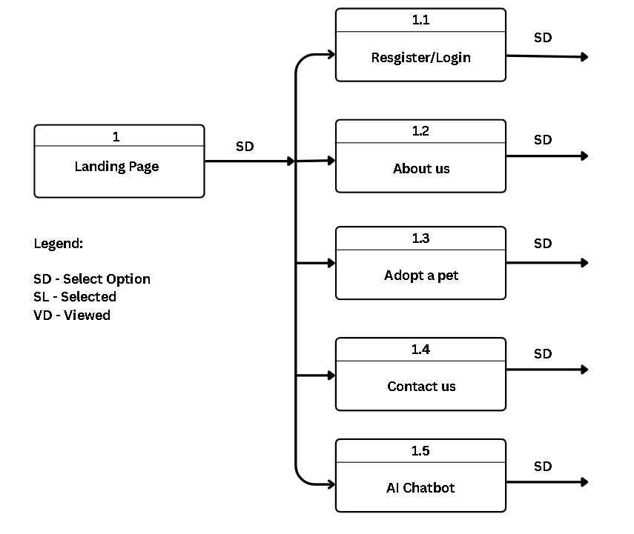
Appendix figure 1. Top-level diagram of the Petadopthub web-based

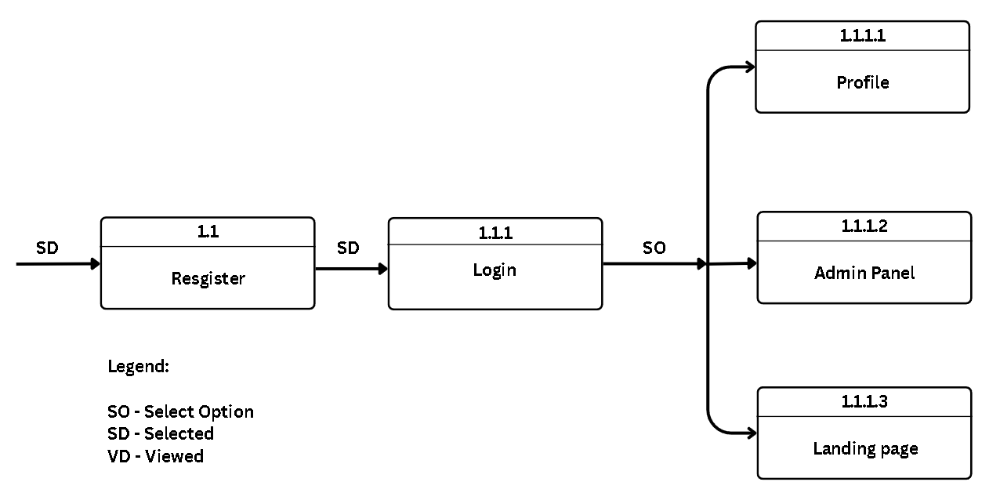
Appendix figure 2. Function of process 1.1
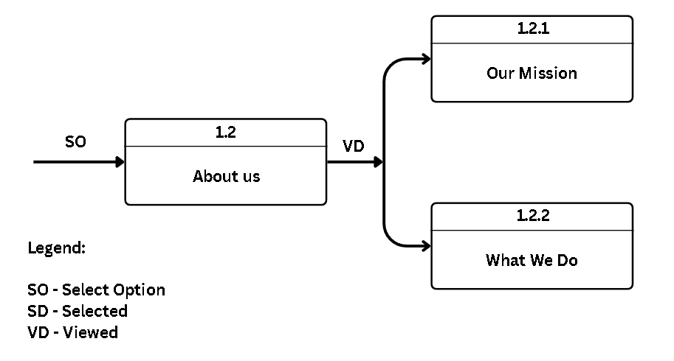
Appendix figure 3. Function of process 1.2
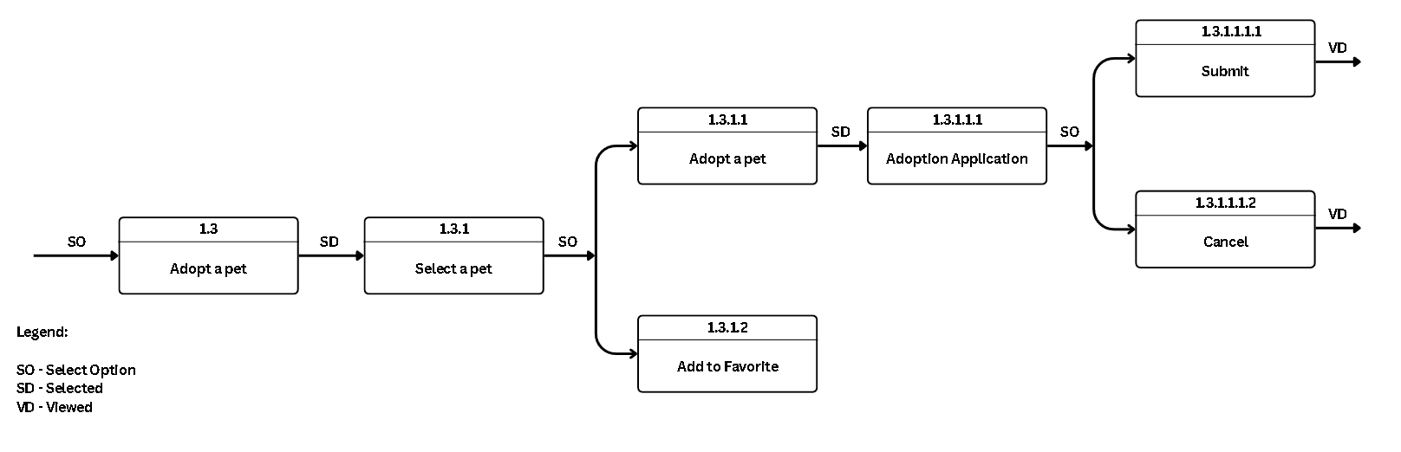
Appendix figure 4. Function of process 1.3
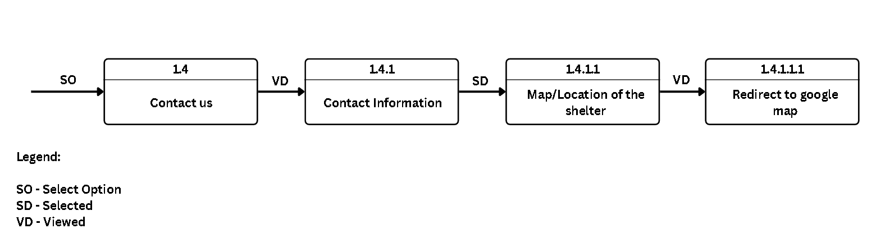
Appendix figure 5. Function of process 1.4
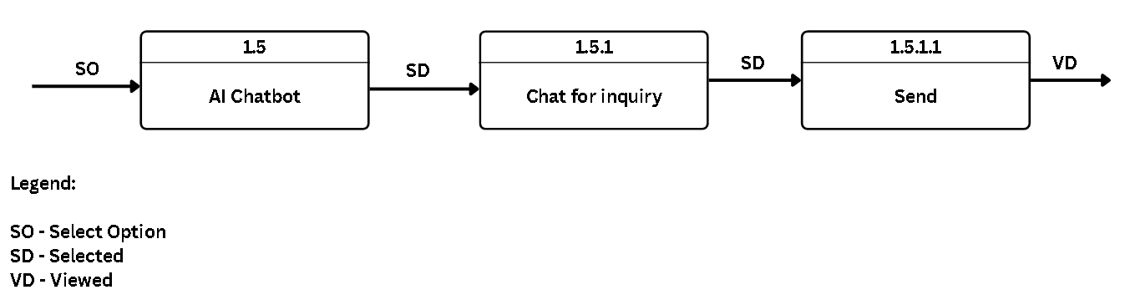
Appendix figure 6. Function of process 1.5

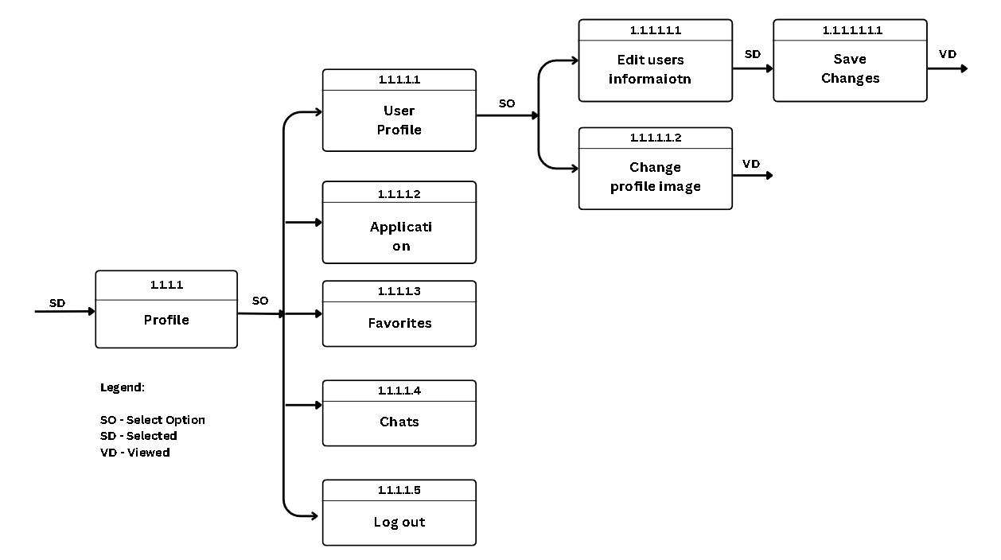
Appendix figure 7. Function of process 1.1.1.1

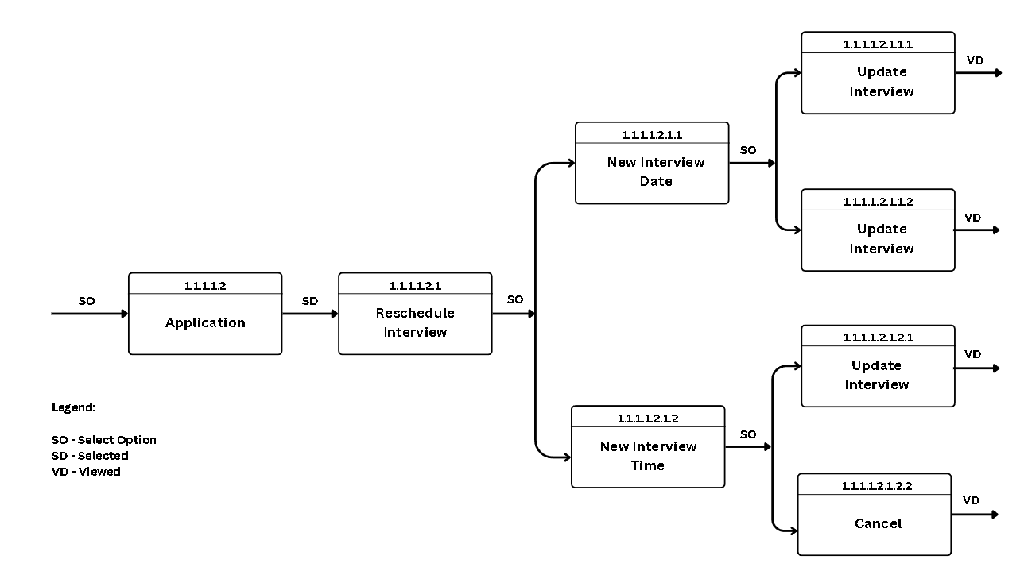
Appendix figure 8. Function of process 1.1.1.1.2
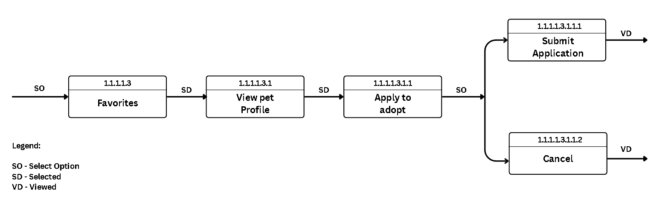
Appendix figure 9. Function of process 1.1.1.1.3
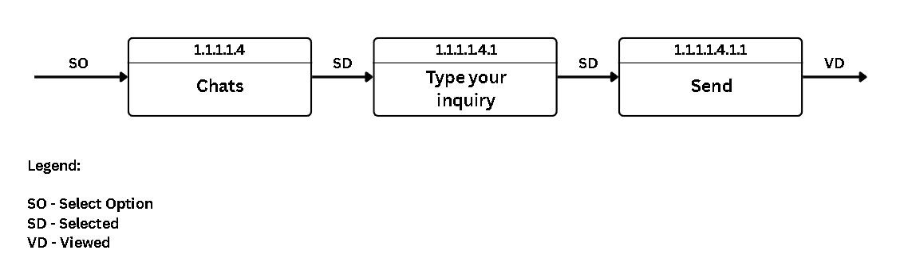
Appendix figure 10. Function of process 1.1.1.1.4
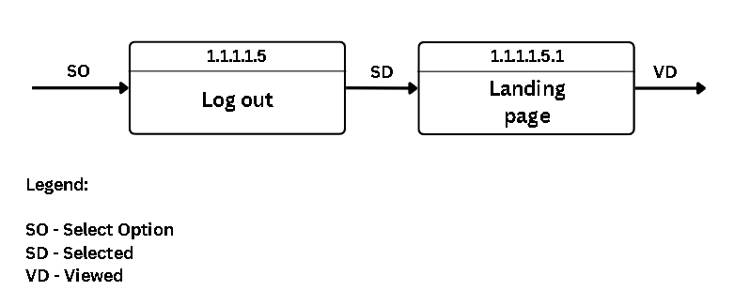
Appendix figure 11. Function of process 1.1.1.1.5

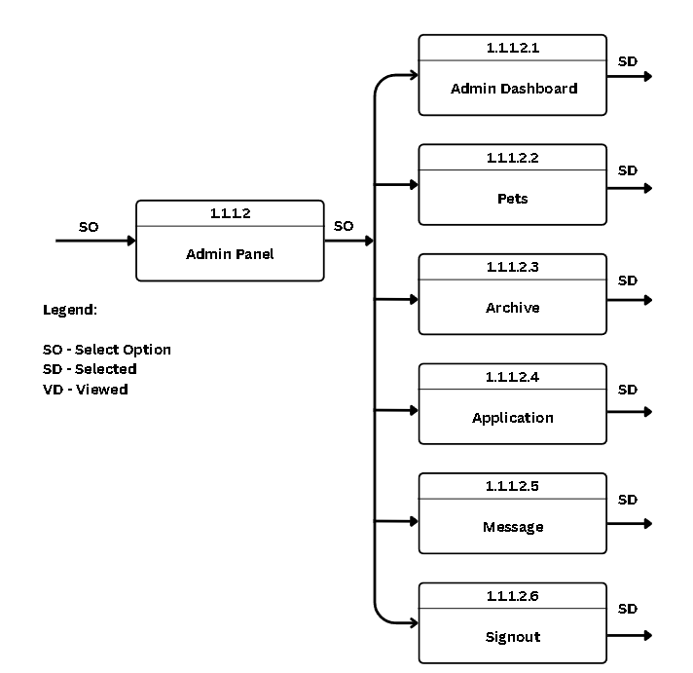
Appendix figure 12. Function of process 1.1.1.2
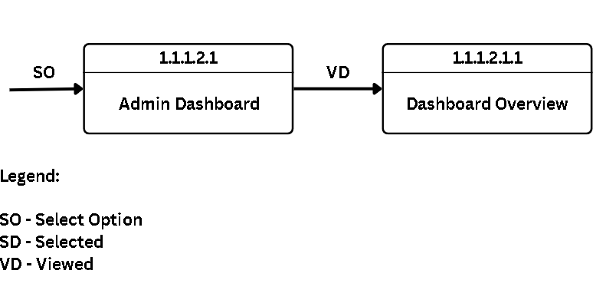
Appendix figure 13. Function of process 1.1.1.2.1

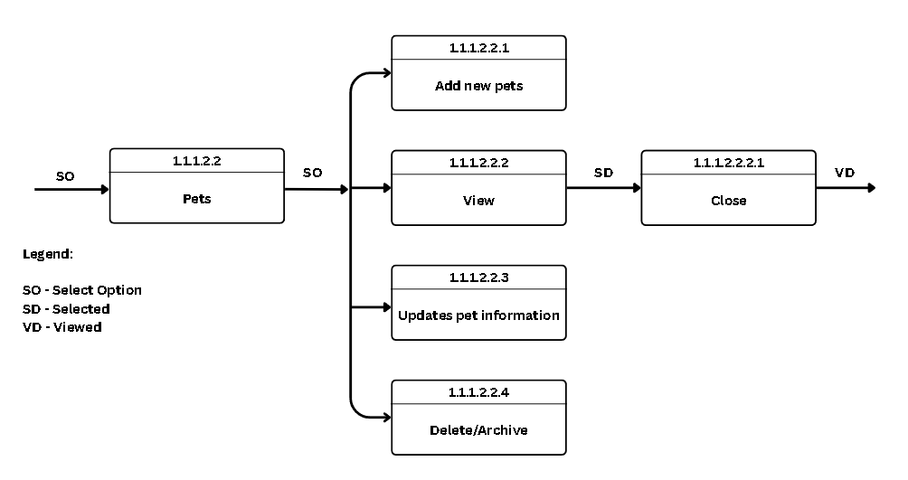
Appendix figure 14. Function of process 1.1.1.2.2
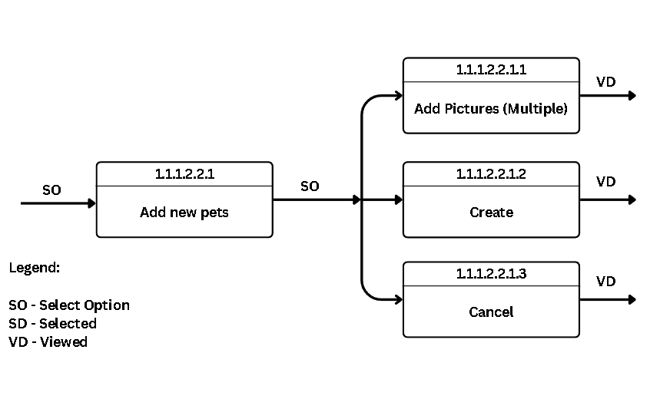
Appendix figure 15. Function of process 1.1.1.2.2.1

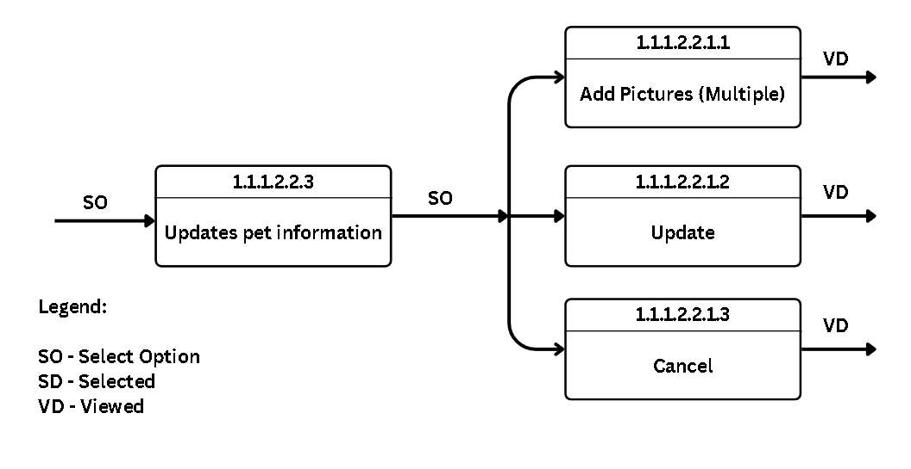
Appendix figure 16. Function of process 1.1.1.2.2.3
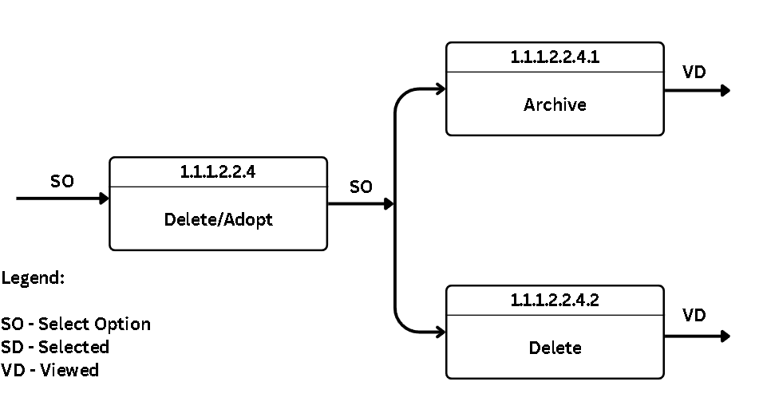
Appendix figure 17. Function of process 1.1.1.2.2.4

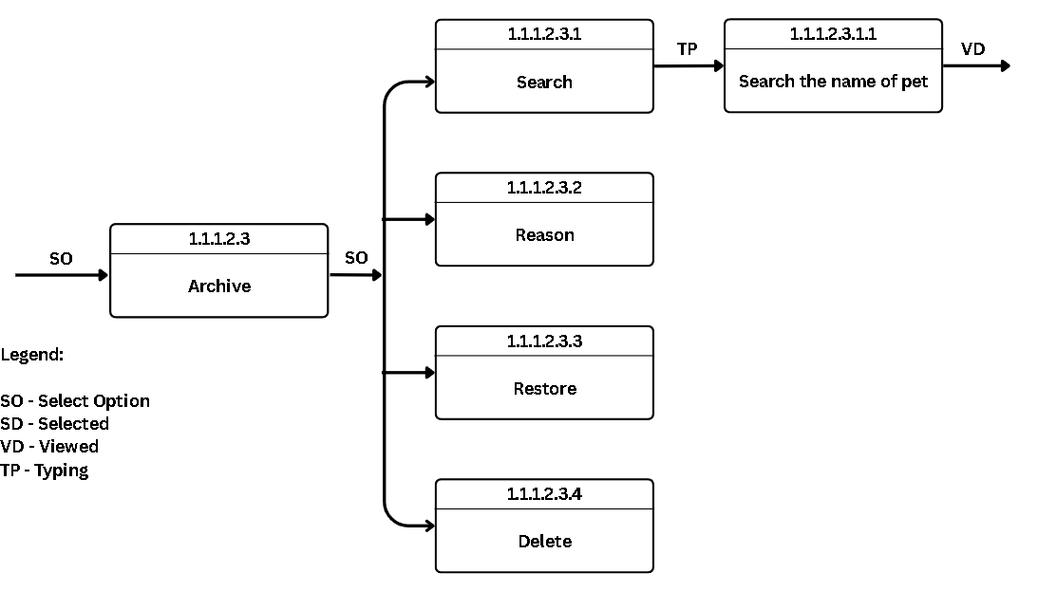
Appendix figure 18. Function of process 1.1.1.2.3

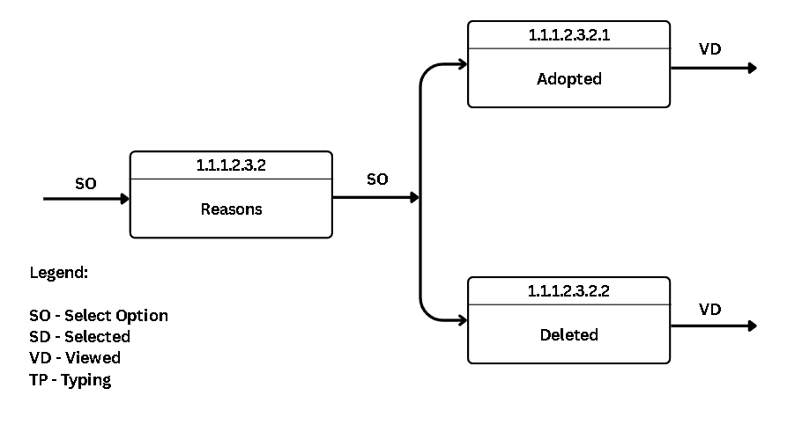
Appendix figure 19. Function of process 1.1.1.2.3.2

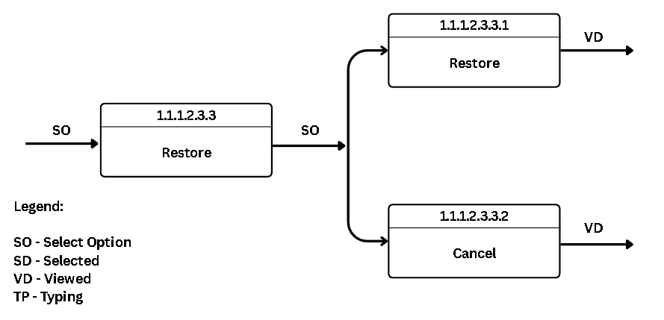
Appendix figure 20. Function of process 1.1.1.2.3.3
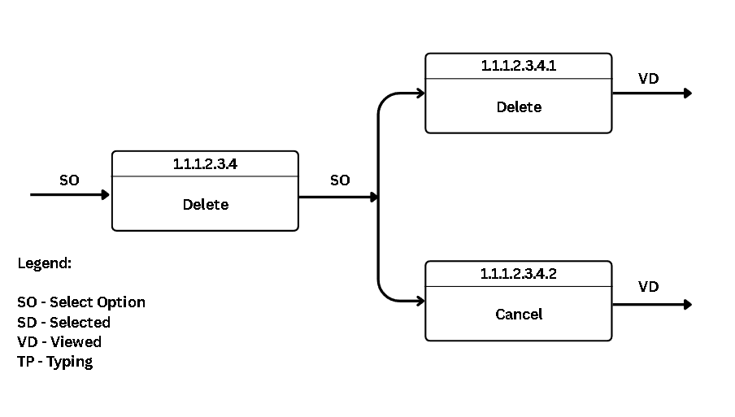
Appendix figure 21. Function of process 1.1.1.2.3.4

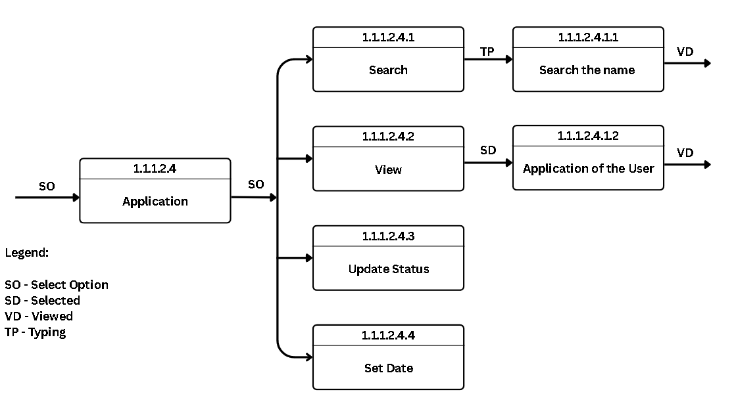
Appendix figure 22. Function of process 1.1.1.2.4
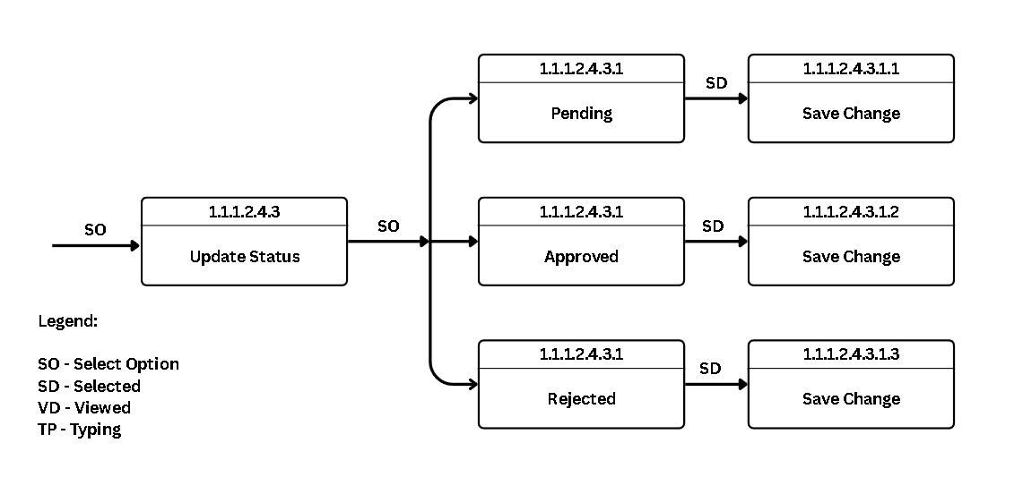
Appendix figure 23. Function of process 1.1.1.2.4.3

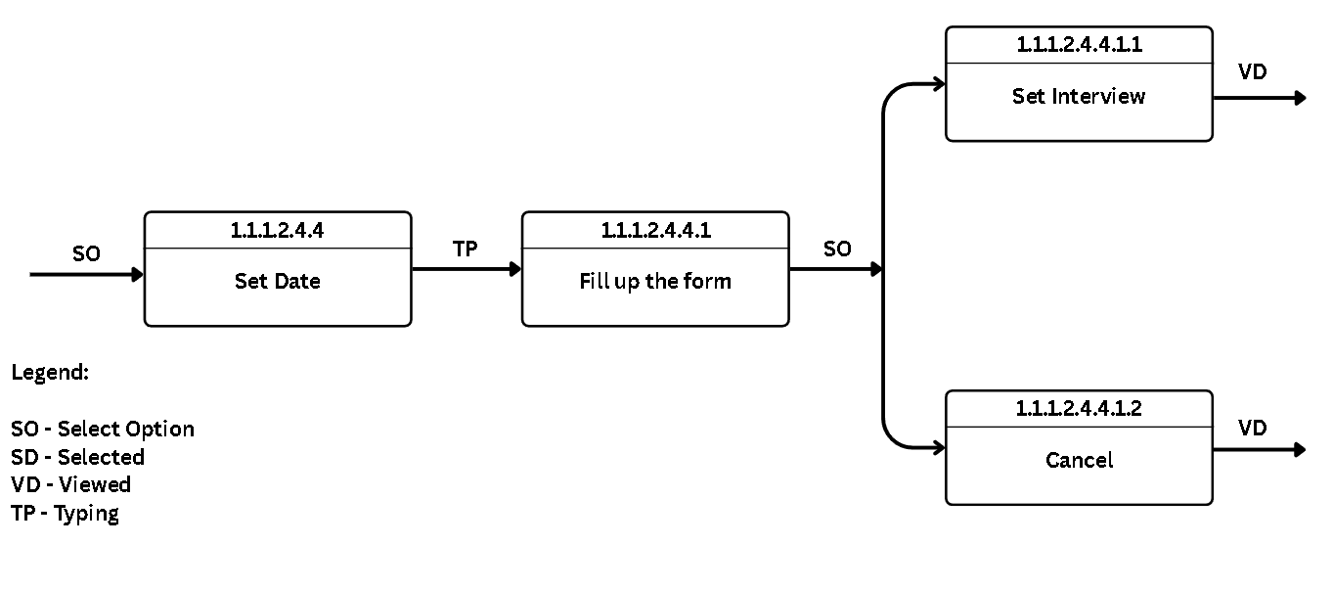
Appendix figure 24. Function of process 1.1.1.2.4.4
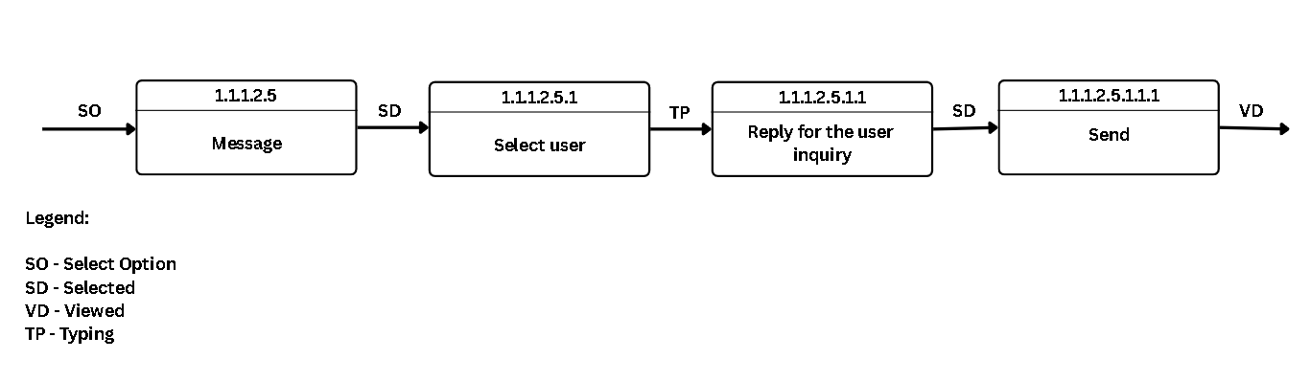
Appendix figure 25. Function of process 1.1.1.2.5
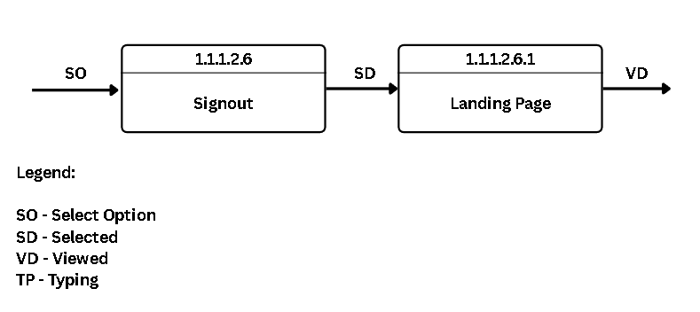
Appendix figure 26. Function of process 1.1.1.2.6
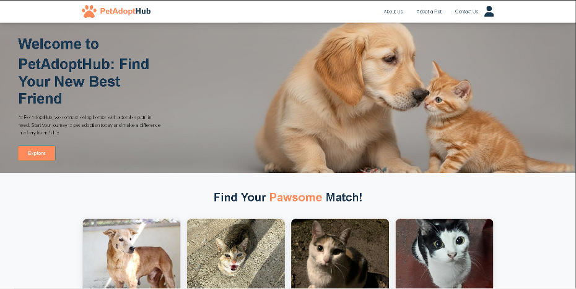
Appendix 3. Screen layouts

Appendix Figure 27. Home Page

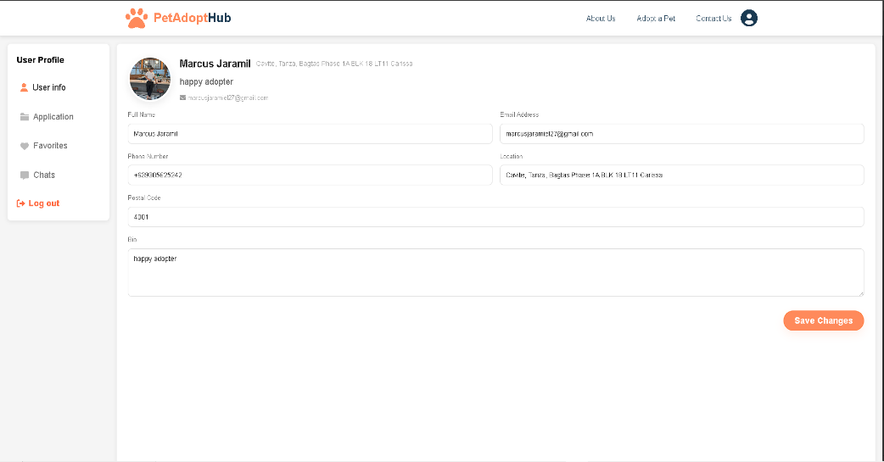
Appendix Figure 28. User Profile Page

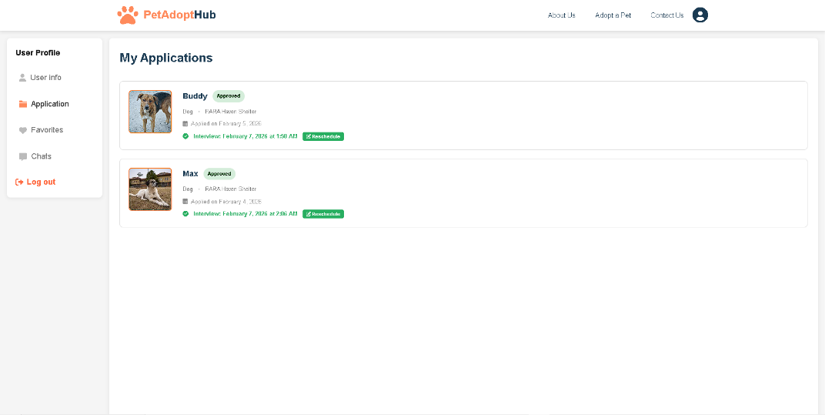
Appendix Figure 29. Adoption Application and Rescheduling
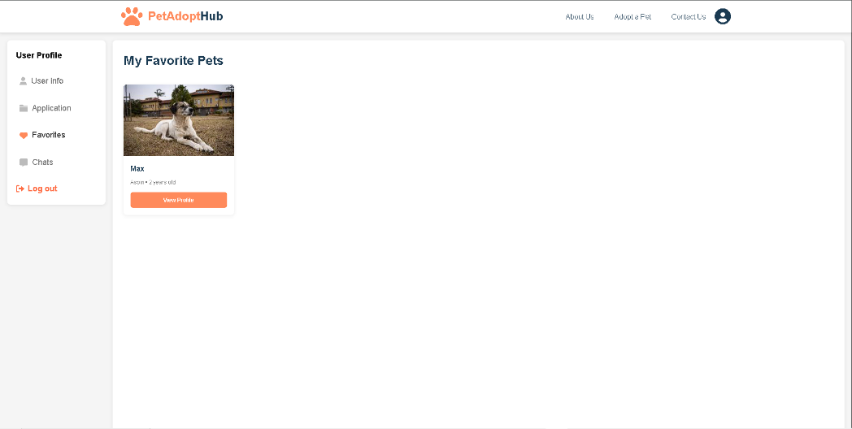

Appendix Figure 30. Favorite Section

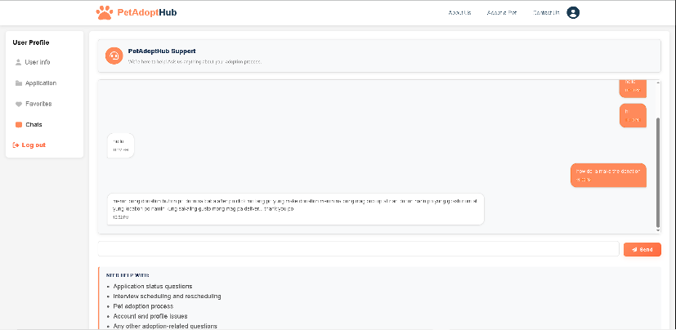
Appendix Figure31. User Chat

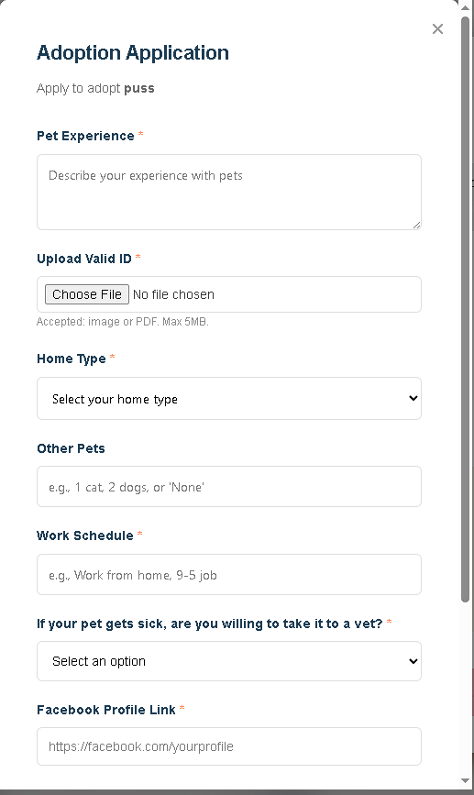

Appendix Figure 32. Adoption Application Form

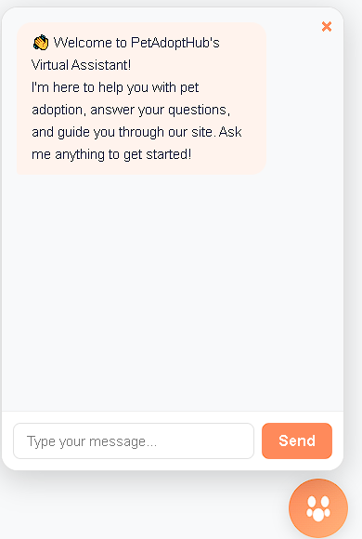
Appendix Figure 33. AI Chatbot

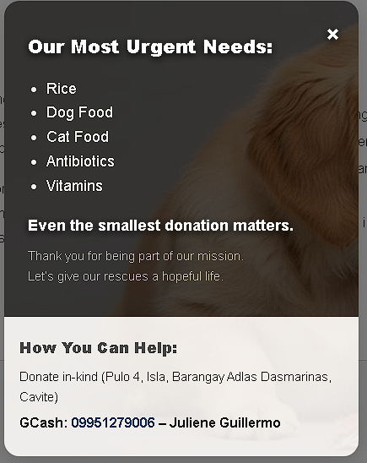

Appendix Figure 34. Donation Information

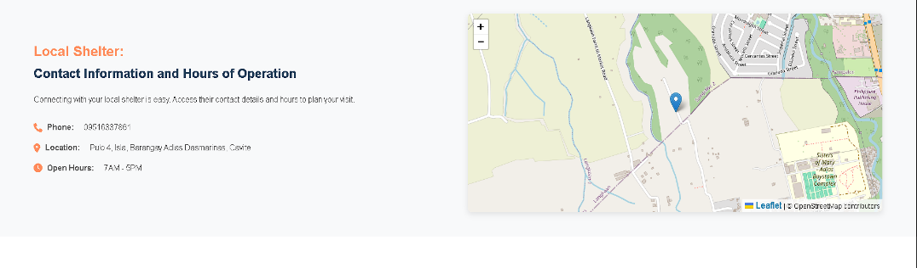
Appendix Figure 35. . Contact and Location
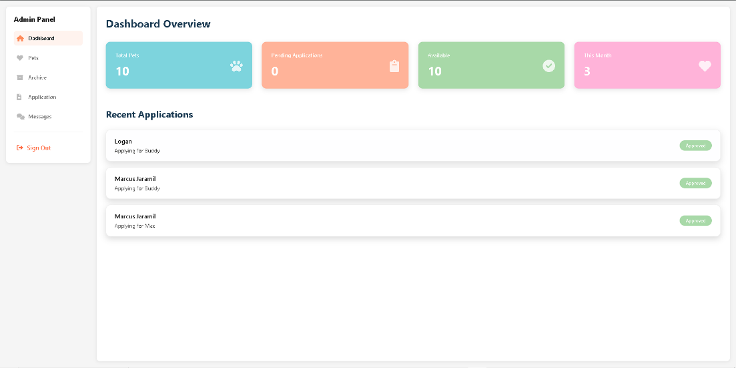

Appendix Figure 36. Admin Dashboard

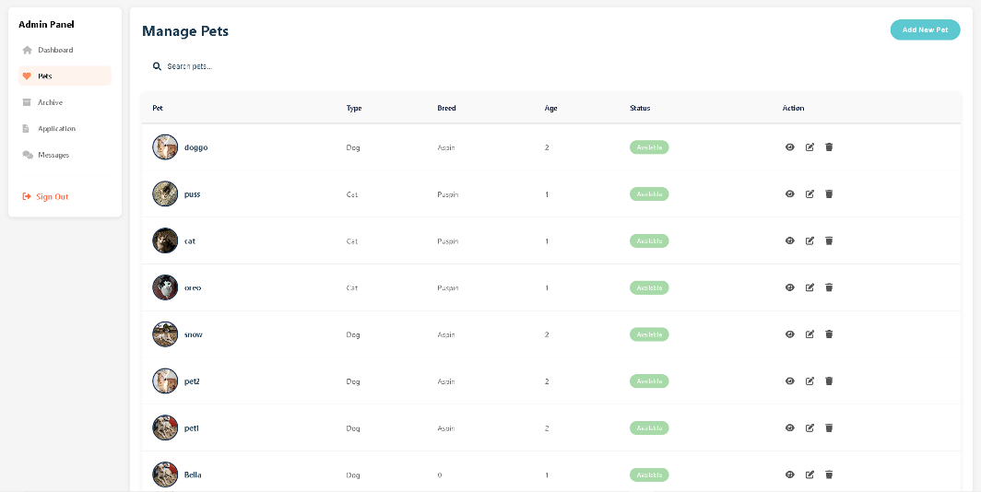

Appendix Figure 37. Manage Pets

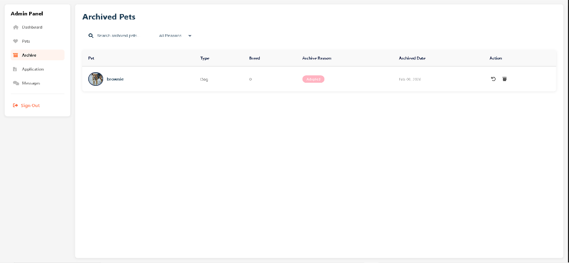

Appendix Figure 38. Archive
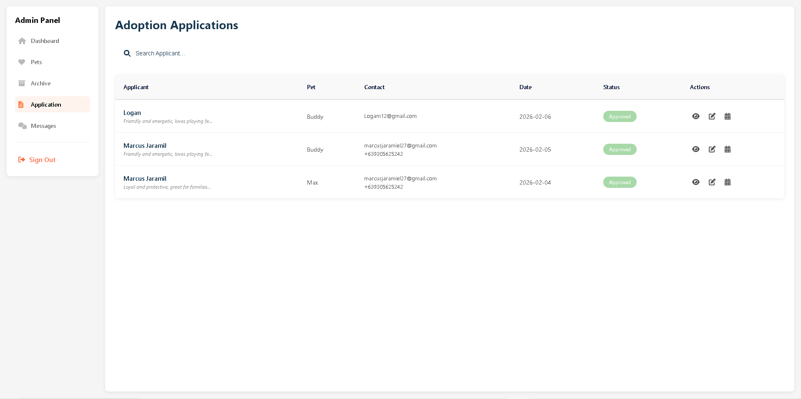

Appendix Figure 39. Adoption Application Management

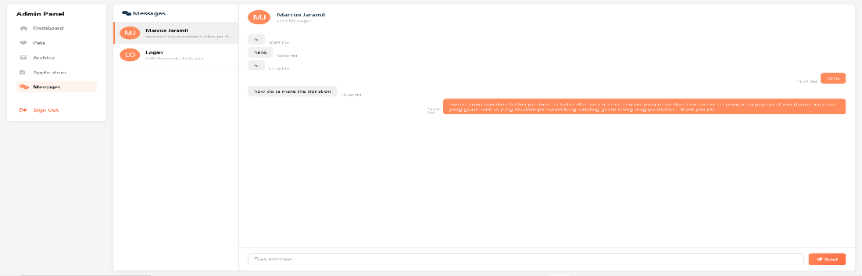

Appendix Figure 40. Admin Chat



CvSU - TC RSU Form No.: __
Republic of the Philippines
CAVITE STATE UNIVERSITY
CvSU Tanza Campus
Tanza, Cavite
(046) 840-7858
cvsutanza@cvsu.edu.ph
www.cvsu.edu.ph

RESEARCH SERVICES UNIT

REQUEST FOR ADVISER AND TECHNICAL CRITIC

NAME: | JARAMIL, MARCUS A; COLON, GERALD; CLORES, EUGINE A;
 | SARMIENTO, JACKELYN P; CONCENSINO, GINA S
COURSE: | BS INFORMATION TECHNOLOGY |  | MAJOR: | _____________________
AREA OF STUDY/RESEARCH AGENDA: |  | PET ADOPT HUB: A WEB PLATFORM FOR ANIMAL SHELTERS TO MANAGE AND PROMOTE PET ADOPTION

CONFORME:

JANOS P. RAPANUT | _______ | JEFFREY M. DELGADO | _______
Adviser | Date | Technical Critic | Date

RECOMMENDING APPROVAL:

JOYCE ERIKA S. SENARIS | _______ | RITCH M. BANATE, PhD | _______
Chairperson | Date | Research Coordinator | Date

APPROVED:

MILDRED A. SEBASTIAN | _______
Campus Administrator | Date


CvSU - TC RSU Form No.: __
Republic of the Philippines
CAVITE STATE UNIVERSITY
CvSU Tanza Campus
Tanza, Cavite
(046) 840-7858
cvsutanza@cvsu.edu.ph
www.cvsu.edu.ph

RESEARCH SERVICES UNIT

PROGRAM OF WORK

Name of Researcher(s) | : | JARAMIL, MARCUS A; COLON GERALD;
 |  | CLORES, EUGINE A; SARMIENTO, JACKELYN P;
 |  | CONCENSINO, GINA S.
Degree/Course | : | BS INFORMATION TECHNOLOGY
Title of Study | : | PET ADOPT HUB: A WEB PLATFORM FOR ANIMAL
 |  | SHELTERS TO MANAGE AND PROMOTE PET
 |  | ADOPTION

ACTIVITY | TARGET DATES | EXPECTED  OUTPUT | DATE COMPLETED
Title proposal |  | Approved title
Activity planning |  | Program of work
Proposal drafting |  | Accepted proposal
Outline proposal |  | Approved outline
Data Gathering |  | Data analyzed/written up
Manuscript preparation |  | Final Manuscript
Final oral defense |  | Research study approved
Manuscript review |  | Final manuscript

APPROVED:

JANOS P. RAPANUT | _______ | JEFFREY M. DELGADO | _______
Adviser | Date | Technical Critic | Date

JOYCE ERIKA S. SENARIS | _______ | RITCH M. BANATE | _______
Chairperson | Date | Research Coordinator | Date

MILDRED A. SEBASTIAN | _______
Campus Administrator | Date


CvSU - TC RSU Form No.: __
Republic of the Philippines
CAVITE STATE UNIVERSITY
CvSU Tanza Campus
Tanza, Cavite
(046) 840-7858
cvsutanza@cvsu.edu.ph
www.cvsu.edu.ph

RESEARCH SERVICES UNIT

PROGRAM OF WORK

Name of Researcher(s) | : | JARAMIL, MARCUS A; COLON GERALD;
 |  | CLORES, EUGINE A; SARMIENTO, JACKELYN P;
 |  | CONCENSINO, GINA S.
Degree/Course | : | BS INFORMATION TECHNOLOGY
Title of Study | : | PET ADOPT HUB: A WEB PLATFORM FOR ANIMAL
 |  | SHELTERS TO MANAGE AND PROMOTE PET
 |  | ADOPTION

ACTIVITY
 | 1 | 2 | 3 | 4 | 1 | 2 | 3 | 4 | 1 | 2 | 3 | 4 | 1 | 2 | 3 | 4 | 1 | 2 | 3 | 4
Title proposal
Activity planning
Proposal drafting
Outline proposal
Data Gathering
Manuscript preparation
Final oral defense
Manuscript review

APPROVED:

JANOS P. RAPANUT | _______ | JEFFREY M. DELGADO | _______
Adviser | Date | Technical Critic | Date

JOYCE ERIKA S. SENARIS | _______ | RITCH M. BANATE | _______
Chairperson | Date | Research Coordinator | Date

MILDRED A. SEBASTIAN | _______
Campus Administrator | Date


CvSU - TC RSU Form No.: __
Republic of the Philippines
CAVITE STATE UNIVERSITY
CvSU Tanza Campus
Tanza, Cavite
(046) 840-7858
cvsutanza@cvsu.edu.ph
www.cvsu.edu.ph

RESEARCH SERVICES UNIT

REQUEST FOR PROPOSAL DEFENSE

Name of Researcher(s) | JARAMIL, MARCUS A; COLON GERALD;
 | CLORES, EUGINE A;
 | SARMIENTO, JACKELYN P;
 | CONCENSINO, GINA S.
Degree/Course | BS INFORMATION TECHNOLOGY
Date of Intended Proposal Defense
Title of Study | PET ADOPT HUB: A WEB PLATFORM FOR
 | ANIMAL SHELTERS TO MANAGE AND
 | PROMOTE PET ADOPTION

Endorsed by:

JANOS P. RAPANUT JEFFREY M. DELGADO
Signature over Printed Name/Date Signature over Printed Name/Date
Adviser Technical Critic

Recommended by:

JOYCE ERIKA S. SENARIS RITCH M. BANATE, PhD
Signature over Printed Name/Date Signature over Printed Name/Date
Chair Research Coordinator

Approved:

MILDRED A. SEBASTIAN
Campus Administrator


CvSU - TC RSU Form No.: __
Republic of the Philippines
CAVITE STATE UNIVERSITY
CvSU Tanza Campus
Tanza, Cavite
(046) 840-7858
cvsutanza@cvsu.edu.ph
www.cvsu.edu.ph

RESEARCH SERVICES UNIT

PROPOSAL DEFENSE EVALUATION
Name of Researcher(s) | JARAMIL, MARCUS A; COLON GERALD;
 | CLORES, EUGINE A;
 | SARMIENTO, JACKELYN P;
 | CONCENSINO, GINA S.
Degree/Course | BS INFORMATION TECHNOLOGY
Date of Intended Proposal Defense
Title of Study | PET ADOPT HUB: A WEB PLATFORM FOR
 | ANIMAL SHELTERS TO MANAGE AND
 | PROMOTE PET ADOPTION

I. Quantitative Evaluation
CRITERIA | RATING | REMARKS
Thesis quality and scientific merit/ relevance (50%)
- Clarity of the problems and rationale (10)
- Attainability of the objectives (15)
- Appropriateness of methodology (10)
- Overall consistency of write-up (15)
Novelty/creativity/originality (20%)
- Inventiveness/innovativeness of the proposal design project/thesis (10)
- Potential intellectual property right (10)
Sustainability and long-term impact (20%)
- Potential impact of the expected results (10)
- Potential benefit to the community (10)
Soundness of targets/deliverables (10%)

- Feasibility in terms of time period (5)
- Budget proposed for the thesis (5)
Total Score

II. Qualitative Evaluation
PART OF THE MANUSCRIPT | COMMENTS, SUGGESTIONS, AND RECOMMENDATIONS
Title and Abstract
Introduction

Objectives
Review of Related Literature
Materials and Methods
Results and Discussion
Summary, Conclusion, and Recommendations

Part III. Other Comments and Suggestions
________________________________________________________________________________________________________________________________________________________________________________________________________________________________________________________________________________________________________________________________________________________________________________________________________________________________________________________________________________________________________________________________________________________________________________________________________________________________________________________________________________________________________________________________________________________________________________________________________________________________________________________________________________________________________________________________________________________________________________________________________________________________________________________________________________________________________________________________________________________________________________________________________________________________________________________________________________________________________________________________________________________________________________________________________________________________________________________________________________________________________________________________

Overall Evaluation: (Please check your recommendation)

____ Approved without revision
____ Approved with minor revision
____ Approved with major revision
____ Disapproved (re-oral defense)
______________________________
Evaluator’s Name and Signature
Date_____________________



CvSU - TC RSU Form No.: __
Republic of the Philippines
CAVITE STATE UNIVERSITY
CvSU Tanza Campus
Tanza, Cavite
(046) 840-7858
cvsutanza@cvsu.edu.ph
www.cvsu.edu.ph

RESEARCH SERVICES UNIT

REQUEST FOR FINAL DEFENSE

Name of Researcher(s) | COLON GERALD;
 | CLORES, EUGINE A;
 | CONCENSINO, GINA S.
 | MARCUS JARAMIL
Degree/Course | BS INFORMATION TECHNOLOGY
Date of Intended Proposal Defense
Title of Study | PET ADOPT HUB: A WEB PLATFORM FOR
 | ANIMAL SHELTERS TO MANAGE AND
 | PROMOTE PET ADOPTION

Endorsed by:

JANOS P. RAPANUT JEFFREY M. DELGADO
Signature over Printed Name/Date Signature over Printed Name/Date
Adviser Technical Critic

Noted:

RITCH M. BANATE, PhD JOYCE ERIKA S. SENARIS
Signature over Printed Name/Date Signature over Printed Name/Date
Research Coordinator Chair

Approved:

JOYCE ERIKA S. SENARIS MILDRED A. SEBASTIAN
Signature over Printed Name/Date Campus Administrator
Chair



CvSU - TC RSU Form No.: __
Republic of the Philippines
CAVITE STATE UNIVERSITY
CvSU Tanza Campus
Tanza, Cavite
(046) 840-7858
cvsutanza@cvsu.edu.ph
www.cvsu.edu.ph

RESEARCH SERVICES UNIT

FINAL DEFENSE EVALUATION

Name of Researcher(s) | JARAMIL, MARCUS A; COLON GERALD;
 | CLORES, EUGINE A;
 | SARMIENTO, JACKELYN P;
 | CONCENSINO, GINA S.
Degree/Course | BS INFORMATION TECHNOLOGY
Date of Intended Final Defense
Title of Study | PET ADOPT HUB: A WEB PLATFORM FOR
 | ANIMAL SHELTERS TO MANAGE AND
 | PROMOTE PET ADOPTION

I. Quantitative Evaluation
CRITERIA | RATING | REMARKS
Thesis quality and scientific merit/relevance (60%)
- Clarity of the abstract (15)
- Objectives were attained (15)
- Appropriateness of methodology (15)
- Overall consistency of write-up (15)
Novelty/creativity/originality (20%)
- Inventiveness/innovativeness of the design project/thesis (10)
- Potential intellectual property right (10)
Sustainability and long-term impact (20%)
- The results have an impact on society and the environment (10)
- Benefit to the community (10)
Total Score

II. Qualitative Evaluation

PART OF THE MANUSCRIPT | COMMENTS, SUGGESTIONS, AND RECOMMENDATIONS
Title and Abstract
Introduction

Objectives
Review of Related Literature
Materials and Methods
Results and Discussion
Summary, Conclusion, and Recommendations

Part III. Other Comments and Suggestions
________________________________________________________________________________________________________________________________________________________________________________________________________________________________________________________________________________________________________________________________________________________________________________________________________________________________________________________________________________________________________________________________________________________________________________________________________________________________________________________________________________________________________________________________________________________________________________________________________________________________________________________________________________________________________________________________________________________________________________________________________________________________________________________________________________________________________________________________________________________________________________________________________________________________________________________________________________________________________________________________________________________________________________________________________________________________________________________________________________________________________________________________

Overall Evaluation: (Please check your recommendation)

____ Approved without revision
____ Approved with minor revision
____ Approved with major revision
____ Disapproved (re-oral defense)
______________________________
Evaluator’s Name and Signature Date: _________________________



CvSU - TC RSU Form No.: __
Republic of the Philippines
CAVITE STATE UNIVERSITY
CvSU Tanza Campus
Tanza, Cavite
(046) 840-7858
cvsutanza@cvsu.edu.ph
www.cvsu.edu.ph

RESEARCH SERVICES UNIT

CERTIFICATE OF COMPLETION

To Whom It May Concern:

This is to certify that _________________________________ had successfully defended his/her/their thesis/EDP/action research entitled _______________________________________on ________________, 20____ at the __________________________________________.

APPROVED:

JANOS P. RAPANUT | _______ | JEFFREY M. DELGADO | _______
Adviser | Date | Technical Critic | Date

MUHAIMIN P. MACAPUNDAG |  | ______ | JOHN PAUL P. DE TORRES | _______
Panel Member | Date |  | Panel Member | Date

JANOS P. RAPANUT | _______ | JEPRE M. DINGLASAN | _______
Panel Member | Date | Panel Member | Date

JOYCE ERIKA S. SENARIS | _______ | RITCH M. BANATE, PhDS | _______
Chairperson | Date | Research Coordinator | Date

MILDRED A. SEBASTIAN | _______
Campus Administrator | Date

