All
Communications (40)
Notes (14)
Quotes (4)
Credit (0)
Ownership History (0)
Concierge (0)
Process Automation
AllAppointmentsTasksUpdates
Status Changed
Mark Armstrong
Sep 28 2026 3:37 PM
Status got changed from Active to Inactive
Reason:
Purchase vehicle in another dealership
Email Sent
Mark Armstrong
Sep 28 2026 3:36 PM
jhwilsonsc@gmail.com
Subject: Re: Re: Exclusive Joyce Koons Honda offer
All good, I hope it treats you well!
Reply All
Preview
3 Open 0 Clicks | Last Opened Last Wed, 4:28 PM
Email Received
Jim Wilson
Sep 28 2026 3:35 PM
Subject: Re: Exclusive Joyce Koons Honda offer
Hi Mark, I wanted to let you know ow that I have secured a Passport elsewhere. Thank you for all your help! Jim Sent from my iPhone
Reply All
Preview
Email Sent
Mark Armstrong
Sep 28 2026 11:04 AM
jhwilsonsc@gmail.com
Subject: Re: Re: Re: Re: Re: Re: Re: Re: Re: Exclusive Joyce Koons Honda offer
Hey Jim, Just wanted to check in and see how you were doing. We were told this morning that the updated dealership discount is now $6,245 - so a hair extra off the top for you. Let me know if you're still interested, I know you mentioned you had some other trade in offers that were more favorable. Best, Mark
Reply All
Preview
7 Open 0 Clicks | Last Opened Last Wed, 4:28 PM
Price Change - Reduced
Mark Armstrong
Sep 28 2026 10:20 AM
High
Last Monday
Done
Assigned To:
Mark Armstrong
Conversica Lead Response
System
Sep 27 2026 2:36 PM
Yes Lola Ian being helped
Conversica Message
System
Sep 27 2026 2:36 PM
Good afternoon Jim,

Thanks for the update, I’m glad to hear you’re being helped with the Honda Passport.

If anything changes, feel free to reach out.

Thank you, and have a good afternoon,

Lola | Customer Care Assistant

Joyce Koons Honda Buick GMC

(866) 711-4118

10660 Automotive Drive, Manassas, VA 20109

www.joycekoonsbuickgmc.com

https://unsubscribe.mailferret.net/unsubscribe.php?sr=cHx6I.3j9btfs
Read More
Conversica Message
System
Sep 27 2026 1:31 PM
Good morning Jim,

I wanted to follow up on your Honda Passport request and make sure nothing was missed.

Were you helped?

Best regards, and have a wonderful morning,

Lola | Customer Care Assistant

Joyce Koons Honda Buick GMC

(866) 711-4118

10660 Automotive Drive, Manassas, VA 20109

www.joycekoonsbuickgmc.com

https://unsubscribe.mailferret.net/unsubscribe.php?sr=cHx6I.3j9btfs
Read More
Engaged Lead Follow Up
System
Sep 25 2026 5:12 PM
Lead is in the Engaged Stage, follow up with lead or reschedule this follow up task.
High
September 25, 2026
Done
Assigned To:
Mark Armstrong
Conversica Message
System
Sep 25 2026 12:39 PM
Good morning Jim,

Just checking in on your Honda Passport request to see how things are going.

Is everything taken care of?

Thank you very much, and have a great morning,

Lola | Customer Care Assistant

Joyce Koons Honda Buick GMC

(866) 711-4118

10660 Automotive Drive, Manassas, VA 20109

www.joycekoonsbuickgmc.com

https://unsubscribe.mailferret.net/unsubscribe.php?sr=cHx6I.3j9btfs
Read More
Email Sent
Mark Armstrong
Sep 25 2026 10:17 AM
jhwilsonsc@gmail.com
Subject: Re: Re: Re: Re: Re: Re: Re: Re: Re: Re: Re: Re: Exclusive Joyce Koons Honda offer
Defiantly does!!
Reply All
Preview
1 Open 0 Clicks | Last Opened Sep 25 2026 11:10 PM
Email Sent
Mark Armstrong
Sep 25 2026 10:16 AM
jhwilsonsc@gmail.com
Subject: Re: Re: Re: Re: Re: Re: Re: Re: Re: Re: Re: Exclusive Joyce Koons Honda offer
2 Attachments
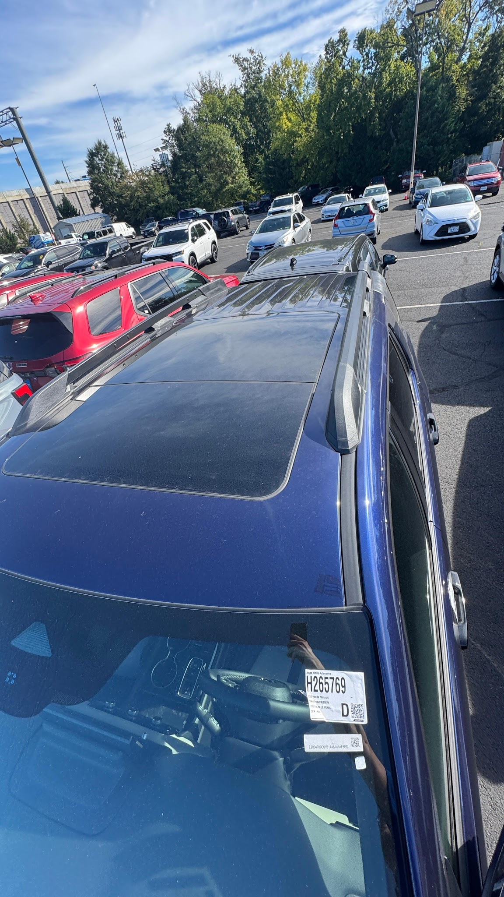
IMG_4096.jpg
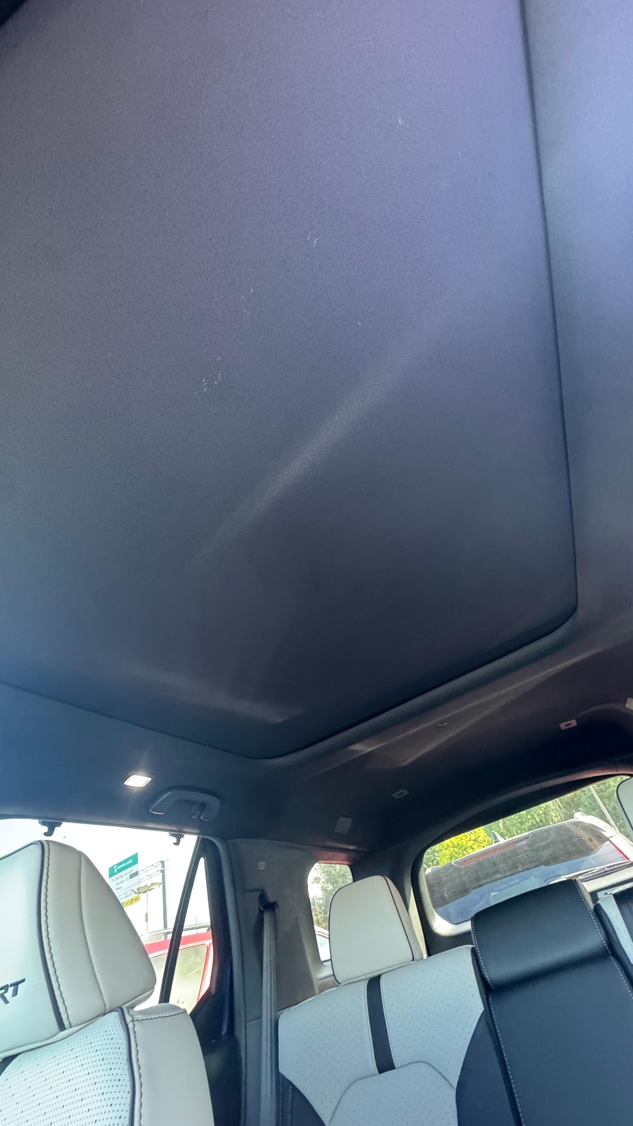
IMG_4095.jpg
Reply All
Preview
2 Open 0 Clicks | Last Opened Sep 25 2026 11:01 PM
Email Sent
Mark Armstrong
Sep 25 2026 9:57 AM
jhwilsonsc@gmail.com
Subject: Re: Re: Re: Re: Re: Re: Re: Re: Re: Re: Exclusive Joyce Koons Honda offer
According to everything I read, it does. I agree it's hard to tell in this photo, so let me go walk out to the car and check. I'll send you another photo. 2026 Honda Passport Stock Number H 265769 Exterior Obsidian Blue Pearl Interior Gray
Reply All
Preview
2 Open 0 Clicks | Last Opened Sep 25 2026 9:44 PM
Email Sent
Mark Armstrong
Sep 25 2026 9:51 AM
jhwilsonsc@gmail.com
Subject: Re: Re: Re: Re: Re: Re: Re: Re: Re: Exclusive Joyce Koons Honda offer
Yes, let me look.
Reply All
Preview
2 Open 0 Clicks | Last Opened Sep 25 2026 9:44 PM
Email Received
Jim Wilson
Sep 25 2026 9:48 AM
Subject: Re: Re: Re: Re: Re: Re: Re: Re: Exclusive Joyce Koons Honda offer
Hi Mark, Sorry I didn't get back to you yesterday. The only option I would accept is the Obsidian Blue Elite Blackout trim. We like the Blue. Can you confirm that vehicle also has the panoramic sunroof? It is hard to tell from the photos. The hangup is also the trade value. I have shopped my trade to three Honda dealers. They came back with $25,625, $26,000 and you offered $21,500. Carvana also offered $26,000. Thank you! Jim
Reply All
Preview
Note
Mark Armstrong
Sep 24 2026 6:17 PM
I called and left a voicemail to the customer’s machine.
Outbound Voicemail
Mark Armstrong
Sep 24 2026 6:15 PM
Called +1 (803) 370 - 4244 and left voicemail
Duration 01:17
Note: I called and left a voicemail to the customer’s machine.
Email Sent
Mark Armstrong
Sep 24 2026 6:15 PM
jhwilsonsc@gmail.com
Subject: Checking In
Hey Jim, I see that a sales manager reached out to you. I just wanted to check in and see if you got my pricing and if there was anything else I could help you with today. I'm about to head home for the evening, but I will be sure to check in first thing in the morning! Best, Mark Armstrong +1(703) 365-8713 Joyce Koons Automotive Delivering Great Value and Exceptional Customer Service 10660 Automotive Dr Manassas, VA 20109 JoyceKoons.com
Reply All
Preview
3 Open 0 Clicks | Last Opened Sep 25 2026 9:41 AM
Engaged Lead Follow Up
System
Sep 24 2026 5:12 PM
Lead is in the Engaged Stage, follow up with lead or reschedule this follow up task.
High
September 24, 2026
Done
Assigned To:
Mark Armstrong
Email Sent
Mark Armstrong
Sep 24 2026 4:40 PM
jhwilsonsc@gmail.com
Subject: Re: Re: Re: Re: Re: Re: Re: Re: Exclusive Joyce Koons Honda offer
6 Attachments
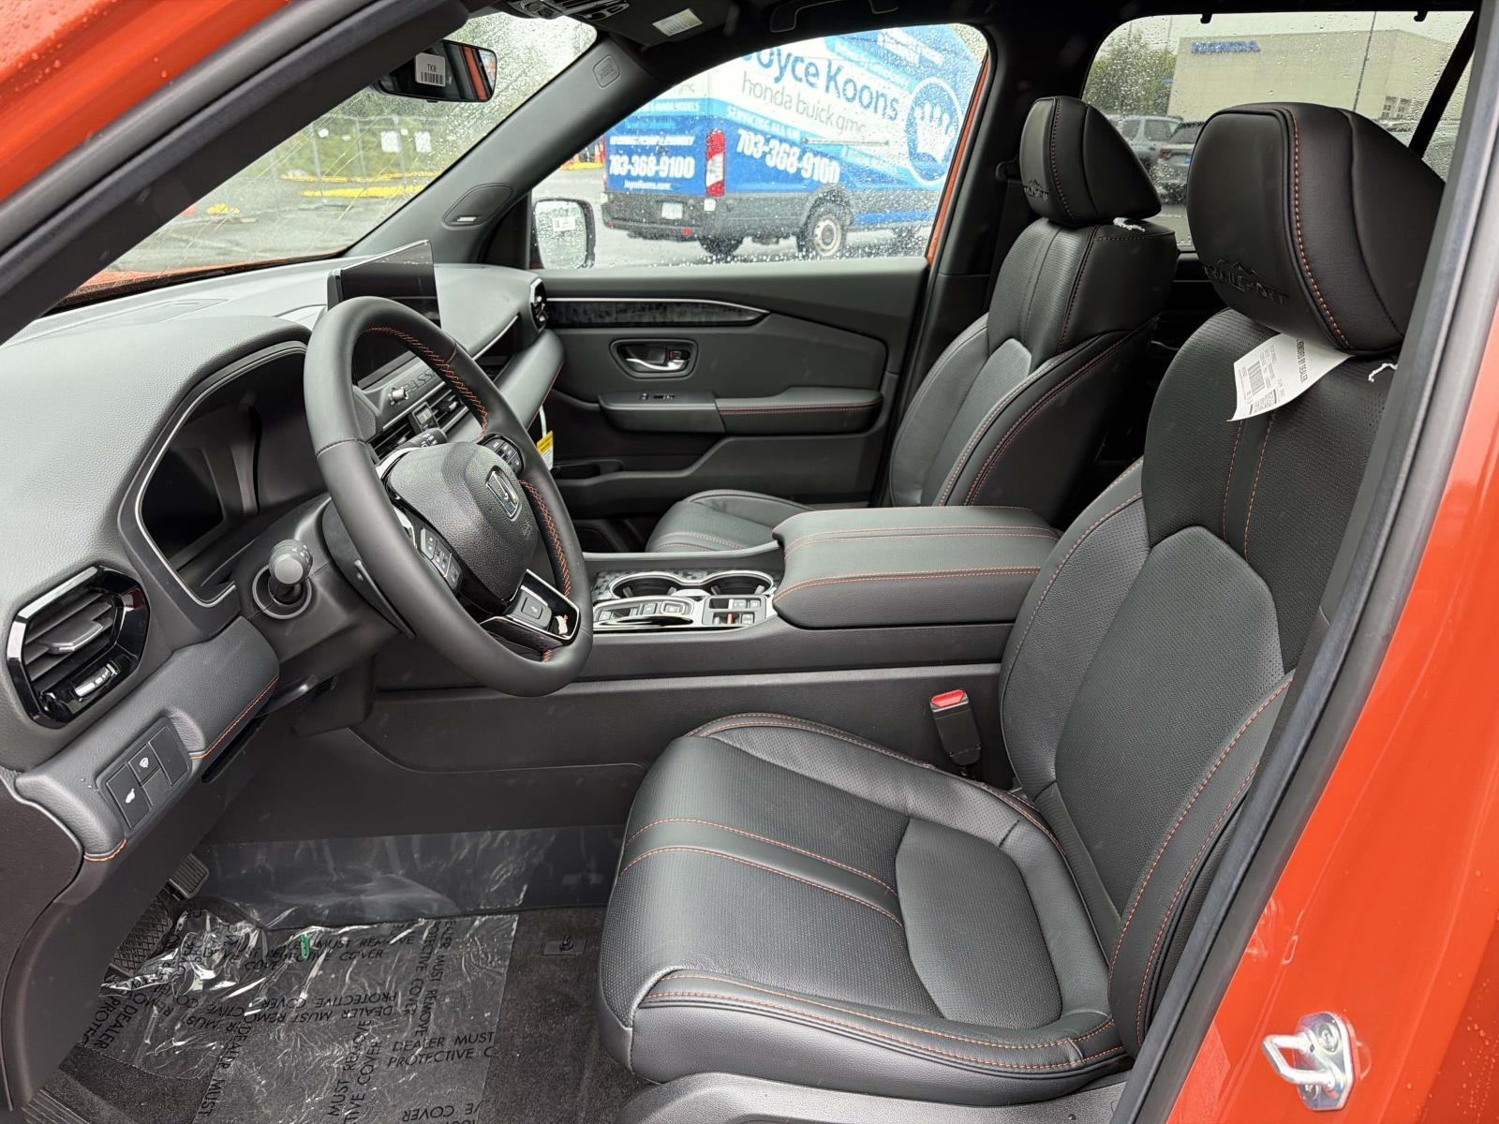
Option 1 - Sunset Orange Interior.jpg
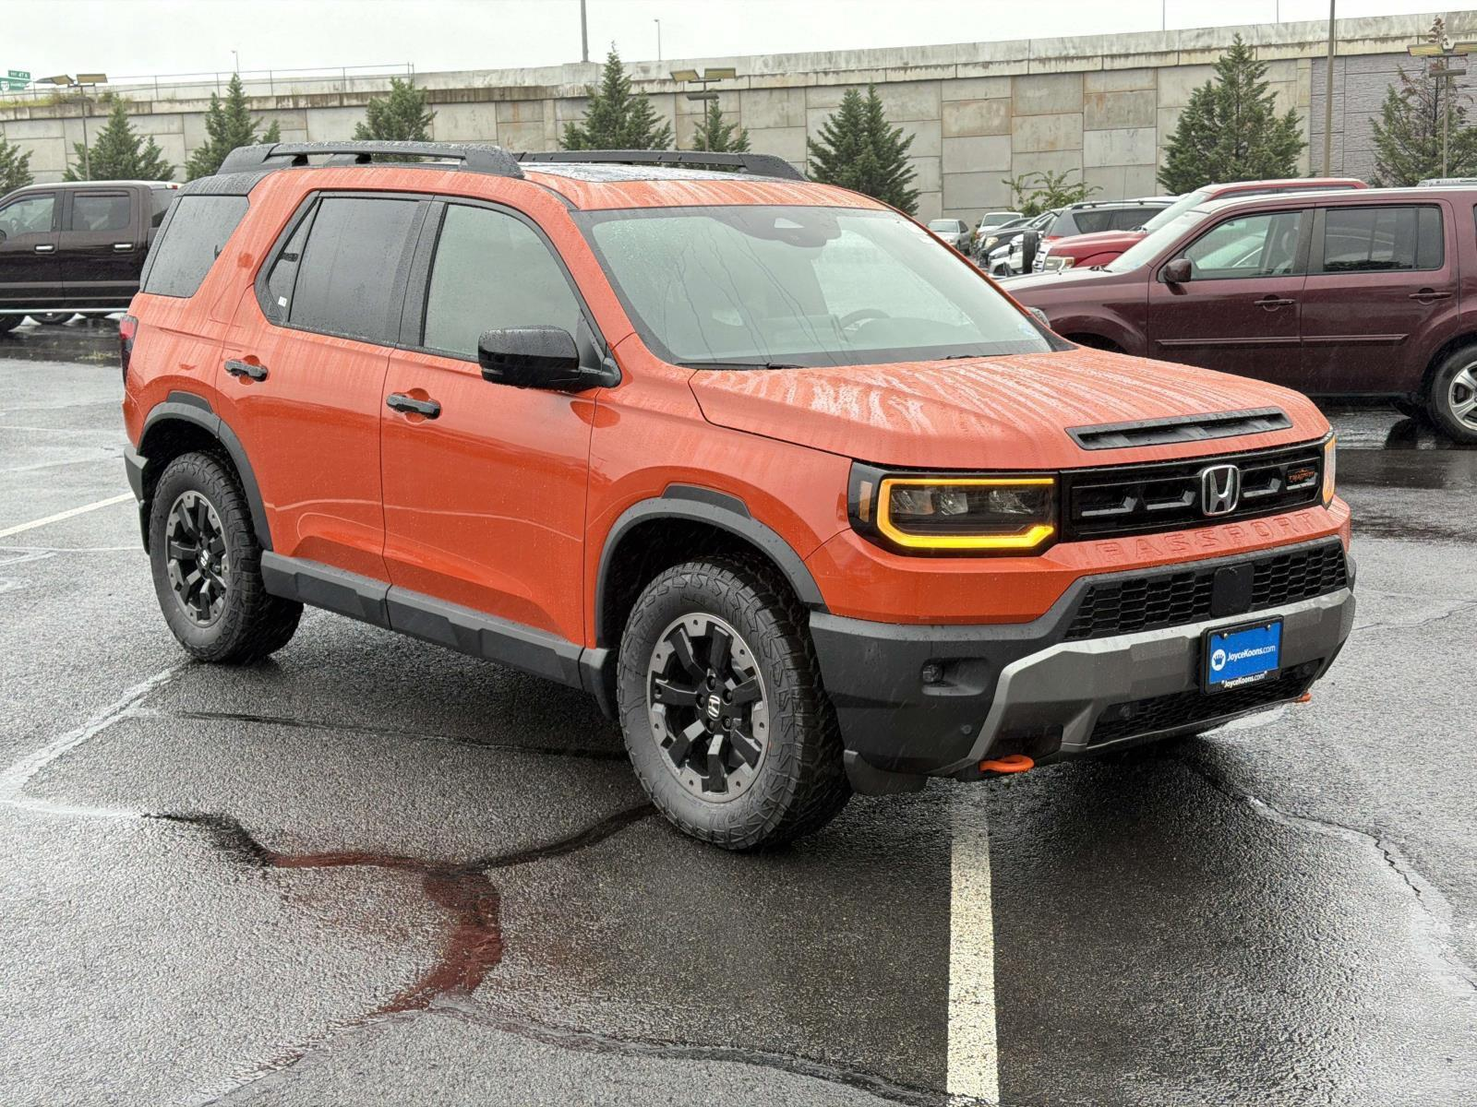
Option 1 - Sunset Orange.jpg
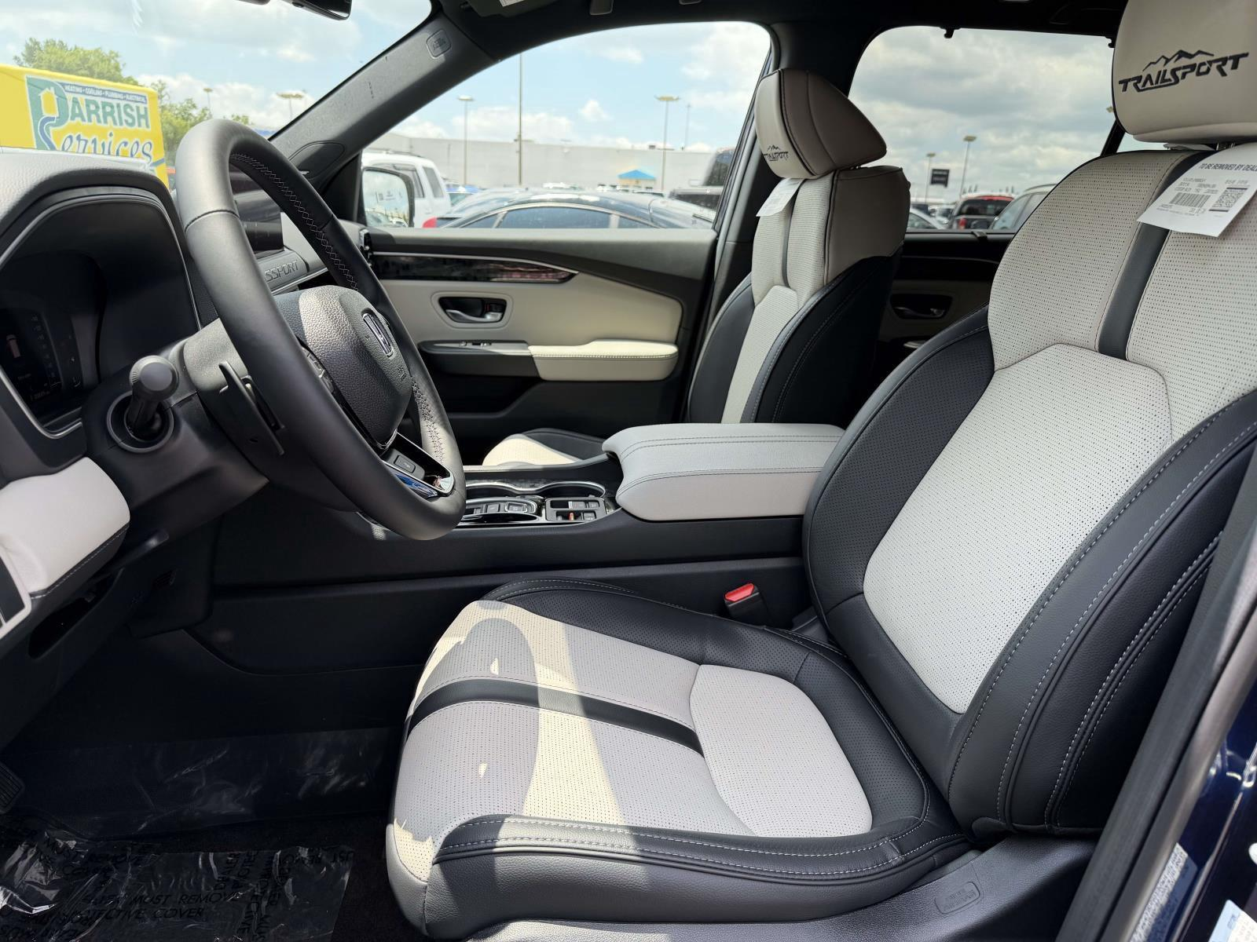
Option 2 - Blackout Gray Interior.jpg
Reply All
Preview
12 Open 0 Clicks | Last Opened Last Wed, 4:28 PM
Email Sent
Mark Armstrong
Sep 24 2026 4:31 PM
jhwilsonsc@gmail.com
Subject: Re: Re: Re: Re: Re: Re: Re: Exclusive Joyce Koons Honda offer
Okay, I got good news and bad news. Bad news is that vehicle isn't available and shouldn't even be on the website. I don't know why it took me this long for someone to mention that, so I'm so sorry. Thank being said, I finally got the numbers for it - I'm dead. The good news is that there are options, and I already have the numbers for it. FIRST ** Your Audi value is: $21,500.00 OPTION #1 The first option is the same trim level (Trail Sport Elite AWD) The difference is the Exterior Color - Sunset Orange The interior is still black though View it on the website here MSRP: $54,600($455 more than the original due to the color) Dealer Discount: - $5,945 Processing Fee: $1,199 Protection Package: $595 Sale Price: $50,449 OPTION #2 The Second option is the color - Obsidian Blue Pearl This model has a gray interior (which I think is nicer) That being said, it's the Trail Sport Elite Blackout trim which is a step up. View it on the website here MSRP: $55,345($980 more than the original trim) Dealer Discount: - $6,095 Processing Fee: $1,199 Protection Package: $595 Sale Price: $51,044 OPTION #3 The third option is Obsidian Blue Pearl with a black interior, but It's the Trail Spor trim which is a step down from what you were originally looking at. View it on the website here MSRP: $50,145($4,00 less than the original trim) Dealer Discount: - $5,045 Processing Fee: $1,199 Protection Package: $595 Sale Price: $46,894 So, it really depends on the features you want. You can find all the details of the trim types - here Feel free to tell me what you want and I can help. THE EXTRAS Tags and Registration: $100-150 (We can't confirm the exact number) Tax (This is the best part) is 5% BUT is capped at $500 Total: no more than $650 I'm going to send you photos of each one. Let me know your thoughts - If you want to call me, I'm available to answer any questions. Best, Mark
Reply All
Preview
2 Open 0 Clicks | Last Opened Sep 24 2026 5:35 PM
Note
Tim Welton
Sep 24 2026 3:50 PM
pitched blackout. he's interested. talk to wife and call me in 20 for numbers
Text Sent
Tim Welton
Sep 24 2026 3:49 PM
https://www.joycekoonshonda.com/vehicle/New/2026/Honda/Passport/5FNYF9H86TB085674/
Vehicle Interest Added
Tim Welton
Sep 24 2026 3:48 PM
Vehicle Interest:
2026 Honda Passport
2026 Honda Passport
+1
Vehicle Interest Added
Tim Welton
Sep 24 2026 3:48 PM
Vehicle Interest:
2026 Honda Passport
2026 Honda Passport
+1
Vehicle Interest Added
Tim Welton
Sep 24 2026 3:48 PM
Vehicle Interest:
2026 Honda Passport
2026 Honda Passport
+1
Primary Vehicle Interest Updated
Tim Welton
Sep 24 2026 3:48 PM
Stock ID:
H265742
H265769
VIN:
5FNYF9H89TB085586
5FNYF9H86TB085674
Vehicle Interest Added
Tim Welton
Sep 24 2026 3:48 PM
Vehicle Interest:
2026 Honda Passport
2026 Honda Passport
+1
Primary Vehicle Interest Updated
Tim Welton
Sep 24 2026 3:48 PM
Stock ID:
H265769
H265742
VIN:
5FNYF9H86TB085674
5FNYF9H89TB085586
Vehicle Interest Added
Tim Welton
Sep 24 2026 3:48 PM
Vehicle Interest:
2026 Honda Passport
2026 Honda Passport
+1
Inbound Call
Tim Welton
Sep 24 2026 3:47 PM
Received a call from +1 (803) 370 - 4244
Duration 02:58
Note: pitched blackout. he's interested. talk to wife and call me in 20 for numbers
Call Back
Deal Sheet
Tim Welton
Sep 24 2026 3:45 PM
Deal Number:
329402
Vehicle:
2026 Honda Passport
329402_DealSheet-debac33e-3e82-4488-8e0a-04e9e5f3d528.pdf
Print
Email
Text
Vehicle Interest Added
Tim Welton
Sep 24 2026 3:45 PM
Vehicle Interest:
2026 Honda Passport
2026 Honda Passport
+1
Primary Vehicle Interest Updated
Tim Welton
Sep 24 2026 3:45 PM
Stock ID:
H265742
H265769
VIN:
5FNYF9H89TB085586
5FNYF9H86TB085674
Deal Sheet
Tim Welton
Sep 24 2026 3:44 PM
Deal Number:
329402
Vehicle:
2026 Honda Passport
329402_DealSheet-a9b4a20f-8b73-455e-b3d2-5f1960d45d5a.pdf
Print
Email
Text
Deal Sheet
Tim Welton
Sep 24 2026 3:44 PM
Deal Number:
329402
Vehicle:
2026 Honda Passport
329402_DealSheet-5746331c-cfb5-4b3f-973d-fb753f3c12a1.pdf
Print
Email
Text
Note
Tim Welton
Sep 24 2026 3:42 PM
I called and left a voicemail to the customer’s machine.
Outbound Voicemail
Tim Welton
Sep 24 2026 3:41 PM
Called +1 (803) 370 - 4244 and left voicemail
Duration 01:02
Note: I called and left a voicemail to the customer’s machine.
Email Sent
Mark Armstrong
Sep 24 2026 3:37 PM
jhwilsonsc@gmail.com
Subject: Re: Re: Re: Re: Re: Re: Exclusive Joyce Koons Honda offer
So sorry for all this back and forth, my manager can't seem to get enough information. I've been running between showrooms. Hopefully this is all I need, we'll see though!!!
Reply All
Preview
3 Open 0 Clicks | Last Opened Sep 24 2026 5:35 PM
Email Received
Jim Wilson
Sep 24 2026 3:35 PM
Subject: Re: Re: Re: Re: Re: Exclusive Joyce Koons Honda offer
Yes, I have the title
Reply All
Preview
Email Sent
Mark Armstrong
Sep 24 2026 3:35 PM
jhwilsonsc@gmail.com
Subject: Re: Re: Re: Re: Re: Exclusive Joyce Koons Honda offer
Is the Audi paid off?
Reply All
Preview
15 Open 0 Clicks | Last Opened Last Wed, 4:28 PM
Note
Ricky Vo
Sep 24 2026 3:16 PM
38 Hanover St Pawleys Island, SC 29585
Email Sent
Mark Armstrong
Sep 24 2026 3:14 PM
jhwilsonsc@gmail.com
Subject: Re: Re: Re: Re: Exclusive Joyce Koons Honda offer
Okay one second, thank you so much!
Reply All
Preview
2 Open 0 Clicks | Last Opened Sep 25 2026 4:53 PM
Note
Mark Armstrong
Sep 24 2026 3:13 PM
38 Hanover St Pawleys Island, SC 29585
Email Received
Jim Wilson
Sep 24 2026 3:13 PM
Subject: Re: Re: Re: Exclusive Joyce Koons Honda offer
38 Hanover St Pawleys Island, SC 29585
Reply All
Preview
Email Sent
Mark Armstrong
Sep 24 2026 3:11 PM
jhwilsonsc@gmail.com
Subject: Re: Re: Re: Exclusive Joyce Koons Honda offer
Okay they're telling me they need your full address to get the tax code. I'm so so sorry.
Reply All
Preview
14 Open 0 Clicks | Last Opened Last Wed, 4:28 PM
Salesperson 2 Assigned
Mark Armstrong
Sep 24 2026 3:01 PM
Ricky Vo got assigned as a Salesperson 2
Email Received
Jim Wilson
Sep 24 2026 3:01 PM
Subject: Re: Re: Exclusive Joyce Koons Honda offer
Hi Mark, Zip 29585 in SC
Reply All
Preview
Email Sent
Mark Armstrong
Sep 24 2026 2:58 PM
jhwilsonsc@gmail.com
Subject: Re: Re: Exclusive Joyce Koons Honda offer
Okay I got the trade value, last thing I need is the zip code you plan on registering it in.
Reply All
Preview
16 Open 0 Clicks | Last Opened Last Wed, 4:28 PM
Outbound Call
Mark Armstrong
Sep 24 2026 2:56 PM
Called +1 (803) 370 - 4244 and contacted
Duration 00:52
Trade-in Updated
Tim Welton
Sep 24 2026 2:52 PM
Vehicle Updated:
2023 Audi Q5
Trade Allowance:
None
$21,500.00
Sales Manager Assigned
Tim Welton
Sep 24 2026 2:51 PM
Tim Welton got assigned as a Sales Manager
Stage Changed
Tim Welton
Sep 24 2026 2:51 PM
Stage got changed from Engage to Proposal
Deal Created
Tim Welton
Sep 24 2026 2:51 PM
Deal Number:
329402
Vehicle:
2026 Honda Passport | 5FNYF9H86TB085674
Status:
Quote
Trade-in Updated
V Bui
Sep 24 2026 2:18 PM
Vehicle Updated:
2023 Audi Q5
Year:
None
2023
Make:
None
audi
Model:
None
Q5
VIN:
WA1GAAFY5P2188242
WA1GAAFY5P2188232
Email Received
Jim Wilson
Sep 24 2026 1:25 PM
Subject: Re: Exclusive Joyce Koons Honda offer
Hi Mark, Here are some photos, sorry it’s wet it is raining here! Sent from my iPhone
20 Attachments
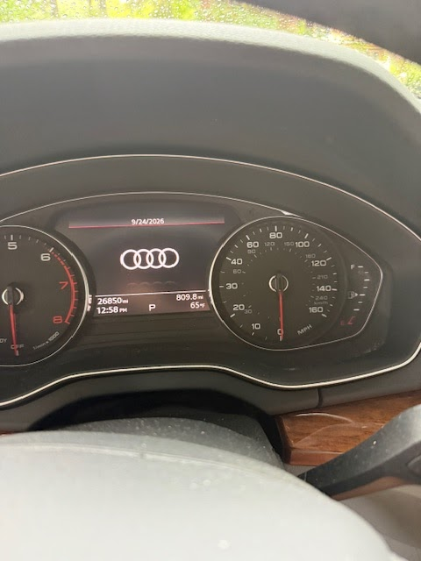
0_image0.jpeg
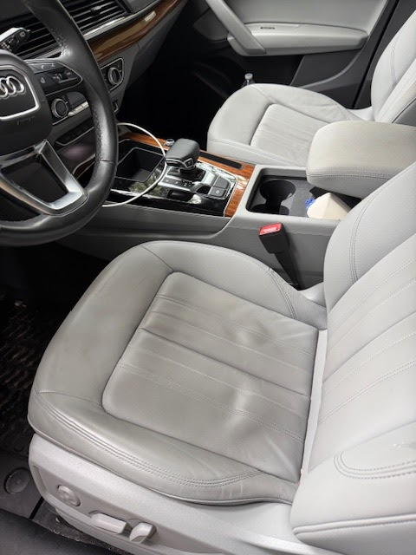
0_image1.jpeg
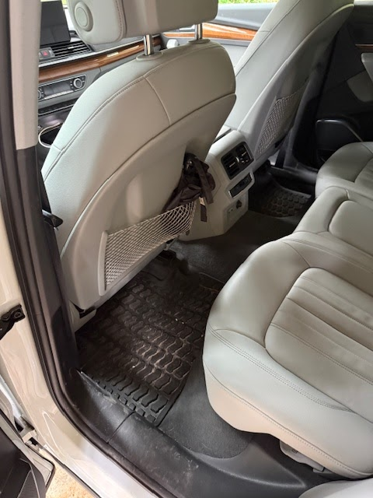
0_image2.jpeg
Reply All
Preview
Email Sent
Mark Armstrong
Sep 24 2026 10:05 AM
jhwilsonsc@gmail.com
Subject: Re: Re: Exclusive Joyce Koons Honda offer
Haha looks like a 3 became a 4. I'll get as much info as I can get you. Once I get the pricing straightened out and sent over, I'll give you a quick ring to go though it.
Reply All
Preview
22 Open 0 Clicks | Last Opened Last Wed, 4:28 PM
Note
Mark Armstrong
Sep 24 2026 10:03 AM
Can you give me the OTD price factors for 29585 zip - so tags / reg and tax
Email Received
Jim Wilson
Sep 24 2026 9:56 AM
Subject: Re: Exclusive Joyce Koons Honda offer
I probably typed wrong. Here is the insurance card with vin Sent from my iPhone
1 Attachments
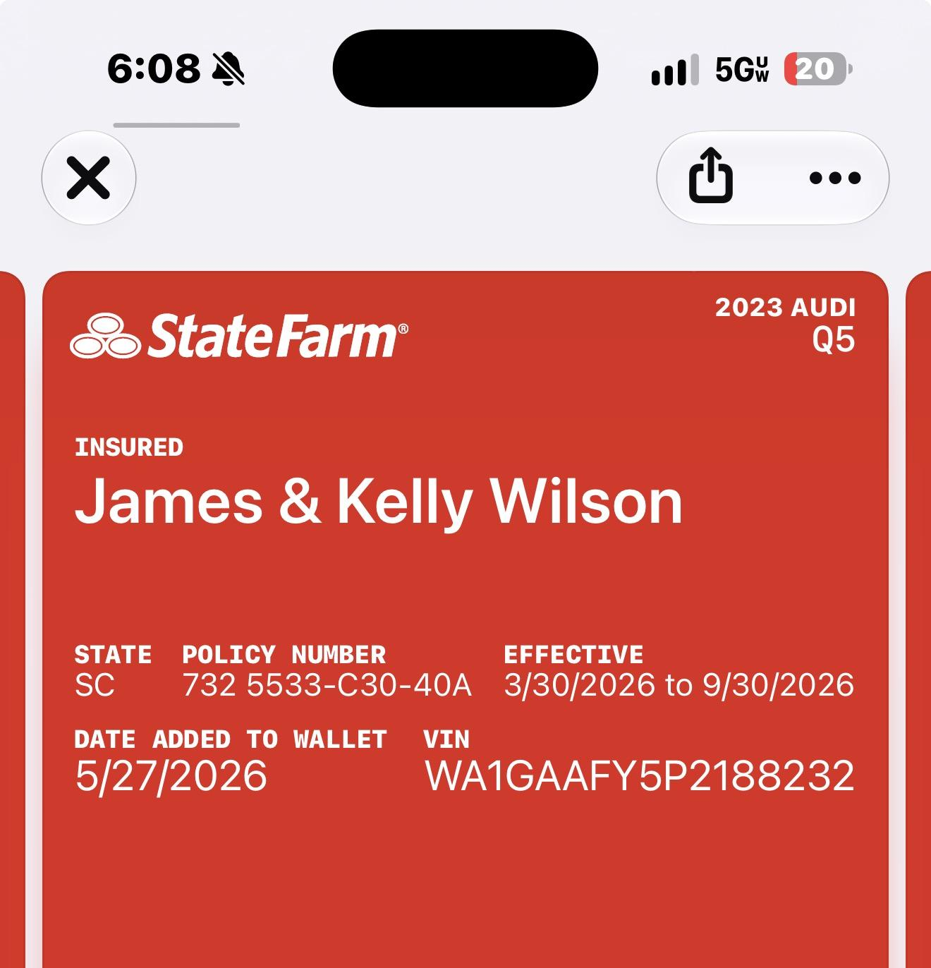
0_image0.jpeg
Reply All
Preview
Email Sent
Mark Armstrong
Sep 24 2026 9:51 AM
jhwilsonsc@gmail.com
Subject: Re: Re: Exclusive Joyce Koons Honda offer
Hey I just tried to run the car without the photos by the trade-in guy - he couldn't find the vin. Could you just double check that the vin is correct? Mark
Reply All
Preview
26 Open 0 Clicks | Last Opened Today, 11:24 AM
Trade-in Added
V Bui
Sep 24 2026 9:47 AM
Vehicle Added:
Make:
None
None
VIN:
None
WA1GAAFY5P2188242
Ownership Type:
None
Loaned/Owned
Trade In Vehicle:
None
Included
Email Received
Jim Wilson
Sep 24 2026 9:28 AM
Subject: Re: Exclusive Joyce Koons Honda offer
Hi Mark, my zip is 29585. Audi has never been wrecked and all maintenance and recalls are current. Sent from my iPhone
Reply All
Preview
Email Sent
Mark Armstrong
Sep 24 2026 9:21 AM
jhwilsonsc@gmail.com
Subject: Re: Re: Exclusive Joyce Koons Honda offer
Sounds perfect! I'll get some information now. Can you confirm your zip code, so I can start calculating your OTD cost?
Reply All
Preview
28 Open 0 Clicks | Last Opened Today, 11:24 AM
Email Received
Jim Wilson
Sep 24 2026 9:19 AM
Subject: Re: Exclusive Joyce Koons Honda offer
Hi Mark, I am away f ok the Audi right now but can send pictures this afternoon. FYI there are no rips, tears, or stains on the interior. Sent from my iPhone
Reply All
Preview
Email Sent
Mark Armstrong
Sep 24 2026 9:09 AM
mark.armstrong@joycekoons.com
Subject: Fwd: Re: Exclusive Joyce Koons Honda offer
+1 (803) 370 - 4244
Reply All
Preview
3 Open 3 Clicks | Last Opened Sep 24 2026 2:52 PM
Email Sent
Mark Armstrong
Sep 24 2026 8:44 AM
jhwilsonsc@gmail.com
Subject: Re: Re: Exclusive Joyce Koons Honda offer
Hey Jim, If you don't mind sending me some photos of the interior and exterior, I can go talk to the team that handles that for you. Should only take me a few minutes to get you an answer. Best, mark
Reply All
Preview
30 Open 0 Clicks | Last Opened Today, 11:24 AM
Stage Changed
Mark Armstrong
Sep 23 2026 5:12 PM
Stage got changed from Attempted Contact to Engage
Email Received
Jim Wilson
Sep 23 2026 5:12 PM
Subject: Re: Exclusive Joyce Koons Honda offer
Hi Mark, If we make a deal, I have to drive to Manassas, so I will need to trade my car vs sell to Carvana/carmax. I have a 2023 Audi Q5 with just under 27,000 miles. Never wrecked 1 owner. Vin WA1GAAFY5P2188242 Audi is in perfect condition. What trade value can you provide? Thanks!Jim Sent from my iPhone
Reply All
Preview
Email Sent
Mark Armstrong
Sep 23 2026 3:20 PM
jhwilsonsc@gmail.com
Subject: introduction
Hey Jim, My name is Mark, I'm here to answer any questions you have. I left you a voicemail earlier explaining the current interest in this particular vehicle. Is there a specific reason this Passport caught your eye? or are you open to different versions? Best, Mark Armstrong +1(703) 365-8713 Joyce Koons Automotive Delivering Great Value and Exceptional Customer Service 10660 Automotive Dr Manassas, VA 20109 JoyceKoons.com We do not rent, sell or exchange email addresses. We encourage you not to unsubscribe so that we can keep you informed about promotions, new vehicles, service tips and service specials, but if you choose to, you can opt out here. If you prefer not to receive further emails from us, Click here to Unsubscribe
Reply All
Preview
2 Open 0 Clicks | Last Opened Sep 23 2026 3:26 PM
checkin
Mark Armstrong
Sep 23 2026 12:55 PM
Medium
September 24, 2026
Manually Closed
Assigned To:
Mark Armstrong
Conversica Lead Response
System
Sep 23 2026 12:38 PM
Email is best. Thanks!
Note
Mark Armstrong
Sep 23 2026 12:09 PM
I called and left a voicemail to the customer’s machine.
Conversica Message
System
Sep 23 2026 12:08 PM
Good afternoon Jim,

Thank you for submitting your request on the Honda Passport.

We would like to connect by texting and can call and email as well. What method is best?

Thank you very much and have a wonderful afternoon,

Lola | Customer Care Assistant

Joyce Koons Honda Buick GMC

(866) 711-4118

10660 Automotive Drive, Manassas, VA 20109

www.joycekoonsbuickgmc.com

P.S. If you prefer text, we may send the info you asked for through an automated system. Otherwise, you can still work with us over email or phone.

¡Se habla español! Háganos saber si prefiere nuestros servicios en español.

https://unsubscribe.mailferret.net/unsubscribe.php?sr=cHx6I.3j9btfs
Read More
Outbound Voicemail
Mark Armstrong
Sep 23 2026 12:07 PM
Called +1 (803) 370 - 4244 and left voicemail
Duration 01:20
Note: I called and left a voicemail to the customer’s machine.
Text Sent
Mark Armstrong
Sep 23 2026 12:07 PM
Jim, 2026 Honda Passport available; details > https://tinyurl.com/mree7tya See email for Selling Price (check spam/junk) >> visit today or tomorrow for test drive? Mark @ Joyce Koons Honda in Manassas, VA
Email Sent
Mark Armstrong
Sep 23 2026 12:06 PM
jhwilsonsc@gmail.com
Subject: Exclusive Joyce Koons Honda offer
Great Prices | Special APR Rates | Big Inventory Jim, Complimentary 1-year or 12,000-mile Honda Service Pass plus additional 1-year or 12,000 mile Joyce Koons Advantage maintenance plan is included with your purchase. Both plans include complimentary Joyce Koons Concierge Pick-Up & Retur n convenience when your new vehicle is due for maintenance. 2026 Honda Passport Stock Number H 265742 Exterior Obsidian Blue Pearl Interior Gray Honda Passport TrailSport Elite AWD > view additional details here Factory Installed Tow Package - Ball Mount - 2" Ball Hitch - Towing Organizer MSRP : $54,365 Joyce Koons Discount : - $ 5,945 Processing Fee : $1,199 Protection Package : $595 Selling Price : $50,214* In-Stock for Immediate Delivery You may qualify for $1,000 or more in additional factory discounts. Ask me for details! Are you interested in visiting us today or tomorrow to test drive & review purchase options for this Passport? Hope to hear from you soon! Mark Armstrong +1(703) 365-8713 Joyce Koons Automotive Delivering Great Value and Exceptional Customer Service 10660 Automotive Dr Manassas, VA 20109 JoyceKoons.com *Selling Price EXCLUDES applicable sales tax, title, registration and electronic titling fees. Selling price includes factory destination freight, protection package (wheel locks & splash guards) and $1,199 processing fee. Selling Price not compatible with 0% APR financing or dealership special offers -- see dealer for details. We make every effort to provide accurate information, and reserve right to correct pricing errors. ePrice valid until COB. Click here to Unsubscribe
Reply All
Preview
36 Open 3 Clicks | Last Opened Today, 11:24 AM
Email Sent
Mark Armstrong
Sep 23 2026 11:55 AM
jhwilsonsc@gmail.com
Subject: My pleasure to help you today!
Great Prices | Special Rates | Big Inventory Jim, Thank you for contacting Joyce Koons Honda Buick GMC as you think about purchasing a Honda Passport. My name is Mark, and it will be my pleasure to assist you. My next email will outline the availability and Selling Price for 2026 Honda Passport. If you don't see another email in your inbox from me in a few minutes, please check your spam/junk folder for my Special ePrice email. Thank you Mark Armstrong +1(703) 365-8713 Joyce Koons Automotive Delivering Great Value and Exceptional Customer Service 10660 Automotive Dr Manassas, VA 20109 JoyceKoons.com We do not rent, sell or exchange email addresses. We encourage you not to unsubscribe so that we can keep you informed about promotions, new vehicles, service tips and service specials, but if you choose to, you can opt out here. If you prefer not to receive further emails from us, Click here to Unsubscribe
Reply All
Preview
2 Open 0 Clicks | Last Opened Sep 23 2026 12:46 PM
Stage Changed
Mark Armstrong
Sep 23 2026 11:55 AM
Stage got changed from Assigned to Attempted Contact
Text Sent
Mark Armstrong
Sep 23 2026 11:55 AM
Hey Jim! Mark from Joyce Koons Honda. I’m about to email you the Passport info you asked for (check spam/junk). I’ll give you a quick ring after. Thanks for checking us out! 'Reply STOP to unsubscribe'
New Internet Lead - Immediate Follow Up Email
System
Sep 23 2026 11:50 AM
New Internet Lead - Immediate Follow Up Email
High
September 23, 2026
Done
Assigned To:
Mark Armstrong
New Internet Lead - Immediate Follow Up Text
System
Sep 23 2026 11:50 AM
New Internet Lead - Immediate Follow Up Text
High
September 23, 2026
Done
Assigned To:
Mark Armstrong
New Internet Lead - Immediate Follow Up Call
System
Sep 23 2026 11:50 AM
New Internet Lead - Immediate Follow Up Call
High
September 23, 2026
Done
Assigned To:
Mark Armstrong
Salesperson Assigned
Lead Assignment Rule | All Other Internet Lead Assignment
Sep 23 2026 11:50 AM
Mark Armstrong got assigned as a Salesperson
Stage Changed
System
Sep 23 2026 11:50 AM
Stage got changed from Created to Assigned
Primary Vehicle Interest Updated
System
Sep 23 2026 11:50 AM
Year:
None
2026
Make:
None
Honda
Model:
None
Passport
Stock ID:
None
H265742
VIN:
None
5FNYF9H89TB085586
Customer Comments
System
Sep 23 2026 11:50 AM
Lead Reference Number - NA; CUSTOMER INSIGHTS- ; CustomerComment : New Submission from Quick Form SRP.

Vehicle URL: https://www.joycekoonshonda.com/vehicle/New/2026/Honda/Passport/5FNYF9H89TB085586/ ADDITIONAL INFO- CustomerComment:

New Submission from Quick Form SRP.

Vehicle URL: https://www.joycekoonshonda.com/vehicle/New/2026/Honda/Passport/5FNYF9H89TB085586/

; Einstein Predicted Priority: Low;;;CHAT TRANSCRIPT- NA
Read More
Lead Created
System
Sep 23 2026 11:50 AM
Vehicle:
2026 Honda Passport
Source:
Hds Program Lead - Dealer Alchemist - Website Quick Form (Oem)

