Codecourse: https://codecourse.com/courses/learn-how-autowiring-works  
  
Thanks to Alex Garrett-Smith  
  
This is a powerful course to explain how containers and autowiring works.  
  
There are 3 video lectures.  
I am starting on video #2.  
  
I will save to git at key milestone points through video 2 and 3 in order to   
follow along and build the course along with Alex.  
The git files will be saved in format vhh.mm (video 2 or 3 and hours and minutes).  
I have used a MS word document to capture a summary of the discussion and also screen   
snips of key outputs. Entries here will also be saved in the same format above.

V00.19

This is my composer.json

{  
 "require": {  
 "symfony/var-dumper": "^6.0",  
 "twig/twig": "^3.8"  
 },  
 "autoload": {  
 "psr-4": {  
 "App\\": "app"  
 }  
 },  
 "scripts": {  
 "start": "php -S localhost:8080 -t public/",   
 "dump": "composer dump-autoload -o"  
 }  
}

“Composer dump” will pull in all the classes and store them into vendor/composer/autoload_classmap.php. This can be done on a regular basis to ensure all classes are autoloaded per psr-4.

“Composer start” will run the program.

App/Config/Config.php is prebuilt for the course.

Note the $config array is hard coded into the class.

v2_01.43

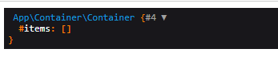

v2_04.03

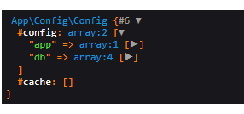

v2_04.39



v2_06.04

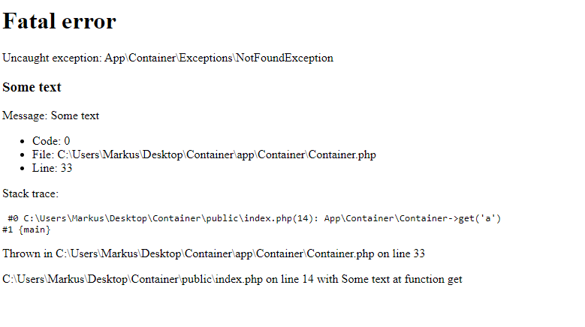

v2_06.59

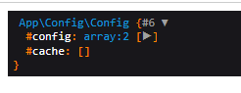

v2_07.35

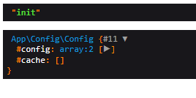

v2_08.09

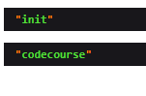

v2_08.32

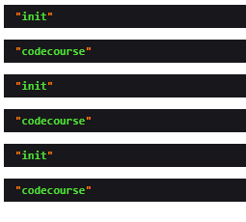

v2_11.23

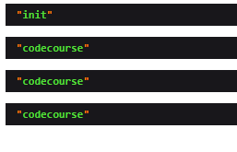

v2.14.41

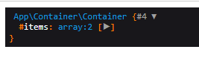

v2_15.14

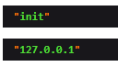

v2_18.19

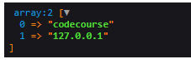

v3_03.16

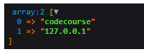

v3_05.56

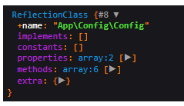

v3_07.10

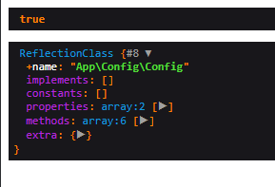

v3_09.47

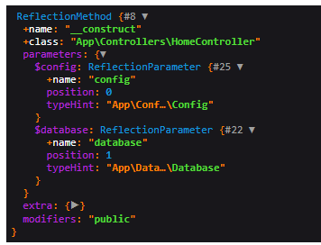

v3_12.21

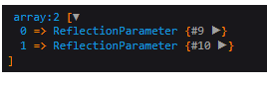

v3_13.01

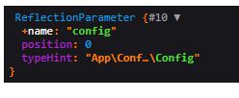

v3_13.29

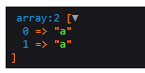

v3_14.59

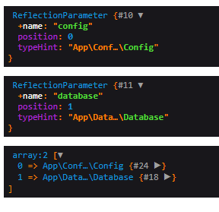

v3_15.30

