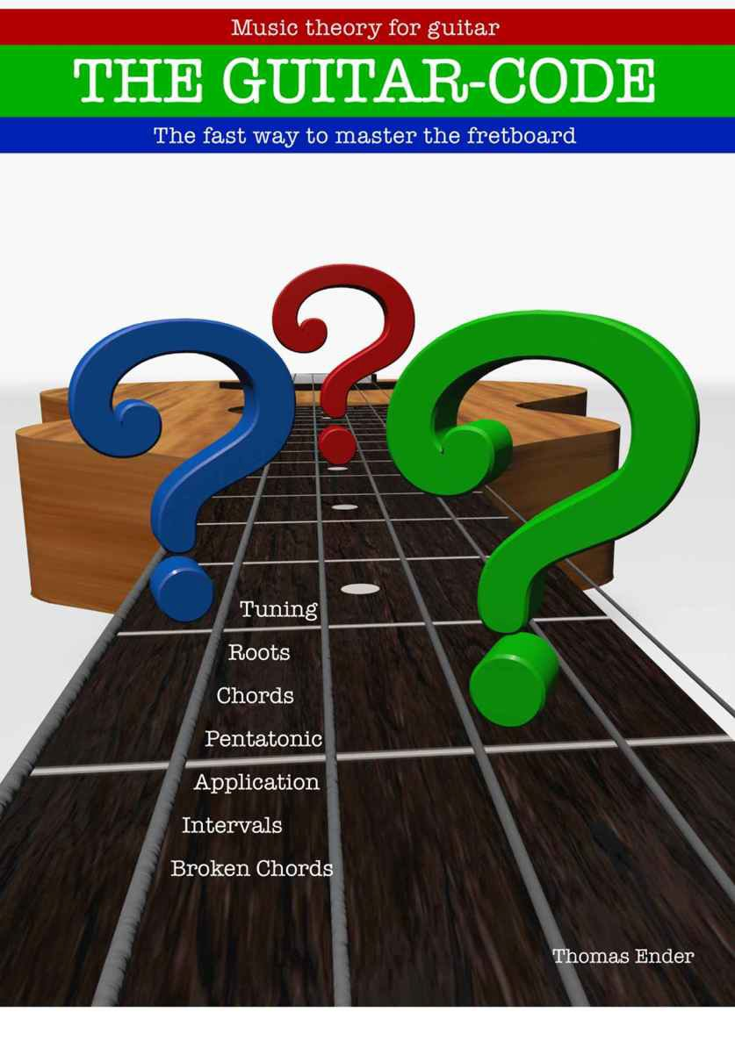

Music theory for guitar

**THE GUITAR-CODE**

The fast way to master the guitar fretboard

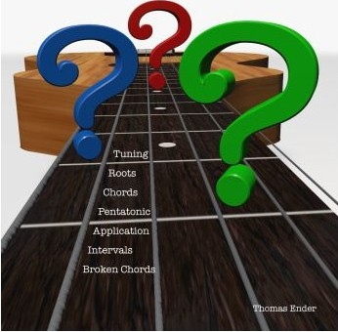

Contents

**What’s it all about?** 4

**3 What it’s all about**

**5 Tuning**

**6 Roots**

**9 Chords**

**20 Pentatonic**

**34 Use It**

**71 Intervals and extended chords**

**109 Broken chords**

**114 About me**

# **What’s it all about?**

In this book, the aspiring guitarist will find everything necessary for a broad, and with practice, deeper understanding of the guitar fretboard. This book should open new doors and unlock a new way of perceiving the guitar fretboard.

Before you begin working through this book though, it is recommended that you be familiar with the basics of guitar playing. In this regard you could consider yourself an advanced beginner when you can play these basic chords fluently (pressing them down on the fretboard), changing between them, while you strum or finger pick clear sounds with your other hand: C Major, A Major, A Minor, G Major, E Major, E Minor, D Major, D Minor.

I will show you how you can master the fretboard by moving these chords up and down the fretboard and which scales you can use with each of them. Equipped with this knowledge, you can easily accompany a song in various ways and being able to transpose a song will become as easy as 1 – 2 – 3. To transpose a song means to convert it into another Key. And this book will also assist you with a solid know how of how to use the fretboard if you have aspirations of being a lead guitarist.

And also, this book brings a solid know how, of the fretboard, for lead guitarists. A lead guitarist can play on their own, typically using lead riffs which are a series of notes played one after the other, linking songs parts payed by others together, or emphasizing dramatic moments in a song.

At the end of almost every chapter, a small exercise can be undertaken to see if you have understood what was explained in the chapter.

# **Tuning**

The tuning used in this entire book is: E(6) A(5) D(4) G(3) B (2) E(1)

If you change the tuning of you guitar, all the chords and scales

change according to the new tuning.

We take a look at exclusively this tuning. We gonna learn how to find every note instantly, every chord instantly and every scale instantly.

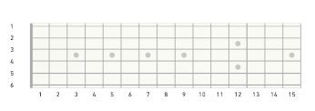

**Exercise: Remember the tuning and fill in the notes in the graphic above. If you got the e-book version, take a piece of paper and a pencil.**

Roots

A root defines the tonal center.

The root gives the scale or chords the first part of its name.

Logically, the root of the C Major chord or C Major scale, must be a

C.

The second part of the name tells us the family of the chord or scale. There are two families we gonna look at -> Major (Dur) and Minor

(Moll)

If a chord is major or minor depends on its third.

In the chapter about intervals, we gonna take a close look at the function of the third.

Now, we wanna bring our attention to the C major chord. Therefore, we look out for all the C’s on the fretboard:

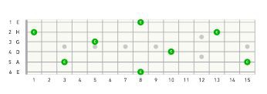

From everyone of this notes, you can build a C major chord! Therefore, its very important, to know all the notes on the fretboard. On the first glance, this may look complex.

But, there are only 12 different notes, that repeat themselves

systematically:

c, c#, d, d#, e, f, f#, g, g#, a, a#, b

If we start with the low E-String, you can find the octave (the same note again) two strings up (d-String) and two frets to the right. (For lefthanders left, of course)

The next octave is again, two strings up (b-string), but this time 3 frets right.

The next octave differs a bit, 3 strings DOWN (a-string), 2 frets right. On the a-string, you find the next octave, again, 2 strings up (g-

string), 2 frets right.

Next octave is 2 strings up (high e-string), and now again 3 frets right.

Then again, 3 strings DOWN (d-string) and 2 frets right.

So if you know the note c or c# or any other note, you can, with this know-how, find every other position of this note quickly, on the entire fretboard.

All the other intervals are gonna be covered in an own chapter. For now we are glad finding the octaves.

**Exercise: Fill in all the notes into the graphic above. The c is already put in. Continue, for example, with c# or any other note. If you got the e-book version, take a piece of paper and a pencil.**

**Chords**

In this chapter, you gonna learn, how to play a chords over the entire fretboard.

This is possible by moving chords.

We stick to our root c and build a major (Dur) chord in every position.

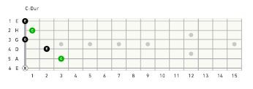

Here, we built a C major chord with the roots on the b-string and the a-string.

The next chord, we gonna build with the roots on the a-string and g- string:

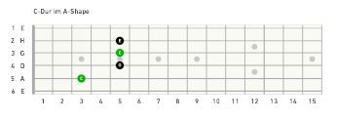

By moving this chord three frets left, until the root is the a-string itself, we get the well known A major chord:

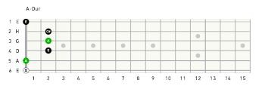

So we deal here with the moved A major chord.

But we built it on the root C – so we get a C major chord.

The next chord uses the roots on the g-string and e-strings:

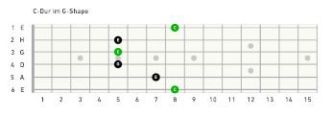

By moving this chord to the head of the guitar, we get the G major chord:

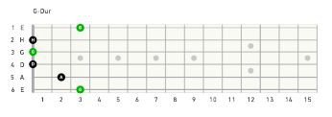

So we deal here with the moved G major chord. But we built it on the root C, so we get C major.

The next roots are found on the E-strings and the D-string.

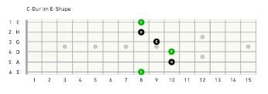

Here we moved the E-chord:

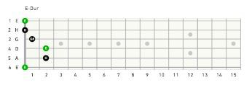

But we build it on the root C, so we get C major.

Next roots are on D-string and B-string:

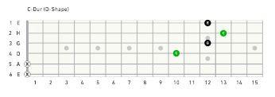

Here we deal with the moved D major chord.

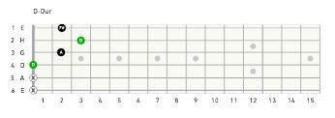

But we built it on the root C, so we get C major.

Here is an overview, of all possible C major positions:

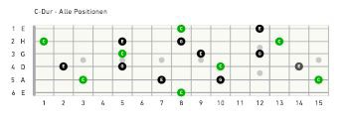

The same way we can handle minor chords. Again, we start with the root C and a chord that will be unfamiliar to most guitarists, but its easy to understand, where this chord is coming from. C minor, roots A-string and B-string

This chord is tricky to grab, but its very good to know it! 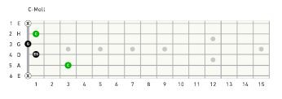 If we compare the C major with the C minor chord, we recognize, that only one note differs – E becomes Eb.

Next position uses the roots on the A-string and G-string:

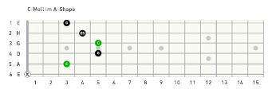

We deal with the moved A minor shape.

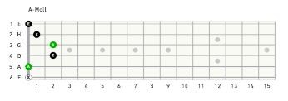

But we built it on the root of C, so we get C minor.

Next chord uses the roots on the G-string and E-strings:

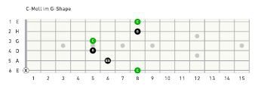

This chord is also very tricky to grab. Grab the notes on the B-string and high E-string with the pinky! This chord also just differs in one note from C Major to C Minor.

Next chord is using the roots on the E-strings and D-strings:

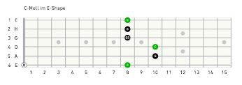

Here we deal with the moved E minor chord:

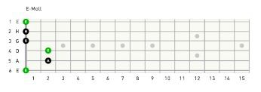

But we built it on the root of C, so we get C minor.

Next chord uses the roots on the D-string and B-string

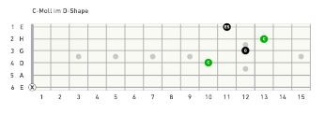

Here we deal with the move D minor chord:

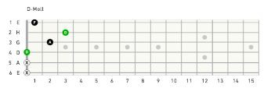

But we built it on the root of C, so we get C minor.

Now we have all the basic forms of chords in this tuning.

Practice this on all roots! You should be able to form major and minor chords an all roots.

**Exercise: Fill in all missing positions of the following chords. If you own the e-book version – use paper and pencil.**





**Pentatonic**

Penta means 5. Tonic means tone.

So the pentatonic is a scale consisting of 5 notes. It's easy to learn and is a good start into scales.

Let's go!

1. Form

The 5 notes can be found over the entire fretboard. It comes in handy to learn the pentatonic scale with 5 different forms.

This 5 forms can be played comfortably over 4 frets in each position

(with one exception)

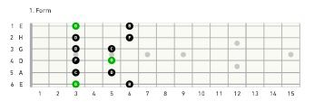

Position (when it comes to scales) mean that every finger of your left hand has one fret to take care of. For example “third position” is on the the frets:

3 – 4 – 5 – 6. (1)fore – (2)middle – (3)ring – (4)pinky

finger.

We look at the root G. This form is widely known as the minor pentatonic. And that's right, cause it contains a minor chord.

In 3. Position – G minor:

weu.;•e Shaf)O

:1 ] I:

*1* l *t.* S

·4 H*'1* t

·!\C I I:I !UI14 IS

But this form also contains a major chord, that is often overseen. In our example, we have a Bb on the sixth fret of the E-string, from which we can build a Bb – major chord:

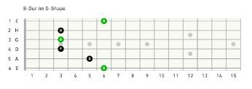

So this form could also be named Bb major pentatonic. For every fret we can use its according finger.

So we go with this fingering:

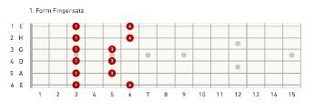

2. Form

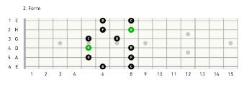

Fingering:

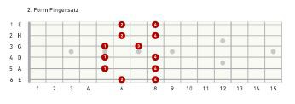

Again we find Bb major:

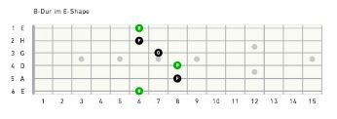

This time as a moved E major chord! And G minor:

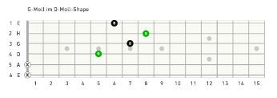

In form of the moved D minor chord.

3. Form

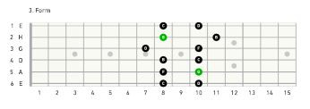

Here comes the exception. This form take 5 frets. Be aware of the G-string and B-string.

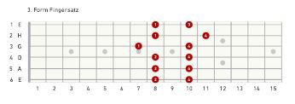

Again we can find both, a major and minor chord.

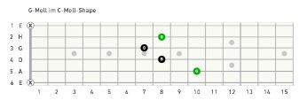For our example G minor:

Moved C minor chord.

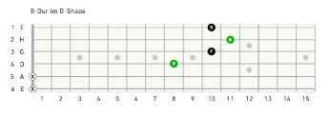Moved D major chord.

Bb major:

4. Form

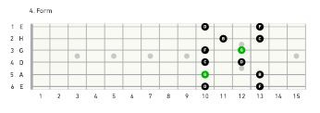

Fingering:

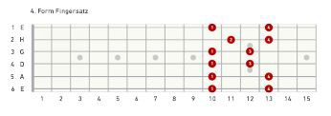

Again we encounter G minor and Bb major.

G minor

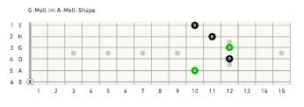

Moved A minor chord.

Bb major

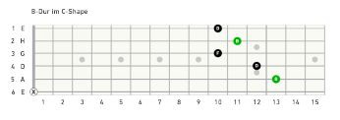Moved C major chord

Use your forefinger to fret the notes on E and B-strings.

Chords --->

5. Form

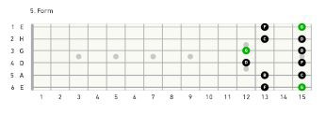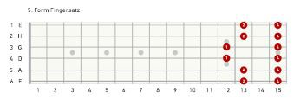Fingering:

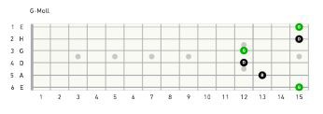Moved G minor chord.

G minor

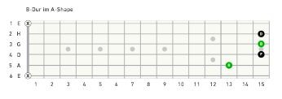Moved A major chord

Bb major

Now you know all 5 forms of the pentatonic with its according major and minor chords.

If we start form 1 on the 3 fret, like in our example here, we get G

minor and Bb major pentatonic.

In all of this 5 forms, we can always find this two chords. The roots of this chords, are 1 ½ step apart each other. In music theory, this is also called relative key.

From your minor root you always find the relative major root 3 frets higher, and from the major root you always find the relative minor 3 frets lower.

If you, f. e., wanna know the relative minor to C major you go like this:

C – B – Bb – A.

The relative minor to C major has to be A minor. Looking for the relative major you go up 3 frets: D – Eb – E – F.

So for the D minor chord, the relative major chord would be F Major.

Put together, all 5 forms of the pentatonic scale look like this:

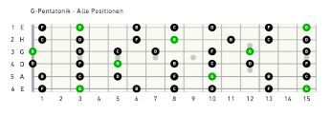

Fret three and four of the first form are also fret one and two of the second form.

This goes with all forms, except form 3 where you have one more fret.

The right half of the fifth form is also the beginning of the first form again. So the circle is perfect.

Exercise: Write down, and play, the complete pentatonic for F#·

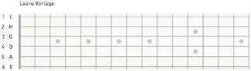minor/A·Maj>r:

I *1* l *t.* S £ 7 II \C II 17 U 14 IS

**Use It!**

Now we are going to apply what we've learned. We take a look at the chord progression C major – F major – G major.

This progression can, f. e., be heard in the Song: ***“The Lenghts” by***

***The Black Keys.***

**1. Position:**



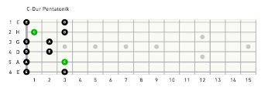

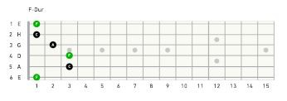

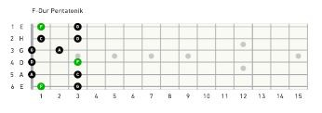

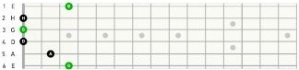c; *o r*

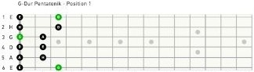I *1* l *t.* S .S 7 It \C II 17 U 14 IS

' *1* l *t.* S 4 *'1* t \C II 17 U 14 IS

Watch out the open strings in this position!

**2. Position:**



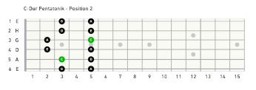

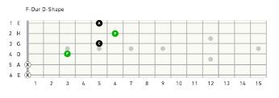

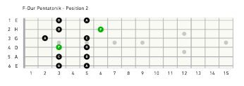

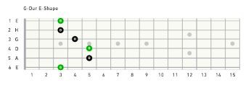

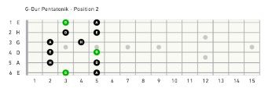

**3. Position:**

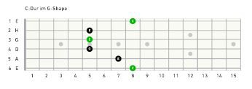

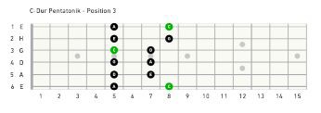

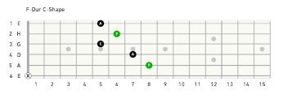

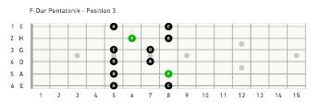

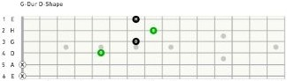

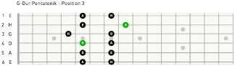' *1* l *t.* S 4 *'1* t \C II 1'1 U 14 IS

' *1* l *t.* S 4 *'1* t \C II 1'1 U 14 IS

**4. Position:**



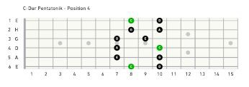

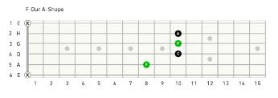

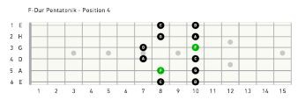

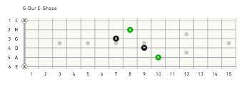



' r

.

' --.

I H

0 0

.

'-- 0 0 - 1-

•

..-- 0 0 --

' 0 ,- - 0

.

to

; A

'

t

• I 1-

I

\1) II I ' U 14 IS

**5. Position:**

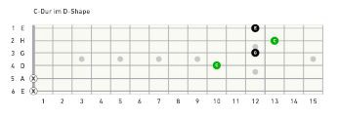

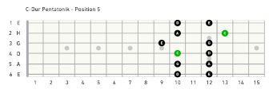

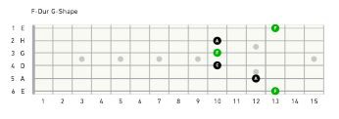

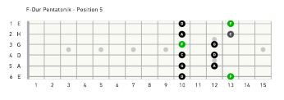

c; o•• Sll po

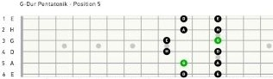U' :*1* t·l l *t.* !S·R4 *'1*·t :·=\CnII 1'1 U 14 IS

' *1* l *t.* S 4 *'1* t lC II 1'1 U 14 IS

Next chord progression, we take a look at, can be heard in the song

***· ou Shook*** *Me"* ***by Led Zeppelin.***

A minor- D minor- **E** minor

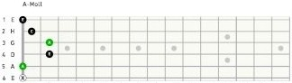**1.Position:**

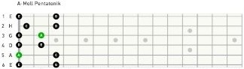I *1* l *t.* S £ 7 II \C II 17 U 14 IS

' *1* l *t.* S 4 *'1* t \C II 17 U 14 IS

G.Mo.I

:J I ·*1*

rl *t.* S·1£

·7 DII

··\C II :17 fU

i14 HIS

0 Nd! II I Cnlll

j (R·H· i a

u= · I

1 *1* l *t.* S 4 *'1* t \C II 17 U 14 IS

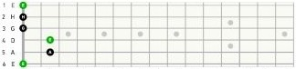E Metl

I *1* l *t.* S £ 7 II \C II 17 U 14 IS



" t 0

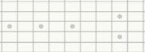

' "

0

'< 0 0 •

' 0 ---L!

• £

' '

l *t.* S 4 *'1* t \C II 17 U 14 IS

**2. Position:**

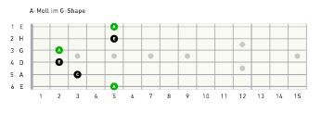

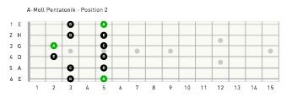

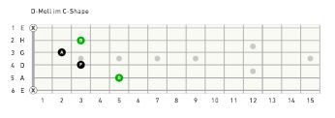

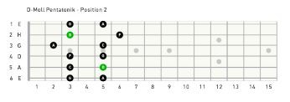

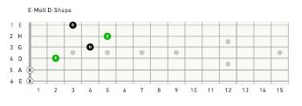

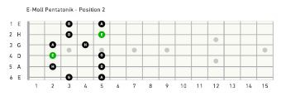

**3. Position:**

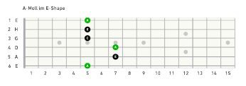

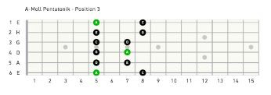

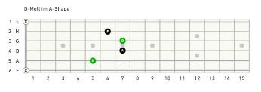

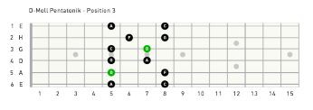

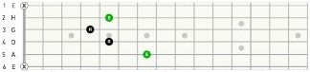e Mo!llm< Sl!.:.oo

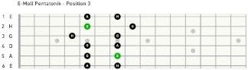' *1* l *t.* S 4 *'1* t \C II 1'1 U 14 IS

' *1* l *t.* S 4 *'1* t \C II 1'1 U 14 IS

4. Position:





' I

' •"

0 0 •

•

• 0 • • 0 •



'

.

• • 0 •



•

•

• .. It u u '" 15

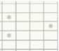• 0

0 0

• 0

0 •

0 0

|  |  |  |
| --- | --- | --- |
| • | 0 |  |
| tt | lttl | tt\1'415 |



::I .

·: boc•

 0

|  |  |  |  |  |
| --- | --- | --- | --- | --- |
| 0  0 | •  • |  | i | • |
|  |  |  |  |  |
|  |  |  |  |  |

t t 10 II It U u, IS

0 WGU ,...,IIC!nlll tl!\11'14

' I • 0



iW

0 0

•

"

• • • 0

' . • 0

• 0 0 •

0

• " "

" " " "

(w.llift,.

•



• 1

' " 0 0 •

.!

• 0 • • 0 •

' 0""



• t

( ......... -......._,

.

' I 0 0

' 0 0

• 0 • • 0

•• 0 0

• 0

• " .. " " '• "

0 0

**5. Position:**

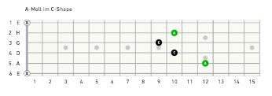

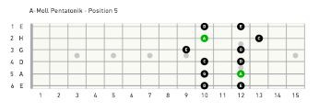

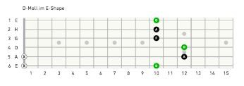

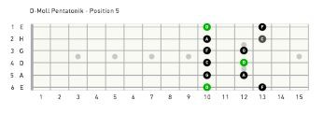

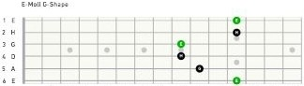

' *1* l *t.* S 4 *'1* t \C II I) U 14 IS

' r



.

I H

' • •

.

•

' 0

; A

'

' *1* l *t.* S 4 *'1* t lC II I) U 14 IS

Again:

I chose this two chord progressions to show you the importance of the

Relative Keys:

C major and A minor share the same Form in each position!

The same goes with F major and D minor and G major and E minor. The relative keys are a minor third (three frets) apart.

Example:

Are we looking for the relative major to A minor we go three frets up. Other way → Are we looking for the relative minor to C major we go

three frets down.

The next chord progression is also very popular, and can be heard in the rock classic *"All Along The Watchtower" by Bob Dylan.*

A minor- G major- F major:

1. Position:

I *1* l *t.* S £ 7 II \C II 17 U 14 IS

' *1* l *t.* S 4 *'1* t \C II 17 U 14 IS

c; o r

:1I

-*1*-Ul *t.* S·1£

·7 DII

··\C II :17 fU

i14 HIS



' *1* l *t.* S 4 *'1* t \C II 17 U 14 IS

f!lo.r

: LI *1*3l *t.* S·1£

·7 DII

··\CfIiI

i17 JU 14 HIS

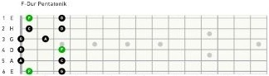I *1* l *t.* S £ 7 II \C II 17 U 14 IS

**2. Position:**













**3.Position:**





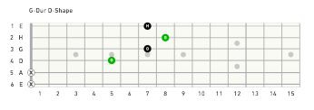



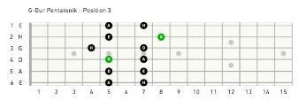



**4.Position:**

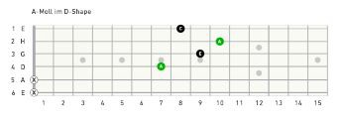

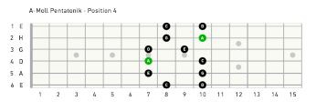



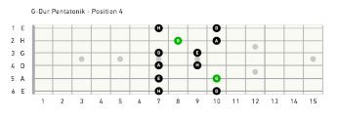





**5.Position:**





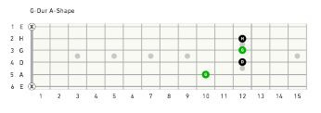

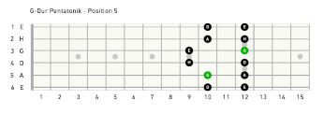





Next chord progression is constantly used in Jazz.

Its also called 2- 5-1 and in the Key of C goes like this: D minor- G major- C major

**1.Position:**

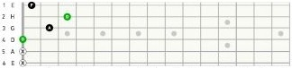G.Mo.I

I *1* l *t.* S £ 7 II \C II 17 U 14 IS

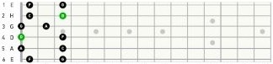0 Nd! II Cnlll POSit fit I

1 *1* l *t.* S 4 *'1* t \C II 17 U 14 IS

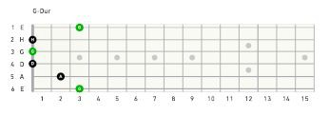

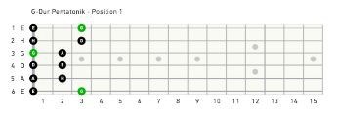

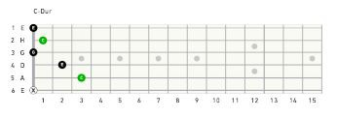

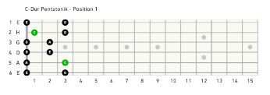

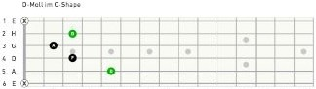**2.Position:**

' *1* l *t.* S 4 *'1* t \C II 1'1 U 14 IS

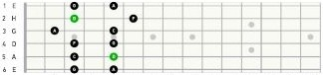0 Nd! II Cnlll Poslt fl2

' *1* l *t.* S 4 *'1* t \C II 1'1 U 14 IS





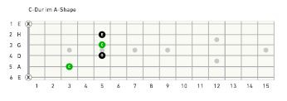



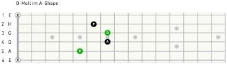**3.Position:**

' *1* l *t.* S 4 *'1* t \C II 1'1 U 14 IS

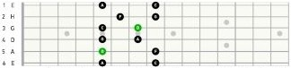0 Nd! IIICnlll Poslt ..l

' *1* l *t.* S 4 *'1* fl \C II 1'1 U 14 IS









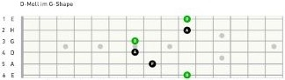**4.Position:**

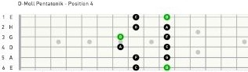' *1* l *t.* S 4 *'1* t 10 II 1'1 U 14 IS

' *1* l *t.* S 4 *'1* fl 10 II 1'1 U 14 IS









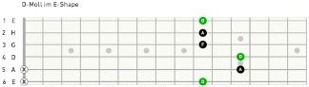**5.Position:**

' *1* l *t.* S 4 *'1* t 10 II 1'1 U 14 IS

0 Nd! IIICnlll POSit 'IS

' r

.

I H -1-- 1-'

' • ·:::t-.

0 0

0 -

0 - 0 To 1-

' 0 I

T 1°

. .

.

- •r. •

; A

' ' *1* l *t.* S 4 *'1* t 10 II 1'1 U 14 IS

I









With this I end this chapter.

Of course, there are plenty more of interesting chord progressions, but it would be way too much to cover them here ;)

**Intervals and extended chords**

An interval describes the distance between two notes.

The following intervals you gonna learn:

First 1

Second 2

Third 3 fourth 4

Fifth 5

sixthh6

Seventh 7

Octave 8

To truly master the fretboard, you have to be able to find every interval everywhere.

As we know from chapter roots, the octave of, f. e., A is an A again:

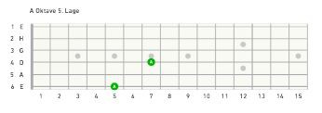

A first of an A is also an A, and this time, the exact same one:

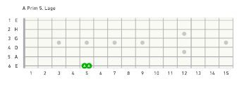

The intervals from first to octave, are classified as follows:

The first group contains the so called **P E R F E C T** intervals.

The second group contains the so called **M A J O R** and **M I N O R**

intervals.

**P E R F E C T:** First 1 fourth 4

Fifth 5

Octave 8

**M A J O R and M I N O R**

Second 2

Third 3 sixth 6

Seventh 7

Second, third, fourth and fifth can appear major or minor. We already covered the octave in the chapter about roots. Let's move on to the:

**Fifth**

This perfect interval is part of every major and minor chord. The fifth of C would be:

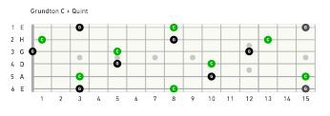

The green dots Indicate the C. The black dots are the fifth of C.

This pattern stays the same, doesn't matter what's the root.

**Third**

is also part of every major and minor chord. In a major chord it appears major – in a minor chord it appears minor.

A minor third is one half step lower than a major third. Let's take a look:

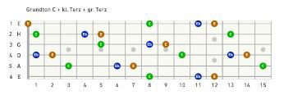

The blue thirds are minor- the brown thirds are major.

The minor third is always found to the left of the major third. Root is green.

When we add the fifth of our root here, we get all positions of the C

major and C minor chord.

Cause a basic chord is always build with the root (1) – the third (3) –

the fifth (5).

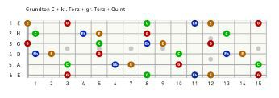

**Major chord:**

Root (Green)– major third (brown) – fifth (Red)

**Minor chord:**

Root (Green) – minor third (blue) – Fifth (Red)

… is a perfect interval:

**Fourth**

Forth is found to the right of the major third.

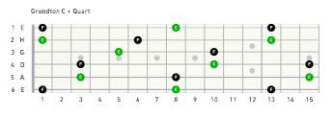

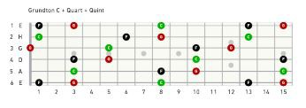The fourth can suspend the third in any chord. We get the suspended fourth chord or sus4.

Let's add our fifths: We see all positions of the Csus4 chord.

**Sixth**

A sixth can also be minor or major:

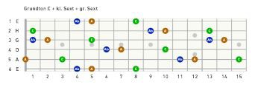

When we add the major third of our root, and take away the minor sixth, we end up with all positions of A minor.

This is because of the relative keys.

A major chord differs in just one note with its relative minor. In our case:

C major: C E G

and

A minor: A C E

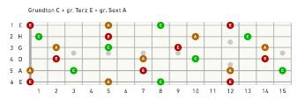

When we stick to the minor intervals we get C minor with a sixth: C Eb Ab

which is the equivalent to

Ab minor: Ab C Eb.

This is also seen as a relationship between chords.

The notes of C minor are C Eb G ---> With a sixth instead

is Ab C Eb ---> Ab major

of a fifth C Eb Ab ---> which

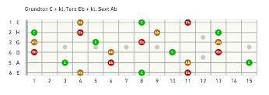**Seventh**

The seventh appears major or minor:

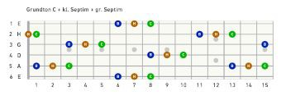

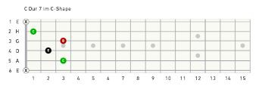Green root, brown major seventh, blue minor seventh. All positions of the C7 Chord:

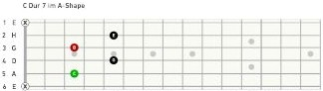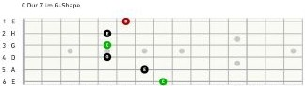' *1* l *t.* S 4 *'1* a \C II I ' U 14 IS

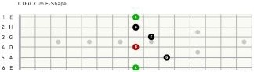' *1* l *t.* S 4 *'1* a \C II 1:)' U 14 IS

' *1* l *t.* S 4 *'1* a \C II 1:)' U 14 IS

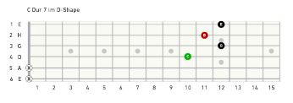

Green root, black major third + perfect fifth, red minor sevenths

All positions of the C major 7 chord:

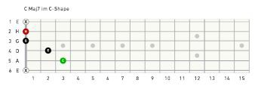

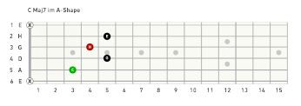

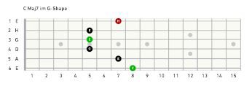

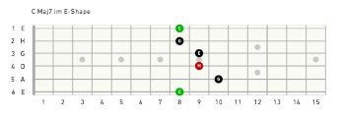

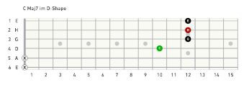

Green root, black major third + perfect fifth, red major seventh

**Second**

The second appears major or minor:

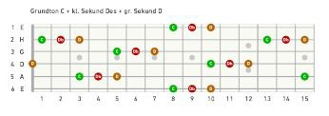

Green root, red minor second, brown major second

Chords with a second are called sus2 or 9th-chords. The sus2 suspends the three, but in a 9th-chord the second adds to it. The two becomes a nine cause :

You start with a root or 1 then comes a third or 3 then comes a fifth or 5, then comes a seventh or 7

and finally its 9 and not 2. You see?

And yes, its exactly the same two notes – just the math differs ;)

In a major chord with minor seventh, the second (or ninth) can appear both, as major or/and minor.

Green root,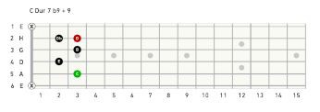 black major third and minor seventh,

black minor second, red major second.

In a major chord with a major seventh, its most common to use a major second. The minor second is rarely found in a major 7 chord.

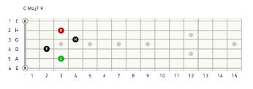

With a minor third, and a minor seventh (a minor 7th) we take also a major second.

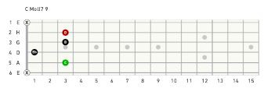

Exercise: Take root A, add minor third, perfect fifth and minor seventh over the complete fretboard

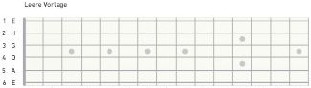You end up with all positions of the A minor7 chord.

I *1* l *t.* S £ 7 II \C II 17 U 14 IS

**Broken chords**

In this chapter I'm gonna show you, how to break down chords.

It's often useful to play just two or three notes of a chord, instead of playing all the strings all the time. Less is more!

I'm gonna demonstrate this with the progression E minor – D major. Instead of playing all possible notes, we focus on just the D-string, G-string and B-string.

Let's take a look at some positions:

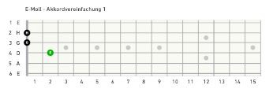

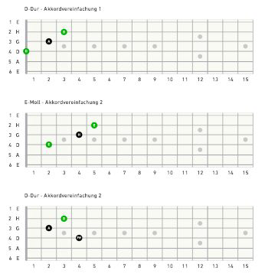

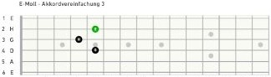

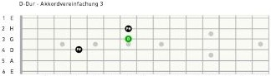' *1* l *t.* S 4 *'1* t \C II 1'1 U 14 IS

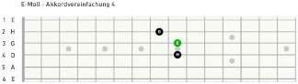' *1* l *t.* S 4 *'1* t \C II 1'1 U 14 IS

' *1* l *t.* S 4 *'1* t \C II 1'1 U 14 IS

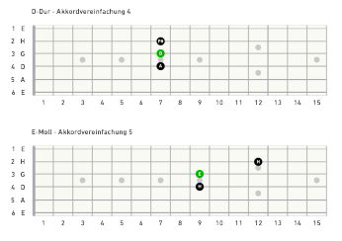

This game can, of course, be continued. For example for the G-

string, B-string and high E-string. Or the A-string, G-string and high

E-string. Or any other combination.

It's up to you know, to find additional positions. With all this knowledge of the fretboard, every player will be able to find his or hers own unique ways along the fretboard

Finally there's only one last thing to say:

**Forget everything you know and P L A Y!**

Special Thanks go to:

Alexander Bickel for grafix and artwork

→ [http://www.alexanderbickel.at](http://www.alexanderbickel.at/)

**About Me**

Early in my childhood I got in touch with music. My father used to play songs on a small home organ and flute. My mother likes to sing and play guitar as well. My first instrument was the trumpet. My first teacher was Laszlo Mezei, a very talented man from Hungary. But when I first heard the sound of Jimmy Page, guitarist of Led Zeppelin, at the age of 14, it was all clear to me. The sound and expression of his playing almost “put a spell on me” - I had found my instrument. I learned to play as much as I could – been playing day and night.

Since then I was member of many bands such as Mind's Garden → [http://www.mindsgarden.com](http://www.mindsgarden.com/). Since 2011 I study classical guitar in Feldkirch. Although my home is Rock and Blues, I like to explore all kinds of music and open up my musical horizon. “Music is my special friend” Music drags me through hard times and completes the good times. I wish that everyone get's touched by music, at least on time

in theirs life, like I'm touched by music everyday. With

this words I close this book. Keep your ears and hearts open! And enjoy the sounds of the universe!

Contact: [soundjunk@yahoo.de](mailto:soundjunk@yahoo.de)