The beginning…
A friend of mine kindly gifted me a BBC Micro Model B, which he had restored back to life.
It was truly a wonderful gift, and it re-energized my interest in the BBC Micro, a machine that I spent countless hours programming in BASIC as a teenager.
After playing with the machine for a while, I decided it would be an interesting exercise to try to write a game for it, in assembly code. Not something I could do in my teens.
My initial thinking was that Daleks, from Docter Who, would make excellent characters to build a platform game around. I also felt a ‘Doctor Who’ theme would play homage to the BBC who commissioned Acorn to design and build the BBC Micro in 1982, which was the computer that incubated a whole generation of programmers, including me.
I also wanted to create a retro game which looked, behaved, and felt more modern than an original 1980’s game, which is hard to do when the hardware has not changed. I believed that I’d have a better chance of accomplishing this with a platform game.
To look and feel more modern I felt the game needed to use higher resolution graphics, with larger sprites and smoother animations than was typically used. To this end I decided to use Mode 1, which has twice as many pixels as Mode 2, which most platform games of the time used.
The downside of Mode 1 is that it can only display four-colors (without scanline palette switching shenanigans). I felt that four colors would be sufficient if each level could define its own palette. I also felt that the limitation might reenforce the retro look of the game. I hope you agree.

Prototype
After landing on a game type, theme, and screen mode, I set out to learn and write some 6502-assembly code.
I (re)read the BBC User and Advanced User guides, and the Advanced Machine Code Techniques for the BBC Micro, by A. P. and D. J. Stephenson, which I found particularly useful.
Of course, the only way to become proficient in any language is to use it. In searching for information on the BBC Micro and 6502 on the web, I discovered beebasm, an excellent assembler that I could use on Windows to produce an SSD, which I could then run in beebem, an emulator I’d used intermittently over the years to play Hunchback, Revs, and Elite… favorite games from my youth. I used Visual Studio as my development environment as it has an excellent editor, and Azure DevOps for the Git repro, as I already had an account.
After looking at some examples that were installed with beebasm, I set out to write a simple prototype to see how many 24x32 Dalek sprites I could animate smoothly in Mode 1. Why 24x32 pixels you may ask… well, it was simply that I was able to draw a reasonable looking Dalek at that size in paint.net, and it would allow me to show five horizontal platforms on the screen.
The prototype was based on one of the beebasm example programs that renders a sphere of rotating dots. The example was super useful as it has code to set the screen mode, set up timer and v-sync interrupts, it has a simple game loop, and it has simple drawing code. I updated the code to use Mode 1 and replaced the drawing code with code that cleared and rendered Dalek sprites.
I created four Dalek sprites in a bitmap atlas using paint.net, with each Dalek image shifted over one pixel, and wrote a C# console app to convert the BMP file into a column ordered Mode 1 memory format, which I then included in the prototype. The sprite rendering code selected the appropriate sprite data to use when rendering a sprite. In Mode 1, each screen memory byte represents four adjacent pixels, so one needs four copies of the source sprite data, each shifted over one pixel, to efficiently draw a sprite at any horizontal position.
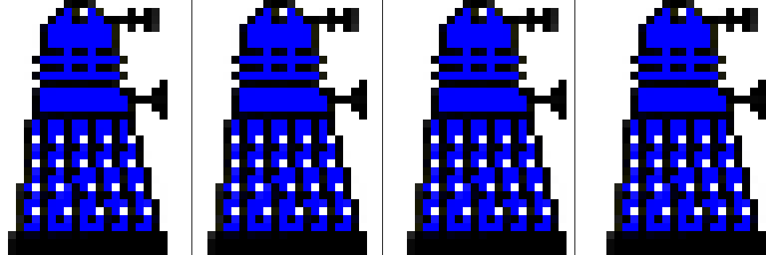
Figure 1
While I was successful in being able to smoothly animate a few Daleks moving across the screen, there weren’t enough cycles to render more than this, which was disappointing.
After exhausting ways to optimize the code, unrolling loops etc., I realized that the code was simply doing too much work and that I needed to simplify things.
The sprite renderer I implemented used masking techniques to overlay sprites over other sprites, and the background. And it used a character-based set of dirty flags, to minimize redrawing. While the techniques worked well for smaller sprites, the prototype demonstrated that the techniques did not scale to larger ones.
I tried simplified the masking functionality to simply OR sprite data against the screen memory, which improved performance, but it also resulted in some unpleasant artifacts.
In the end I concluded that the only way to animate larger sprites smoothly was to just copy sprite data directly to screen memory and live with the constraint that sprites cannot overlap each other, or other graphical elements.
After removing the overlay and redraw code, the prototype performed as I had hoped. I could animate six Dalek sprites smoothly.
The prototype showed what was possible, and perhaps more importantly what wasn’t. It also helped greatly in developing my 6502 assembly skills and refreshing my memory of the BBC Micro.

Turning the prototype into a game
Turning the prototype into a game was an iterative process of exploring and introducing new pieces of functionality, addressing gaps and issues, whilst continuously trying to find ways to reduce memory usage, whilst keeping performance where it needed to be.
The following sections provide a journal of the journey…
The journal was written after most of the coding was complete and was created by reviewing the source-code history, identifying key areas of work, and writing about them.

Level design
The first thing to do was to figure out how I was going to represent and draw a game level.
After looking at several options, I chose a page/tile-based representation where a level was comprised of a set of pages, arranged in a pattern, with each page containing a grid of tiles. I knew memory, or lack thereof, was going to be a challenge so I used a spreadsheet to try out different combinations of tile counts, tiles sizes, page counts etc.
The numbers led to a level comprised of 8 pages, each containing a 16x16 grid of tile indices, referencing up to 32 tiles, each 16x16 pixels in size. The first tile would always be blank so would not need to be represented. The page layout would be represented using an 8x8 grid of page indices. The total memory required to represent a level was 4K.
The numbers also mapped nicely onto the level coordinate system, where the high-byte maps to pages, and the low-byte maps to page tiles (high-nibble) and tile pixels (low-nibble). A Dalek was also exactly two tiles tall. Nice!
To save memory, I decided to reduce the width of the screen from 320 to 256 pixels, which reduced the screen memory from 20K to 16K. I’d use the 4K I saved to hold the level data.
I created a few 16x16 tile designs in paint.net and updated the BMP converter to convert these to a character ordered Mode 1 screen format. I then included this tile data, plus a hard-coded level page into the prototype, and implemented a draw-tiles routine that rendered the level page. I now had something that started to look like a game.
The next step was to add the player character.

Player Character
The natural choice for the player character was ‘The Doctor’, but I’m not an artist so creating a set of sprites to animate the Doctor in a convincing way seemed a daunting task, so I decided to use ‘K9’ instead… a character that appeared in several series which I have fond memories of. I could draw K9.
I created sprite images for K9 in the same way that I had created sprites for the Daleks and added zero-page variables to hold K9’s position and updated this using the WASD keys. I was now able to move K9 around the screen, be it through walls and platforms.

Adding animations
I formalized how animations worked by introducing animation constants (ANIMATE_LOOK_LEFT, ANIMATE_MOVE_RIGHT, AMIMATE_TURN_LEFT_TO_RIGHT etc.), zero-page variables, and frame callbacks. Each game character has an associated callback function which is called every frame, after all the characters have been rendered. The callback function implementations contain the logic for updating character positions, selecting the appropriate sprite, and determining what happens when an animation ends. I encapsulated the necessary animation invocation logic in k9Animate and dalekAnimate routines that accepted an animation constant and set up the appropriate frame callbacks. This simple model worked surprisingly well and formed the basis for later extensions.
The next natural step was to add scrolling functionality… but I’d need a full level defined to scroll around in first. Time to write a level editor.

Level Editor
A game level editor is an essential tool for creating a platform game, as it provides a way to graphically design and create levels. Think of it as a specialized form of painting program.
I wrote the level editor in C#/Windows-Forms as it was the easiest way for me to quickly build a graphical editor. A simple Windows-Forms app with a few custom controls would be more than sufficient. I’ve developed numerous graphics-based applications over the years so creating the level editor was quite simple for me.
The editor allows one to create, load, edit, and save a level file, which can then be binary included within the game code. The editor also allows one to select the page layout (how the level’s eight pages are arranged), select the four colors of the level’s palette, edit individual tiles, and define a page’s tiles.
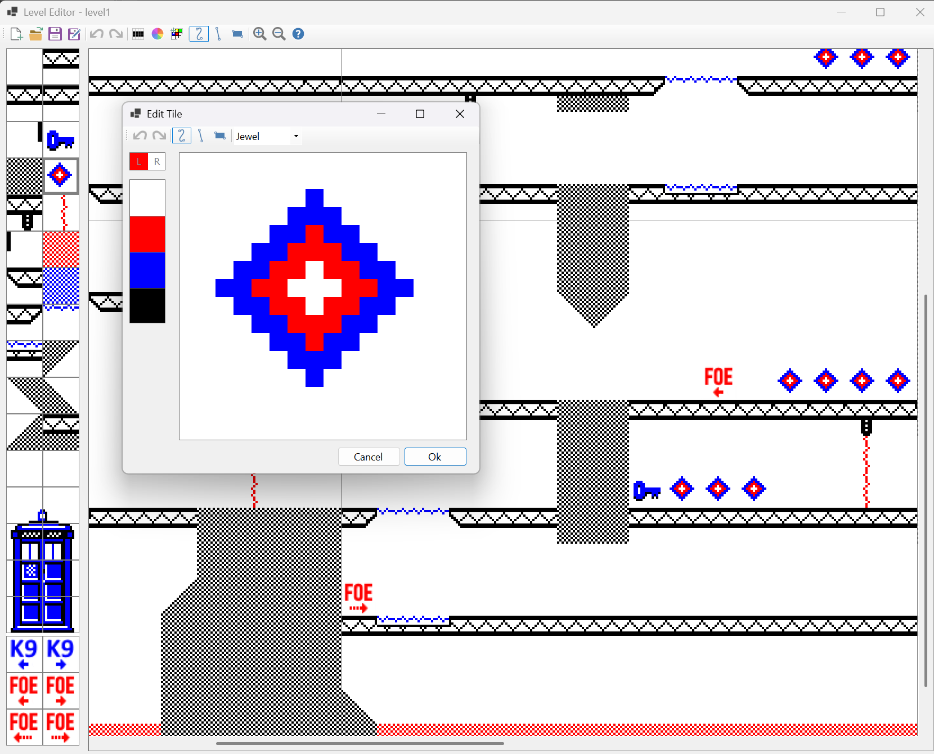
Figure 2
Using the editor, I created a basic level file and included it directly within the game code using the beebasm’s INCBIN directive.
The editor was revised and extended during development of the game, with additional features added as needed.

Scrolling
With the level data included in the game code, I was then able to write code to scroll around the level, in half tile (8-pixel) increments, using the arrow keys.
This was somewhat challenging to get right as the code had to draw the correct half width tile strip, or half height tile strip, from the correct screen location, correctly spanning page boundaries, efficiently… and then update the screen start address in the hardware, so the screen shifted. The change introduced several zero-page variables to keep track of the top left coordinate of the screen, and its start address.
I also had to update the draw-sprite routine to transform sprite level coordinates to screen coordinates (by subtracting the screen position) and handle cases where address calculations that crossed the upper screen memory boundary wrapped around correctly.
It was now time to address some other issues…

Clipping
The first thing to address was clipping, or lack thereof. The draw-sprite code was first updated to perform broad level clipping whilst transforming the sprite level coordinates into screen space. For example, if the sprite’s left screen coordinate is larger than 255, the sprite is fully clipped. Likewise, if the sprite’s right screen coordinate is less than zero, it’s also fully clipped. The same is true with the sprite’s top and bottom screen coordinates.
Adding the broad clipping tests was straightforward and improved performance significantly, as the screen area covers one-eighth of a game level.
If the code gets past the broad clipped tests, all or some portion of the sprite is visible… so the next step is to perform finer grained clipping by comparing each of the sprite’s edges against their corresponding screen edges, reducing the sprite’s rendered width and height, and top and/or left source image offset, appropriately. For example, if the right edge of the sprite falls beyond the right edge of the screen, we need to reduce the rendered width. Likewise, if the left edge of the sprite falls before the left edge of the screen. But in this case, we also need to offset the source image and set the sprite’s left edge to zero.
Adding the fine-grained clipping code was also straightforward, but it did increase the size of the draw-sprite routine significantly.

Smearing
Another issue that needed to be addressed was pixel trails that were left on the screen when K9 was moved up and down. These were the result of the sprite images not having a blank line along their top and bottom edges.
One option would be to add the blank lines to the sprite images, but that wastes valuable memory (328 bytes). The approach I took was to extend the draw-sprite routine to optionally draw the blank lines and use this functionality when animating the sprites up or down.

Collision detection
I also needed to stop K9, and Daleks, from passing through each other, and walls. I needed a way to detect collisions.
After looking at several options l landed on using a tile-based approach, where each tile location in a level is marked as being occupied or not. With this information, game character movement can be restricted by testing the next tile location’s occupancy. Of course, the occupancy information must also be updated as characters move across tiles.
I updated the level model to hold this occupancy information directly within the page tile grids, which up until this point just held tile indices (values 0..31). I used one of the three unused high bits to hold the information.
The implementation was straightforward, though handling page boundaries proved challenging and led to code complexity and quality issues. More on this later.

Game objects
I was now at the point where I needed to introduce more game objects, to make the levels more interesting to play. I also needed a way for K9 and Daleks to move between floors (they can’t climb stairs!), and I wanted to add doors and collectables (keys and jewels) that would unlock doors and give K9 health.
I concluded that game objects were either static or dynamic in nature. Jewels and keys are static as they don’t move, animate, or have any intrinsic behavior. However, K9, Daleks, doors, and elevators do animate, move, and do have intrinsic behavior. They are dynamic.
I realized that by introducing the notion of tile-type, I could embed static objects (jewels and keys) directly within a level, which the game code can look up and act upon. I also realized that tile types could also be used to denote where doors and elevators were located.
So, I updated the level editor to allow a tile to be marked as being either a space, wall, floor, elevator, door, jewel or key, and serialized this information with the level data. A tile’s type could now be resolved using a table lookup at runtime.
I did, however, need a better way to represent dynamic game objects in the game.

Dynamic game objects
Up until this point, K9, Daleks, and elevators were represented using their own set of variables, and doors did not exist.
To allow levels to have different numbers of Daleks, elevators, and doors, I consolidated all game objects into a unified set of correlated arrays. I settled on there being at most 48 game objects, including K9.
K9 would always be the first game object (index zero), followed by all the Daleks (from index one), then all the elevators, and finally all the doors. The start index and counts of Daleks, elevators, and doors are stored as zero-page variables.
The resultant correlated arrays were:
- objectXLo & objectXHi - Object’s left level coordinate (high and low byte)
- objectYLo & objectYHi - Object’s top level coordinate (high and low byte)
- objectWidth & objectHeight - Object’s width and height
- objectAnimation - Object’s current animation (ANIMATE_LOOK_LEFT etc.)
- objectState - Object’s state. High nibble contains generic render flags (redraw, erase-above, erase-below). Low nibble holds K9, Dalek, elevator, and door specific data.
- objectSpriteIndex - Object’s sprite index (specifies which sprite to render)
- objectFrameCallbackLo & objectFrameCallbackHi - Object’s frame callback function invoked every frame (high and low address bytes)
- objectFrameCounter - Object’s animation counter, used to control the duration of animations.
Refactoring the code took some time, but the resultant code was much cleaner and tighter, and there was much less of it!
I updated the level editor allowing K9 and Daleks to be placed within a level, specifying their direction, and initial motion. These game objects, along with elevators and doors, were serialized to the level file and read by the level initialization code to populate the zero-page variables and game object correlated arrays.

Title screen
I introduced the game’s title screen, a Mode 7 screen containing a game’s description and controls. Gameplay starts when the spacebar key is pressed.
As an aside, holding the start of the game made it much easier to debug, as it allowed me to launch the debugger and set break points before the game loop was entered.
As part of this change, I wrote a routine to display Mode 7 text, which can include teletext control codes, which I used to render colored and double height text.

Auto-scrolling
I then enhanced gameplay by implementing a simple form of auto-scrolling, where the screen automatically scrolls when K9 is unable to see more than a third of the screen. The scroll is fast and fluid, with the game continuing to function during the scroll. Repeatedly turning at an auto-scroll boundary causes the screen to scroll back and forth. This form of scrolling was chosen as it allows K9 to move freely around the screen and yet progress across screens in a fluid manner. I felt this was preferable to having K9 fixed in the center of the screen or scroll when K9 reached the edge of the screen.
The changes were straightforward to implement. I just needed to introduce zero-page variables to hold a scroll count and scroll direction, update the scrolling code (called from within the game loop) to read these, and update these variables as needed when K9 turns or moves.

Level completion
I now needed a way for K9 to finish and exit a level. The level I had designed already contained an image of the Tardis at the exit point, which was made up of six unique tile designs, but I didn’t have a way of detecting that K9 had successfully reached the Tardis.
The solution was to introduce an exit tile type and mark the six tiles as being exit tiles. I updated the level editor and updated the k9Animate routine to test for the new exit tile type, displaying a level completed overlay.
The overlay was created by drawing a Mode 1 text block over the screen. To do this I wrote a draw-text routine that rendered text characters, using the MOS character bit patterns defined in ROM at &8000. I couldn’t use the MOS text rendering routines as I’d customized the screen, making it narrower.
The code to load the next level would come later.

Revisiting the page grid design
In reviewing the code, and looking for ways to free up memory, I noticed that there was quite a bit of code that was dealing with level page boundaries, be it in different ways. I was also conscious of several difficult to fix bugs related to page boundaries, and knew I’d likely encounter more challenges as I added more game functionality, such as laser hit testing, line-of-sight calculations, and elevator motion.
I reflected on the benefits of the page grid design and concluded that whilst an attractive feature, it fell in the ‘nice to have’ category and was not essential… so I decided to remove the feature entirely. A level would simply be a tile grid whose extents could be either 128x16, 64x32, 32x64, or 16x128 tiles.
I updated the level-editor to operate on a single tile grid, replacing the page-grid layout dialog with a tile-grid layout dialog, and then refactored all the game code. The changes were extensive.
The resultant code was simpler and cleaner in many areas, and the overall program code size reduced significantly. The change also made it far easier to implement features developed later.
As an aside, I concluded later that the issue was not with the data model, but with my unwillingness to accept the cost of an abstraction (function-based or macro-based) that was required to traverse it cleanly.

Adding door functionality
Up until this point doors did not function. Daleks and K9 were blocked from going through them.
After thinking over several options for how doors should operate, I concluded that doors should automatically open and close for Daleks, and that K9 would need a key to use a door, and that keys could only be used once, but multiple keys could be collected. I would also allow K9 to follow a Dalek through a door without using a key.
Implementing this behavior required quite a few changes. Central to this was updating the door frame callback function to test if a Dalek or K9 is next to the door and then change its visible state appropriately. The easiest way to do this is to test the tile grid occupied flag of the adjacent tiles, though this does not contain sufficient information to determine whether K9 or a Dalek is occupying and adjacent tiles.
Since this information was important and likely needed for future functionality (which it was), I introduced two supplemental tile grid flags denoting whether the occupancy was for a Dalek or K9.
As before, bit 7 marks that a tile location is occupied by something, and bits 0..5 hold the tile index (values 0..31). But now bits 5 and 6 specify if the occupancy is by K9 or a Dalek.
Updating the code to set and clear the supplemental tile grid flags was straightforward, though resolving related bugs proved challenging. More on this later.
I then updated the draw-sprite routine to draw the background color if the sprite index is -1. This was done by setting srcBaseAddr and stride variables to zero (the first 32-bytes of memory contain zeros). I need this functionality to show an open door.
I also needed to store the current state of the door. Whether it is open or closed. This information is stored in the low nibble of objectState array.
I was now able to fully implement the door functionality, adding logic to test the K9 and Dalek occupancy states of the adjacent tiles, determine if the door should be open or closed, determine if the state changed, persist this, and then update the sprite index appropriately, assigning -1 if the door is open.
As an aside, I later enhanced the door logic so that once a door is unlocked with a key, it remains unlocked until a Dalek uses the door.

The ‘Gamebar’
I was now at a point where I wanted to track K9’s health, and implement functionality to collect jewels and keys, and show this information in a gamebar, located at the top right of the screen.
I added zero-page variables for K9’s health and a key-count, initializing these during game startup. I then updated the k9Animate function to collect jewels and keys. I just needed to check the tile type when K9 was blocked from moving left or right. If the tile type is a jewel or key, the code updates K9’s health or key count and invokes a clearTile routine.
The clearTile routine clears the tile’s index, so the tile is blank from now on, and redraws the tile. Voila, the key or jewel is collected!
I then added code to render the gamebar. As before, I created a gamebar sprite using paint.net and used the BMP converter app to generate a Mode 1 screen representation which I included in the game code. To save memory, the asset only contains four digits ‘0’ to ‘3’.
I then wrote code to render the gamebar, which shows K9’s current level of health, and key count. To gamebar is redrawn every eight frames.
In addition to this, I needed to update the scrolling code to redraw the gamebar and draw the tile strips around it. The latter was fiddly to get right.
I later revisited the gamebar adding code to show the current level number, and extended the number of supported digits from four (0..3) to ten (0..9). Numerous code size optimizations were needed to free up sufficient space for these later changes.

Elevator functionality
Up until this point, elevators were static and didn’t move. I probably should have implemented their behavior earlier, but I knew implementing them would be challenging and a fair amount of code would need to be written, so I procrastinated. But no longer…
I first broke down the required functionality into the following major steps:
- Determine if K9 is on an elevator and whether it can move in the desired direction.
- Check if the destination location is occupied.
- Start the animation.
- Animate K9 and the elevator ascending or descending.
- End the animation
These steps were then broken down into more detail…
- Determine if K9 is on an elevator, and whether the elevator can move in the direction K9 wants to move. This is performed by:
  - Check if K9 is on an elevator by querying the tile-types of the tiles directly underneath K9 are elevator. This is a relatively inexpensive test.
  - Determine if the elevator can move in the desired direction by traversing the tile-grid in that direction, looking for an elevator tile type. If another non-space tile is encountered first, the elevator cannot move in that direction.
  - Find the elevator game object that K9 is on by iterating over all the elevator game objects, looking for a positional match.
- Check if the destination location is occupied, by checking the occupancy state of the tiles just above the destination location. If the tiles are occupied, the elevator is blocked from moving. If the tiles are clear, we know the elevator can move.
- Initiate movement, in the desired direction, by:
  - Mark the tiles just above the destination location as occupied, to stop a Dalek from occupying them as this would be bad.
  - Remember the current location of the elevator, as we want to restore this after the elevator stops. The objectFrameCount is repurposed for this.
  - Mark K9 and the elevator game objects as both ascending or descending by populating their respective objectState’s erase-above or erase-below render flags. This also ensures the objects don’t smear the screen.
  - Set the elevator’s frame callback function to either an ascend or descend frame callback function.
- Animate K9 and the elevator ascending or descending, whilst restricting K9’s movement, until the elevator reaches the destination position. This functionality is implemented in the ascend and descend frame callback function set above. These functions perform the following:
  - Increment/decrement the vertical position of K9 and the elevator
  - Check if the screen needs to be scrolled by calling the auto-scroll code.
  - Check if the elevator has reached its destination position. This is done by first checking if the elevator is positioned at a tile location (e.g. Y mod 16 is zero) and checking if the tile at that location is an elevator.
  - If the elevator has reached its destination, the callback is set to a stop elevator frame callback function, which will be called on the next frame.
- Complete the animation. This functionality is implemented in the stop elevator callback function set above. The function performs the following:
  - Clear the erase-above or erase-below render flags set on K9 and the elevator. Smearing is no longer an issue.
  - Restore the elevator’s position, using its original position stored in objectFrameCounter variable, which we repurposed.
  - Mark the tiles above the original elevator’s position as unoccupied as K9 is no longer there.
  - Mark the tiles where K9 is now as occupied by K9. They were previously just marked as occupied.
  - Restore the frame callback back to the static elevator frame callback function.
During development I also discovered that I also needed to…
- Update draw objects game loop code so that descending elevators are rendered before K9, to avoid drawing artifacts occurring.
- Restrict K9’s to just turning when riding a platform by checking the erase-above and erase-below objectState’s render flags
This may seem like a lot of steps to allow K9 to just move up and down elevators in the game, but all the steps are necessary to implement the behavior. The functionality was implemented in around 600 lines of assembly code, and accounts for about 10% of all gameplay code.
The functionality was later extended to allow Daleks to also ride elevators.

God mode
At this point K9 could navigate through an entire level, taking elevators as needed to avoid Daleks. However, testing the game was becoming more difficult as K9 was blocked from going through doors, unless a key was collected, and there wasn’t a simply way to scroll around the level to validate the behavior of game objects that were not visible on screen. I therefore decided to implement a ‘god mode’ that would give K9 unlimited health and keys; and allow the level to be scrolled independently from K9’s movements. The implementation was straightforward.

K9’s laser
One advantage of using K9 as the player character is that K9 has a laser, which can be fired at Daleks, and destroy them after prolonged application.
To improve gameplay, the laser can only be used if K9’s health is above 25 percent, and using the laser depletes K9’s health. The laser is fired when the space key is held down.
When activated, the flickering beam of light is drawn by rendering the laser beam one frame, clearing it the next frame, then rendering the beam again the next frame, and so on.
The laser beam is drawn horizontally from K9’s muzzle until it hits something. And if it hits a Dalek, detected by reading a tile’s occupied state, the corresponding Dalek game object is marked as ‘lasered’ and its health is reduced. If the Dalek’s health reaches zero, it is destroyed.
The beam is cleared by drawing the background color over the laser beam.
A ‘lasered’ Dalek also flickers, which is achieved by rendering a ‘lasered’ Dalek sprite differently. A render-lasered flag was introduced which signifies this effect and the draw sprite routine was updated to render ‘lasered’ sprites differently, using a shift and masking technique that applies the laser color to the sprite.
I initially had some concerns about the performance impact of drawing the laser beam and lasered sprite effect, however I was unable to detect any noticeable impact when playing the game. This is probably because the additional cost is roughly equivalent to having another Dalek sprite animating on screen.
Notable code changes include:
- A zero-page laserFrameCount variable was introduced which controls laser rendering. The laser beam is drawn when its value is 2, cleared when its value is 1. The variable is decremented every frame, if its value is not zero.
- A space key handler was added, that sets laserFrameCount to 2 if the space key is down and laserFrameCount is zero. Holding the space key down results in the value toggling between 2 and 1.
- A Dalek’s current health is stored in the lower nibble of the objectState variable. This is initialized during level initialization. This value is decremented if the Dalek is hit by a laser. If the value becomes zero, the Dalek is destroyed by setting its sprite index to -1, marking it for redraw, clearing the relevant tile occupancy flags, and setting its frame callback to the address of a RTS instruction.
- A render-lasered flag was introduced to denote a game object as being ‘lasered’, as outlined above. This is the fourth render flag in the high nibble of the objectState variable. Also updated the draw sprite routine to render lasered sprites by applying the laser color to the sprite data using shifts and masking techniques. Note that the ‘lasered’ flag is cleared after use.

Debugging tile grids
As development progressed, more and more features relied on the three tile grid occupancy flags being maintained correctly, and there was no simple way to ensure this was the case. Bugs that resulted in these not being set correctly would manifest later as odd behaviors, making identifying and fixing the root bugs challenging.
What was needed was a graphical way of seeing the values of all the tile grid occupancy flags. I therefore wrote a debugTileGridFlags routine that rendered a little box showing the three values graphically, positioned at the top left of every tile displayed on the screen.
The function is invoked within the game loop after all rendering. The code is conditionally assembled when a DEBUG_TILE_GRID_FLAGS constant is set to 1. The gamebar is not shown then the when the flag is set, as code space must be freed up to allow debugTileGridFlags to be assembled. A SKIP directive is also used to ensure that the number of unused bytes does not change when the DEBUG_TILE_GRID_FLAGS is set.
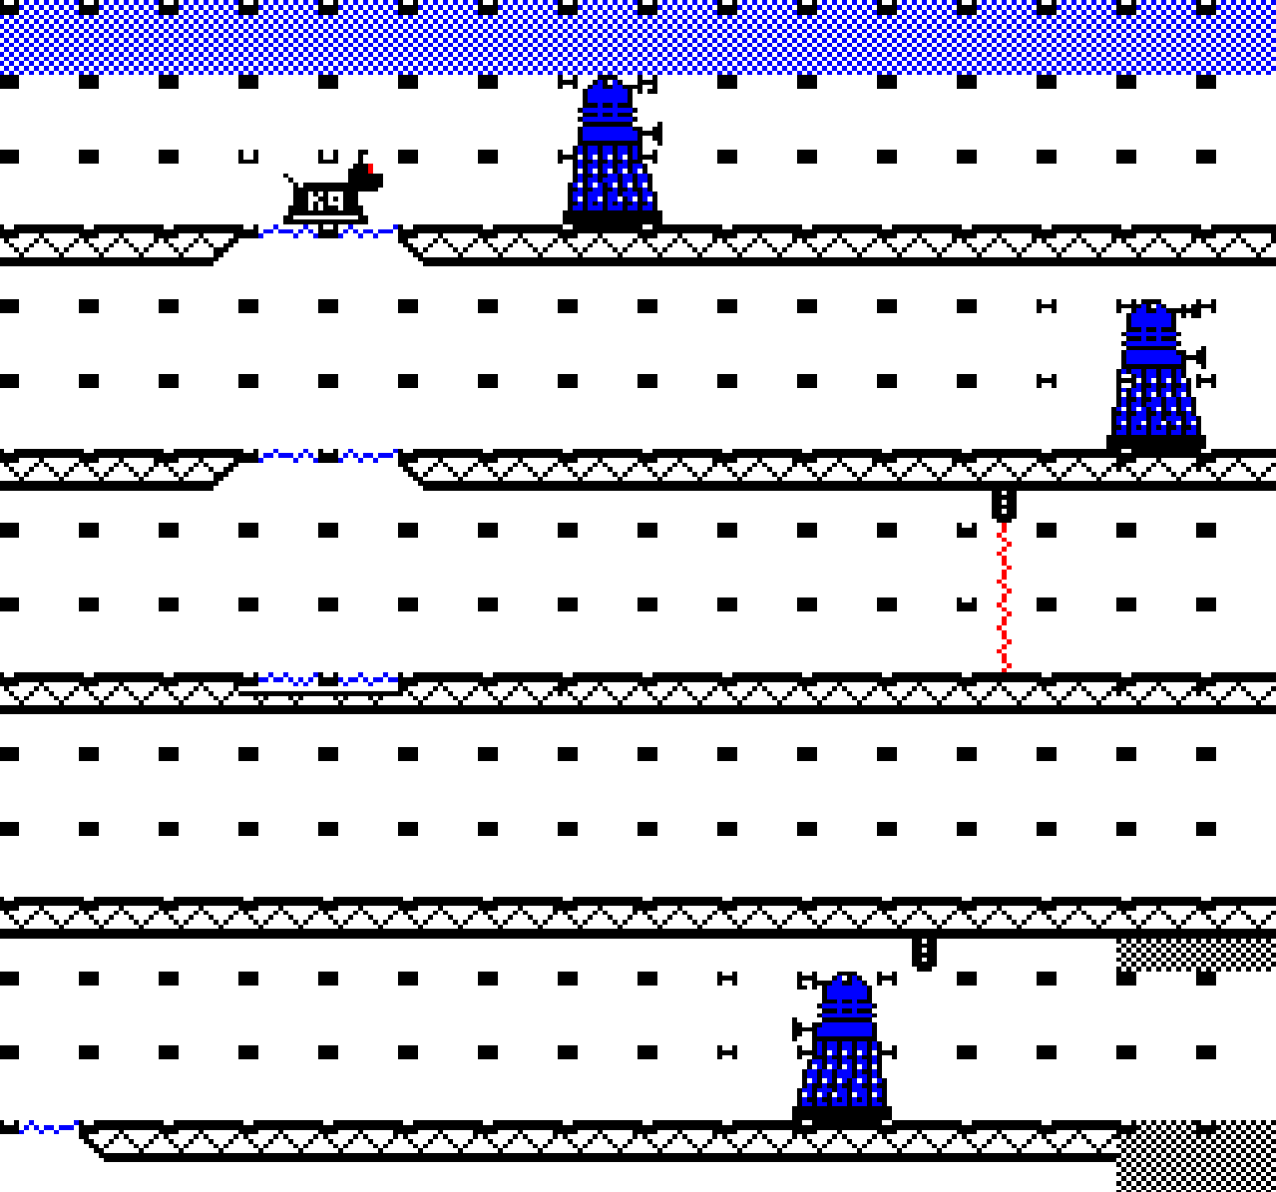
Figure 3
Key
Tile occupied by something other than K9 or a Dalek
Tile occupied by K9
Tile occupied by a Dalek
The debug functionality proved to be incredibly helpful. It illuminated several issues which were easy to identify and fix and it became the de-facto thing to enable when odd behaviors were observed. One notable fix it led to was that there was a timing issue when K9 turned around, which intermittently left a residual occupied flag set. The tile flags showed exactly the conditions of when this occurred.

Source file reorganization
Up until this point, all game code was in a single source file, and it was getting unmanageably long at 6300+ lines… so I divided this into eleven separate files, organized by functional area, as depicted below.
Filename | Description
program.6502 | Main program file
scroll.6502 | Scrolling functionality
draw.6502 | Drawing routines
k9.6502 | K9 behavior
enemy.6502 | Dalek behavior
elevator.6502 | Elevator behavior
door.6502 | Door behavior
tilegrid.6502 | Tile grid helper functions
utils.6502 | Utility functions
level.6502 | Level initialization
titles.6502 | Program initialization / titles
Truth be told, the single file was probably getting unmanageable at around 4000 lines. I just knew where all the code was and could just navigate to it quickly with the scrollbar, or with a quick ‘find’.

Sound functionality
During the early parts of development, I explored driving the sound chip directly (not documented above). However, after realizing I needed most of the sound functionality that MOS provided, I switched over to use the built in MOS functionality.
To do this I needed MOS to process Timer1 interrupts which normally occur every 1/100th of a second. However, I didn’t want MOS sound processing to impact game performance, so I changed Timer1 to interrupt every 1/50th second, when the last scanline of the screen is being read… just before the v-sync event occurs and a new frame is drawn.
This was implemented by changing the game’s interrupt handler to set Timer1’s duration when v-sync occurs, and modified Timer1’s interrupt code to pass on the interrupt to MOS.
It should be noted that MOS is invoked at half the frequency it normally is, resulting in SOUND and ENVELOPE duration values being effectively doubled.
I based the sound effect routine, what invokes a sound, on one that I found in Elite sources, that populates an eight-byte parameter buffer from four-bytes of data held in a sound effect table.
I temporarily hooked up a couple of sound effects to validate that the functionality worked correctly, which it did.
I decided that I’d define and hook up all the sound effects later, when the game was closer to being functionally complete, and when I’d have a clearer vision of the game’s sound design.
As an aside, my earlier explorations driving the sound chip directly turned out to be very useful when I later added code to play the Doctor Who theme when the title screen is shown.

Code size optimizations
At this point in development, memory was becoming a real issue, and I still had quite a bit of functionality to implement, so I needed to find ways to free up more memory.
The first thing I did was review how the game was using the lower areas of memory to see if I could repurpose more memory from MOS and DFS. I managed to reclaim 224 bytes, which was encouraging.
I then looked for ways to reduce memory usage within the gameplay code. I found and removed several redundant routines and replaced objectWidth and objectHeight game object arrays with a function that used a small lookup table instead, caching the width and height values instead, and widthMinusOne and heightMinisOne. The later values simplified many functions that were subtracting one from width or height. This freed up even more memory.
As part of the later change, I stored the object type in the objectAnimation game object array, shifting up the other values, and renamed this array to objectType.

Display tearing
The draw code up until now rendered all game objects in the order that they occurred within the unified game object arrays, irrespective of their position. This could lead to screen tearing, where a drawn object, or part of a drawn object, is displayed on the next frame, resulting in a visual ‘tearing’ effect.
The screen is displayed through a top to bottom scanline read of the screen memory. To avoid tearing, game objects need to be drawn before the scanline read reaches them. So, game objects need to be rendered in a top to bottom order.
The simplest way to do this is maintain a separate object-draw-order array which contains a top-to-bottom ordered list of game object indices. Game objects are then rendered by iterating over this array. The array is resorted every half second or so.
I initially sorted the array using a Counting Sort, which is a very efficient algorithm that can be coded in relatively few instructions. I repurposed a section of zero-page (transient variables) for the counts buffer, so no additional memory was needed.
I considered using a Bubble Sort but believed it would take more code and would be slower. Bubble Sort is arguably the worst sorting algorithm there is. Many folks think it shouldn’t even be taught in school.
However, its performance is reasonable over small data sets and good when the data is already sorted, or close to being sorted, which is the case here. So, I implemented it and to my surprise it took less code than the Counting Sort implementation. And tests showed that only a few passes (2 to 5) were needed to resort the array when game characters were moving vertically. Given the findings, I decided to use it instead of the Counting Sort implementation as it freed up some memory.

Level loading/reloading
Before I could implement level loading functionality, I first needed to be able to create level files within the SSD (disk image).
I did this by replacing the current level’s level data and sprite atlas data with the new level’s level data and sprite atlas data, saving this block of assembled code to the SSD using the file named ‘level1’. I was also careful to include the assembled code for level.6502 within the file, which contains the necessary level initialization code.
I then wrote a loadLevel function to load a level file into memory at the appropriate location and then invoke the loaded initializeLevel routine to set things up. A showLevel routine was finally invoked to show the level.
The level file is loaded by first switching to DFS (by invoking the ‘DISK’ command) and then calling the MOS osfile routine which instructs DFS to load the file.
It should be noted that calling the osfile routine caused multiple reads and writes to occur on pages which the game had repurposed. Specifically:
- Disc catalog information is written to page &0E (DFS workspace) overwriting existing sprite data. This is not an issue because the level sprite data will be refreshed in this page during level initialization.
- Pages &17 and &18 (DFS workspace) are also read and modified. Game code resides in these pages. To avoid issues, the code is saved elsewhere and the pages cleared before the osfile function is called. The game code is then restored after the call. An ASSERT is used to ensure that the loadLevel code is not assembled within these pages, which would be bad.
The palette colors are all set to black during the loading process.
The title screen was updated with instructions for how to restart a level, and a ‘R’ key handler was implemented to call the loadLevel routine indirectly through a reloadLevel routine.
There was insufficient memory to implement all the changes so more memory needed to be freed up. After reviewing the sources multiple times, I concluded that the best way to reclaim memory was to use Mode 7 level complete screens, which allowed me to delete all the Mode 1 text routines I’d previously written. I was forced to make the trade.
I could now restart the current level by pressing the ‘R’ key. Yeah!
The next step was to create two more levels and update the level complete screen to load the next level or show a new game complete screen when the last level was completed.
Later in development, I extended ‘god mode’ to load a specific level if its corresponding digit key was pressed (e.g. ‘1’, ‘2’, or ‘3’).

Darek behavior
The last big piece of functionality I needed to implement was Dalek behavior. Making Daleks behave like Daleks.
I landed on the idea that Daleks would be directed by an ‘action’, which could be either look, pace, or pursue. The basic behavior of a Dalek could then be built around these. The behaviors being:
Look – Dalek is motionless, looking either left or right.
Pace – Dalek paces slowly left and right, turning if it encounters a wall.
Pursue – Dalek moves quickly towards K9 and fires its weapon if K9 is in range.
If a Dalek sees K9, the action is promoted to Pursue, and if a pursuing Dalek loses K9, the action is demoted to Pace.
I then layered on more behaviors, such as if a Dalek is lasered from behind, it turns.
I spent some time developing ideas for how Daleks could pursue K9 in a more believable way, pursuing K9 up or down elevators, searching for K9 when he’s no longer visible etc. I concluded that the easiest way to accomplish this would be to add a directional component to the Pursue action which indicated the direction that K9 was last seen in. The Pursue action became PursueLeft, PursueRight, PursueUp, or PursueDown.
Here is the final list of pursue behavioral rules:
PursueLeft and PursueRight – Daleks move quickly left or right, or vice versa. If a Dalek encounters a wall, the Dalek turns, and the action is changed to PursueUp or PursueDown.
PursueUp and PursueDown – Daleks move quickly left or right, or vice versa, looking for an elevator to ride up or down. If a Dalek encounters a wall, the Dalek turns, and the action is toggled between PursueUp and PursueDown. Daleks wait if the elevator it wants to ascend or descend on is blocked from moving.
And here is the list of common behavioral rules:
- If a Dalek does not have sufficient health to move or use its weapon, the Dalek’s action is set to Look
- If a Dalek is lasered from behind, the Dalek turns.
- If k9 is in sight, the action is set to pursueLeft or pursueRight. If K9 is seen on an elevator, the action is set to pursueUp or pursueDown.
- A pursuing Dalek slows down when its health is less than 50% and can’t move or use its weapon if its health is less than 25%.
- If a Dalek is obstructed by something, but not a wall, it waits for the obstruction to clear or turn around if three seconds’ elapse.
- If k9 is within weapons range, the Dalek fires its weapon. Daleks do not move when using their weapon.
- If the elevator a Dalek is on stops, the Dalek looks for k9 and turns if not seen. If K9 is still not seen, the Dalek will try to descend/ascend again.
- If k9 is not seen by any Dalek for 10 seconds, all Daleks whose action is pursue are downgraded to pace. This rule is not applied if a pursing Dalek is waiting on an elevator which is blocked from moving, probably by K9 (aka the player).
Implementing the above rules was a fulfilling exercise. I first focused on implementing the look, pace, pursueLeft and pursueRight related rules.
I implemented a dalekAI function that encapsulated the common behavioral rules, running these against each Dalek every 16 frames. It’s invoked from the game loop.
The routine checks to see if K9 is in sight (using a helper routine), promoting the Dalek’s action to PursueLeft or PursueRight if so. The function also checks to see if K9 is within weapon’s range, firing its weapon if it is.
I then updated the dalekAnimate and all the Dalek frame callback functions to amend their behaviors based on the current action. The challenge was keeping the impact (increased code-size) to a minimum. A lot of time was spent refactoring these functions to use as few code bytes as possible.
One notable challenge was how best to show damage being inflicted on K9. After brainstorming many ideas, I ended up implementing a simple first-person effect where the screen is flashed black, at a low frequence, and an obnoxious sound is played. The effect is quite effective!
I also added a Mode 7 incomplete level screen, which shows if K9’s health becomes zero. Pressing space restarts the level.
I then turned to implementing the PursueUp and PursueDown behavioral rules.
Of course, Daleks needed to be able to ride elevators, so I had to generalize the elevator code to support this. Fortunately, the low nibble of the elevator’s objectState variable was not used so I could store the passenger’s object index there. This restricted the number of Daleks within a level to fifteen (K9 is zero), which was fine. I modified the level editor to enforce the limit.
I also had to modify the game loop object drawing code, which renders all the game objects in their draw order, as descending elevators need to be rendered before their passenger.
I was then able to implement all the remaining rules.
On reflection, I’m surprised how a small set of fairly simple rules can give rise to behaviors which appear far more complex.

Sound effects design
With the game functionality almost complete, now was a great time to add the game’s sound effects, which play a vital role in reenforcing aspects of the game.
Here is a breakdown of the sound themes and corresponding sound effects I implemented:
- Low health – Heart monitor beeps provide a que that K9’s health is low. This is reenforced by a continuous tone sound when K9 dies.
- Daleks in pursuit - When one or more Daleks are in pursuit of K9, a PacMan like sound effect plays, giving the player a sense of pressure. The sound effect provides an important que as there may be times when a Dalek sees K9 before the player sees the Dalek!
- Level finished – when a level is successfully completed an affirmative sound is played, which mimics the sound made by the BBC Micro being turned on.
- Collecting something – when a jewel and key it collected, a joyful affirmative sound is played. A medium tone which quickly rises to a high tone.
- Door is locked – when K9 is blocked by a locked door, a short negative sound is played. A medium tone which quickly falls to a low tone.
- Laser activated – when K9’s laser is active, a low oscillating tone is sounded.
- K9 is hurt – when K9 is damaged by an Dalek weapon, an annoying white noise sound effect is played, which is quite unpleasant. It is sounded at the same time that the screen pulses black.
- K9 movement – help to break the silence of K9 moving around the screen, a low volume movement hum sound effect is played.

Implementation
Eleven sound effect entries were needed to implement the above, which leverage the four available channels. The channels are used as follows:
- Channel 0 (noise channel) is used for the ‘pain’ effect.
- Channel 1 is used for the laser, low-health, K9 died, and level-completed sound effects. These sound effects are mutually exclusive so there is no conflict.
- Channel 2 is used for the collect key/jewel, door locked, and K9 movement sound effects. These sound effects are mutually exclusive except for the movement sound effect. The game uses a frameCount based timer to inhibit playing the movement sound effect when the other sound effects are playing.
- Channel 3 is used for playing the Daleks ‘in pursuit’ sound effect.
Sound effects are also used to silence sounds on a channel. There is a sound effect to silence the laser sound effect (channel 1), and a sound effect to silence the pursuit sound effect (channel 3).
This assignment of sound effects across channels works surprisingly well.
It should be noted that several sound effects reference one of four envelope definitions, which add richness to the sounds.
As part of this change, I introduced a new source file: sound.6502 which contains all the gameplay sound functionality.

Addressing feedback
After completing the game’s functionality, I sought feedback and suggestions on what I could do to improve. This led to a number of great suggestions, which included:
- Show health bars above Daleks, so one knows how much remaining health they have (implemented)
- Play the Doctor Who theme when the title screen is shown (implemented)
- Use the speech chip and sideways RAM to sound ‘exterminate! exterminate!’ when Daleks are in pursuit.
- Add a Tardis sound effect when entering and leaving a level.
In addition to these I also wanted to…
- Allow game properties to be set within the level editor. For example, the strength of K9’s laser and the strength of enemy weapons (implemented)
- Add a graphical pre-titles screen, inspired by the ACORNSOFT games (implemented)
- Develop more levels, featuring other types of enemies.
The following sections describe the design and implementation of implemented features.

Adding enemy health bars
One of the first pieces of feedback I received was that some Daleks seemed harder to destroy than others, and that it didn’t help that there was no way of knowing how much remaining health Daleks had. The unpredictability aspect turned out to be a bug in the hit-detection code, which I fixed.
I did, however, like the idea of showing a health bar above Daleks, though implementing this would be challenging as there was almost no available memory to implement the feature.
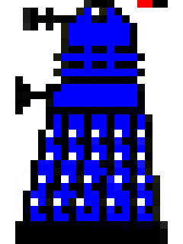
Figure 5
Visually, I just wanted to show a simple bar that shows three levels of health, which can be drawn using two writes to the screen. The challenge was to figure out how to do this efficiently using as little memory as possible.
Working on the basis that I could find the memory, somehow, I temporarily commented out the game bar code to free up some memory and then set out to develop an implementation.
To display a health bar, I needed to write an eight-pixel strip (two bytes) to the screen, with clipping etc. To do this efficiently I pick the appropriate pixel strip from a health bar atlas (shown below), where the X axis denotes how much health to show, and the Y axis denotes the horizontal position. A separate array is used to map Dalek sprites to the horizontal position, and whether the health bar is shown on the left or right side.

Figure 6
I considered writing the health bar bytes directly into the sprite data and let the drawSprite routine do all the work of putting the pixels on the screen, however this would result in the ‘lasered’ effect being applied which I didn’t want, so I needed to render the pixels to the screen, with clipping etc.
The resultant routine and calling code are 185 bytes in size and uses 41 bytes of data (health bar atlas + sprite array). The total memory required was 226 bytes.

Finding 226 bytes…
Finding 226 bytes of memory was challenging, especially since I’d already spent considerable time optimizing the code for size. After several hours of research and experimentation, I found five memory regions which I believed I could repurpose.
Region | Size
MOS printer buffer | 64
MOS keyboard buffer | 32
DFS workspace &1090-&10BF | 48
DFS workspace &10E0-&10FF | 16
NMI workspace &D01-&D5F | 51 (I was already using 44 bytes)
Total | 211
However, I’d have to reorganize the locations of many data objects to be able to leverage these new regions (which are transient in nature), and I’d have to add code to request access to the NMI memory.
I used the memory spreadsheet to develop a new memory map which I then implemented in the code. After the changes I still had a small shortfall, which I addressed by factoring out more common code from drawObject and drawLaserOn, incurring a small performance cost, which was not noticeable.

Doctor Who theme music
Adding Doctor Who theme music to the title screen was an interesting adventure.
The original Doctor Who theme music was composed by Ron Grainer and arranged and realized by Delia Derbyshire, assisted by engineer Dick Mills. Ref: BBC Two - An Adventure in Space and Time - Delia Derbyshire
I found Delia Derbyshire’s score online, which contained melody, harmony, and bass lines… with no more than three notes played at once, except in one bar where four notes are played together. I needed to remove one of the notes as the BBC Micro’s SN76489 sound chip has only three tone generators. The change is barely noticeable.
A larger issue is that the score contains many bass notes whose frequency is lower than the lowest frequency the SN76489 sound chip supports, on the Beeb. Fortunately, there is a technique which uses a timer that can work around this limitation (see section below).
As an aside, I didn’t want to play sampled music because of its low fidelity. I wanted to create a game which felt more modern than an original 1980’s game and playing low fidelity sampled music did not fit with this vision.
The next step was figuring out how to get the arrangement into a format that can be efficiently stored and played on the BBC Micro. MIDI is an obvious choice, so I set about creating a MIDI file from Delia Derbyshire’s arrangement.
I installed a trial version of Sibelius, which I used to input the arrangement. It took a few hours to get the score entered. I then used Sibelius’s Export MIDI feature to create a MIDI file.
I then created a MIDI conversion tool that converted the MIDI file into a more compact and SN76489 friendly format.

MIDI conversion tool
The conversion tool reads a type-0 MIDI file, filters and processes the contained MIDI events, and creates a new file that contains just note-on and note-off events, which have the following compact format:
note-on = <delta-time> <pitch> <tone-generator>
note-off = <delta-time> 0 <tone-generator>
Where:
<delta-time> represents the time since the last event, in 1/100th of a second units. The value is stored as a one-byte or two-byte value with the top bit denoting the latter. The high-byte precedes the low-byte. Values 0 to 127 are represented using one byte, values 128 to 32767 are represented using two bytes.
<pitch> signifies the pitch of the note to play in a note-on event. It is stored in the top six bits if the next byte. The value is in the range 1 to 63 and is calculated by subtracting twenty-seven from the corresponding MIDI note number.
0 signifies a note-off event. A value is stored in the same six bits that <pitch> uses.
<tone-generator#> is stored in the bottom two bits of the byte. The values 0 to 2 specify which tone generator the event applies to.
The events are terminated with <delta-time> &FF, where the delta-time specifies how long to pause before replaying the music.
During conversion, note events are assigned to one of the three tone generators, delta-times are converted to 1/100th second units, and redundant note-off events are removed.
The resultant file is 1813-bytes, less than a quarter the size of the source MIDI file, which is 7413-bytes.

Playing lower frequency notes
The lowest note that the SN76489 sound chip can natively support is lower ‘B’ (123.47 Hz), that is just over an octave below ‘Middle-C’.
The bad news is that most music scores, including Delia Derbyshire’s arrangement, contain notes with lower frequencies than this.
The good news is that one can generate lower tones by 1) configuring the SN76489 to output its highest frequency (125KHz), and 2) toggle the volume at twice the desired frequency. Timer2 can be used for the latter, in one-shot mode.
The technique takes advantage of the BBC Micro’s filtering circuitry that smooths the sound chip’s output. This result in the desired lower frequency square wave, as depicted below.
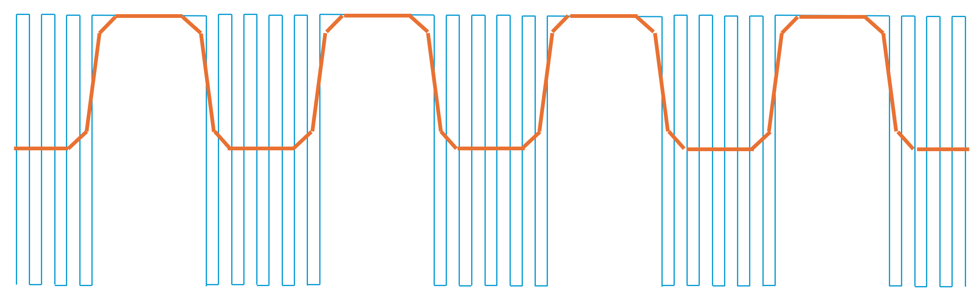
Figure 4
The main limitation of this technique is that the maximum achievable volume is half that of native tones. Fortunately, the bass line is played at a lower volume, so this limitation is not an issue.
Of course, one must drive the sound chip directly to generate lower frequencies, which for practical reasons precludes MOS sound functionality from being used to play the theme music. Fortunately, I had explored driving the sound chip directly earlier during development, so I had a fairly good idea of what was involved.

Run-time implementation
The music functionality is encapsulated in music.6502, which is loaded in the upper memory, just below where the Mode 7 title screen memory resides (see Memory usage and layout section). The music code and data are overwritten when the screen mode is switched prior to gameplay.
The music data is binary included at the beginning of music.6502. The file also contains a pitch table with 256 rows (512 bytes), which is used during runtime to look up SN76489 register frequency values or timer duration values for playing low-frequency notes. Each row in the table represents a quarter-semi-tone increment, from 38.89Hz to 1545.98Hz.
The title functionality starts and stops playback by invoking the playMusic and stopMusic routines. These routines start and stop the music, which is played in the background using a dedicated Interrupt Service Request (IRQ) routine, and two dedicated timers.
The first timer is used to read note events from the music data, update frequency and amplitude accumulators (using melody, harmony, and bass envelope definitions), and update the SN76489 sound chip… every 1/100th of a second.
The second timer is used to play lower frequency notes, by toggling the highest producible pitch at twice the lower note’s frequency.
The trickiest part of the implementation was replicating the core parts of the MOS envelope functionality, which was needed to make the notes sound more interesting.
I spent quite a bit of time tweaking the envelope definitions to get a more interesting sound. Of course, I was not able to replicate the original sound given the Beeb’s limited capabilities. I did though get to a point where I felt the arrangement was representative, at least in spirit and was recognizable. Hopefully you agree.

Titles screen
After adding the Doctor Who theme music, I added a new title page, like the ones shown in ACORNSOFT games, which appears before the game instructions. This turned out to be quite straightforward as there is an excellent online teletext editor (zxnet.co.uk) which can export a BBC Micro Mode 7 screen memory dump, which can then be binary included and copied to the Mode 7 screen memory region.
The hardest part was coming up with a name for the game and designing the screen for it.
I spent some time reviewing Doctor Who episode names, but for some reason the phase ‘Adventures in Time’ kept popping into my head. There was a Doctor Who film made in 2013 named ‘An Adventure in Space and Time’ which is where I think it came from, but I can’t say for sure.
Regardless, ‘Adventures in Time’ seemed an apt title for the game so I set about designing the screen. I tried to replicate the same colors and mosaic font used in the ACORNSOFT screen, but unfortunately there was no enough room to fit ‘ADVENTURES’ so I changed the title to ‘An Adventure in Time’ which also let me replicate the four-color bands. I was happy with the result.
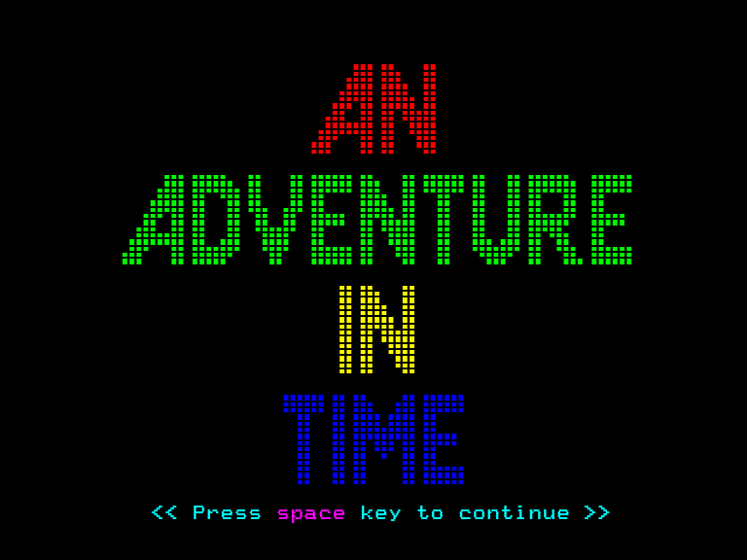

Miscellaneous
These sections aim to provide more details on various aspects of the game and its implementation.

Memory usage and layout
This section describes the game’s memory layout, which was designed for a disc version of the game, where levels are loaded/reloaded from disc.
The limited memory on the BBC micro creates a lot of challenges, so finding ways to eke out and repurpose memory is essential. Thankfully, there are great resources online that help here. The Elite documentation by Mark Moxon is noteworthy.
The general approach I took was to use sub &1100 areas of memory to hold static data (lookup tables & sprite data), while repurposing as much memory as possible that MOS and DFS uses. Static data is relocated during startup and level initialization. I also used as much of zero-page as possible to hold game variables and transient data (routines parameters and locals).
The result is that during gameplay the 32K of available memory is allocated as follows:
Address (hex) | Allocation | Size (bytes)
0000 | Zero-page game variables | 144
0090 | Zero-page MOS variables | 112
0100 | Game sprite data | 192
01C0 | Program stack | 64
0200 | MOS general workspace | 256
0300 | Game sprite data and tile-types table | 256
0400 | Game objects, sprite data, and level palette | 1024
0800 | MOS sound/printer workspace | 128
0880 | Game sprite data address table | 64
08C0 | MOS sound/printer workspace | 64
0900 | Game health bar atlas and tile address table (NMI workspace) | 96
0D60 | MOS ROM workspace | 160
0E00 | Game sprite data | 512
1000 | DFS workspace | 144
1090 | Game sound effects | 48
10C0 | DFS workspace | 32
10E0 | Game health bar table and draw lookup tables | 32
1100 | Gameplay code area | 7680
2BA9 | Game sprite data | 1184
3040 | Level tiles | 1984
3800 | Level tile grid | 2048
4000 | 256x256 4-color screen | 16384
Several things are worth noting:
- The stack (page 1) is reduced to just 64 bytes, allowing 192 bytes to be repurposed.
- Gray rows depict memory MOS and DFS uses that I was unable to repurpose.
- Blue rows depict memory MOS and DFS uses but are repurposed. This is achieved by avoiding related MOS and DFS functionality or using the functionality in limited and controlled ways. Notable regions repurposed include the NMI workspace (which has to be acquired from MOS), the MOS keyboard and printer buffers, and transient regions of DFS workspace.
- There is 3.5K of sprite data, most of which is distributed across the lower memory space.
- There are only 7680 bytes of code space available. Only the code that runs during gameplay is located here.
- During gameplay, the game uses 97.2% of the 32K available. MOS/DFS use 896 bytes.
The 16K of screen memory is repurposed during startup and level initialization. The differences are highlighted below.
Address (hex) | Allocation | Size (bytes)
3040 | Level tiles | 1984
3800 | Level tile grid | 2048
4000 | Level extents | 2
4002 | Level tile types | 32
4022 | Level palette | 16
4032 | Level coefficients | 5
4037 | Level object descriptors (48) | 144
40C7 | Level sprite data | 3616
4EE7 | Level initialization code | 1329
5418 | Titles and game initialization code | 2348
5D44 | Music data and code | 3214
69D2 | Unused memory | 4654
7C00 | Mode 7 screen | 1024

The white and gray rows show the layout after a level file is loaded, which includes level data, sprite data, and level initialization code. The initialization code copies the loaded sprite data to their lower memory locations and populates the game object data structures from the metadata and object descriptors.
The light blue row shows the game initialization and music data/code which runs only once, during startup to initialize the game, show the Mode 7 title screens, and play the Doctor Who theme music.
During startup the title screens are displayed in Mode 7, so the data/code above &4000 is not visible. During level loading, the palette colors are set to black.
The memory layout evolved during the development of the game, with allocations moved as needed.

Optimizations
Here is the list of code speed optimizations which had the largest impact:
- Unrolled the inner loops in the draw sprite routines, where the game spends a significant amount of time, and used relative jump tables to jump into the unrolled loops efficiently.
- Used tile grid flags to mark tile positions that are occupied by something resulted in efficient collision-detection and hit-testing code, where the tile grid can be queried directly. Game objects are only enumerated after a tile-grid match.
- The use of an object redraw flag ensures that game objects are only rendered when they need to be.
- Broad clipping is performed near the start of the draw sprite routines, during level to screen coordination mapping, resulting in fully clipped objects being discarded quickly. Seven out of eight objects are typically fully clipped.
- Reduced the number of animation updates. For example, static doors and elevator sprites change every eight frames. This reduces the amount of redrawing that occurs per frame.
- Reduced per frame workloads by spreading work across frames. For example, Dalek AI is executed on an individual dalek every sixteen frames.
- Used an optimized Bubble Sort algorithm for sorting game objects vertically, to help to ensure that rendering stays ahead of the display scanline read that sweeps across screen memory. The code is executed every 32 frames (approx. twice a second) so it has a negligible impact on overall performance. The algorithm is also quite efficient over small datasets which are already sorted, or close to being sorted. Tests showed that the algorithm re-sorts the draw-object-order array in just a few passes typically.
- Runtime code modifications to implement an indirect JSR instruction. E.g. JSR (address), used to call frame callback functions. Also modified conditional branch offsets to efficiently resolve the tile address give and X, Y coordinates. The offsets differ for different sized level tile grids.
- Reduced the use of the stack by using zero-page transient variables as routine parameters and local variables extensively.
And here is a list of notable code size organizations used:
- Refactored program and level initialization, pushing as much code as possible out of the gameplay code area.
- Removed objectWidth & objectHeight arrays, replacing these with zero-page cached variables: width, height, widthMinusOne, and heightMinusOne. The last two variables allowed for several functions to be simplified which were previously subtracting one from objectWidth & objectHeight.
- Bit-packed objectType and objectState array data. These variables hold numerous distinct properties.
- Reduced the use of the stack by using zero-page transient variables as routine parameters and local variables extensively.
- Aggressively used all available memory, for a disc-based program.
- Factored out duplicated code, where this saves code bytes and does not significantly impact performance.
- Only code/data that is strictly needed during level play is resident in memory. For example, game initialization code (which runs when the game is titles) is loaded where the screen memory would be, and executed from there. Likewise, level initialization code is packaged with the loaded level data and executed after being loaded. The code is not seen because the palette is set to black during level loading and initialization.
- Run-length encoded text strings, compacting their size.
Several generic 6502 optimization techniques were used also. These included:
- Used conditional branching whenever possible, instead of jumps. The conditional branch instructions take up two bytes whilst the jump instruction takes up three bytes.
- Used tail JMP xxxx instead of JSR xxxx, RTS, or better still use a conditional branch (see above). In either case the implicit RTS is documented.
- Better still, if the calling function is placed above the called function, it can just fall through to it!
- Used zero based constants removes the need to use CMP to test against them.
- Factored out RTS instructions, when possible. Routines that conditionally branch to an RTS instruction share a common return point.
- Used tables to drive functionality, where this reduces code size. The k9Animate and dalekAnimate routines do this.
- Overlap static data when the values overlap. For example, the osfileBlock and vduCommands buffers (program.6502) both have six trailing zero bytes. The buffers are overlapped with vduCommands flipped.
- 16-bit unsigned numbers are compared (A > B) using the following compact pattern:
LDA Al
CMP Bl
LDA Ah
SBC Bh
BCC label
Ref: Bruce Clark 6502.org Tutorials: Compare Instructions

Coding style
The code is quite structured with routines used extensively throughout the program. Each routine has a comment block detailing its purpose, parameters, and modified variables.
Routines always define a new scope (a wonderful beebasm feature) to limit the scope of contained labels and local data. Nested scopes are not used.
Control flow is typically expressed using if ... then … else … and loop … while like constructs, with label names reflecting this. E.g. loop, else, endif etc. Loop, then, and else bodies are also indented to reenforce the block nature of the code.
Occasionally, routines return indirectly through a tail jump, or don’t return and fall through to the routine below. These cases are always called out using a comment.
Comments are shown in-line with the code and occasionally to the right. They aim to provide a higher-level outline of the code rather than document what every instruction is doing.
Routine parameter passing uses the following rules:
The accumulator is typically used to pass arguments to routines that accept a single argument, and the X register is exclusively used to pass game objects, as an index. In other situations, zero-page variables are used to pass arguments. The Y register is rarely used.
As for the stack… routines occasionally push and pop values, but this is rare. Zero-page variables are typically used to hold temporary values as this avoids issues where control flow can result in push/pop mismatches.

Game design
The playability of a game is determined by many factors. The player needs to be challenged, and needs to work, to feel a real sense of gratification and reward later. The players’ attention must also be held by the game, by presenting occasional surprises and changing things up on the player. And above all, the player should not be punished for playing the game. The game must be robust (not crash) and its difficulty should increase in a reasonable manner.
The following choices were made to make this game feel more modern.
Unlike many 1980’s games, K9 does not have three lives and there isn’t a notion of score or points. The goal of the game is to just successfully navigate K9 through all the levels.
K9 dies when K9’s health becomes zero. K9 gains health by collecting jewels, and loses health when using the laser, or when attacked by a Dalek. When K9’s health is low, the laser cannot be used and the health bar in the game bar changes color. To reinforce low health, a heart rate monitor beep is sounded every second or so. This becomes a continuous tone if K9 dies.
If K9 dies, the current level is restated. The user can also choose to restart the current level if they become stuck, by pressing the ‘R’ key.
And unlike many 1980’s games, the player direction keys are WASD.
Locked doors and keys are used to add a puzzle element to the game. Keys can be collected and then used to pass through locked doors, after which they are used. Doors stay unlocked until a Darek uses them. Alternatively, K9 can follow a Dalek through a door.
Other puzzle elements of the game include getting a Dalek to follow K9, and then hiding K9 behind a door, blocking a Dalek from using an elevator for a specific amount of time, and using a Dalek to hide from another one.
To hold the attention of the player, each level can have its own palette and sprite definitions. The relative strength of jewels and Daleks can also be configured.
The above choices hopefully give the game a more modern feeling, where gameplay is more open, and the consequences of dying less severe. That said, there are no saved checkpoints, so the game must be played from start to finish in one go (unless an emulator is used).

Missteps
From reading this document, it may appear that every decision taken was a good one, and things were fully thought though before implementation began, and that coding was purely a typing exercise, and that development proceeded without detours or missteps. This was not the case.
The reality is that developing code is an iterative process (at least for me) where I build out a spike of functionality, flush it out, build on it, rework it, and then refine it. I then pursue another area of functionality in a similar manner occasionally going back to revisit and rework early work, while always trying to improve on what I have. Sometimes, the code becomes complex or convoluted, and the path forward is less clear and harder to pursue. This is normally an indication that there is something inherently wrong or missing with the approach, or underlying data structures, so one steps back and revisits previous decisions and choices. Unfortunately, I’m not smart enough to see the full ramifications of every decision I make so I occasionally need to backtrack.
Here are a few examples of approaches taken that turned out not to be the best choices. I include these as they may be of interest.
- Page grids. Early in the development of the game I came up with a level model that allowed for an arbitrary arrangement of pages. From a data structure perspective, the model was simple and provided for a wide range of interesting level topologies. However, any code that traversed tiles had to deal with potential page boundaries. The mistake I made was not realizing that choosing such a data structure would require that I adopt an abstraction (function-based or macro-based) to traverse it, which was something I was not willing to do. In trying to avoid this I ended up with complex code in several key areas of functionality… drawing tile strips when scrolling, collision detection, laser hit detection, and elevator operations. After spending considerable time fixing several nasty bugs, I stepped back and asked myself if the benefits of the page grid design outweighed all the added code complexity. I concluded it wasn’t and removed the page grid, opting instead to go with a single large rectangular tile grid which could be either 16x128, 32x64, 64x32, or 128x16 tiles in size. The change resulted in a significant reduction in code size, and much simpler tile traversal logic throughout the code base.
- In game level completion screens. I initially wrote the game level complete screens as Mode 1 overlays, rendering the graphics and text directly over the gameplay screen. To do this I needed to write custom drawText routines that used the MOS’s character definitions stored at &8000. Although this worked well, the draw code took up precious bytes and I was forced to take these back, so I switched the screens to use Mode 7 instead. The lack of memory forced several difficult decisions like this one during later stages of development.
- Sound. I initially thought that I could use less memory if I drove the sound chip directly, rather than use the MOS sound and envelope functionality. This was misguided and stemmed from a limited knowledge and underestimating what was involved. After spending several days exploring this approach, I realized that I was essentially implementing an alternative implementation of code that already existed in ROM and could just be called.
However, the exportation was not entirely wasted as the knowledge gained was invaluable when I later added the Doctor Who theme music to the title screen, which couldn’t be played using the MOS sound and envelope functionality.
- Constants. For most of the development, constant names were a mix of uppercase and camel-case names, without formalized rules. This resulted in several hard to fix bugs caused by accidentally using the wrong address mode when using a constant name. After being stung by a nasty intermittent draw sprite bug which was difficult to reproduce and diagnose, I finally adopted a scheme where constant values are uppercase, and constant addresses are in camel-case. This simple rule made spotting address mode mistakes far easier. All uppercase constants should be proceeded with a ‘#’ and all camel-case constants should not, unless they are being used within #HI(…) or #LO(…).

Resources
6502 instruction set - 6502 Instruction Set
6502 tutorials - 6502.org: Tutorials and Primers
Memory Map - mdfs.net/Docs/Comp/BBC/AllMem
DFS memory usage – mdfs.net/Docs/Comp/BBC/Disk/DFSMem
Elite disc version (Mark Moxon) - About the BBC Micro disc version of Elite - Elite on the 6502

