An Adventure in Time

The beginning…
A friend of mine kindly gifted me a BBC Micro Model B, which he had restored back to life.
It was truly a wonderful gift, and it re-energized my interest in the BBC Micro, a machine that I spent countless hours programming in BASIC as a teenager.
After playing with the machine for a while, I decided it would be an interesting exercise to try to write a game for it, in assembly code. Not something I could do in my teens.
After considering several ideas, I decided to create a Doctor Who themed game, featuring Daleks as the main antagonists. Daleks seemed like excellent characters around which to develop a game. Additionally, the Doctor Who theme would pay homage to the BBC, which commissioned Acorn to design and produce the BBC Micro back in 1982.
The BBC Micro was instrumental in nurturing an entire generation of programmers, including myself.
I also wanted to create a retro game that looked, behaved, and felt more modern than a 1980’s game, which is hard to do when the hardware has not changed. I believed that I’d have a better chance of accomplishing this with a platform game.
The next step was to create a prototype…

Prototype
The first thing I did was re-familiarize myself with the BBC Micro’s capabilities and learn to program in 6502 assembly.
To this end, I read the BBC User and Advanced User guides, and the Advanced Machine Code Techniques for the BBC Micro, by A. P. and D. J. Stephenson, which I found particularly useful.
Of course, the only way to become proficient in any language is to use it.
In searching for information on the BBC Micro and 6502 on the web, I discovered BeebAsm, an excellent assembler that I could use on Windows to produce a disc image, which I could then run in BeebEm, an emulator I’d used intermittently over the years to play Hunchback, Revs, and Elite… favorite games from my youth.
I used Visual Studio as my development environment as it has an excellent editor, and initially Azure DevOps for the Git repro, as I already had an account. I later moved the repro to GitHub.
After looking at some examples that were installed with BeebAsm, I set out to write a simple prototype to see how many Dalek sprites I could animate smoothly.
To feel more modern, I decided to use screen Mode 1, which has twice as many pixels as Mode 2, the screen mode that most 1980’s platform games used, and I landed on the Dalek sprites being 32x24 pixels in size, which are quite large by 1980 standards. In Mode 1, five platforms of Daleks fit comfortably on the screen.
To animate the Daleks smoothly, I would move them pixel by pixel. In Mode 1, each byte of screen memory represents four adjacent pixels, so one needs four copies of the source sprite data, each shifted over one pixel, to efficiently render a sprite at an arbitrary horizontal position.
I created the four Dalek sprites in a bitmap atlas using paint.net and wrote a C# console app to convert the bitmap file into a column ordered Mode 1 memory format, which I then used in the prototype. The sprite rendering code selected the appropriate sprite data to use based on the rendered position.
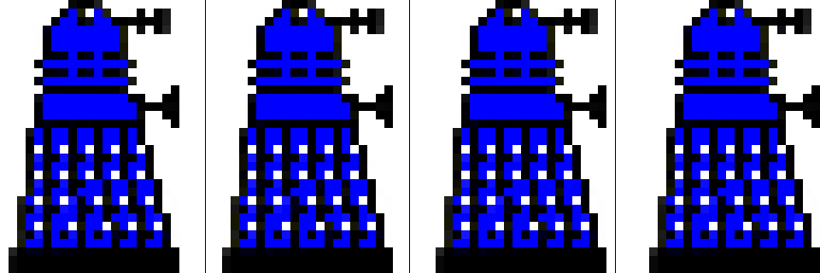
Figure 1
The prototype was based on BeebAsm’s demo program that renders a sphere of rotating dots. The example was super useful as it has code to set the screen mode, set up timer and v-sync interrupts, it has a simple game loop, and it has simple drawing code. I updated the code to use Mode 1 and replaced the drawing code with code that cleared and rendered the Dalek sprite images.
While I was successful in being able to smoothly animate a three Daleks moving across the screen, there weren’t enough cycles to render more than this, which was very disappointing.
After exhausting ways to optimize the code, unrolling loops etc., I realized that the code was simply doing too much work and that I needed to simplify things.
The sprite renderer I implemented used masking techniques to overlay sprites over other sprites, and the background. And it used a character-based set of dirty flags, to minimize redrawing. While the techniques worked well for smaller sprites, the prototype demonstrated that the techniques did not scale to larger ones.
I tried simplified the masking functionality to simply OR sprite data against the screen memory, which improved performance, but it also resulted in some unpleasant artifacts.
In the end I concluded that the only way to animate larger sprites smoothly was to just copy sprite data directly to screen memory and live with the constraint that sprites cannot overlap each other, or other graphical elements.
After removing the overlay and redraw code, the prototype performed as I had hoped. I could animate six Dalek sprites smoothly.
The prototype showed what was possible, and perhaps more importantly what wasn’t. It also helped greatly in developing my 6502 assembly skills and refreshing my memory of the BBC Micro.

Turning the prototype into a game
Turning the prototype into a game was an iterative process of exploring and introducing new pieces of functionality, addressing gaps and issues, whilst continuously trying to find ways to reduce memory usage, whilst keeping performance where it needed to be.
The following sections provide a journal of the journey…
Portions of the journal were written after the core functionality was completed and was created by reviewing the source-code history, identifying key areas of work, and writing about them.

Level design
The first thing to do was to figure out how I was going to represent and draw a game level.
After looking at several options, I chose a page/tile-based representation where a level was comprised of a set of pages, arranged in a pattern, with each page containing a grid of tiles. I knew memory, or lack thereof, was going to be a challenge so I used a spreadsheet to try out different combinations of tile counts, tiles sizes, page counts etc.
The numbers led to a level comprised of 8 pages, each containing a 16x16 grid of tile indices, referencing up to 32 tiles, each 16x16 pixels in size. The first tile would always be blank so would not need to be represented. The page layout would be represented using an 8x8 grid of page indices. The total memory required to represent a level was 4K.
The numbers also mapped nicely onto the level coordinate system, where the high-byte maps to pages, and the low-byte maps to page tiles (high-nibble) and tile pixels (low-nibble). A Dalek was also exactly two tiles tall. Nice!
To save memory, I decided to reduce the width of the screen from 320 to 256 pixels, which reduced the screen memory from 20K to 16K. I’d use the 4K I saved to hold the level data.
I created a few 16x16 tile designs in paint.net and updated the BMP converter to convert these to a character ordered Mode 1 screen format. I then included this tile data, plus a hard-coded level page into the prototype, and implemented a draw-tiles routine that rendered the level page. I now had something that started to look like a game.
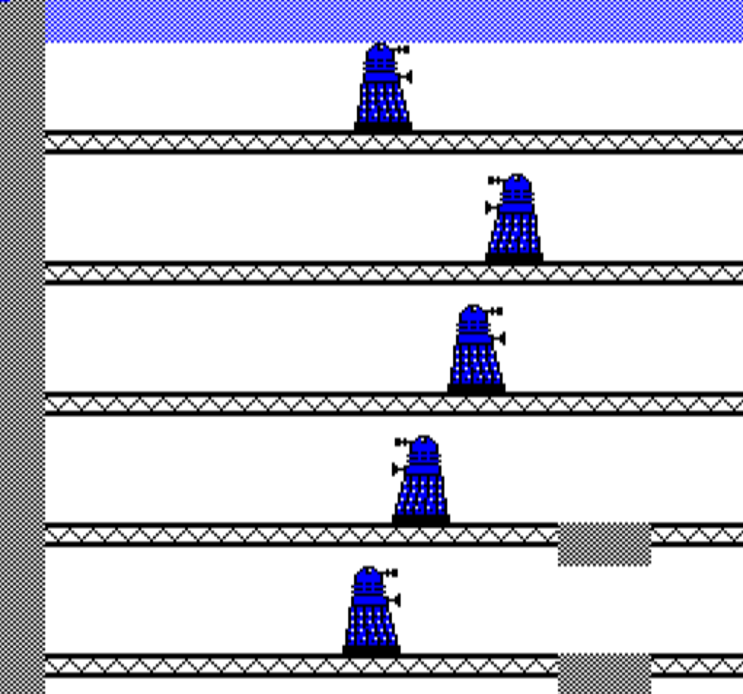
The next step was to add the player character.

Player Character
The natural choice for the player character was ‘The Doctor’, but I’m not an artist so creating a set of sprites to animate the Doctor in a convincing way seemed a daunting task, so I decided to use ‘K9’ instead… a character that appeared in several series which I have fond memories of. I could draw K9.
I created sprite images for K9 in the same way that I had created sprites for the Daleks and added zero-page variables to hold K9’s position and updated this using the WASD keys. I was now able to move K9 around the screen, be it through walls and platforms.
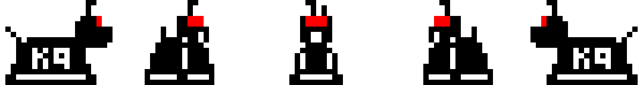

Adding animations
I formalized how animations worked by introducing animation constants (ANIMATE_LOOK_LEFT, ANIMATE_MOVE_RIGHT, AMIMATE_TURN_LEFT_TO_RIGHT etc.), zero-page variables, and frame callbacks. Each game character has an associated callback function which is called every frame, after all the characters have been rendered. The callback function implementations contain the logic for updating character positions, selecting the appropriate sprite, and determining what happens when an animation ends. I encapsulated the necessary animation invocation logic in k9Animate and dalekAnimate routines that accepted an animation constant and set up the appropriate frame callbacks. This simple model worked surprisingly well and formed the basis for later extensions.
The next natural step was to add scrolling functionality… but I’d need a full level defined to scroll around in first. Time to write a level editor.

Level Editor
A game level editor is an essential tool for creating a platform game, as it provides a way to graphically design and create levels. Think of it as a specialized form of painting program.
I wrote the level editor in C#/Windows-Forms as it was the easiest way for me to quickly build a graphical editor. A simple Windows-Forms app with a few custom controls would be more than sufficient. I’ve developed numerous graphics-based applications over the years so creating the level editor was largely a typing exercise for me.
The editor allows one to create, load, edit, and save a level file, which can then be binary included within the game code. The editor also allows one to select the page layout (how the level’s eight pages are arranged), select the four colors of the level’s palette, edit individual tiles, and define a page’s tiles.
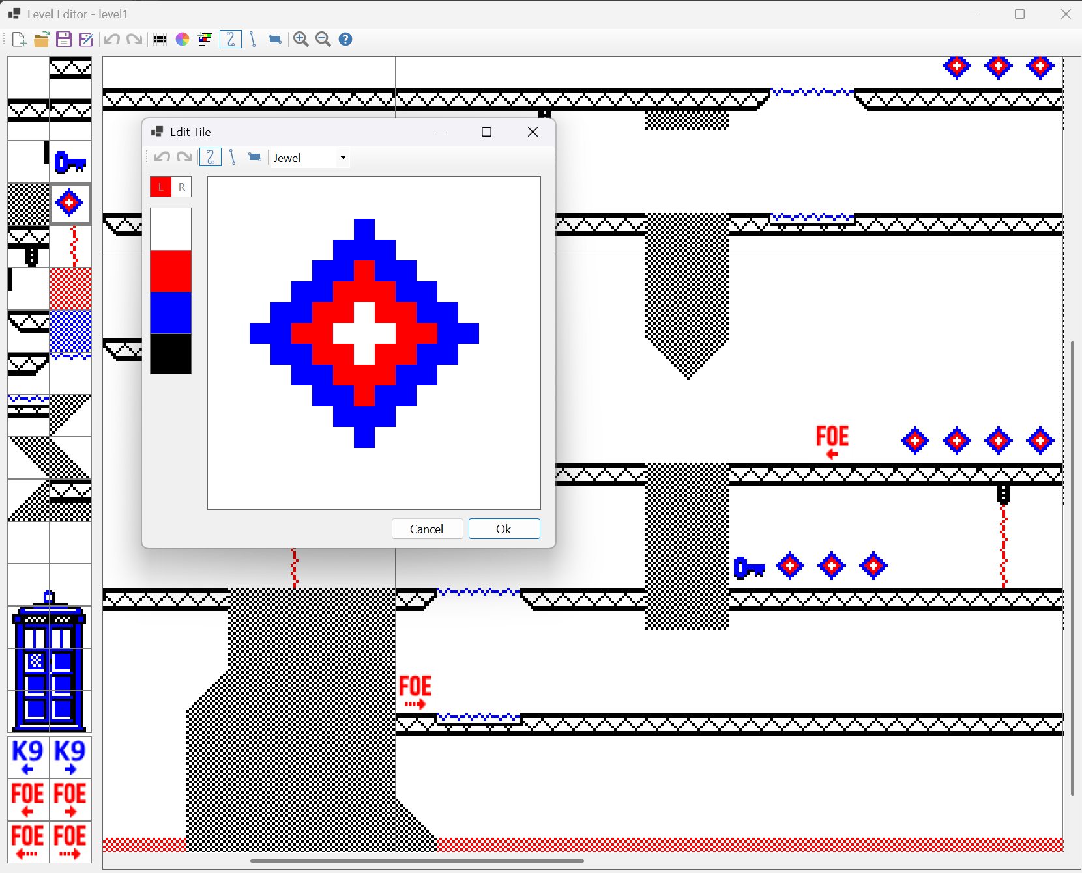
Figure 2
Using the editor, I created a basic level file and included it directly within the game code using the BeebAsm’s INCBIN directive.
The editor was revised and extended during development of the game, with additional features added as needed.

Scrolling
With the level data included in the game code, I was then able to write code to scroll around the level, in half tile (8-pixel) increments, using the arrow keys.
This was somewhat challenging to get right as the code had to draw the correct half width tile strip, or half height tile strip, from the correct screen memory location, correctly spanning page boundaries, efficiently… and then update the screen start address in the hardware, so the screen shifted. The change introduced several zero-page variables to keep track of the top left position of the screen, and its start address.
I also had to update the draw-sprite routine to transform sprite level coordinates to screen coordinates (by subtracting the top-left screen position) and handle cases where address calculations that crossed the upper screen memory boundary wrapped around correctly.
It was now time to address some other issues…

Clipping
The first thing to address was clipping, or lack thereof. The draw-sprite code was first updated to perform broad level clipping whilst transforming the sprite level coordinates into screen space. For example, if the sprite’s left screen coordinate is larger than 255, the sprite is fully clipped. Likewise, if the sprite’s right screen coordinate is less than zero, it’s also fully clipped. The same is true with the sprite’s top and bottom screen coordinates.
Adding the broad clipping tests was straightforward and improved performance significantly, as the screen area covers one-eighth of a game level.
If the code gets past the broad clipped tests, all or some portion of the sprite is visible… so the next step is to perform finer grained clipping by comparing each of the sprite’s edges against their corresponding screen edges, reducing the sprite’s rendered width and height, and top and/or left source image offset, appropriately. For example, if the right edge of the sprite falls beyond the right edge of the screen, we need to reduce the rendered width. Likewise, if the left edge of the sprite falls before the left edge of the screen. But in this case, we also need to offset the source image and set the sprite’s left edge to zero.
Adding the fine-grained clipping code was also straightforward, but it did increase the size of the draw-sprite routine significantly.

Smearing
Another issue that needed to be addressed was pixel trails that were left on the screen when K9 was moved up and down. These were the result of the sprite images not having a blank line along their top and bottom edges.
One option would be to add the blank lines to the sprite images, but that wastes valuable memory (328 bytes). The approach I took was to extend the draw-sprite routine to optionally draw the blank lines and use this functionality when animating the sprites up or down.

Collision detection
I also needed to stop K9, and Daleks, from passing through each other, and walls. I needed a way to detect collisions.
After looking at several options l landed on using a tile-based approach, where each tile location in a level is marked as being occupied or not. With this information, game character movement can be restricted by testing the next tile location’s occupancy. Of course, the occupancy information must also be updated as characters move across tiles.
I updated the level model to hold this occupancy information directly within the page tile grids, which up until this point just held tile indices (values 0..31). I used one of the three unused bits to hold the information.
The implementation was straightforward, though handling page boundaries proved challenging and led to code complexity and quality issues. More on this later.

Game objects
I was now at a good point to introduce more game objects, to make the levels more interesting to play. I also needed a way for K9 and Daleks to move between floors (they can’t climb stairs!), and I wanted to add doors and collectables (keys and jewels) that would unlock doors and give K9 health.
I concluded that game objects were either static or dynamic in nature. Jewels and keys are static as they don’t move, animate, or have any intrinsic behavior. However, K9, Daleks, doors, and elevators do animate, move, and do have intrinsic behavior. They are dynamic.
I realized that by introducing the notion of a tile-type, I could embed static objects (jewels and keys) directly within a level, which the game code can look up and act upon. I also realized that tile types could also be used to denote where doors and elevators were located.
So, I updated the level editor to allow a tile to be marked as being either a space, wall, floor, elevator, door, jewel or key, and serialized this information with the level data. A tile’s type could now be resolved using a runtime table lookup.
I did, however, need a better way to represent dynamic game objects in the game.

Dynamic game objects
Up until this point, K9, Daleks, and elevators were represented using their own set of variables, and doors did not exist.
To allow levels to have different numbers of Daleks, elevators, and doors, I consolidated all game objects into a unified set of correlated arrays. I settled on a level having at most 48 game objects, including K9.
K9 would always be the first game object (index zero), followed by all the Daleks (from index one), then all the elevators, and finally all the doors. The start index and counts of Daleks, elevators, and doors are stored as zero-page variables.
The resultant correlated arrays were:
- objectXLo & objectXHi - Object’s left level coordinate (high and low byte)
- objectYLo & objectYHi - Object’s top level coordinate (high and low byte)
- objectWidth & objectHeight - Object’s width and height
- objectAnimation - Object’s current animation (ANIMATE_LOOK_LEFT etc.)
- objectState - Object’s state. High nibble contains generic render flags (redraw, erase-above, erase-below). Low nibble holds K9, Dalek, elevator, and door specific data.
- objectSpriteIndex - Object’s sprite index (specifies which sprite to render)
- objectFrameCallbackLo & objectFrameCallbackHi - Object’s frame callback function invoked every frame (high and low address bytes)
- objectFrameCounter - Object’s animation counter, used to control the duration of animations.
Refactoring the code took some time, but the resultant code was much cleaner and tighter, and there was much less of it!
I updated the level editor allowing K9 and Daleks to be placed within a level, specifying their direction, and initial motion. These game objects, along with elevators and doors, were serialized and read by the game’s level initialization code to populate the zero-page variables and game object correlated arrays.

Title screen
I then introduced the game’s title screen, a Mode 7 screen containing a game’s description and controls. Gameplay starts when the spacebar key is pressed.
As an aside, holding the start of the game made it much easier to debug, as it allowed me to launch the debugger and set break points before the game loop was entered.
As part of this change, I wrote a routine to display Mode 7 text, which can include teletext control codes, which I used to render colored and double height text.
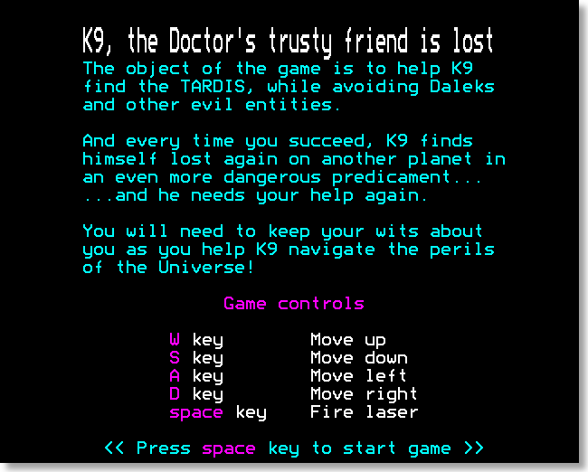
Figure 3

Auto-scrolling
I then enhanced gameplay by implementing a simple form of auto-scrolling, where the screen automatically scrolls when K9 is unable to see more than a third of the screen. The scroll is fast and fluid, with the game continuing to function during the scroll. Repeatedly turning at an auto-scroll boundary causes the screen to scroll back and forth. This form of scrolling was chosen as it allows K9 to move freely around the screen and yet progress across screens in a fluid manner. I felt this was preferable to having K9 fixed in the center of the screen or scroll when K9 reached the edge of the screen.
The changes were straightforward to implement. I just needed to introduce zero-page variables to hold a scroll count and scroll direction, update the scrolling code (called from within the game loop) to read these, and update these variables as needed when K9 turns or moves.

Level completion
I now needed a way for K9 to finish and exit a level. The level I had designed already contained an image of the Tardis at the exit point, which was made up of eight unique tile designs, but I didn’t have a way of detecting that K9 had successfully reached the Tardis.
The solution was to introduce an exit tile type and mark the eight tiles as being exit tiles. I updated the level editor and updated the k9Animate routine to test for the new exit tile type, displaying a level completed overlay.
The overlay was created by drawing a Mode 1 text block over the screen. To do this I wrote a draw-text routine that rendered text characters, using the MOS character bit patterns defined in ROM. I couldn’t use the MOS text rendering routines as I’d customized the screen, making it narrower.
The code to load the next level would come later.

Revisiting the page grid design
In reviewing the code, and looking for ways to free up memory, I noticed that there were multiple pieces of code that dealt with page boundaries, in different ways. I was also conscious of several difficult to fix bugs related to page boundaries, and knew I’d likely encounter more challenges as I added more game functionality, such as laser hit testing, line-of-sight calculations, and elevator motion.
I reflected on the benefits of the page grid design and concluded that whilst an attractive feature, it fell in the ‘nice to have’ category and was not essential… so I decided to remove the feature entirely. A level would simply be a tile grid whose extents could be either 128x16, 64x32, 32x64, or 16x128 tiles.
I updated the level-editor to operate on a single tile grid, replacing the page-grid layout dialog with a tile-grid layout dialog, and then refactored all the game code. The changes were extensive.
The resultant code was simpler and cleaner in many areas, and the overall program code size reduced significantly. The change also made it far easier to implement features developed later.
As an aside, I concluded later that the issue was not with the data model, but with my unwillingness to accept the cost of an abstraction (function-based or macro-based) that was required to traverse it cleanly. There is a lesson here.

Adding door functionality
Up until this point doors did not function. Daleks and K9 were blocked from going through them.
After thinking over several options for how doors should operate, I concluded that doors should automatically open and close for Daleks, and that K9 would need a key to use a door, and that keys could only be used once, but multiple keys could be collected. I would also allow K9 to follow a Dalek through a door without using a key.
Implementing this behavior required quite a few changes. Central to this was updating the door frame callback function to test if a Dalek or K9 is next to the door and then change its visible state appropriately. The easiest way to do this is to test the tile grid occupied flag of the adjacent tiles, though this does not contain sufficient information to determine whether K9 or a Dalek is occupying and adjacent tiles.
Since this information was important and likely needed by future functionality (which it was), I introduced two supplemental tile grid flags denoting whether the occupancy was for a Dalek or K9.
As before, bit 7 marks that a tile location is occupied by something, and bits 0..5 hold the tile index (values 0..31). But now bits 5 and 6 specify if the occupancy is by K9 or a Dalek.
Updating the code to set and clear the supplemental tile grid flags was straightforward, though resolving related bugs proved challenging. More on this later.
I then updated the draw-sprite routine to draw the background color if the sprite index is -1. This was done by setting srcBaseAddr and stride variables to zero (the first 32-bytes of memory contain zeros). I need this functionality to show an open door.
I also needed to store the current state of the door. Whether it is open or closed. This information is stored in the low nibble of objectState array.
I was now able to fully implement the door functionality, adding logic to test the K9 and Dalek occupancy states of the adjacent tiles, determine if the door should be open or closed, determine if the state changed, persist this, and then update the sprite index appropriately, assigning -1 if the door is open.
As an aside, I later enhanced the door logic so that once a door is unlocked with a key, it remains unlocked until a Dalek uses the door, and locks it again.

The ‘Game Bar’
I was now at a point where I wanted to track K9’s health, and implement functionality to collect jewels and keys, and show this information in a game bar, located at the top right of the screen.
I added zero-page variables for K9’s health and a key-count, initializing these during game startup. I then updated the k9Animate function to collect jewels and keys. I just needed to check the tile type when K9 was blocked from moving left or right. If the tile type is a jewel or key, the code updates K9’s health or key count and invokes a clearTile routine.
The clearTile routine clears the tile’s index, so the tile is blank from now on, and redraws the tile. Voila, the key or jewel is collected!
I then added code to render the game bar. As before, I created a game bar sprite using paint.net and used the BMP converter app to generate a Mode 1 screen representation which I included in the game code. To save memory, the asset initially only contained four digits ‘0’ to ‘3’.
I then wrote code to render the game bar, which shows K9’s current level of health, and key count. To game bar is redrawn every eight frames.
In addition to this, I needed to update the scrolling code to redraw the game bar and draw the tile strips around it. The latter was fiddly to get right.
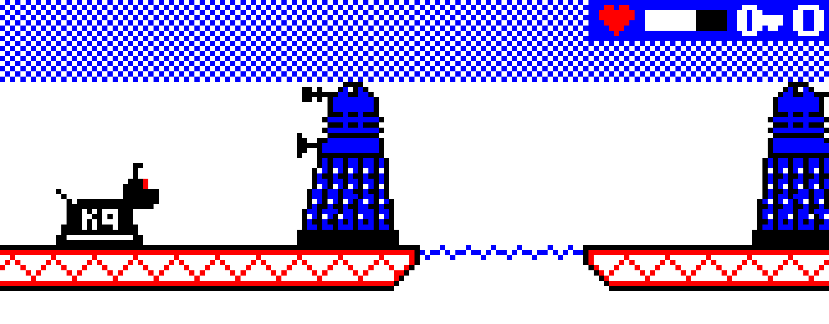
Figure 4
I later revisited the game bar adding code to show the current level and extended the number of supported digits from four (0..3) to ten (0..9). Numerous code size optimizations were needed to free up sufficient space for these changes.

Elevators
Up until this point, elevators were static and didn’t move. I probably should have implemented their behavior earlier, but I knew their implementation would be challenging and a fair amount of code would need to be written, so I procrastinated. But no longer…
I first broke down the required functionality into the following major steps:
- Determine if K9 is on an elevator and whether K9 can move in the desired direction.
- Check if the destination location is occupied.
- Start the animation.
- Animate K9 and the elevator ascending or descending.
- End the animation
These steps were then broken down into more detail…
- Determine if K9 is on an elevator, and whether the elevator can move in the direction K9 wants to move. This is performed by:
  - Check if K9 is on an elevator by querying the tile-types of the tiles directly underneath K9. This is a relatively inexpensive test.
  - Determine if the elevator can move in the desired direction by traversing the tile-grid in that direction, looking for an elevator tile type. If another non-space tile is encountered first, the elevator cannot move in that direction.
  - Find the elevator game object that K9 is on by iterating over all the elevator game objects, looking for a positional match.
- Check if the destination location is occupied, by checking the occupancy state of the tiles just above the destination location. If the tiles are occupied, the elevator is blocked from moving. If the tiles are clear, we know the elevator can move.
- Initiate movement, in the desired direction, by:
  - Mark the tiles just above the destination location as occupied, to stop a Dalek from occupying them as this would be bad.
  - Remember the current location of the elevator, as we want to restore this after the elevator stops. The objectFrameCount is repurposed for this.
  - Mark K9 and the elevator game objects as both ascending or descending by populating their respective objectState’s erase-above or erase-below render flags. This ensures the objects don’t smear the screen.
  - Set the elevator’s frame callback function to either an ascend or descend frame callback function.
- Animate K9 and the elevator ascending or descending, whilst restricting K9’s movement, until the elevator reaches the destination position. This functionality is implemented in the ascend and descend frame callback functions set above. These functions perform the following:
  - Increment/decrement the vertical position of K9 and the elevator
  - Check if the screen needs to be scrolled by calling the auto-scroll code.
  - Check if the elevator has reached its destination position. This is done by first checking if the elevator is positioned at a tile location (e.g. Y mod 16 is zero) and checking if the tile at that location is an elevator.
  - If the elevator has reached its destination, the callback is set to a stop elevator frame callback function, which will be called on the next frame.
- Complete the animation. This functionality is implemented in the stop elevator callback function set above. The function performs the following:
  - Clear the erase-above or erase-below render flags set on K9 and the elevator, as smearing is no longer an issue.
  - Restore the elevator’s position, using the original position stored in objectFrameCounter variable, which we repurposed.
  - Mark the tiles above the original elevator’s position as unoccupied as K9 is no longer there.
  - Mark the tiles where K9 is now as occupied by K9. They were previously just marked as occupied.
  - Restore the frame callback back to the static elevator frame callback function.
During development I discovered that I also needed to…
- Update the draw objects game loop code to render descending elevators before K9, to avoid rendering artifacts.
- Restrict K9’s movement when riding a platform by checking the erase-above and erase-below objectState’s render flags.
This may seem like a lot of steps to allow K9 to just move up and down elevators in the game, but all the steps are necessary to implement the behavior. The functionality was implemented in around 600 lines of assembly code, and accounts for about 10% of all gameplay code.
The functionality was later extended to also allow Daleks to ride elevators and later specialized to support teleports.

God mode
At this point K9 could navigate through an entire level, taking elevators as needed to avoid Daleks. However, testing the game was becoming more difficult as K9 was blocked from going through doors, unless a key was collected, and there wasn’t a simply way to scroll around the level to validate the behavior of game objects that were not visible on screen. I therefore decided to implement a ‘god mode’ that would give K9 unlimited health and keys; and allow the level to be scrolled independently from K9’s movements.
The functional was later extended to allow an arbitrary level to be loaded by pressing the associated number key.
The implementation was straightforward.

K9’s laser
One advantage of using K9 as the player character is that K9 has a laser, which can be fired at Daleks, and destroy them with prolonged application.
To improve gameplay, the laser can only be used if K9’s health is above 25 percent, and using the laser depletes K9’s health. The laser is fired when the space key is held down.
When activated, the flickering beam of light is drawn by rendering the laser beam one frame, clearing it the next frame, then rendering the beam again the next frame, and so on.
The laser beam is drawn horizontally from K9’s muzzle until it hits something. And if it hits a Dalek (detected by reading a tile’s occupied state) the corresponding Dalek game object is marked as ‘lasered’ and its health is reduced. If the Dalek’s health reaches zero, it is destroyed.
The beam is cleared by drawing the background color over the laser beam.
A ‘lasered’ Dalek also flickers, which is achieved by rendering a ‘lasered’ Dalek sprite differently. A render-lasered flag was introduced which signifies this effect and the draw sprite routine was updated to render ‘lasered’ sprites using a shift and masking technique that applies the laser color to the sprite data.
I initially had some concerns about the performance impact of drawing the laser beam and lasered sprite effect, however I was unable to detect any noticeable impact when playing the game. This is probably because the additional cost is roughly equivalent to having another Dalek sprite animating on the screen.
Notable code changes include:
- A zero-page laserFrameCount variable was introduced which controls laser rendering. The laser beam is drawn when its value is 2, cleared when its value is 1. The variable is decremented every frame, if its value is not zero.
- A space key handler was added, that sets laserFrameCount to 2 if the space key is down and laserFrameCount is zero. Holding the space key down results in the value toggling between 2 and 1.
- A Dalek’s current health is stored in the lower nibble of the objectState variable. This is initialized during level initialization. This value is decremented if the Dalek is hit by a laser. If the value becomes zero, the Dalek is destroyed by setting its sprite index to -1, marking it for redraw, clearing the relevant tile occupancy flags, and setting its frame callback to the address of a RTS instruction.
- A render-lasered flag was introduced to denote a game object as being ‘lasered’, as outlined above. This is the fourth render flag in the high nibble of the objectState variable. Also updated the draw sprite routine to render lasered sprites by applying the laser color to the sprite data using shifts and masking techniques. Note that the ‘lasered’ flag is cleared after use.

Debugging tile grids
As development progressed, more and more features relied on the three tile grid occupancy flags being maintained correctly, and there was no simple way to ensure this was the case. Bugs that resulted in these not being set correctly would manifest later as odd behaviors, making identifying and fixing the root bugs challenging.
What was needed was a graphical way of seeing the values of all the tile grid occupancy flags. I therefore wrote a debugTileGridFlags routine that rendered a little box showing the three values graphically, positioned at the top left of every tile displayed on the screen.
The function is invoked within the game loop after all rendering. The code is conditionally assembled when a DEBUG_TILE_GRID_FLAGS constant is set to 1. The game bar is not rendered shown when the flag is set, as code space must be freed up to allow debugTileGridFlags to be assembled. A SKIP directive is also used to ensure that the number of unused bytes does not change when the DEBUG_TILE_GRID_FLAGS is set.
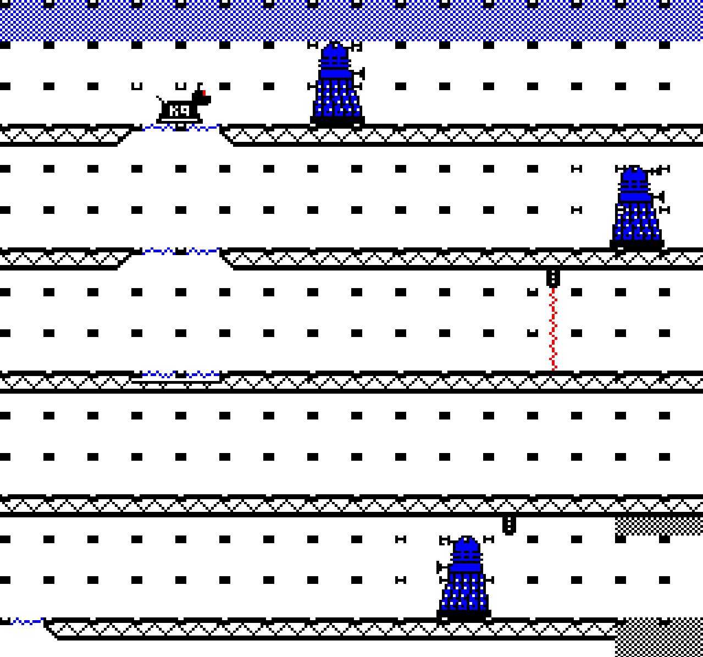
Figure 5
Key
Tile occupied by something other than K9 or a Dalek
Tile occupied by K9
Tile occupied by a Dalek
Tile unoccupied
The debug functionality proved to be incredibly helpful. It illuminated several issues which were easy to identify and fix and it became the de-facto thing to enable when odd behaviors were observed. One notable fix it led to was that there was a timing issue when K9 turned around, which intermittently left a residual occupied flag set. The tile flags showed exactly the conditions of when this occurred.

Source file reorganization
Up until this point, all game code was in a single source file, and it was getting unmanageably long at 6300+ lines… so I divided this into eleven separate files, organized by functional area, as depicted below.
Filename | Description
program.6502 | Main program file
scroll.6502 | Scrolling functionality
draw.6502 | Drawing routines
k9.6502 | K9 behavior
enemy.6502 | Dalek behavior
elevator.6502 | Elevator behavior
door.6502 | Door behavior
tilegrid.6502 | Tile grid helper functions
utils.6502 | Utility functions
level.6502 | Level initialization
titles.6502 | Program initialization / titles
Truth be told, the single file was probably getting unmanageable at around 4000 lines. I just knew where all the code was and could just navigate quickly with the scrollbar, or using ‘find’.
Later, the following additional files were introduced to implement additional functionality.
Filename | Description
finale.6502 | Game complete experience
interstitial.6502 | Interstitial screens
mode7.6502 | Mode 7 utility routines
sample.6502 | Sample-based sound effects
sound.6502 | Tone-based sound effects
switch.6502 | Switch functionality
teleport.6502 | Teleport functionality
transition.6502 | Screen transitions

Sound functionality
During the early parts of development, I explored driving the sound chip directly (not documented above). However, after realizing I needed most of the sound functionality that MOS provided, I switched over to use the built in MOS functionality.
To do this I needed MOS to process Timer1 interrupts which normally occur every 1/100th of a second. However, I didn’t want MOS sound processing to impact game performance, so I changed Timer1 to interrupt every 1/50th second, when the last scanline of the screen is being read… just before the v-sync event occurs and a new frame is drawn.
This was implemented by changing the game’s interrupt handler to set Timer1’s duration when v-sync occurs, and modified Timer1’s interrupt code to pass on the interrupt to MOS.
It should be noted that MOS is invoked at half the frequency it normally is, resulting in SOUND and ENVELOPE duration values being effectively doubled.
I based the sound effect routine, what invokes a sound, on one I found in Elite sources, that populates an eight-byte parameter buffer from four-bytes of data held in a sound effect table.
I temporarily hooked up a couple of sound effects to validate that the functionality worked correctly, which it did.
I decided that I’d define and hook up all the sound effects later, when the game was closer to being functionally complete, and when I’d have a clearer vision of the game’s sound design.
As an aside, my earlier explorations driving the sound chip directly turned out to be very useful when I later added code to play the Doctor Who theme when the title screen is shown. The exploration was also helpful in implementing sample-based sounds, which were later implemented and enabled when 16K+ of sideways RAM is present.

Code size optimizations
At this point in development, I needed to free up some memory as there was still functionality to implement and memory was becoming tight.
The first thing I did was review how the game was using the lower areas of memory to see if I could repurpose more memory from MOS and DFS. I managed to reclaim 224 bytes, which was encouraging.
I then looked for ways to reduce memory usage within the gameplay code. I found and removed several redundant routines and replaced objectWidth and objectHeight game object arrays with a function that used a small lookup table instead, caching the width and height values instead, and widthMinusOne and heightMinusOne. The later values simplified many functions that were subtracting one from width or height. This freed up even more memory.
As part of the later change, I stored the object type in the objectAnimation game object array, shifting up the other values, and renamed this array to objectType.

Display tearing
The draw code up until now rendered all game objects in the order that they occurred within the unified game object arrays, irrespective of their position. This could lead to screen tearing, where a drawn object, or part of a drawn object, is displayed on the next frame, resulting in a visual tearing effect.
The screen is displayed through a top to bottom scanline read of the screen memory. To avoid tearing effects, everything on the screen must be rendered either before the scanline read, or after it, consistently, every frame. This is often referred to as ‘chasing the beam’.
The simplest way to achieve this is for the game-loop to wait on the v-sync interrupt signal, which occurs shortly after the beam reaches character row 35 (which is not visible) and then render everything in a top-down order, to keep ahead of the chasing scanline read.
And the simplest way to render everything in a top-down order is to maintain a separate object-draw-order array which contains a top-to-bottom ordered list of game object indices. Game objects are then rendered by iterating over this array. The array is resorted every half second or so.
I initially sorted the array using a Counting Sort, which is a very efficient algorithm that can be coded in relatively few instructions. I re-purposed a section of zero-page (transient variables) for the ‘counts’ buffer the algorithm needs, so no additional memory was needed.
I considered using a Bubble Sort but believed it would take more code and would be slower. Bubble Sort is arguably the worst sorting algorithm there is, so I initially did not consider using it. Many educators believe it’s so bad that it shouldn’t be taught.
That said, Bubble Sort is an adaptive algorithm, meaning that its performance is quite good when the data is already sorted, or close to being sorted, which is the case here. So, I implemented it and to my surprise it took less code than the Counting Sort implementation. And tests showed that only a few passes (2 to 5) were needed to resort the array when game characters were moving vertically. Given the findings, I decided to use it instead of the Counting Sort implementation as it freed up some memory.
After implementing sample-based sounds (see later), the v-sync signal was brought forward to when the screen memory read finishes, which is 18 scanlines (1152 micro-seconds) before the v-sync interrupt is signaled. This gave the game-loop a slight head-start reducing tearing effects which occur when sample-based sounds are played.
Of course, one could signal v-sync earlier than this, but tearing could then occur during scrolling.

Level loading/reloading
Before I could implement level loading functionality, I first needed to be able to create level files within the SSD (disk image).
I did this by replacing the current level’s level data and sprite atlas data with the new level’s level data and sprite atlas data, saving this block of assembled code to the SSD using the file named ‘level1’. I was also careful to include the assembled code for level.6502 within the file, which contains the necessary level initialization code.
I then wrote a loadLevel function to load a level file into memory at the appropriate location and then invoke the loaded initializeLevel routine to set things up. A showLevel routine was finally invoked to show the level.
The level file is loaded by first invoking the ‘DISK’ command, which switches to DFS. The ‘LOAD <filename>’ command is then executed to load the level file.
It should be noted that DFS commands cause multiple reads and writes to occur on pages which the game has repurposed. For example, disc catalog information is written to page &0E (DFS workspace) overwriting existing sprite data. This is not an issue because the level sprite data is refreshed in this page during level initialization. Page &17 is also read and modified, which has been repurposed with game code. The page is therefore backed up to &7B00 and cleared beforehand and restored afterwards.
The palette colors are all set to black during the loading process.
The title screen was updated with instructions for how to restart a level, and a ‘R’ key handler was implemented to call the loadLevel routine indirectly through a reloadLevel routine.
There was insufficient memory to implement all the changes so more memory needed to be freed up. After reviewing the sources multiple times, I concluded that the best way to reclaim memory was to use Mode 7 level complete screens, which allowed me to delete all the Mode 1 text routines I’d previously written. I was forced to make the trade.
I could now restart the current level by pressing the ‘R’ key. Yeah!
The next step was to create two more levels and update the level complete screen to load the next level or show a new game complete screen when the last level was completed.
Later in development, I extended ‘god mode’ to load a specific level if its corresponding number key was pressed.
The loadLevel code was later refactored with all the DFS functionality moved to a dfsCommand routine, which included the code to save, clear, and restore page &17.

Darek behavior
The last big piece of functionality I needed to implement was Dalek behavior. That is, making Daleks behave like Daleks.
I landed on the idea that Daleks would be directed by an ‘action’, which could be either look, pace, or pursue. The basic behavior of a Dalek could then be built around these. The behaviors being:
Look – Dalek is motionless, looking either left or right.
Pace – Dalek paces slowly left or right, turning if it encounters a wall.
Pursue – Dalek moves quickly towards K9 and fires its weapon when K9 is in range.
If a Dalek sees K9, the action is promoted to Pursue, and if a pursuing Dalek loses K9, the action is demoted to Pace.
I then layered on more behaviors, such as if a Dalek is lasered from behind, it turns.
I spent some time developing ideas for how Daleks could pursue K9 in a more believable way, pursuing K9 up or down elevators, searching for K9 when he’s no longer in sight. I concluded that the easiest way to accomplish this would be to add a directional component to the Pursue action which indicated the direction that K9 was last seen in. The Pursue action became PursueLeft, PursueRight, PursueUp, or PursueDown.
Here is the final list of behavioral pursue rules:
PursueLeft and PursueRight – Daleks move quickly left or right, or vice versa. If a Dalek encounters a wall, the Dalek turns, and the action is changed to PursueUp or PursueDown.
PursueUp and PursueDown – Daleks move quickly left or right, or vice versa, looking for an elevator to ride up or down. If a Dalek encounters a wall, the Dalek turns, and the action is toggled between PursueUp and PursueDown. Daleks wait if the elevator it wants to ascend or descend on is blocked from moving.
And here is the list of common behavioral rules:
- If a Dalek does not have sufficient health to move or use its weapon, its action is demoted to Look
- If a Dalek is lasered from behind, the Dalek turns.
- If k9 is in sight, the action is set to pursueLeft or pursueRight. If K9 is seen on an elevator, the action is set to pursueUp or pursueDown.
- A pursuing Dalek slows down when its health is less than 50% and can’t move or use its weapon if its health is less than 25%.
- If a Dalek is obstructed by something, but not a wall, it waits for the obstruction to clear or turn around if three seconds’ elapse.
- If k9 is within weapons range, the Dalek fires its weapon. Daleks do not move when using their weapon.
- If the elevator a Dalek is on stops, the Dalek looks for k9 and turns if not seen. If K9 is still not seen, the Dalek will try to descend/ascend again.
- If k9 is not seen by any Dalek for 10 seconds, all Daleks whose action is pursue are downgraded to pace. This rule is not applied if a pursing Dalek is waiting on an elevator which is blocked from moving, probably by K9 (aka the player).
Implementing the above rules was a fulfilling exercise. I first focused on implementing the look, pace, pursueLeft and pursueRight related rules.
I implemented a dalekAI routine that encapsulated the common behavioral rules, running these against each Dalek every 16 frames. The routine is invoked from the game loop.
The routine checks to see if K9 is in sight (using a helper routine), promoting the Dalek’s action to PursueLeft or PursueRight if so. The function also checks to see if K9 is within weapon’s range, firing its weapon if it is.
I then updated the dalekAnimate and all the Dalek frame callback functions to amend their behaviors based on the current action. The challenge was keeping the impact (increased code-size) to a minimum. A lot of time was spent refactoring these functions to use as few code bytes as possible.
One notable challenge was how best to show damage being inflicted on K9. After brainstorming many ideas, I ended up implementing a simple first-person effect where the screen is flashed intermittently to black and an obnoxious sound is played. The result is quite effective!
To minimize the risk triggering a seizure, the flash frequency was set at 1.56Hz, outside of the 3-30Hz range that some individuals are sensitive to. A second long pause was added later between every pair of flashes to ensure the flashes are also intermittent.
I also added a Mode 7 incomplete level screen, which shows if K9’s health becomes zero. Pressing space restarts the level.
I then turned to implementing the PursueUp and PursueDown behavioral rules.
Of course, Daleks needed to be able to ride elevators, so I had to generalize the elevator code to support this. Fortunately, the low nibble of the elevator’s objectState variable was not used so I could store the passenger’s object index there. This restricted the number of Daleks within a level to fifteen (K9 is zero), which was fine. I modified the level editor to enforce the limit.
I also had to modify the game loop object drawing code, which renders all the game objects in their draw order, as descending elevators need to be rendered before their passenger.
I was then able to implement all the remaining rules.
On reflection, I’m surprised how a small set of fairly simple rules can give rise to behaviors which appear far more complex.

Sound effects design
With the game functionality mostly complete, now was a great time to add the game’s sound effects, which play a vital role in reenforcing aspects of the game.
Here is a breakdown of the sound themes and corresponding sound effects I implemented:
- Low health – Heart monitor beeps provide a que that K9’s health is low. This is reenforced by a continuous tone sound when K9 dies.
- Daleks in pursuit - When one or more Daleks are in pursuit of K9, a PacMan like sound effect plays, giving the player a sense of pressure. The sound effect provides an important que as there may be times when a Dalek sees K9 before the player sees the Dalek!
- Level finished – when a level is successfully completed an affirmative sound is played, which mimics the sound made by the BBC Micro being turned on.
- Achievement – when a jewel and key it collected an affirmative sound is played. A medium tone which quickly rises to a high tone. Later in development, this sound effect was also used for unlocking doors, flipping switches, teleports, and destroying destructible walls.
- Blocked– when K9 is blocked by a locked door, a short negative sound is played. A medium tone which quickly falls to a low tone. Later in development, this sound effect was also used for blocked teleports.
- Laser activated – when K9’s laser is active a low oscillating tone is sounded.
- K9 is hurt – when K9 is damaged by a Dalek weapon, an annoying white noise sound effect is played, which is quite unpleasant. It is sounded while the screen flashes black.
- K9 movement – help to break the silence of K9 moving around the screen, a low volume movement hum sound effect is played.

Implementation
Eleven sound effect entries were needed to implement the above, which leverage the four available channels. The channels are used as follows:
- Channel 0 (noise channel) is used for the ‘pain’ effect.
- Channel 1 is used for the laser, low-health, K9 died, and level-completed sound effects. These sound effects are mutually exclusive so there is no conflict.
- Channel 2 is used for the achievement, blocked, and K9 movement sound effects. These sound effects are mutually exclusive except for the movement sound effect. The game uses a frameCount based timer to inhibit playing the movement sound effect when the other sound effects are playing.
- Channel 3 is used for playing the Daleks ‘in pursuit’ sound effect.
Sound effects are also used to silence sounds on a channel. There is a sound effect to silence the laser sound effect (channel 1), and a sound effect to silence the pursuit sound effect (channel 3).
This assignment of sound effects across channels worked surprisingly well.
It should be noted that several sound effects reference one of four envelope definitions, which add richness to the sounds.
As part of this change, I introduced a new source file: sound.6502 which contains all the gameplay sound functionality.

Improving the game…
After completing the game’s functionality, I sought feedback and suggestions on what I could do to improve it. This led to several great suggestions, which included:
Suggestion | Implemented
Show health bars above Daleks, so one knows how much remaining health they have | Yes
Play the Doctor Who theme music when the title screen is shown | Yes
Use sideways RAM to sound ‘exterminate! exterminate!’ when Daleks are in pursuit | Yes
Improve the experience entering and leaving levels | Yes
Improve the game complete experience | Yes
Add teleports, allowing K9 to navigate a level in a non-linear manner | Yes
Allow k9 to destroy walls with the laser | Yes
Add wall switches which K9 can activate using his laser. The switches can activate elevators, teleports, doors, Daleks, or destroy walls | Yes
Design more levels | Yes
In the final level, let K9 activate a bomb, whose parts of collected earlier in the game, which will kill all the Daleks. K9 must rush to the TARDIS before the bomb explodes | No

In addition to this, I wanted to make the following improvements:
Improvement | Implemented
Allow game properties to be set within the level editor. For example, the strength of K9’s laser and the strength of enemy weapons | Yes
Add a graphical pre-titles screen, inspired by the ACORNSOFT games | Yes
Add a credits screen, shown when the game is completed | Yes
Develop more levels, featuring other types of enemies | Yes
The following sections describe the design and implementation of some of these improvements.

Adding enemy health bars
One of the first pieces of feedback I received was that some Daleks seemed harder to destroy than others, and that it didn’t help that there was no way of knowing how much remaining health Daleks had. The unpredictability aspect turned out to be a bug in the hit-detection code, which I fixed.
I did, however, like the idea of showing a health bar above Daleks, though implementing this would be challenging as there was almost no available memory to implement the feature.
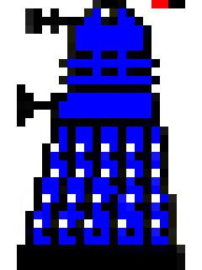
Figure 6
Visually, I just wanted to show a simple bar that shows three levels of health, which can be drawn using two writes to the screen. The challenge was to figure out how to do this efficiently using as little memory as possible.
Working on the basis that I could find the memory, I temporarily commented out the game bar code to free up some memory and then set about developing an implementation.
To display a health bar, I needed to write an eight-pixel strip (two bytes) to the screen, with clipping etc. To do this efficiently I pick the appropriate pixel strip from a health bar atlas (shown below), where the X axis denotes how much health to show, and the Y axis denotes the horizontal position. A separate array is used to map Dalek sprites to the horizontal position, and whether the health bar should be left aligned or right aligned with the sprite.

Figure 7
I considered writing the health bar bytes directly into the sprite data and let the drawSprite routine do all the work of putting the pixels on the screen, however this would result in the ‘lasered’ effect being applied which I didn’t want, so I needed to render the pixels to the screen, with clipping etc.
The resultant routine and calling code are 185 bytes in size and uses 41 bytes of data (health bar atlas + sprite array). The total memory required was 226 bytes.

Finding 226 bytes…
Finding 226 bytes of memory was challenging, especially since I’d already spent considerable time optimizing the code for size. After several hours of research and experimentation, I found five memory regions which I believed I could repurpose.
Region | Size
MOS printer buffer | 64
MOS keyboard buffer | 32
DFS workspace &1090-&10BF | 48
DFS workspace &10E0-&10FF | 16
NMI workspace &D01-&D5F | 51 (I was already using 44 bytes)
Total | 211
However, I’d have to reorganize the locations of many data objects to be able to leverage these new regions (which are transient in nature), and I’d have to add code to request access to the NMI memory.
I used the memory spreadsheet to develop a new memory map which I then implemented in the code. After the changes I still had a small shortfall, which I addressed by factoring out more common code from drawObject and drawLaserOn, incurring a small performance cost, which was not noticeable.

Doctor Who theme music
Adding Doctor Who theme music to the title screen was an interesting venture.
The original Doctor Who theme music was composed by Ron Grainer and realized by Delia Derbyshire, assisted by engineer Dick Mills.
I found the original score online, which contains melody, harmony, and bass lines… with no more than three notes played at once, except in one bar where four notes are played together. I needed to remove one of the notes as the BBC Micro’s SN76489 sound chip has only three tone generators. The change is barely noticeable.
A larger issue is that the score contains many bass notes whose frequency is lower than the lowest frequency the SN76489 sound chip supports, on the BBC Micro. Fortunately, there is a technique which uses a timer that can work around this limitation (see section below).
As an aside, I didn’t want to play sampled music because of its low fidelity. I wanted to create a game which felt more modern than an original 1980’s game and playing low fidelity sampled music did not fit with this vision.
The next step was figuring out how to get the arrangement into a format that can be efficiently stored and played on the BBC Micro. MIDI is the obvious choice, so I set about creating a MIDI file from Delia Derbyshire’s arrangement.
I installed a trial version of Sibelius, which I used to input the arrangement. It took a few hours to get the score entered. I then used Sibelius’s Export MIDI feature to create a MIDI file.
I then created a MIDI conversion tool that converted the MIDI file into a more compact and SN76489 friendly format.

MIDI conversion tool
The conversion tool reads a type-0 MIDI file, filters and processes the contained MIDI events, and creates a new file that contains just note-on and note-off events, which have the following compact format:
note-on = <delta-time> <pitch> <tone-generator>
note-off = <delta-time> 0 <tone-generator>
Where:
<delta-time> represents the time since the last event, in 1/100th of a second units. The value is stored as a one-byte or two-byte value with the top bit denoting the latter. The high-byte precedes the low-byte. Values 0 to 127 are represented using one byte, values 128 to 32767 are represented using two bytes.
<pitch> signifies the pitch of the note to play in a note-on event. It is stored in the top six bits if the next byte. The value is in the range 1 to 63 and is calculated by subtracting twenty-seven from the corresponding MIDI note number.
0 signifies a note-off event. A value is stored in the same six bits that <pitch> uses.
<tone-generator#> is stored in the bottom two bits of the byte. The values 0 to 2 specify which tone generator the event applies to.
The events are terminated with <delta-time> &FF, where the delta-time specifies how long to pause before replaying the music.
During conversion, note events are assigned to one of the three available tone generators, delta-times are converted to 1/100th second units, and redundant note-off events are removed.
The resultant file is 1813-bytes, less than a quarter the size of the source MIDI file, which is 7413-bytes.

Playing lower frequency notes
The lowest note that the SN76489 sound chip can natively support on the BBC Micro is lower ‘B’ (123.47 Hz), that is just over an octave below ‘Middle-C’.
The bad news is that most music scores, including Delia Derbyshire’s arrangement, contain notes with lower frequencies than this.
The good news is that one can generate lower tones by 1) configuring the SN76489 to output its highest frequency (125KHz), and 2) toggle the volume at twice the desired frequency. Timer2 can be used for the latter, in one-shot mode.
The technique works for two reasons. Firstly, the SN76489’s voltage output does not oscillate evenly around zero volts as one might expect, and secondly, the amplifier chip/circuit smooths the signal, with any high frequency remnants being at a far higher frequency than a human can hear.
These two characteristics result in the desired lower frequency square wave, as depicted below. Ref: Security: Sampled sound 1980s style: from SN76489 square waves to samples.
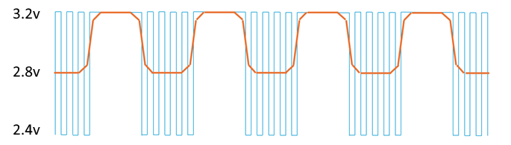
Figure 8
The main limitation of this technique is that the maximum achievable volume is half that of native tones. Fortunately, the bass line is played at a lower volume, so this limitation is not an issue.
Of course, one must drive the sound chip directly to generate lower frequencies, which for practical reasons precludes MOS sound functionality from being used to play the theme music. Fortunately, I had explored driving the sound chip directly earlier during development, so I had a fairly good idea of what was involved.

Run-time implementation
The music functionality is encapsulated in music.6502, which is loaded in upper memory, just below where the Mode 7 title screen’s memory resides (see Memory usage and layout section). The music code and data are overwritten when the screen mode is switched prior to gameplay.
The music data is binary included at the beginning of music.6502. The file also contains a pitch table with 256 rows (512 bytes), which is used during runtime to look up SN76489 register frequency values or timer duration values for playing low-frequency notes. Each row in the table represents a quarter-semi-tone increment, from 38.89Hz to 1545.98Hz.
The title functionality starts and stops playback by invoking the playMusic and stopMusic routines. These routines start and stop the music, which is played in the background using a dedicated Interrupt Service Request (IRQ) routine, and two dedicated timers.
The first timer is used to read note events from the music data, update frequency and amplitude accumulators (using melody, harmony, and bass envelope definitions), and update the SN76489 sound chip… every 1/100th of a second.
The second timer is used to play lower frequency notes, by toggling the highest producible pitch at twice the lower note’s frequency.
The trickiest part of the implementation was replicating the core parts of the MOS envelope functionality, which was needed to make the notes sound more interesting.
I spent quite a bit of time tweaking the envelope definitions to get a more interesting sound. Of course, I was not able to replicate the original sound given the BBC Micro’s limited capabilities. I did though get to a point where I felt the arrangement was representative, at least in spirit and was recognizable. Hopefully you agree.

Titles screen
After adding the Doctor Who theme music, I added a new title page, like the ones shown in ACORNSOFT games, which appears before the game instructions. This turned out to be quite straightforward as there is an excellent online teletext editor (zxnet.co.uk) which can export a BBC Micro Mode 7 screen memory dump, which can then be binary included and copied to the Mode 7 screen memory region.
The hardest part was coming up with a name for the game and designing the screen for it.
I spent some time reviewing Doctor Who episode names, but for some reason the phase ‘Adventures in Time’ kept popping into my head. There was a Doctor Who film made in 2013 named ‘An Adventure in Space and Time’ which is where I think it came from, but I can’t say for sure.
Regardless, Adventures in Time seemed an apt title for the game so I set about designing the screen. I tried to replicate the same colors and mosaic font used in the ACORNSOFT screen, but unfortunately there was not enough room to fit ‘ADVENTURES’ so I changed the title to An Adventure in Time which also let me replicate the four-color bands. I was happy with the result.
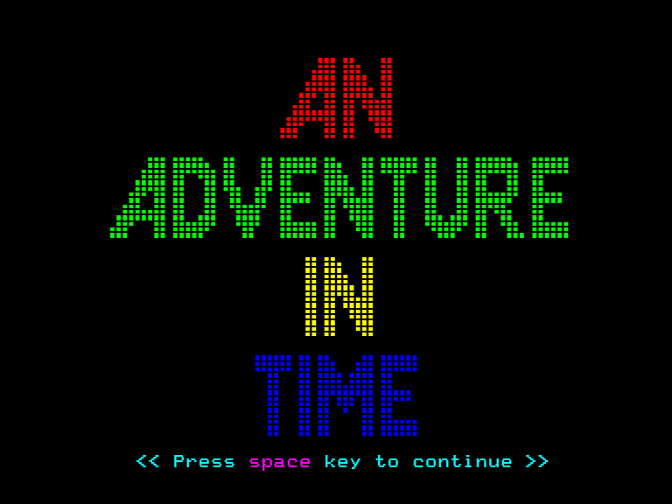

Sample based sound effects
One suggestion, which I really liked, was to use the speech synthesis chip to sound ‘exterminate’, when Daleks were pursuing K9.
To do this, “exterminate" needed to be encoded/compressed using LPC (Linear Predictive Coding), a speech compression format that the Texas Instruments TMS-5220 speech chip in the BBC Micro uses.
Unfortunately, the Dalek voice, which is created using a ring modulator box, does not encode very well using LPC, which was designed specifically to encode human voices.
I was therefore left with the choice of not implementing the feature or trying to play an “exterminate” sample instead, which I knew would have its own challenges.
Sampled music can be played on the BBC Micro by configuring the SN76489 to output its highest frequency (125KHz) and then modulate the volume using PCM sample data, at the frequency of the PCM encoding.
While doable, it’s quite hard to reproduce samples of good quality, for several reasons.
Firstly, the sound chip’s volume must be updated at the encoding frequency. For 8-bit/8KHz samples (a reasonable format to use), this happens 160 times a frame. If the update code takes 50 cycles to execute (a reasonable estimate), there is a 20% impact on game performance, which is clearly not good.
Secondly, the effective resolution of the SN76489 is just four bits, as it only has sixteen levels of volume. If 8-bit samples are used, half the bits are thrown away! One can improve the quality by over-sampling at twice the frequency, but this doubles the performance impact. One can also use multiple tone generators to gain one or two additional bits of resolution, at the cost of memory and performance.
Thirdly, sampled data is large. An “exterminate” sample encoded at 8-bit/8KHz is 16K, uncompressed. That’s a lot of memory for two seconds of sampled sound!
I felt the feature was worth pursuing as sample sounds would improve gameplay, even if performance was impacted a little. And the sound data would fit on 16K of sideways RAM so I could make the feature dependent on that.

Implementation
The first thing I did was to use Audacity to create an 8/8K WAV file from an exterminate.mp3 file I downloaded from the internet. I then created a WAV converter console app which extracted the PCM data from the WAV file, writing it to a pcm.dat file.
I then needed to figure out how to load this data into sideways RAM, which resides at address &8000, when selected.
One cannot include the data in the game binary directly, as the disc filing system ROM resides at &8000 when it’s running, so the PCM data must first be loaded to regular memory and then copied to sideways RAM from there.
During startup, there is sufficient free memory to allow the data to be loaded in five chunks. I therefore updated program.6502 to binary include and package the data into five distinct files (pcm1..pcn5) in the disc image.
I then modified the startup code to detect and populate sideways RAM as described. I also updated the title screen to display "press space to continue" after the PCM data completes loading, as this process can take several seconds.
To play the sample, I repurposed tone generator 3. This is normally used to play the Dalek pursuit sound effect which isn’t needed since “exterminate” will be sounded instead.
On entering a level, the tone generator’s frequency is set to 125KHz and its volume is set to zero. The tone generator’s volume is then modulated one PCM sample at a time, using an 8KHz timer (User-VIA Timer1). I extended the existing in-game interrupt routine to do this.
Code was then added to play the sample instead of invoking the pursuit sound effect.
The resultant “exterminate” sound was much better than I expected, and better still, the performance impact was not too bad. There was a little tearing but no detectable slowdown or control latency. This was very encouraging.

Adding additional samples
Given the results, I wanted to add more samples… a Dalek groan and a Dalek weapon sound effect. To do this I needed to compress the PCM data.
Fortunately, the 8-bit PCM data was very compressible since only half the bits were used. The SN76489 sound chip has sixteen volume levels (4-bits of resolution). The PCM samples could be stored in low and high nibbles, doubling the capacity. The additional samples would fit!
However, updating the in-game interrupt routine to efficiently read the low and high nibbles was challenging.
The solution I landed on was to encode the first half of the sample in the low nibbles, and the second half of the sample in the high nibbles, and then run over the data in two passes, rewriting the sample extraction code prior to each pass.
In the first pass, AND #&0F : AND #&0F is written and used to extract the low nibbles, in the second pass, LSR A : LSR A : LSR A : LSR A is written and used to extract the high nibbles. AND #&0F is repeated to fill the 4 code bytes that four LSR A instructions use.
The WAV converter console app was then updated to read the additional WAV files that I also created in Audacity, stacking these in the generated pcm.dat file. The app was also updated to write a start/end address table for the encoded samples, which the runtime uses to select the appropriate sample.

Optimizations
Modulating a tone generator’s volume at 8K (160 times a frame) whilst minimizing the performance impact was essential. Every instruction executed in the interrupt routine is executed 160 times a frame. Minimizing the number of instructions was thus paramount.
The first thing I did was to ensure that the User-VIA Timer1 interrupt is active only when samples are played. I then ensured that the routine first tests for the 8KHz timer, only branching if the interrupt is for something else. Falling through a branch takes one less cycle than branching.
I then implemented the two-pass approach outlined above to extract the low and high nibbles. The average cost of these instructions is six cycles. An additional two cycles are needed to set the top four SN76489 control bits.
The code included a 16-cycle spin loop, which was needed to write data to the SN76489 sound chip. The write enable line must be kept low for at least 16 cycles before it is set high again.
I replaced the spin loop with code moved from above, to advance the PCM cursor, test for a page boundary, and restore Y.
I also ‘end aligned’ the PCM data at page boundaries, allowing for more efficient ‘end of half sample’ testing. The tests are only performed at page boundaries, with just the high byte tested.
To reduce tearing, which unfortunately occurs when samples are played, the v-sync signal (which the game loop waits on) was brought forward to when the screen memory read finishes, which is 18 scanlines (1152 micro-seconds) earlier than when the actual v-sync interrupt occurs.

Integration
Five sound vectors were introduced to decouple sounds from their implementation. The vectors are set during level initialization, and the game code was updated to indirect through these vectors.
Vector | Normal implementation | Sample implementation
soundVector_beginPursuit | soundEffect_pursuitOn | sample_soundExterminate
soundVector_updatePursuit | RTS (no sound effect) | sample_updatePursuit
soundVector_endPursuit | soundEffect_pursuitOff | sample_stop
soundVector_enemyLasered | RTS (no sound effect) | sample_soundGrown
soundVector_weaponFired | soundEffect_pain | sample_soundWeapon
All the runtime sample functionality was then moved to a new source file (sample.6502). This includes an alternative in-game interrupt service routine which contains the sampling functionality. The routine jumps into the regular in-game interrupt routine to process other interrupts. The routine is installed in place of the regular in-game routine when sideways RAM is detected.
With the game bar code reinstated (it was previously commented out), there was insufficient memory for sample.6502 to be loaded. This was not a surprise as there were only a few bytes available before all the sample code was written.
One option would be to load sample.6502 in sideways RAM and execute the code from there. A better option was to move a game sprite atlas to sideways RAM and load sample.6502 where the asset previously resided. The game-bar asset (224-bytes) was the ideal choice, being slightly larger than the sample code.
The changes to affect this change were straightforward, though I did need to reduce the size of the pcm.dat file by 256 bytes.
I also updated the level editor adding a setting which specifies whether sample sounds should be played or not. One can imagine a level which does not contain Daleks.

Improving game level entry and exit
Another suggestion was to improve the level entry and exit experiences, by showing some form of palette cycling accompanied by additional sounds, as the experiences were weak in comparison to the rest of the game.
Whilst I agreed that the experiences were weak, I was not sure about palette cycling. Perhaps I could do something different instead.
I started by looking at what additional samples I could add if an additional 16K of sideways RAM was available.

Adding samples
I initially tried to implement TARDIS sound effect, by looping a sample and fading it out using an attenuation table. This worked reasonably well in BeebEm, though there was a noticeable performance hit. Unfortunately, on the BBC Micro a very noticeable audible hiss was present.
I tried several things to reduce the hiss, and had some success, but was not able to reduce it to an acceptable level. I concluded it would be better to play different samples instead.
I found three good MP3 samples on the internet… two of K9 saying “affirmative” and “insufficient data”, and one of the TARDIS doors being opened. The latter could be played when a level is completed. And K9 could say “insufficient data” at the start of a level and “affirmative” after destroying a Dalek.
Audacity was used to convert the three MP3 files to 8/8k WAV files, and the WAV converter console app was updated to convert and encode these files into a second PCM data file which was then packaged in the game image as five additional files.
The game startup code was then updated to load the second set of PCM data files into a second 16K of sideways RAM, if present. A secondary set of sound vectors were also introduced, as shown below. The game code was updated to use these new vectors. The sample.6502 code was also updated to play the new sounds.
Secondary Vector | Normal implementation | Sample implementation
enemyDestroyed | RTS (no sound effect) | sample_soundK9Affirmative
startLevel | RTS (no sound effect) | sample_soundK9InsufficientData
completeLevel | soundEffect_levelComplete | sample_soundTardisDoor

I was pleased with the results as the additional samples certainly improved the audible experience. I then looked at the visual experience.

Adding visual transitions
After looking at several possible ways of visually entering and leaving a level, I landed on the idea of implementing a crop transition (shown below), as I could see how this could be implemented using a timer, switching the palette at the top and bottom of the animating crop boundaries.
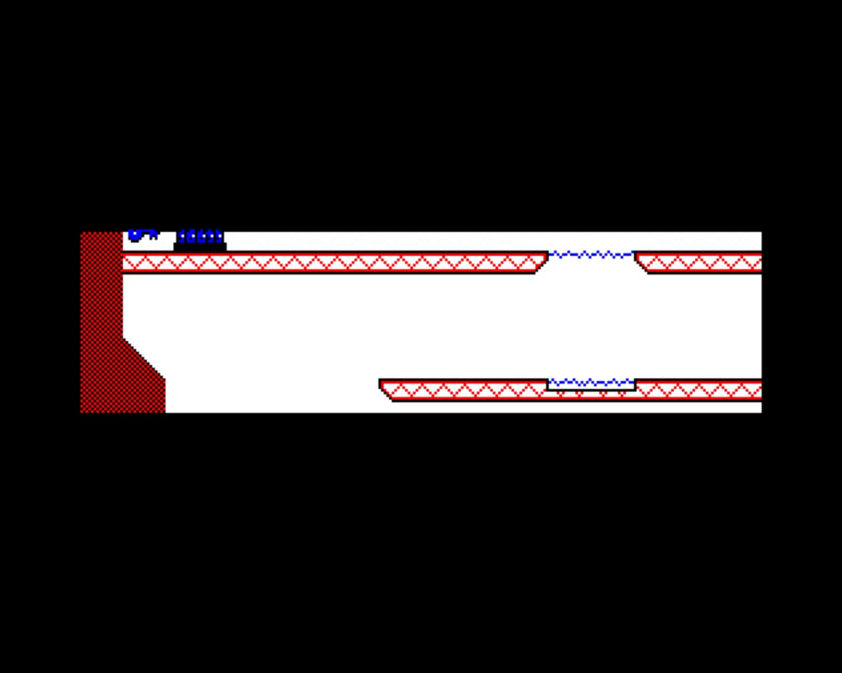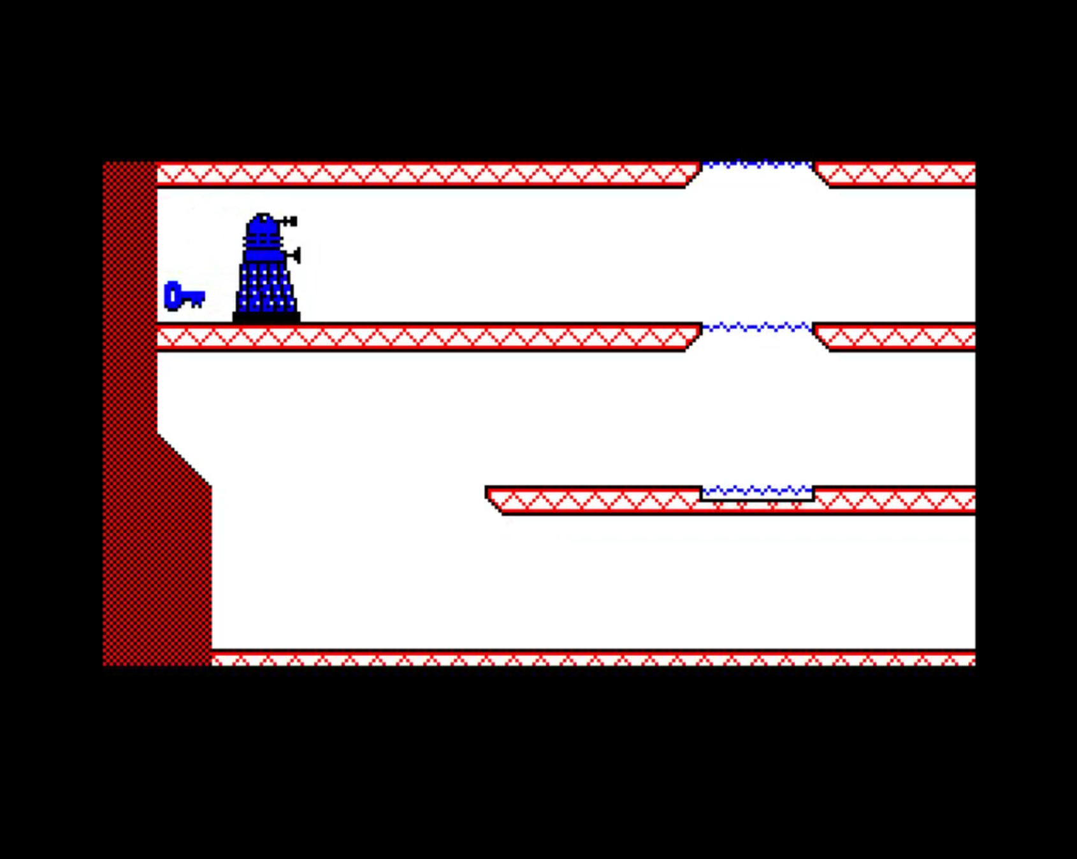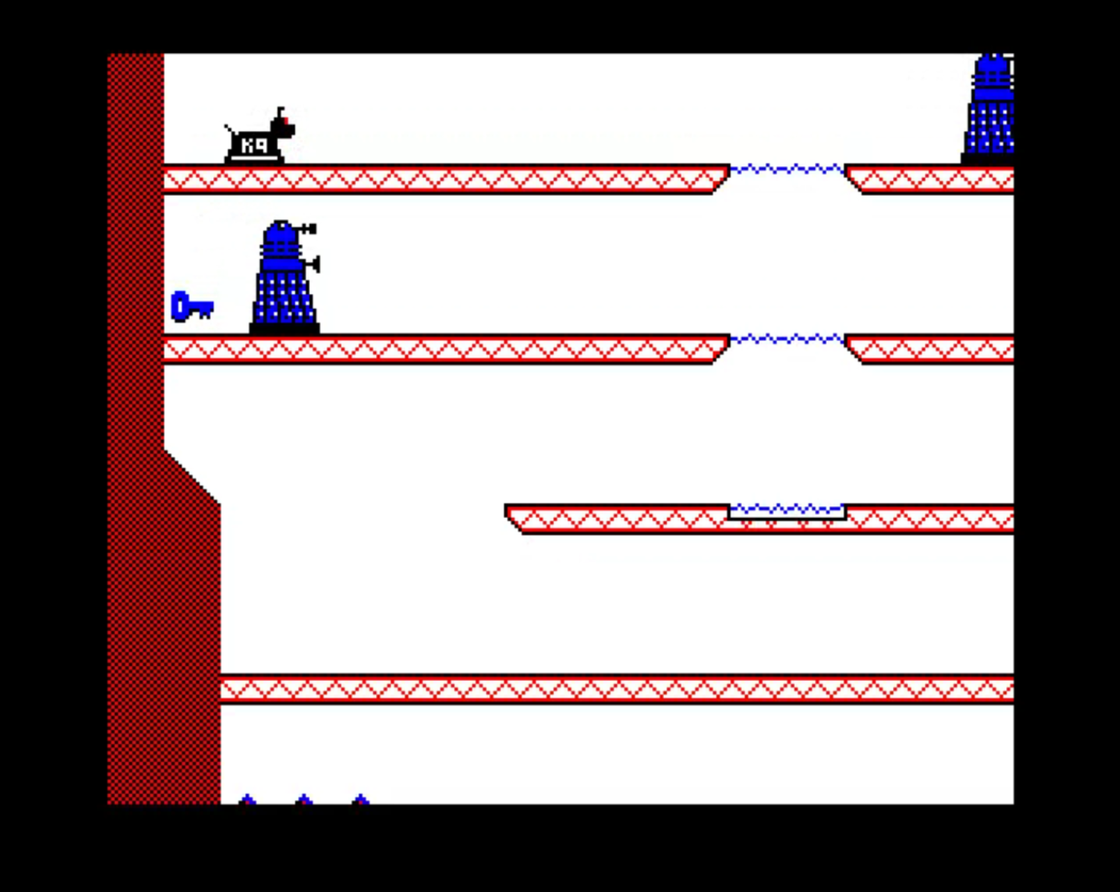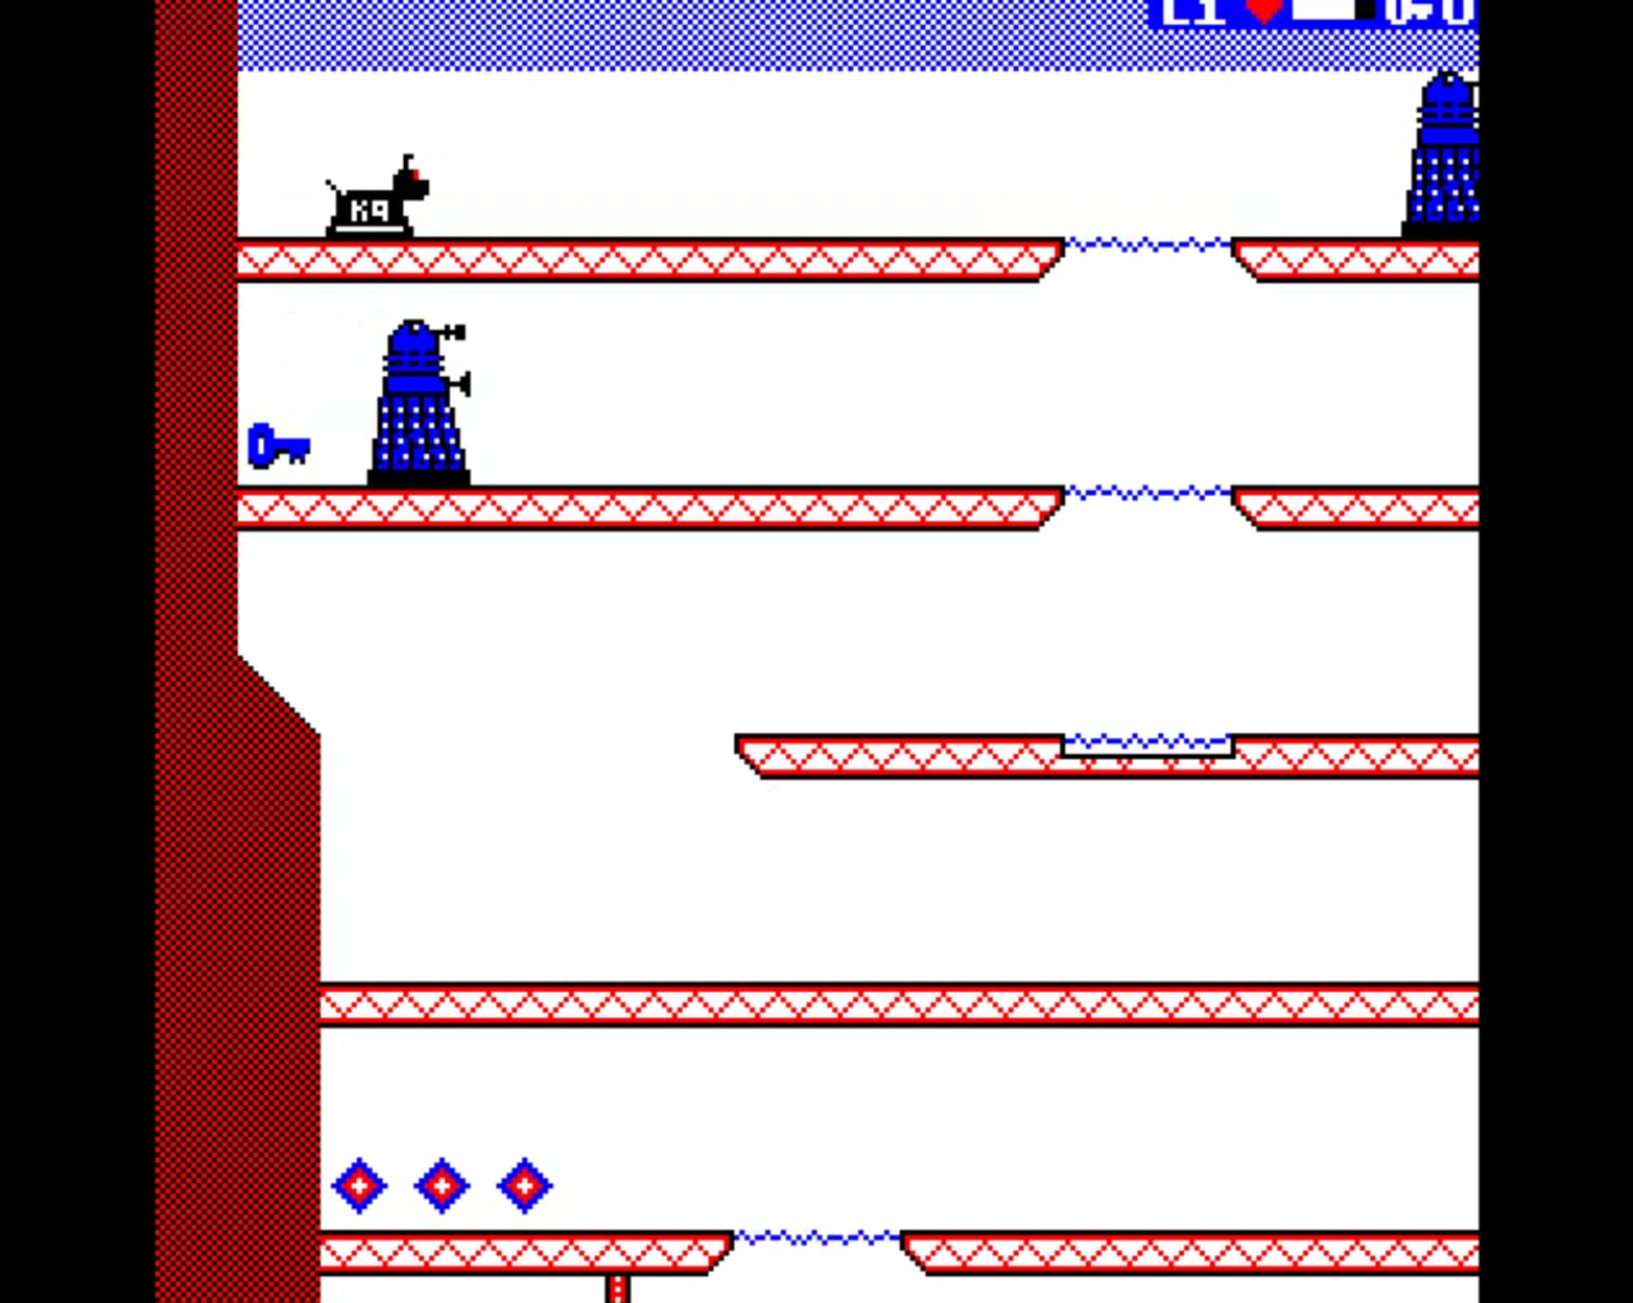
I reread Mark Moxon’s explanation for how palette switching was implemented in REVs, where a continuous timer is used in a clever way, and rewatched Kieran Connell’s ACORN Masterclass interrupts video (part 2) which includes a great explanation of scanline timings. Both were invaluable.
The show and hide crop animations were implemented using a new interrupt service routine, which is switched in while the transition runs, with existing System-VIA v-sync and Timer1 interrupts repurposed, with Timer1 switched over to continuous mode.
The transition interrupt service routine’s v-sync handling code simply sets Timer1’s primary and latch timer values, and signals ‘v-sync’, allowing the game loop to run as normal.
The routine’s Timer1 handling code performs a few actions. It first checks to see if the animation has completed (a countdown counter is used for this), restoring everything back if it has. The code then determines whether the interrupt request is for the top or bottom crop boundary.
If the interrupt request is for the top crop boundary, the palette is switched to the level’s palette and the interrupt is passed on to MOS, allowing MOS to process sounds.
If the interrupt request is for the bottom crop boundary, the palette is switched to black, and delta values are applied to the timer variables, to animate them. The interrupt is not passed on to MOS.
The crop transition functionality was encapsulated in a new source file (transition.6502) which was included in program.6502. The level entry and exit routines were then updated to invoke the new code as appropriate.
Unfortunately, more memory had to be found in integrate the changes within the game play code. I managed to find 84 bytes by streamlining the god-mode key handlers and factoring out some duplicated top-level draw code… but I still needed another 140 bytes or so.
After reviewing all the memory usage, I concluded that a more radical change would be needed to include the crop transitions, which I really liked.
I therefore reluctantly reduced the number of level tile designs from thirty-two to thirty. This freed up 128 bytes of memory.
The change was not as significant as it might sound because the existing level designs all contained two or more unused tiles. Twenty-nine tile designs, plus a blank, would be fine.
I therefore updated the level editor and game code to accommodate the change, converting the level data files to the new format in the process. As part of this I also moved the crop transition variables into zero page (reducing code size further), moving the black palette (16-bytes) out to regular memory. After these changes, the code just fit, barely.

Game completed improvements
Another change was to improve the ‘game complete’ experience, which currently displayed just a couple of lines of text. The suggestion was to display a more graphical screen, whilst playing the Doctor Who theme music in the background. I would also add a credits screen, which I wanted to do.
Implementing the feature was straightforward, though it was necessary to package the related code and data in a separate file within the game image and then load and execute it.
The feature was implemented by first creating new teletext screens (shown below) and then creating a new source file (finale.6502) which contains a finale routine which starts playback, displays the screens, and then loops forever.
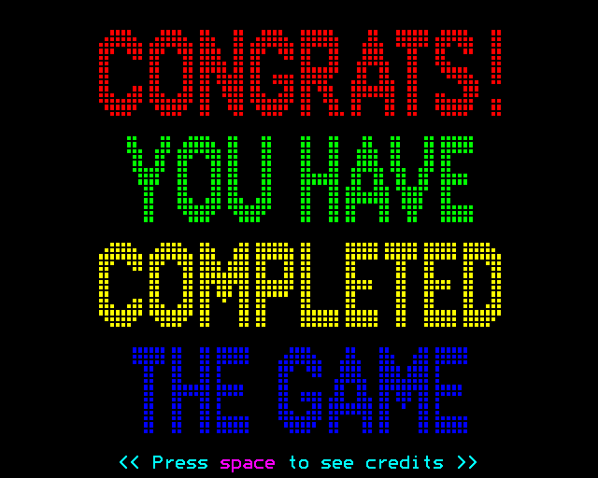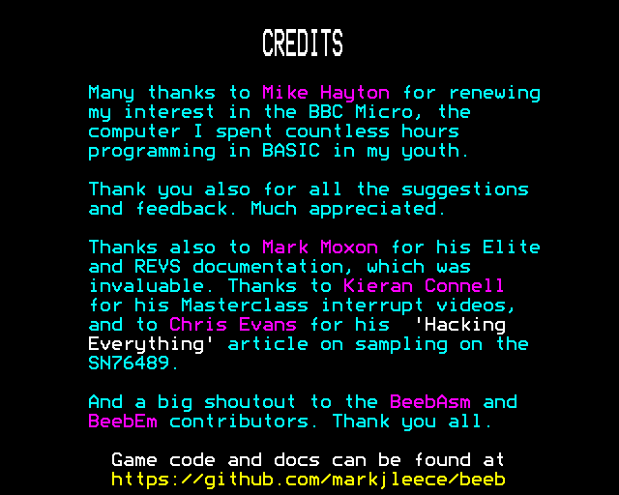

Teleports
Another great suggestion was the idea of adding teleports which would allow K9 to traverse a level in a non-linear way.
Of course, the main challenge implementing these would be memory. After evaluating options, I decided to reduce the size of the TARDIS a little, so that it was made up from six tile designs instead of eight. I could then reduce the number of tiles designs in a level from thirty to twenty-eight, which freed up 128 bytes of memory.
I initially implemented teleports as static tiles with a new tile type (TILE_TYPE_TELEPORT), which were augmented by an additional data structure which contained teleport destination information. K9 would automatically teleport to the appropriate destination location when over two adjacent teleport tiles.
Whilst this worked, the behavior felt somehow odd as Daleks moved over teleport tiles without teleporting, and visually the teleport platforms were static, unlike elevators and doors which animated.
I therefore reimplemented teleports as dynamic objects, which animate, where pressing up or down keys initiates travel. Since adding a new dynamic type would require nine bits in objectState, I decided to treat teleports as a special kind of elevator, using objectFrameCounter to hold the destination teleport location.
It was a challenge to squeeze the additional code and teleport sprite definitions (96 bytes) into the image, even though I had freed up 128 bytes, but I managed it.

Implementation
As outlined above, a teleport is treated as a special kind of elevator, where the destination’s teleport’s index is held in objectFrameCounter. Teleport tiles also have a new tile type: TILE_TYPE_TELEPORT.
The level editor was updated to support teleport tiles, allowing the user to define teleport tiles and place them within a level, where distant pairs of teleport tiles are automatically assigned letters: ‘A’, ‘B’, ‘C’ etc. A sparse teleport grid data structure was introduced to hold these values, which are populated during file load and used during file write to serialize the appropriate teleport destination indices. The tile grid panel paint code was also updated to show the teleport letters.
New teleport sprite atlas BMP files were created in the level asset folders, with the BMPConverter console app updated to convert and include these in the generated level atlas data files. The generated files were 96 bytes larger.
The memory spreadsheet was then updated to account for the differences, giving new address locations for many objects. The game program was then updated to account for these changes. The net was 32 bytes of code space.
These game code changes included updating the level initialization code to interpret the serialized teleport destination indices to differentiate teleports from elevators, initializing teleport objects appropriately.
A new rideTeleport routine was introduced to teleport K9, which performs the following actions:
- Check if K9 is on a teleport, returning ‘failure’ if not. An efficient tile-grid based lookup is performed to do this.
- Find the actual teleport object (elevator) K9 is on.
- Find the destination teleport object (elevator), held in objectFrameCounter.
- Check if the destination teleport is occupied, sounding a ‘blocked’ sound effect if it is, and return ‘success’ indicating that K9 is on a teleport.
- Calculate the delta-distance between the destination and current teleport locations.
- Perform a crop hide transition, to depict K9 travelling somewhere.
- Undraw K9 at the current location.
- Clear the tile-grid flags at K9’s current location.
- Update K9’s position by applying the delta-distance calculated above.
- Set the tile-grid flags at K9’s new location.
- Scroll the view by the delta-distance calculated above.
- Mark K9 for redraw, so K9 is drawn at the new location.
- Finally, perform a crop show transition to reveal K9 on the destination teleport.
This routine is invoked from k9MoveVertically which is called when the ‘W’ or ‘S’ keys are pressed.
A teleport frame callback routine was also introduced that rotates through the four teleport sprites every eight frames.
The new teleport routines use 250 bytes, which is substantially more than the 32 bytes of code space freed up. The deficit was found through numerous code size optimizations, which included:
- Factoring out common code in K9 and Enemy frame callback routines.
- Leveraged the Y register to initialize variables.
- Factoring out common top-level code in draw.6502.
- Using code modification techniques to reduce the size of the draw and undraw laser routines.
- Splitting sprite and tile address tables into low-byte and high-byte tables.
- Removing redundant CLC and SEC instructions.
Later, a new source file (teleport.6502) was introduced which contains the teleport specific routines.

Destructible walls
I was now at the point where I’d didn’t think I would be able to implement any more features as I’d pretty much exhausted ways to free up more memory, or so I thought.
I then remembered that additional memory could be reclaimed by moving the Mode-7 interstitial experiences into the level files. I had previously considered this but decided against it due to concerns about user experience. However, with crop transitions now implemented, spinning the disc after a crop transition would be fine, so I proceeded with the changes, which were straightforward to implement.
I moved all the Mode 7 utility routines into a new source file (mode7.6502) and included this after the level initialization code (level.6502). I then updated how the game, levels, and the finale files were packaged to include the Mode 7 code. The changes freed up 361 bytes!
I then set out to design and implement destructible walls, a feature that allows K9 to destroy a wall using his laser.

Behavior
From a behavioral perspective, destructible walls look and behave differently from regular walls. When hit with a laser, the entire tile is re-rendered with the laser effect applied, giving feedback that they are different. And after a two second blast, the tile is replaced with space. An achievement sound effect is also played to re-enforce the behavior.

Implementation
Destructible walls are implemented using a new tile type: DESTRUCTIBLE_WALL. The level editor was updated to allow tiles to be tagged using this new tile type.
The laser hit testing code was then updated to detect destructible walls. If the laser hits a destructible wall the wall’s strength is reduced, and if it reaches zero, the wall tile is destroyed by replacing it location with a blank tile. Otherwise, the wall tile is drawn with a lasered effect applied.
A new drawTile routine was needed to draw a tile, optionally rendered with a laser effect applied. Four zero-page variables were also added to remember a destructible wall’s screen location, its remaining strength, and whether it should be redrawn.

Switches
After implementing destructible walls, there were still 192 bytes of free memory available. Another feature could be implemented.
After reviewing the suggestion list, I decided to add switches, as I could see how these could be used to make levels more interesting.

Behavior
From a behavioral perspective, I landed on the idea that a switch can be turned on by a two second blast of K9’s laser, at which point one or more paired objects would be activated. I decided that Daleks, doors, elevators, teleports, and tiles, could all be paired with a switch. I would also allow multiple objects to be paired to a switch, but not allow an object to be paired with multiple switches.
I landed on the following activation behaviors that occur when the switch is turned on:
- Paired stationary Daleks start moving. Their action is promoted to ‘PACE’.
- Paired tiles are replaced with space.
- Paired doors, elevators and teleports become operational.
Of course, the last behavior requires that doors, elevators, and teleports can be disabled, which is not currently supported. I decided that disabled doors, elevator, and teleports don’t animate and are not operational.

Implementation
Switches are modelled using two new tile types: SWITCH_OFF and SWITCH_ON.
The level editor was updated to support these and updated to enforce that only one SWITCH_OFF and SWITCH_ON tile can be defined within a level, and that a SWITCH_ON tile must be defined if a SWITCH_OFF tile is placed.
The editor was also updated allowing game objects and tiles to be paired by control clicking on the switch and then control clicking on objects and tiles. Switch pairings can be removed by replacing a switch, paired object, or paired tile.
The level file format was extended to include a 32-byte data block which encodes the levels’ switch pairings. The encoding is as follows:
Switch pairings = <switch-record> *
Where:
<switch-record> = <switch-address> <paired-objects> <paired-tiles>
Where:
<switch-address> is a two-byte tile grid address (little endian format).
<paired-objects> = <count> <object-index> *
<paired-tiles> = <count> (<tile-x-coord> <tile-y-coord>) *
Where:
<count> is a one-byte value containing the number of paired objects or tiles.
<object-index> is a one-byte value containing the index of a paired object.
<tile-x-coord> and <tile-y-coord> are two-byte values containing the level X and Y coordinates of a paired tile.
This nets to the following memory usage:
- Each switch requires 4 bytes (switch-address + two counts)
- Each paired object (Dalek, door, elevator, or teleport) requires 1 byte
- Each paired tile requires 4 bytes (two two-byte coordinates)
The level editor was updated to serialize the switch pairings, reporting an error if there is insufficient memory to encode a switch’s pairings.
The serialized object descriptors were updated to include a disabled state, which is set for all paired doors, elevators, and teleports.
The game code was then modified as follows…
A corresponding disabled state was introduced for elevators, teleports, and doors, overloading the existing lasered render flag (that’s used for Daleks). The level initialize code was updated to set this state for paired doors, elevators, and teleports, and their respective frame callback routines were modified to implement the disabled behavior, which do nothing when the disabled state flag is set.
The destructible wall laser hit-testing code was then generalized to also support switch-off tiles, replacing these with switch-on tiles instead of a space. The code was also updated to activate the switch’s paired objects by enumerating over the 32-byte data block, activating the appropriate paired objects.
Paired Daleks’ actions are promoted to PACE, paired tiles are replaced with a blank tile, and the disabled state flag is cleared for paired doors, elevators, and teleports.
An achievement sound effect was also added for when a switch is turned on (and when a destructible wall is destroyed) to reenforce that something occurred.
A new source file (switch.6502) was introduced which contains the switch activation code.
Several additional code size optimizations were needed to squeeze in the functionality within the available memory. These included factoring out more duplicated code.
I was now at the point where I didn’t believe it was possible to reclaim enough memory to implement another feature, so I turned my attention to adding more game levels.

Adding more Levels
During the development of the game, I designed and developed three levels of increasing difficulty. Each of these was developed and maintained as features were added, keeping their file formats up to date.
With the feature set now complete, and the file format stable, now was a good time to add more levels to the game, to fill out the experience.
With the goal of keeping players engaged, I designed the following three additional levels:
Level 4 - Weeping Angels – A level with weeping angels, instead of Daleks, set within a graveyard theme. Sample-based sounds are disabled in the level.
Level 5 - Maze – A level consisting of a maze of teleports, with surprises! K9 must navigate the maze to find the TARDIS. A locked door is placed just in front of the TARDIS, so a hidden key must also be found.
Level 6 - Mine – A mine containing a multitude of destructible walls, with some switches to activate elevators. K9 must descend to find the TARDIS. K9 needs to back track to consume more jewels to have sufficient health to complete the level.
The BMP console app and game were updated to incorporate these. The game was now complete.
Levels 7, 8, and 9 are left for others to design.

Reflections
With the game complete, now was a good time to look back and reflect on the effort and lessons learned.
From a time perspective, it’s interesting that as much time was spent incorporating feedback as was spent creating the initial game. For me it reenforces the importance of seeking feedback, listening to it, and acting on it. I also found the feedback immensely valuable in that it pushed me to do far more than I would have done otherwise.
The game took nine months to develop, from start to finish, with me dedicating a dozen or so hours a week to it, sometimes more. As development progressed, updating this document became quite valuable as it served as both a reference and place to explore new ideas. It was also a great place to capture feedback.
As for whether writing a platform game was a good choice or not… it certainly was. For someone who didn’t know 6502 assembly, or the BBC Micro’s capabilities that well, the challenge of writing a platform game provided enough opportunity to learn a host of new and interesting things.
The decision to write a disc-based game was also a good choice because on reflection I doubt I could have written a multi-level Mode 1 based platform game with large sprites and smooth animations that fit on a cassette. The Mode 1 sprite assets just use too much memory. Fortunately, most BBC Micro configurations today have a SD card-backed disc drive installed.
Managing memory, or lack thereof, was a constant challenge throughout development. Interestingly, over half of the introduced functionality was developed under tight memory constraints, where memory had to be found to implement the features. Looking back, it is remarkable that there were so many opportunities to use memory in different ways to allow so much functionality to be added, and it wasn’t as if the game was developed without code size in mind. From early on I used the Elite disc version as a template.
As for my 6502 assembly programming skills… I would rate myself as now being somewhat proficient, however I am conscious that my code is somewhat ‘C’ like, and I know I don’t leverage the instruction set to the extent that I could.
I have also become quite fond of the instruction set. As someone who has programed in numerous higher-level languages, it is very refreshing to use a language that has relatively few features and hard constraints, as it limits the choices one has to make.

Appendix
These appendix sections aim to provide more details on various aspects of the game and its implementation.

Memory usage and layout
This section describes the game’s memory layout, which was designed for a disc-based game, where levels and interstitial experiences are loaded from disc.
The limited memory on the BBC micro creates a lot of challenges, so finding ways to eke out and repurpose memory is essential. Thankfully, there are great resources online that help here. The Elite documentation by Mark Moxon is noteworthy.
The memory layout evolved during the development of the game, with allocations moved as needed. This section shows the final layout.

Game play
During game play, the screen consumes half of the available 32K RAM, leaving just 16K for the game code and data, plus MOS and DFS workspaces.
The general approach I took was to use sub &1100 areas of memory to hold static data (lookup tables & sprite data), while repurposing as much memory as possible that MOS and DFS uses. Static data is relocated during startup and level initialization. I also used as much of zero-page as possible to hold game variables and transient data (routines parameters and locals).
The result is that during gameplay the 32K of available memory is allocated as follows:
Address (hex) | Allocation | Size (bytes)
0000 | Zero-page game variables | 144
0090 | Zero-page MOS variables | 112
0100 | Game sprite data | 192
01C0 | Program stack | 64
0200 | MOS general workspace | 256
0300 | Game sprite data and tile-types table | 256
0400 | Game objects, sprite data, and black palette | 1024
0800 | MOS sound/printer workspace | 128
0880 | Game tile and sprite low address tables (MOS printer buffer) | 64
08C0 | MOS sound/printer workspace | 64
0900 | Game sprite data, plus tile & sprite high address tables (NMI WS) | 1120
0D60 | MOS ROM workspace | 160
0E00 | Game sprite data | 512
1000 | DFS workspace | 144
1090 | Game sound effects | 48
10C0 | DFS workspace | 32
10E0 | Game health bar table and draw lookup tables | 32
1100 | Gameplay code area | 6960
2C30 | Game sprite data* | 1280
3130 | Level palette | 16
3140 | Level tiles (27) | 1728
3800 | Level tile grid` | 2048
4000 | 256x256 4-color screen | 16384
Several things are worth noting:
- The stack (page 1) is reduced to just 64 bytes, allowing 192 bytes to be repurposed.
- Gray rows depict memory MOS and DFS uses that I was unable to repurpose.
- Blue rows depict memory MOS and DFS uses that is repurposed by the game. This is achieved by avoiding related MOS and DFS functionality or using the functionality in limited and controlled ways. Notable regions repurposed include the NMI workspace (which is acquired from MOS), the MOS keyboard and printer buffers, and transient regions of DFS workspace.
- There is 3.7K of sprite data, most of which is distributed across the lower memory space.
- There are only 6960 bytes of code space available. Only the code that runs during gameplay is located here.
- During gameplay, the game uses 97.2% of the 32K available. MOS/DFS use just 896 bytes.
- *On machines with 16K+ of sideways RAM, sampling code (sample.6502) replaces the game-bar sprite atlas at &3050, which is relocated to &BF20 in sideways RAM.

Startup & Titles
During startup and titles, memory addresses &3130 to &8000 are allocated as follows:
Address (hex) | Allocation | Size (bytes)
3130 | Level palette | 16
3140 | Level tiles (27) | 1728
3800 | Level tile grid | 2048
4000 | Level extents | 2
4002 | Level tile types | 28
401E | Level settings | 5
4023 | Level object descriptors (48) | 192
40E3 | Level switch pairings | 32
4103 | Level sprite data | 3712
4F83 | Level initialization code | 1761
5664 | Mode 7 routines | 76
56B0 | Startup and title experiences | 2639
60FF | Music data and code | 3216
… | … | …
6E66 | PCM load buffer (used to load PCM data to sideways RAM) | 3226
7B00 | DFS command page backup | 256
7C00 | Mode 7 screen | 1024

The white and gray rows show the layout of a level, after it is loaded. Level 1 is embedded within the program where it would reside if it were loaded. See the Level Loading section below for more details.
The light blue rows show the layout of the game initialization and title functionality, which includes common Mode 7 routines, title screens, and the Doctor Who theme music data and code.
The light salmon row shows the memory used to load PCM data into sideways RAM.
The light purple row shows a page backup region used by dfsCommand, which is invoked by populateSidewaysRAM, to save and restore code in Page &17, that DFS overwrites.

Level loading
Levels are loaded from disc when one of the following occurs:
- The player presses the ‘R’ key to reload the current level.
- K9 reaches the TARDIS, but not on the last level.
- K9’s battery is depleted.
It should be noted that the level files include the experiences one sees when K9 completes a level or dies.
Level files include level data, sprite data, level initialization code, and level experiences (‘level complete’ and ‘K9 died’). The initialization code copies the loaded sprite data to their lower memory locations and populates the game object data structures from the metadata and object descriptors. On machines with 16K+ of sideways RAM, the code also copies the 224-byte game bar asset to &BF20.
The memory layout after a level file is loaded is as follows:
Address (hex) | Allocation | Size (bytes)
3130 | Level palette | 16
3140 | Level tiles (27) | 1728
3800 | Level tile grid | 2048
4000 | Level extents | 2
4002 | Level tile types | 28
401E | Level settings | 5
4023 | Level object descriptors (48) | 192
40E3 | Level switch pairings | 32
4103 | Level sprite data | 3712
4F83 | Level initialization code | 1761
5664 | Mode 7 routines | 76
56B0 | Interstitial experiences | 1419
… | … | …
7B00 | DFS command page backup | 256
7C00 | Mode 7 screen | 1024
A level file is simply loaded at address &3030, populating the memory space as depicted by the white, gray, and light blue rows above.
The white rows are identical to how memory is arranged during game play.
The grey rows contain the data and code used to initialize a loaded level.
The light blue row shows the Mode 7 ‘level complete’ and ‘k9 died’ experiences.
The light purple row shows a page backup region that was used by dfsCommand, invoked by loadLevel, to save and restore code in Page &17, that DFS overwrites.

Game completion
When K9 reaches the TARDIS on the last level, the finale experience is loaded from disc and invoked. The memory layout during this experience is as follows:
Address (hex) | Allocation | Size (bytes)
… | …
5664 | Mode 7 routines | 76
56B0 | Finale experience | 2639
60FF | Music data and code | 3216
… | …
7C00 | Mode 7 screen | 1024
The finale file is loaded at address &5664, populating the light blue rows depicted above.

Optimizations
Here is the list of code speed optimizations which had the largest impact:
- Unrolled the inner loops in the draw sprite routines, where the game spends a significant amount of time, and used relative jump tables to jump into the unrolled loops efficiently.
- Used tile grid flags to mark tile positions that are occupied by something resulted in efficient collision-detection and hit-testing code, where the tile grid can be queried directly. Game objects are only enumerated after a tile-grid flag match.
- The use of an object redraw flag ensures that game objects are only rendered when they need to be.
- Broad clipping is performed near the start of the object draw routines, when level coordinates are transformed to screen coordinates, resulting in fully clipped objects being discarded quickly. Seven out of eight objects are typically fully clipped.
- Reduced the number of animation updates. For example, static doors and elevator sprites change every eight frames. This reduces the amount of redrawing that occurs per frame.
- Reduced per frame workloads by spreading work across frames. For example, Dalek AI is executed on an individual dalek every sixteen frames.
- Used an optimized Bubble Sort algorithm for sorting game objects vertically, to help to ensure that rendering stays ahead of the display scanline read that sweeps across screen memory. The code is executed every 32 frames (approx. twice a second) so it has a negligible impact on overall performance. The algorithm is efficient over small datasets which are already sorted, or close to being sorted. Tests showed that the algorithm re-sorts the draw-object-order array in just a few passes, typically.
- Runtime code modifications to implement an indirect JSR instruction. E.g. JSR (address), used to call frame callback functions. Also modified conditional branch offsets to efficiently resolve the tile address give and X, Y coordinates. The offsets differ for different sized level tile grids.
- Reduced the use of the stack by using zero-page transient variables as routine parameters and local variables extensively.
And here is a list of notable code size optimizations used:
- Refactored program and level initialization, pushing as much code as possible out of the gameplay code area.
- Removed objectWidth & objectHeight arrays, replacing these with zero-page cached variables: width, height, widthMinusOne, and heightMinusOne. The last two variables allowed for several functions to be simplified which were previously subtracting one from objectWidth & objectHeight.
- Bit-packed objectType and objectState array data. These variables hold numerous distinct properties.
- Reduced the use of the stack by using zero-page transient variables as routine parameters and local variables extensively.
- Factored out duplicated code, where this saves code bytes and does not significantly impact performance.
- Only code/data that is strictly needed during level play is resident in memory. For example, game initialization code (which runs when the game is titles) is loaded where the screen memory would be, and executed from there. Likewise, interstitial screen experience and level initialization code is packaged with the loaded level data and executed after being loaded.
Several generic 6502 optimization techniques were used also. These included:
- Used conditional branching whenever possible, instead of jumps. The conditional branch instructions take up two bytes whilst the jump instruction takes up three bytes.
- Used tail JMP xxxx instead of JSR xxxx, RTS, or better still use a conditional branch (see above). In either case the implicit RTS is documented.
- Better still, if the calling function is placed above the called function, it can just fall through to it!
- Used zero based constants removes the need to use CMP to test against them.
- Factored out RTS instructions, when possible. Routines that conditionally branch to an RTS instruction share a common return point.
- Used X and Y registers to initialize variables, using increment and decrement instructions when values differ by one.
- Used tables to drive functionality, where this reduces code size.
- Used unsigned integers for scalar values. Comparing unsigned integers require less instructions than comparing signed ones.
- 16-bit unsigned numbers are compared (A > B) using the following compact pattern:
LDA Al : CMP Bl : LDA Ah : SBC Bh : BCC label
Ref: Bruce Clark 6502.org Tutorials: Compare Instructions

Coding style
The code is structured with routines used extensively throughout the program. Each routine has a comment block detailing its purpose, parameters, and modified variables.
Routines always define a new scope (a wonderful BeebAsm feature) to limit the scope of contained labels and local data. Nested scopes are not used.
Control flow is typically expressed using if ... then … else … and loop … while like constructs, with label names reflecting this. E.g. loop, else, endif etc. Loop, then, and else bodies are also indented to reenforce the block nature of the code.
Occasionally, routines return indirectly through a tail jump, or don’t return and fall through to the routine below. These cases are always called out using a comment.
Comments are shown in-line within the code and occasionally to the right. They aim to provide a higher-level outline of the code rather than document what every instruction is doing.
Routine parameter passing uses the following rules:
The accumulator is typically used to pass arguments to routines that accept a single argument, and the X register is used to pass game objects, as an index. In other situations, zero-page variables are used to pass arguments. The Y register is rarely used.
As for the stack… routines occasionally push and pop values, but this is rare. Zero-page variables are typically used to hold temporary values as this avoids issues where control flow can result in push/pop mismatches.
Code-inlining is infrequently used in the code base, as it can result in lengthy routines which are less readable. Macros are also seldomly used. Code readability is preferred over performance and code-size, except in hot-paths.

Game design
The playability of a game is determined by many factors. The player needs to be challenged, and needs to work, to feel a real sense of gratification and reward later. The players’ attention must also be held by the game, by presenting occasional surprises and changing things up on the player. And above all, the player should not be punished for playing the game. The game must be robust (not crash) and its difficulty should increase in a reasonable manner.
The following choices were made to make this game feel more current.
Unlike many 1980’s games, K9 does not have three lives and there isn’t a notion of score or points. The goal of the game is to just successfully navigate K9 through the levels.
K9 dies when K9’s health becomes zero. K9 gains health by collecting jewels, and loses health when using the laser, or when attacked by a Dalek or other enemy. When K9’s health is low, the laser cannot be used and the health bar in the game bar changes color. To reinforce low health, a heart rate monitor beep is sounded every second or so. This becomes a continuous tone if K9’s battery is flat.
If K9 dies, the current level is restated. The user can also restart the current level by pressing the ‘R’ key, if needed.
And unlike many 1980’s games, the player direction keys are WASD.
Locked doors and keys are used to add a puzzle element to the game. Keys can be collected and then used to pass through locked doors, after which they are used. Doors stay unlocked until a Darek uses them. Alternatively, K9 can follow a Dalek through a door.
Other puzzle elements of the game include getting a Dalek to follow K9, and then hiding K9 behind a door, blocking a Dalek from using an elevator for a specific amount of time, and using a Dalek to hide from another one.
To hold the attention of the player, each level can have its own color palette and sprite definitions. The relative strength of jewels and Daleks can also be configured.
Teleports were later added to allow K9 to traverse a level in a non-linear manner.
Destructible walls and switches were also added later to expand puzzle opportunities.
The above choices hopefully give the game a more modern feeling, where gameplay is more open, and the consequences of dying less severe. That said, there are no saved checkpoints, so the game must be played from start to finish in one go, unless an emulator is used.

Missteps
From reading this document, it may appear that every decision taken was a good one, and things were fully thought though before implementation began, and that coding was purely a typing exercise, and that development proceeded without detours or missteps. This was not the case.
The reality is that developing code is an iterative process (at least for me) where I build out a spike of functionality, flush it out, build on it, rework it, and then refine it. I then pursue another area of functionality in a similar manner occasionally going back to revisit and rework early work, while always trying to improve on what I have. Sometimes, the code becomes complex or convoluted, and the path forward is less clear and harder to pursue. This is normally an indication that there is something inherently wrong or missing with the approach, or underlying data structures, so one steps back and revisits previous decisions and choices. I’m unable to see the full ramifications of every decision so occasionally I need to backtrack, adapt, and move forward again.
Here are a few examples of approaches taken that turned out not to be the best choices. I include these as they may be of interest.
- Page grids. Early in the development of the game I came up with a level model that allowed for an arbitrary arrangement of pages. From a data structure perspective, the model was simple and provided for a wide range of interesting level topologies. However, any code that traversed tiles had to deal with page boundaries. The mistake I made was not realizing that choosing such a data structure would require that I adopt an abstraction (function-based or macro-based) to traverse it, which was something I was not willing to do. In trying to avoid this I ended up with complex code in several key areas of functionality. After spending considerable time fixing several nasty bugs, I stepped back and asked myself if the benefits of the page grid design outweighed all the added code complexity. I concluded it wasn’t and removed the page grid, opting instead to go with a single large rectangular tile grid which could be either 16x128, 32x64, 64x32, or 128x16 tiles in size. The change resulted in a significant reduction in code size, and much simpler tile traversal logic throughout the code base.
- In game level completion screens. I initially wrote the game level complete screens as Mode 1 overlays, rendering the graphics and text directly over the gameplay screen. To do this I needed to write custom drawText routines that used the MOS’s character definitions stored at &8000. Although this worked well, the draw code took up precious bytes and I was forced to take these back, so I switched the screens to use Mode 7 instead. The lack of memory forced several difficult decisions like this one during later stages of development.
- Sound. I initially thought that I could use less memory if I drove the sound chip directly, rather than use the MOS sound and envelope functionality. This was misguided and stemmed from a limited knowledge and underestimating what was involved. After spending several days exploring this approach, I realized that I was essentially implementing an alternative implementation of code that already existed in ROM and could just be called.
- Constants. For most of the development, constant names were a mix of uppercase and camel-case names, without formalized rules. This resulted in several hard to fix bugs caused by accidentally using the wrong address mode when using a constant name. After being stung by a nasty intermittent draw sprite bug which was difficult to reproduce and diagnose, I finally adopted a scheme where constant values are uppercase, and constant addresses are in camel-case. This simple rule made spotting address mode mistakes far easier. All uppercase constants should be proceeded with a ‘#’ and all camel-case constants should not, unless they are being used within #HI(…) or #LO(…).

Resources
- 6502 instructions set - 6502 Instruction Set
- 6502 tutorials - 6502.org: Tutorials and Primers
- Security: Sampled sound 1980s style: from SN76489 square waves to samples
- Memory Map - mdfs.net/Docs/Comp/BBC/AllMem
- DFS memory usage – mdfs.net/Docs/Comp/BBC/Disk/DFSMem
- Elite disc version (Mark Moxon) - About the BBC Micro disc version of Elite - Elite on the 6502

