Beeb Profiler
After finishing ‘An Adventure in Time’, I needed something to do, and I thought I could use my stills to help others develop games for the BBC Micro.
One thing that I really could have used when writing the game was a graphical-based profiler, like the one in Visual Studio. I imagine others would also find this useful.

Approach
Profilers typically do three things: Measure Analysis Present Results
The easiest way to measure 6502 code is by logging executed instructions within an emulator like BeebEm.
To this end, I modified BeebEm, adding new File 'Capture Perf…' and 'End Perf' menu items, to log executed instructions to a .perf file (see .Perf File Format section).
I then developed a Windows application, BeebPerf, that reads a .perf file, analyzes the contained logged instructions, and presents the results in an interactive way.

BeebEm changes
BeebEm is modified to generate a .perf file (see BeebEm Code Changes section).
The changes add Capture Perf… and End Perf File menu items allowing a performance trace to be recorded to a .perf file.
A modified version of BeebEm can be built using Visual Studio 2022 or 2026 using the following instructions:
- Using the Tools Get Tools and Features… ensure the following components are installed:
- MSVS v142 – VS 2019 C++ x64/x86 build tools (v14.29 – 16.11)
- C++ v14.29 (16.11) MFC for v142 build tool (x86 & x64) – needed for afxres.h/rc

- Using the Git Clone Repository…, clone the BeebEm repository: ‘https://github.com/stardot/beebem-windows.git’
- Using the Git Open in Command Prompt, execute the following git command to apply the changes. The path to the patch file will likely need changing.
git apply ..\beebperf\beebem_changelist.diff
- Reopen and build the solution
- Run BeebEm and verify that the File menu contains a Capture Perf… item.

Recording a .Perf file
To start a performance recording select the File Capture Perf… menu item, choosing the name of the file to create. To end the recording, select the File End Perf menu item.
Keep recording times to under a minute. A one-minute recording will use approximately 40Mb to 80Mb of disk space and may take tens of seconds to load in BeebPerf.
And avoid recording over BBC disc activity, if code is being loaded. BeebPerf gets confused by overlapping code.

Including labels
Labels can be included in generated .Perf files by launching BeebEm with its
-DebugLabels <file> command-line option set. Alternatively, label files can be side loaded into BeebPerf using its Labels dialog.
Files compatible with the BeebEm -DebugLabels option include:
- Labels files generated using BeebAsm.exe -labels <file> command-line option.
- Labels files generated using the ExtractLabels console app, which is built as part of the BeebPerf solution. As an example, the following command extracts the labels from assembler_output.txt, writing these to labels.txt.
ExtractLabels.exe assembler_output.txt > labels.txt

BeebPerf
BeebPerf is a standalone Windows application that can open a .perf file, analyses its data, and presents the performance results in a graphical way to the user.
The application is comprised of several views which can be used to analyze different aspects of performance. Many of the views are based from Visual Studio.

UX Design
The general layout of BeebPerf is shown below. The layout is divided into three resizable rows.
The top row, positioned beneath the toolbar, contains the timeline and associated display frames. The current analysis time range is shown in blue.
The middle row contains a set of tabbed views, each providing a different view of the analysis results, for the selected time range. In the image below, the Routines tab is selected and viewed.
The bottom row shows the selected routine’s executed instructions, with their associated metrics.
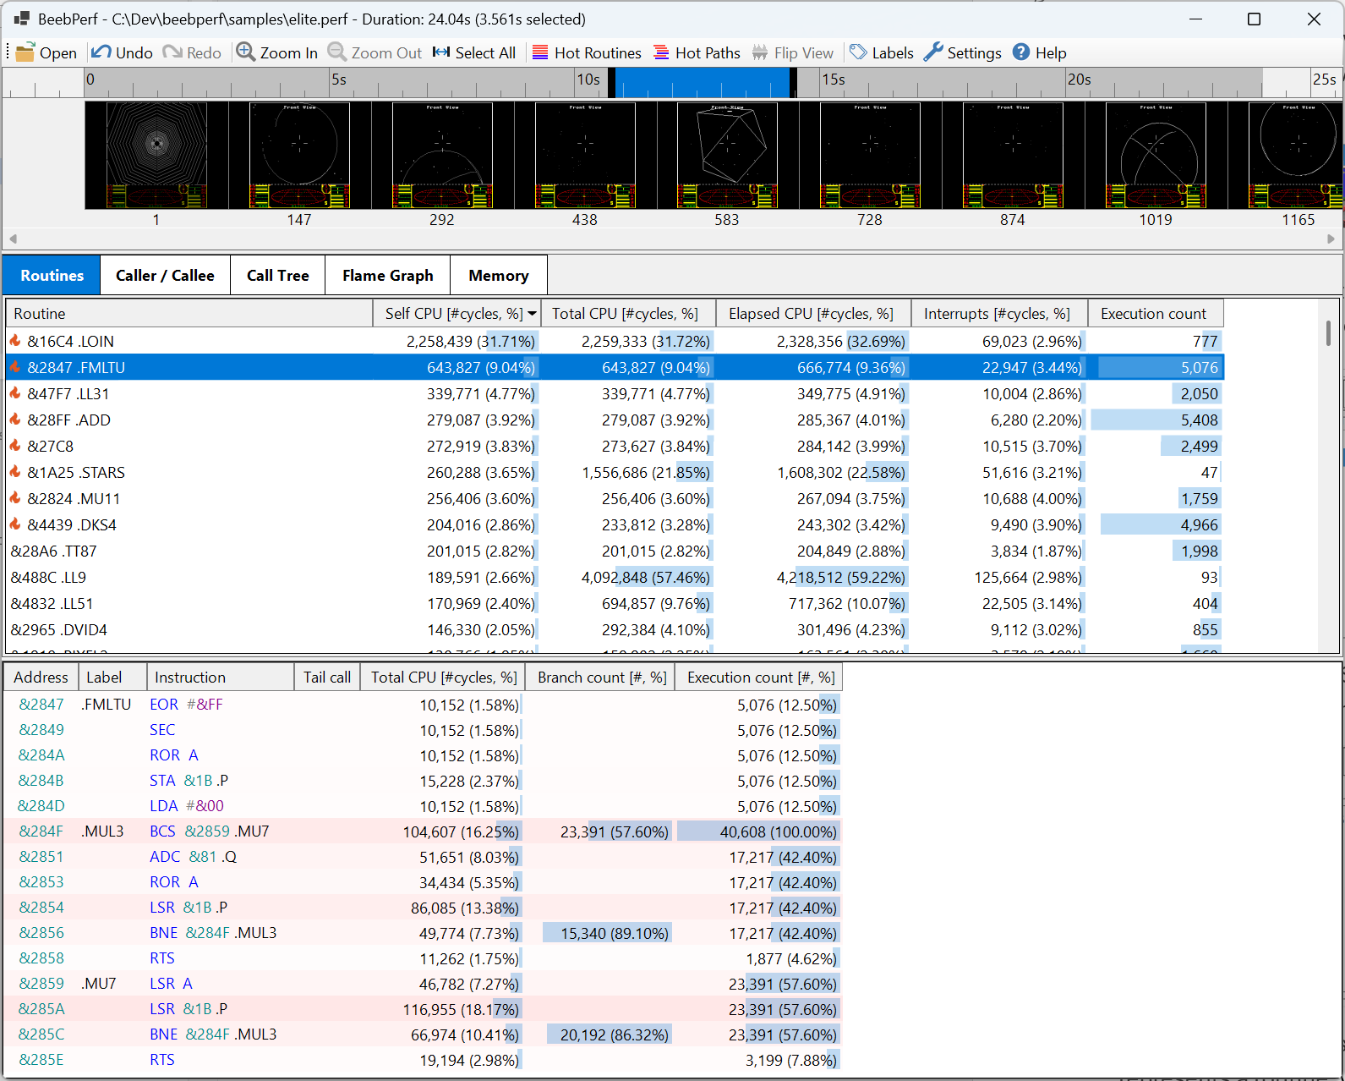
Here is a more detailed descriptions of each section:

Timeline panel
Shows the recorded timeline allowing the user to select a specific time range to analyze (shown in blue). This can be modified by dragging the black colored end handles or selecting the Select All toolbar button. The Zoom In and Zoom Out buttons change the scale. Display frames are shown below the timeline. Their size can be changed by dragging the bottom dividing border. Frame numbers are displayed under each display frame.
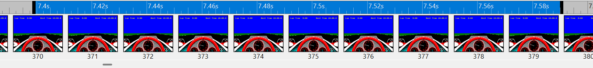

Routines tab
Shows the routines in the program, sorted by self-CPU counts. The routines with the highest self-CPU usage are marked as ‘hot’. The routines can also be sorted by total CPU, elapsed CPI, interrupts, and execution count.
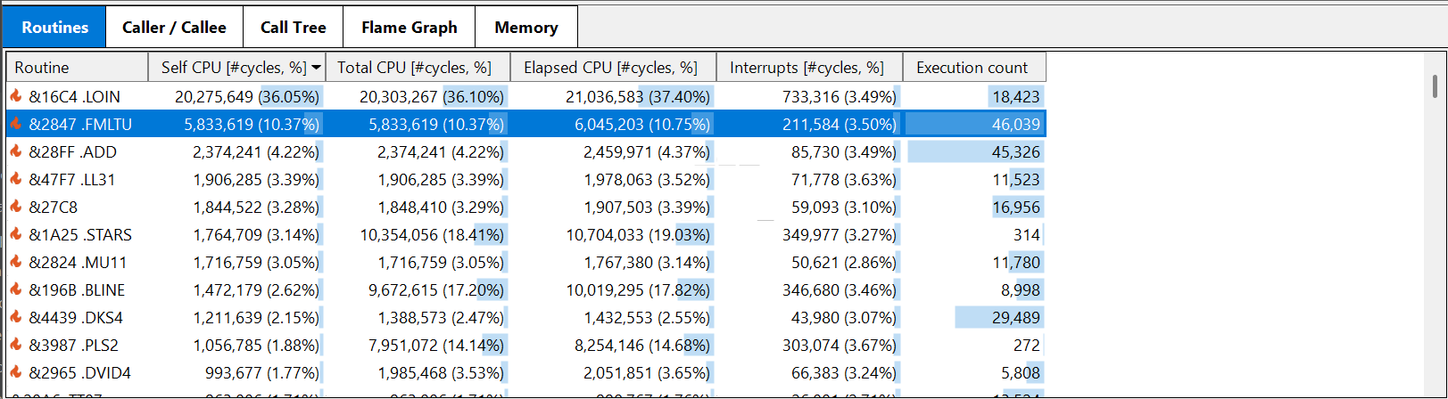
Term | Description
Self CPU | Number of cycles spent executing instructions within the routine.  Excludes cycles spent in other routines and interrupt code.
Total CPU | Number of cycles spent executing instructions within the routine, and any routines it invokes directly or indirectly, from JSR’s, tail-calls, and/or fall-throughs.  Excludes the cycles spent executing interrupt code during the execution of the routine.
Elapsed CPU | Number of cycles spent executing instructions within the routine, or any routines it invokes directly or indirectly, from JSR’s, tail-calls, and/or fall-throughs.  Includes the number of cycles spent executing interrupt code during the execution of the routine, or any invoked routines.
Interrupts | Number of cycles spent executing interrupt code during the execution of the routine.
Execution count | The number of times the routine was invoked
The relationship between Total CPU, Interrupts, and Elapsed CPU is:
Elapsed CPU = Total CPU + Interrupts
The percentages shown are the percentage of cycles with respect to the total number of cycles in the analysis time range.

Caller \ Callee tab
Useful for visualizing the callers and callee of the selected routine.
Shows a routine’s calling and called routines, showing their total CPU cycles and percentages with respect to the total number of cycles in the analysis time range.
Selecting a caller or callee makes it the currently selected routine.
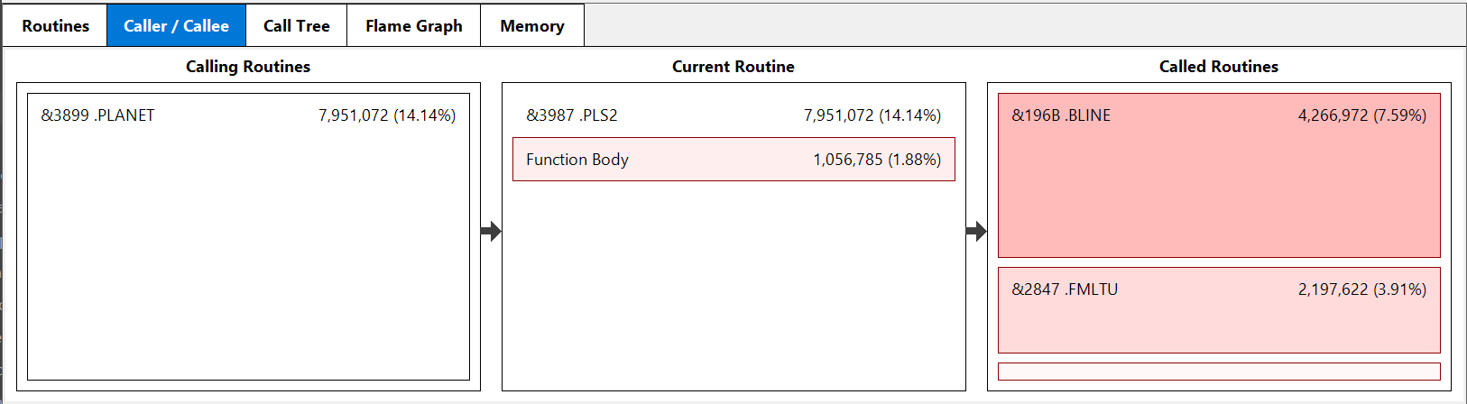

Call Tree tab
Provides a hierarchical, top-down view of executed code paths, showing exactly which routines called which, how long they ran, and how often they were called etc.
The call tree show all the routine’s call paths, sorted by total CPU cycles. The top-level nodes represent the program and interrupt entry points. Each node in the tree shows metrics for the context in which it was invoked.
Note how the Total CPU counts declines through descendants.

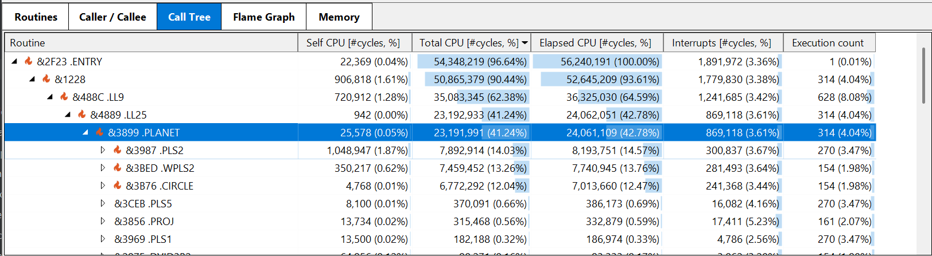Flame graph tab
Useful for pinpointing CPU usage, identifying bottlenecks, and visualizing call paths.
Provides a percentage breakdown of the selected function’s call graph, by Total CPU cycles, where siblings are sorted by Total CPU cycles.
Clicking on a routine makes it the new selected routine. Clicking in white space clears the selection.
The view can be flipped vertically by pressing the toolbar Flip button.
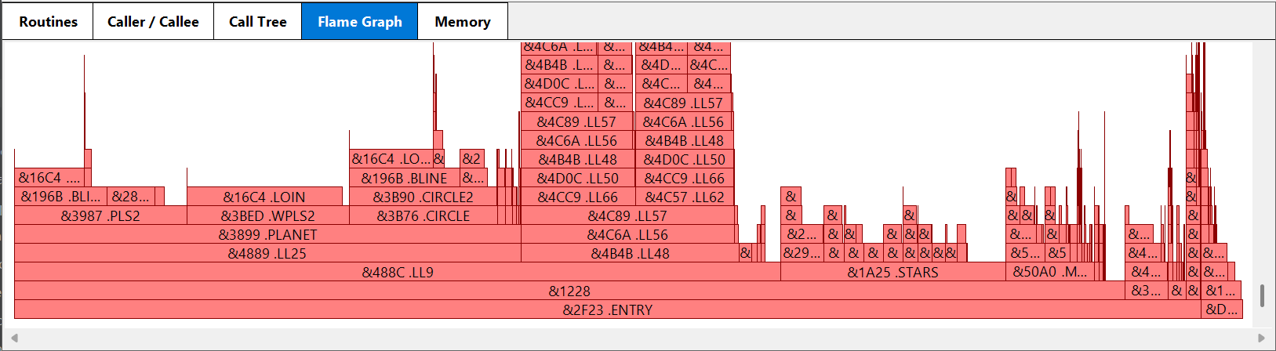

Memory tab
The memory tab lists the highest to lowest accessed memory in the application. The memory can optionally be filtered to just zero-page addresses.
Selecting an address populates a panel on the right listing all the routines which read or write to the selected address, with their respective read and write counts. Selecting a routine from the list selects the routine in the code panel, in which the read and write counts are shown.
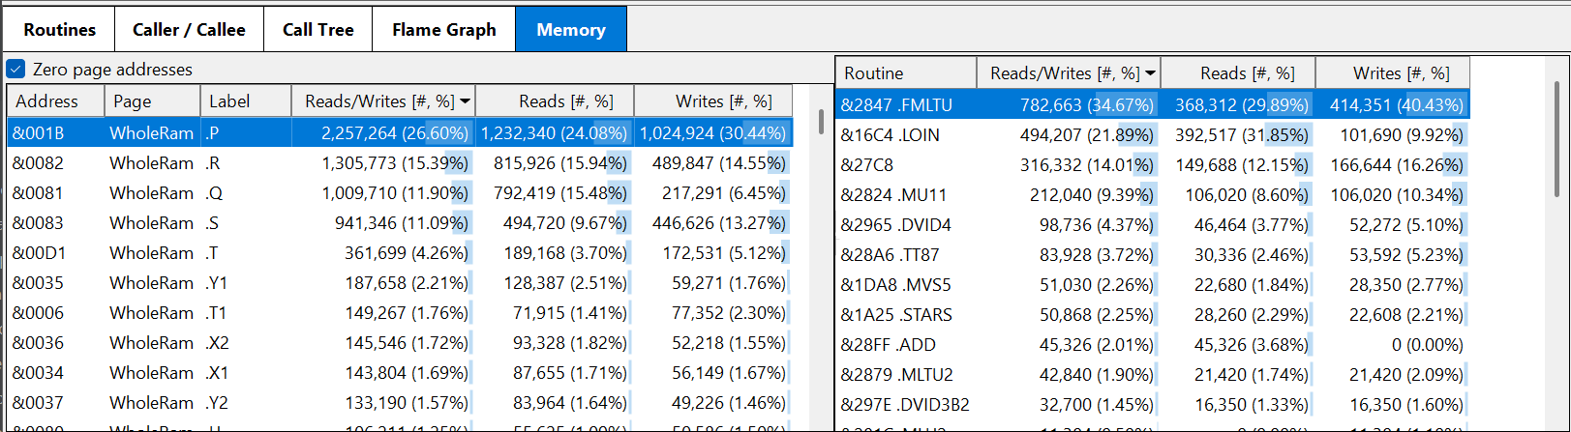

Code panel
Used to view the performance of a routine’s instructions.
The panel shows the selected routine’s executed instructions. If alternative opcode sequences exist, a vertical bar denotes that the code was modified.
If the routine is selected in the Memory tab (right-hand panel), the read and write memory counts are also displayed.
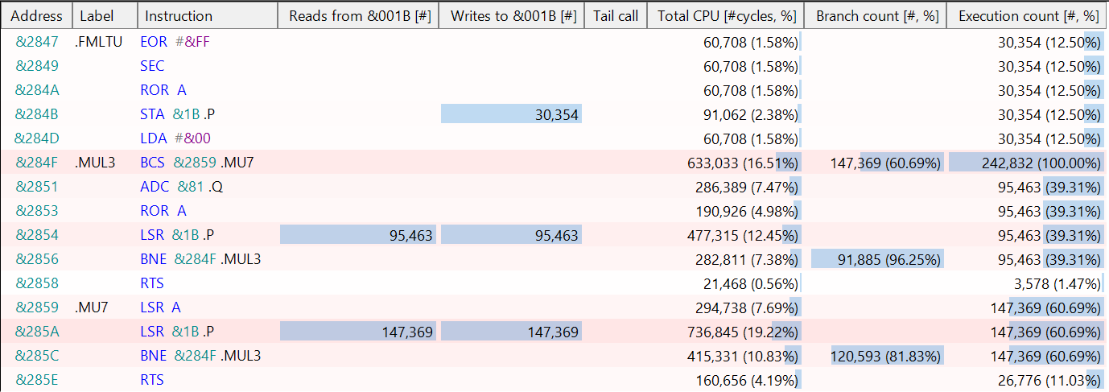
Term | Description
Tail call | Whether a JMP or branch instruction invokes a tail call.
Total CPU | Number of cycles spent executing the instruction, including cycles spent in invoked routines (directly or indirectly) from JSR’s and tail-calls.  Excludes the cycles spent executing interrupt code during execution.  The percentage shown is with respect to the total number of cycles executed by the routine, including cycles spent in invoked routines (directly or indirectly) from JSR’s and tail-calls.
Branch count | The number of times the branch was taken, and the percentage of times the branch was taken with respect to being executed.
Execution count | The number of times the instruction was executed.

Labels
The labels dialog allows labels to be loaded from files and enabled/disabled. The labels defined in a .perf file are also listed (<…>). Labels can be extracted from BeebAsm.exe output or -labels option generated files.
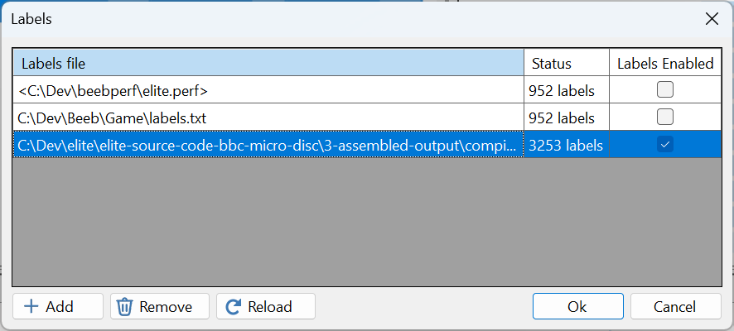

Settings
The settings dialog allows several display options to be set, including the default font scaling, theme (light or dark mode), and code formatting and color options.
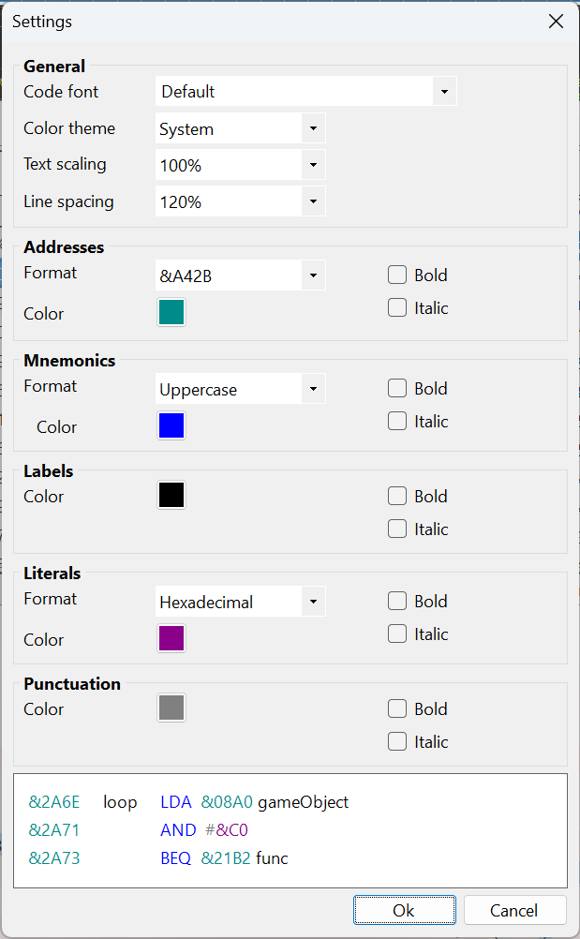

Help
The Help dialog displays getting started instructions, and other information.

Managing the ‘context’
The application has the notion of the current analysis time range (blue bar), current selected routine, call-stack, and address. Each view shows results based on these. Some views allow the context to be changed.

Undo-Redo History
The application supports undo/redo. The following actions can be undone and redone:
- Select time-line range
- Select/deselect routine/call-stack
- Select tab
- Select/deselect memory address
- Show zero-page addresses
- Show hot routines
- Show hot paths
- Flip flame graph
- Display settings changes
- Labels dialog changes

Current Limitations
The profiler’s current limitations include:
- Label duplication. If multiple labels map to the same address, the incorrect label may be displayed.
- Overlapping code. If code is loaded and executed over previously run code, the profiler may not function correctly. Current algorithms for identifying routines and stack frames do not support overlapping code.
- Code-patterns. Some 6502 coding patterns can result in deep tail-call paths being generated, which can impede analysis and UI responsiveness. For example, calling into the middle of a loop within another routine can result in deep call-paths.

BeebPerf Design
BeebPerf is a .NET Windows Forms app, written in C#. Whilst alternative tech stacks could have been used, this combination is well suited for building a Visual Studio Profiler like experience.
I considered implementing the analysis portions in C++, to keep the memory footprint low, however this turned not to be necessary.
The application is built around a single BeebPerf Form which ties the application together. The form…
- Defines the application’s layout (arrangement of toolbar, tabbed views, and panels). All the UX components, including the main form, are in the ux folder.
- Coordinates .Perf file loading and analysis, leveraging CPU, memory, and video analysis components (owned by the form). These components are located in the root project folder.
- Manages the application context (current selected time range, routine, call stack, address, and selected tab).
- Translates user actions to operations, which interact with the undo-redo history (owned by the form). Every undoable user action is encapsulated by a corresponding operation. All the operations classes are located in the operation folder.
- Coordinates setting changes (changes to fonts, scaling, and theme).
- Holds the label files and owns the associated label resolver which UX components use to resolve addresses to labels.
- Serializes user preferences.

App startup
A number of important operations are performed during app startup. These include:
- Preference loading.
- Loading the labels files (uses the LabelsFileReader class defined in the project root folder).
- Reopens the last opened .Perf file, if it exists.
- Initialize all UI components.

.Perf file loading
A .perf file is loaded asynchronously using the PerfReader class which creates and populates an instance of the Model class.
Model – represents a loaded .Perf file. It contains the following fields:
- BBC model and CPU
- Program snapshot taken at the beginning of the recording, containing:
  - Register values
  - Rom Paging register and Access Control register
  - Call stack (array of mini stack frames)
  - Hidden RAM address (Integral)
  - Video ULA register and palette
  - Video control registers
  - Memory snapshots
- Labels (array or name/address pairs)
- Instructions (array of Instruction)
As part of the loading process, addresses are converted to canonical addresses, where every address has an associated page identifier.
Canonical Address – represents a unique memory address. It contains the following immutable fields:
- Page – memory page
- Address – absolute memory address
All the events and instructions defined across the read .perf file’s execution chunks are put in a single large array of Instruction.
The snapshot call stack is represented by a list of mini stack frames.
MiniStackFrame – represents a mini stack frame. Contains the following fields:
- Call-type (Root, JSR, BRK, IRQ, NMI)
- Start address
- Return address
- Return stack pointer
Instruction – represents an individual recorded instruction or event. Contains the following immutable fields:
- Type (instruction or event-type)
- Cycle count (instruction/interrupt)
- Opcode address (instruction)
- Opcode & operand (instruction)
- Stack value (instruction)
- Stack pointer (instruction)
- Memory address (instruction)
- Memory read/write values (instruction)
- Destination address (instruction/interrupt)
- Return address (instruction/interrupt)
- Display field (display event)
To minimize memory, Instruction is defined as a 12-byte fixed sized struct.

Static analysis
Static analysis is performed after a .perf file is loaded. The form class asynchronously invokes CPU and video analysis in parallel.

Static CPU analysis
The goal of static CPU analysis is:
- Identify every routine in the program.
- Identify every stack frame in the program, and its associated call-stack.
- Identify all the contexts (call-stacks) in which routines are invoked.
Routines, Stack frames, and call-stacks are represented using the following model types:
Routine – represents a unique code routine. Contains the following fields:
- Start address
- End address
- Label (optional)
- Aggregated CPU Metrics, by CallStack – populated by dynamic analysis
- Total aggregated CPU Metrics – populated by dynamic analysis
- Hot Routine – populated by dynamic analysis
StackFrame – represents a unique stack-frame within the recorded program. Contains the following fields:
- Call Stack (inherited for implementation efficiency)
- Children (child stack frames)
- First and last instruction indices
- Start and end cycle counts
- Highest and lowest instruction address
- CPU Metrics – populated by dynamic analysis
CallStack – represents a call stack within the recorded program. Contains the following fields:
- Call-type (None, JSR, IRQ, NMI, BRK, Tail-call, fall-through)
- Parent call stack
- Routine reference
- Start address (same as routine’s start address)
- Return address
- Return stack pointer
The identify of a CallStack is defined by the sequence of addresses up through the parent chain, ending at the root or a call stack that has an ISR call type.
CPU static analysis performs the following:
- Identify all routines in the program. This is tricky as one must deal with interrupt code, tail call optimizations, indirect call optimizations, and call chaining.
The following rules are used to identify routines.
- Every routine address in the snapshot call-stack is a routine.
- Every JSR destination address is by definition a routine.
- Every Interrupt destination address is by definition a routine.
- Every RTS destination address, which does not have a corresponding call-site, is also a routine.
- Every jump or branch destination address is also a routine, if the instruction and destination addresses cross a routine boundary.
The algorithm used to perform the above iterates over every instruction, simulating the programs stack, whilst maintaining a mini call stack.
The identified routines are referenced by two collections: A dictionary of routines by start address, and a sorted list of routines by start address.
- Identify all the stack-frames in the program
A stack-frame tree is created by first constructing an initial stack-tree from the snapshot call stack, before iterating over all the recorded instructions, creating nested stack-frames as code traverses over the routines and interrupts in the program. Tail-call and fall-through stack frames are also created as part of this process.
As instructions are enumerated, the associated stack frame’s first and last instruction indices, start and end cycle counts, and highest and lowest addresses are updated.
And after the last instruction has been processed, the remaining stack frames are unwound to set the final end cycle counts.
And finally, any tail-call stack frames which were inserted during the construction of the initial call stack are reviewed to determine if they need reparenting to new routines.

Static Display Frame analysis
An execution trace includes screen memory display read events, which indicates when the 6845 CRT control chip starts reading screen memory to display each frame.
Static display frame analysis uses these events to recreate frame snapshots, which are created by simulating how the 6845 CRT is used in conjunction with the ULA and Teletext chips (Mode 7) to read screen memory, translate the data to pixels, and render these to the displayed frame. Note that the rendered frames do not have a border.
Frame recreation supports the following features:
- Standard modes 0-6, and teletext mode 7
- Non-standard video modes (e.g. Mode 8)
- Mixed non-teletext modes (mid-frame ULA changes)
- Interlaced support
- Over-scan resolutions up to 1024x640
- Hardware scrolling
Limitations:
- No support for shadow RAM reads
- No support for the hardware cursor
- No support for non-interlaced teletext modes
- No support for mixed teletext and non-teletext modes
- No support for graphics tablets
- No support for custom ULA palette hardware

Dynamic analysis
Dynamic analysis is performed after static CPU analysis is completed, and whenever the analysis timespan is changed by the user.
The form class asynchronously invokes dynamic CPU and memory analysis in parallel.

Dynamic CPU analysis
- Calculate the CPU metrics for every routine, for a specific timespan
- Use the CPU metrics to generate the hot routine list - routines with the highest self-CPU values.
- Use the CPU metrics to generate a call tree, where child nodes are ordered by their inclusive-CPU metrics.

Dynamic Memory analysis
- Calculate the memory usage metrics, for a specific timespan. Iterate over all instructions within the timespan populating a dictionary mapping memory address read/write counts.
- Use the memory access map to identify the highest and lowest memory usage lists.

UX Design and implementation
The application is built around a main Form (BeebPerfForm) which ties the different aspects of the application together. The form…
- Defines the layout of the application, the layout of the app’s custom forms and panels (see below).
- Orchestrates the asynchronous loading of .perf files, and static / dynamic analysis.
- Translates user actions into operations which in turn are held in an Undo / Redo history (owned by the form).
- Manages the current context (current time-range, selected routine, call-stack, memory address, and selected tab).
- Manages the current set of labels files (edited using the Labels dialog).
- Loads and save persistent app state (user preferences and labels files).
- Orchestrates display settings changes (theme and scaling).
The UX is constructed from a set of custom forms, panels, and controls. Here is the inventory:
Custom form / control | Custom | Description
BeepPerfForm | Form | The main form
TimelineView | Panel | Timeline with frame snapshots
TabControlEx | Panel | Tab control
GridView | DataGridView | Base grid control providing common profiler related functionality
RoutinesView | GridView | Routines view
CallerCalleeView | Panel | Caller / callee view
CallTreeView | GridView | Call tree view
FlameGraph | Panel | Flame graph view
MemoryView | GridView | Memory view (left-hand side)
MemoryRoutinesView | GridView | Memory view (right-hand side)
CodeView | GridView | Code / disassembly panel
Spinner | Panel | Progress spinner control
LabelsDialog | Form | Labels dialog
SettingsDialog | Form | Settings dialog
SampleCodePanel | Panel | Sample code panel used in the settings dialog
HelpDialog | Form | Help dialog

One notable helper class is the ReentrancyGuard (also in ux folder) which is used to stop cyclic api event api event … loops from occurring.

Undo Redo
Undoable user actions are implemented as operations, which live in as undo / redo history, owned by the main form. The operations in the operation folder.
The undo / redo history class (UndoRedoHistory) has the following public methods:
- bool Execute(Operation op)
- bool CanUndo()
- bool CanRedo()
- void Undo()
- void Redo()
- void Clear()
where Operation (an abstract class) has the following similar named interface methods:
- bool Execute()
- void Undo()
- void Redo()
The UndoRedoHistory class internally manages two stacks, which hold separate undo and redo histories.
- The Execute(Operation op) method calls Execute on the passed operation, and if this succeeds calls Clear (to clear the undo & redo stacks) and pushes the operation onto the undo stack
- The Undo method pops an operation from the undo stack, and calls Undo on it.
- The Redo method pops an operation from the redo stack, and calls Redo on it.
- The Clear method clears the undo and redo stacks.
Every undoable user action in the app is implemented as an operation. These are located in the operation folder.
Operation implementations typically hold copies of the state before, and after, the related action is performed, which are then applied within the undo and redo methods.

Compression library – zlib
The PerfReader class uncompresses chuck data using the open source zlib library. Copyright (C) 1995-2024 Jean-loup Gailly and Mark Adler.
The sources can be found in the zlib project within the BeebPerf solution. The project builds to create zlib.dll.
The PerfReader class calls the zlib apis using P/Invoke.

.Perf File Format
This section describes the .perf file format (version 1.0).
As outlined above, a .perf file is used to decouple the measurement and analysis aspects of profiling. BeebEm is modified to generate a .perf file, which BeebPerf reads and analyses.
The format strives to balance the needs of:
- Limiting the impact on BeebEm performance, when a performance capture is, and more importantly, is not being taken.
- Limiting the number of BeebEm source code changes.
- Limiting the size of a .Perf file.
- Maximizing the genericness of the captured information, allowing the format to be used for purposes other than profiling.
- Ensuring the format can be extended in the future.

Overview
A .pref file contains sufficient information to analyze CPU metrics, memory, and screen rendering. It contains a snapshot of the BBC Micro at the start of recording and a log of all executed 6502 (or 65C02) instructions. The log contains all 6502/65C02 register state changes, all memory accesses and values, plus key events like interrupts and begin screen display. It also optionally contains label information.
The file uses a binary chunk-based format with the following chunks:
<header_chunk> + <labels_chunk>^{opt} + <snapshot_chunk> + <execution_chunk>¹⁺
Every chunk has a common header which is followed by its respective data. Different chunk types have different data formats.
All scalar values are stored in little-endian format, unless stated otherwise.

Common Header
Every chunk has a common header which contains the chunk’s type and data descriptor.
<common_header> =
<tag> + <compression> + <original_size> + <compressed_size>
<tag> (4 bytes) A four-character string denoting the chunk type. The following table lists the permissible tag values:
Tag | Chunk
‘PFhd’ | <header_chunk>
‘PFlb’ | <labels_chunk>
‘PFss’ | <snapshot_chunk>
‘PFex’ | <execution_chunk>

<compression> (1 byte) The compression algorithm used to compress the chunk data.
Value | Description
0 | No compression
1 | zlib 1.3.1 (default algorithm)
<original_size> (4 bytes) The size of the chuck data, before compression, in bytes.
<compressed_size> (4 bytes) The size of the chuck data, after compression, in bytes. If the data is not compressed, the value matches <original_size>.

Header Chunk
The header chunk is the first chunk and it contains the file’s version, BBC model, and the total execution count.
<header_chunk> = <common_header(‘PFhd’)> + <header_data> where
<header_data> =
<major_version> + <minor_version> + <bbc_model> + <total_execution_count>
<major_version> (1 byte) Major version number. Value is 1.
<minor_version> (1 byte) Minor version number. Value is 0.
<bbc_model> (1 byte) The BBC model
Value | Model | Instruction set
0 | BBC Model B | 6502
1 | BBC Model Integra B | 6502
2 | BBC Model B Plus | 6502
3 | BBC Master 128 | 65C02
4 | BBC Master ET | 65C02

<total_execution_count> (4 bytes) The total number of executed instructions plus events in the file.
Header chunks are not compressed.

Labels Chunk
The optional labels chunk contains label information.
<labels_chunk> = <common_heade(‘PFlb’)> + <label_data> where
<label_data> = list of <label>, where:
<label> = <label_address> + <label_name>
<label_address> (2 bytes) A 16-bit address.
<label-name> A null-terminated label name.

Snapshot Chunk
The Snapshot Chunk contains a snapshot of the machine’s state at the beginning of the recording, prior to the first recorded instruction (see execution-chuck). It contains a snapshot of the machine’s CPU registers, paging registers, call stack, video 6845 and ULA registers, and memory.
<snapshot_chunk> = <common_header(‘PFss’)> + <snapshot_data> where
<snapshot_data> =
<program_counter> + <accumulator> + <x_register> + <y_register> + <status_register> + <stack_pointer> + <rom_paging_register> + <acccon> + <call_stack> + <screen_address> + <hidden_ram_address>^{opt} + <6845_registers> + <ULA_video_control_register> + <ULA_palette> + <memory_snapshot>
<program-counter> (2 bytes). The value of the program counter.
<accumulator> (1 byte). The value of the accumulator.
<x_register> (1 byte). The value of the X register.
<y_register> (1 byte). The value of the Y register.
<status_register> (1 byte). The value of the status register.
<stack_pointer> (1 byte). The value of the stack register.
<rom_paging_register> (1 byte). The value of the ROM paging register (set via SHEILA address &FE30).
<acccon> (1 byte). The value of the access control register (set via SHEILA address &FE34).
<call_stack> = <stack_frame_count> + <stack_frame>¹⁺
The call stack is comprised of a list of stack frames, each representing the nested invocation of either a JSR, IRQ, NMI, or BRK within the program. The first stack frame represents the program itself.
The contained start and return addresses are expressed in page / absolute address pairs. Page locations will typically be in whole RAM or a ROM page.
The root stack frame represents the program. Its start address is either the first sub &8000 instruction jumped to from above &8000, or the first instruction executed if no such jump occurs. Its type and return stack pointer values are always zero (Root stack frame) and &FF.
Each nested stack frame also contains the return address and stack pointer. The values that the program counter and stack register are set to by the returning RTS or RTI instruction.
<stack_frame_count> (1 byte) The number of stack frames.
<stack_frame> = <stack_frame_type> + <start_address_page> + <start_address> + <return_address_page> + <return_address> + <return_stack_pointer>
<stack_frame_type> (1 byte) The stack frame’s type. The value can be one of the following:
Type | Description
0 | Root stack frame
1 | Created with JSR
2 | Created with IRQ
3 | Created with NMI
4 | Created with BRK

<start_address_page> (1 byte) The memory page where the start address is located. The value can be one of the following:
Page | Description
0..15 | ROM page <N>
16 | Whole RAM
17 | Shadow RAM
18 | Private RAM
19 | Filing System RAM
20 | Hidden RAM
21 | Other

<start_address> (2 bytes) Address of the invoked routine, or the start address of the program (root stack frame). This is an absolute address.
The program start address is either the first sub &8000 instruction jumped to from above &8000, or the first instruction executed if no such jump occurs.
<return_address_page (1 byte) The memory page where the return address is located. The value is defined in the above table. The value in the root stack is always 16 (Whole RAM).
<return_address> (2 bytes) Return address. The value that the program counter is set to by the returning RTS / RTI instruction. This is an absolute value. The value in the root stack is always zero.
<return_stack_pointer> (1) Return stack pointer. The value that the stack register is set to by the returning RTS / RTI instruction. The value in the root stack frame is always &FF.
<screen_address> (1 byte). The value specifies the screen address, as defined by the following table. This is used in conjunction with hardware scrolling to wrap screen addresses.
Value | Screen address
0 | &4000
1 | &6000
2 | &3000
3 | &5600
Note that bit-1 and bit-0 match bit-5 and bit-4 of the System VIA Port B addressable latch.
<hidden_ram_address> (1 byte). Populated only on the BBC Model B Integra. The value contains the hidden memory address (set via SHEILA address &FE38). Reads and writes to SHEILA address &FE3C access this hidden address.
<ULA_video_control_register> (1 byte). The value of the ULA video control register.
<ULA_palette> (16 bytes). The ULA’s 16 palette entries where physical colors are xor’d with 0x7.
<6845-registers> (18 bytes). The values of the 6845’s 18 registers.
<memory_snapshot> =
<base_memory> + <paged_memory> + <shadow_ram>^{opt} + <mos_ram> ^{opt} + <filing_system_ram>^{opt} + <private_ram>^{opt} + <hidden_ram>^{opt}
The following table shows which elements are included based on the BBC model.
Included memory | Model B | Model B Integra | Model B+ | Master
<base_memory> | yes | yes | yes | yes
<paged_memory> | yes | yes | yes | yes
<shadow_ram> |  | yes | yes | yes
<mos_ram> |  |  |  | yes
<filing_system_ram> |  |  |  | yes
<private_ram> |  | yes | yes
<hidden_ram> |  | yes
<base_memory> (64K) The default 64K of memory. Addresses 0 to &FFFF.
<paged_memory> = <page_count> + <page_data> ^{n}
<page_count> (1 byte) The number of pages.
<page_data> = <page_bank> + <page_readonly> + <page_memory>
<page_bank> (1 byte) A page bank id (0 to 16).
<page_readonly> (1 byte) A page read-only flag. 0 = writable, 1 = read-only
<page_memory> (16K) The memory contents of a page. Addresses &8000 to &BFFF.
<shadow_ram> (20K) Populated on Model B Plus, BBC Model B Integra, and BBC Master. Addresses &3000 to &7FFF.
<mos_ram> (4K) Populated on BBC Master. Addresses &8000 to &8FFF.
<filing_system_ram> (8K) Populated on BBC Master. Addresses &C000 to &DFFF.
<private_ram> (12K) Populated on BBC Model B Plus and BBC Model B Integra. Addresses &8000 to &AFFF.
<hidden_ram> (256 bytes) Populated on BBC Model Integra B.

Execution Chunk
An execution chunk contains a list of 6502 or 65C02 executed instructions and events. One or more instruction chunks can exist in the file.
<execution_chunk> = <common_header(‘PFex’)> + <execution_data> where
<execution_data> = list of <instruction> and/or <event> where:
<event> = <event_marker> + <event_params>
<event_marker> (2 bytes). A two-byte value that distinguishes an <event> from an <instruction>. The marker also specifies the event type and subsequent parameters as depicted in the table below.
Two-byte values | Event type | Event params
&80, &00 | Maskable interrupt (IRQ) | <interrupt_event_params>
&80, &01 | Non-maskable interrupt (NMI) | <interrupt_event_params>
&80, &02 | Begin display | <display_field>
&80, &03..&7F | Reserved for future use

The maskable (IRQ) and non-maskable (NMI) interrupt events signify that an interrupt has occurred. A begin display event signifies that the screen memory read, used to display screen memory, begins. The screen memory is read every 50th of a second.
<interrupt_event_params> =
<cycle_count> + <destination_address> + <return_address>
<cycle_count> (1 byte) Specifies how many cycles it took to jump to the service routine. This is always seven.
<destination_address> (2 bytes). The address of the interrupt service routine. For NMI interrupts, the value held in $FFFA–$FFFB. For IRQ’s, the value held in $FFFE–$FFFF.
<return_address> (2 bytes). The return address that was pushed on the stack.
<display_field> (1 byte). 0 for even field, 1 for odd field (when interlaced sync is enabled).
<instruction> =
<opcode_address> + <opcode> + <operand>^{opt} +
<cycle_count> + <modified_registers> + <destination_address>^{opt} + <memory_address>^{opt} <memory_read_value>^{opt} + <memory_write_value>^{opt}
<opcode_address> (1, 2, or 3 bytes) The instruction’s opcode address is encoded in 1, 2 or 3 bytes as depicted in the following table, where addresses are stored in relative format if possible. Absolute addresses are stored in big-endian format (high-byte precedes low-byte).
Address format | <byte-0> | <byte-1> | <byte-2>
Relative address: -63 to 63 | &81..&FF
Absolute address: &0000..&7FFF | 0..&7F | 0..&FF
Absolute address: &8000..&FFFF | &80 | &80..&FF | 0..&FF
Not an instruction (see events) | &80 | 0..&7F

The following pseudo code depicts how the opcode address is written.
# at the beginning of recording
lastOpcodeAddress = 0

# write opcode address
var diff = opcodeAddress – lastOpcodeAddress
lastOpcodeAddress = opcodeAddress
if abs(diff) <= 63 then
# relative address
writeByte(diff + 0xC0)
else
# absolute address (big-endian)
if opcodeAddress >= 0x8000 then
writeByte(0x80)
endif
writeByte(hiByte(opcodeAddress))
writeByte(loByte(opcodeAddress))
endif
<opcode> (1 byte) The instruction’s opcode.
<operand> (0, 1, or 2 bytes) The instruction’s operand value. The number of bytes is defined by the instruction’s opcode, per the 6502 & 65C02 instruction set.
<cycle_count> (bits 0..2 of next byte) Contains the number of cycles the instruction took to execute. The value in the range: 2..7.
<modified_registers> =
<modified_register_flags> + <accumulator>^{opt} + <x_register>^{opt} + <y_register>^{opt} + <status_register>^{opt} + <state_pointer>^{opt}
<modified_register_flags> (bits 3..7 of next byte). Bit flags indicating which register value(s) the instruction modified. The table below lists which bits are set for each corresponding modified register. The bits are only set if the executed instruction changed the contents/value of the corresponding register.
Bit | Modified register
3 | Accumulator
4 | X Register
5 | Y Register
6 | Status Register
7 | Stack Pointer
The initial values of the registers are defined in the snapshot chunk (see section above).
<accumulator> (0 or 1 byte) Contains the value of the accumulator. The value is written if the corresponding bit is set in <modified_register_flags>.
<x_register> (0 or 1 byte) Contains the new value of the X register. The value is written if the corresponding bit is set in <modified_register_flags>.
<y_register> (0 or 1 byte) Contains the new value of the Y register. The value is written if the corresponding bit is set in <modified_register_flags>.
<status_register> (0 or 1 byte) Contains the new value of the status register. The value is written if the corresponding bit is set in <modified_register_flags>.
<state_pointer> (0 or 1 byte) Contains the new value of the stack pointer. The value is written if the corresponding bit is set in <modified_register_flags>.
<destination_address> (2 bytes) Populated for the RTI, RTS, BRK, JMP (abs), and JMP (abs, X) (65C02 extension) instructions, with the address of the resolved destination address.
<memory_address> (2 bytes) Populated for all opcodes (except JMP (abs) and JMP (abs, X)) that read or write to memory using the following indexed and/or indirect addressing modes:
- Zero-page, X
- Zero-page, Y
- Absolute, X
- Absolute, Y
- (Zero-page, X)
- (Zero-page), Y
- (Absolute)
- (Absolute, X) - 65C02 extension
- (Zero-page) - 65C02 extension
Contains the resolved address, or &FFFF for indirect addresses that could not be resolved.
<memory_read_value> (1 byte) Populated for opcodes (except LDA, LDX, and LDY) that read from an address, excluding the stack (e.g. PLA). Contains the value read. This includes instructions like INC memory that read a value from memory, increment it, and write it back.
The value is not populated for LDA, LDX and LDY as the associated register contains the read value.
<memory_write_value> (1 byte) Populated for opcodes (except STA, STX, and STY) that write to an address, excluding the stack (e.g. PHA). Contains the value attempted to be written. This includes instructions like ASL memory that read a value from memory, shift it, and write it back.
The value is not populated for STA, STX and STY as the associated register contains the written value.

BeebEm Code Changes
The performance functionality is encapsulated within a PerfWriter class (PerfWriter.h/cpp)
The class provides methods for starting and ending a performance session, and methods for logging executed interrupts and instructions in the emulator. The class also encapsulates the functionality to generate a .perf file.
Internally, logged interrupts and instructions are written to the .perf file using read and write buffers.
Logged events and instructions are recorded in a write buffer, whilst previously recorded instructions in the read buffer are read, compressed, and written to the .perf file in chunks, using another thread. The read and write buffer’s roles are swapped when the write buffer is full.
Any errors that occur during recording are reported to the user when the session is ended. Errors include file IO errors, compression errors, and buffer contention. In practice, the latter should not happen unless I/O error occurs. Only the first error is reported.
Changes to BeebEm are kept to a minimum. Here is a list of the changes made to the existing source files:
6502.h/cpp
- Added calls to PerfWriter_WriteInstruction(…) and PerfWriter_WriteInterrupt(…) to log instructions and interrupts. These wrapper functions only invoke the PerfWriter instance during a performance capture.
- Added static variables (LastReadWriteAddress, LastReadValue, and LastWriteValue) to store the last accessed memory address, read value, and write value. These values are passed to PerfWriter_WriteInstruction(…). Added helpers (ReadZeroPage, WriteZeroPage, ReadPaged, WritePaged) which wrap the respective functionality whilst updating these variables. Updated the emulator interpretation code to use the new helpers.
- Defined new struct (StackFrame) and static variables (StackFrames, StackFrameCount) to capture the current call stack, and added helpers (PushStackFrame, SyncStackFrames, SetStackFrame, UpdateRootStackFrame) to maintain this. Updated the emulator’s interpretation code to invoke the new helpers.
- Updated Load6502UEF and Save6502UEF to serialize the call stack.
- Added helper to get the emulator’s call stack: GetStackFrames (…). This is called during snapshot chunk serialization.
- Added helper to get the emulator’s registers: GetRegisters(…). This is called during snapshot chunk serialization.
- Removed ReadPaged and WritePaged macros which are no longer used.
BeepMem.h/cpp
- Defined new struct (MemPageType) and function (BeebMemPage) that returns the page associated with an address. This is invoked by SetStackFrame (see 6502.cpp).
- Externed Hidden, Private, and HidAdd variables so these are accessible during snapshot serialization.
- Removed BEEBWRITEMEM_DIRECT macro which is no longer used.
Video.cpp
- Added call to PerfWriter_WriteBeginDisplayEvent(…) to log the start of screen display. This wrapper function only invokes the PerfWriter class during a performance capture.
Debug.h/cpp
- Externed Labels vector so the labels are accessible during snapshot serialization.
BeebWin.h/cpp, BeebWinIo.cpp
- Added performance capture functionality in the UX. Added UpdatePerfCaptureMenu(), CapturePerf(), EndPerfCapture(), and IsCapturingPerf() functions (modelled from the existing video capture functionality) and invoked these in a similar way to how video capture is implemented. The only notable differences are that CapturePerf creates an instance of the PerfWriter class, initializes it, and EndPerfCapture closes the capture, and deletes the PerfWriter instance.
BeebWinPrefs.h/cpp
- Added a performance capture file path preference, used to remember the location of the last written .perf file.
UefState.cpp
- Incremented UEFSTATE_VERSION as the call stack is serialized.
BeebEm.rc, Resource.h
- Added Capture Perf… and End Perf file menu items, and respective ids.
*BeebEm.vcxproj.filters
- Added entry for PerfWriter.cpp
*.vcxproj
- Updated WindowsTargetPlatformVersion to 10.0
- Updated PlatformToolset to v142.

Patch file
The BeebEm code changes are saved as a git patch file, which is created using the following git commands:
git add -N src\PerfWriter.h src\PerfWriter.cpp
git diff > ..\beebperf\beebem_changelist.diff

The patch can be applied to the BeebEm sources using the following git command:
git apply ..\beebperf\beebem_changelist.diff

