SOILGOOD
An IoT and AI-Based Soil Monitoring and Crop Recommendation System for Smart Farming
Final Project Documentation
Course Code: CTELEC4L — Elective 4
Instructor: Mr. Paul John DC Cabance
Section: ITE232
Submitted by:
Mark Joel Alcaraz
October 2026

TABLE OF CONTENTS
Right-click here and choose 'Update Field' to build the Table of Contents.

CHAPTER 1
PROJECT OVERVIEW

Introduction
Agriculture remains one of the most critical sectors in the Philippines, yet many smallholder farmers continue to rely on traditional practices and personal experience when making decisions about irrigation, fertilization, and crop selection. Without reliable soil and weather data, these decisions are often based on guesswork, which can lead to over- or under-watering, improper nutrient application, and the planting of crops that are not compatible with current soil conditions. The result is reduced yield, wasted inputs, and avoidable losses — challenges that weigh heavily on farmers whose livelihoods depend directly on the health of their land.
The emergence of low-cost Internet of Things (IoT) devices and cloud-based artificial intelligence (AI) services has opened new opportunities for data-driven farming. Soil sensors can now capture detailed, real-time information about soil condition, while AI models can translate this data into practical, farmer-friendly recommendations. These technologies, however, are often locked behind expensive commercial platforms or presented through complex dashboards that are difficult for ordinary farmers to use.
This project responds to that gap by developing SoilGood, an IoT and AI-assisted mobile application that supports farmers in irrigation, nutrient management, and crop management through real-time soil monitoring and intelligent recommendations. The system uses an ESP32 microcontroller integrated with an 8-in-1 soil sensor (moisture, pH, temperature, electrical conductivity, salinity, and NPK) to collect readings every fifteen minutes. These readings are sent to a Supabase cloud backend, combined with weather information from the Open-Meteo API, and interpreted by an AI model through a Supabase edge function. A Flutter-based mobile application then presents live soil data, weather information, historical records, and AI-assisted recommendations in a form that farmers can act on directly in the field.

Project Objectives

General Objective
To develop SoilGood, an IoT and AI-assisted mobile application that supports farmers in irrigation, nutrient management, and crop management through real-time soil monitoring and intelligent recommendations.

Specific Objectives
Specifically, the project aims to:
- Build an IoT-based soil monitoring device using an ESP32 integrated with soil moisture, pH, temperature, electrical conductivity (EC), salinity, and NPK sensors to collect real-time soil data.
- Develop a real-time monitoring module that displays soil sensor readings, weather information, and historical monitoring records.
- Integrate a weather API that provides current weather conditions and forecast data to support irrigation and crop management decisions.
- Develop an AI-assisted recommendation module that analyzes soil sensor readings and weather data to assess soil conditions, generate irrigation recommendations, identify appropriate soil management actions, and recommend crops that are compatible with the monitored soil conditions.

Scope of the Project
This project covers the design and development of SoilGood, an IoT and AI-assisted mobile application that supports farmers, farm owners, and agricultural practitioners in irrigation, nutrient management, and crop-related decisions. The system uses ESP32 devices with an 8-in-1 soil sensor to collect moisture, pH, temperature, EC, salinity, and NPK readings, and allows multiple sensors under one farm account for different planting plots or zones. A Flutter-based mobile application presents live soil data, weather information, historical records, and AI-assisted recommendations. Weather data from a weather API is combined with soil readings to assess soil conditions, suggest irrigation needs, identify soil management actions, and recommend compatible crops. The project focuses on SoilGood as a decision-support tool and does not aim to fully automate farm operations or replace the judgment of the farmer.

Limitations
The system depends on a stable internet connection for real-time updates, cloud storage, weather retrieval, and AI-generated recommendations, so weak or unavailable connectivity may delay live monitoring and AI outputs. The application is limited to farms and devices registered within SoilGood and does not cover multi-farm accounts under one user, large-scale commercial farm platforms, or national agricultural information systems. Soil readings reflect only the conditions at each sensor's installation point, so areas without a device remain unmeasured, and results may be affected by sensor placement, calibration, or environmental interference.
Device Wi-Fi configuration is handled during laboratory setup and flashing, while farmer-side network setup through SoftAP or Bluetooth is outside the current scope. AI recommendations are advisory only and should not be treated as guaranteed agricultural prescriptions, since final decisions remain with the farmer. Weather information depends on an external free weather API, so forecast accuracy and availability are subject to the limits of that service. In-app alerts are supported while the application is in use, but push notifications when the app is fully closed are not included in this version. Lastly, the project centers on a working prototype for practical demonstration and does not include large-scale provincial deployment, paid enterprise IoT platforms, or satellite-based crop monitoring.

CHAPTER 2
SYSTEM ANALYSIS AND DESIGN

System Description
SoilGood is organized into four cooperating layers: the field hardware, the Supabase cloud backend, the external APIs for weather and AI, and the Flutter mobile application used by the farmer. The field layer consists of one or more ESP32 microcontrollers connected to 8-in-1 soil sensors. Each ESP32 reads the sensor at a regular interval (approximately every fifteen minutes) and submits the reading to Supabase through a constrained ingestion endpoint that uses an anonymous key and a per-device token, keeping the service role key off the device.
The Supabase cloud layer stores every soil reading and weather snapshot in structured PostgreSQL tables, broadcasts new rows through Realtime so the mobile application can update without polling, and hosts an edge function that bundles the latest soil reading and weather snapshot into a single prompt for the AI model. The external APIs layer provides current and forecast weather from Open-Meteo and language-based reasoning from the AI model. Finally, the Flutter application presents the live data and recommendations to the farmer through the Home, Analytics, Crops, and Profile tabs, with notifications accessible from a bell icon in the app bar. Figure 1 shows how these layers fit together.
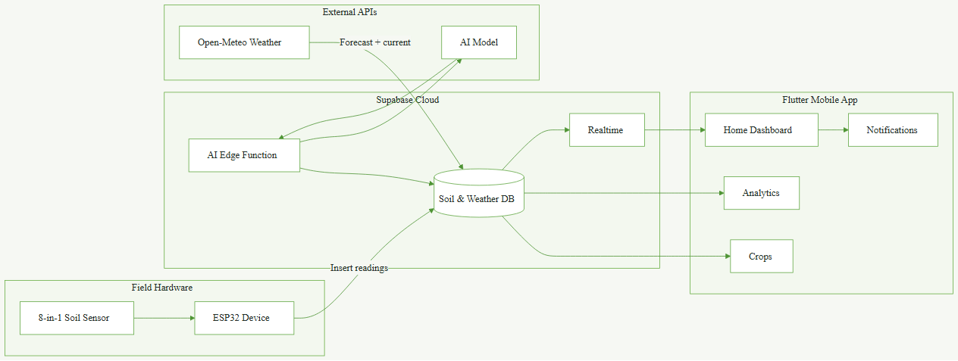
Figure 1. SoilGood System Architecture.

System Flow
The data flow begins the moment the ESP32 captures a soil reading and ends the moment the farmer sees a recommendation on the mobile application. Each soil reading is inserted into the soil_readings table and each weather snapshot into the weather_snapshots table. The AI edge function then combines the two most recent records, sends them to the AI model, and persists the response in the ai_assessments and ai_recommendations tables. The mobile application subscribes to these tables through Supabase Realtime, so the farmer sees the latest reading, current weather, and most recent AI assessment without manually refreshing. Figure 2 presents this flow.
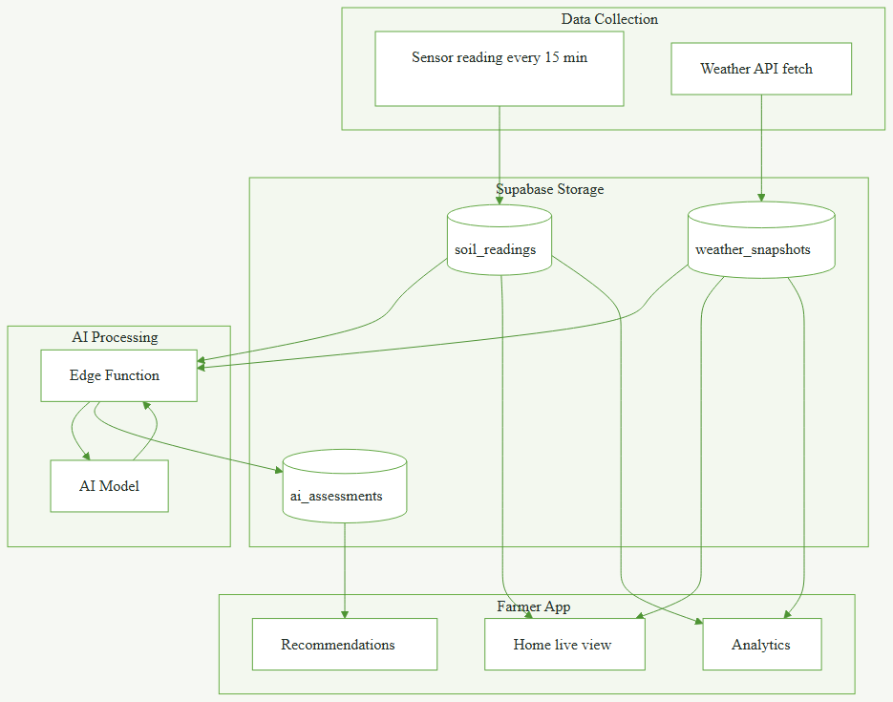
Figure 2. SoilGood System Data Flow.

Use Case Diagram
The system involves the following actors and functions:
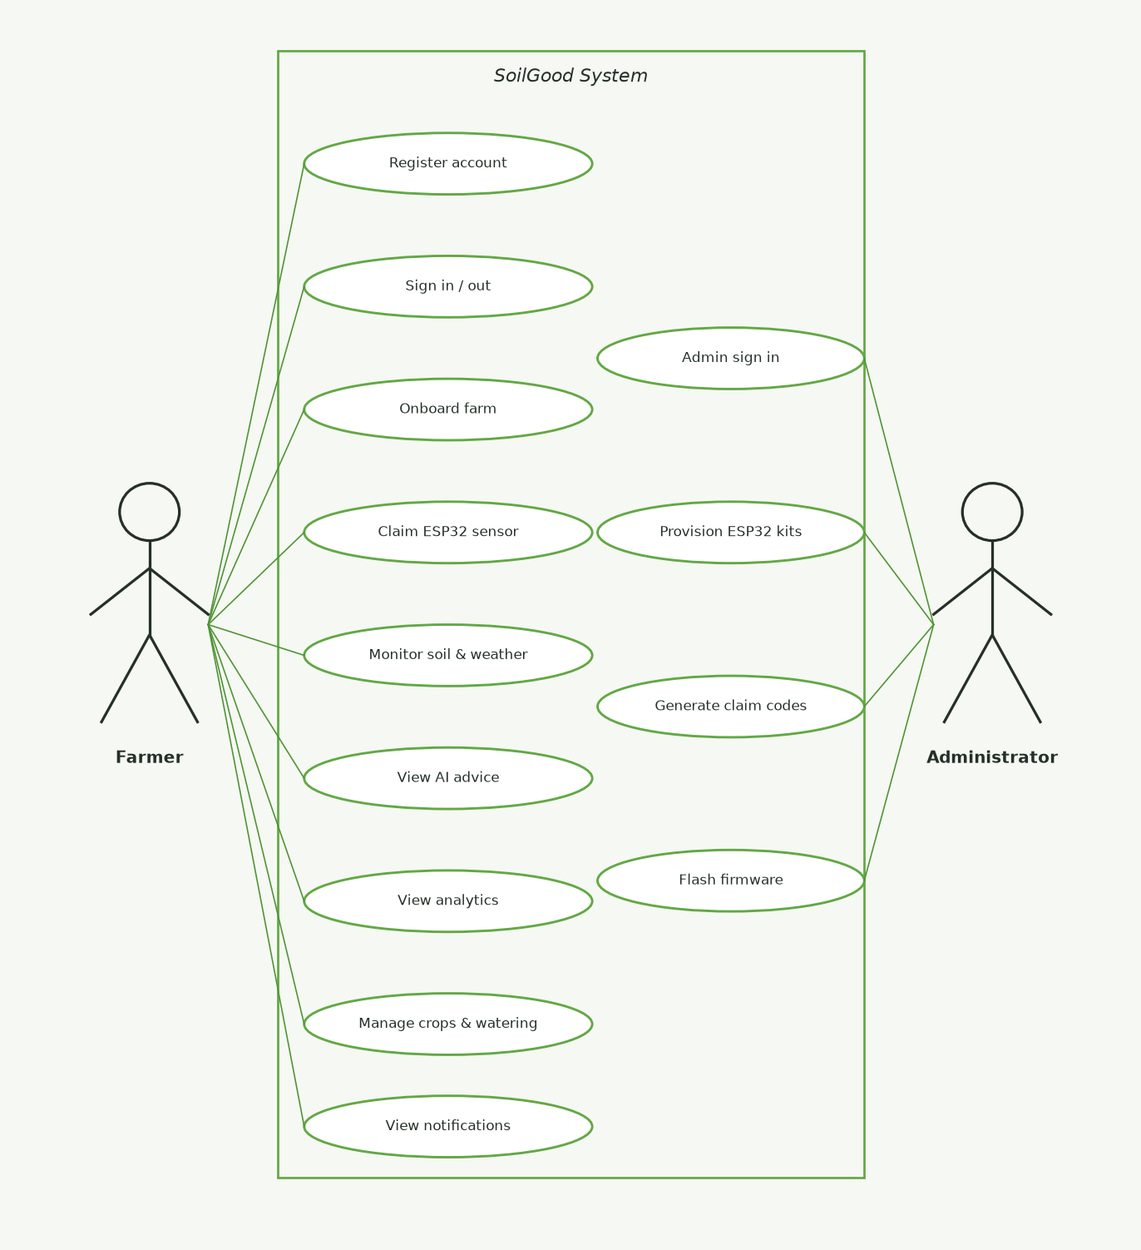
Figure 3. SoilGood Use Case Diagram.
The primary human actors are the Farmer, who performs day-to-day monitoring and decision-making through the mobile application, and the Administrator, who prepares and provisions ESP32 kits in the laboratory before they are distributed to farmers. The farmer registers an account, signs in and out, completes farm onboarding, claims an ESP32 sensor, monitors live soil and weather, views AI advice, reviews analytics, manages crops and watering logs, and reads in-app notifications. The administrator signs in, provisions new ESP32 kits, generates claim codes, and flashes device firmware. External system actors — the ESP32 device, the Open-Meteo weather API, and the AI model — participate in these flows through automated interfaces and are not shown as separate stickmen for clarity.

Database Design
SoilGood uses a PostgreSQL database hosted on Supabase. The schema is designed so that each farmer owns a profile, each profile owns one or more farms, and each farm aggregates its devices, soil readings, weather snapshots, plantings, AI assessments, farm actions, and notifications. Row-Level Security (RLS) is enabled on every table so that a signed-in user can only read or write records belonging to their own farm. The schema of each table is shown below.
Table: profiles
Field | Type | Description
id | uuid (PK) | Links 1:1 to auth.users (Supabase Auth).
first_name / last_name | text | Farmer's name.
barangay / municipality_city / province | text | Farmer's home address.
role | text | 'farmer' or 'admin'.
created_at / updated_at | timestamptz | Timestamps.

Table: farms
Field | Type | Description
id | uuid (PK) | Unique farm ID.
owner_id | uuid (FK) | References profiles(id); the owner.
name | text | Farm name.
barangay / municipality_city / province | text | Farm location (address).
latitude / longitude | double | GPS coordinates of the farm pin.
soil_texture | text | sandy / sandy_loam / loam / clay_loam / clay / unknown.
soil_series | text | Optional Philippine soil series (e.g. maligaya, bantog).
created_at | timestamptz | Timestamp.

Table: devices
Field | Type | Description
id | uuid (PK) | Unique device ID.
farm_id | uuid (FK) | References farms(id); null when the kit is unclaimed.
planting_id | uuid (FK) | References plantings(id); the active plot this sensor watches.
device_uid | text | Hardware UID (unique).
ingest_token | text | Per-device auth token used for soil reading ingestion.
claim_code | text | Code printed on the kit that the farmer enters to claim it.
name | text | Display name (default 'SoilGood Sensor').
status | text | unclaimed / active / offline / error.
last_seen_at / claimed_at / created_at | timestamptz | Timestamps.

Table: soil_readings
Field | Type | Description
id | uuid (PK) | Unique reading ID.
device_id | uuid (FK) | References devices(id).
recorded_at | timestamptz | When the reading was taken.
moisture_percent | double | Soil moisture (%).
ph | double | Soil pH.
soil_temperature_c | double | Soil temperature (°C).
ec | double | Electrical conductivity.
salinity | double | Salinity level.
nitrogen / phosphorus / potassium | double | NPK macronutrient values.
validation_status | text | ok / warning / error (range check result).
validation_message | text | Optional validation note.

Table: weather_snapshots
Field | Type | Description
id | uuid (PK) | Unique snapshot ID.
farm_id | uuid (FK) | References farms(id).
recorded_at | timestamptz | When the snapshot was captured.
temperature_c | double | Air temperature (°C).
humidity_percent | double | Humidity (%).
rainfall_mm | double | Rainfall (mm).
rain_probability | double | Rain probability (0–100).
wind_speed | double | Wind speed.
weather_condition | text | Condition label (e.g. 'clear', 'rain').
source | text | Data source label (default 'unknown').

Table: crops
Field | Type | Description
id | uuid (PK) | Unique crop ID.
name | text | Crop name (unique).
moisture_min / moisture_max | double | Preferred moisture range.
ph_min / ph_max | double | Preferred pH range.
temperature_min_c / temperature_max_c | double | Preferred temperature range.
ec_min / ec_max | double | Preferred EC range.
nitrogen / phosphorus / potassium (min / max) | double | NPK preference ranges.
salinity_min / salinity_max | double | Salinity tolerance range.
growing_season | text | Preferred season (e.g. wet, dry).
notes | text | Additional guidance notes.

Table: plantings
Field | Type | Description
id | uuid (PK) | Unique planting ID.
farm_id | uuid (FK) | References farms(id).
crop_id | uuid (FK) | References crops(id).
planted_at | date | Planting date.
expected_harvest_at | date | Expected harvest date.
status | text | planned / active / harvested / failed / replaced.
created_at | timestamptz | Timestamp.

Table: ai_assessments
Field | Type | Description
id | uuid (PK) | Unique assessment ID.
farm_id | uuid (FK) | References farms(id).
soil_reading_id | uuid (FK) | References soil_readings(id); the soil input used.
weather_snapshot_id | uuid (FK) | References weather_snapshots(id); the weather input used.
overview | text | AI-generated narrative assessment.
soil_health_score | double | Numeric overall soil health score.
generated_at | timestamptz | When the assessment was created.
model_name / prompt_version | text | AI model identifier and prompt version.

Table: ai_recommendations
Field | Type | Description
id | uuid (PK) | Unique recommendation ID.
assessment_id | uuid (FK) | References ai_assessments(id).
type | text | irrigation / nutrient / soil_management / crop_suitability.
title / description | text | Recommendation text.
priority | text | low / medium / high.
recommended_action | text | Suggested concrete action.
valid_until | timestamptz | When this recommendation expires and should be regenerated.
created_at | timestamptz | Timestamp.

Table: farm_actions
Field | Type | Description
id | uuid (PK) | Unique action ID.
farm_id | uuid (FK) | References farms(id).
created_by | uuid (FK) | References profiles(id); the farmer who logged the action.
action_type | text | irrigation / fertilizer / planting / treatment.
amount / unit | double / text | Quantity and its unit of measurement.
notes | text | Optional action notes.
performed_at | timestamptz | When the action was done.

Table: farm_notifications
Field | Type | Description
id | uuid (PK) | Unique notification ID.
farm_id | uuid (FK) | References farms(id).
type | text | irrigation / nutrient_low / soil_alert / sensor_error / device_offline / phase_change.
severity | text | info / warning / urgent.
title / body | text | Notification title and message.
soil_reading_id | uuid (FK) | Optional link to soil_readings(id) when relevant.
dedupe_key | text | Dedup key: one row per type per farm per Manila day.
read_at | timestamptz | When the farmer read the notification (null if unread).
created_at | timestamptz | Timestamp.

CHAPTER 3
SYSTEM DEVELOPMENT

Tools and Technologies Used
SoilGood is a Flutter mobile application for farmers, backed by Supabase and an AI model, with an ESP32 microcontroller as the field sensor. The stack favors free and open components so the system stays affordable to deploy and easy for future student researchers to extend. The technologies are grouped below by the layer they belong to.
Hardware (Field Device)
- ESP32 microcontroller. Reads the attached soil sensor over the RS485/UART interface and transmits readings over Wi-Fi.
- 8-in-1 soil sensor. Captures soil moisture, pH, temperature, electrical conductivity (EC), salinity, nitrogen, phosphorus, and potassium in a single probe.
- Lab-flashed firmware. Each kit is pre-provisioned with a device UID, an ingest token, and the Supabase project URL so no service-role credentials ever live on the device.
Frontend / Mobile
- Flutter (Dart). Cross-platform UI toolkit used to build the SoilGood mobile application. The target form factor is a small Android phone used in the field.
- Supabase Flutter SDK. Handles authentication, database queries, and Realtime subscriptions for the Home dashboard.
- SoilGood theme. Primary green (#4A7C59), matte white background, Literata and Nunito Sans typography. Tuned for readability in outdoor light and large tap targets for field use.
- Mapping and geolocation. Used during onboarding to let the farmer drop a GPS pin on the farm's location.
- Phone-first responsive layout. Content column is capped at a readable width on larger screens so tablets or Chrome do not stretch sensor cards into giant blocks.
Backend / Data
- Supabase PostgreSQL. Hosts the eleven application tables listed in Chapter 2 (profiles, farms, devices, soil_readings, weather_snapshots, crops, plantings, ai_assessments, ai_recommendations, farm_actions, farm_notifications).
- Supabase Auth. Email and password sign-in; a profile row is auto-created for each new user through a database trigger.
- Supabase Realtime. New soil_readings and farm_notifications are pushed to the mobile app the moment they are inserted, so the Home dashboard updates without polling.
- Supabase Edge Functions. Server-side function that bundles the latest soil reading and weather snapshot and invokes the AI model, then persists the result into ai_assessments and ai_recommendations.
- Row-Level Security (RLS). Enabled on every table so a signed-in user can only read or write records that belong to their own farm; the device ingest path uses a constrained RPC rather than service-role access.
AI and External Services
- AI model via Supabase edge function. Produces farmer-facing assessments and typed recommendations (irrigation, nutrient, soil management, crop suitability) based on the latest soil and weather inputs.
- Open-Meteo. Free weather API that supplies current conditions and a short forecast for the farm's GPS pin; snapshots are persisted in weather_snapshots so the AI and Analytics modules can reuse them.
Development Environment
- Cursor and Visual Studio Code. Primary IDEs for Flutter and SQL work.
- Android Studio. Used for Flutter emulator, Android device debugging, and APK builds.
- Flutter SDK and Dart. Framework and language runtime for the mobile app.
- Arduino IDE / PlatformIO. Used to flash the ESP32 firmware with its device UID and ingest token during lab provisioning.
- Git and GitHub. Source-code history, branching, and backup.
- Android phone. Primary target device used throughout development and testing.

Development Process
Requirements Gathering
Requirements came from the observed problem in Philippine smallholder farming: real-time soil and weather information is either unavailable or locked behind expensive commercial platforms, so irrigation, fertilization, and crop decisions often rely on guesswork. Functional requirements included an IoT soil-sensing kit built around the ESP32 and an 8-in-1 sensor, a mobile dashboard that shows the latest reading and current weather, historical analytics over selectable date ranges, a crop catalog with matching and a seven-day water plan, AI-generated recommendations tied to the specific soil and weather inputs that produced them, and an in-app alert inbox. Non-functional requirements included realtime list updates so the Home screen does not need manual refresh, phone-first UX tuned for farmers in the field, Row-Level Security on every table to isolate each farmer's data, and avoidance of any service-role credentials on the ESP32.
Design
The system was split into four cooperating layers on one project: the field hardware (ESP32 + 8-in-1 sensor), the Supabase cloud backend, the external APIs (Open-Meteo and the AI model), and the Flutter mobile application. The mobile app itself was split into a farmer app shell (Home, Analytics, Crops, Profile) and an admin provisioning path that is only reachable to accounts with the 'admin' role. Data design follows the schema described in Chapter 2: each farmer owns a profile, each profile owns one or more farms, and each farm aggregates its devices, soil readings, weather snapshots, plantings, AI assessments, farm actions, and notifications. AI output is treated as advisory, not prescriptive — the farmer still makes the final call — and the edge function only regenerates an assessment when its soil or weather inputs change or its validity expires.
Development
Modules were built iteratively, each delivered in a short plan–build–test–refine cycle that kept the prototype runnable at every stage. The order of implementation was:
- User authentication and farmer onboarding (profile, farm location pin, soil texture).
- Admin device provisioning and the claim-code flow for ESP32 kits.
- ESP32 firmware and the constrained Supabase ingestion endpoint for soil readings.
- Home dashboard with the latest 8-in-1 reading and live updates via Supabase Realtime.
- Open-Meteo integration for current weather and short forecast on the Home screen.
- Analytics module with historical trends, period averages, and watering logs.
- Crops module with catalog matching, planting selection, a rolling seven-day water plan, and phase-based care insights.
- AI edge function and the ai_assessments / ai_recommendations pipeline, with regeneration gated on input changes.
- In-app notifications inbox with deduplication per farm per day.
- End-to-end polish, error states, offline handling, and the final testing pass.
SQL scripts under docs/context/ provision tables, grants, and RLS policies. Lab flashing scripts prepare ESP32 kits with their device UID, ingest token, and claim code before distribution. The Flutter app is built and installed on a physical Android device for day-to-day testing while the ESP32 streams live readings to the same Supabase project.
Testing
Features were tested on a real Android device connected to the production Supabase project, with a provisioned ESP32 kit transmitting live sensor readings. Tested flows included user registration and sign-out, farm onboarding, sensor claiming, sensor-to-cloud ingestion with range validation, live Home updates, Open-Meteo weather retrieval, irrigation guidance against the forecast, nutrient and soil out-of-band alerts, device-offline detection, Row-Level Security isolation between accounts, and AI recommendation reuse when inputs are unchanged. Remaining UI polish and farmer-side Wi-Fi provisioning are treated as ongoing work and are listed in Chapter 5.

CHAPTER 4
RESULTS AND TESTING

System Features
The completed SoilGood prototype delivers the following features. Each feature was implemented, integrated with the Supabase backend, and verified on a real Android device before this documentation was prepared.
Feature 1: User Authentication and Onboarding
Description:
Farmers register and sign in using email and password through Supabase Auth. On first launch, a profile row is auto-created by a database trigger. The onboarding flow collects first and last name, Philippine address (barangay / municipality / province), farm name, a GPS pin on an interactive map, and soil texture (with optional Philippine soil series). Administrators sign in with the same auth flow and are routed to admin provisioning tools instead of the farmer app shell.
Feature 2: ESP32 Device Claiming and Soil Data Ingestion
Description:
ESP32 kits are pre-provisioned in the laboratory with a unique claim_code, a device UID, and an ingest token. Farmers enter the claim code in the app to link a kit to their farm, and the kit can then be placed on an active planting plot. Every fifteen minutes the ESP32 submits an 8-in-1 reading (moisture, pH, temperature, EC, salinity, nitrogen, phosphorus, potassium) to Supabase through a constrained ingestion endpoint — the device uses the anonymous key plus its per-device token and never the service-role key. Readings are validated against expected ranges before storage, and out-of-range values are flagged with a validation status.
Feature 3: Real-time Soil and Weather Monitoring (Home)
Description:
The Home dashboard shows the latest 8-in-1 soil reading with live updates via Supabase Realtime, so new rows appear within seconds without manually refreshing. Current weather and a short forecast from Open-Meteo for the farm's GPS pin are shown alongside the soil card. The AI section surfaces the current soil condition and the most recent irrigation, nutrient, and crop-care guidance tied to the latest reading and weather.
Feature 4: Historical Analytics and Period Insights
Description:
Analytics presents historical soil trends over selectable date ranges with period averages, day-level reading review, a period weather overlay, and watering logs. A period-based AI insight summarizes the soil conditions and management actions for the selected window, giving the farmer a longer-term view that the live Home screen cannot show.
Feature 5: Crop Matching and Cultivation Support
Description:
The Crops module matches crops from the catalog against the farm's latest soil snapshot and highlights the closest fits. Farmers can select a planting, record planted and expected harvest dates, and follow a rolling seven-day water plan generated from current soil moisture and the weather forecast. A 'Mark watered' action logs a farm_action, and phase-based care insights adapt the advice to the current growth phase of the crop.
Feature 6: AI-Assisted Recommendation Module
Description:
A Supabase edge function bundles the most recent soil reading and weather snapshot and sends them to the AI model, then persists the response as an assessment plus typed recommendations (irrigation, nutrient, soil_management, crop_suitability) with priority and a concrete recommended action. The function regenerates only when the soil or weather input changes or the assessment's validity expires; otherwise the saved assessment is reused, which avoids duplicate 'thinking' and conserves API calls.
Feature 7: In-app Notifications
Description:
A bell icon in the app bar opens an inbox of classified alerts: irrigation, nutrient_low, soil_alert, sensor_error, device_offline, and phase_change. Each alert is deduplicated per farm per Manila day so the inbox does not flood when the sensor stays in the same state. Severity is color-coded (info, warning, urgent), and new notifications appear live through Supabase Realtime.
Feature 8: Admin Device Provisioning
Description:
An admin workflow prepares ESP32 kits before they are distributed to farmers. The admin signs in with the 'admin' role, provisions a kit (inserting its device UID and ingest token into the devices table with status 'unclaimed'), and generates a claim code printed on the kit's box. Firmware is flashed in the lab so the farmer never has to configure Wi-Fi credentials on first boot.

Functional Testing
The following test cases were executed to verify system functionality. Each test was performed on a real Android device connected to the production Supabase project, with a provisioned ESP32 kit transmitting live sensor readings.
Table 1. Functional Testing Results.
Test Case | Expected Result | Status
Register / Sign in / Sign out (email + password) | Account created in Supabase Auth; session persists after sign in; sign out clears the session. | Passed
Farm Onboarding (profile, location pin, soil texture) | Farm saved with GPS pin and soil texture; farmer proceeds to the app shell. | Passed
Claim ESP32 Sensor (claim code) | Sensor linked to the farm after entering the claim code; appears in the device list. | Passed
ESP32 Soil Reading Ingestion & Validation | Reading received by Supabase; out-of-range values flagged; valid rows stored in soil_readings and visible in the app. | Passed
Home Shows Latest Live Soil Reading | Most recent reading shown via Supabase Realtime; stale or missing data visibly flagged, never faked. | Passed
Irrigation 'Water Today' Guidance | Correct advice based on current soil moisture and the near-term rainfall forecast. | Passed
Nutrient and Soil Out-of-Band Alert | Alert raised and shown in the notifications inbox for critical readings (e.g. extreme pH). | Passed
Device-Offline / No-New-Reading Detection | Offline state displayed when the sensor stops sending beyond the expected interval. | Passed
Farm Data Access Control (RLS) | Only the authenticated owner can read or write that farm's readings, devices, assessments, and actions. | Passed
AI Recommendation Reuse When Inputs Unchanged | AI regenerates only when soil or weather inputs change; otherwise the saved assessment is reused. | Passed

Evaluation
The prototype was evaluated against the project objectives and against general software-quality criteria such as usability, reliability, and security. The main strengths and weaknesses observed during development and testing are listed below.
Strengths
- Clear farmer-facing purpose: makes real-time soil data and practical AI advice accessible to smallholder farmers who normally decide by guesswork.
- Multi-sensor support per farm: more than one ESP32 kit can be placed on different planting plots under the same farm account.
- Real-time updates via Supabase Realtime keep the Home screen live without manual refresh.
- Row-Level Security isolates each farmer's data at the database level, so one account cannot read another farm's readings.
- Device safety: the ESP32 uses the anonymous key plus a per-device token for ingestion; the service-role key never lives on the hardware.
- AI recommendations regenerate only when soil or weather inputs change or validity expires, which conserves API calls and prevents stale duplicate advice.
- Phone-first Flutter UI tuned for farmers (large tap targets, matte colors, Literata and Nunito Sans for readability in outdoor light).
- Free-tier stack (Flutter, Supabase, Open-Meteo) keeps prototype deployment cost near zero.
Weaknesses
- Internet-dependent for core operations (live monitoring, AI recommendations, weather retrieval); weak rural signal can delay updates.
- AI output is advisory only — farmers must still apply their own judgment, and model availability depends on an external service.
- Push notifications when the application is fully closed are not implemented in this version; alerts are only shown while the app is in use.
- Farmer-side Wi-Fi provisioning (SoftAP or Bluetooth) is not implemented, so new ESP32 kits must still be configured in the laboratory.
- Sensor readings reflect only the installation point; parts of the farm without a sensor remain unmeasured.
- Weather accuracy depends on Open-Meteo, which is a free general-purpose API and is not calibrated for farm-level microclimates.
- The current data model assumes one owner per farm; multi-farm accounts and farm-level sharing are not yet supported.
- Soil sensor accuracy depends on calibration and placement and has not been independently validated against laboratory tests.

CHAPTER 5
CONCLUSION AND RECOMMENDATIONS

Conclusion
SoilGood demonstrates that an affordable combination of IoT hardware, a free-tier cloud backend, and an AI model can deliver useful, farmer-facing decision support in a mobile application. The ESP32 and 8-in-1 soil sensor reliably supply real-time soil readings, Supabase provides a secure and realtime-capable backend with row-level data isolation, Open-Meteo supplies free weather data suitable for day-to-day decisions, and the AI edge function turns these inputs into practical advice on irrigation, nutrients, soil management, and crop suitability.
All four specific objectives of the project were met: an IoT monitoring device was built, a real-time monitoring module with historical records was developed, a weather API was integrated, and an AI-assisted recommendation module was deployed. The ten functional test cases that cover authentication, onboarding, data ingestion, live display, irrigation guidance, alerts, offline detection, access control, and AI consistency all passed. The resulting prototype is runnable on a real Android device and is ready for presentation and demonstration.

Recommendations
The following recommendations are offered to extend SoilGood beyond its current prototype scope and to further strengthen its usefulness for Filipino farmers:
- Add push notifications so farmers can receive urgent alerts (critical soil condition or device-offline) even when the application is fully closed.
- Implement a farmer-side Wi-Fi configuration flow (SoftAP or Bluetooth provisioning) so new ESP32 kits can be connected in the field without returning to the laboratory.
- Introduce an offline mode that caches the most recent readings, weather, and AI assessments so the app remains useful in areas with weak or intermittent internet.
- Expand the crop catalog with locally verified soil and climate ranges for additional Philippine crops, and refine the AI prompt with region-specific guidance.
- Add Tagalog (and other regional language) localization for the farmer-facing text so the application is more approachable for farmers who are not comfortable reading English.
- Support multi-farm accounts under one owner so farmers managing several parcels can switch between them inside the same account.
- Explore additional sensors (e.g. soil temperature at depth, ambient light, or air temperature) and calibrate the 8-in-1 sensor against laboratory tests for improved accuracy.
- Pilot the system with a small group of farmers to gather qualitative feedback and measure actual yield or input savings, then refine the UX and recommendations based on observed usage.

