Sales and Marketing Requirements Specification

1. Executive Summary
  - Purpose
This document is meant for online clothing shop web application is to intended to provide complete solutions of vendors as well as customers through single get way using internet. It will enable vendors to step up online shops, to browse through the shop and purchase online without visiting the shop physically.
  - Purpose and Scope of this Specification
This system allows the customer to maintain their cart for add or cancel the product trough internet.
2. Product/Service Description
2.1 Product context
Show the product context of Sales and marketing and how does it interface with the other system. If customer want to buy some clothes via online she/he needs to register to the online shop which scope of sales and marketing before customer get the product she/he must need to filled and do the create account, manage account, place order, add to cart and cancel if the user change his/her mind while ordering. But before that happen sales and marketing has interface to the other system such: Human resource to get the employees hiring and support, ware house to order and ship the product and last is Accounting and Finance to collect the money from the customer.
Diagram 2.1
(Sales & Marketing)
- Create Account
- Manage Account
- Place order
- Cancel order



Customer Payment
Register
Accounting
Product
Employee
Customer



Human Resource
Ware House

2.2 User Characteristic
Student every student represent as a user that takes the test of clothes online shop that we may consider as improvement in sales and marketing interface.
Staff to had a rapidly sales a staff must have a clear communication skill to customer and in system interface
Server is the system that accepts multiple connections from customer and the serves that result.
2.3 Assumptions
- User has an active internet connection or has access to one to view the website.
- The user have at least basic knowledge of computer
- The users know the English language, as user interface uses.
2.4 Constraints
The system should build using a web page development tool like HTML, XAMPP
2.5 Dependencies
The system depends in the following:
- It does depend in Supply Chain Management, any of the purchase product of sales and marketing has order from the stock of SCM. If SCM process occurs some failure the Sales and marketing might have a problem about the product too.
- Sales and Marketing system depend in accounting system, the data of the product that enter from Sales was direct to Accounting system.
- It depend in Human Resource system in assigning employee and also at the Employees hiring that scope of Sales and marketing and its direct from human resource system.

3. Requirements
3.1 Functional Requirements
When using a system the first interface that might see are the system home page that includes Home, Product, Apply Job, About Us, Feedback, Sign up and the Login navigation bar.
3.1.1 When clicking the Home it will view the:
- Feature Products, pucrases some of the trends product and customer can choose order from it. And will click the
- Add to cart button if customer had already done in shopping.
- Shopping cart will appear from the top right side of the system and it will view the customer order and its specs. Correspond in
  - Clear cart, all of the order should clear and it back from the home.
  - Check out total it’s either continue shopping or pay on store
- Continue shopping button will help the customer to add the product that they want to add to their cart.
- Pay on store it has four (4) parts that must need to fill up include the Account, Personal Data, Payment, Confirm
- The Account form required customer Full name, Email and Postal Code then click the account button then the next things will show up its
- Personal data includes Address, country, City and phone number after filling up then click the personal data at the lower part of the system.
- Payment includes how much is the appropriate shipping fee of customers order is has auto generate in the system and also has a Delivery address and Total amount of the product that customers order.
- Confirm the last process for pay on store the customer should click the “proceed” button if she/he are surely want to order the product.
3.1.2 About Us, are viewing the vision of the system and does the customer contact us in case of error.
3.1.3 Apply Job
For the person who want to apply job should fill up the form that includes Employee ID, Full Name, position, Salary then lick the submit button and it will direct from the Human Resource system.
3.1.4 Feedback, need a requirements such a customer ID, Name, Email, Mobile Number and has a form for customers for any suggestion, recommendation “feedback” about the services. The click the submit button.
3.1.5 Sign up customer must need to create an account to easy access when in delivery process. Customer need to fill up the form that includes Registration ID, Full name, Contact Number, Email, Address, Username and Password the click the sign up button, after clicking the button the Log in will pop up.
3.1.6 Log in, the user name and password that customer fill from sign up will be the username and password that is uses in log in form. Customer must log in a valid username and password. then click the Log in button.
3.1.7 Registration
If the customer are new and don’t have any account in shop she/he must be register to shop if not the user can’t go to the shopping cart.
3.1.3 Add to Cart
When customers done to shopping cart she/he can add to the cart and place the order.
3.1.4 Change to Cart
If the customers change his/her mind then it can cancel the order of the product from shopping cart
3.1.5 Logout
After ordering product the customer must logout his/her account from website.

3.2 User Interface Requirements
The various interface of the product could be:
- Login Page
- Registration Form
- Information about the product (Price, Brand, Quantity, Size, Color)
- If the user clicks the button add to cart then another screen of shopping cart should be open.

Home Page
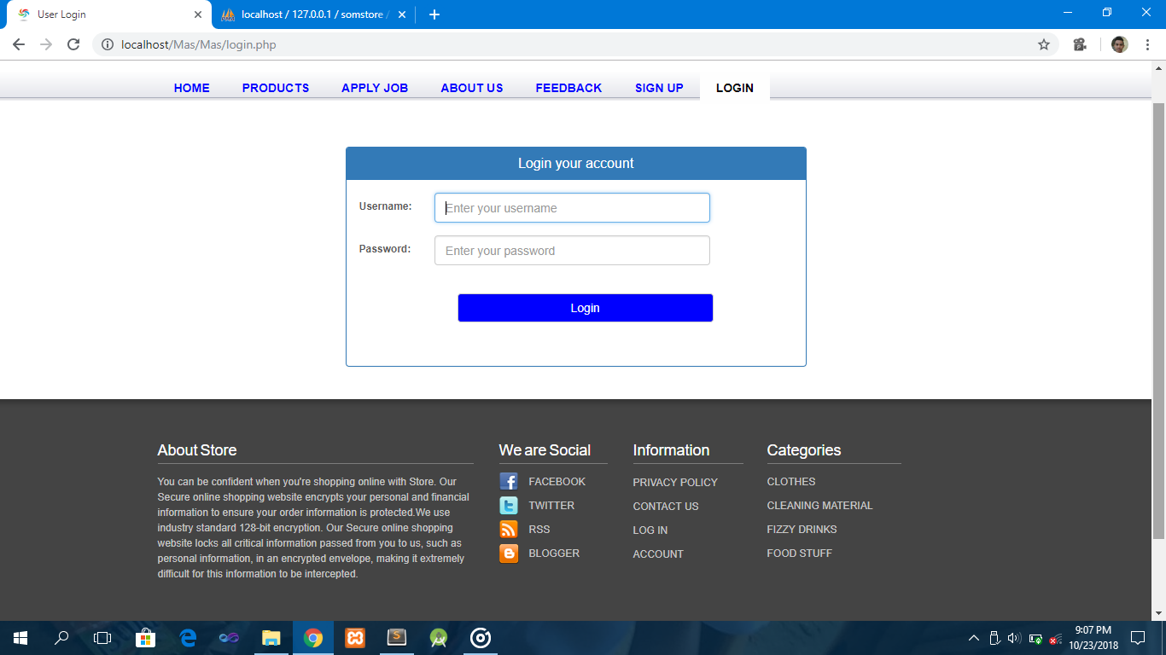
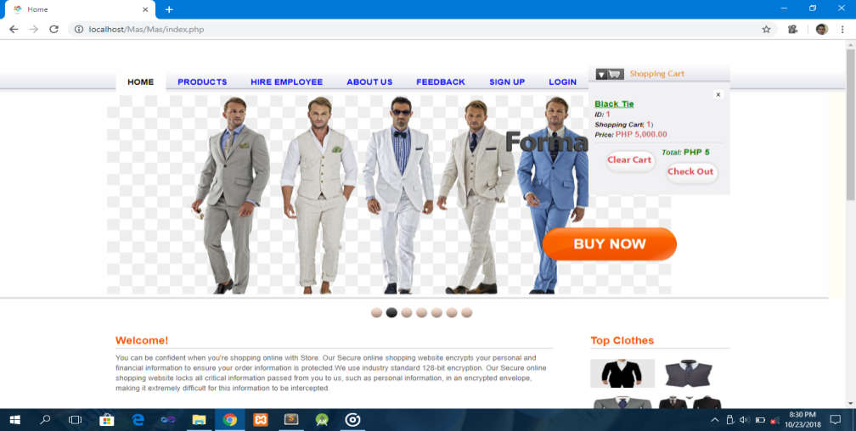
Login Form

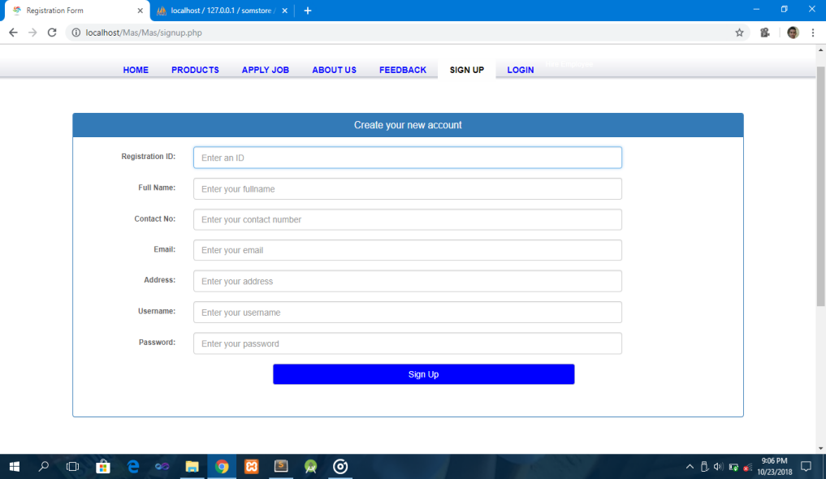
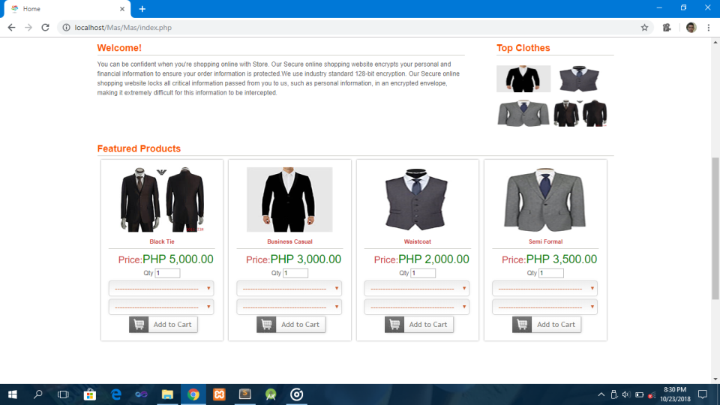
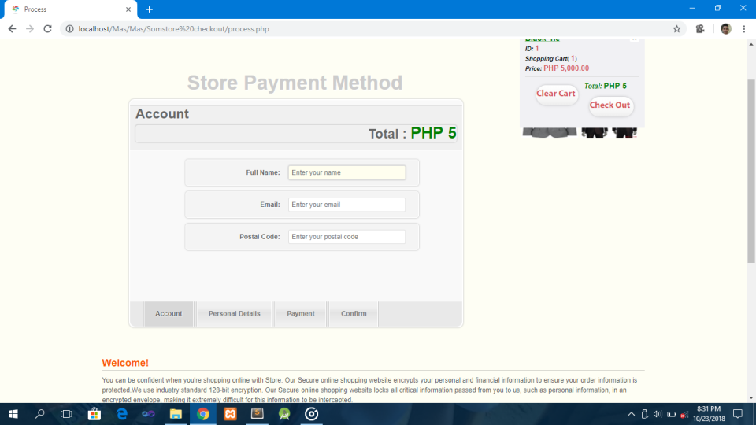
Fill Up the payment Form
Fill Up the personal Detail
Fill Up the account form

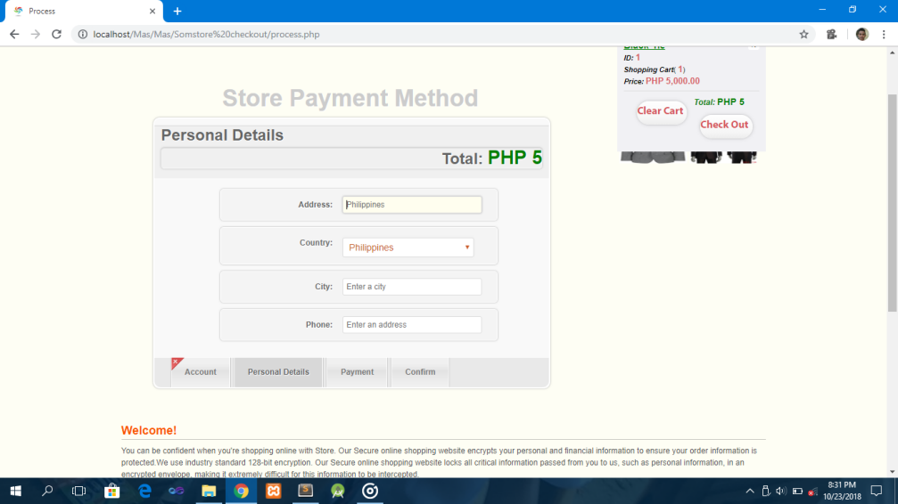
Shipping Fee
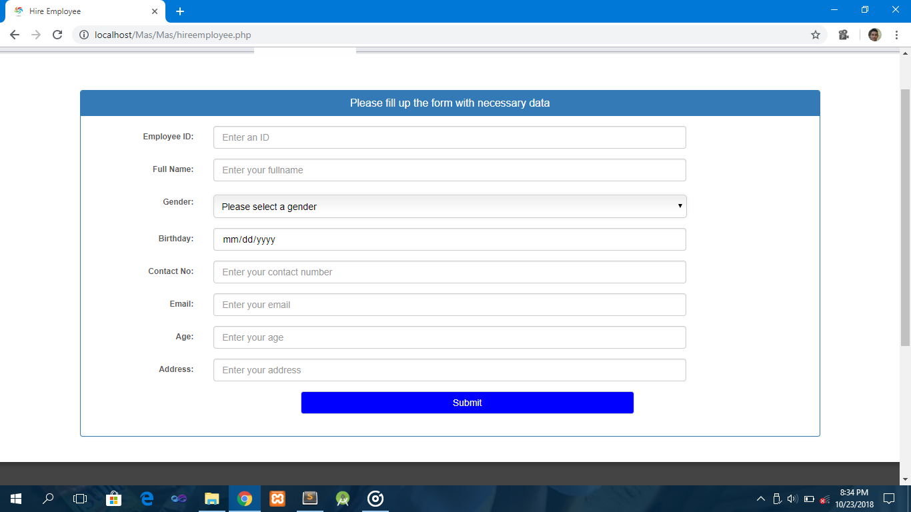
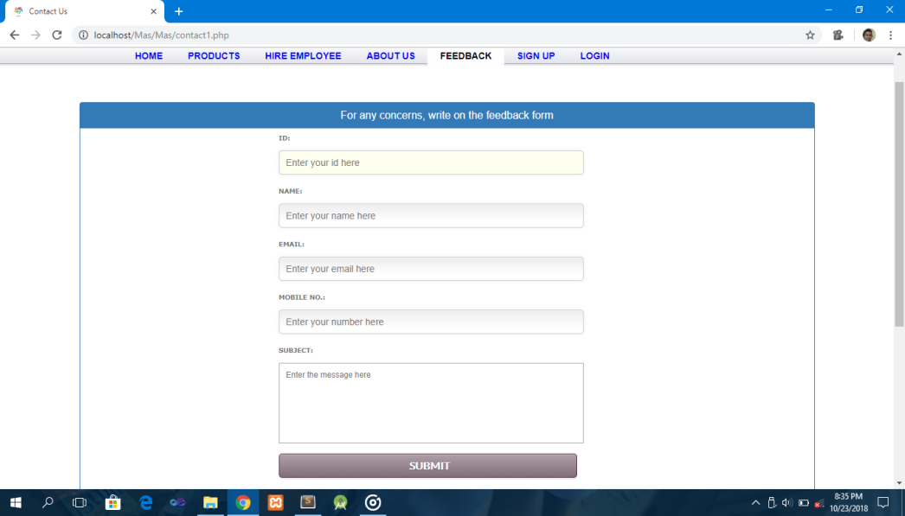
Hiring Employee’s Form
User Feedback

3.4 Performance
3.4.1 Capacity

3.4.2 Availability
The system can access anytime, anywhere from web browser.
3.4.3 Latency
3.5 Manageability/Maintainability
3.5.1 Monitoring

3.5.2 Maintenance
3.5.3 Operations

3.6 System Interface/Integration
3.6.1 Network and Hardware Interface
The system must run over the internet. So that, all the hardware shall require to connect the internet
3.6.2 System Interface
The system is on the server it is required Data Base to store any transaction from the system and the user must have a web browser to access the shop.
3.7 Security
3.7.1 Protection
This system has a protection from malicious including :
- Admin can’t view user information such password
- Password encryption
- User can’t login without account
3.7.2 Authorization and Authentication

3.8 Data Management
Requirements to be placed in data base including;
- Registration, products, delivery details.
- Anytime
- Registration, records, hiring information
- Data entities and relationships
- Login with an existing account to access
- keeping data within data base and extra copies
- No registration is required if there is an existing account, registered account can access easily.
- 25 rows can be only occupied in database.
- Text, VarChar, Int are the data types that has been used in database.

3.9 standard compliance
• UR04: For Incremental delivery each user requirement shall include measure of priority so that the developer can decide the production schedule.
• UR10: An output of the User Requirements Phase shall be the User Requirements Document.
• Error: Prevent the developer from completing the action that would result in non-compliance.
• Warning: Indicate to the developer that the result of the action is non-compliance.
• Guideline: Suggest to the developer that compliance to a practice should be checked.

Authorization and authentication
• The login page checks to see if the current user is authenticated, if not, we present a login form and the user must submit a username and password for authentication.
• Authenticated users are able to access the requested page , for selecting and updating customer orders in data base.

